Diabetes Prediction Using Data Mining
by
Khadiza Khanom
ID: 171-15-1151

Farzana Hasnat Mou
ID: 171-15-1181

Firuj Samiha Mim
ID: 171-15-1153

This Report Presented in Partial Fulfillment of the Requirements for the Degree of Bachelor of Science in Computer Science and Engineering

Supervised By

Ohidujjaman
Sr.Lecturer
Department of CSE
Daffodil International University

Co-Supervised By

Md.Reduanul Haque
Sr.Lecturer
Department of CSE
Daffodil International University



DAFFODIL INTERNATIONAL UNIVERSITY
Dhaka, Bangladesh
December 2020

APPROVAL

This Project titled “Diabetes Prediction Using Data Mining”, submitted by Khadiza Khanom, Farzana Hasnat Mou and Firuj Samiha Mimto the Department of Computer Science and Engineering, Daffodil International University, has been accepted as satisfactory for the partial fulfillment of the requirements for the degree of B.Sc. in Computer Science and Engineering and approved as to its style and contents. The presentation has been held on 8th December, 2020

Board of Examiners

(Name) Chairman
Designation
Department of CSE
Faculty of Science & Information Technology
Daffodil International University

(Name) Internal Examiner
Designation
Department of CSE
Faculty of Science & Information Technology
Daffodil International University

(Name) External Examiner
Designation
Department of -------
Jahangirnagar University

Declaration
We hereby declare that, this project has been done by us under the supervision of Ohidujjaman, Sr.Lecturer, Department of CSE Daffodil International University. We also declare that neither this project nor any part of this project has been submitted elsewhere for award of any degree or diploma.
Supervised by:

Ohidujjaman
Sr.Lecturer
Department of CSE
Daffodil International University

Co-Supervised by:

Md.Reduanul Haque
Sr.Lecturer
Department of CSE
Daffodil International University

Submitted by:

Khadiza Khanom
ID:171-15-1151
Department of CSE
Daffodil International University

Farzana Hasnat Mou
ID: 171-15-1181
Department of CSE
Daffodil International University

Firuj Samiha Mim
ID:171-15-1153
Department of CSE
Daffodil International University

ACKNOWLEDGEMENT
First we express our heartiest thanks and gratefulness to almighty God for His divine blessing makes us possible to complete the final year project/internship successfully.

We really grateful and wish our profound our indebtedness to Ohidujjaman,
Sr.Lecturer, Department of CSE Daffodil International University, Dhaka. Deep Knowledge & keen interest of our supervisor in the field of “Data Mining” to carry out this project. His endless patience ,scholarly guidance ,continual encouragement , constant and energetic supervision, constructive criticism , valuable advice ,reading many inferior draft and correcting them at all stage have made it possible to complete this project.

We would like to express our heartiest gratitude to -----, -----, and Head, Department of CSE, for his kind help to finish our project and also to other faculty member and the staff of CSE department of Daffodil International University.

We would like to thank our entire course mate in Daffodil International University, who took part in this discuss while completing the course work.

Finally, we must acknowledge with due respect the constant support and patients of our parents.

Abstract

This current epoch is facing a hard nut to crack which is none other than diabetes. Increasing blood sugar is the main issue of this deadliest disease. We get glucose from our food what we eat. Insulin is a hormone. It helps to get sugar or glucose from blood into our cell and produce energy. If there are lack of insulin and glucose cannot be got in cell then it remains left over in blood and that’s why the glucose level in blood increased. This is mainly known as diabetes. Diabetes is dependent on our lifestyle. When we are not aware of our diet, weight and body fitness, we use to consume extra sugar through our food and the extra sugar cannot be utilized to produce energy and they remain same that causes glucose high. Proper production and management of Insulin hormone is necessary. There are two form of diabetes such as type 1 and type 2. Diabetes causes so many complication in our body. It affect our kidney, eyes, heart and so on. It is good to be aware of having diabetes as well as lead a controlled life. When it is too late to identify diabetes, it causes so many difficulties. Consulting a doctor and visiting diagnostic centers is a tiresome process for a patient. But now-a-days the improvement of data mining and machine learning approaches find out a solution of this troublesome issue. This paper is the description of our study to predict diabetes of women in an early stage using data mining algorithms. To make us work, we have used six data mining algorithms namely K Nearest Neighbors, Decision Tree, Logistic Regression, Support Vector Classifier, Naïve Bayes and Random Forest. We have experimented on Pima Indians Diabetes Database (PIDD) that is chosen from Kaggle which contains 768 record and 9 features (first 8 are independent and the last one is dependent), a community of data science. K Nearest Neighbors algorithm are in the utmost position considering accuracy. Its accuracy rate is about 78.57% which is a far cry from the other algorithms. This exploration are acting by some ordinary factors accountable for this chronic disease as for instance pregnancies, glucose, blood pressure, BMI, insulin, age, etc.
Keywords: Diabetes prediction, data mining, data mining algorithms (LR, KNN, SVC, NB, DT, RN).

TABLE OF CONTENTS
CONTENTS | PAGE
Board of examiners | ii
Declaration | iii
Acknowledgements | iv
Abstract | V
CHAPTER

CHAPTER 1: Introduction | 1-3
1.1 Introduction | 1-2
1.2 Motivations  1.3 Research Questions  1.4 Expected Outcome  1.5 Report Layout  Chapter 2: Background  2.1 Preliminaries  2.2 Related Works  2.3 Research summary  2.4 Scope & Challenges  Chapter 3: Research Methodology  3.1 Introduction  3.2 Research Subject and Instrumentation  3.3 Data source and collection  3.4 Descriptive Statistic  3.5 Data Visualization  3.6 Data preprocessing  3.6.1 Feature Engineering  3.6.2 Criteria for selection  3.7 Working Flowchart  3.8 Implemented Algorithm  3.8.1 Support Vector Classifier  3.8.2 Naive Bayes  3.8.3 Decision Tree  3.8.4 Logistic Regression  3.8.5 Random Forest Machine Learning  3.8.6 K Nearest Neighbors  CHAPTER 4 : EXPERIMENTAL RESULTS AND DISCUSS  4.1 Experimental Results & Analysis  4.1.1 Confusion Matrix and Heat Map of Support Vector  4.1.2 Confusion Matrix and Heat Map of Naive Bayes  4.1.3 Confusion Matrix and Heat Map of Decision Tree  4.1.4 Confusion Matrix and Heat Map of Logistic Regression  4.1.5 Confusion Matrix and Heat Map of Random Forest  4.1.6 Confusion Matrix and Heat Map of K Nearest Neighbors  4.2 Evaluation measures  Chapter 5: Impact on Society, Environment and Sustainability  5.1 Impact On Society  5.2 Impact On Environment  5.3 Ethical Expects  5.4 Sustainability Plan  Chapter 6: Summary, Conclusion, Recommendation and Implication for Future Research  6.1 Conclusion  6.2 Future Work | 2  3  3  4  5-8  5  5-7  8  8  9-25  9  9-10  10  10-11  12-15  15-17  16  17  18  19-25  19-20  20-21  21-22  22-23  23-24  24-25  26-29  26-28  27  27  27  28  28  28  29  30-31  30  30  30  31  32-33  32  33
REFERENCES | 34-35

LIST OF FIGURES
FIGURES | PAGE NO
Figure 1: Preview Data Table. | 10
Figure 2: Histogram of Pregnancies. | 12
Figure 3: Histogram of Glucose. | 12
Figure 4: Histogram of Blood Pressure. | 13
Figure 5: Histogram of Skin Thickness. | 13
Figure 6: Histogram of Insulin. | 13
Figure 7: Histogram of BMI. | 14
Figure 8: Histogram of Diabetes Pedigree Function. | 14
Figure 9: Histogram of Age. | 14
Figure 10: Correlation Heat Map | 15
Figure 11: Statistical Analysis. | 16
Figure 12: Working Procedure Flowchart. | 18
Figure 13: Flowchart of SVC | 19
Figure 14: Flowchart of NB | 21
Figure 15: Flowchart of DT | 22
Figure 16: Flowchart of LR | 23
Figure 17: Flowchart of RF | 24
Figure 18: Flowchart of KNN | 25
Figure 19: Plotting a graph of KNN | 25
Figure 20: Results | 26
Figure 21: Confusion Matrix of SVC | 27
Figure 22: Heat map of DT | 27
Figure 23: Confusion Matrix of NB | 27
Figure 24: Heat map of NB | 27
Figure 25: Confusion Matrix of DT | 27
Figure 26: Heat map of DT | 27
Figure 27: Confusion Matrix of LR | 28
Figure 28: Heat map of LR | 28
Figure 29: Confusion Matrix of RF | 28
Figure 30: Heat map of RF | 28
Figure 31: Confusion Matrix of KNN | 28
Figure 32: Heat map of KNN | 28

LIST OF TABLES

TABLES | PAGE NO
Table 1 Related studies on Diabetes Prediction | 6-7
Table 2 : Dataset Description | 9
Table: 3 Features and Data Type | 11
Table 4: No. of Positive and Negative Data | 16
Table 5: Ratio of Training and Testing Dataset | 26
Table 6: Results | 32

CHAPTER 1
Introduction

  - Introduction
There is a huge data in everywhere as well as in medical field and it is very hard to manage them in a systematic way. If we are able to use them in an efficient way we can update ourselves to the digital world as information and data is everything in this digital world. That is why classification stratagems are performed to classify data into several classes in accordance with some limitations relatively a separate classifier. An infelicity, diabetes which causes hamper to the production of insulin hormone that is responsible for disordering in carbohydrate metabolism in addition with it upturns the glucose level in blood. A person undergoes with high blood sugar while containing diabetes. Escalating hunger, thirst and frequency of urination are the results owing to high blood sugar. Still now, there are two different kinds of diabetes called type 1 and type 2. In type 1, patient body is unable to produce insulin and in type 2 either insulin does not produced or does not use properly. Between them type 2 diabetes is the mostly common and can be found in a significant number in human body. If diabetes is not treated properly, so many difficulties can be happened like non kenotic hyperosmolar coma and diabetic ketoacidosis. The measurement of sugar substance cannot be checked while testing diabetes as considering a crucial health issue. The prime cause of infecting in diabetes is sugar consistency though weight, insulin and hereditary factor are also act as functional factor. If insulin hormone done not work properly and consumed glucose cannot be get into human cell then it left over in blood and increase glucose level. Glucose get into the cell and produce energy. By this process the consistency of glucose in blood remain uniform. Now-a-days in Bangladesh diabetes is become a household word to every family. In the world now about 422 million people are infected by diabetes, greatly in lower-middle economic countries and 1.6 million deaths directly connected with diabetes according to World Health Organization (WHO). The global appearance of diabetes among grown up is 8.5% in 2014 which was 4.7% in 1980. Premature mortality is increasing and its rate is 5% between 2020 and 2016.
Diabetes patients is very normal all over the world. But in developed countries the number of diabetes patients is the most [1]. As most of the people are not conscious about their body and what they are consuming as well as shows unwilling to exercise, the number of diabetes patient is growing rapidly. To stay far from the difficulties, early identification is the unique redress. When someone can know that possibility of having diabetes is present in her body then she can definitely try to take some precusions in time. As most of the in women are not enough conscious about their health and try to avoid medical treatment without any major issue, they can take the advantages of predicting diabetes in a vast way. To take under consideration about this, there are so many researchers who are trying to continue their study for prediction and dragooning diseases with the help of classification algorithms in machine learning approaches as Decision Table, Naive Bayes, SVC, J48, Decision Tree etc. because it has been proved by research that in diagnosing diseases machine learning works better. The management capability of a big quantity of data is the strength of machine learning and Data Mining algorithms. While studying it can gather data from many sources and combine the background information. This study concentrates on predicting diabetes for women. In this work, K Nearest Neighbors, Decision Tree, Logistic Regression, Support Vector Classifier, Naïve Bayes and Random Forest machine learning classification algorithms are utilized for predicting diabetes disease in a patient body. This work is done on PIDD dataset. Exploratory ability of all algorithms are differentiate into various measures and gained best accuracy.

  - Motivations

Diabetes, a group of metabolic disorder distinguished by a high blood sugar level over an extended period of time. Though increasing frequency of urination, increasing hunger, increasing thirst is the common symptoms of diabetes, it has also some minor symptoms as well for instance losing weight, felling pain in hands or feet, blurry vision, extreme fatigue etc. Type 1 and type 2, these are the two form of diabetes. In diabetes, one may have complications in major organs of the body like heart, kidneys, eyes, nerves, blood vessels so on. Early detection is the only solution to prevent major problems. Because if someone detect their diabetes in an initial stage and control the blood sugar then it will help not to fall in extreme complications. In Bangladesh, women are mostly infected with diabetes as they are not used to with enough physical activities and not aware of their health condition. They always try to hide health issue because they don’t want to get in extra tiresome process of going under medical treatment.
That is why many studies, experiments and researches are done in this era. This study is about early prediction of diabetes. It will save many lives and it will help to lead a healthier life as well. Our main motive is to reduce the complications caused by diabetes. By predicting diabetes earlier, immature death will decrease. In this study we emphasized about pregnant patient. Pregnant women are always having so many difficulties during their pregnancy. Having diabetes is now a very common issue. When a woman is in her
maternity period and if she is infected with diabetes then it will be more complicated for her. In pregnancies it becomes more complicated for a women to give a certain birth of a new baby. Early prediction of diabetes can prevent birth defects by maintaining some precautions. As diabetes is a crucial disease, no one should ignore it. It is a matter of thought that how one can predict diabetes more accurately and the process of it will less time consuming. Our study is all about women patients as if they can get the proper prediction result of diabetes. This study is also about to find out the highest accuracy rate among the six data mining algorithms by machine learning approaches as we have used six algorithms here. It will help to choose the best algorithm on this purpose. We found K nearest neighbor

1.3 Research Questions
➢ What is Diabetes?
➢ What are the reasons of having diabetes?
➢ What are the major issues in having diabetes?
➢Who will be the target patients?
➢ How to detect diabetes?
➢ Is diabetes prediction taking a notable place in data mining?
➢ Can we solve the diabetes prediction by machine learning technique?
➢ Which machine-learning algorithm is giving the best prediction precision?

1.4 Expected Outcome
Prediction of diabetes is a burning issue of modern age in medical field. At present diabetes have become a crux for both patients and doctors. That’s why medical technologies are finding the best way to predict diabetes by the aid of machine learning algorithms. As machine learning algorithms are able to manage a vast data set and to predict diabetes there is need of some normal data which can be gained from a simple
test, data mining techniques are utilized for this. There are so many techniques to predict diabetes via data mining and machine learning algorithms. Data mining and machine learning algorithms have such a great positive impact on medical files as well. The techniques are supper convenient to use also. In our study we have used here K Nearest Neighbors, Decision Tree, Logistic Regression, Support Vector Classifier, Naïve Bayes and Random Forest. To predict the best classifier, we have used the component of confusion matrix as well. Confusion matrix is the statistical classification. In unsupervised learning, confusion matrix is considered as matching matrix and in supervised learning confusion matrix is used as performance visualization of algorithms.

1.5 Report Layout

Before start anything we need introduction and motivation and our paper chapter 1 we discuss about introduction and our motivation on this topic which is Diabetes prediction and why we chose it. In this paper, Chapter 2 covers the related working area. When we complete our introduction, we focused on those worked what is related with our topics collect their valuable information. Basically, our 2 chapter normally discussed about related work. Consequence in chapter 3 we discuss about implement algorithm, we chose famous 6 algorithms’ (K Nearest Neighbors, Decision Tree, Logistic Regression, Support Vector Classifier, Naïve Bayes and Random Forest) and applied those algorithms in our dataset to searching best one and it’s our methodology part. Chapter 4 we talk about all of our algorithm’s outcome and evaluation. Then in Chapter 5 we talk about the impact on society, environment and sustainability plan. Finally, Chapter 6 we got our distinguish result which can say the comparative best one. It’s our conclusion part. At last, we show references from where we collect our information.

Chapter 2
Background

2.1 Preliminaries
Diabetes is one of the most familiar non-infectious illness in the universe. It is estimated as the seventh chief reason for demise. People are under check by the National Institute of Diabetes and Digestive and Kidney Diseases as the number of diabetes patient is increasing [2]. There is also so many researches and experiments on women patients to predict diabetes. For medical professionals and researchers, the major goal is to predict diabetes earlier. In this modern world, Computer science has a grandiose technological newness. By using computer proficiency and algorithms like machine learning and data mining, charge effective, efficacious and faster techniques can be formed for prediction of diabetes and this is showed by the collaborative researches. To predict diabetes several prediction models have been developed by many researchers utilizing data mining. Data mining is now a vive technology that have the efficiency of performing in complex data as well.

2.2 Related Works
Diabetes could apparent severally in every diabetes patient as every patient has several unmodified and modified risk factors. The major complication of diabetes is retinopathy in Indonesia [3]. In Indonesia, the percentage of diabetes patient was 10.9%, but it is becoming higher now [4]. Data mining and machine learning have become the essential techniques for exploring and achieving knowledge from complicated and huge attributed data recorded by medical. There is a variance among the techniques in data mining which can create association between unstructured and structured data. That is why so many studies and researches are around there about prediction of diabetes using data mining and machine learning. In the table, this paper metering some of related works on this topic:

Table 1: Related studies on Diabetes Prediction
Reference | Used Dataset | Prediction Method and Accuracy
Changsheng Zhu et al. [19] | A data set of Pima Indians Diabetes dataset (UCI repository) | They have integrated PCA, K-means and Logistic Regression. The result is 89%.
Talha Mahboob Alam et al. [17] | A dataset from National Institute of Diabetes and Digestive and Kidney Diseases (UCI repository) | They have used three machine learning algorithms namely ANN (75.7%), RF (74.7%) and K-means (73.6%). In this ANN has the highest accuracy.
Cut Fiarni et al. [3] | Tested on three data sets (Sri Pamela Hospital and Kumpulan Pane Hospital, Tebing Tinggi, and Dolok Community Health Center) | Among NB, C4.5 DT, K-means (68%) k-means gave the highest accuracy.
Sajida Perveen et al. [14] | A dataset from CPCSSN (2003 to 2013) | They have used J48 machine learning algorithms.
Deepti Sisodia and Dilip Singh Sisodia [18] | Data set of PIDD | DT (73.82%), SVC (65.1%) and NB (76.3%)
Aishwarya Mujumdar and Dr. Vaidehi V [6] | A collection of data contains 800 records and 10 attributes | SVC, RF, DT ETC, Perceptron, AB, GBC, LR, NB, LDA, KNN. LR gave the highest accuracy about 96%.
Neha Prerna Tigga and Shruti Garg [15] | A collection of data via online questionnaire containing 18 questions | LR, KNN, NB, RF, SVC, DT. RF gave the highest accuracy about 96%.
Han Wu, Shengqi Yang et al. [16] | Pima Indians Diabetes Dataset | Proposed a model based on data mining techniques with the higher accuracy of 3.04% from others.
Xue-Hui Meng et al. [9] | A collection of data from random people of China and Guangzhou | LR (76.13%), ANN (73.23%), DT C5.0 (77.87%)
Francesco Mercaldo et al. [13] | PIDD(UCI repository) | J48, MP, HT, J Rip, BN and RF
Messan Komi et al. | Dataset of local hospital | GMM, SVC, LR, ELM, ANN
Fikirte Girma Woldemichael and Sumitra Menaria | Pima Indians Diabetes Dataset | J48, SVC, NB, BP. BP gave the highest accuracy about 83.11%.
S.Selvakumar et al. [20] | Pima Indians Diabetes Dataset | BLR (69%), MP (71%) and KNN (80%)
Rahul Joshi and Minyechil Alehegn | Pima Indians Diabetes Dataset | KNN, NB, RF and J48.
Dr. D. Asir Antony Gnana Singh et al. | Dataset from their own medical history | NB, ML and PRF. NB gave better accuracy.

2.3 Research summary
As we can see from the above studies, there are so many machine learning algorithms and data mining techniques have been used to predict diabetes. PIDD (Pima Indian Diabetes Dataset) are mostly used dataset in this regard. A method was proposed to use image of tongue texture, color and geometry features of diabetic patients [5]. Some researcher worked in WEKA and some of them have done using Python programming language. WEKA is an environment of knowledge analysis and it was invented in New Zealand. WEKA is most common and used tools for this purpose. Machine learning approaches are also utilized in this regard and in this era machine learning is a leading techniques for any kind of experiment as it is easy to handle and faster. We have gone through so many papers and studies are done for prediction diabetes. But we did not find any research which have six data mining algorithms with machine learning approaches using Python programming language that gives a clear comparison among them. Most of the researches have not acted on comparing the algorithms in this way on a specific dataset. Our intention is to predict diabetes by using K Nearest Neighbors, Decision Tree, Logistic Regression, Support Vector Classifier, Naïve Bayes and Random Forest algorithms. In our study we have compared the accuracy of these six algorithm by which we have found the best algorithm for predicting diabetes.

2.4 Scope & Challenges
Our first task after managing the dataset was checking manually to find whether the dataset has missing, zeros or impertinent data. Our first challenge was filling the missing data rows and converting the zeros in a valid data. After that, we check our dataset whether there is any string format as our algorithms can’t understand string format of data. Those were our challenges. The main scope of our work is there is no one worked with these six algorithms at the same dataset.

Chapter 3
Research Methodology

3.1 Introduction
The analytical portion of a research work is the main portion. It depends on either assessment or developing a technique. We need to obey a few process to complete the developing or applying procedure as our working dataset is from medical sector. We follow the steps to perform our algorithms on PIDD (Pima Indian Diabetes Dataset). The initial step of our work was to collect data set from a reliable source which provides trustful information called PIDD from Kaggle. This research work is mainly divided into 6 steps. The first one was to import all the required libraries of python such as numpy, pandas, matplotlib.pyplot, seaborn. After that we import our collected dataset. Then we followed descriptive statistic, data visualization, data preprocessing, data modeling and model evaluation steps and got our final result. In table two there is the description of our dataset. Here, the number of instance are 768 and the number of attributes are 9.

Table 2: Dataset Description
Database | No. of Instance | No. of Attributes
PIDD | 768 | 9

3.2 Research Subject and Instrumentation
Our study works is Predicting Diabetes of a woman. For our work, we have to apply machine learning techniques such as LR, KNN, NB, RF, SVC and DT. Most of the Machine-learning algorithms work effectively with data. For getting a better computation, we have given our algorithms a mixed dataset of whose have possibility of being infected by diabetes and whose have not any possibility of being infected by diabetes.

Machine learning has some algorithms like unsupervised, supervised, and semi-supervised learning. Unsupervised learning don’t provide error signals while learning and organizing information [7]. If the correct classification is already imputed, from data source a training data sample based learning refers supervised learning [7]. Semi-supervised data means a few quantity of labeled data are available [8]. In our research we have used python programming language to execute algorithms we have chosen and also use visual studio platform for coding. Python is an object oriented programming language and it is more convenient to learn and apply as it is mostly similar to human language. Visual studio is the most useful and handy IDE which have so many built in functions and libraries which makes coding easy. The dataset was in csv format. That why we used to open it through Microsoft office excel.

3.3 Data source and collection
Our algorithms are performed on Diabetes Dataset called PIDD that is taken from Kaggle. It contains medical detail of 768 cases of patients who are female. This dataset contains 9 numerical valued attributes. Some research are performed on 12 features [9]. In our dataset there are 8 independent attributes and one is dependent attribute. The last one outcome feature is only dependent and all the rest of the features are dependent. If outcome column contains ‘0’ value, it is considered as negative of diabetes test and if outcome column contains ‘1’ value, it is considered as positive of diabetes test. In table 4 there is the definition of dataset description and in table 5 there is the descriptions of Attributes.

3.4 Descriptive Statistic
In this step we have preview of data by dataset.head() function. By this we can see the first 5 records of our dataset.

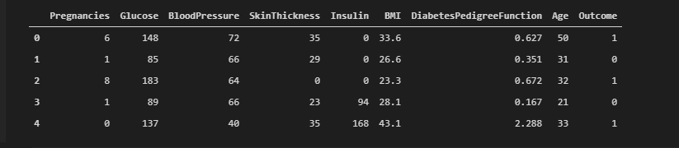
Figure 1: Preview Data Table.
After that we find out the number of records and attributes of this used dataset. This is called dataset dimension in rows and columns. The data type of the features are also found out and in Table 3 there is the visualization of these. BMI and Diabetes Pedigree Function are in the float type and all the rest are integer which is noted by int.

Table: 3 Features and Data Type

Features Name | Data Type
Pregnancies | Int
Glucose | Int
Blood Pressure | Int
Skin Thickness | Int
Insulin | Int
BMI | Float64
Diabetes Pedigree Function | Float64
Age | Int
Outcome | Int

Then we came up with the statistical summary of the features which contains number of object, mean values, standard deviation, minimum values, quarantines and maximum values. After that we count the null values. In short, there are total of 768 records and 9 features in the dataset. Each features can be either integer or float datatype. Some features like Glucose, Blood Pressure, Insulin, BMI have zero values which represent missing data. There are zero NaN values in the dataset.

3.5 Data Visualization
In this step, firstly we came up with the outcome countplot. Secondly histogram of all features have got.
Pregnancy: In pregnancy a women can infected by diabetes. That is why it is important to take the history of having pregnancy to predict diabetes. If the patient infected by diabetes previously, then there is a chance to have diabetes in future. Here is the histogram of this feature.

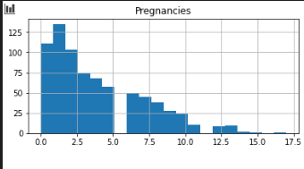

Figure 2: Histogram of Pregnancies.

Glucose: When glucose level in blood is higher than normal known as hyperglycemia, called diabetes. When we take food as meal, our body breaks them into sugar and our cell consume them from blood to produce energy. But when sugar fails to get in cell and stay in blood then the glucose level increase. Here is the histogram of this feature.
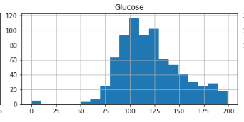

Figure 3: Histogram of Glucose.
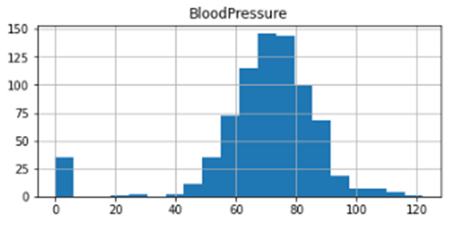
Blood Pressure: The pressure against the blood vessels walls of circulating blood is known as blood pressure. Most of the diabetes patients have high blood pressure who are suffering from type 2 diabetes. The common causes of this two diseases are inactivity, chronic inflammation, obesity and a diet high sodium and fat. Here is the histogram of this feature.

Figure 4: Histogram of Blood Pressure.
Skin Thickness: Skin is the biggest organ of our body. There is collagen in our skin and it has a strong relation with insulin production. . Here is the histogram of this feature.
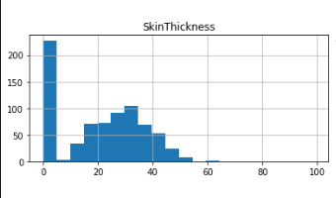

Figure 5: Histogram of Skin Thickness.
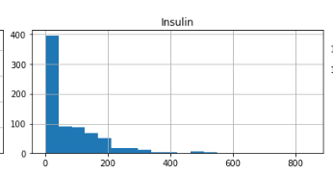
Insulin: Insulin is a hormone which is produced from pancreatic islets beta cell. It helps to send glucose into cell from blood. When it stops working an abnormal situation happens in human body. To control glucose level we need to inject insulin in our body.

Figure 6: Histogram of Insulin.
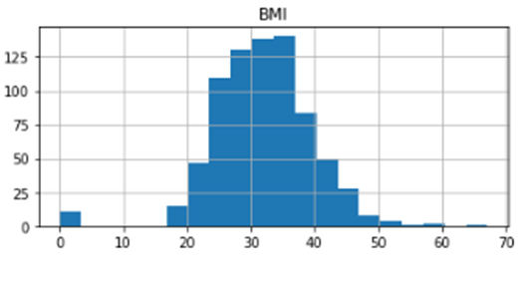
BMI (Body Mass Index): Body mass index is the ration of the weight in kilogram format and the square of height in meters format. Higher BMI contains higher possibility of diabetes. Here is the histogram of BMI.

Figure 7: Histogram of BMI.
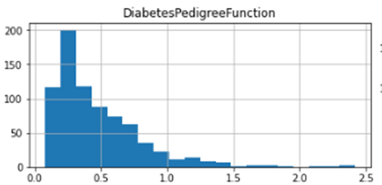
Diabetes Pedigree Function: It refers that is there any history of having diabetes in the family. Because diabetes can be transfer genetically. Here is the histogram is this feature.

Figure 8: Histogram of Diabetes Pedigree Function.
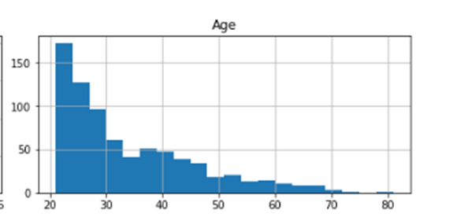
Age: Diabetes can affect in every age. But mostly after 65 people have diabetes. Around 14% people is affect by diabetes in their 45-64 age. And around 4% people is affect by diabetes in their 22-44 age. Here is the histogram is this feature.

Figure 9: Histogram of Age.

After that we find out the scatter plot matrix and pair plot matrix also. Then we find out the correlation between the features. Here is the correlation heatmap.
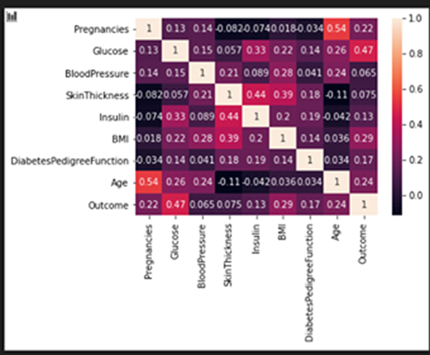

Figure 10: Correlation Heat Map

The countplot tells us that the dataset is imbalanced, as number of patient who don’t have diabetes is more than who do. From the correlation heatmap, we can see that there is a high correlation between outcome and glucose, BMI, age, insulin. We can select these features to accept input from the user and predict the outcome.

3.6 Data preprocessing
For getting a fragment of exact consequences, the main procedure of data mining is preparation of data. A dataset may have missing values, inconsistent values, Noise. Data integrations, data cleaning, data reduction process and data transformation techniques are used to remove them. In Blood pressure, Glucose, Insulin, BMI etc. attributes have some zero values. This is representing missing values. By using MEAN method, we managed them. Then our task was checking the data set manually whether there is any string values. Because some algorithms like SVC, is unable to act on string values. In our dataset, each feature can be float or integer data type. In the outcome column, ‘1’ represents diabetes positive and ‘0’ represents diabetes negative. In our chosen dataset, there is 614 negative and 154 positive instances. It indicates that this is an imbalanced dataset.

In this step we assigned our dataset in a new variable. Then we replace zero values with the Nan values. In this case, we only took Glucose, Blood Pressure, Skin thickness, Insulin and BMI features as their correlation were high. After that, we find out the number of Nan values and replaced Nan values with the mean values. Again, we came up with the new statistical summary. Later, we have done scaling features using Min Max scalar method. We scale Glucose, Insulin, BMI and age. We did dividing test and training dataset in this preprocessing part. Afterwards we checked the dimension of X train, Y train, X test and Y test. Here we found from our dataset the negative and positive instance which are showing in table 4 and figure 2 is the statistical summary of updated dataset.
Table 4: No. of Positive and Negative Data
Total No. of Instance | No. of Positive Instance | No. of Negative Instance
768 | 154 | 614

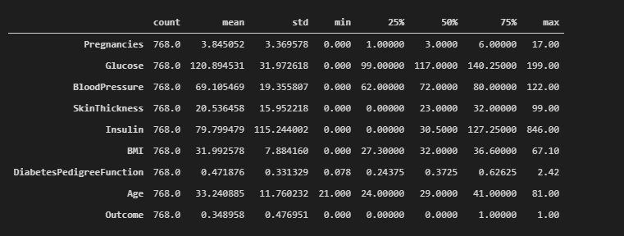
Figure 11: Statistical Analysis.

3.6.1 Feature Engineering
We get classifier’s coefficients by the trained model, after our dataset have been fitted. After distinguishing these coefficients to one another by their size, selection of feature is done. A tremendous job in machine learning is to decrease the features number from the dataset. It is considered as the training for speed up, over fitting avoidance and giving best results of classification. If we take a look at the coefficients, we can find which features have higher priority and which have less. In our dataset, there is 9 features and the target class is ‘Outcome’ in which if there is ‘0’ it means diabetes negative and if ‘1’, it means diabetes positive.

3.6.2 Criteria for selection
Having a linear relationship between two variables is considered as Correlations. Correlation coefficient is calculated between -1 to 1. If correlation value is 0, it indicates there is no correlation. If correlation value is near to 1, it indicates positive correlation and if the value is near to -1, it indicates negative correlation. Linear dependency between features is represented by high correlation. High correlation is also needed in provide similar outcome on the dependent variable. After discovering two features that is keeping high correlation, can be removed.

3.7 Working Flowchart
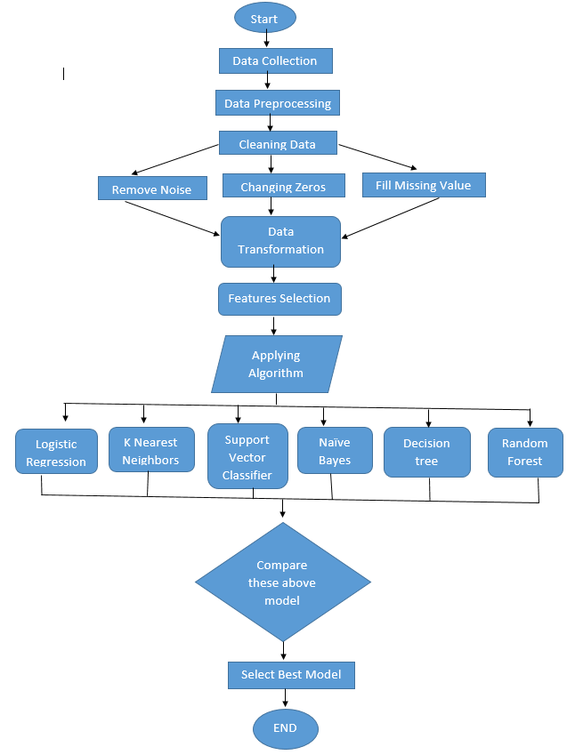

Figure 12: Working Procedure Flowchart.

3.8 Implemented Algorithm
Supervised learning techniques are used in this article that acted on testing and training. Classification model is constructed by the training dataset. To get the result, this constructed model is applied on the testing dataset. The results of this performance will be shown by the six machine learning algorithms. Implementation algorithms is the part under of data modeling process. Here are the description of each algorithms which have been utilized in this research.
3.8.1 Support Vector Classifier
For classifying problems, the most popular algorithm SVC (supervised machine learning) algorithm can be employed. The main purpose of supervised machine learning is to partition the data sets into classes for identifying the two marginal hyper plane identify the best top margin to isolate two classes and minimize the structural risk and kernel functions to improve efficiency. Separating the classes supervised machine learning will produce hyper planes which separates the classes correctly. Both linear and nonlinear data follows a new classification method which is supervised machine learning. In linear part the data can be used a street line and two dimensions but it is not needed in non-linear data and it uses three dimensions. The hyper plane creates a manner which help the supervised machine learning minimized the errors. Supervised machine learning follows kernel trick where kernel takes non separable problems into separable problems which makes supervised machine learning more powerful, flexible and exact. Supervised machine learning find hyper plane using support vector and margins. At last for predictable diabetes used confusion matrix to evaluate performance of supervised machine learning. Support vectors are nearest points of the classifier margin [10].
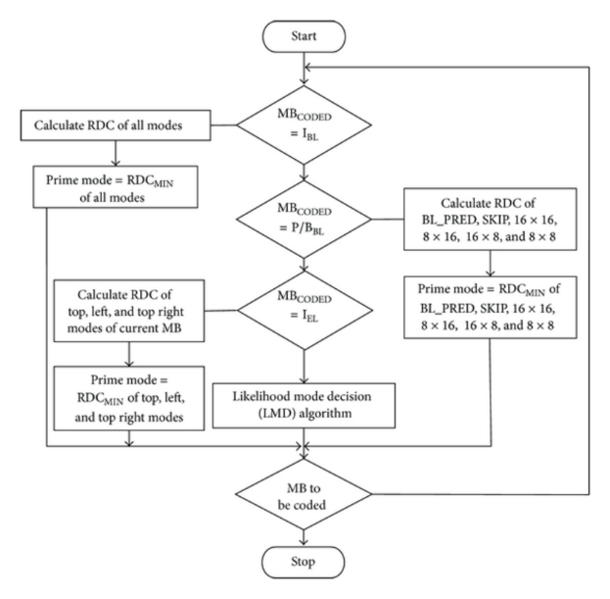
Figure 13: Flowchart of SVC.
3.8.2 Naive Bayes
In data mining Naive Bayes classifier is the techniques which applies Bayes theorem with strong independent assumption between the features. Naive Bayes is a potential machine learning algorithm which is used in various classification work. Naive Bayes enhances the Bayes rules when the features are uncommitted. The Naive Bayes needs binning to manage his own data. The earmarked features in a class are free from another feature. All the feathers are exclusive and irrelevant to each other. In this algorithm, zero's is the substitution of numerical data and zero vector is the substitution of categorical data. On the basis of classification purpose, the Naive Bayes is a powerful algorithm which is used for conditions probability based. The Naive Bayes is also a machine learning classifier which works for disequilibrium problem and missing data. The Naive Bayes is also using in both of binary and multi-class classification. To calculate probability Naive Bayes uses counting techniques. So at last Naive Bayes algorithm is fast, highly scalable and scoring for this.

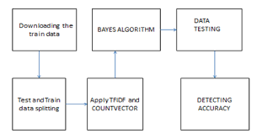
Figure 14: Flowchart of NB

3.8.3 Decision Tree
In these research, decision tree is a classification technique to violate specific dataset into small and smaller subsets of data. It follows tree structure, tree based knowledge means information collection in judgment making intention. In decision tree it has decision nodes and leaf nodes and branches where decision tree follows supervised machine learning technique using confusion matrix. Decision tree can deal both of numerical and categorical data. Decision nodes categorize various shapes and leaf nodes illustrate classification. For predicting the features in a particular dataset the decision tree also uses information gain and entropy. Entropy measures errors in data sets and entropy is also measured within the range of 0 and 1. However, it is used for classifying because it is simple to explain to the technical team and this technique is automatic. It’s used simple ness to follow and profitable to actualization. Finally, Decision tree uses hubs and inter-hubs for prognosis and classification.
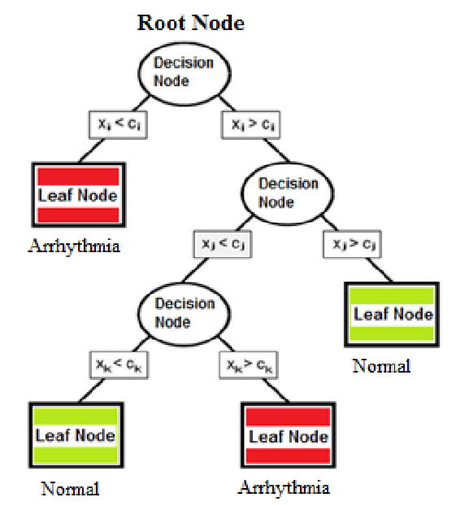
Figure 15: Flowchart of DT.

3.8.4 Logistic Regression
Logistic regression is also known as logistic regression based on supervised learning. Logistic regression is an algorithm which is used in machine learning deals with probability to measure the relationship between dependent and independent variable. In logistic regression binary is used as a dependent variable and its limited number of possible values are 0 to 1. In logistic regression the independent variable can be continues or binary. Here, the features values are the independent variable and the target values are known as dependent variable. The main goal of the logistic regression is to find the best filing model for dependent and independent variable relationship. Logistic regression finds error values using log loss formula. Logistic regression takes steps for constant output. At last logistic regression can identified whether the final result is true or false. Logistic regression is very simple and efficient to train.

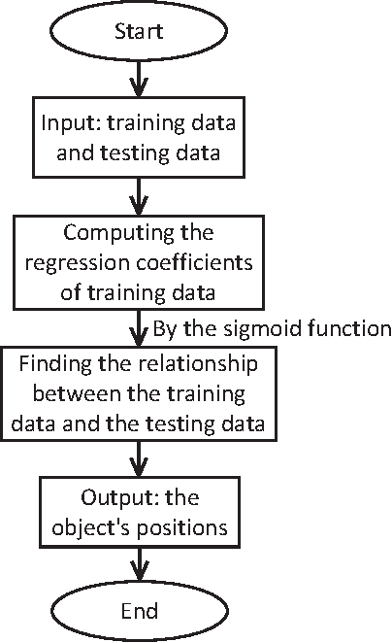

Figure 16: Flowchart of LR

3.8.5 Random Forest Machine Learning

Random forest is a supervised learning method that uses most popular machine learning algorithm. To predict actual result from some actual values in the features of data sets. Every tree has very low type relationship in prognosis time. Random forest algorithms task is to predict random forest by combining n decision tree and predicts each created tree for in first phase. From multiple datasets given data sets to the random forest classifier divide data into subsets and given it to decision tree and in the basis of all result the random forest classifier predicts the last result and this procedure follows by random forest machine learning. Random forest algorithm helps to predict output from high accuracy. When large ratio of data missed then the random forest algorithm can maintain accuracy. Lastly, random forest is used in both regression and classification work. This random forest classifier works randomly and increase the accuracy of the model.

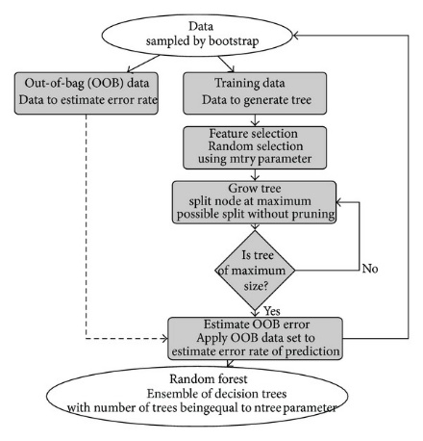
Figure 17: Flowchart of RF

3.8.6 K Nearest Neighbors
In the past, k nearest neighbors known as a non-parametric methodology that has been used in statistical estimations. k nearest neighbor's main purposes is stocking K nearest neighbor's all gain able cases that categorizes new classes based on distance function. K nearest neighbors is an easy and soft algorithm that is the blending of numerical and categorical values in the datasets. K nearest neighbors also raises the issue of numerical variables between 0 and 1. This point is labeled by a better part of vote of the group work for the k samples. Concept of numerical voting is built by the nearest neighbors rule by the K Nearest Neighbors procedure that is a straightforward exchange. At last, k nearest neighbors follow classified machine learning algorithm for identifying the number of nearest neighbors and counts all the training samples. In k nearest neighbors algorithm it is needed to handle missing data that create a special distance in sensible class out layers. In these paper, K nearest neighbors is flexible classification scheme that is easy to implement.

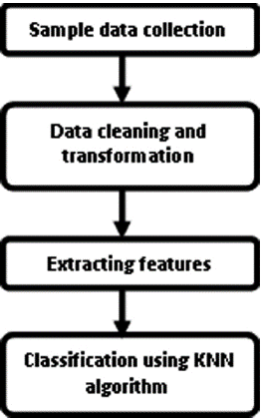
Figure 18: Flowchart of KNN.

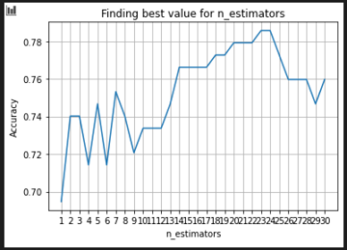
Figure 19: Plotting a graph of KNN

CHAPTER 4
EXPERIMENTAL RESULTS AND DISCUSS

4.1 Experimental Results & Analysis
To predict diabetes used dataset is evaluated using accuracy score metric. After that we multiply the found result to get them in percentage format. Here, Pregnancies, Glucose, Blood Pressure, Skin Thickness, Insulin, BMI, Diabetes Pedigree Function and age acted as independent variable and outcome acts as a dependent variable. Only binary value is taken by Outcome.0 refers diabetes negative and 1 refers diabetes positive. The full dataset is divided in 80:20 ratio of train set and test set respectively for training the dataset. All of the data mining algorithms i.e. K Nearest Neighbors, Decision Tree, Logistic Regression, Support Vector Classifier, Naïve Bayes and Random Forest are implied on the train set to get the test set results. From the comparison, we can observe that K nearest neighbors gets the highest accuracy of 78.57%. Here we are providing the confusion matrix and heat map of each algorithms to better understand.

Table 5: Ratio of Training and Testing Dataset
Total No. of Instance (%) | No. of Training Instance (%) | No. of Testing Instance (%)
100 | 80 | 20

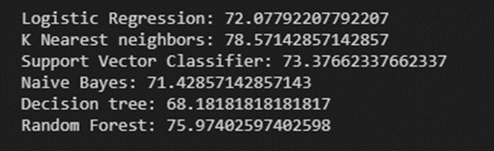

Figure 20: Results

4.1.1 Confusion Matrix and Heat Map of Support Vector
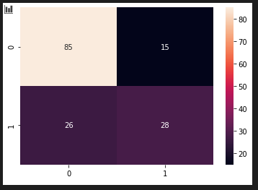
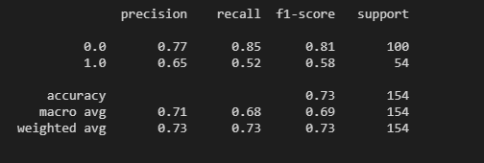
Figure 21: Confusion Matrix of SVC Figure 22: Heat map of DT

4.1.2 Confusion Matrix and Heat Map of Naive Bayes
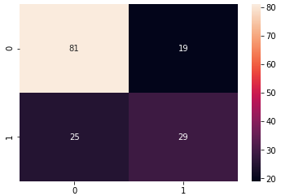
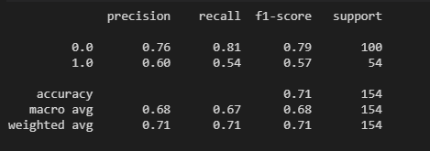
Figure 23: Confusion Matrix of NB Figure 24: Heat map of NB

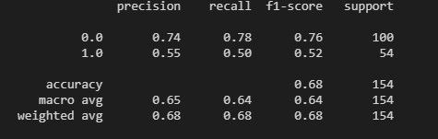
4.1.3 Confusion Matrix and Heat Map of Decision Tree
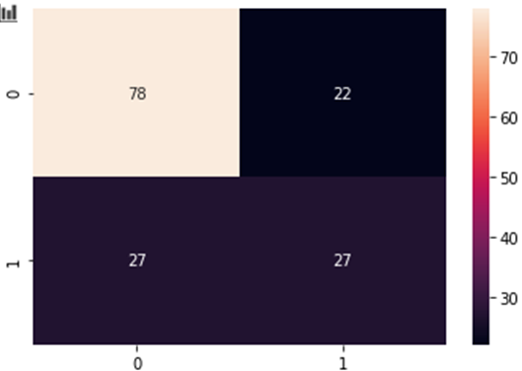

Figure 25: Confusion Matrix of DT Figure 26: Heat map of DT
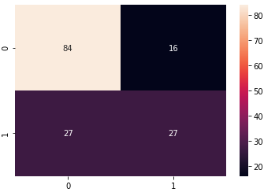
4.1.4 Confusion Matrix and Heat Map of Logistic Regression
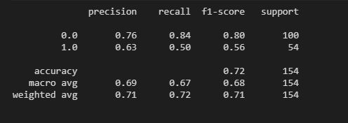
Figure 27: Confusion Matrix of LR Figure 28: Heat map of LR

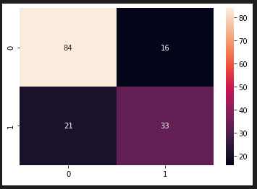
4.1.5 Confusion Matrix and Heat Map of Random Forest
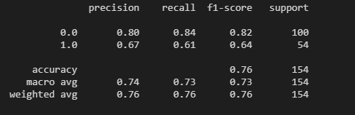
Figure 29: Confusion Matrix of RF Figure 30: Heat map of RF

4.1.6 Confusion Matrix and Heat Map of K Nearest Neighbors
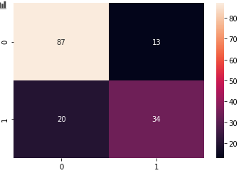
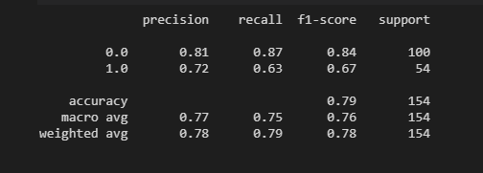
Figure 31: Confusion Matrix of KNN Figure 32: Heat map of KNN

4.2 Evaluation measures
The performance of the classifiers has been identified in Diabetes prediction for different plans with their proper parameters, the ratios of accuracy, recall, precision, F1-score and report which are received using confusion matrix. Cases are explained as True-Positive (TP) and false positive (FP) while True-Negative (TN) and False-Negative (FN).

Precision = $\frac{TP}{(FP + TP)}$ [Ratio of the anticipated positive cases] [11]
Recall = $\frac{TP}{(FN + TP)}$ [Ratio of positive cases] [12]
Accuracy = $\frac{(TP + TP)}{(FP + TN + FN + TP)}$ [Ratio of the total number of predictions]
F- Measure = $\frac{2 × Precision}{ (recall + precision) × Recall}$ [Count Balance between recall and precision]

Chapter 5
Impact on Society, Environment and Sustainability

5.1 Impact on Society:
Our thesis totally depends on diabetes prediction using women's data. In our society most of the people cannot maintain their pre work or boundaries to stay healthy so they effect many types of disease. Among them diabetes is one of them. Due to unconsciousness many women are affected diabetes which may impacts on our society. So, our thesis paper will ensure that our diagnosis will be correct and professional. Thus we have predicted diabetes previously by using our created software we may found whether our diabetes is rises or fall. Such application should be cover by entire state. By using this one can be aware about the personal health and wellbeing is concerned.

5.2 Impact on Environment
In medical, for diabetes prediction doctors have given blood sugar test, hemoglobin test and for doing this test we have used some chemical or other things which is harmful. But if we use our thesis type solution we may easily predict our diabetes level. Our thesis has depended on software. Software is processed all data by computer systems. So, using software predict the diabetes is not harmful, in fact it’s an easy and quickly identified process. This process cannot impact on our air, soil, water and also not damages our immune cells. So it’s a healthy and quickly process to follow.

5.3 Ethical Expects
In this paper, using diabetes prediction algorithm is totally ethical. In this paper, to continue diabetes prediction algorithm we have needed to use various kinds of data sets for predicting diabetes. For these reason, to collect this data from people we need permission of people and this data are valid. This process of collecting information is not harmful for people. So, this process of collecting data sets are totally ethical.

5.4 Sustainability Plan
A sustainable diabetes self-management program is passion, dedication and enthusiasms for the work. In this time, software and hardware both are used for obtaining successful and satisfying result for predicting diabetes. The diabetes initiative demonstrated that there is key strategy that can increase programs sustainability for the effective program. The diabetes prediction algorithms are maintaining sustainability and for this reason people may use this algorithm for many days and it’s so much helpful for everyone to use.

Chapter 6
Summary, Conclusion, Recommendation and Implication for Future Research
6.1 Conclusion
Pima Indian Diabetes Dataset Feature Engineering and Data analysis is very significant in the case of diabetes prediction for enhancing the performance of classifier for patients. There are so many researchers are thinking about to diagnose other common disease [13]. To predict Diabetes exactly we should use suitable algorithms which give us better representation. In this research paper, we have discussed about machine-learning techniques (SVC, DT, LR, KNN, RF, NB) six steps and also try to find out the suitable method and there we get 72.07% in LR, 78.75% in KNN, 73.38% in SVC, 71.43% in NB, 68.18% in DT and 75.97% in RF. K Nearest Neighbors exceeded the other classifiers which have found in empirical assessment exhibit. RF is also gives better accuracy very near to KNN.As medical multifaceted nature increments various dynamic paid data mining methods will be prosperous. Ensuing researchers will also work with diabetes prediction. This provides the promotion searches on some new point of view for the best classification that hunt for new and also flourished algorithms.

Table 6: Results
Algorithms Name | Accuracy (%)
SVC | 73.38
DT | 68.18
LR | 72.07
KNN | 78.75
RF | 75.97
NB | 71.43

6.2 Future Work
Future work in our study, we have used the modern technology as our world is now in modern era. We have used machine learning algorithms to predict diabetes. As our work is all about the women, dataset which have men patients’ information cannot be used in our algorithms. That is the drawback of our work though we have only focused women patients. So, our future work will be to integrate the two system, one is which can predict women diabetes and another is which can predict men diabetes as well. Another future work can be software base prediction. In which a patient doesn’t need to go hospital at all. One can give their information in a website, web application or software and that will be able to predict diabetes of that particular patient. It will be more attractive, efficient and acceptable to people after years of time. We will also try to diagnose diabetes in a patient by machine learning and data mining algorithms that can help people to get more accurate result. After years of study, new algorithms can be innovated to perform in this regard to give a better solution.

Reference

[1] Shaw, J. E., R. A. Sicree, and P. Z. Zimmet. (2010) “Global Estimates of the Prevalence of Diabetes for 2010 snd 2030.” Diabetes Res Clin Pract 87: 4–14
[2] William C Knowler, Peter H Bennett, Richard F Hamman, and Max Miller. 1978. Diabetes incidence and prevalence in Pima Indians: a 19-fold greater incidence than in Rochester, Minnesota. American Journal of Epidemiology 108, 6 (1978), 497–505.)
[3] Cut Fiarni, Evasaria M. Sipayung, Siti Maemunah. Analysis and Prediction of Diabetes Complication Disease using Data Mining Algorithm. ScienceDirect. Bandung 4132, Indonesia. Vol 161. Pp 449–457. 2019.

[4] Health Research and Development Division of Ministry of Health Republic of Indonesia. (2018) Basic Health Research Survey.
[5] Zhang, Bob, B.V.K. Vijay Kumar, David Zhang. (2014) “Detecting Diabetes Mellitus and Non proliferative Diabetic Retinopathy Using Tongue Color, Texture and Geometry Features.” IEEE Transaction on Biomedical Engineering 61 (2): 491-501.
[6] Aishwarya Mujumdara, Dr. Vaidehi V. Diabetes Prediction using Machine Learning Algorithms. ScienceDirect. Kodaikanal, India. Vol 165. pp 292–299. 2019.
[7] R. Sathya, Annamma Abraham. Comparison of Supervised and Unsupervised Learning Algorithms for Pattern Classification. ScienceDirect. Bangalore, India. Vol. 2, No. 2, 2013
[8] Mohamed Alloghani, Jamila Mustafina, Dhiya Al-Jumeily, Ahmed J. Aljaaf. Supervised and Unsupervised Learning for Data Science. Springer. ISBN 978-3-030-22474-5
[9] Xue-Hui Meng, Yi-Xiang Huang, Dong-Ping Rao, Qiu Zhang, Qing Liu. Comparison of three data mining models for predicting diabetes or prediabetes by risk factors. ScienceDirect. Cancer Center of Sun Yat-Sen University, People’s Republic of China. Vol 29. Pp 93-99. 12 March 2012.
[10] Sisodia, D., Singh, L., Sisodia, S., 2014. Fast and Accurate Face Recognition Using SVC and DCT, in: Proceedings of the Second International Conference on Soft Computing for Problem Solving (SocProS 2012), December 28-30, 2012, Springer. pp. 1027–1038
[11] Wei Zhe, Ye Guangjian, Wang Nengcai. Analysis for risk factors of type 2 diabetes mellitus based on FP-growth algorithm. China Med Equip 2016; 13(5):45–8.
[12] Guo Yirui. Application of artificial neural network to predict individual risk of type 2 diabetes mellitus. J Zhengzhou Univ 2014; 49(3):180–3.
[13] Francesco Mercaldoa, Vittoria Nardoneb, Antonella Santone. Diabetes Mellitus Affected Patients Classification and Diagnosis through Machine Learning Techniques. ScienceDirect. Benevento, Italy.vol 112. pp 2519-2528. 8 September 2017.
[14] Sajida Perveena, Muhammad Shahbaza, Aziz Guergachib, Karim Keshavjee. Performance Analysis of Data Mining Classification Techniques to Predict Diabetes. ScienceDirect. Riyadh, Saudi Arabia. Vol 82.pp 115 – 121. 30 March 2016.
[15] Neha Prerna Tiggaa, Shruti Garg. Prediction of Type 2 Diabetes using Machine Learning Classification Methods. ScienceDirect. Mesra, Ranchi, India. Vol 167. Pp 706–716. ICCIDS 2019.
[16] Han Wu, Shengqi Yang, Zhangqin Huang, Jian He, Xiaoyi Wang. Type 2 diabetes mellitus prediction model based on data mining. ScienceDirect. Beijing, 100124, China. Vol 10. Pp 100-107. 12 December 2017.
[17] Talha Mahboob Alama,∗ , Muhammad Atif Iqbala , Yasir Alia, Abdul Wahabb, Safdar Ijazb, Talha Imtiaz Baigb, Ayaz Hussainc, Muhammad Awais Malikb, Muhammad Mehdi Razab, Salman Ibrarb, Zunish Abbasd. A model for early prediction of diabetes. ScienceDirect. Lahore College for Women University, Pakistan. Vol 16. Pp 100-204. 4 July 2019.

[18] Deepti Sisodiaa, Dilip Singh Sisodia. Prediction of Diabetes using Classification Algorithms. ScienceDirect. G.E Road, Raipur and 492001, India. Vol 132. Pp 1578-1585. 2018.

[19] Changsheng Zhua, ∗, Christian Uwa Idemudiaa , Wenfang Feng . Improved logistic regression model for diabetes prediction by integrating PCA and K-means techniques. ScienceDirect. Lanzhou, 730050, China. vol 17. Pp 100-179. 4 April 2019.

[20] S.Selvakumar1, K.Senthamarai Kannan2 and S.GothaiNachiyar3, Prediction of Diabetes Diagnosis Using Classification Based Data Mining Techniques. ScienceDirect. India. Vol 12. pp. 183-188. Number 2 (2017).

Thank You!
Best of Luck

