Handwritten Bengali Digit Recognition Using Machine Learning Approach BY
Md. Toufiqur Rahman ID: 171-15-9385

This Report Presented in Partial Fulfillment of the Requirements for the Degree of Bachelor of Science in Computer Science and Engineering [Font-14]

Supervised By

Ms. Zarintasnim Shejuti
Lecturer Department of CSE
Daffodil International University Co-Supervised By
Md. Reduanul Haque Sr. Lecturer Department of CSE
Daffodil International University



DAFFODIL INTERNATIONAL UNIVERSITY

DHAKA, BENGALIDESH DECEMBER 2020

APPROVAL

This Project titled “Handwritten Bengali Digit Recognition Using Machine Learning Approach”, submitted by Md. Toufiqur Rahman ID: 171-15-9385 to the Department of Computer Science and Engineering, Daffodil International University, has been accepted as satisfactory for the partial fulfillment of the requirements for the degree of B.Sc. in Computer Science and Engineering and approved as to its style and contents. The presentation has been held on December 8, 2020.
BOARD OF EXAMINERS

Dr. Syed Akhter Hossain Chairman
Professor and Head
Department of Computer Science and Engineering Faculty of Science & Information Technology Daffodil International University

Dr. S.M. Aminul Haque Internal Examiner Assistant Professor & Associate Head
Department of Computer Science and Engineering Faculty of Science & Information Technology Daffodil International University

Md. Ohidujjaman Internal Examiner
Lecturer
Department of Computer Science and Engineering Faculty of Science & Information Technology Daffodil International University

Dr. Mohammad Shorif Uddin External Examiner Professor
Department of Computer Science and Engineering Jahangirnagar University

I

DECLARATION

We hereby declare that, this project has been done by us under the supervision of Ms. Zarintasnim Shejuti, Lecturer, Department of Computer Science and Engineering Daffodil International University. We also declare that neither this project nor any part of this project has been submitted elsewhere for award of any degree or diploma.

Supervised by:

Ms. Zarintasnim Shejuti
Lecturer Department of CSE
Daffodil International University

Co-Supervised by:

Md. Reduanul Haque Sr. Lecturer Department of CSE
Daffodil International University

Submitted by:

Md. Toufiqur Rahman
ID: -171-15-9385
Department of CSE
Daffodil International University

II

ACKNOWLEDGEMENT

First we express our heartiest thanks and gratefulness to almighty God for His divine blessing makes us possible to complete the final year project/internship successfully.

We really grateful and wish our profound our indebtedness to Ms. Zarintasnim Shejuti, Lecturer, Department of CSE Daffodil International University, Dhaka. Deep Knowledge & keen interest of our supervisor in the field of “Machine Learning” to carry out this project. His endless patience ,scholarly guidance ,continual encouragement
, constant and energetic supervision, constructive criticism , valuable advice ,reading many inferior draft and correcting them at all stage have made it possible to complete this project.

We would like to express our heartiest gratitude to Dr. Syed Akhter Hossain, Professor and Head, Department of CSE, for his kind help to finish our project and also to other faculty member and the staff of CSE department of Daffodil International University.

We would like to thank our entire course mate in Daffodil International University, who took part in this discuss while completing the course work.

Finally, we must acknowledge with due respect the constant support and patients of our parents.

III

ABSTRACT

Hand written digit recognition in Bengali language is one of the important starting point for creating an OCR (Optical Character Recognition) in the Bengali language. Nevertheless, sometimes absence of massive and fair data collection, recognition in Bangla digit was not build already. In our work, an honest and fair data source known as NumtaDB is make use for recognition Bengali digits. Moreover, troublesome endeavor is added to get the solid presentation and good precision for fair, common, natural, gigantic and particularly more extended NumtaDB dataset. In that case, various sorts of preprocessing frameworks are make use for planning images and significant CNN (Convolutional Neural Network) is make use for the request of representation in this paper. Furthermore, LeNet-5 architecture based CNN (Convolutional Neural Network) model has specified superb execution. Our accomplished testing exactness 97.5% which is an adequate outcome for massive and honest NumtaDB dataset contrasting with other one-sided datasets. A numerous of preprocessing of images is as well as significant before preparing. We make use of some preprocessing strategies for hazy and loud images. Yet these are not sufficient for the first class. Examination of the system gets out the EMNIST and MNIST datasets were performed so as to comfort the evaluation.

IV

TABLE OF CONTENTS
CONTENTS | PAGES
Board of examiners | I
Declaration of the Student | II
Acknowledgement | III
Abstract | IV
CHAPTER
CHAPTER 1: INTRODUCTION | 1-2
Introduction | 1
Motivation | 1-2
Objectives | 2
Report Layout | 3
CHAPTER 2: BACKGROUND | 4-5
Review work | 4
Bangla community perspective | 5
CHAPTER 3: RESEARCH METHODOLOGIES | 6-11
Working procedure | 6
3.1.1 Dataset | 6-8
3.1.2 Proposed approach | 9
3.1.2.1 Pre-processing of images | 9

3.1.2.1.1 Image resizing and Gray scaling | 9
3.1.2.1.2 Interjection | 10
3.1.2.1.3 Expelling Blur from Images | 10
3.1.2.1.4 Sharpening Images | 10
3.1.2.1.5 Taking out clutter from Images | 11
3.1.2.2 LeNet-5 architecture based convolutional neural network | 11
3.1.2.2.1 Architecture of the proposed model | 12-13
3.1.2.2.2 The Parameters of training model | 14

CHAPTER 4: RESULT AND OBSERVATIONS | 15-16
Environment of experiment | 15
Train, Validation, and Test | 15
Outcome with prediction | 15
Result analysis | 16
Run time analysis | 16
CHAPTER 5: CONCLUSION | 17
REFERENCE | 18-20

Index OF FIGURES

FIGURES | PAGE  Number
Figure 3.1: The images of NumtaDB Dataset | 7
Figure 3.2: The augmented images of NumtaDB dataset | 7
Figure 3.3: Preprocessed Images | 11
Figure 3.4: Proposed LeNet-5 CNN architecture design | 12
Figure 4.1: Outcomes with their prediction | 15

Index OF Tables

Tables | PAGE  Number
Table 3.1: Shows the Dataset Summary | 8
Table 3.2: Summary of our proposed LeNet-5 model | 12-13
Table 3.3: The Parameters of training model | 14

VII

CHAPTER 1

Introduction

  - Introduction

In this new decade of 2020, there has been much interest in machine learning approach. Especially when it comes between handwritten and printed forms, handwritten digit recognition, it is more challenging. The hand written numbers written by different persons. It is not easy to identify and it also varies in both size and shape. Innumerable variations in writing types of individual character make the recognition task difficult. On the other hand, other problems like distinct character shapes, interconnections of the neighboring characters, the overlaps further complicate the problem. That’s why recognizing Bengali digit from documents and other sources, it is becoming more important. The unique number of Bengali digits contains total 10 numbers. The main goal is seeing exceptional composed by hand digits. Using NumtaDB dataset the task is fair, high exactness for gigantic, normal, clear execution. (1).
The source of the data is a mixing of five data collection that were collected from different origin, racket, understanding, shear, zooming, rotate, quality, stature move, obstacles, superimposition and separation. We have managed noisy and blur images here. For that point our prepared images are characterized by CNN (Convolutional Neural Network) using its LeNet-5 classic network architecture.
This paper is controlled as looks for further. The review tasks are found in part II, our data and proposed approach are illustrated in portion III. In Segment IV, the method of pre-phase of processing images. We exemplified the ordering of the LeNet-5 plan in Zone V. In Zone VI, our result at last the finishing and future works are taught in Section VII.
1

Motivation

Along with visual data the importance of digit data has grown drastically in recent years. In fact, it seems like that digit data has become a lot more crucial than other forms. People share their bank balance, password and many more digit related things on the internet every day.
Now-a-days, one of the most famous using area is Machine learning. Machine learning lets its user to express their thoughts in the form of various area. CNN (Convolutional Neural Network) made my motivation to recognize Bengali digit through digital way. Moreover, there are lots of researchers reliant on Bengali handwritten digit recognition. Many effective research works on physically composed digit recognition for English language and other languages as well. EMNIST (7) and MNIST (8) are the most known data record for recognition of English handwritten digit recognition. This idea of recognizing through people’s working tasks in regular day worked as the motivation behind my project.

Research Objective
My research objectives are given below.

    - To study various data and analyze them.
    - To make the process faster of recognizing method.
    - To study many algorithms and select the right one for my choice.
    - To contribute in Bengali OCR (Optical Character Recognition).
    - To use in many viewable works. For example: Postal code, Zip code, mail, bank receipt etc.

2

Report Design

In this research paper, contains five chapters. This section follows the parts of each sequence that we make use of in our report briefly.

    - Chapter 1: Introduction

    - Chapter 2: Background

    - Chapter 3: Research Methodologies IV.Chapter 4: Result & Observation V.Chapter 5: Conclusion

3

CHAPTER 2 BACKGROUND

  - Review Works
There are not so much investigations on Bengali hand written digit recognition utilizing Deep Learning. However, a huge segment about the evaluated works used asymmetrical dataset CMATERDB 3.1.1 [3] since the data source; NumtaDB was not approachable at that situation. Beginning late several specialists have portrayed a uppermost exactness of 99.50% utilizing the auto encoder and remarkable CNN composition for dataset; CMATERDB 3.1.1. Besides, the design of binary was take advantage of recognition of Bengali digits [4]. By specific researchers, Le-net was operating for identification of Bengali digit [5]. The CNN (Convolutional Neural Network) framework was demonstrated for better supervise learning and precision [6]. Thereupon, forwarding specialists of Bengali hand written digit acknowledgment are advancing intense CNN plan. Many different classifiers, for example: Neural Network (NN), Support Vector Machine (SVM) and more for written by hand written digit identification. The demonstration of CNN (Convolutional Neural Network) is superior to different classifiers. As a result, this network turned into the in progress pattern transcribed number acceptance. Fine-tuned Convolutional neural framework engineering by having extra layers or further hubs has turned into a procedure to break the best in class precision. In case of our Bengali language, some enormous research works in English language physically composed for hand written digit acknowledgment; EMNIST [7] & MNIST [8], they are the most outstanding dataset for English composed by hand written digit identification. We examined about judging EMNIST and MNIST dataset before. The evaluation task of this paper is connecting with many English hand written digit recognition work we had done before.
4

Bengali community perspective

The Bengali language is native to the region of our country (Bangladesh). There are also significant and huge Bengali speaking communities in the world. For example: In the Middle East, the United States, Singapore, Malaysia, Australia, Canada the United Kingdom etc. (Reference)

5

CHAPTER 3 RESEARCH METHODOLOGIES
  - Working procedure
For recognition methodology, there are some procedure to follow to gain the hand written digit recognition. There are some steps to take for acknowledgment straight-forward hand written digit recognition method. The methods are demonstrating below.

Dataset
In our proposed methodology, we suggest importance to the dataset named NumtaDB which contains Eighty-Five thousand and more Bengali manually written digit images. The reason for choosing this dataset was, this dataset is fair, natural, honest and checked on the dataset in details. NumtaDB, can confirm proposed methodology execution unblemished and we trust our proposed methodology will gain around a similar precision for genuine manually hand written digit recognition. The images from the dataset are authentic images with no pre-maintenance. NumtaDB dataset is a gathered dataset from five grand origins. As stipulated by this data origin, the origins are named from ‘a’ to ‘e’. The composing and trial sets have different sub-groups depending on the fountainhead of the data (test-a, setting up etc.). Datasets have been distributed with well-planned and demonstrated with the objective that hand written from a comparable subject is missing in both. Every images of this data origin, NumtaDB is focused to 180 * 180 pixels.

6

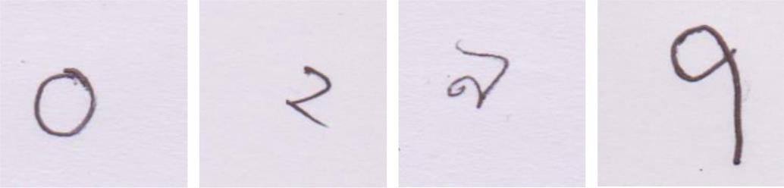

Figure-3.1: The images of the NumtaDB dataset

In the judgement of NumtaDB, a set of enlarged datasets (enlarged from trial images of dataset ‘A’ and ‘C’. are connected to the testing set which comprises of the go along with enlargements. (9)

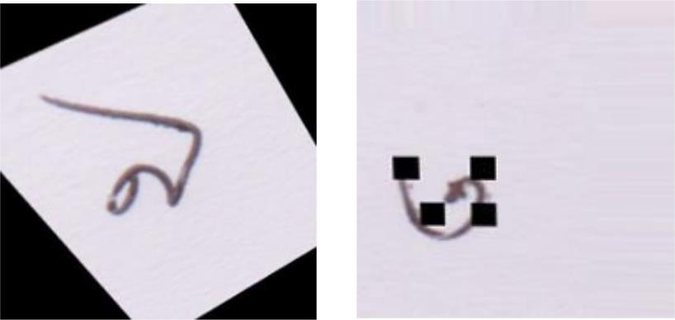

Figure-3.2: The augmented images of the NumtaDB dataset

7

- Space-based modification: Relocation, Channel repostion, Sprint, Span shift, spinning, Trim, Logged, Hue reposition, Crash, Logged, Brilliance, Overlying, Obstructions.
For this reason, our dataset; NumtaDB has made Bengali hand written digit recognition. In this way, dataset; NumtaDB has made hand written digit identification for Bengali, even more testing by increased images.
EMNIST (7) dataset, the comprehensive version of dataset; MNIST where we make use of EMNIST digits and EMNIST balanced data for digit and alphabet identification. EMNIST digits dataset contains 280,000 models with 10 types of classes and 30,000 models for respectively class. On the other hand, MNIST dataset (8) is the most mainstream with adjusted dataset in English language composed by hand and has a readiness lot of 60,000 models and a trial set of 10,000 models. Respectively class there are 6,000 having ready models and 1,000 trial models. Dataset attributes are given below [10];

Code Name | Train for Test | Total Digit in Training | Total Digits in Testing | Total Digits with combined
Code Name | Split | Total Digit in Training | Total Digits in Testing | Total Digits with combined
a | 85%-15% | 19702 | 3489 | 23191
b | 85%-15% | 359 | 69 | 428
c | 85%-15% | 24298 | 4381 | 28679
d | 85%-15% | 10908 | 1948 | 12856
e | 85%-15% | 16777 | 2970 | 19747

Table-3.1: Shows the Dataset summary
8

Proposed approach

We proposed clustering NumtaDB dataset composed by hand made for massive two effective advances. They are given below.
- CNN (Convolutional Neural Network) model. LeNet-5 architecture.
- Pre-phase of processing of images.

The delicacy of our two significant advances are displayed in further part IV and part V.

Preprocessing of images

NumtaDB dataset, which we used, it accommodates massive amount of images of digits with different in size and again the dataset is unbiased. In that case, we have to process these before our procedures. These processes are given below.

Image Resizing and Gray Scaling

The starting size of our dataset, NumtaDB dataset images holding 180*180 pixels, which are enormous for pre-phase of processing productively without any reason. Moreover, we diminish the size of images to 32*32 pixels. Furthermore, transform all RGB (Red, Green and Blue color) images to gray scale images. The disguised channel is changed over to one channel from three channels.
9

Interjection
Due to resizing images can lose a lot of significant data. Between territory addition is recommended strategy for images depredation. In this strategy is resampling make use of pixel zone connection. We used between zone addition in the good way for resizing images.

Expelling Blur from Images
We needed to make use of Gaussian blur to attach obscure from the start and afterward subtract the obscured images from the first one. In this phase, we added a weighted bit of the cover to get de-obscured images. (11)

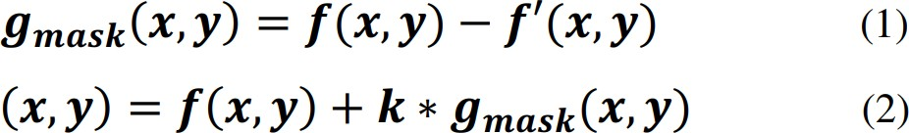

The blurred image is represented by f’(x,y) and weight is represented by k for generality.

Sharpening Images
There are massive channels for honing images. We make use of the Laplacian channel and our filer is 3*3.

[-1 | -1 | -1]
[-1 | 9 | -1]
[-1 | -1 | -1]

Taking out Clutter from Images
We needed pepper and salt clamor from dataset’s images and make use of middle channel for taking out salt and pepper clamor. In the wake of pre-phase of maintenance, the images become keen, understandable and both of salt and pepper free.

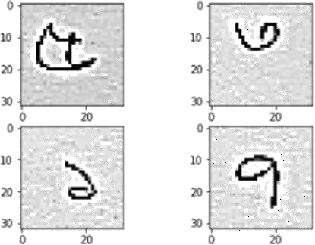

Figure-3.3: Preprocessed images

      - LeNet-5 architecture based convolutional neural network CNN (Convolutional Neural Network) has been giving exceptional execution in the stage of hand written digit recognition throughout the previous couple of years. CNNs are the establishment of current best in class profound learning-
based PC vision. Different types of architecture we use LeNet architecture of CNN for our work. LeNet-5 was utilized on huge scale to naturally characterize written by hand digits. LeNet is a significant design is that before it was imagined, character acknowledgment had been done for the most part by utilizing highlight building by hand, trailed by an AI model to figure out how to arrange hand-built highlights. LeNet made hand designing highlights repetitive on the grounds that the system takes in the best interior portrayal from crude pictures consequently.
11

Architecture of the Proposed model
In this Proposed architecture contains of 3 convolutional layers and 3 completely associated layer. The initial layer has 32 channels and every channel size is 5×5. The second layer has 64 and size of each channel is 3×3. And the third layer has 128 channels with 3×3 channel size. ReLu (Rectified Linear unit) [12] is utilized as an enactment work for all surfaces. Max-pooling layers & Batch normalization are utilized after each layer. 2×2 is the pool scale of Max-pooling surface. Batch normalization is utilized for accelerate research [13]. Among the three completely associated layers, the first has 120 channels and the middle one has 84 channels, along with the final has 10 channels for the 10 digits. In The last actuation function is a softmax work for arrangement. Here we make use of Adam optimizer
[14] streamlining agent for refreshing loads. Fig. represents the structure of Proposed LeNet-5 construction based CNN engineering. From contribution to yield each design is stamped appropriately.
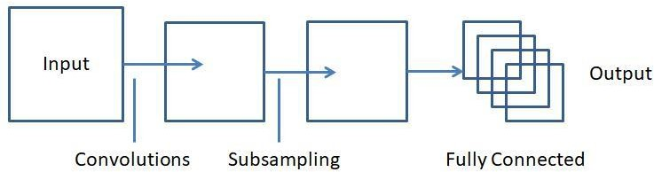

Figure-3.4: Proposed LeNet-5 CNN architecture design

Table-3.2: Summary of our proposed LeNet-5 model

12

Layer (type) | Output Shape |  | Param #
Conv2d_4 | (None, 28, 28, | 32) | 832
Maxpooling2d_4 | (None, 14, 14, | 32) | 0
Batch_normalization_4 | (None, 14, 14, 32 |  | 128
Conv2d_5 | None, 12, 12, | 64 | 18496
Maxpooling2d_5 | None, 6, 6, 64 |  | 0
Batch_normalization_5 | None, 6, 6, 64 |  | 256
Conv2d_6 | None, 4, 4, 128 |  | 73856
Maxpooling2d_6 | None, 2, 2, 128 |  | 0
Batch_normalization_6 | None, 2, 2, 128 |  | 512
Flatten_2 | None, 512 |  | 0
Dense_4 | None, 120 |  | 61560
Dense_5 | None, 84 |  | 10164
Dense_6 | None, 10 |  | 850
13

The parameters of training model

The course of action model of our arrangement is needy upon explicit parameters.

Table-3.3: The parameters of training model

Parameter | Point
Rate of learning | 10^-3
Size of Batch | 64
Epoch | 30
Shuffle | True

14

CHAPTER 4

RESULT AND OBSERVATIONS

  - Hardware
Our hardware of experiment is setup with Intel core-i5 processor, AMD Radeon R5 M255 GPU and 8GB of RAM.

Train, Validation, and Test
Surrounded by 85000+ pictures, train chop portion of dataset; NumtaDB is 85% and the test chop portion is 15% [15]. On this investigation, we chop the preparation information into preparing and approval remaining the chop proportion about 80%-20%. Here we utilize the approval information to assess the representation execution. Finally, our conclusive outcome is estimated by test data. The test data of NumtaDB are from five one of kind origins (‘a’ to ‘e’) and furthermore duo expanded, datasets were conveyed from testing set A and C. These are for our Evolution.

Outcome with prediction
Some images of output with their prediction are given below;
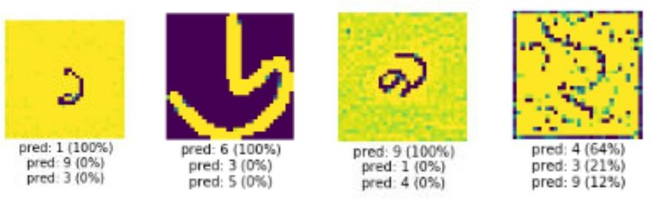

Figure-4.1: Outcomes with their prediction

15

Result analysis

After 30 epochs we get outcome, Test accuracy 97.5%.

Run time analysis

The handling time of preparing is additionally estimated. The all-out preparing time is 55.96 mins.

16

CHAPTER 5 CONCLUSION
In this report, we presented LeNet-5, CNN (Convolutional Neural Network) based recognition methodology of Bengali hand written digit for a standard and testing dataset. We gained 97.5% test perfection result, which is an adequate result for massive and honest NumtaDB dataset contrasting with extra one-sided datasets. Preprocessing of images additionally important before preparing. We exploit few processing procedures for unclear and loud images. Yet these are not sufficient for elite class. As forward to it, we think in moving information increase system and more developed CNN model can beat these issues of recognizing expanded images.

17

REFERENCES

- S. Alam, T. Reasat, R.M. Doha, and A.I Humayun, “NumtaDBAssenbled Bengali handwritten digits”,

arXiv:1806.02452 [cs.CV], 6 June, 2018.

  - M. Shopon, N. Mohammed, and M. A. Abedin, "Bengali handwritten digit recognition using autoencoder and deep convolutional neural network," 2016 International Workshop on Computational Intelligence (IWCI), Dhaka, 2016, pp. 64- 68.

  - T. Hassan, and A.H. Khan, “Handwritten Bengali numeral recognition using Local Binary Pattern,” In

Electrical Engineeringand Information CommunicationTechnology (ICEEICT), 2015
International

Conference on, pp. 1-4. IEEE, 2015.

  - U. Bhattacharya, and B. B Chaudhuri, “Handwritten numeral databases of indian scripts and multistage recognition of mixed numerals”, In IEEE transactions on pattern analysis and machine intelligence, 31(3) on
pp.444-457. IEEE,2009.

  - M.I.H.R.I. M.A.H. Akhand, and M. Ahmed, “Convolutional neural network training with artificial pattern for Bengali handwritten numeral recognition”, ICIEV, vol. 1, no. 1, pp. 16, 2016

18

  - S. Afshar, G. Cohen and J. Tapson, A. Schaik, “EMNIST: An extension of MNIST to handwritten letters.”, arXiv:1702.05373[cs.CV], 2017.

  - Y. Lecun, and C. Cortes, “The MNIST database of handwrittendigits,” 1998. [Online]. Available:

http://yann.lecun.com/exdb/mnist/

G. Cohen, S. Afshar, and J. Tapson, A. Schaik, “EMNIST: An extension of MNIST to handwritten letters.”,

arXiv:1702.05373[cs.CV], 2017.

  - Bengali Ai , “NumtaDB: Bengali Handwritten Digits”, 2018. [Online]. Available: https://www.kaggle.com/BengaliAI/numta. [Accessed: 608-2018].

  - “Evaluation of Bengali handwritten digit recognition challenge”, 2018.[Online]

[11]R. Gonzalez, and R.E. Woods, “Digital Image Processing”, Third Edition, pp. 162- 163.

- V.Nair, and Hinton, G. E. “Rectified linear units improve restricted boltzmann machines.”
Proceedings

of the 27th International Conference on Machine Learning (ICML-10). 2010

- S. Ioffe, and C. Szegedy, “Batch Normalization: Accelerating deep network
training by reducing internal covariance shift”, arXiv:1502.03167[cs.LG], 2 March, 2015.

D. Kingma, and J. Ba, “Adam: A method of stochastic optimization”, arXiv:1412.6980[cs.LG], 2015

19

[15] S. Alam, T. Reasat, R.M. Doha, and A.I Humayun, “NumtaDBAssenbled Bengali handwritten digits”,

arXiv:1806.02452 [cs.CV], 6 June, 2018.

- : "Kuwait restricts recruitment of male Bangladeshi workers | Dhaka Tribune". www.dhakatribune.com. 7 September 2016. Archivedfrom the original on 30 August 2017. Retrieved 4 December 2017.

- ^ "Bahrain: Foreign population by country of citizenship, sex and migration status (worker/ family dependent) (selected countries, January 2015) – GLMM". GLMM. 20 October 2015. Archivedfrom the original on 16 December 2017. Retrieved 4 December2017.

- ^ "Saudi Arabia". Ethnologue. Archived from the original on 23 November 2017. Retrieved 4 December 2017.

20

