AUTOMATED CLASSROOM HUMIDITY CONTROL SYSTEM

by
ABDULLAH AL MAHMOOD YASIR
ID: 171-15-9053
SAKIB MAHMUD
ID: 171-15-9063
MOHAMMED FAHIM HASAN SHARIF
ID: 171-15-9394

NASUR AHMED
ID: 171-15-9012

This Report Presented in Partial Fulfillment of the Requirements for the Degree of Bachelor of Science in Computer Science and Engineering

Supervised By

Md. Ohidujjaman Tuhin
Senior Lecturer
Department of CSE
Daffodil International University



DAFFODIL INTERNATIONAL UNIVERSITY
Dhaka, Bangladesh
December 2020
APPROVAL

This Project titled “Automated Classroom Humidity Control System”, submitted by Abdullah Al Mahmood Yasir ID: 171-15-9053, Sakib Mahmud ID: 171-15-9063, Mohammed Fahim Hasan Sharif ID: 171-15-9394 and Nasur Ahmed ID: 171-15-9012 to the Department of Computer Science and Engineering, Daffodil International University, has been accepted as satisfactory for the partial fulfillment of the requirements for the degree of B.Sc. in Computer Science and Engineering and approved as to its style and contents. The presentation has been held on 8 December 2020.

Board of Examiners

Dr. Syed Akhter Hossain Chairman
Professor and Head
Department of CSE
Faculty of Science & Information Technology
Daffodil International University

Md. Ohidujjaman Tuhin Internal Examiner
Senior Lecturer
Department of CSE
Faculty of Science & Information Technology
Daffodil International University

(Name) External Examiner
Designation
Department of -------
Jahangirnagar University

Declaration

We hereby declare that, this project has been done by us under the supervision of Md. Ohidujjaman Tuhin, Senior Lecturer, Department of CSE Daffodil International University. We also declare that neither this project nor any part of this project has been submitted elsewhere for award of any degree or diploma.

Supervised by:

Md. Ohidujjaman Tuhin
Senior Lecturer
Department of CSE
Daffodil International University
Co-Supervised by:

Tajim Md. Niamat Ullah Akhund
Lecturer
Department of CSE
Daffodil International University

Submitted by:

Abdullah Al Mahmood Yasir
ID: 171-15-9053
Department of CSE
Daffodil International University

Sakib Mahmud
ID: 171-15-9063
Department of CSE
Daffodil International University

Mohammed Fahim Hasan Sharif
ID: 171-15-9394
Department of CSE
Daffodil International University

Nasur Ahmed
ID: 171-15-9012
Department of CSE
Daffodil International University

ACKNOWLEDGEMENT

First we express our heartiest thanks and gratefulness to almighty God for His divine blessing makes us possible to complete the final year project/internship successfully.

We really grateful and wish our profound our indebtedness to Md. Ohidujjaman Tuhin, Senior Lecturer, Department of CSE Daffodil International University, Dhaka. Deep Knowledge & keen interest of our supervisor in the field of “Internet of Things (IOT)” to carry out this project. His endless patience, scholarly guidance, continual encouragement, constant and energetic supervision, constructive criticism, valuable advice, reading many inferior draft and correcting them at all stage have made it possible to complete this project.

We would like to express our heartiest gratitude to Dr. SM Aminul Haque. Associate Professor, Department of CSE, for his kind help to finish our project and also to other faculty member and the staff of CSE department of Daffodil International University.

We would like to thank our entire course mate in Daffodil International University, who took part in this discuss while completing the course work.

Finally, we must acknowledge with due respect the constant support and patients of our parents.

Abstract
This is 21st century, which basically called the era of science and technology on the other hand this is also the time of globalization and digitalization. With the advancement of new technology we gather new experience and do new invention according to the current situation of global environment .Day by day air is polluted more and more. For optimizing this situation we innovate and idea which is basically build a strong and trustable air and humidity monitoring for the classroom .Where students don’t feel any kind of suffocation during learning. That System is fully automated and generate and analysis data from through a sustainable internet connection. This report presents the future of an automated classroom where air properties are very balance on the other hand how the system controlled the humidity of the classroom. This is an IoT based project. After the testing the project, we make a successful classroom humidity control system model and cost-consuming device to generate data set for the environment. Using the sensors, microcontroller, cloud, machine learning and overall IoT technology we design a classroom monitoring system called “Automated Classroom Humidity Control System” based on IOT. The overall system is controlled and monitoring from a user friendly UI, where admin can mo0nitor the humidity, temperature and air properties. After collected data set we can predict the emission level, humidity, temperature and other data analysis using the machine learning algorithm.

TABLE OF CONTENTS
CONTENTS | PAGE
Board of examiners | i
Declaration | ii
Acknowledgements | iii
Abstract | iv
List of Tables | xi
List of Figures | ix – x
CHAPTER 1: Introduction | 1-4
1.1 Introduction | 1-2
1.2 Motivation | 2-3
1.3 Rational of the Study | 3-4
1.4 Expected Output | 4
CHAPTER 2: Background | 5-8
2.1 Introduction | 5
2.2 Related Works | 5-6
2.3 Comparative Studies | 6-7
2.4 Scope of the Problem | 7
2.5 Challenges | 7-8
CHAPTER 3: Methodology and Requirement Specification | 9-24
3.1 Introduction | 9
3.2 Hardware Requirement and Analysis | 9
3.2.1 Arduino UNO R3 | 9-10
3.2.2 Bread Board | 11
3.2.3 LED | 11
3.2.4 Jumper Wires | 12
3.2.5 Resistors | 12
3.2.6 DC Power Battery | 12
3.2.7 Power Bank | 13
3.2.8 DC Fan | 13
3.2.9 LCD | 13-14
3.2.10 L298N Motor Driver | 15
3.2.11 Raspberry Pi 3 B+ | 16-17
3.2.12 Wi – Fi Adapter | 17
3.2.13 DHT22 Sensor | 17
3.2.14 MQ – 135 Sensor | 18
3.2.15 NODEMCU | 18-19
3.3 Software Requirement and Analysis | 19
3.3.1 Arduino IDE | 19
3.3.2 Thonny Python IDE | 20
3.3.3 Thing Speak | 20
3.3.4 Jupyter Notebook | 21
3.4 Device Functional Requirement | 21
3.5 System Diagram | 22
3.6 Process of Data Collection | 23-24
3.7 Required Programming Languages | 24
CHAPTER 4: Design Specification | 25-29
4.1 Device Structure | 25
4.2 Sensors Controlling Procedure | 25
4.3 Power Supply Controlling Procedure | 26
4.4 Total Cost Estimation of Components | 26
4.5 Complete Implementation of Requirement Design | 27-29
CHAPTER 5: Implementation and Result Analysing | 30-41
5.1 Database implementation | 30
5.2 Machine Learning Model Implementation | 31
5.3 Algorithm | 32-33
5.4 Prediction Testing | 33-34
5.5 Sensors Data Graph Visualization | 35
5.5.1 Temperature Graph Plot | 35-36
5.5.2 Humidity Graph Plot | 36-37
5.5.3 CO2 ppm Graph Plot | 37-38
5.5.4 Bar Plot Graph of Temperature with Humidity | 38
5.5.5 Bar Plot Graph of Temperature with CO2 ppm | 39
5.5.6 Bar Plot Graph of Weather Type with CO2 ppm | 39
5.5.7 Point Plot Graph of Temperature and Humidity | 40
5.5.8 Point Plot Graph of Temperature and CO2 ppm | 40
5.5.9 Pair Plot Graph of Temperature, humidity and CO2 ppm | 41
CHAPTER 6: Summary, conclusion and Future Scope of Implementation | 42-43
6.1 Summary of the Project | 42
6.2 Conclusion | 42
6.3 Future Scope of Implementation | 43
REFERENCES | 44

LIST OF FIGURES
FIGURES | PAGE NO
Figure – 3.2.1 Arduino Uno Board | 10
Figure – 3.2.2 Breadboard | 11
Figure – 3.2.3 LED | 11
Figure – 3.2.4 Jumper Wires | 12
Figure – 3.2.5 Resistor | 12
Figure – 3.2.6 Battery (9V) | 12
Figure – 3.2.7 Power Bank | 13
Figure – 3.2.8 DC Fan | 13
Figure – 3.2.9 1602 LCD with I2C Driver | 14
Figure – 3.2.10 L298N Motor Driver | 15
Figure – 3.2.11 Raspberry Pi Model 3B+ | 16
Figure – 3.2.12 External Wi – Fi Adapter | 17
Figure – 3.2.13 DHT22 Sensor | 17
Figure – 3.2.14 MQ – 135 Sensor | 18
Figure – 3.2.15 NODEMCU | 18
Figure – 3.3.1 Arduino IDE | 19
Figure – 3.3.2 Thonny Python IDE | 20
Figure – 3.3.4 Jupyter Notebook | 21
Figure – 3.5 System Diagram | 22
Figure – 3.6.1 Thing Speak Data Collection | 23
Figure – 3.6.2 Offline Data Collection | 24
Figure – 4.5.1 Complete Implementation of Requirement Design | 28
Figure – 4.5.2 Complete Implementation of Requirement Design | 28
Figure – 4.5.3 Complete Implementation of Requirement Design | 29
Figure – 5.1 Database Implementation | 30
Figure – 5.2 CO2 ppm detection Module | 31
Figure – 5.3 CO2 ppm Finding Algorithm | 32
Figure – 5.4.1 Prediction Testing Score | 33
Figure – 5.4.2 Prediction Result – 1 | 34
Figure – 5.4.3 Prediction Result – 2 | 34
Figure – 5.5.1.1 Temperature Graph Plot (Thing Speak) | 35
Figure – 5.5.1.2 Temperature Graph Plot (Jupyter Seaborn) | 36
Figure – 5.5.2.1 Humidity Graph Plot (Thing Speak) | 36
Figure – 5.5.2.2 Humidity Graph Plot (Jupyter Seaborn) | 37
Figure – 5.5.3.1 CO2 ppm Graph Plot (Thing Speak) | 37
Figure – 5.5.3.2 CO2 ppm Graph Plot (Jupyter Seaborn) | 38
Figure – 5.5.4 Bar Plot Graph of Temperature with Humidity (Jupyter Seaborn) | 38
Figure – 5.5.5 Bar Plot Graph of Temperature with CO2 ppm (Jupyter Seaborn) | 39
Figure – 5.5.6 Bar Plot graph of Weather Type with CO2 ppm (Jupyter Seaborn) | 39
Figure – 5.5.7 Point Plot Graph of Temperature and Humidity (Jupyter Seaborn) | 40
Figure – 5.5.8 Point Plot Graph of Temperature and CO2 ppm (Jupyter Seaborn) | 40
Figure – Pair Plot Graph of Temperature, Humidity and CO2 ppm (Jupyter Seaborn) | 41

LIST OF TABLES
TABLES | PAGE NO
Table – 3.2.1 Arduino Specifications | 10
Table – 3.2.9 I2C LCD Specifications | 14
Table – 3.2.10 L298N Specifications | 15
Table – 3.2.11 Raspberry Pi Specifications | 16-17
Table – 3.2.15 Nodemcu Specifications | 19
Table – 4.4 Cost of Sensors and Components | 26

CHAPTER 1
INTRODUCTION

1.1 Introduction:
Internet of things (IOT) is a giant network which connects devices. This network is generally built with the help of various sensors data. Sensors are embedded in every physical device. Main concept of the domain (IOT) is between communication, interaction and co-operations of devices and create a broad network to reach the common ambition. This network is assembled for a specific reason that, what should be the manner of this connected devices and how they should work. These device gathers and shares data about how they are used and the environment in which they are operated. IOT devices shares this data with some very specific secured cloud or data storage server provided from some organization. Then this data is trimmed by using some data analysis algorithm for getting a good quality data for implementing in other devices for ensuring better deployment result and continue development and optimization. This flexibilities of Internet of things (IOT) can enhance one device to be connected with the entire system and give us an optimistic support of monitoring, tracking and better decision making for our business along with monitoring our properties when we are far away from them. As a premise of IOT growth, it is stepping into every part of our lives. IOT provide us an easier life through a broad thoroughness of applications, exempli gratia electronic health care, electronic smart farm, home automation system concept. The concept of home automation system and using the resources of air purification system is the main focus of this research to develop an automated classroom humidity control system. The 21st century is the era of science and technology. With the revolution of time technology is also modifying day by day. People first introduced with water heater at 1889 which is the first ahead step towards home automation. On the other hand, day by day increased number of factories is another headache of air pollution, when people started to study about air purification also a reason of O3 layer damaged. Home automation and air purification system is increasing day by day and making a great position in market and providing a better opportunity to work and research on this field for the engineers. Basic concept of IOT becomes very popular now a day because of its flexibilities and user interactive features. IOT platform use various kind of wireless network technology, exempli gratia internet, Wi-Fi, GSM and various kind of network establishment module. Here we design an automated classroom humidity control system using an Arduino UNO, Temperature and humidity sensor, Gas sensor to maintain the classroom humidity and surrounding in tolerable range. The Arduino is connected with the Raspberry Pi for Serial Communication. And, Nodemcu module is also connected with the Think Speak which use to get the provided data from the sensor and calculate it with some data mining algorithm for get proper quality data and help us to server the goal for achieve a humidity-controlled classroom.

1.2 Motivation
Air pollution and Electricity is the biggest problem of all nation in the world. All developed and developing countries facing this problem. Health problems and other disease risen more rapidly, especially children and adult people affected and survived. In urban areas in developing countries, the number of factories, industries and vehicles increasing day by day. So, the climate changes rapidly and the condition of weather getting bad day by day. In urban areas institutes like school, college, university students are facing many health diseases because of the area of classroom is not enough for the students. So the classroom environment is not suitable for the students. Huge number of students but the size of room is not enough for the students. As a result, the ratio of CO2 increases and then this uncomfortable environment of classroom creates many problems like eye pain, headache, shortness of breath. An absence of legitimate moistness control can bring about a wide scope of undesirable conditions for classroom tenants to experience. From skin and eye aggravation to rashes, dry skin, and even emptied energy out of the body working more enthusiastically to counter the helpless air dampness content, these issues can cause a lot of disturbance and distress. Imagine yourself in these conditions and consider whether you would have the option to center and be gainful as effectively. Then one important thing is electricity consumption- Low relative moistness can bring about a higher-than-typical development of friction-based electricity, which would then be able to curve all the more without any problem. This produces electrostatic releases, which are both disagreeable and represent a danger, particularly when strengthened, for example, on exceptionally conductive surfaces in low dampness. They can likewise make harm gadgets, for example, PCs and hard drives, adulterating information and making it harder to complete work. Studies show that high classroom temperatures, just as low study hall temps, can influence an understudy's capacity to learn and work. As per Psych Central, elevated levels of mugginess which is normally joined by blistering climate brought down scores on fixation while expanding drowsiness. A heatwave with high stickiness can here and there make us feel like we are inadequate with regards to energy. This system also can save a lot of electricity. So, all these unavoidable condition rises because of uncontrolled humidity of classroom. If we can control the humidity of classroom, then all these problems will be gone. We can easily control humidity by using this system.

1.3 Rational of the Study
Air quality monitoring system is a common topic in the world. In this day Air quality monitoring and IOT works together. Many research and real-time implementation are being developed and some advance projects are developed on IOT based platform for air quality monitoring system. Internet of Things (IOT) build up for web-enabled device or apps that can control the embedded hardware, sensor and other things and also collect data and send it in their surrounding area. IOT devices are called smart device because it can communicate with their related devices easily. The advantages of Automated Classroom Humidity Control system is that it can easily monitor the information of the humidity and track the database. Many Humidity Control systems perspectives of Bangladesh are relatively more expensive and difficult to maintain the system. But IOT based humidity controlling system is comparatively more easy and simpler than other humidity controlling system. The security is not major concern of IOT based humidity controlling system. It can work via wireless or Ethernet connection. So, IOT based humidity controlling system in classroom is a good field to develop and work. It’s a great opportunity to improve the classroom environment and monitoring the classroom condition all the time. It helps to improve the environment of the classroom because this system can monitor the classroom environment all the time and also take action to maintain the stable condition of the classroom environment. This system take action like, if the humidity level increases the Fan, AC turn on automatic to reduce humidity and automatic off when the humidity level in suitable condition.
1.4 Expected Output
Store, analyze, collect the data of the classroom environment change for public use and research purpose. Our IOT device can be easily setup in any classroom easily. It is portable so it can be easily shifted any place. The device collects real-time data and store in cloud storage and also offline system. It collects different classroom data easily and store it separately. It also helps to analyze the data and make the difference of classroom environmental change. This device takes action to change the different classroom environment condition like automatic fan turning on when temperature and humidity cross the suitable level and automatic turns off when decreases the temperature and it get backs to suitable condition. Our device used for.
- Monitoring all the time in classroom Air quality
- Record Temperature, Humidity and CO2
- Taking action if the level of Temperature, Humidity and CO2 crosses suitable range
- Save the Electricity
- Real-Time data visualization

CHAPTER 2
BACKGROUND

2.1 Introduction
We will make a humidity control of DIU study hall/classroom dependent on IOT in this venture. Humidity relies upon some significant components of climate/air. Air checking framework in which we monitor air quality through Thing Speak and turns on cooling appliances and also controls its speed if air quality goes past a specific level and so on It will show the air quality in PPM on the LCD and on the site page, so we can screen it without any problem. In different apparatuses, comparative gas can be estimated. Just few gas indicator applications are accessible, however in this endeavor IOT, huge information for a ton of information and cloud innovation likewise incorporated a level.

2.2 Related Works
The intolerable level of humidity of study hall/classroom and moistness controlling is an extremely basic point the world over. Effectively blended a-day dampness checking and IoT. A few genuine ventures and work are being created or are being created based on a dampness observing framework dependent on IOT. Loads of individuals are working with this zone. Loads of thoughts have just been delivered about this field. We discovered heaps of apparatuses around us to screen unlevel mugginess, for example, gadgets for gas location and give ready or other upsetting back rub. Other created nations need to ensure their degree of the air is underneath the cross line. Thus, they are working with that sort of gadget and utilizing IOT innovation to get shrewd framework. Internet of Things (IOT) is a worldwide "keen gadget" framework fit for detecting, interfacing with, and collaborating with clients and different frameworks. The long-standing environmental change has been generally credited to the expanded degree of carbon dioxide in the air. The grounds need great air quality as a learning climate, and it should be observed and dealt with so scholastics can participate in sound and fruitful. Appropriate and safe air is a huge ecological component. Without it, the individual can't get by for over a moment. Alarmingly, some anthropogenic exercises are genuinely contaminating this essential part of the climate, which makes extraordinary damage human wellbeing, nature and properties.

2.3 Comparative Studies
Oxygen is the main food of the lung, this is the basic need of the human body and other living beings. There is some toxic gasses consist in the air molecule which is harmful for human body and other beings .On the other hand it also misbalance the ratio of air. We humans are daily producing new factories, doing urbanization and burning fuel for our daily need. Basically, it helps to pollute air and this air pollution growing problems. Needed gas should be available in sufficient quantities and in a balanced formation where the Oxygen and other gasses are not below the minimum level. This level can be disrupt in many ways .This disruption happened for urbanization, where day by day new construction, factories ,waste , burning fuel and heavy traffic. Where produce many processing gas known as waste or negative gasses. Now a days it is high time we should give our best concentration in this matter or it will turn in to a great crises for our future. Therefore, we are developing a humidity control system for a classroom where the concentration of every air particle is detected and controlled by system and the amazing part of the system is this is durable and cheap. All the internal and external components we used in this project is easily collectable from any electronic store. We are using Nodemcu and Arduino UNO and Raspberry Pi 3B+. Nodemcu is a module which is basically very cheap comes with a very stable Wi-Fi module. For gas particle detection we are using MQ – 135 gas detection sensor which is also cheap in price. We are also using Wi-Fi adapter for better performance and communication. On the other hand we are also using DHT22 Temperature and Humidity Sensor to measure humidity and temperature. By combining these sensors and Nodemcu, we are able to store data to in an online database which helps to work with real time data on web API. On the other hand we are using IoT and Machine Learning technologies together for make a resourceful and efficient system. We use cloud services such as the Thing Speak to process nodes that sends mass amounts of data. We also deal with the new buzz language Python for combining Machine learning and generate a graph from the analysis.

2.4 Scope of the Problem
In recent era the changes of weather is very ridiculous as well as the properties of air .With that point of view we have to do something about it. This project is automated with a great user friendly feature. Here we use the python for developing the semi part of the project which is Machine learning. Because python is a platform independent that is supported in any devices. We are also facing some problems to build the project .First is a sustainable and durable power to run the system. The system needs twenty four seven power backup. So we use a power bank for the emergency backup. On the other hand we need 24 X 7 reliable and efficient internet connection which is needed for the data transfer to the Thing Speak server. Therefore, the backup we are using Nodemcu with a very stable Wi-Fi module. We are also using MQ-135 gas detection sensor. Combination of the Nodemcu module and MQ series sensor to create another problem that is they both need the single analog pin. For analog pin allocation for both sensor we extend the pin using bread board.

2.5 Challenges
This selective section is fully focus on the problems we faced during the growth of our project and the implementation and the deployment segment as well as solutions we had to come up with. During the development of the project we faced a problem with sustainable power supply for a long period of time and the durability which is cheaper. For the solution, we are using a portable healthy power bank with the system for direct power supply for a long period of time. For charging the battery from the outdoor environment, a solar panel is used, so we do not have to worry about the power supply. It will manage to automatically charge itself and the device can be operable for a long period of time without any hustle. Now comes the most significant part of the system, this project is based on IOT. For this we must need an internet connection. New world is developing internet day by day. Most of the places are covered in internet. Connected with internet of a system means it can be operated from any location from the earth. If Wi-Fi is not available, we can use GSM for the communication.

CHAPTER 3
METHODOLOGY & REQUIREMENT SPECIFICATION

3.1 Introduction:
Every system contains Requirements Specification for Software and Hardware. SRS or Software Requirement Specification indicates the process and activity of a system to be developed. It was modeled after BRS (Business Requirement Specification). The methodology of research in any field indicates about techniques and process to reach the solution of that particular field.
Requirement Specification for both software and hardware for this system is described below.

3.2 Hardware Requirements and Analysis
3.2.1 Arduino Uno R3
Arduino is a microcontroller based on chipset ATmega328-p. It is a programmable board. It contains EEPROM to store bytes when power vis turned off. Arduino IDE is used for programming the Arduino board. It contains an USB connection to upload code from computer to board. While USB is connected, different power source is not needed. Also, serial communication can only be done if USB is connected. It also contains an external power source, a 7-12 V DC adapter pin. That means the board operate from battery power.
The Arduino UNO board contains 14 digital input / output pin. Where, 6 of them can be used as a Pulse-Width-Modulation (PWM) output. It means those pins can work as a potentiometer or voltage regulator (Limit: 0-5 V). Arduino UNO board also has 6 analog input pins., 3 GND, one 5V output and one 3.3 V output for low voltage device, a 16MHz crystal oscillator and a reset button.

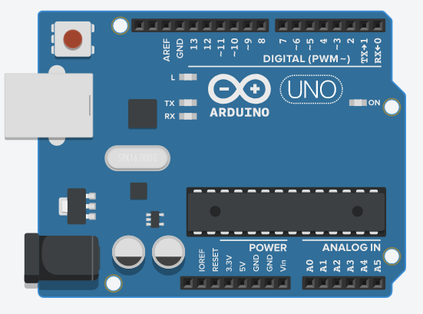

Figure – 3.2.1: Arduino UNO Board
Arduino Specification:
Names of Microcontroller | ATmega328-p (8 bit)
Main operating voltage | 5 V
Input Voltage range for DC adapter pin (Recommended) | 7 – 12 V
Limit of input voltage | 6 – 20 V
Analog Pins for input | A0 to A5 (6 pins)
Digital Input / Output Pins | 14 pins (6 PWM output pins)
Range of DC current on Input / Output pins | 40 mA
Range of DC current for 3.3 V pin | 50 mA
Flash Memory Size | 32 KB (0.5 used for bootloader)
SRAM Size | 2 KB
EEPROM Size | 1 KB
Frequency or Clock Speed | 16 MHZ
Table – 3.2.1: Arduino Specifications
3.2.2 Breadboard
Breadboard is a solder less board. It has both parallel and serial connection structure. To develop a prototype or any electronic project model, this board is of great use. Soldering isn’t needed here for connecting the wires. Just plug and play method. Prototype of any digital circuit can be made just by inserting the wires in connector holes where it seems suitable.
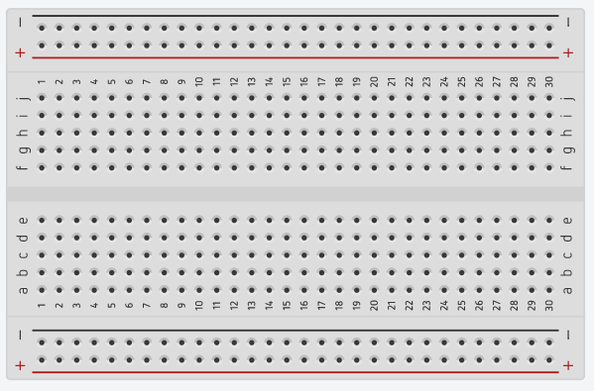

Figure – 3.2.2: Breadboard
3.2.3 LED
Light Emitting Diode (LED) are low power consumption bulbs. These are commonly used as indicator. Within our project it is also used as motor speed indicator.
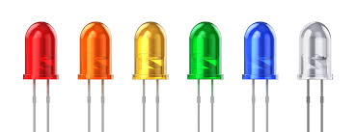

Figure – 3.2.3 – LED

3.2.4 Jumper Wires
Jumper Wires is the only component which is used in any project in a large amount. Jumper Wires are used for connecting the sensors to Arduino or any other module through breadboard or directly. Male to Female, Male to Male and Female to Female, these three types Jumper Wire are used. In our project, all of them were used.
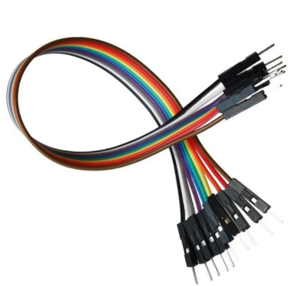

Figure – 3.2.4: Jumper Wires

3.2.5 Resistors
Resistor is a circuit element which implements electrical resistance. It is also known as the two-terminal electrical module of passive type. It is used for reducing the current flow within electrical circuits.

Figure – 3.2.5: Resistor
3.2.6 DC Power Battery (9V)
9V batteries are small in size but contains high voltage current f. These are dry cell battery. It is a rectangular shape and polarized connector battery.
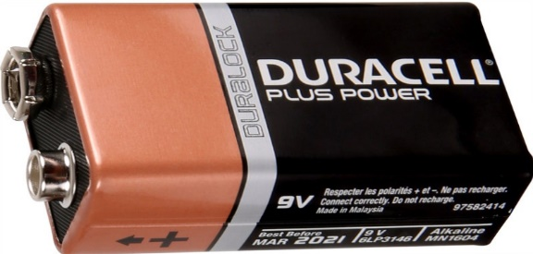

Figure – 3.2.6: Battery (9V)
3.2.7 Power Bank

Power Bank is a rechargeable power supply unit. A long durable power bank is be used for this project. A 30,000 mAh Power Bank is used for powering the whole system.
Figure – 3.2.7: Power Bank
3.2.8 DC Fan
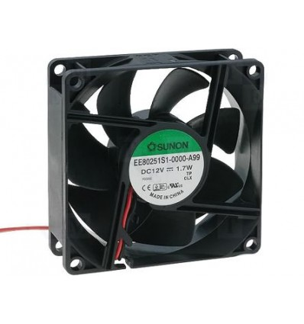
A 12V brushless DC motor/fan is used as a demonstrator for electrical cooling components.
Figure – 3.2.8: DC FAN (12V)
3.2.9 16X2 LCD Display with I2C Driver
The 1602 parallel Liquid Crystal Display has 2 line and 16 character with a blue backlight system. Now this lcd has 8 pins. So, using only the lcd will waste 8 pins of Arduino. Instead, we used an I2C driver alongside with the lcd. The I2C driver is soldered with the LCD and it has 4 pins. VCC, GND, SDA & SCL. It has also a potentiometer, by which the visibility of character bits can be controlled. The character or values displayed in the LCD can be either numeric or text value.
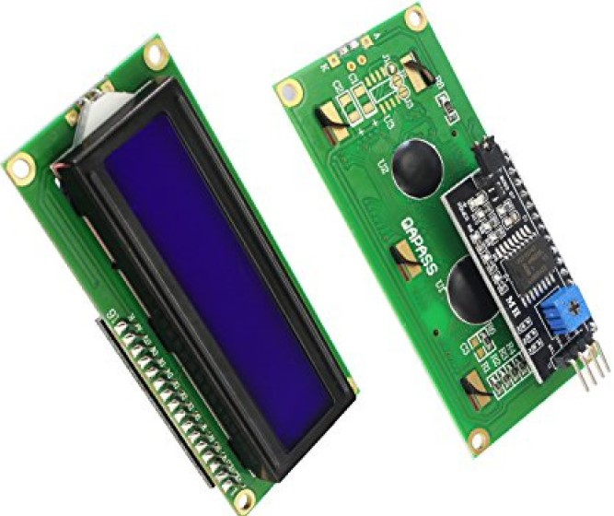
Figure – 3.2.9: 1602 LCD with I2C driver

LCD with I2C Specification:
Voltage of Operation | 5 V
Controller or Interface | I2C driver
Dimensionality of display | 80 X 36 X 20 mm
Address of I2C | 0X20 to 0X27 (by default 0X27)
Color of character within LCD | Black with a blue backlight contrast.
Adjustment of Character contrast | Has a built-in potentiometer with the I2C driver.
Character visualization | 16 X 2 LCD (2 rows, each row contains 16 characters, total 32 character)
Pins | 4 pins (GND and VCC connects with Arduino GND and 5V, SDA and SCL connects with analog pins of Arduino, generally A4 & A5)
Table – 3.2.9: I2C LCD Specifications
3.2.10 L298N Motor Driver
L298N is a DC motor driver. It can also operate stepper motor. The Motor driver can take voltage from 5V to 46V as an input supply voltage to controlling the motor speed and angle of rotation. This motor driver can control two DC motor at the same time. There are two enable pins to control the speed of motor according to the PWM signal from Arduino.
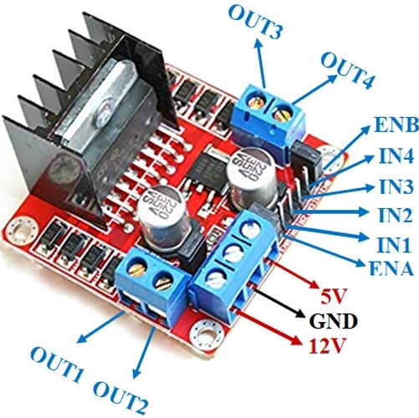

Figure – 3.2.10: L298N Motor Driver
L298N Motor Driver Specification:
Chip of Motor Driver | L298N H-Bridge (Double)
Maximum supply voltage for motor driver | 46 V
Maximum supply current for motor driver | 2 A
Voltage for logic circuitry | 5 V
Operatable voltage for motor driver | 5V – 35V
Current of logic circuitry | 0 – 36 mA
Range of maximum power supply | 25 W
Dimensionality of motor driver | 43 X 43 X 26 mm
Table – 3.2.10: L298N Specifications
3.2.11 Raspberry Pi 3B+
Raspberry pi is a single board computer. ARM chipset is used here. It has 40 GPIO pin. It is a portable IOT device. Raspbian OS which is a Linux Distro is booted here. The OS runs from a microSD card. This board has both built-in Wi-Fi, Bluetooth and ethernet port with 4 USB connection. In our project it is used with Arduino to perform serial communication with it. The device will be controlled wirelessly.
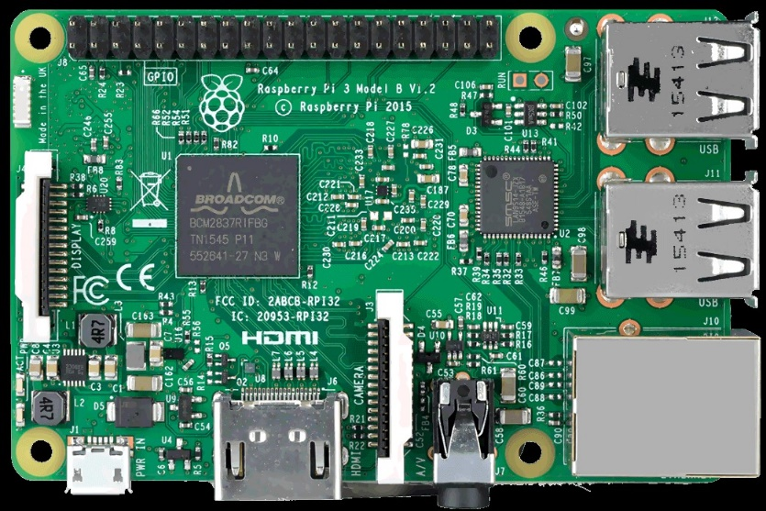

Figure – 3.2.11: Raspberry Pi model 3 B+
Raspberry Pi model 3 B+ Specifications:
Processor | Broadcom, ARM V8 64-bit processor
SDRAM Size | 1 GB
Wireless Connectivity | - 2.4 GHz & 5 GHz wireless LAN  - Bluetooth version 4.2
Ethernet Port | Gigabyte Ethernet (Maximum range 300 Mbps)
Ports | - HDMI Port (Full-Size)  - USB 2.0 ports (4 Amount)  - MicroSD card port for operating system booting and also work as internal storage  - Stereo output port (4 Pole)
Connectors | - Camera connector for Raspberry PI  - Touchscreen DSI Display Port for Raspberry PI
Power Input | DC 5V 2.5 A
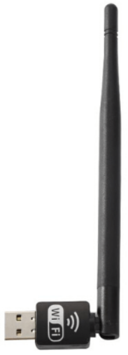
Table – 3.2.11: Raspberry Pi Specification
3.2.12 External Wi – Fi Adapter
An external Wi – Fi adapter is much strong and has connection durability than built in module of Wi – Fi. This is the reason for using an external Wi – Fi adapter with Raspberry PI.

Figure – 3.2.12: External Wi – Fi Adapter
3.2.13 DHT22 Temperature and Humidity Sensor
DHT22 is a low-cost temperature and humidity sensor. Which requires voltage from 3 to 5 volt to operate, where maximum current rate is 2.5 mA. It can read humidity from 0 – 100% with an accuracy of 2 – 5%. And, also cam read temperature value -40 to 80 degree Celsius with an accuracy of (±0.5 %). It performs much better than dht11, that is why we chose DHT22 sensor.
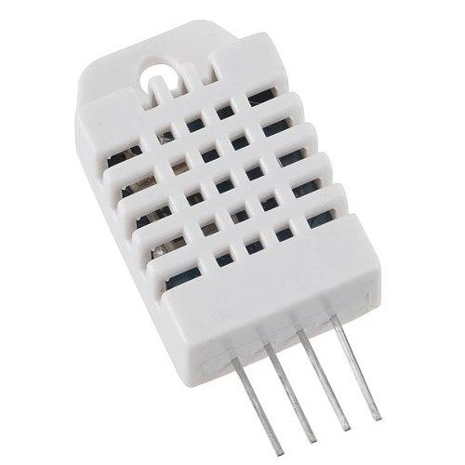

Figure – 3.2.13: DHT22 Sensor
3.2.14 MQ – 135 Gas Detection Sensor
MQ135 is a highly responsive and sensitive sensor in terms of detecting gas. It can detect smoke, $CO_{2}$, $NH_{3}$, Benzene, Alcohol etc. In this case we calibrated our sensor to detect $CO_{2}$ gas only at ppm scale. It takes approximately 20 seconds to preheat. Then it gives accurate value. And, operating voltage of this sensor is 0 – 5 V.
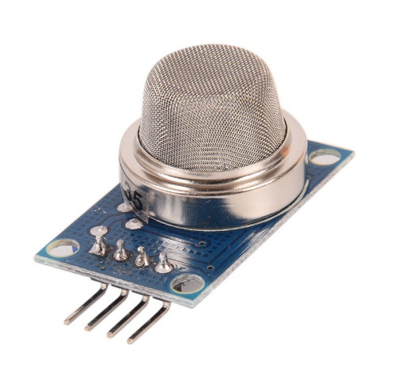

Figure – 3.2.14: MQ – 135 Gas Sensor
3.2.15 NODEMCU (ESP8266 12E)
NODEMCU is an IOT platform device. The Speciality of this board is that it runs on ESP8266 Wi – Fi module. Both of its board and firmware is opensource. It can pass sensor value directly to cloud using internet. It is based on ESP – 12E Module.
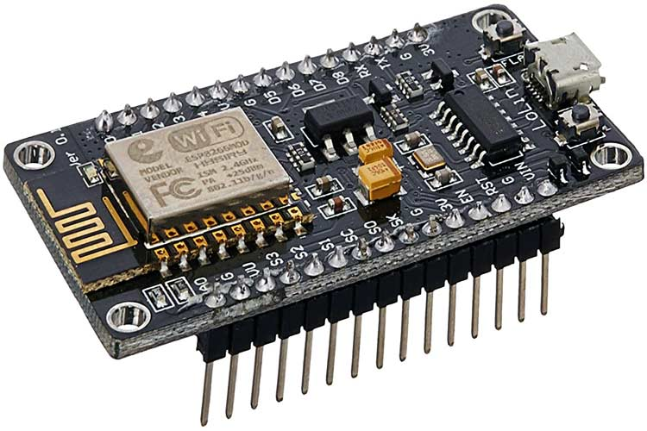

Figure – 3.2.15: NODEMCU (ESP8266 12E)

NODEMCU (ESP8266 12E) Specifications:
Names of Microcontroller | Tensilica Xtensa LX106 RISC CPU (32 bit)
Main operating voltage | 3.3 V
Input Voltage range for DC USB pin | 7 – 12 V
Analog Pins for input | A0 (only 1 pin)
Digital Input / Output Pins | 16 pins
Number of UARTs | 1
Number of I2Cs | 1
Flash Memory Size | 4 MB
SRAM Size | 64 KB
Number of SPIs | 1
Frequency or Clock Speed | 80 MHZ
Table – 3.2.15: Nodemcu Specification
3.3 Software Requirements and Analysis
In this project, to develop its functional activity, help of some software and coding part is needed. Required software coding scheme for this project is described below.
3.3.1 Arduino IDE
Arduino IDE will be used for coding the Arduino board and NODEMCU. Arduino board is coded as it will be used for serial communication with raspberry pi. And, NODEMCU is coded as it will upload temperature, humidity and CO2 ppm in Thing Speak cloud server.


Figure – 3.3.1: Arduino IDE

3.3.2 Thonny Python IDE
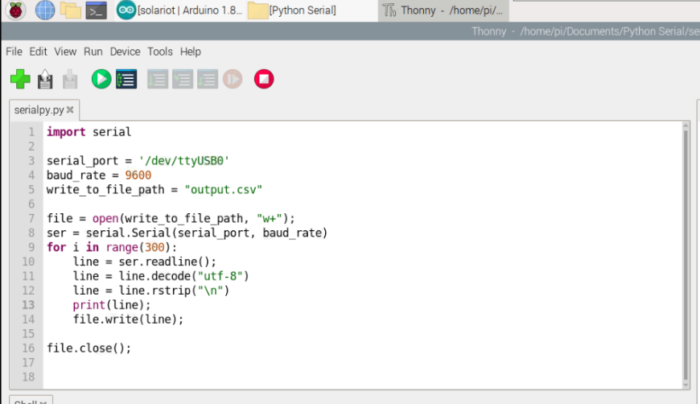
This is a python code compiling IDE, which is used in raspberry pi for making serial communication with the Arduino board and store temperature, humidity, CO2 ppm in a CSV file for using in a machine learning model and also for collecting data in offline mode, as Thing Speak doesn’t collect every data of the sensor. It is mixed with a lot of missing values. The following is the IDE itself and the code is for making serial communication with Arduino Board.
Figure – 3.3.2: Thonny Python IDE

3.3.3 Thing Speak Cloud Server
Thing Speak is used as a web application for plotting real time graph while collecting data. It will collect temperature, humidity and CO2 ppm data. And, plot graph for each of the field with respect to time and date. It collects or uploads sensors data in its server with a 15 seconds time pause. The, plots the graph according to time and date. It is generally used for data visualization in IOT projects.
3.3.4 Jupyter Notebook
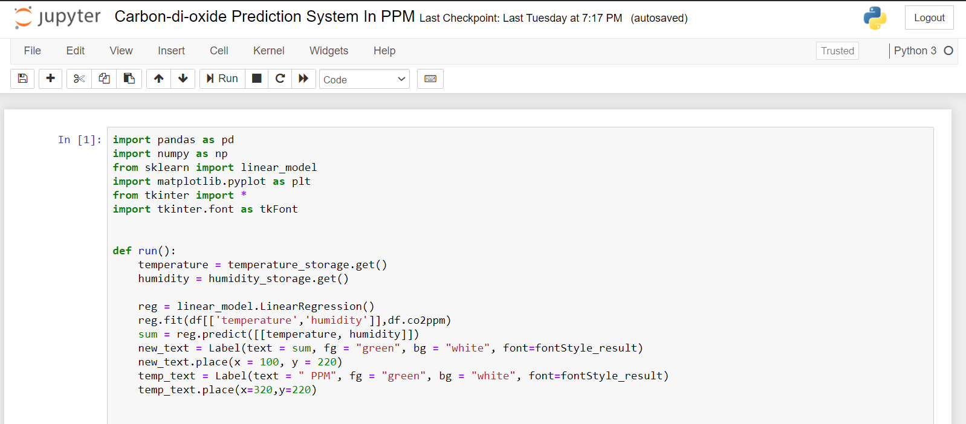
Jupyter Notebook is a Python IDE. Which is generally used for machine learning purpose. It is a web application used for data visualization, prediction, learning, pattern recognition, machine learning, simulation etc. It is an open – source Integrated Development Environment (IDE). In our project we used it to create an application to predict CO2 range in PPM meter from temperature and humidity. Also, we used it for visualization of our collected data (temperature, humidity, co2 ppm).
Figure – 3.3.4: Jupyter Notebook
3.4 Device Functional Requirement
- Controlling the speed of fan or any flow range of any other cooling device.
- Monitoring the overall classroom environment.
- As it controls the speed of cooling device, so it saves a lot of electricity by doing so.
- Uploads Realtime data in cloud server and also saves those data in CSV form in offline.

3.5 System Diagram
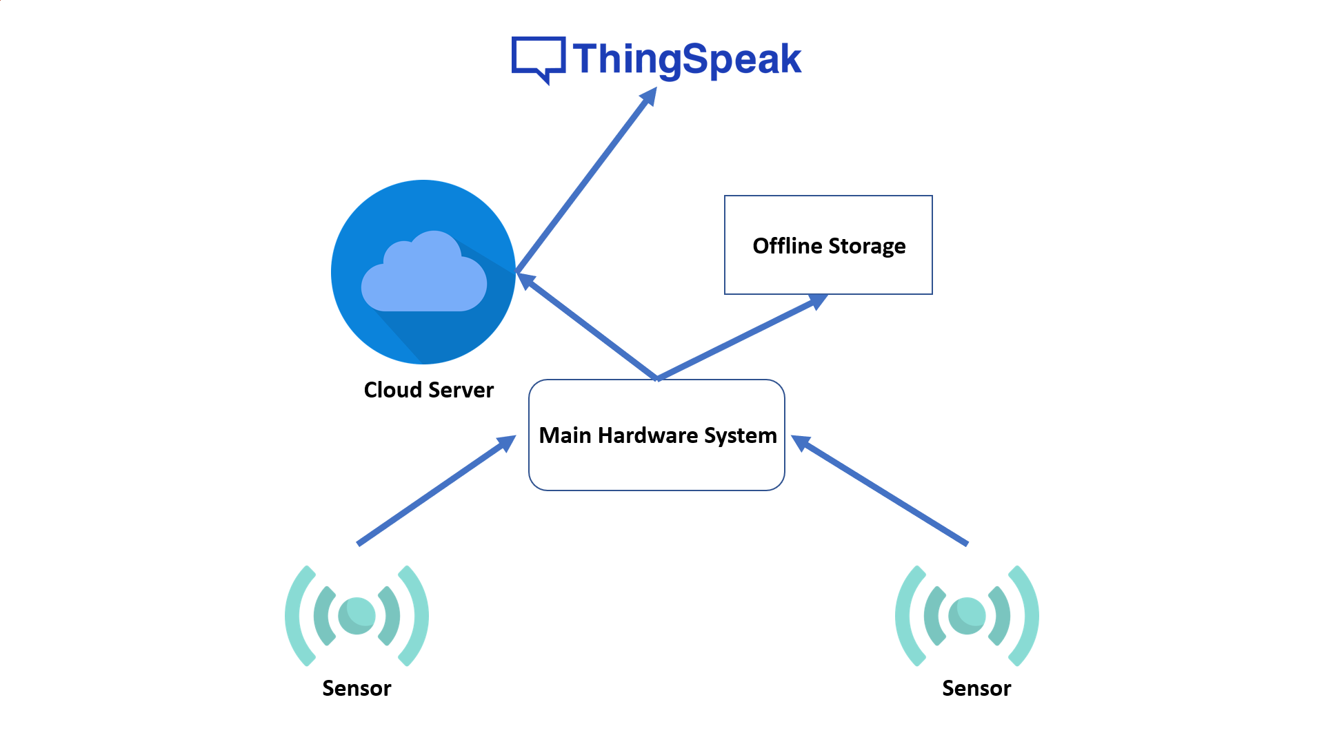
The diagram below illustrates the basic work flow of the system. The sensor first gathers data from surrounding environment, then sends it to the system. In our case system has two brains. One is Arduino connected to raspberry pi for serial communication and another is NODEMCU. So, when the sensors sends data to the whole system, then those data is transmitted to both Arduino and NODEMCU. Through the NODEMCU the data is sent to the cloud server and then those data are plotted in graph through Thing Speak. In the Arduino section the data is sent from Arduino Serial port to raspberry pi serial port in order to collect those data offline in CSV format.
Figure – 3.5: System Diagram
This is the simple System diagram of the whole device. Which is illustrated through some blocks to demonstrate the systems working procedures.
3.6 Process of Data Collection
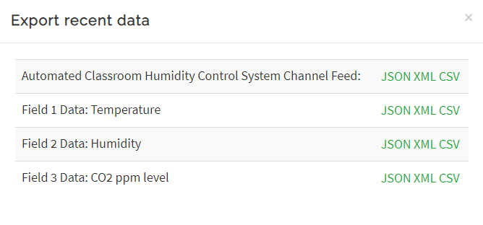
When the machine is powered by battery it immediately starts to send data to the Thing Speak cloud server. Where for every field a graph is plotted with respect to time. When the sensors receives power, then inside the sensor chemical reactions happen and it provides analog value to the Arduino and NODEMCU board. Then through a program those analog values are converted as temperature, humidity and co2ppm. Here we collect data in two different segment. One is online via Thing Speak and another is offline. We did that because, in the Thing Speak server data is collected from sensors after 15 seconds of delay. So, within those 15 seconds many data isn’t collected by Thing Speak. For that we implemented a method to collect data both online and offline. In this way there will be no missing values.
Figure – 3.6.1: Thing Speak data Collection

The above data chart was collected by Thing Speak cloud server. There are three different fields for three types of data. And, from the Raspberry Pi with Serial communication with Arduino we get below data chart. Where every value is store, because there is no 15 seconds delay in offline data storing unlike Thing Speak.

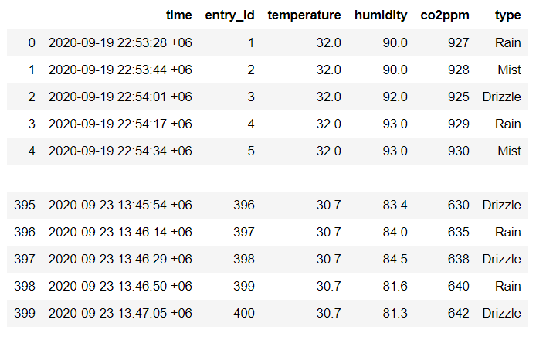
Figure – 3.6.2: Offline Data Collection

3.7 Required Programming Languages
- Basic knowledge in C/C++.
- Embedded Programming Language.
- Python 3

CHAPTER 4
DESIGN SPECIFICATION

4.1 Device Structure
The whole device is mounted in a plain hard board. All of the sensors, fan and microcontrollers are connected through a bread board. Analog pin and digital pin of sensors have common point in bread board, because both Arduino and Nodemcu are connected with those common pins. VCC and GND of both Arduino and Nodemcu has also a common connecting point in bread board. Both of these micro controllers are connected to these pin parallelly. The sensors are in opposite side of the board. The fan is placed near the sensors. The motor driver is in center position. The LED and LCD situated near Arduino. And, Raspberry Pi is in front of Arduino for connecting easily. And last of all two different places for power supply unit.

4.2 Sensors Controlling Procedure
The power bank supplies 5V to overall circuit. VCC & GND pin of Arduino and VCC & GND pin of Nodemcu both are connected parallelly, as doing so both boards will have a stable voltage connection which is very important for reading sensors value. The sensor starts to send value to the boards whenever they receive 5V power supply. The Analog and digital input pin of both Arduino and Nodemcu is also connected parallelly as they receive same sensors value parallelly. Then, Nodemcu begins to receive data from sensors and then send them to Thing Speak server and Arduino sends them to serial port of Raspberry Pi for saving them in offline in CSV format.

4.3 Power Supply Controlling Procedure
For the power supply of the whole unit, we used two power sources. One is 3x1 9V battery or 27 V power supply for motor driver to rotate and control the speed of DC fan. Then, another power source for the rest of the system is a 30,000 mAh power bank. With the help of this power bank we managed to power up one Nodemcu, one Arduino board, two sensors (DHT22, MQ – 135), one LCD, several LED light and one raspberry pi 3 b+ board. All of these module takes high capacity of power supply which is the reason to use this 30,000 mAh power bank.

4.4 Total Cost Estimation and List of the Components
Serial | Sensors and Components | Price
1 | Arduino UNO R3 | 250 taka
2 | Bread Board | 20 taka
3 | LED | 5 taka
4 | Resistors | 5 taka
6 | Jumper Wires | 20 taka
7 | 9V Battery | 25 x 3 = 75 taka
8 | Power Bank (30,000 mAh) | 8000 taka
9 | 12V DC Fan | 50 taka
10 | 1602 LCD with I2C Driver | 350 taka
11 | L298N Motor Driver | 110 taka
12 | Raspberry Pi 3 B+ | 4500 taka
13 | Wi – Fi Adapter | 700 taka
14 | DHT22 Sensor | 200 taka
15 | MQ – 135 Gas Sensor | 150 taka
16 | ESP8266 12E NODEMCU | 400 taka
Table – 4.4: Cost of Sensors and Components
Total cost for this whole project is approximately 14,835 or 15,000 taka.
4.5 Complete Implementation of Requirement Design
The whole hardware of the device is mounted on a plain hard board. The board contains of multiple sensors, bread board, wires and many other components. The prototype circuit was implemented through bread board. As, we used two micro controllers here so we have to make an arrangement of placing common pins for both micro controllers. Both of the Arduino and Nodemcu will receive sensor data at the same time.
For that both of the boards Analog and Digital pins have to be connected together with the sensor to receive data at the same time. VCC and GND for both microcontrollers is placed parallelly through bread board as it will maintain a balanced voltage flow within the both boards, which is essential for reading sensors data correctly. Analog and Digital pins which are common for sensors for the two boards also placed in parallel sequence.
Whenever the sensor receives voltage it will start to send data to the micro controllers. The Nodemcu will instantly send data to the Thing Speak for plotting the graph whenever it receives power and sensors data.
On the other hand the Arduino will also receive the sensors data and will communicate with the raspberry pi through serial port and raspberry pi will collect those 3 data in a CSV format. In the mean time real time sensors data that means temperature, humidity and co2ppm will also be shown in the LCD display and according to the temperature and co2ppm the fan will rotate and maintain its speed through motor driver. There is also three LED is used for indicating the motors current rotating speed in PWM (Pulse Width Modulation).
The whole system will be powered by two power source. One is 9V battery of quantity three which is equals to 27V is used for Motor Driver, as it can take voltage up to 45V. And, then for the rest of the component and sensors the board is powered with a 30,000 mAh power bank with output voltage of 5V. As, it has mass capacity, it will be enough for keeping the circuit voltage flow for a long duration of time.

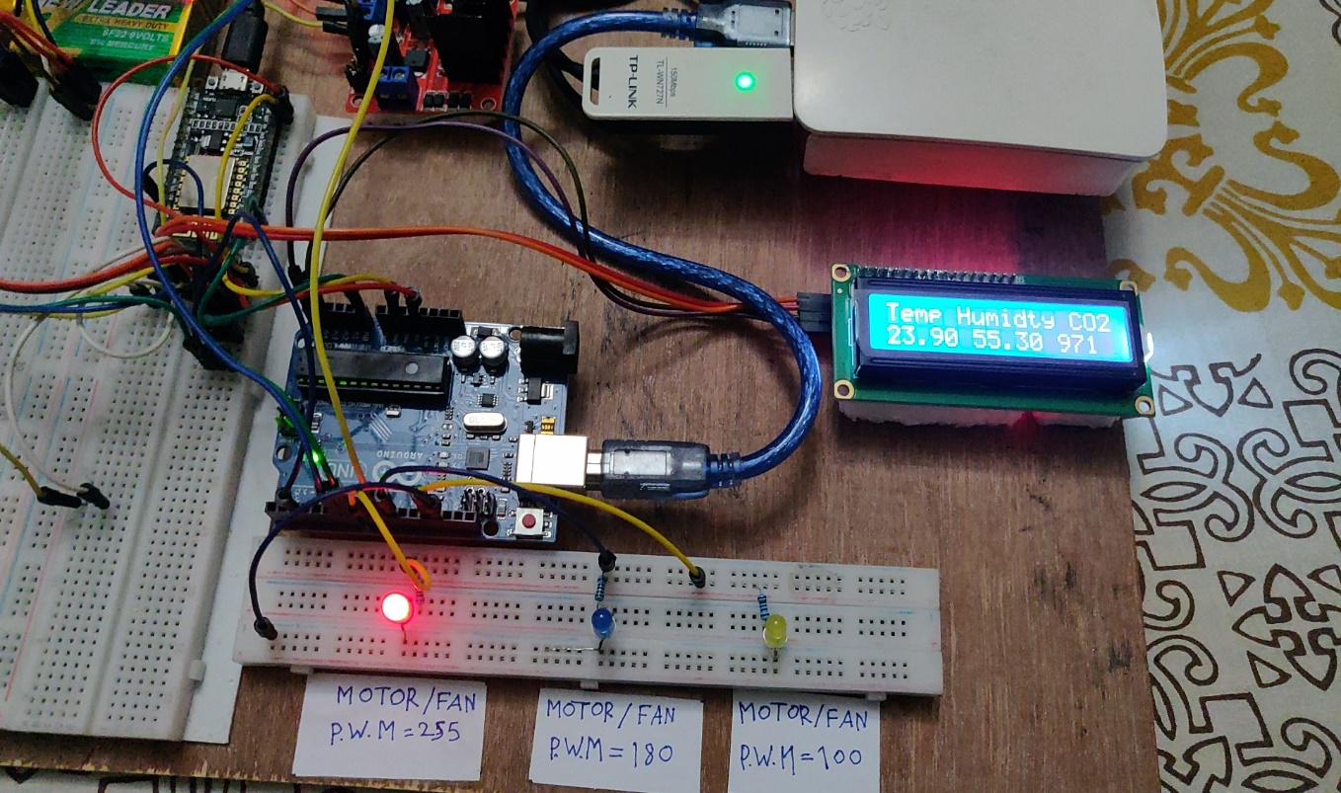
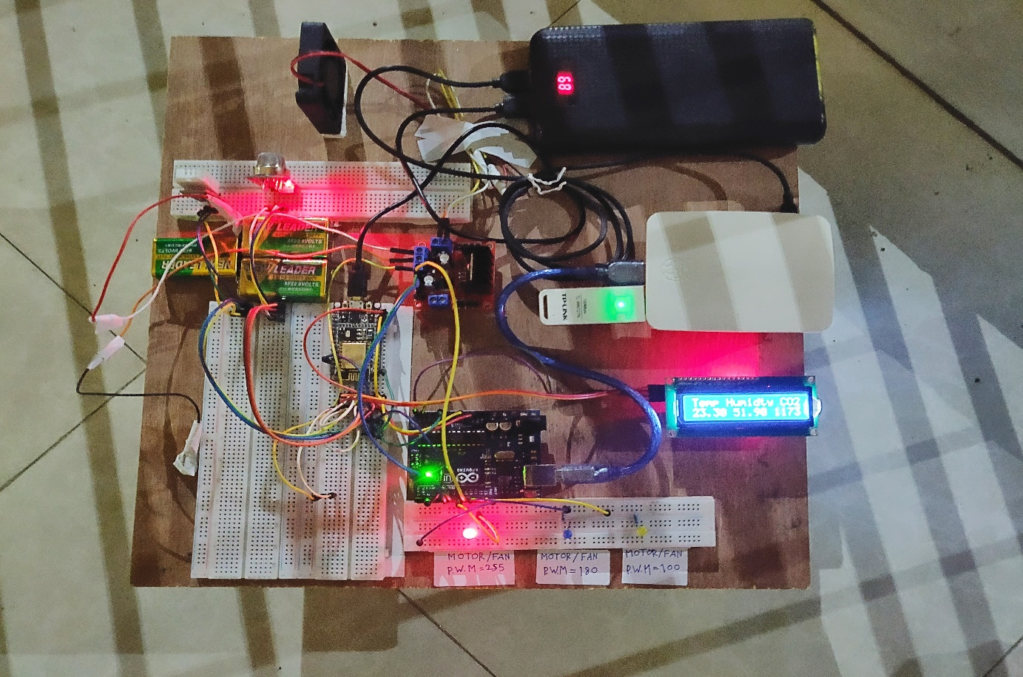
Figure – 4.5.1: Complete Implementation of Requirement Design
Figure – 4.5.2: Complete Implementation of Requirement Design
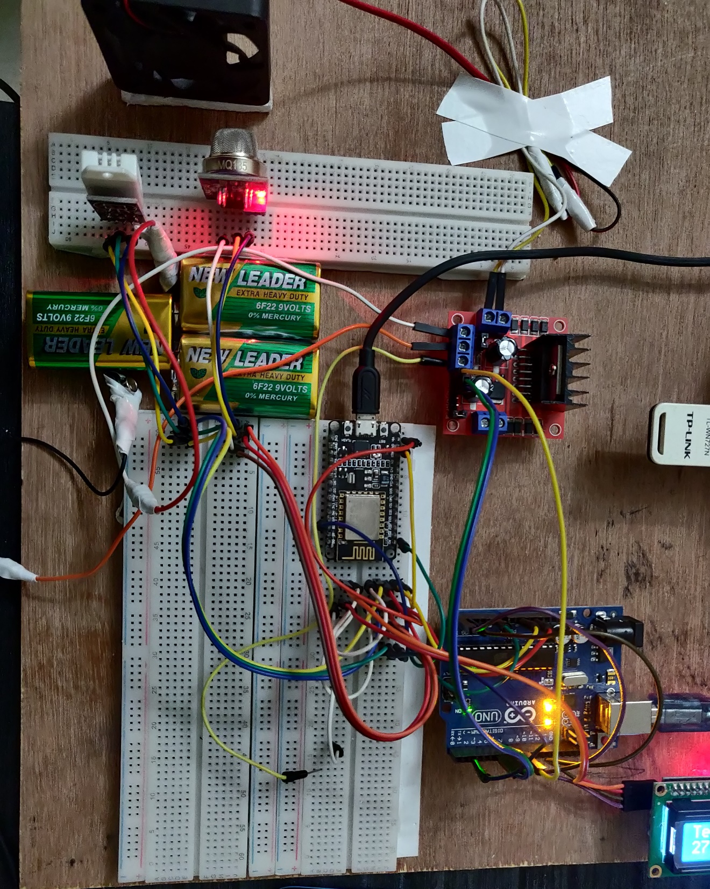
Figure – 4.5.3: Complete Implementation of Requirement Design

CHAPTER FIVE
IMPLEMENTATION AND RESULT ANALYSING

5.1 Database Implementation
In any project where data is collected, then database for those data is mandatory. Our project is no different than that. We have also sensors that takes data from environment. We need to store it somewhere for data visualization, analysis of the data or handling the data. We used Thing Speak server for database and visualizing the data. Our data will be stored with respect to date and time for any time zone we want.
Figure – 5.1: Database Implementation

The sensor of the device starts to work when the machine is activated. Then the sensors begin to cope with the environment and chemecal reaction within sensors takes place in order to generate values. Those values are Analog values. Which is collected by Thing Speak and stored in a database also at the same time it plots graph for every field according to the time those data were stored. Different graphs for different sensors and their different activity is generated. It changes time to time. It shows real time situation of the sensors and its surrounding environment.

5.2 Machine Learning Model Implementation
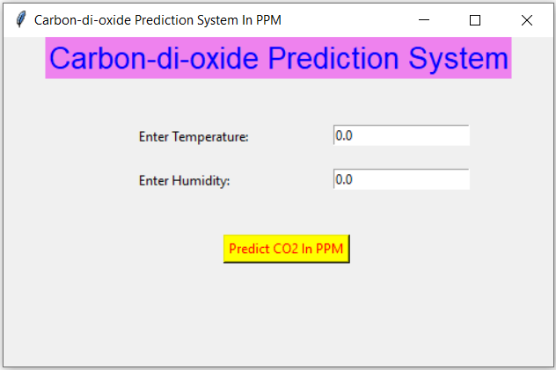
We applied a machine learning model for our project. Our model is trained to predict values. We have three different types of numeric values. We implemented a method to predict the co2ppm range of a classroom based on temperature and humidity. We did this because it will reduce cost in future. As, this model gets accurate and strong day by day, then there will be a time when we will be able to detect co2ppm of any enclosed classroom without the gas sensor. The system will be much simpler and faster in this way. Also, it will reduce a lot of cost for not buying extra gas sensors. Here, temperature and humidity is independent variable and co2ppm is dependent variable. We applied Linear Regression Model to predict the value. And for user interface we used python’s Tkinter library.
Figure – 5.2: CO2 ppm detection module

5.3 Algorithms
We used two sensors named DHT22 which can detect temperature & humidity and we used MQ – 135 which is a gas censor for detecting smokes and different types of gas. This sensor is not designed for detecting CO2 gas alone. Whenever it detects any gas, it detects presence of multiple gas and gives a value according to that. In our case we need only CO2 in ppm scale. So, we had to calibrate and map the sensor (MQ – 135) in a way that it gives CO2 value in ppm scale. It has to be done with some code to get this kind of value. The algorirthm for detecting only CO2 in ppm is described below.
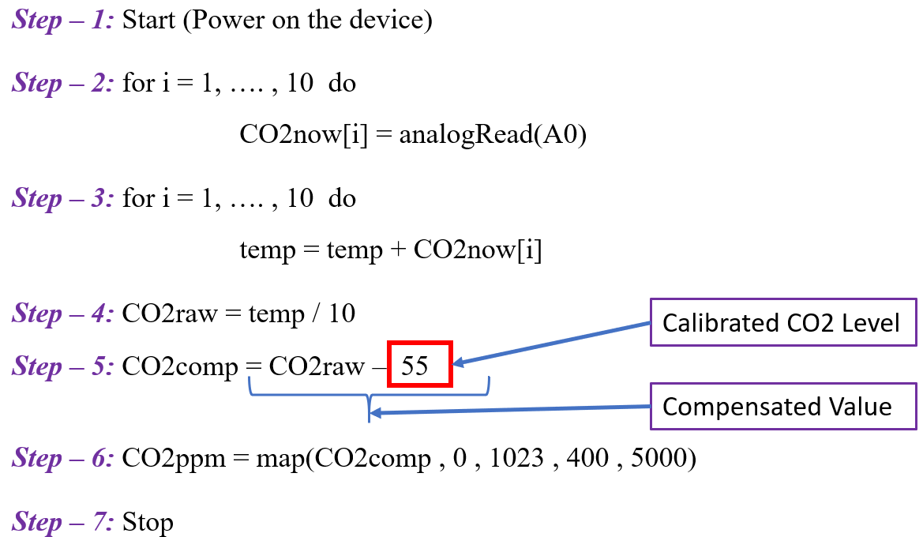
Figure – 5.3: CO2ppm finding Algorithom
Here, at Step – 4, the value 55 is a calibrated value for MQ – 135. This value was measured in an environment where CO2 emission is low and air quality is much better. After taking this value it has to be substracted from raw anlog value to get compensated value. Then, that compensated value is maped. We know that in Arduino analog range is from 0 to 1023. So, we maped the compensated value for the analog range 0 to 1023 with 400 to 5000 to get CO2 in ppm range. As, 400 to 5000 is the ppm scale of world CO2 emission level.
5.4 Prediction Testing
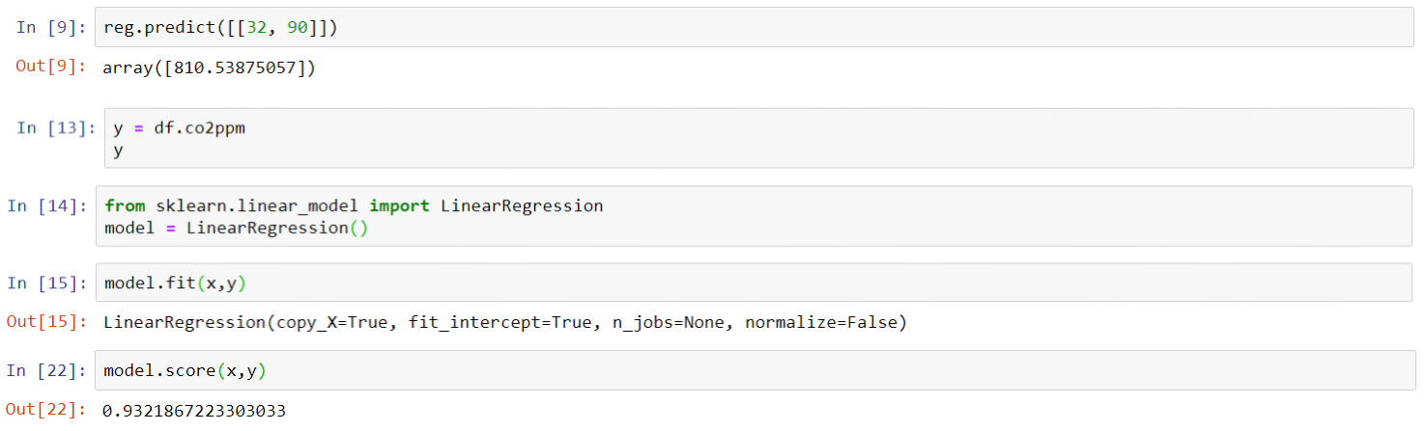
In this project we implemented a machine learning model to predict CO2 in ppm scale on the basis of temperature and humidity. Here, temperature and humidity is independent value and co2ppm is dependent value. We trained this model using Linear Regressiuon. Our model is 93% accurate in time of prediction. Temperature and humidity is considered as X intercept and co2ppm is considered as Y intercept.
Figure – 5.4.1: Prediction Testing Score

Now, we developed a user interface for this prediction testing using Tkinter. It is very simple and user friendly UI, which takes two input temperature and humidity and shows the predicted output of CO2 in ppm scale.
As we discussed already on the above that our prediction system has accuracy of 93%. So, it predicts very close value according to the real datashhet value. The more data we gather, the more our percentage of accuracy will be increased. Using the system continiously will generate a huge amount of data. So, whenever we will predict from those huge data set, it can be said that the accuracy of predicting CO2 in ppm scale will be much more close and accurate.
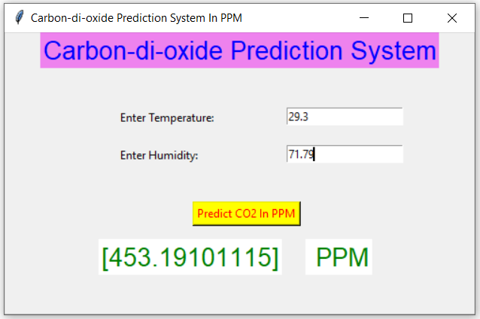

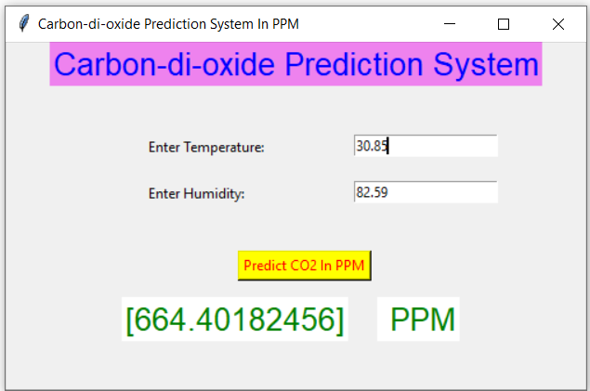
Figure – 5.4.2: Prediction Result – 1

Figure – 5.4.2: Prediction Result – 2

5.5 Sensors Data Graph (Visualization)
As, we have used Thing Speak for visualizing the data obtained by the sensors. In case of our project, we have three types of numeric data temperature, humidity and co2ppm. There is also another categorial data type for showing weather condition, which is not used for Thing Speak data visualization. Our data visualization will contain both Thing Speak generated and locally generated graph. The locally generated graph was plotted by panda and seaborn library in Jupyter Notebook.

5.5.1 Temperature Graph Plot
Here, we visualized Temperature data in both ThingSpeak and distplot. ThingSpeak plotted the graph with respect to time. And, distplot is showing histogram type of graph with a line on it.
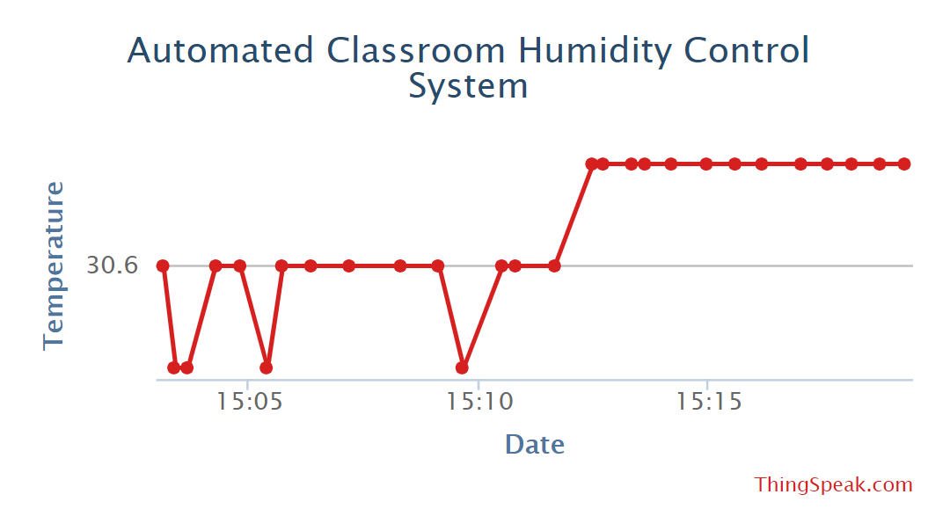
Figure – 5.5.1.1: Temperature Graph Plot (Thing Speak)
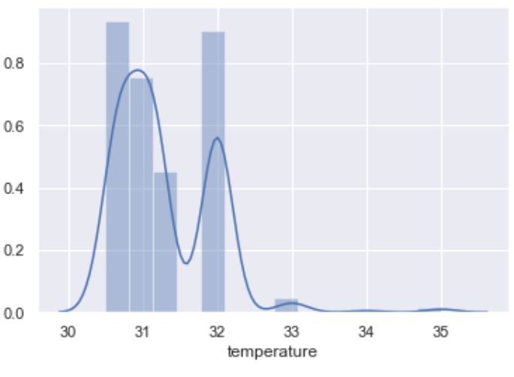
Figure - 5.5.1.2: Temperature Graph Plot (Jupyter Seaborn)
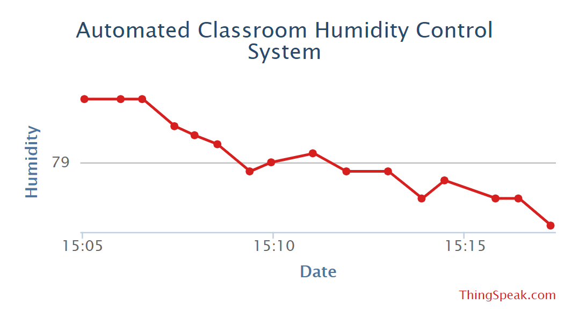
5.5.2 Humidity Graph Plot
Here, we visualized Humidity data in both ThingSpeak and distplot. ThingSpeak plotted the graph with respect to time. And, distplot is showing histogram type of graph with a line on it.
Figure – 5.5.2.1: Humidity Graph Plot (Thing Speak)
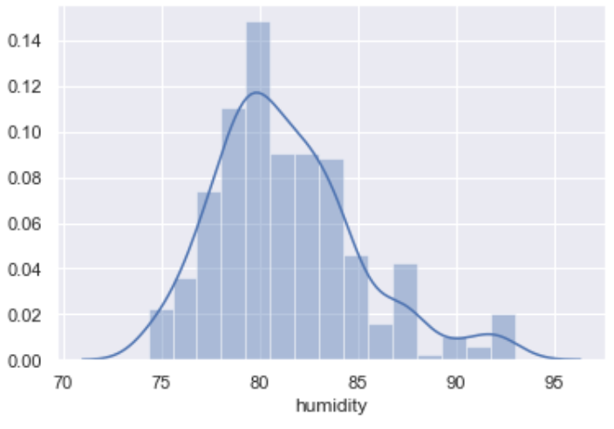

Figure – 5.5.2.1: Humidity Graph Plot (Jupyter Seaborn)
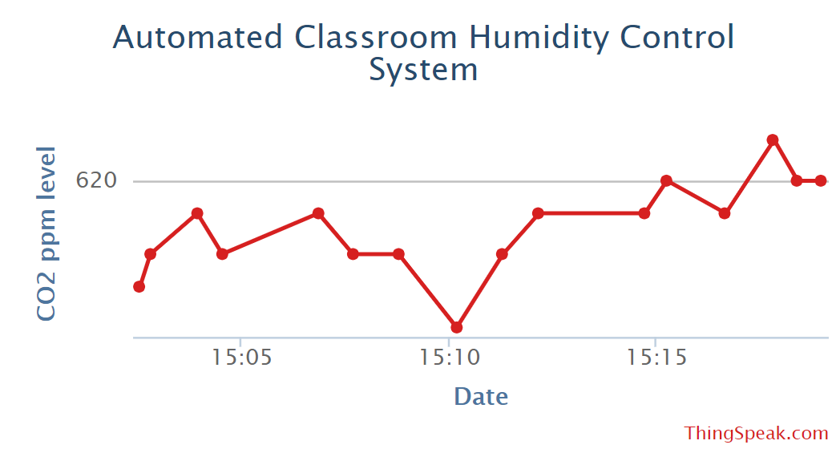
5.5.3 CO2 ppm Graph Plot
Here, we visualized CO2 PPM data in both ThingSpeak and distplot. ThingSpeak plotted the graph with respect to time. And, distplot is showing histogram type of graph with a line on it. The function distplot() with combination of matpolib is used here.
Figure – 5.5.3.1: CO2 ppm Graph Plot (Thing Speak)
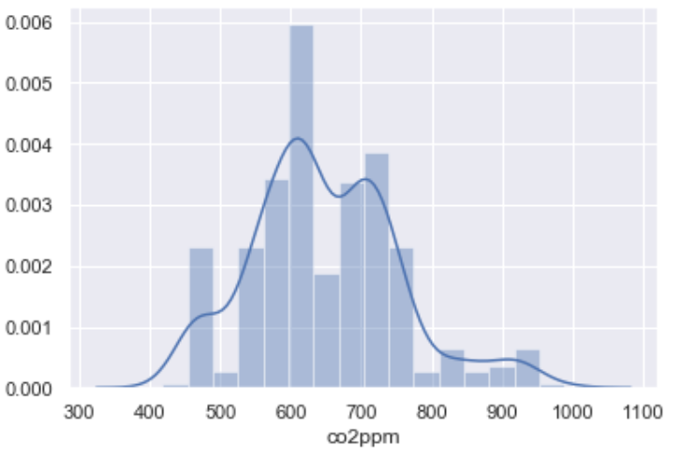

Figure – 5.5.3.2: CO2 ppm Graph Plot (Jupyter Seaborn)
5.5.4 Bar Plot Graph of Temperature with Humidity
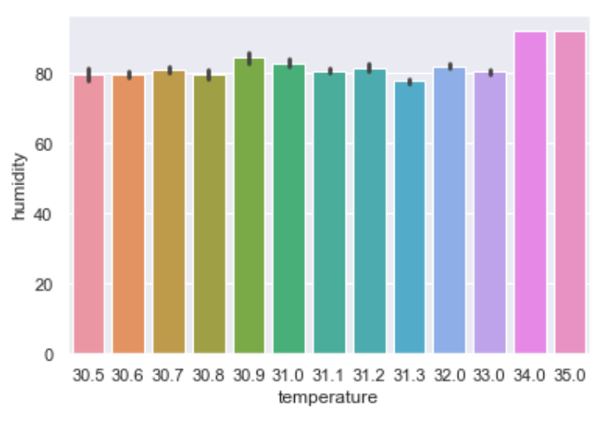
The barplot() function of library seaborn is used here. Here two types of data Temperature and Humidity both are measured with proportional to each other as X-axis and Y-axis.
Figure – 5.5.4: Bar Plot Graph of Temperature with Humidity (Jupyter Seaborn)
5.5.5 Bar Plot Graph of Temperature with CO2 ppm
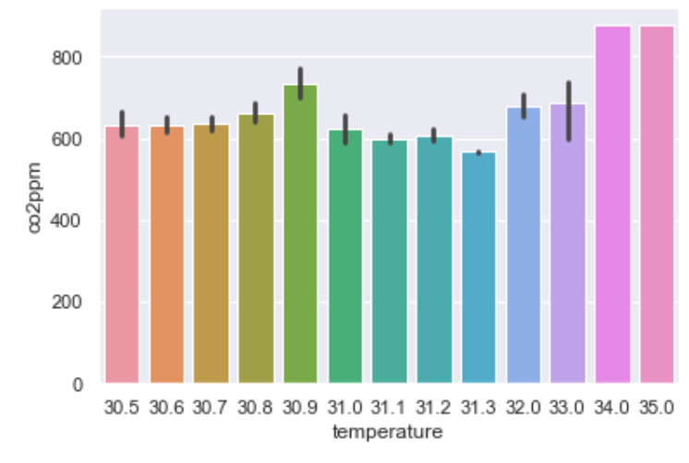
Here, two numeric data type variable Temperature and CO2 ppm is used for drawing this bar grapgh. The barplot() function of library seaborn is used here. Here two types of data Temperature and CO2 ppm both are measured with proportional to each other as X-axis and Y-axis.
Figure – 5.5.5: Bar Plot Graph of Temperature with CO2 ppm (Jupyter Seaborn)
5.5.6 Bar Plot Graph of Weather Type with CO2 ppm
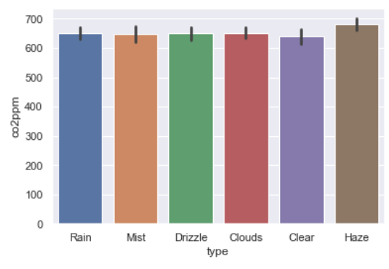
Here, one numeric and one categorial data type variable Temperature and CO2 ppm is used for drawing this bar graph. The barplot() function of library seaborn is used here. Here both variable are measured with proportional to each other as X-axis and Y-axis.
Figure – 5.5.6: Bar Plot Graph of Whether Type with CO2 ppm (Jupyter Seaborn)
5.5.7 Point Plot Graph of Temperature and Humidity
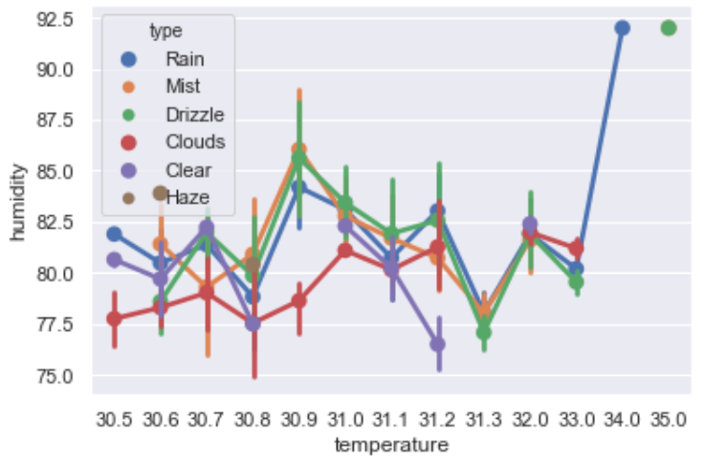
Estimation of central tendency is point plot. Here, Temperature and Humidity of numeric data is plotted with points data weather type which is categorial type. Both estimation and confidence interval is used in case of point plot.
Figure – 5.5.7: Point Plot Graph of Temperature and Humidity (Jupyter Seaborn)
5.5.8 Point Plot Graph of Temperature and CO2 ppm
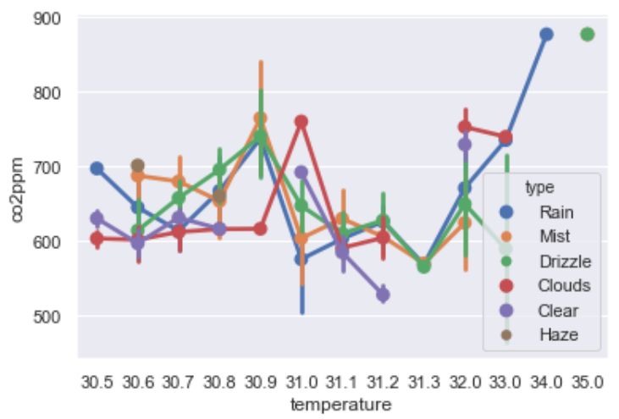
In library Seaborn function pointplot() is used for making this kind of graph. Estimation of central tendency is point plot. Here, Temperature and CO2 ppm of numeric data is plotted with points data weather type which is categorial type. Both estimation and confidence interval is used in case of point plot.

Figure – 5.5.8: Point Plot Graph of Temperature and CO2 ppm (Jupyter Seaborn)
5.5.9 Pair Plot Graph of Temperature, humidity and CO2 ppm
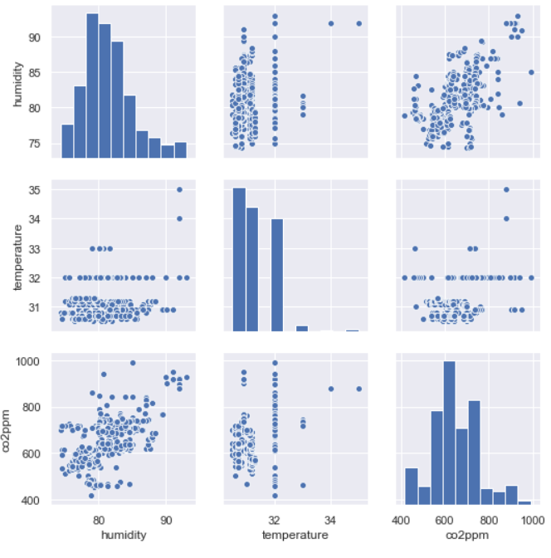
Pair plot shows pair wise relationships among data types. Measuring data variation of multiple variable pair wise, the pair plot is used. It is good for analyzing numeric type of data. Here Humidity, Temperature and CO2 ppm all of these three variables are numeric type. Each variable will be shared in y-axis across a single row and x-axis across a single column.

Figure – 5.5.9: Pair Plot Graph of Temperature, humidity and CO2 ppm (Jupyter Seaborn)
CHAPTER 6
SUMMARY, CONCLUSION AND FUTURE SCOPE OF IMPLEMENTATION

6.1 Summary of The Project

Maintaining tolerable range of environment is one of the most challenging and important things in the world right now. Certain kinds of data sets like tracking of changing climate, its surrounding air particle density is very important now. Our project is mainly focused and based on this concept. We developed a system to monitor humidity and environment of an enclosed classroom and to automate the cooling device to control the tolerable range of air quality inside classroom. Thing Speak and Jupyter Seaborn was used for plotting different types graphs for generated data. Also, a machine learning prediction system was created for this project.

6.2 Conclusion

This automated classroom humidity control system was made with affordable and low cost components. It can be used for long time to collect thousands of data without any delay. The total hardware system is pretty small and portable, that is why it can be planted in any indoor enclosed compartment. The controlling of cooling device and speed of the cooling device was successful in every attempt. Also, the machine learning prediction system for predicting co2ppm was closely accurate. It was successful at saving a lot of power for electrical cooling appliances. There was no issue of Wi – Fi signal drop or serial data collection failed for the system. So, it can be said the system is pretty stable, user friendly and flexible.

6.3 Future Scope of Implementation

This is the Era of fourth Industrial revolution. And the main theme of fourth Industrial revolution is Internet of Things (IOT). The usage of IOT device is getting higher every day. For example, there are a lot of IOT project and systems available for air quality monitoring or controlling it. Aa our project is also IOT based, so we have a lot of sector to add or develop within our project to make it more powerful and more precise. The Future Implementation proposal for or current project is discussed below.
- We can add more type of gas sensors to detect other types of air particle, which would make the system more precise.
- As we calibrated a sensor to detect CO2, we can implement an industrial quality sensor which can actually detect CO2 separately. It would make our data set much cleaner and precise.
- We can develop a smartphone app for monitoring the system from phone.
- The machine learning model for prediction can be updated using more independent variables.
- Currently we are controlling the cooling device and its speed for controlling the humidity, but in future we can provide oxygen enriched air to the classroom to control and maintain air quality more precisely and effectively.

REFERENCES

[1] Jigar Parmar, pranay Palv, Trishal Nagda, and Hezel Lopes, “ IOT based Weather Intelligence”, IEE, Mumbai, India, 19 November 2018.
[2] ] Learn about Home automation and security system from publication at <<https://www.researchgate.net/publication/311734099_Home_Automation_and_Security_System>>[ Last visited 4 December 2020 at 11:37pm]
[3] Tapashetti, A., Vegiraju, D., & Ogunfunmi, T. (2016). IoT-enabled air quality monitoring device: A low cost smart health solution. 2016 IEEE Global Humanitarian Technology Conference (GHTC). doi:10.1109/ghtc.2016.7857352
[4] Marques, G., & Pitarma, R. (2017). Monitoring Health Factors in Indoor Living Environments Using Internet of Things. Recent Advances in Information Systems and Technologies, 785–794. doi:10.1007/978-3-319-56538-5_79
[5] Gabriel Neagu, Stefan Preda, Alexandru Stanciu, Vladimir Florian “A Cloud-IoT based sensing service for health monitoring” 2017 E-Health and Bioengineering Conference (EHB), June 2017, DOI: 10.1109/EHB.2017.7995359

