A WEB BASED PROJECT: Skilled, Semi-Skilled Worker Recruiting and Supply Services
BY
Rahat Rhidoy
ID: 171-15-1493

Fahim Al Imran
ID: 171-15-1483

AND
Ahsanul Haque Noyan
ID: 171-15-9527

This Report Presented in Partial Fulfillment of the Requirements for the Degree of Bachelor of Science in Computer Science and Engineering.

Supervised By

Ohidujjaman
Sr.Lecturer
Department of CSE
Daffodil International University

Co-Supervised By

Md. Sabab Zulfiker
Lecturer
Department of CSE
Daffodil International University



DAFFODIL INTERNATIONAL UNIVERSITY
Dhaka, Bangladesh
December 2020

APPROVAL

This Project titled “Skilled,Semi-Skilled Worker Recruiting and Supply Services”, submitted by Rahat Rhidoy, ID No:171-15-1493 , Fahim Al Imran , ID No : 171-15-1483 and Ahsanul Haque Noyan , ID No :171-15-9527 to the Department of Computer Science and Engineering, Daffodil International University, has been accepted as satisfactory for the partial fulfillment of the requirements for the degree of B.Sc. in Computer Science and Engineering and approved as to its style and contents. The presentation has been held on 8th December 2020.

Board of Examiners

Dr.Syed Akhter Hossain Chairman
Professor and Head
Department of CSE
Faculty of Science & Information Technology
Daffodil International University

Dr.S.M. Aminul Haque Internal Examiner
Associate Professor
Department of CSE
Faculty of Science & Information Technology
Daffodil International University

Ohidujjaman Internal Examiner
Sr.Lecturer
Department of CSE
Daffodil International University

Declaration

We hereby declare that, this project has been done by us under the supervision of Ohidujjaman, Sr. Lecturer, Department of CSE Daffodil International University. We also declare that neither this project nor any part of this project has been submitted elsewhere for award of any degree or diploma.

Supervised by:

Ohidujjaman
Sr.Lecturer
Department of CSE
Daffodil International University

Co-Supervised by:

Md.Sabab Zulfiker
Lecturer
Department of CSE
Daffodil International University

Submitted by:

Rahat Rhidoy
ID: -171-15-1493
Department of CSE
Daffodil International University
Fahim Al Imran
ID: -171-15-1483
Department of CSE
Daffodil International University

Ahsanul Haque Noyan
ID: -171-15-9527
Department of CSE
Daffodil International University

ACKNOWLEDGEMENT
First we express our heartiest thanks and gratefulness to almighty God for His divine blessing makes us possible to complete the final year project/internship successfully.

We really grateful and wish our profound our indebtedness to Supervisor Ohidujjaman, Sr. Lecturer, Department of CSE Daffodil International University, Dhaka. Deep Knowledge & keen interest of our supervisor in the field of Web Development to carry out this project. His endless patience ,scholarly guidance ,continual encouragement , constant and energetic supervision, constructive criticism , valuable advice ,reading many inferior draft and correcting them at all stage have made it possible to complete this project.

We would like to express our heartiest gratitude to Dr. Syed Akhter Hossain, Professor and Head, Department of CSE, for his kind help to finish our project and also to other faculty member and the staff of CSE department of Daffodil International University.

We would like to thank our entire course mate in Daffodil International University, who took part in this discuss while completing the course work.

Finally, we must acknowledge with due respect the constant support and patients of our parents.

Abstract

A2Z Service is a platform for helping skilled or semi-skilled unemployed persons whom have skills but they can't find any kind of job. A2Z Service will provide their job depending on their skill and requirements like house worker, mechanic, electrician, driver, Covid Test, Delivery Boy and so on. Using our platform, interested person will be able to directly communicate with the admins that will provide them the possibilities of getting a good service and many other facilities as like their requirements. It will make it easier for workers to find their work, and also it will make easier for those who are looking for workers for their daily work and it will reduce the obstacle between both. Therefore worker will be able to get the actual value of their works. Our websites would provide interested people the facilities of hiring our workers for their services. Using our system, they will be able to easily get their desired tasks at a far distance. The system would change the notifications to the users that would help them to easily get their desired employee. There will be a feature named Worker Holiday. It will contains daily workers list of our system. That will help our clients to know the exact skill of our listed worker. Clients will able to search for their desired employers of their worship. Our website will be both and will have instructions on how to use our website in every page.

 | TABLE OF CONTENTS
 | CONTENTS | PAGE
 | Board of Examiners ………………………………………………………………….. | 2
 | Declaration …………………………………………………………………………… | 3
 | Acknowledgements ………………………………………………………………….. | 4
 | Abstract …………………………………………………………………………….... | 5
 | Table of Contents ……………………………………………………………………. | 6
 | List of Figures………………………………………………………………………… | 9
 | List of Tables ………………………………………………………………………… | 10

CHAPTER
CHAPTER 1: INTRODUCTION | 11-13
1.1 Introduction | 11
1.2 Motivation | 11
1.3 Objectives | 12
1.4 Expected Outcome | 12
1.5 Overview of The Report | 12-13
CHAPTER 2: BACKGROUND | 14-16
2.1 Introduction | 14
2.2 Relevant Work | 14
2.3 Compare Analysis  2.4 Scope of the Problem  2.5 Challenges | 15  15-16  16
CHAPTER 3: SPECEFICATION of REQUIREMENTS  3.1 Introduction  3.1.1 Software Requirement  3.1.2 Framework, Language ,Tools  3.1.3 Requirements of Hardware  3.1.4 Tools  3.1.5 Database | 17-21  17  17  17-18  18  18  18-19
3.2 Business Process Diagram | 19-20
3.3 Description of Use Case Model | 20-21
CHAPTER 4: DESIGN IDENTIFICATION

4.1 User Interface Design | 22-38
4.2 Back-end Parrt Design of Website  4.3 Implemen of Requirements | 39  40
CHAPTER 5: IMPLEMENT AND TESTING  5.1 Introduction | 41-44  41
5.2 Implementation of Database | 41
5.3 Implementation of Designing part of Website | 41-42
5.4 Implementation of Interactions  5.5 Test Reports with Results | 42  43-44
CHAPTER 6: CONCLUSION AND FUTURE STEPS | 45-46
6.1 Conclusion and Future Steps | 45
6.2 Scope of this project for Future Developments | 45
REFERENCES  Plagiarism Report | 46  47

LIST OF FIGURES
FIGURES | PAGE NO
Figure 3.1: Business Model Diagram | 20
Figure 3.2: Use Case Diagram for User | 21
Figure 4.1.1: Register website as a user | 23
Figure 4.1.2: User Login Interface | 24
Figure 4.1.3: Front Look of website | 25
Figure 4.1.4: Admin Dashboard | 26
Figure 4.1.5: All Service Page | 27
Figure 4.1.6: All Categories Page | 28
Figure4.1.7: Service Provider Registration Page | 29
Figure 4.1.8: All Service Provides  Figure 4.1.9: Pending order Page  Figure 4.1.10: Service Page  Figure 4.1.11: All approve service page  Figure 4.1.12: Create a service from dashboard  Figure 4.1.13: Service type fixed rate  Figure 4.1.14: Hourly rate service type  Figure 4.1.15: Service details page  Figure 4.1.16: Book Service page  Figure 4.2: Data Base design of A2Z Service  Figure 4.3: Requirements of Implementation | 30  31  32  34  35  35  36  37  38  39  40

LIST OF TABLES
 | PAGE NO
  TABLES
  Table 5.5.1: Login Test and Reports | 43
  Table 5.5.2: Registration Test Result | 44

CHAPTER 1

Introduction

  - Introduction

A2Z Service is an user friendly website with browser support. A2Z Service is basically a platform for the uneducated, unemployed but skillful that will help them to get the appropriate value of their skills. Using this platform interested people will be able to hire workers for get their services daily as well as will be able to hire them for monthly services too. It will help our client to directly contact with our listed workers of a far distance that will reduce the unwanted layers between owner and employee. Our clients will be able to hire various kind of laborers as well as our laborers will get their job according to their skills. This platform is totally user friendly and developed considering to make easily usable for the interested people.

1.2 Motivation

Inspiration behind this project:
▪ The rate of unemployment in Bangladesh is unexpectedly very high.
▪ According to “The daily star” women contribution to the economy is lower in 2019 than in 2010.
▪ The youth unemployment rate was estimated to be 10.6%- with one in every ten young
people being jobless.
Most of them are illiterate.
▪ It is extremely difficult for people now to pursue a road to generating new employment opportunities.
▪ Our platform will make opportunities to find job in according to their skill.

1.3 Objectives
Objectives of this project
- We will find worker who wants to work for money like household work.
- Admin will collect all their details to ensure security of our valued customers.
- Interested persons will be able to find out skilled service providers for their desired service.
- Workers Salary And People’s Demand will be our top Priority
- Online payment system (e.g. Mobile Banking) will be integrated.

1.4 Expected Outcome
The expected outcome of this project is
▪ House worker (e.g. Mason, mechanic, electrician) will get source to income.
▪ It will take less time to find work
▪ People can choose worker as their desired qualification.
▪ Woman will get work without harassment
▪ Percentage of our earnings will be shared with the service providers.
▪ Unemployment rate will be reduced digitally.

1.5 Overview of the Reports
From Chapter one you will introduce with the project and its motivation, objectives, and goals.
- Chapter -2 will display the project making challenges and phases.
- Chapter -3 will displayed about our projects Software Requirement.
- Chapter -4 will displayed basically System Analysis.
- Chapter -5 designed our projects specification and systems.
- Chapter -6 will display Implement, and Testing.
- Chapter -7 will display conclusion of the project

CHAPTER 2
Background Information

2.1 Introduction
We have decided to create a platform that will help illiterate people to get jobs. Some people do not get job due to lack of adequate education.
Many are unemployed in spite of their qualifications. Because they have no educational certificate. Which is why interested people can’t even find people like them according to their needs. Our platform is made for this two types of people. Our platform will work to make a balance & profit between job seekers and the interested people of them.

2.2 Relevant Works

We are mainly works for service provide like Shifting, Cleaning, Household, Electric & Plumbing, Repairing, Security Service, Car Service and many more.
Bua BD provides their house hold service. They works only this specific task.
On the hand Uber, Pathao provides ride sharing services. Ride sharing is main theme of their project.
We find out "My Electrician" an application they provide information of electrician.
We decided to make such a platform where people can find all these services like all in one.

2.3 Compare Analysis
Finding a home service supplier at the terribly right time may be a challenge if you don’t have a well and smart reference to someone already. Well, things may be totally different these days as home service is currently simply out there on-line.
You may have detected a couple of few websites already, however there area unit a lot of to require you out of the hassles you place yourself in.
Recently, Sheba.xyz has found out a very nice platform for house maintenance services. But essentially these are effective within the Dhaka City only. Therefore you will see on the sheba web site that their main purpose is to supply the specified service to the interested people. So providing job to the skillful people is not their main priority like us.
Buabd are providing only housemaid. Uber, pathao are providing ride sharing so it's helpful for those who knows only how to drive.
HelloLaundry Cleaningbd are ready to serve few specific object.
Our platform are ready to provide almost any of the modern daily service like virtual doctor, house shifting package, house cleaning service,covid-19 sample collection etc that you can’t imagine before. We will try to cover Dhaka city & also serve outside Dhaka city. Because our main object is to grant jobs to the jobless individuals & state is in each town in our Country as much as we can.
Besides we are including a new feature like covid-19 test in this pandemic situation. Our employee will have test by less cost. We will make sure our clients that none of our employees are affected by Corona.

2.4 Scope of the problem

We are mainly developing this platform for skilled, semi-skilled unemployed person who has skill but did not get job. For taking this project our main reason was helping unemployed person and it will reduce unemployed rate of Bangladesh.
To implement this project we discuss with those person who has skill but did not get job .We find out their problems or what they actually want.
In our society, maximum works for mid or high level people but this is true that minimum number of peoples thinking about root level workers. Then we decided we can make this platform where every root level workers can get job based on their own capability. And on the other hand we give this services our society mid or high level peoples who finding root level workers but did not get their easily. For those reason we make this platform which help to connect workers and clients.

But for making this platform firstly we discuss with our user and clients about their satisfactions means which they mainly want from this platform. And they were very glad hearing about this type of services.

2.5 Challenges
- Making our workers capable of using the website is the biggest challenge.
- Reaching the root level workers & get their info is a big challenge.
- Making our website more user friendly.
- Get user & workers requirements it’s also a big challenge.

CHAPTER 3

Specification of Requirements

3.1 Introduction
Requirements of Software is a itemized depiction of a software system to be created with its practical and non-functional necessities. It might incorporate the utilization instances of how users will cooperate with the software system. The software requirement specification document includes all necessary requirements those are needed for project development. To build up the system we ought to have clear understanding of what we were going to develop. To achieve this goal, we have continuously communicated with our targeted users, we gathered their requirements, analyzed them and finally develop a high efficient user friendly system mostly for the root level users.

3.1.1 Software Requirement
We have to fulfil some minimum software requirement to develop this system. The choice of software requirement is as per the following. Our system is mainly a web based platform. We have developed a mobile friendly & all browser supported system. Here we needed XAMPP for make server on computer. We have used sublime text editor, Visual Studio Code editior for write this project code. We needed composer for laravel functionality. We also have used JIRA (an online based tool) to track our development progress and to properly distribute the tasks among the team members. Finally after the completion of our system we have also deployed this at hosting serve using Cpanel.

3.1.2 Framework, Language, and Tools
We have used HTML5, CSS3, Bootstrap5, JavaScript, JQuery and Ajax as the front end technology. We have used Laravel (PHP as the server side language of will handle the backend of our system. Here MySQL is used as relational database. Here we also needed XAMPP for make server on computer. As the code editor we have used sublime text editor, Visual Studio Code. We needed composer for laravel functionality. We also have used JIRA for monitoring our development process properly.

3.1.3 Requirements of Hardware
.
• Processor – Dual Core (minimum)
• Hard Disk – 50 GB
• Memory – 1GB RAM

3.1.4 Tools
We have used a lot of modern software development tools to develop our system. We have tried to follow to software development life cycle (SDLC) as much as possible. To improve this website we used the following tools:

- JIRA.
- Sublime Text Code Editor
- MySQL database.
- Xampp Server.
- Chrome Browser.
- Visual Studio Code.
- Live Server.
- Adobe Photoshop.

3.1.5 Database
Database is one of the most important parts of software development. Database stores the user’s data & shows them for user interactions. So we were about to choose the best option for database. Hence we choose MySQL as our system’s database. We analyzed the project requirements properly, then design the software architecture, and then accordingly design our database maintaining the relational database management system. We followed the database normalization procedures & tried to keep our database as much as simple.

3.2 Business Process Diagram
Diagram of business process is in a word the graphical representation of what a system of capable of doing, what’s are its possible outcomes. Business process modeling is in fact the workflow of a system , thats why this process may be analyzed, improved, and automated. BPM is usually done with the use of various types of graphical contents such as: flow charts, data flow diagrams and so on. The below figure is the overall business model of our systems. It represents almost all the dataflow and working procedure of our 3 types of users: admin, service providers & normal user (customer).

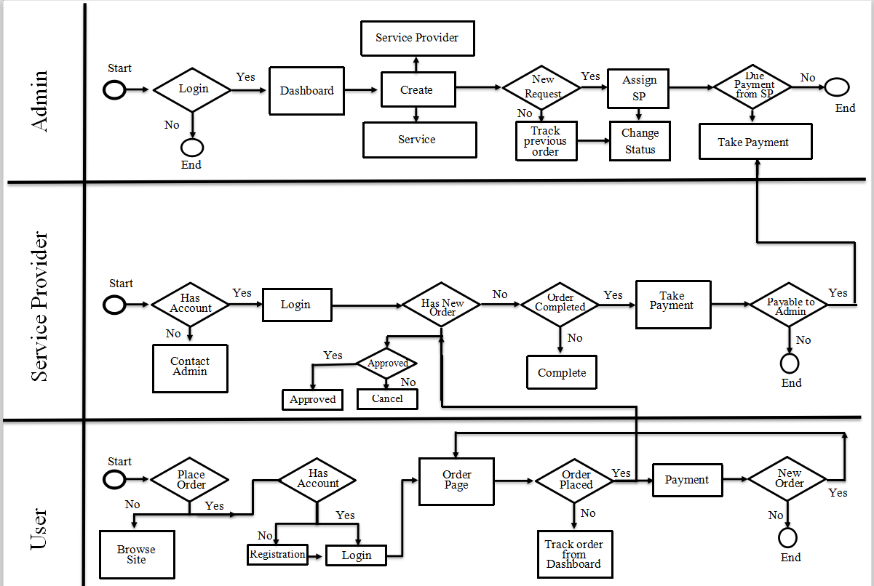

Figure 3.1: Business Model Diagram

3.3 Description of Use Case Model
Use case diagram mainly show a projects entire conditions and it helps to understand how it’s going on and what are the ultimate goals of the project. And we try to make this based on our website that how it works.

Our system has three different levels of users: Admin, Customer and Service provider. The below attachment represents the use case diagram of our system and how they interact with the system.
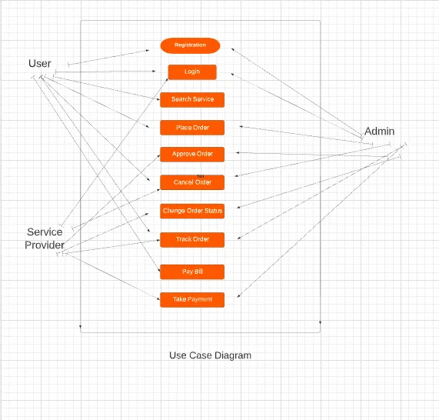

Figure 3.2: Use Case Diagram for User

Chapter 4
Design Identification
4.1 User Interface Design

Since our users are mostly the uneducated persons, in fact root level user, we were viewing to develop a system that will be more user friendly, easy to interact & attractive also. That’s why we have used a great attention while developing the front end of our system, were more focused & careful of not being so complex while designing the UI of our system. Our system is responsive, have all browser support & optimized. That’s why it doesn’t require high speed internet to be loaded. We have used HTML5, CSS3, Bootstrap5, JavaScript, JQuery, Ajax Technology to develop the front end of our system. Below attachments are some of the representations of our system’s front end.

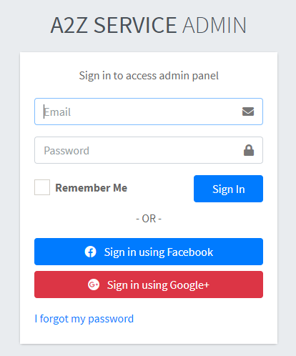

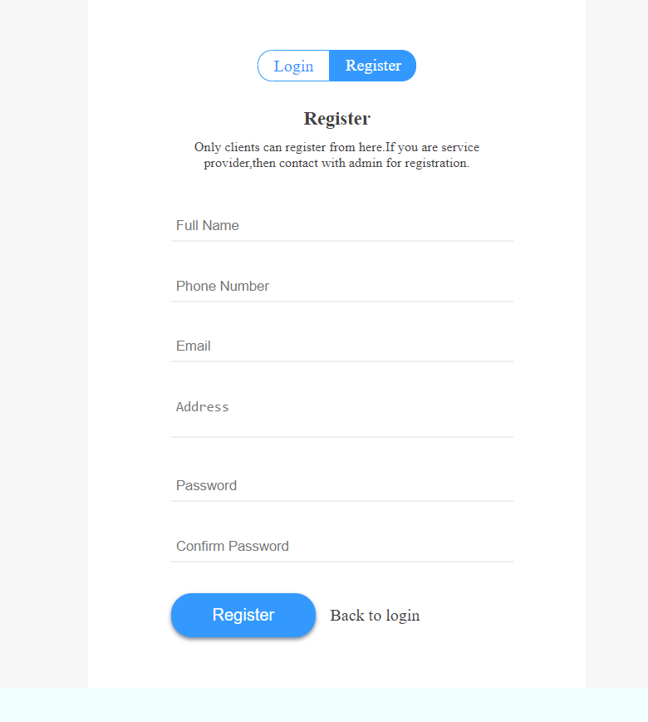

Figure 4.1.1: Register page as a user

Admin Login: Admin will login their own ID and their Admin Password
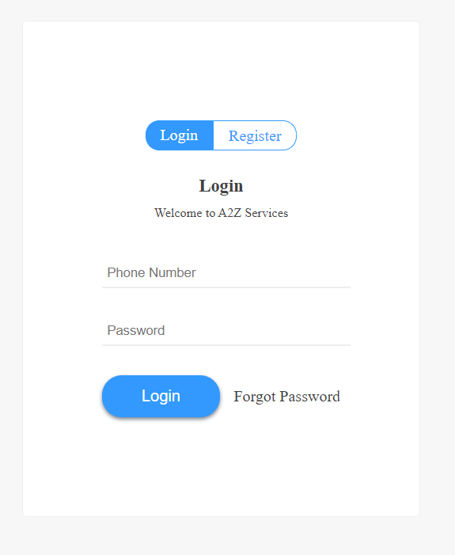

Figure 4.1.2: User Login Interface
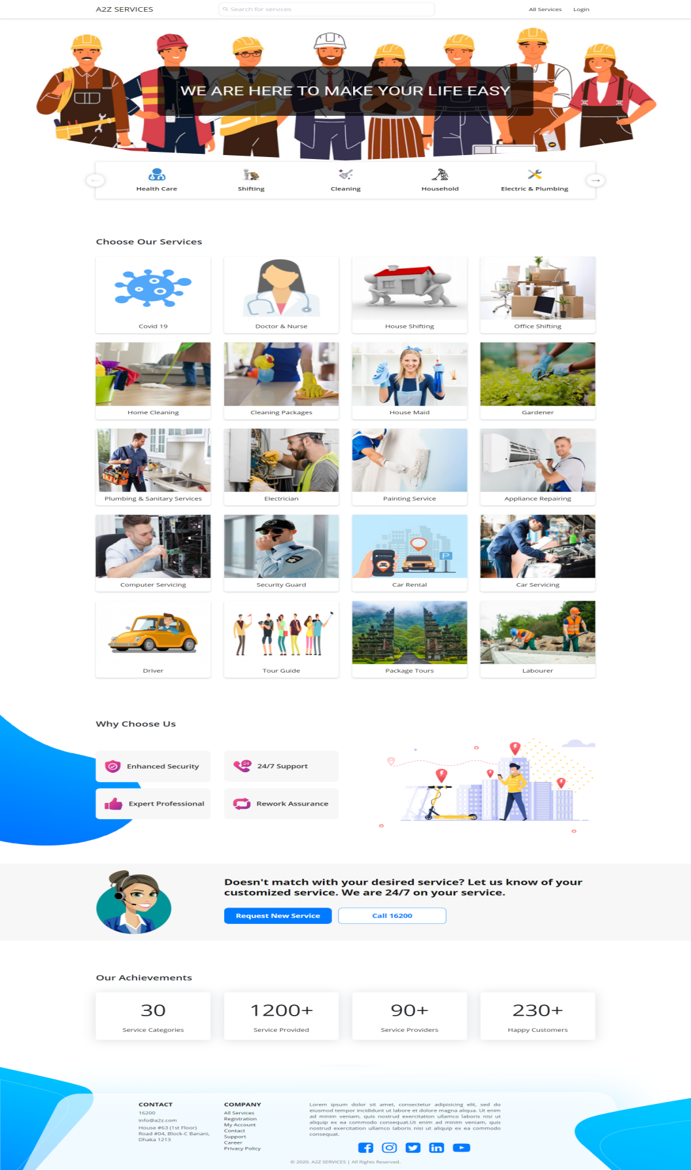

Figure 4.1.3: Front look of website
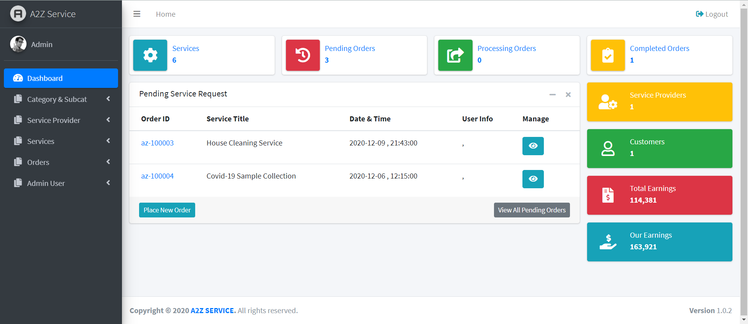

Figure 4.1.4: Admin Dashboard.

Admin panel: Admin will control entire website from this dashboard. Only Admin can access this dashboard and admin will control all activities from this dashboard.

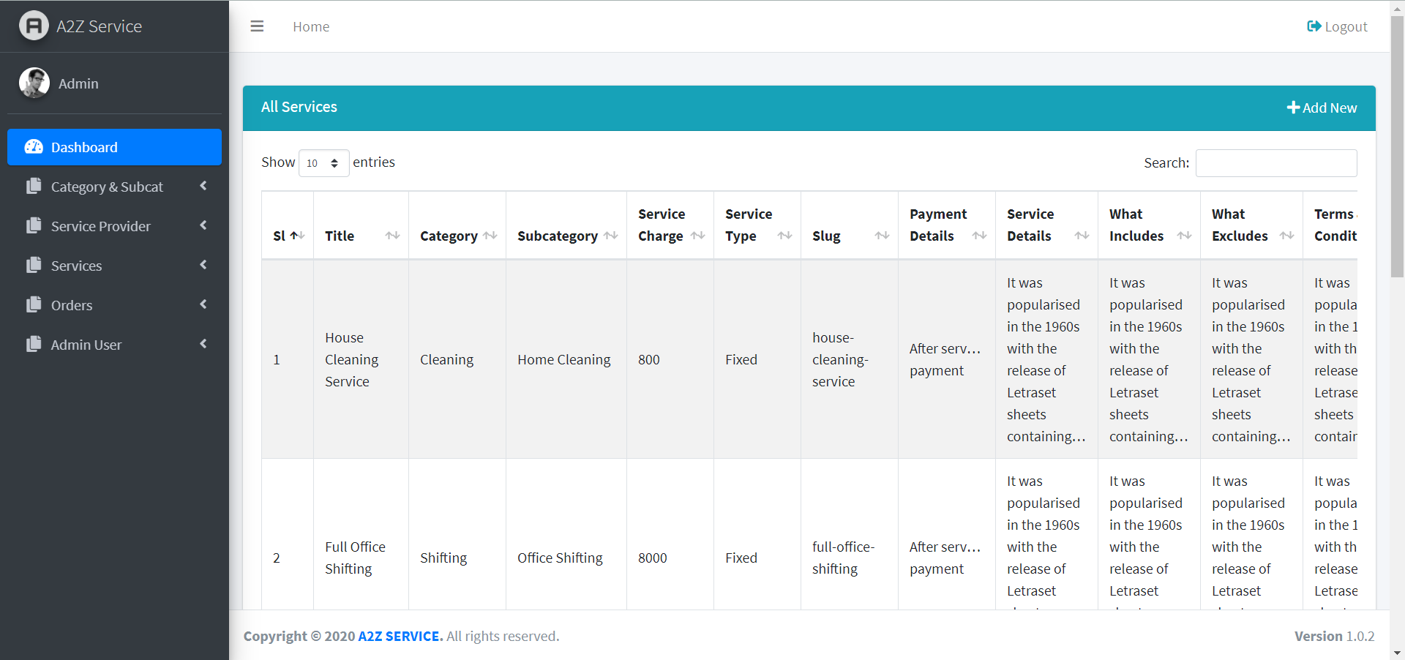

Figure 4.1.5: All Service page
Service: From here admin can see all the services of website and admin can add services here and delete from here.

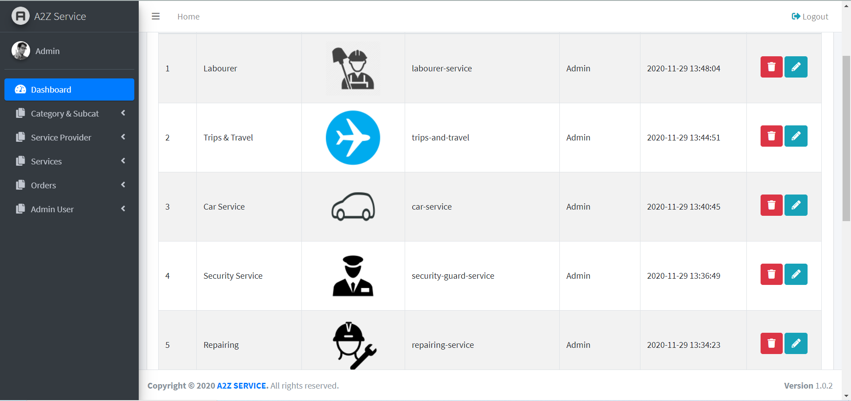

Figure 4.1.6: All Categories Page
Registration: Here is all the category of services of websites. And here is options to add category and delete category of website.

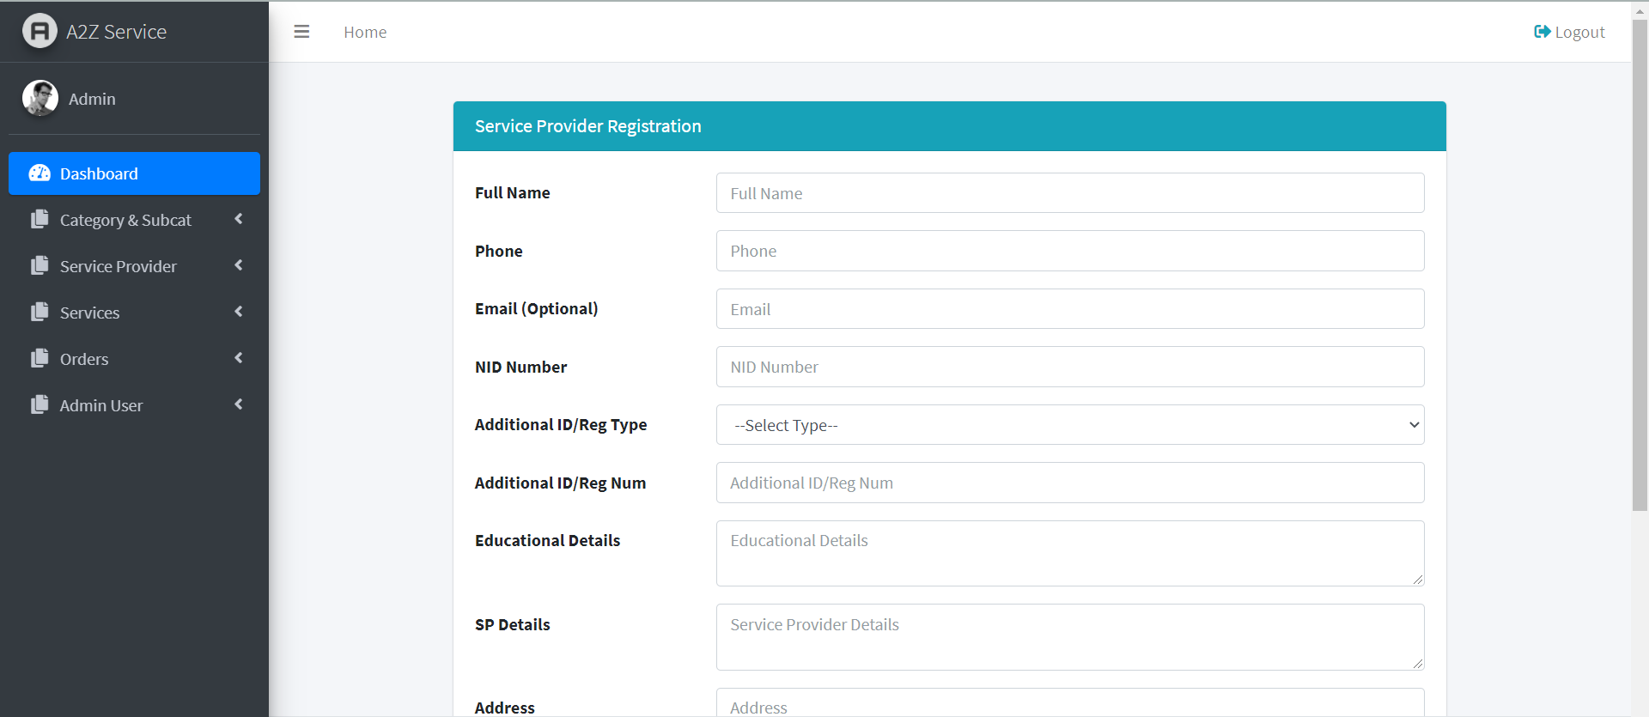

Figure 4.1.7: Service Provider Registration Page

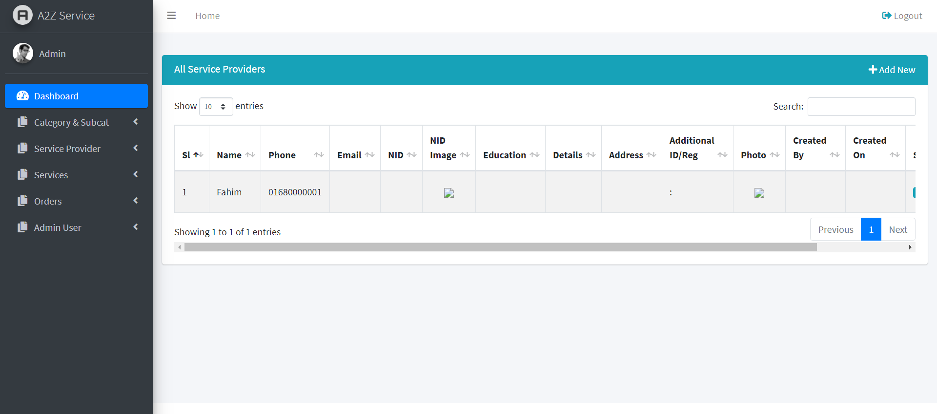
Figure 4.1.8: All Service Providers
When a service provider registered as a provider he or she will listed at our websites and we will assign them as their service and they will give service user of website.
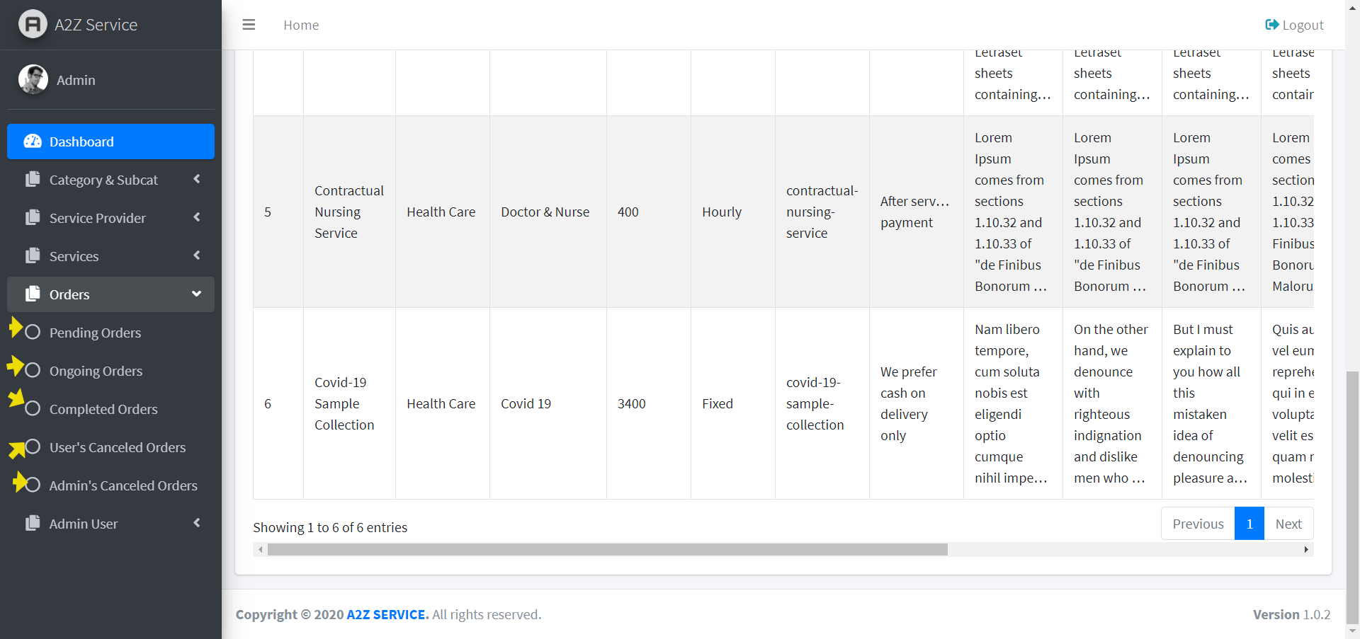
Figure 4.1.9: Pending Orders Page

When a client ordered a service from our website, admin will change the status as a complete, Pending, Ongoing or complete. And from dashboard admin main the all orders from this website.
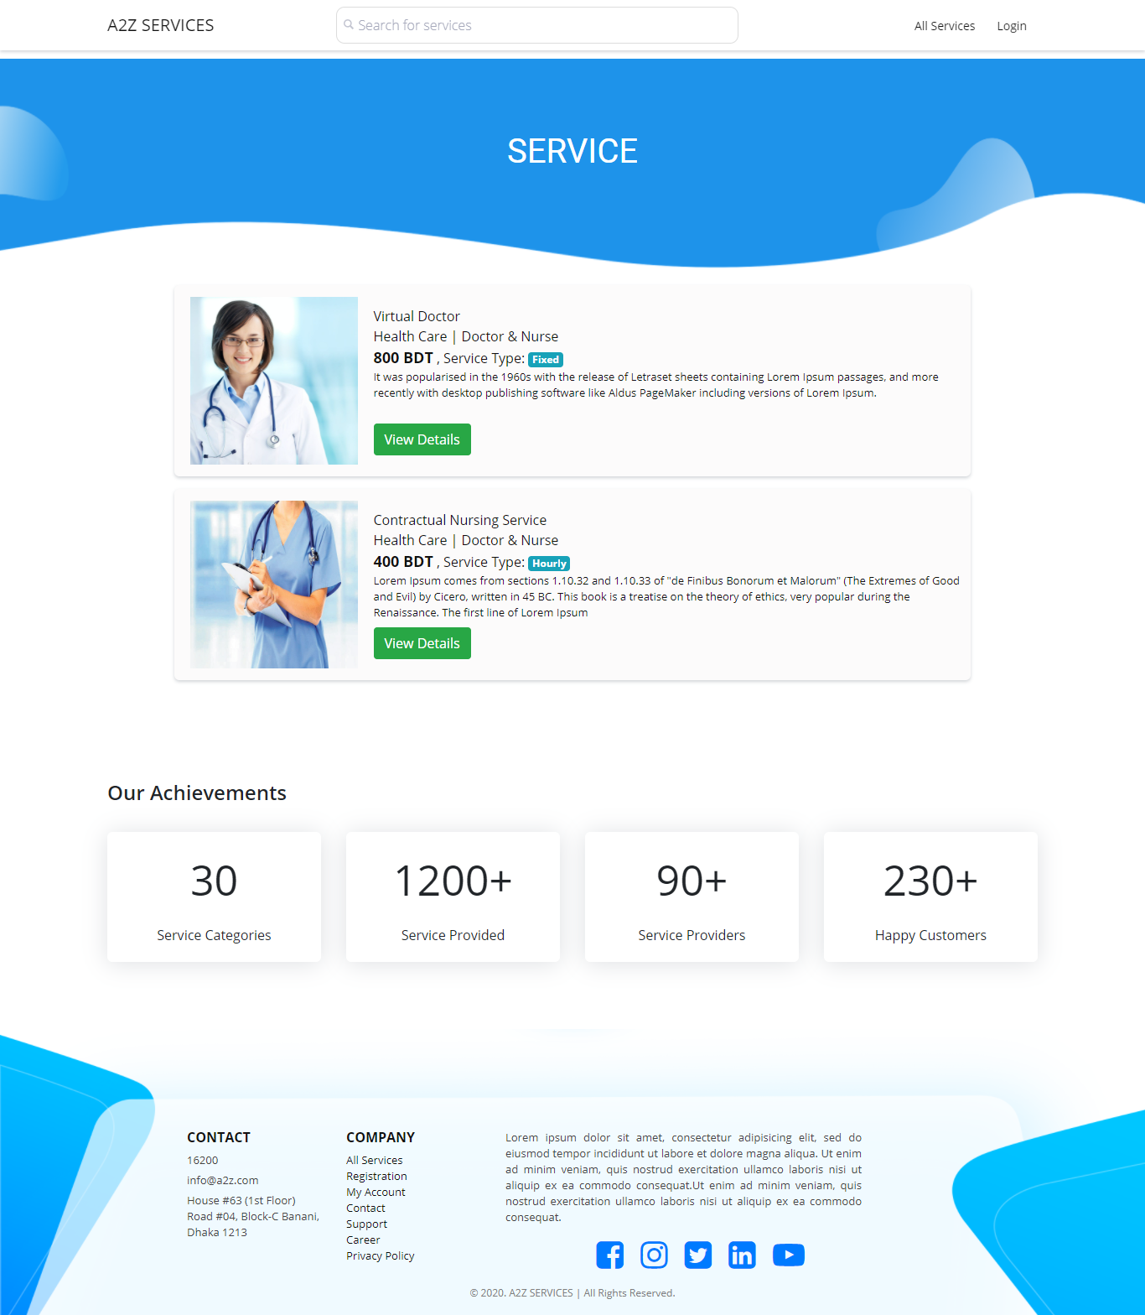

Figure 4.1.10: Service Page

User will get their service or choose their service from website and then from view details button they will get details or contact for that services.

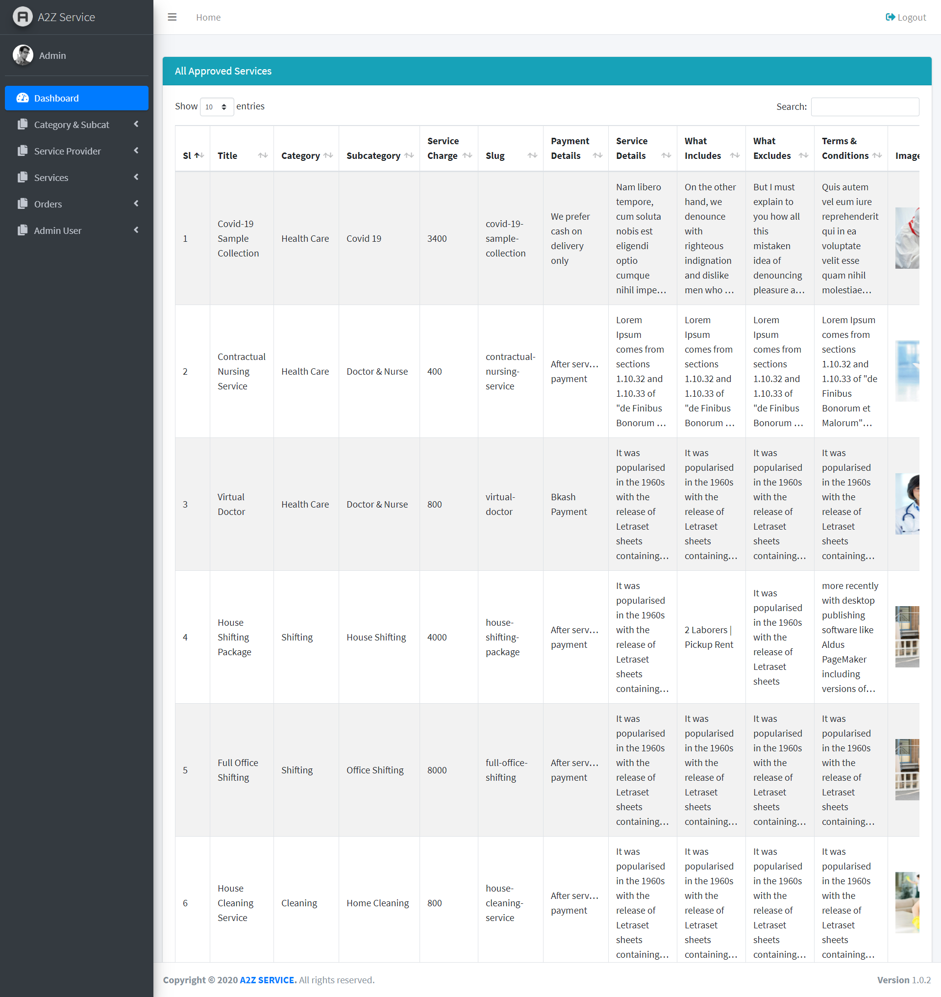

Figure 4.1.11: All approved services page

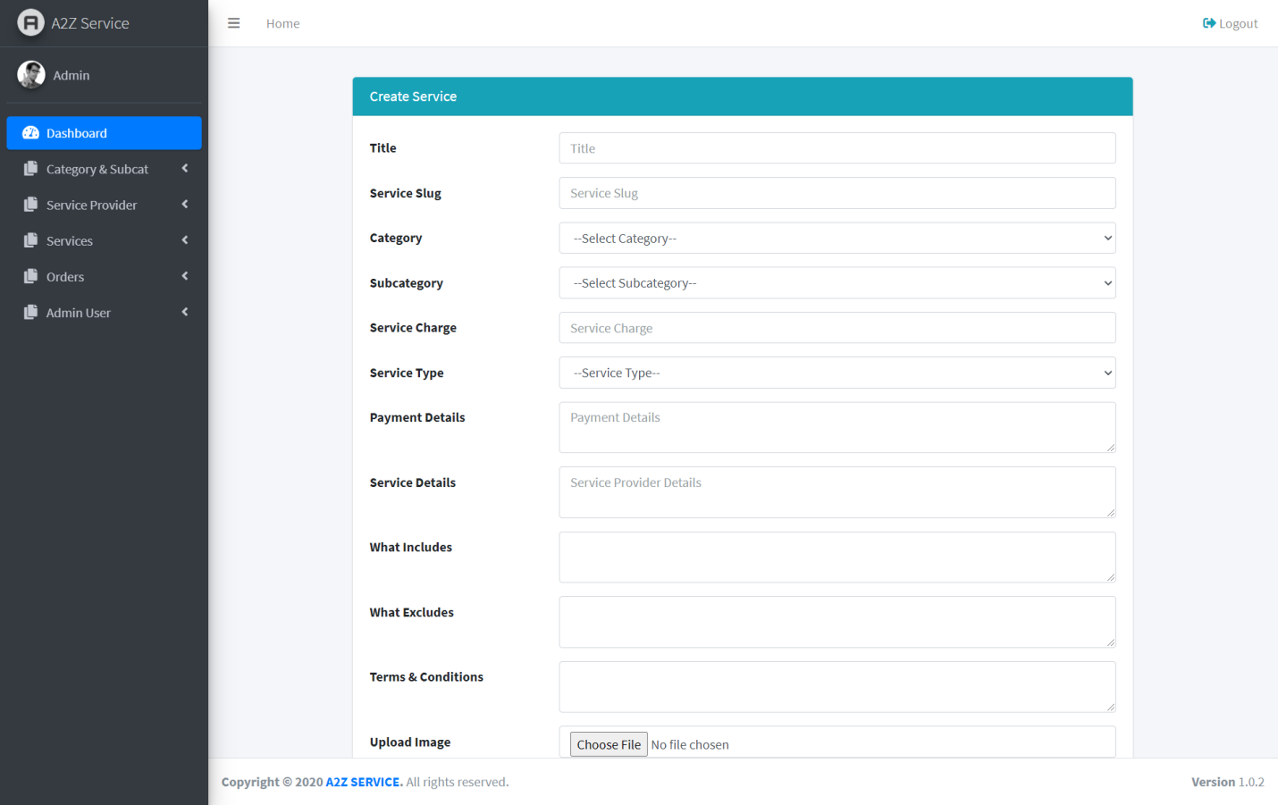

Figure 4.1.12: Create a service from dashboard

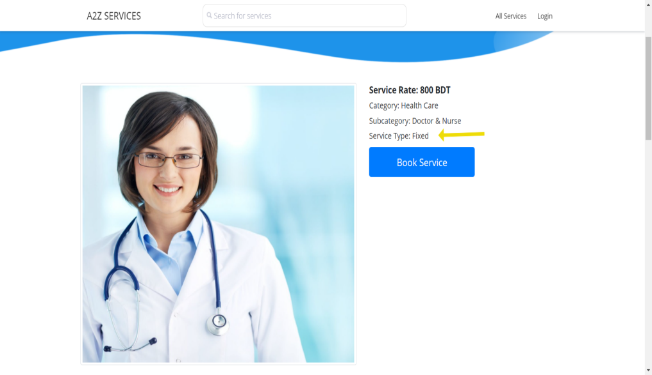

Figure 4.1.13: Service type fixed rate
User purchase their service by fixed rate and it’s a cash on delivery payment system.

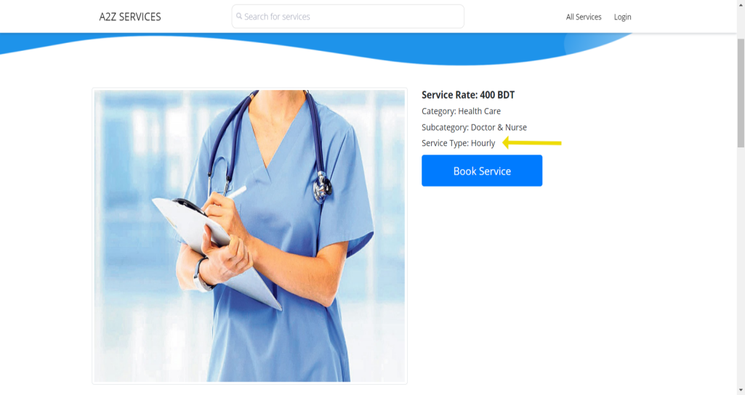

Figure 4.1.14: Hourly rate service type
User will book their service by hourly rate if they no need whole day service.
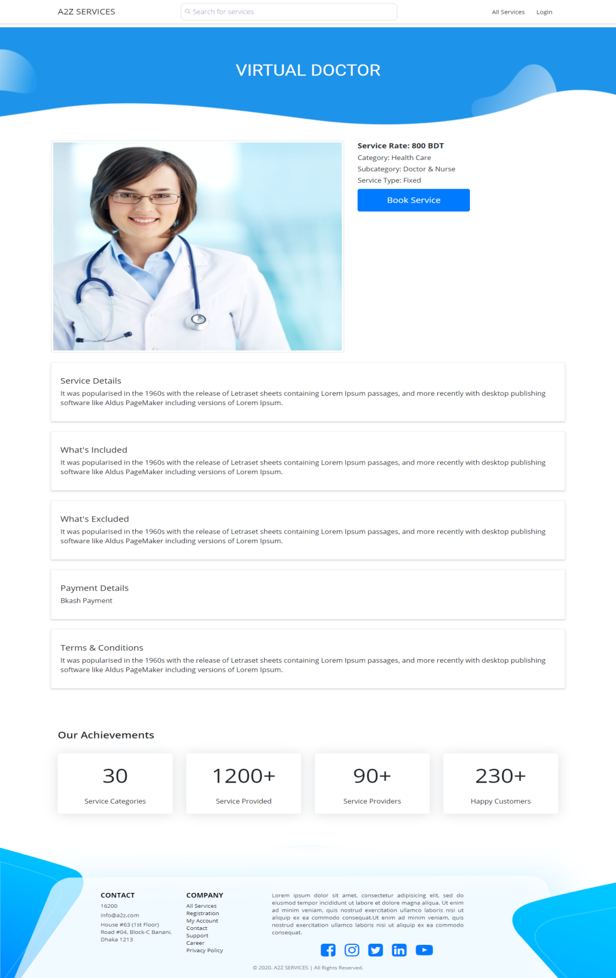

Figure 4.1.15: Service Details Page

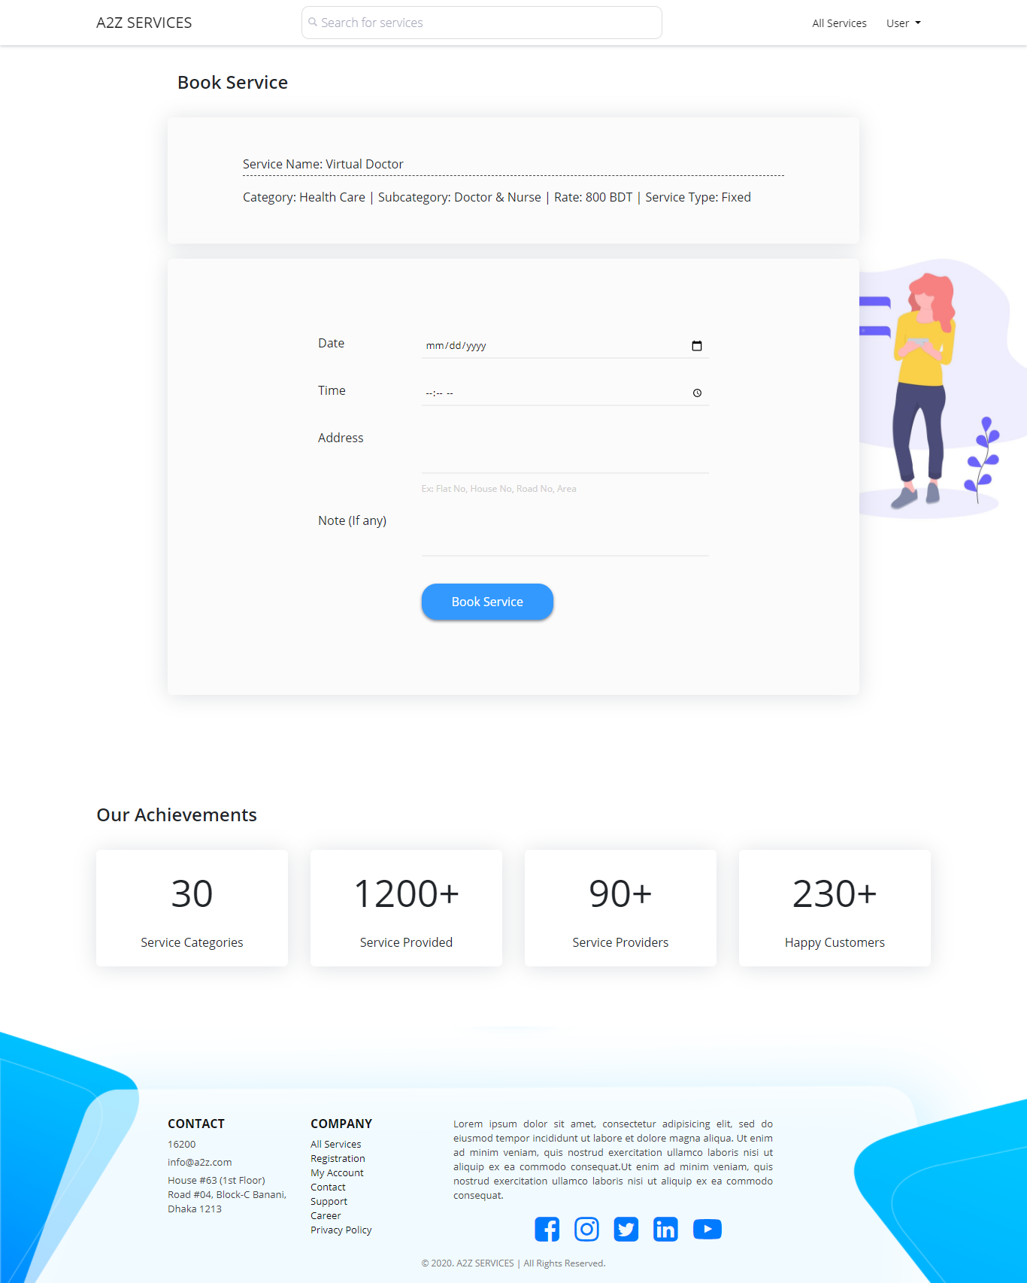
Figure 4.1.16: Book Service Page

4.2 Back-end Part Design of Website
We have tried to make our software architecture as simpler as our user interface. That’s why our database design is also much simple. We didn’t go for complex structure. The below attachment is the representation of our backend design.
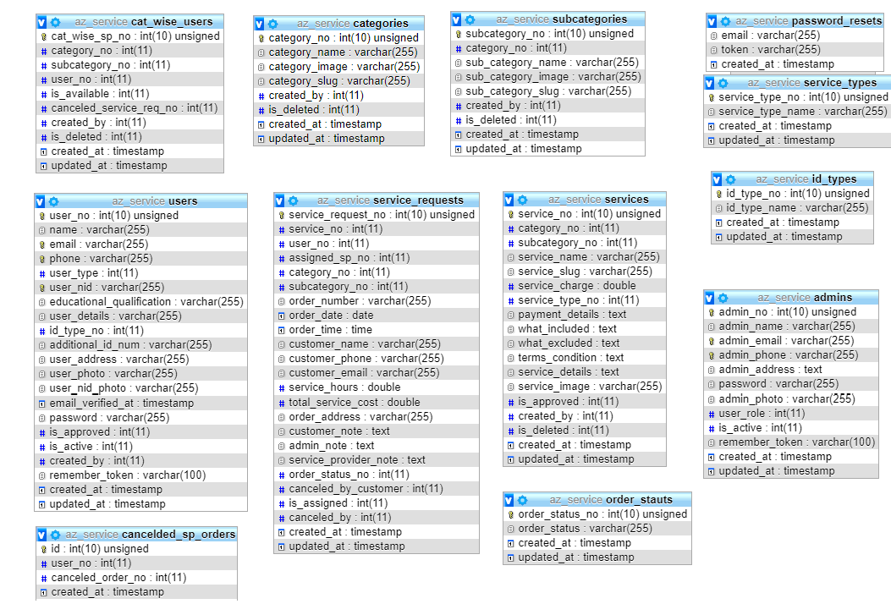
Figure 4.2: Database Design of A2Z Service

4.4 Implement of Requirements
Requirements analysis was the first process of the project. Very first we analysis our requirements, we discuss about the requirements and get ideas when we discuss with user and service provider. After analysis our requirements we build prototype and then we test prototype. After testing user prototype we move on design of our website. We analysis different kinds of website and get ideas and then we make a unique design of website.
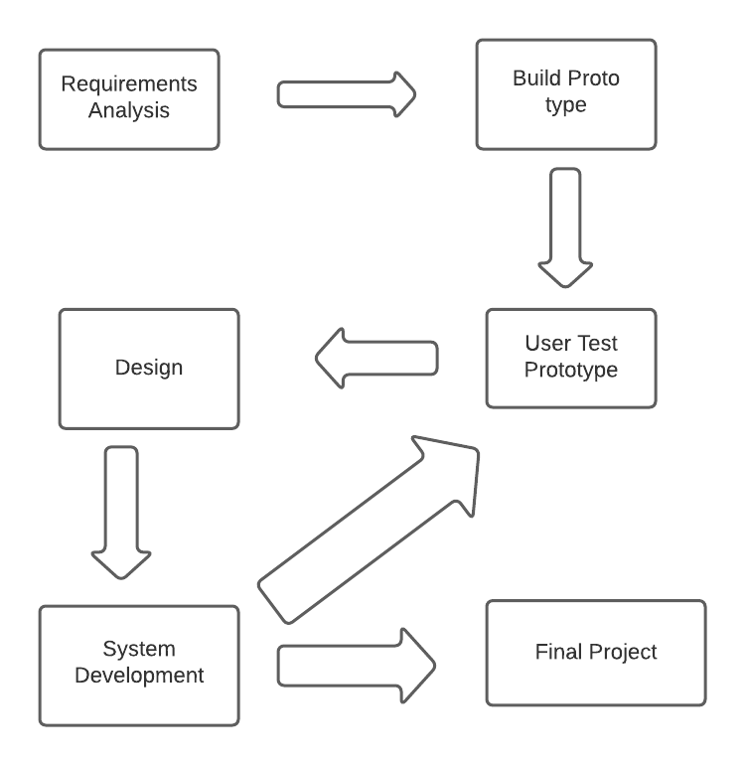
Figure 4.3: Requirements of Implementation
Finishing our front-end design part we start the development of our project that's the back-end part of the website. And we tried to make it simple not to do complex and design MySQL data base. After development we again test our prototype and after many times trying & testing that when realize projects has no bug then we make it as complete.
To implement this website, we kept service providers important documents like National ID card, Passport or Driving License for security purpose.

CHAPTER 5

Implement and Testing
5.1 Introduction
For implementation Our A2Z service website we analysis our requirements. Though our website is for root level workers and we provide service, so we discuss with our users and workers about the service and work of A2Z Service Website. From their perspective finally we distribute our project and start making this website.

5.2 Implementation of Database
For implement our database we use MySQL database and Relational Database Management System. We design our database very simple we do not make it more complex. Also we design this thinking about our ultimate goal. We try to do our database normalization.
Main fact is we analysis our requirements of our ultimate goal and gather knowledge about that and we design our database base on this.

5.3 Implementation of Designing part of Website
Implementation of front-end design, first we discuss design about our website and then we start implement our front-end design.

For complete front-end design we use HTML, CSS, Bootstrap, JavaScript and JQuery.

HTML: This is the main base of a website, that means it make structure of website.

CSS: CSS mainly works for design purpose like it gives design of website.

Bootstrap: Bootstrap mainly a frontend framework which is built with html and css.

JavaScript: JavaScript mainly make a static webpage to dynamic webpage.

JQuery: It’s a platform JavaScript library and its design to simplify Html.

5.4 Implementation of Interaction
For implementation of interaction our project we discuss our user and service provider and make it simplify and make it best website for users for their better experience.
- User friendly website.
- Simplify website user interface
- Secure their information

5.5 Test Reports with Results

Table 5.5.1: Login Test and Report
Test No | Date | Module | Cases | Data | Pass/Fail | Number of Bug | Comments
1 | 01/12/20 | Login | Admin Login | Username and Password of Admin | Pass | N/A | Admin Login access
2 | 01/12/20 | Login | User Login | User’s Phone No and Password | Pass | N/A | Users login access
3 | 01/12/20 | Login | Login as Service  Provider | Mobile No and Password | pass | N/A | login access for registered service provider

Table 5.5.2: Registration Test Result

Test No. | Date | Module | Cases | Data | Result | Number of Bug | Comments
1 | 01/12/20 | Verify Registration | User’s verify and Registration | Name of User, Phone No. ,email and password | Pass | N/A | Registration for the users
2 | 01/12/20 | verify Registration | Service provider verify and Registration | User’s name,mobile number,email,Identity card and password | pass | N/A | Registrations for the sevice provider

CHAPTER 6
Conclusion and Future Steps
6.1 Conclusion and Future Steps

We have tried to satisfy the explanation to finish the project and increase our initiative.
We are promising with this creation. where everyone seems to be thinking of making a system which will help them, We have thought of our hired unemployed workers who are at the forefront of our
economy. However they're avail for our country, they're being bereft of their exactl values
of their service. We have a tendency to ask for the fair value of their work and to stand by them to
connect with their digital approach.. We know that the task isn't very easy to form them capable of mistreatment this method however we are hopeful. Once our uneducated selected workers wasn’t capable of finding any job, however currently they're doing it by the digital method like us. It would be satisfactory if a single workers of us get benefited using this website.

6.2 Scope of this project for Future Development
Our project may be increased with a lot of options and contents to assist the users. We’ve some planed regarding some options to be enforced in future to form the system simpler and user friendly. Some of these options area unit mentioned below:
- Voice instruction in all the pages to make the system additional usable for the users.
- Users will be able to use Google Maps to find out how far their assigned service providers are from them.
- Payment gateway integration.
- Face detection to ensure the authenticity of the service providers.

REFERENCES
[1] Software Requirements Introduction, << https://www.microtool.de/en/knowledge-base/what-is-a-software-requirements-specification/ >>
[2] Design specification, << https://en.wikipedia.org/wiki/Design_specification>>
[3] Business model diagram, https://www.lucidchart.com/documents/view/ef086821-85f9-4a9e-ac49-1b2cd45126bc/0 >>

Plagiarism Report

