CONVERTING HEAT TO ELECTRICITY USING THERMOELECTRIC MODULE

BY

SHANTONU PRODHAN
ID: 171-15-1481

MD. MAHADI HASAN
ID: 171-15-1490

MD. JAHIDUL ISLAM
ID: 171-15-1293

S M SHAHRIAR
ID: 171-15-1287

This Report Presented in Partial Fulfillment of the Requirements for the Degree of Bachelor of Science in Computer Science and Engineering

Supervised By
Ohidujjaman
Sr. Lecturer
Department of CSE
Daffodil International University

Co-Supervised By
Md. Mahfujur Rahman
Lecturer
Department of CSE
Daffodil International University



DAFFODIL INTERNATIONAL UNIVERSITY
DHAKA, BANGLADESH
JANUARY 2021
APPROVAL

This Project titled “Converting Heat To Electricity Using Thermoelectric Module”, submitted by Shantonu Prodhan, Md. Mahadi Hasan, Md. Jahidul Islam, and S M Shahriar to the Department of Computer Science and Engineering, Daffodil International University, has been accepted as satisfactory for the partial fulfillment of the requirements for the degree of B.Sc. in Computer Science and Engineering and approved with its style and contents. The presentation has been held on January 14, 2021.

BOARD OF EXAMINERS

________________________
Dr. Syed Akhter Hossain Chairman
Professor and Head
Department of Computer Science and Engineering
Faculty of Science and Information Technology
Daffodil International University

_______________________
Dr. S M Aminul Haque Internal Examiner
Associate Professor and Associate Head
Department of Computer Science and Engineering
Faculty of Science & Information Technology
Daffodil International University

_______________________
Ohidujjaman Internal Examiner
Sr. Lecturer
Department of Computer Science and Engineering
Faculty of Science & Information Technology
Daffodil International University

DECLARATION
We hereby declare that this project has been done by us under the supervision of Ohidujjaman, Sr. Lecturer, Department of CSE, Daffodil International University, and co-supervision of Md. Mahfujur Rahman, Lecturer, Department of CSE, Daffodil International University. We also declare that neither this project nor any part of this project has been submitted elsewhere for the award of any degree or diploma.

Supervised by:

_______________________
Ohidujjaman
Sr. Lecturer
Department of CSE
Daffodil International University

Co-Supervised by:

_______________________
Md. Mahfujur Rahman
Lecturer
Department of CSE
Daffodil International University

Submitted by:

Shantonu Prodhan
ID: 171-15-1481
Department of CSE
Daffodil International University

Md. Mahadi Hasan
ID: 171-15-1490
Department of CSE
Daffodil International University

Md. Jahidul Islam
ID: 171-15-1293
Department of CSE
Daffodil International University

S M Shahriar
ID: 171-15-1287
Department of CSE
Daffodil International University
ACKNOWLEDGEMENT

First of all, we express our heartiest thanks and gratefulness to Almighty God for His divine blessings which makes us successfully complete this project.

We feel grateful to and wish our profound indebtedness to our supervisor Ohidujjaman, Sr. Lecturer, Department of Computer Science & Engineering Daffodil International University, Dhaka. His endless patience ,scholarly guidance ,continual encouragement , constant and energetic supervision, constructive criticism , valuable advice ,reading many inferior draft and correcting them at all stage have made it possible to complete this project.

We would like to express our earnest gratitude to Prof. Dr. Syed Akhter Hossain, Professor and Head, Department of Computer Science & Engineering, for his endless support and also to other faculty members and the staff of the CSE department of Daffodil International University.

We would like to thank our entire course mates at Daffodil International University, who participated in this discussion and helped to complete the course work.

Finally, we must acknowledge our parents' constant support and patience with due respect.

ABSTRACT

This paper involves the development of a prototype that uses heat to generate electricity using thermoelectric modules. The electricity is generated using the Seebeck effect. When there is a temperature difference on each side of the thermoelectric module it produces a voltage which is called the Seebeck effect. The power generated from a single module is very small but sufficient power can be generated by coupling this module in series. The Thermoelectric Cooler (TEC) module will be used to generate electricity because it is much cheaper and reliable. The TEC works as a Thermoelectric Generator (TEG) that generates electrical energy when one side of the device is heated and the other side is cooled. From a burning candle or other heat sources, a TEC can easily produce 1.25 ~ 1.75 volts with the help of a heatsink on the cooling side. Although the voltage may vary from module to module.

TABLE OF CONTENTS

CONTENTS PAGE
Board of examiners i
Declaration ii
Acknowledgement iii
Abstract iv

CHAPTER

CHAPTER 1: INTRODUCTION 1-2
1.1 Introduction 1
1.2 Motivation 1-2
1.3 Objective 2
1.4 Expected Outcome 2

CHAPTER 2: BACKGROUND 3-4
2.1 Introduction 3
2.2 Related Work 3
2.3 Comparative Study 3
2.4 Scope of The Problem 3
2.5 Challenges 4

CHAPTER 3: REQUIREMENT SPECIFICATION 5-8
3.1 Use Case Model 5
3.2 Flowchart Model 6
3.3 Requirements Collection and Analysis 6
3.4 Required Data Collector 7
3.5 Required Technology 7-8
3.6 Required Hardware 8
3.7 Design Requirements 8
CHAPTER 4: DESIGN SPECIFICATION 9-10
4.1 Front End Design 9-10
4.2 Back End Design 10
4.3 Interaction Design 10

CHAPTER 5: IMPLEMENTATION AND TESTING 11-16
5.1 Implementation of Front End Design 11-13
5.2 Implementation of Back End Design 14
5.3 Implementation of Project 14-16

CHAPTER 6: CONCLUSION AND FUTURE SCOPE 17-17
6.1 Discussion and Conclusion 17
6.2 Limitations of Our Project 17
6.3 Scope for Future Developments 17

APPENDIX 18

REFERENCE 19

LIST OF FIGURES
FIGURES | PAGE NO
Figure 3.1.1: Use Case Model | 5
Figure 3.2.1: Flowchart Model | 6
Figure 3.5.1: Thermoelectric generator module | 7
Figure 5.1.1: Home Page | 11
Figure 5.1.2: Data Submission Page | 12
Figure 5.1.3: Dataset Page | 12
Figure 5.1.4: Data Details Page | 13
Figure 5.1.5: Data Update Page | 13
Figure 5.2.1: Back End Design | 14
Figure 5.3.1: Thermoelectric Power Generation | 15
Figure 5.3.2: Control Box circuit diagram | 16

CHAPTER 1
Introduction

1.1 Introduction
There is a lot of temperature wastage around us that we cannot use properly and effectively. At the same time, this waste temperature affects global warming. That's why the thermoelectric module comes to the rescue so that at least some of the temperature dissipation can be reduced. The thermoelectric generator modules are solid-state devices that can convert external heat directly to electricity. The fact of the matter is that the low thermal conductivity ensures that when one side is heated, the other side is cooled, which helps to create a larger voltage during the temperature gradient. Since it has no moving parts, it is silent, long-lasting and its maintenance cost is very low. The thermoelectric modules usually consist of several structural thermocouples based on the Seebeck effect; the thermocouples are serially connected to increase the thermoelectric output. The output voltage of the thermocouple module can be increased in proportion to the number of thermocouple components.
Very little cost is used to create this project so that it is acceptable and affordable for everyone. Especially those who live in rural areas and do not have access to electricity. It can turn on the LED light integrated into the system with a single candle or any heat source. While with the minimal setup it may not illuminate the area too much, it can do just fine. A motor can be connected to the system to provide cool air but it consumes more power. Also, an integrated battery provides a few hours of extra support even when the heat source is removed. The battery can be charged if the system is not in use or it can be charged with an external power source. This project is portable and can be easily carried around. Additionally, we have created a website to store our project information such as output and other information.

1.2 Motivation
We have tried to investigate some of the causes of global warming and heat dissipation is one of them. Our initiative in this project is to make proper use of heat wasted from various fuels or heat sources. We have seen in remote areas where there is no electricity supply, people in remote areas spend the night in the light of the hurricane lantern. However, using hurricane lanterns does not provide enough light and consumes a lot of fuel. Also, we cannot use solar energy properly which requires a lot of knowledge to manage and is also quite expensive. Ultimately our only goal is to use the generated heat properly to convert it into electricity so that we can save our environment and the world from global warming and further disasters.

1.3 Objective
Our primary objectives behind creating this project:
- Reducing global warming
- Generating electricity at low cost or for free
- Preventing heat dissipation
- Making the project accessible and affordable so that it is within the reach of everyone
- Making the project environment friendly
- Creating a website that helps monitor project status and contains information
- Finally, meeting the demand for electricity even if it is a small amount

1.4 Expected Outcome
We expect that using our methodology is capable of generating electricity even on a small scale. Also, it is possible to generate more electricity with less fuel consumption. We have tried to make the project cheaper so that it is affordable for everyone. As this project is portable, it will be possible to take it anywhere. The output that will be generated from this project will be very effective for illuminating an LED, running a DC motor, easy movement, and other purposes. Finally, we want to make it a simple solution to the need for electricity.

CHAPTER 2
Background

2.1 Introduction
The technology we used in this project to generate electricity is a thermoelectric module. The module is performed when there is a difference in temperature on both sides. The temperature difference means that one side of the module will be hot and the other side will be cold. If the hot and cold sides are reversed, the polarity will also be reversed. For example, if we put a candle on the hot side, the cold side will be hotter. So to generate electricity properly, we need to keep the cold side cold and the hot side hot. The heatsink can do the job of keeping the cold side cool.

2.2 Related Work
While making our project, we have seen that others have made this type of project quite expensive and complicated. And the modules used are rarely available. We have also noticed that excess heat has been applied to power generation and a lot of heat has been lost. But in our project, we tried to generate more electricity at very low heat which no one else could do. Also, no website has been created before where project data can be stored. At the same time, we have made this project more accessible and cheaper.

2.3 Comparative Study
Our project can perform better and it will give better results than expected than other projects. Also, our project gives an accurate output. It has more durability and it works flawlessly without any breaks. We have consistently highlighted each part of our project and tried to give an accurate idea about the use of each part.

2.4 Scope of The Problem
Creating such a generator is challenging but we have tried our best to make it a success. We test it regularly to make sure it works efficiently without any problems. But we could have improved this project if we had better quality equipment. Nevertheless, we continue our efforts to improve this project.

2.5 Challenges
Here are our challenges for this project:
- Make the project more efficient and environmentally friendly
- Minimize maintenance costs
- Run the project without any hassle for a long time
- Collection of accurate output data for further research
- Quick repair facility in case of any problem
- Make a website that is user friendly so that the user understands and submit correct pieces of information
- Make sure people understand how this system works so they can manage it properly without compromising or damaging it

CHAPTER 3
Requirement Specification

3.1 Use Case Model
The following use case model describes the different roles of the users of our website and how they act according to their roles. Here two actors named Admin and User are interacting with the system. Users do not need to be a member of the website because they have full access to the website. The admin has full access to the website and also can change the information on the website

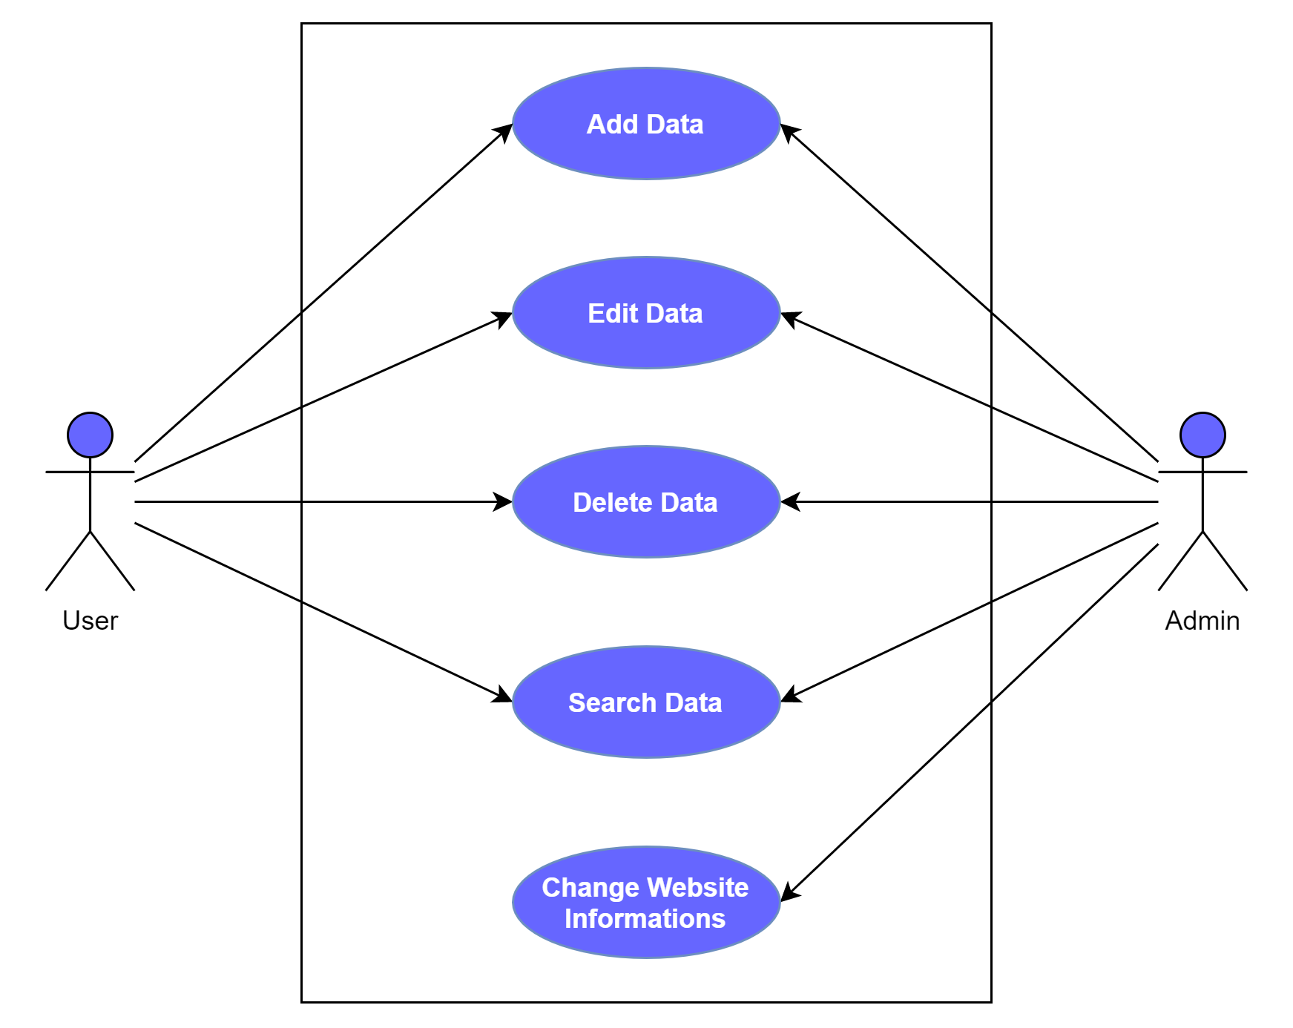

Fig. 3.1.1: Use Case Model

3.2 Flowchart Model
The following flowchart model shows an overview of how the foreground of the website works and how it interacts with the user. This model also helps to visualize what is going on and helps to understand the whole process through it.

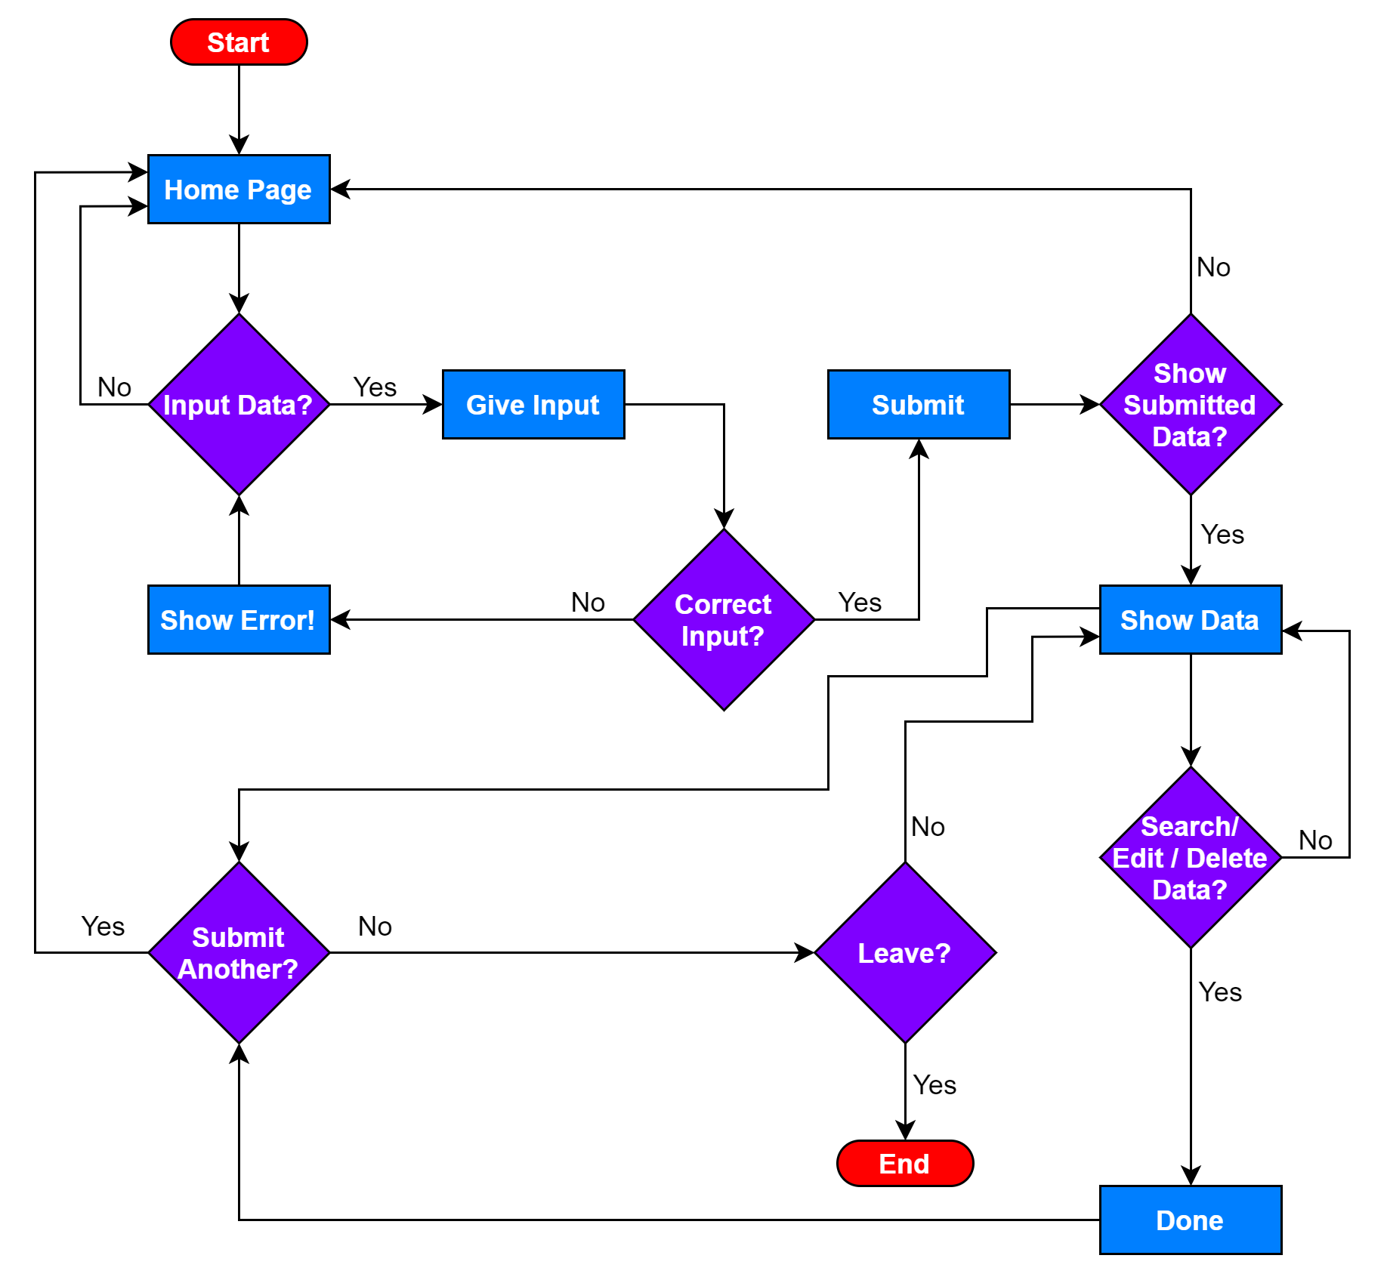

Fig. 3.2.1: Flowchart Model

3.3 Requirements Collection and Analysis
We have collected and combined all the requirements to create a graphical view of our project and website. While gathering the requirements, we did a lot of research and found the best way to get good results and there are opportunities for future analysis. Without the requirements, we cannot draw any graphical content and it will be very difficult to implement. This graphical view helps to understand the details of the project and to implement every single task.

3.4 Required Data Collector
We created a website to securely store the output data of the project. The website is divided into sections where output can be submitted, edited, deleted, and searched as needed. The data on this website will play an important role in our future research.

3.5 Required Technology
The thermoelectric module is the main technology of our project. It is a simple configuration that is electrically connected in series with several thermocouples (semiconductors) and thermally connected in parallel [Fig. 3.5.1]. It consists of a combination of p-n thermoelement components. Positive (P-type) and negative (N-type) doped semiconductor components are electrically connected in series and thermally connected in parallel. Initially, the conductors in the module maintain uniform distribution of charge carriers. The thermoelectric modules are reliable units that have no moving parts and have a wide range of sizes but they have low power conversion efficiency. Although, the thermoelectric generators are the best choice where the reliability of the power supply is very important.

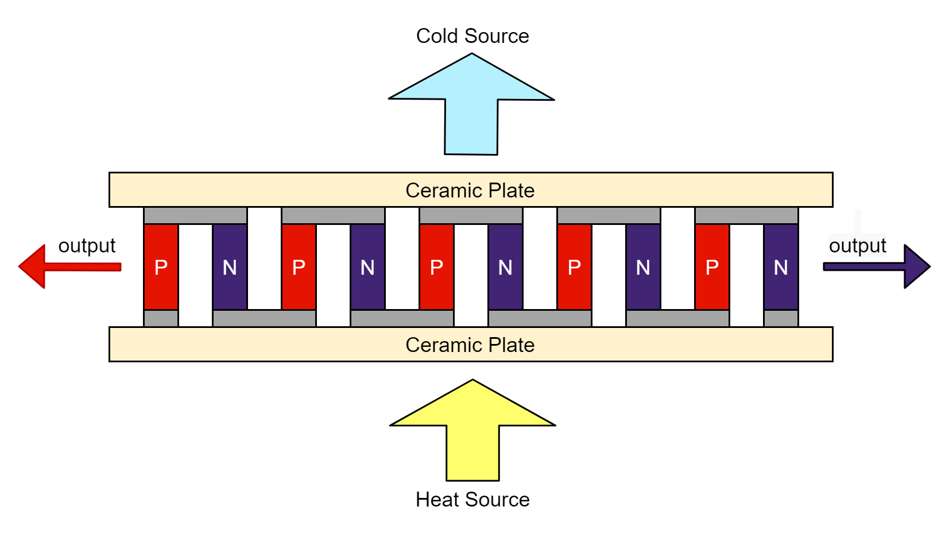
Fig. 3.5.1: Thermoelectric generator module

As mentioned earlier, a thermoelectric module can be used as TEC or TEG. In general, some internal materials and components of thermoelectric modules may differ between TECs and TEGs. Several studies have shown that a thermoelectric cooler is more efficient than the thermoelectric generators in generating electricity at temperatures below 500 K.
In this case, the lower side is connected to the heat source and the upper side to a heat sink. Thermoelectric power generators are often the equivalent of physically cooling modules with the exception that long-lasting and dense components are used.

3.6 Required Hardware
We needed some extra hardware to run this project well along with some other customizations. While we were digging further we noticed that some heat was escaping and the project could not run properly. So we made a case with wood to hold all the modules and other components together for the generator. Although wood is cheap, it is safe to touch when heated and it does not cause any problems and works well. Among the more hardware, we needed was a DC-DC step-up booster, some toggle switches, a battery with a case, a battery charge indicator, some potentiometers, and some input-outputs.

3.7 Design Requirements
The design requirements are:
- The user can get up to a maximum of 3.8 volts.
- The user can control the output volts with the help of a potentiometer.
- Users can use the battery and the generator at the same time to get maximum output.
- Users will be able to charge the battery with the generator and external power sources.
- The user can use any device according to the maximum output capacity of the system.
- On the website, the data can be inserted, deleted, edited, or searched by the user.
- Administrators can update the data related to this project.

CHAPTER 4
Design Specification

4.1 Front End Design
The front end design of our project website is quite straight forward. Typically, users can add, delete, edit, or search data without any special permission. The UI of our website is quite simple and there are no complications. The more data that is given, the more knowledge we can gain and this is very helpful for our future research work. Our website requires HTML, CSS, Bootstrap, AJAX, and JavaScript for the front end design.

HTML
HTML stands for Hypertext Markup Language. It is a code that is used to construct a web page and its content. Also, HTML is used to create electronic documents displayed on the World Wide Web and it consists of combinations of different elements.

CSS
CSS means Cascading Style Sheet. CSS describes how HTML elements will be displayed on the screen and it is used to describe the look and format of any document written in a markup language. CSS helps our website to color elements, apply margins or padding, keep borders, resize text, and much more.

Bootstrap
Bootstrap is a great package of HTML, CSS, and JavaScript frameworks used to develop responsive and fast websites. We used Bootstrap for our website to search and select data entry without refreshing the website.

AJAX
Ajax allows websites to transmit and retrieve data seamlessly from a server without interfering with the display. This allows us to search our web pages' databases behind the screen, especially without reloading the entire page.

JavaScript
JavaScript is used to create and control dynamic website content. JavaScript makes our webpages alive, helps to animate texts, automatically change colors, refresh, scroll, and more.

4.2 Back End Design
The back end design describes how a server works in the background that is not visible to our eyes. The back end design of our website requires PHP and MySQL.

PHP
PHP stands for Hypertext Preprocessor, a server-side scripting language that is embedded in HTML and used to create dynamic web pages. We have used PHP on our website for flexibility and smooth data transfer.

MySQL
MySQL stands for Relational Database Management System (RDBMS) and it is a free open source database management system that allows us to manage relational databases. With the help of MySQL our website stores data in the MySQL database and retrieves the information whenever we need it.

4.3 Interaction Design
The interaction designs of our project website are:
- Users can add new data
- Users can view and modify data
- Users can delete existing data
- Users can leave a comment based on data
- Users can search for specific data

CHAPTER 5
Implementation and Testing

5.1 Implementation of Front End Design
The implementation of the front end design of our website is shown below:

Home Page
This is the first page where the journey begins. The user inputs data to this page and submits it. The submitted data goes directly to the database. Also, this page allows the user to display datasets by clicking on “Show Data” without any submission of data.

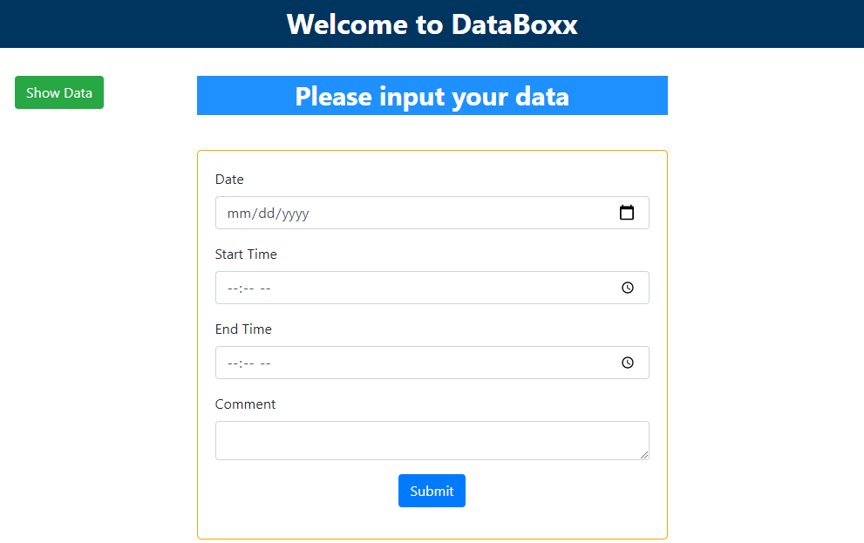

Fig. 5.1.1: Home Page

Data Submission Page
After the user successfully submits the data it is the next page that shows the confirmation. If the user does not enter valid information, it shows a warning sign and the user will be able to input the data again.


Fig. 5.1.2: Data Submission Page

Dataset Page
This page shows all the data that are submitted by the user. Users can view and edit the details of the data.

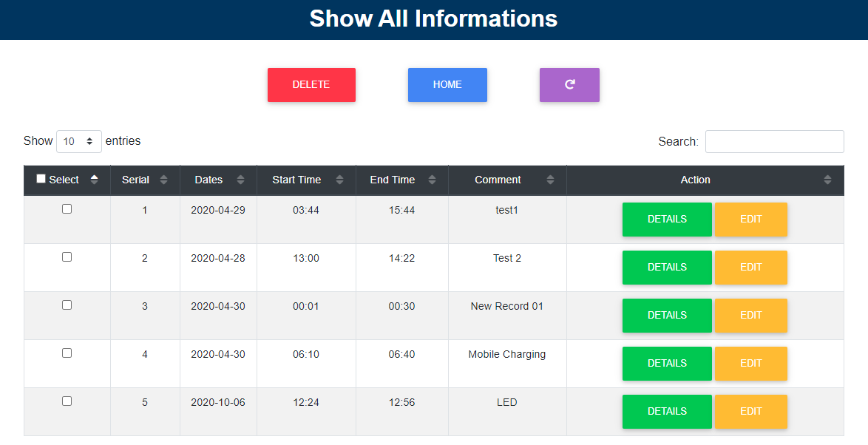

Fig. 5.1.3: Dataset Page

Data Details Page
This page shows the details of the selected data


Fig. 5.1.4: Data Details Page

Data Update Page
This page allows the user to edit the information of the data


Fig. 5.1.5: Data Update Page
5.2 Implementation of Back End Design
This is the main dataset that was originally used for our website. This is done by using phpMyAdmin, free and open-source software that lets us manage MySQL administration on the web. The back end design of our project website is shown below:







Fig. 5.2.1: Back End Design

5.3 Implementation of Project
Our system is capable of delivering 3.8 volts in two minutes and this voltage can be used to illuminate an LED or drive a small DC motor. Being portable it can be used anywhere.
This system uses two Thermoelectric Cooler (TEC1-12706) modules and is connected to the series so that the output voltage can be multiplied. To make the generator compact, one thermoelectric module is placed on top of the other. So that the module below can deliver the heat to the top module. The candle is used as a heat source and heat sinks have been used for heat exhaustion which will give input for the modules [Fig. 5.3.1]. The figure [Fig. 5.3.1] is referred to as the generator.
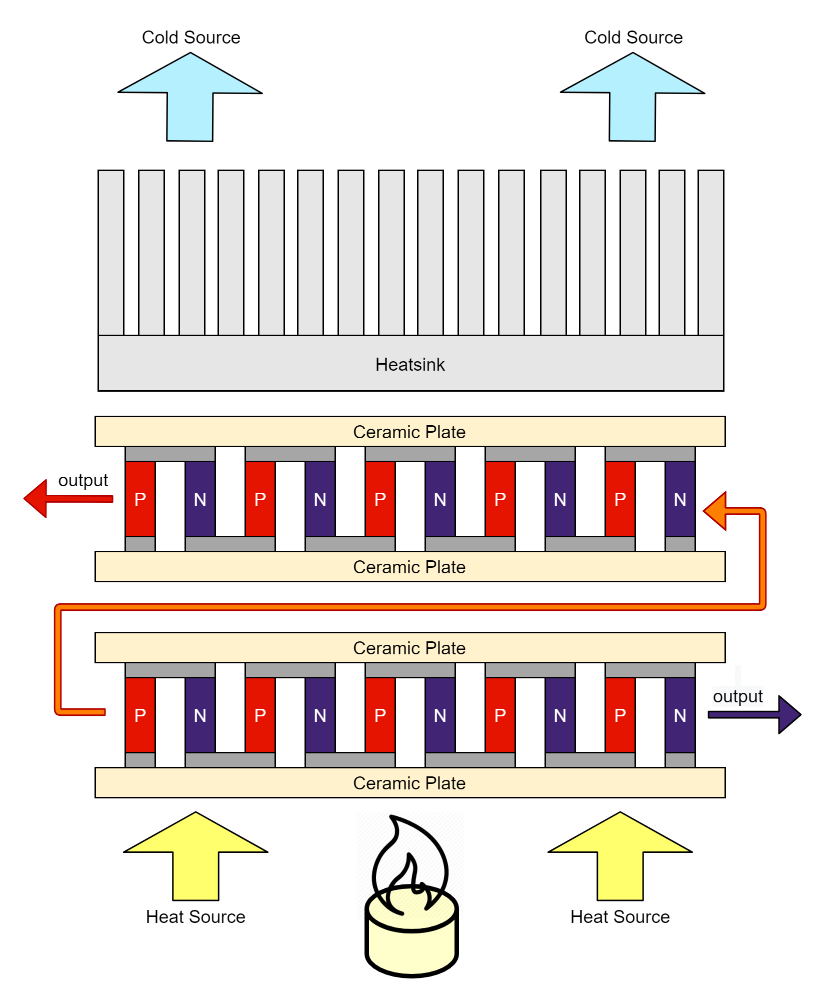
Fig. 5.3.1: Thermoelectric Power Generation

Initially, the output voltage from the generator can range from 3 to 3.5 volts. A DC-DC step-up booster called MT3608 is used to control and increase the voltage. However, the booster can take inputs between 2 and 24 volts whose efficiency is 93% and ensures that it is stable at 3.8 volts. Also, the maximum output of the booster is 28 volts and the output can be changed by turning the potentiometer.
A compact size control box [Fig. 5.3.2] has been designed and built to have all the necessary inputs and outputs. The control box contains a battery case, two-way toggle switches, potentiometers, one input, two outputs, and an additional USB I/O. The toggle switch helps to choose whether the source of the input should be the battery or the generator. The potentiometer is connected in series to the switch and acts as a voltage divider that helps control the output, such as the speed of the motor or the brightness of the LED. The USB I/O device can detect how much battery is left by showing the LED indicator. Also, It helps to charge the battery with external input or it can also be used as an output to charge the phone or for any other purpose.
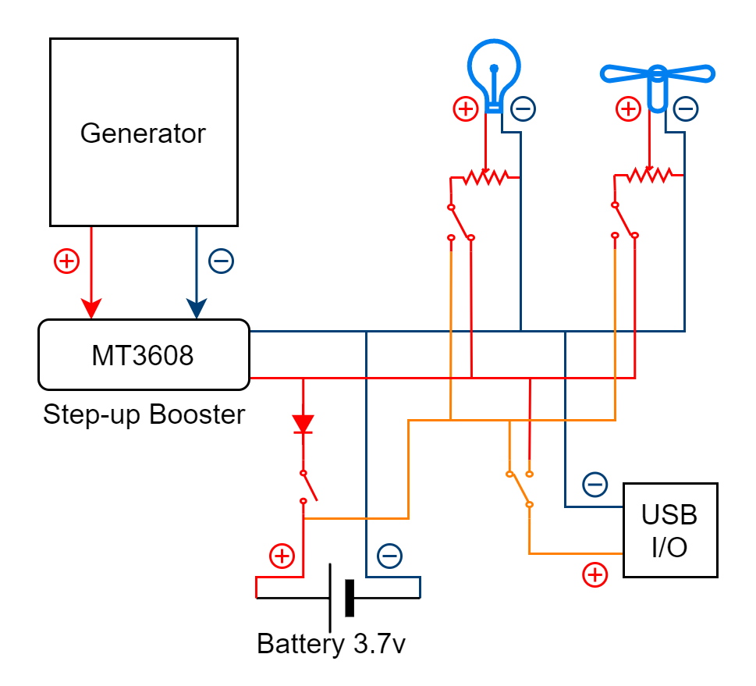
Fig. 5.3.2: Control Box circuit diagram

CHAPTER 6
Conclusion and Future Scope

6.1 Discussion and Conclusion
After all the testing and fixing of the errors, our project and website work perfectly and effectively. The UI of the website is very basic and there are no complicated instructions. Also, the generator is working as expected. This project will be handy where people are suffering in need of electricity. We will continue our project for further development and add more features.

6.2 Limitations of Our Project
There are two limitations to our project that we have faced so far. These are:
- The system is not generating enough amperage output with electricity. We need more thermoelectric modules to cover the amperage limitation which is more expensive and needs more heat.
- If the modules exceed the temperature limit, it may be damaged inside and may not work well. But despite the limitations, our project can run perfectly.

6.3 Scope for Future Developments
The expected future developments are:
- Implementing a more stable and better-optimized version of this system
- Getting more electricity with the lowest temperature input
- Providing completely free power generation
- Using better thermoelectric modules for better results
- Eliminating the use of fuel in power generation
- Spreading its use more widely
- Making our website more stable and secure
- To do more researching on it for further improvements

APPENDIX

Project Reflection
After all the hard work we have finally been able to successfully build our project and we are really happy with the result. We have applied various strategies to implement our project and choose the best method. Also, the website is working reliably and has not encountered any problems yet. Despite all the costs and limitations, we have been able to make this project a success. This encourages further development and further customization of the project. We will continue to try to upgrade our project and do much more with it.

REFERENCES

[1] DiSalvo, F.J., “Thermoelectric cooling and power generation.” Science, vol. 285, no. 5428, pp.703-706, Jul 1999.
[2] L. E. Bell, “Cooling, heating, generating power, recovering waste heat with thermoelectric systems,” Science, vol. 321, no. 5895, pp. 1457–1461, Sep. 2008.
[3] Lertsatitthanakorn, C. “Electrical performance analysis and economic evaluation of combined biomass cook stove thermoelectric (BITE) generator.” Bioresource technology, vol. 98, no. 8, pp 1670-1674, May 2007.
[4] Rowe, D.M. and Min, G., “Evaluation of thermoelectric modules for power generation.” Journal of power sources, vol. 73, no. 2, pp. 193-198, Jun 1998.
[5] Orr, B., Singh, B., Tan, L. and Akbarzadeh, A., “Electricity generation from an exhaust heat recovery system utilising thermoelectric cells and heat pipes.” Applied Thermal Engineering, vol. 73, no. 1, pp.588-597, Dec 2014.
[6] Karri, M.A., Thacher, E.F. and Helenbrook, B.T., “Exhaust energy conversion by thermoelectric generator: Two case studies.” Energy Conversion and Management, vol. 52, no. 3, pp.1596-1611, Mar 2011.
[7] Mori, Masayoshi, et al. “Simulation of Fuel Economy Effectiveness of Exhaust Heat Recovery System Using Thermoelectric Generator in a Series Hybrid.” SAE International Journal of Materials and Manufacturing, vol. 4, no. 1, pp. 1268–1276, Dec 2011.
[8] K. Ono and R. O. Suzuki, “Thermoelectric power generation: Converting low-grade heat into electricity,” J. Met., vol. 50, no. 12, pp. 49–51, Dec. 1998.
[9] Kinsella, C.E., O’Shaughnessy, S.M., Deasy, M.J., Duffy, M. and Robinson, A.J., “Battery charging considerations in small scale electricity generation from a thermoelectric module.” Applied Energy, vol. 114, pp. 80-90, Feb 2014.
[10] Hsu, C.T., Huang, G.Y., Chu, H.S., Yu, B. and Yao, D.J., “An effective Seebeck coefficient obtained by experimental results of a thermoelectric generator module.” Applied Energy, vol. 88, no. 12, pp. 5173-5179, Dec 2011.
[11] Rowe, D.M., “Thermoelectric generators as alternative sources of low power.” Renewable energy, vol. 5, no. 5-8, pp.1470-1478, Aug 1994.
[12] Wu, C., “Analysis of waste-heat thermoelectric power generators.” Applied Thermal Engineering, vol. 16, no. 1, pp.63-69, Jan 1996.
[13] Fan, H., Singh, R. and Akbarzadeh, A., “Electric power generation from thermoelectric cells using a solar dish concentrator.” Journal of electronic materials, vol. 40, no. 5, pp.1311-1320, Apr 2011.

