

Faculty of Engineering
Department of Textile Engineering

Project (Thesis) on
Study on Quality Issues in Knit Fabric

Course code: TE-4214 Course title: Project (Thesis)

Submitted by:
Abu Hossain Sarkar ID: 171-23-269
Md. Minhazur Rahman ID: 171-23-278
Md. Asif Sazzad Antu ID: 171-23-293

Supervised by:
Dr. Md. Mahbub Haque
Professor
Department of Textile Engineering
Daffodil International University

A thesis submitted in pertial fulfilment of the requirements for the degree of
Bachelor of science in Textile Engineering
Advance Apparel Manufacturing Technology

DECLARATION

We hereby declare that, this project has been done by us under the supervision of Dr. Md. Mahbubul Haque, Professor, Department of TE, Daffodil International University. We also declare that neither this project nor any part of this project has been submitted elsewhere for award of any degree.

Prepared By:
Name | ID | Signature
Abu Hossain Sarkar | ID: 171-23-269 | 
Md. Minhazur Rahman | ID: 171-23-278
Md. Asif Sazzad Antu | ID: 171-23-293

Department of Textile Engineering
Daffodil International University.

ACKNOWLEDGEMENT

We specific our humblest feeling to almighty God, the owner of all sovereignty, the extremely merciful, and therefore the supreme United Nations agency has given United States the strength and chance to hold out this study.

It is our nice pleasure to specific acknowledges our deep sense of feeling and intense obligation to our revered and learned teacher and guide faculty member Dr. Engr. Md. Mahbubul Haque, Professor, Department of textile engineering, narcissus international university, Dhaka.

We want to specific our deepest appreciation, regard and heartiest feeling to our revered teacher and guide faculty member Dr. Engr. Md. Mahbub Haque, for his continuous and diligent steering, valuable suggestions and constructive criticism and constant watch and inspiration to hold out the work with success. while not his donnish steering, shut oversight, useful recommendation it'd not are attainable to United States to advance even one success to attain our desired goal in time. we have a tendency to shall stay ever grateful to him.

We additionally appreciative to our revered teachers for his or her constant support and technical facilitate throughout the work. we have a tendency to additionally appreciative to all or any college members of textile engineering department for his or her valuable recommendation throughout our thesis work.

We would prefer to thanks our entire course mate in narcissus International University, United Nations agency took half during this discuss whereas finishing the course work.

We additionally grateful to auto-clave operators, the accountable persons for his or her constant support and technical facilitate throughout the work. we have a tendency to additionally collect several data to travel to the business and university laboratory. Finally, we have a tendency to should acknowledge with due respect the constant support hymenopter patients of our folks. At least we have a tendency to thanked all of revered one that facilitate United States to finish this work properly.

ABSTRACT
The project is on the "Quality problems in Denim Production. This study examines what's vital for prime quality of Denim, and what processes and factors affects the intrinsic quality of the Denim material. supported this, compilations of reclaim statistics was created and interviews and quality testing was conducted to examine if top quality needs is vital to each manufacture denim of fine quality and to scale back the quantity of complaints.
Our Denim business is associate incorporated business thus it's obligatory to see the procedures from the earliest place to begin. It moves toward turning into from the yarn to the finished item. we tend to square measure here tried to represent the standard parameter within the Denim division.
Quality management is a crucial a part of the daily business of a corporation and may permeate the whole organization and every one processes. so as to form denim with top quality, quality testing is a crucial a part of a high-quality management. Quality tests square measure created to make sure that the product meets the strain and expectations on its properties. Quality tests additionally play a crucial role within the compilation and analysis of client reclaims. Despite the standard and quality tests, there's a risk that discontent customers reclaim product they're not proud of. To relate client claims against the standard of tests may be a great way to gauge what the matter is, or if it even may be a downside.
The study showed that top quality can be the answer to make sure the assembly of denim with top quality. However, the matter is advanced and so, the answer to scale back claims and high-quality product to be one thing else or a part of the answer. That goes for any company to be at home with the underlying quality dimensions and supported that analyse wherever the vital points square measure found in their development and producing method.
For the corporate of this study, the authors take into account that the answer doesn't exist raising quality needs, however rather that the stitching ought to be improved and additional internal control over garment mensuration lists ought to be created. Quality tests cannot prove an absence of quality material and so the authors take into account that abundant of the claims square measure thanks to smart can.

“Table of Content”

DECLARATION 2
ACKNOWLEDGEMENT 3
ABSTRACT 4
Chapter-01: Introduction Error! Bookmark not defined.
INTRODUCTION 8
Objective of the study: 10
Limitations: 11
Chapter-02: Organization Overview 12
Orion Knit Textile Limited: 13
Perform of the Company: 13
Location & space of the Orion Knit & Textile: 14
Aim of the Company: 14
Organization Values: 15
Rahim & Salek Textile LTD.: 15
Quality Control: 16
Quality and Compliance: 17
Strength: 17
Chapter-03: Literature Review 18
Quality Issue: 19
Purpose of Training: 19
Blessings of Quality Issue: 20
Issues of Quality Issue: 21
Task Analysis. 26
Chapter-04: Analysis and Evaluation 29
Quality Issue method of Orion Knitting Textile: 30
Salek and Rahim Textile: 32
Findings from Questioners 34
Chapter-05: Findings, Recommendations and Conclusion 41
Findings: 42
Recommendation: 43
Conclusion: 44
References: 45

Chapter-01
Introduction

INTRODUCTION

This section provides associate degree introduction to the study. It conjointly declares the aim and also the base of this study and restrictions that were applied. of affiliates
The essence of the look of denim is variation. The fit, the color and most of all, the finishing processes square measure evermore altered. Denim finishes square measure a company’s risk to form a completely unique product. every detail and decision regarding the developing methodology of a spick-and-span denim vogue square measure being designed into the final quality of the garment. If the merchandise does not meet the expectations of the purchasers, they are going to induce discontented and a number of of the purchasers will come back the merchandise with criticism.
During all processes of the assembly chain, several actor’s square measure involved; designers, pattern makers, quality department, shoppers and suppliers. to those named actors even a lot of people square measure another, making the assembly chain long and so the activities reach such a lot on the far side a company’s own walls.
To produce and maintain high quality jeans, the quality management could be a important a part of the merchandise developing- and production section. the quality management square measure usually expressed in many various ways in which during which, from quality management systems to quality needs and tests. Quality tests square measure very important to secure the product’s pledged properties, but in addition to make it potential to guage shopper complaints and claims. By take a glance rating the merchandise and place the check results in relation to the reclaims, analyses are created on whether or not or not the reclaims square measure valid or not.
How can an organization, to a most extent, avoid getting discontent customers, and by that decrease the quantity of denim reclaims? can the solution be high quality needs on the product’s physical quality?

Background of the study The great success of Knit business of Bangladesh over the last 20 years has surpassed the foremost positive prospect. these days the attire export sector may be a multi-billion-dollar producing and export business within the country. the force of the readymade garment exports is unquestionably one in all the foremost necessary social and economic developments in modern Bangladesh. With over one and a million girls employees utilized in semi-skilled and masterly jobs manufacturing consumer goods for exports, the expansion of the knit and industry has had sweeping implications for the society and economy of Bangladesh. therefore Knit &Textile is that the biggest sector. once a year Bangladesh earns seventy-seven.75% by commerce readymade clothes merchandise. Bangladesh is that the world 2d country of constructing RMG. That RMG square measure return from clothes, & knit & textile works. therein sector their square measure several competitors if you would like to create your company in a very smart position you wish masterly & skilled hands in your company level. within the field of human resource management of a corporation, Quality Issue is that the field involved with the higher performance of people and teams in structure setting. within the dynamic section of the market, all organizations have variety of opportunities to grab and number of challenges to fulfill. thanks to such surroundings, the dynamic organizations square measure swimmingly living within the gift competition. To survive within the competition and to fulfill the necessities, the management has to modification their policies, rules and rules. For living the business and changing into a sure-fire pillar within the market; coaching may be a tool that may facilitate in gaining competitive blessings. smart coaching programs therefore lead to conquest of the essential goals for the business. the main target of Human Resource Development is on developing the foremost superior force that helps the organization for ordered growth. Quality Issue programs square measure the essential structural and purposeful foundations for the event of the staff. These foundations square measure necessary for guiding the staff through totally different things. Quality Issue programs square measure the framework for serving to workers to develop their personal and skilled skills, knowledge, and skills.
Statement of the problem: Quality Issue refers to the follow of providing coaching, workshops, coaching, mentoring, or different learning opportunities to workers to inspire, challenge, and inspire them perform the functions of their position to the most effective of their ability. coaching has become a compulsory tool to survive within the exhausting facing men. To accelerate the human resource management accomplishment, coaching works as a serious a part of its dimensions. Knitting business is taking part in a crucial role to economy of our country. As mentioned earlier there ar around 0.5 billion folks operating in knitting and textile business. so as to finish the method of operating the business want knowledgeable and skillful and economical workers and staff. As variety of study has been conducted concerning condition of knitting business however no analysis has been conducted concerning Quality Issue of workers and staff of knitting business. That’s why this study is extremely a lot of required. This report can facilitate to seek out out the current scenario of employee in knitting business. What styles of coaching they're obtaining, and what form of coaching ought to be provided.

Objective of the study:
Broad objectives: The primary purpose of the study is to possess a radical understanding regarding the standard Issue in knitting business of Asian country. Secondary objectives: • To examine this Quality Issue program of knitting business.
• To live the perspective of workers toward coaching.
• To value the worker performance once obtaining coaching session.
• To give some recommendation that will be necessary to revamp the coaching programs of knitting business.
• To live the differential changes in output because of coaching analysis Methodology Research styles are crucial in decisive whether or not the analysis objectives are achieved or not. the planning of a study defines the study kind like descriptive, co relative, semi-experimental, and experimental, review, analytical etc. Descriptive analysis describes information and characteristics regarding the population or development being studied. As this study describes the standard Issue of knitting business of Asian country that’s why this report is descriptive in nature.
Levels of knowledge assortment Data assortment could be a important a part of each analysis. the amount of knowledge assortment is classified in the main into primary and secondary varieties. Secondary information encompasses a heap of benefits that primary sources might not be able to supply. The report is especially supported primary information. Some secondary information has conjointly been employed in this paper.
Sources of knowledge Primary information Sources: Primary information are those, that are collected directly from the sector or base level. I even have taken interview of govt members of three knitting business of Asian country information centers of and that i have conducted these interviews shortly once conversations of interest. The interviews are neither formal nor structured. the final strategy for the interviews is to start out off with broad queries and follow upon the interviewee’s responses, to capture his/her meanings. Beside this I even have surveyed on workers of this three corporations to assemble the data to try and do this an form has been used that is being connected in appendix half. Secondary information Sources: Secondary information is collected by somebody apart from the user. Secondary information analysis saves times. it's virtually not possible to conduct a replacement analysis while not secondary information. during this study, the secondary information has been collected from the text books and websites.

Limitations: I have tried my maximum to create this report a good one however because of some limitations I couldn't make this study as made as I wished. the restrictions are:
• There square measure around 2500 knitting company in operation in People's Republic of Bangladesh. If I were ready to collect knowledge from of these knitting firms, then the study would become additional informative.
• Those United Nations agency united to be my respondent didn't offer all data|t I asked for and that they conjointly didn't permit Maine to assemble thorough knowledge concerning them.
• Most of the businesses weren't interested to be my respondent and replenish the form.
• Many companies aren't interested as a result of they need to take care of privacy concerning their valuable data.
• Most of the respondent square measure busy attributable to their work they didn’t offer the time correctly to gather proper data.

Chapter-2

Organization Overview

Orion Knit Textile Limited:

Orion Knit Textiles Ltd. could be a 100% export headed composite knit textile unit established with the commitment to cater the world desires in knit and casual consumer goods lines, using the State-of-Art technology. Aiming at the context of the ever-changing international demand, international surroundings on trade, the project encompassed the Knitting, Dyeing, process of materials, Ready-made clothes production, Printing, Embroidery to be out there from one stop service. The machines and equipments setup ar procured from foremost complete, famed for his or her prime quality, product integrity and dependable production. The hands engaged to hold out the day to day business ar all extremely virtuoso, strictly skilled, immensely tough. The distinctive combination of organized social control and Technical team in one hand and latest, advanced and balanced technology on the opposite handcrafted the project one amongst the highest to be referred during this field within the Country. the most effective use of continuous development of Human Resources by providing them International normal surroundings, Trainings, Orientations and civil right is that the keys for achieving comprehensive competency altogether the amount of the structure Hierarchy. it's been established with the target and vision to cater the wants of twenty first century of worldwide knit apparels market from one stop service being committed to On-time Delivery, Short interval, Quality Assurance, worth Affordability and social responsibility.

.

Perform of the Company:
As a poster organization, the fundamental performs of Orion Knit textiles ltd. is to earn healthy profit for the corporate. However, such basic perform is insulated with alternative collateral functions, making operating surroundings compatible to international normal, concentrating high on HRD together with remunerative welfare for the workers, polishing off social responsibilities for the workers and, to some extent, for the state, maintaining prime quality name management, etc. OKTL being an honest company Company offers priority to surroundings Management, Social Responsibility and Compliance problems. These ar well acknowledged and have reflection in varied reviews, audit and visit reports.

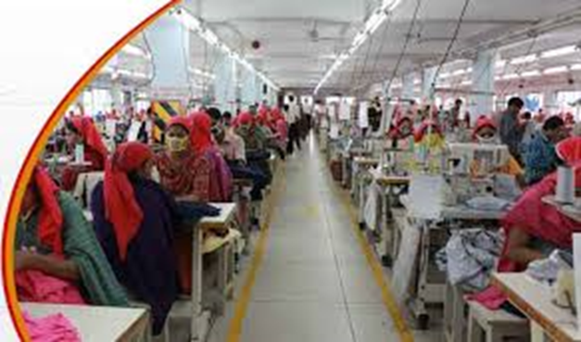

Location & space of the Orion Knit & Textile:
About seventy kilometers (2 hour drive) from the International landing field of capital of Bangladesh, East Pakistan the project is found in Jamirdia, HabirBari, Valuka underneath the District of Mymensingh in an exceedingly well developed road Communication.
• Surface Area: 5 Acres of area and a complete of 183,000 sq. feet of works premises.
• Floor Area: clothes works Area: seventy,7000 Sq. Ft. Production area for materials coloring & Finishing: eighty three,000Sq.Ft. Storage, Utility and others: thirty3,000 Sq. Ft.

Aim of the Company:
• To deal fairly, open and honest with all workers, customers and suppliers.
• To price and support one another contribution.
• To perpetually get the most effective price from the resources out there.
• To attain and maintain position of world category producing.
• Continuous development of individuals competence.
• Recognizing individual contribution.
• Introducing new and innovative merchandise and technologies.
• Assuring quality merchandise from advanced producing facilities.
• Exceeding client satisfaction and granting trust through quality services. Moreover, the Management and workers of Orion Knit Textiles Ltd Ltd works to implement quality altogether steps of their activity ranging from choosing raw materials through all steps of productions to the last word finished merchandise.

Organization Values:
In order to realize our aspired vision we tend to shall take the subsequent values
• Quality in everything we tend to do
• Live up our commitment
• Transparent and truthful altogether our dealings
• Take initiative to exceed normal
• Trust and respect for every alternative
• Work as a team • Focus on total client satisfaction
• Expand export market
• Socially accountable.

Rahim & Salek Textile LTD.:
Rahim & Salek textile ltd ar the sister concern. each ar within the cluster of KNIT ASIA LTD. Knit Asia restricted could be a Worldwide accountable attire Production (WRAP) could be a certified compliant production concern. it's its Head workplace at Tejgaon and has its Printing and Embroidery Unit at East Narshinghapur, Ashulia, Savar. Knit Asia employs employees within the workplace or works as per the grading and also the classification that is formed for the aim of establish the scale of measurement of various men engaged within the clothes trade underneath S.R.O No. 280-law/ 2006/ Sha-6/ N.M. Board-1/2006. Salek Textile Ltd.is forty tons/day aotucoro yarn spinning mills. Our extraordinary growth is clear from the rise in production capability two.40 to 77.00 tons per day. Rahim Textile Ltd. is pioneer in materials process. The unit is presently manufacturing prime quality bleached and written cloth for export. Rahim Textile Ltd.(Woven & knit everywhere printing & dyeing)
• Stork printer
• Manforts Stenter
• Kusters continuous coloring
• Dilmenler knit coloring
• Corino Sqeezer
• Lafer compactor

Quality Control:
Our quality starts with the procurance of the fiber that is brought you from the U.S.A with tight quality parameters. mistreatment Uster HVI, AFIS, UTs, and Tenso fast, all incoming materials ar completely checked and in process watching ar done terribly delightly. materials the least bit stages bear all sorts of testing and analysis mistreatment knowledge Color, SDL Atlas and Wascator science laboratory testing instrumentation. sewing quality and productivity is maintained by well trained supervisor and monitored and analyzed by our in house engineering department mistreatment the acceptable computer code applications. The textile trade needs very smart, efficient, and reliable infrastructure and utilities. so all our departments ar planed taking into thought, movements, access, safety, future enlargement. All production units ar directed to control to full potency and therefore maintenance and utilities receive special attention from all level management.
To ensure this we've got endowed within the following machinery:
• Generates from Waukesha, U.S.A
• Compressor from Kaeser, Germany
• Boilers from omnical Federal Republic of Germany and Hust U.S.A
• BBT from Simens Our effluent Treatment Plant (ETP), the biggest Biological ETP obtained within the country Simem Italy).

Quality and Compliance:
• Rahim & Salek is that the country initial knit works in East Pakistan to get WARP Certification and currently having level certification and incorporated all aspects of social and moral compliance into its business practices.
• Rahim & Salek Textile could be a Oeko Tex one hundred Certified works and ensured all environmental and Chemical compliance normal.
• Rahim & Salek Textile meets the moral Standards of Wal-Mart and BSCL.
• Rahim and Salek Textile contains a quality management system in situ and sewing unit is ISO 9001:2008 Certified
• 100% environmentally compliant works with an efficient Effluent Treatment Plant (ETP). All our effluent tested to internationally accepted chassis and COD levels then discharged.
• Both Company ar cotton U.S.A licenses
• Our sewing facility maintains C-TPAT is approved by Jordache cluster.
• Both firms has the power to manufacture organic merchandise & OE/100 normal certified works.

Strength:
The members of the Directories have sturdy international instructional background in Textile Technology and Management. they're the pioneers within the textile growth in East Pakistan and contend direct roles all the policies and technical department of textile and consumer goods trade. The board works at policy together with development taking into thought the world business situation.

Chapter-3

Literature Review

Quality Issue:
Bangladesh is that the notable name of RMG (readymade garments). In our country textile sector is play a really vital role in our economy. therein competitive business environment; human resource is play the vital role of any business like Knit & textile. For the superior work force and for the superior productivity coaching works sort of a wheel. during this competitive world, coaching plays a crucial role within the competent and difficult format of business. Quality Issue of staff is vital in organizations during this era of competition thanks to the very fact that organizations got to survive, grow and develop. coaching is taken into account because the method of upgrading the information, developing skills, transportation regarding perspective and activity changes, ANd rising the power of the tyro to perform tasks effectively an d with efficiency in organizations (Wills, 1994; Palo et al, 2003; Henry M. Robert et al, 2004. Stewart (1996) combines the 2 ideas of Quality Issue and offers a corporation perform that has the result of making certain that the contribution of people and teams in achieving the structure objectives the' the event of applicable information, skills and perspective of the staff. Quality Issue play a crucial role within the effectiveness of organizations and to the experiences of individuals in work. coaching has implications for productivity, health and safety at work and private development. All organizations using individuals got to train and develop their workers. once someone rent for a corporation he/she should would like a coaching to understand regarding a way to perform smart therein organizations. fast changes in technology, products, and business application build it necessary for would like Quality Issue of their staff.

Purpose of Training:
Training is that the remedy of the corporate. It will increase the productivity of the corporate. within the textile sector if the corporate build to additional profit the corporate got to will increase productivity the corporate should coaching their staff. coaching is that the nerve that suffices the necessity of fluent and swish functioning of labor that helps in enhancing the standard of labor lifetime of staff and structure development too. within the dynamical section of the market, all organizations have range of opportunities to grab and number of challenges to satisfy. Some in need of purpose of coaching are given below
: • To increase productivity & quality
• To promote skillfulness ability to new strategies
• To scale back the amount of accident
• To increase job satisfaction displaying itself in lower labor turn-over & less absence
• To increase potency.

Blessings of Quality Issue:
Knowledge and skills development are important to the health of organizations. we tend to board AN modern era these days, and organizations ar habitually valued not simply on their physical however on their intellectual capital. coaching is one among the chief strategies of maintaining and rising intellectual capital, that the quality of AN organization’s coaching affects its worth. primitive or poorly trained staff price considerably additional to support than well-trained staff do. coaching affects worker retention and could be a valuable trade goods that, if viewed as AN investment instead of as AN expense, will manufacture high returns. There ar various sources of on-line info regarding Quality Issue. many of the sites recommend reason for supervisors to conduct coaching among staff. Quality Issue programs ar the fundamental structural and practical foundations for the event of the staff. the benefits of Quality Issue ar given below:

• Increased job satisfaction and morale among staff. This has {an added|another|one additional an additional a new an extra} advantage of creating your company more enticing to prospective staff
• Employees feel supported and enabled in their work.
• New skills and information are often nonheritable
• Existing skills and information are often increased or updated, sanctioning individuals to any improve well-tried strengths
• Improvements in confidence, capability and competency
• Employees ar ready to balance their work life and private life during a higher manner that results in reduction of stress
• Increasing the extent of worker motivation
• Training rising the worker morale will increase the productivity and commitment of the staff towards the structure goals.
• Learns from the tyro
• Improve the task information & ability the least bit levels of the organizations
• Helps to make a more robust company image
• Fasters genuinely, openness & trust
• To reduces ratio
• Improving labor management relation
• Training regarding Risk management, fireplace safety, harassment , diversity etc
• They improve the communication between all levels of management that helps in minimizing conflicts between completely different levels of staff between completely different levels of staff


Issues of Quality Issue:
Some drawback will happen between HR/Training and different elements of the organization, normally thanks to differing priorities among performance management functions at intervals a business, and notably regarding coaching, development and welfare of workers
• A failure to spot the particular wants of learners and for learners to possess their own development wants
• Objectives set by trainers, instead of the learners
• Little acceptance by learners of the necessity to require responsibility for his or her own development
• Constraints of your time for preparation and participation in learning events
• A failure to follow through learning on the far side an incident or course
• Failing to attain high worth via transfer of the educational
• HR haven't any authority over trainees thus cannot management coaching take-up
• HR funds ar typically cut if profits come back stressed
• Often takes individuals far from their job for variable periods of your time
• Bad habits passed on
• Narrow expertise
Coaching wants Assessment (TNA) A coaching would like exists once there's a spot between what's needed of someone to perform their work with competence and what they actual understand. A “training wants assessment”, or “training wants analysis”, is that the methodology of deciding if a coaching would like exists and if it will, what coaching is needed to fill the gap. The results {of coaching|of coaching} wants analysis can highlight the topic matter required to be lined throughout the training course. The information and skills gained throughout the coaching can increase skills and permit participants to perform their jobs at a suitable level. the requirements assessment are often quite easy and obvious. as an example, once a replacement system is introduced, it's assumed that nobody has the information to control it – and also the coaching would like is noted. but if the organization was change systems, the necessity might not be thus obvious. By conducting coaching wants analysis you'll target the cluster that has to be trained also as hone in on precisely what coaching is needed. The purpose of conducting a wants assessment is to stop a fast fix approach to business issues. A TNA done properly can make sure the resolution addresses the important problems and effectively focuses the suitable resources, time and energy toward targeted solutions. There is quite an little bit of literature written on the subject. This paper presents just some major points. The reasons for doing coaching wants assessment
• To confirm whether or not coaching is required
• To confirm causes of poor performance
• To confirm content and scope of coaching
• To confirm desired coaching outcomes
• To offer a basis of measuring
• To gain management support
The requirements Assessment method the assessment are often as elaborated and concerned PRN. Factors to think about once considering the extent of detail ar time, money, variety of individuals concerned, cruciality of ability, anticipated come back on investment? resources obtainable, etc. A comparison of a number of the factors between in-depth and a mini assessment follows. Type of Information Quantitative Qualitative Methods Multi-tiered approach, Surveys, Observation, interviews, Focus teams Document reviews Interviews Focus teams Scope Widespread structure involvement Broad locomote objectives Fewer individuals concerned Short term focus Length Several months to a year Few days to per week Cost Expensive Inexpensive Focus Linked o outlined outputs Immediate, fast results Exposure/Visibility High profile and risk Lower risk Determine whom to assess Again this relies on the goal and depth of the analysis. classes of individuals will include:
Senior management Human resource personnel Target population Vendors Target population managers Clients Direct reports (those UN agency report back to target population) Competitors Co-workers and peers Industry consultants or observers Steps within the wants Assessment method
wants Assessment method. The following the requirements Assessment method were undertaken Step One: Identify drawback Needs Determine structure context Perform gap analysis Set objectives Step Two: Determine style of wants Analysis Establish methodology choice criteria Assess blessings and downsides for methods Step Three:
Collect Data Conduct Interviews Administer questionnaires and surveys Review documents Observe individuals at work Step Four:
Analyze Data Conduct chemical analysis or Conduct Quantitative Analysis? Determine solutions/recommendations Step Five: Provide Feedback Write report and build speech Determine next step – coaching needed? Step Six: Develop Action arrange Once this formal want assessment method is completed the data is employed because the basis for coaching style, development and analysis. but you want to still assess the attitudes, information and ability level of participants before every session. audiences could have different wants. this could be done each through a basic form sent simply before a particular coaching event and additionally throughout the welcome time of every session.
Job Analysis (Task Identification) A job analysis involves the dissecting of employment or major work event into its part elements. This dissection permits you as a trainer to know what farmers, fishermen, or different agricultural staff truly kill the course of their work. This analysis permits you to higher perceive the “what is” side of wants analysis. The parenthetical statement following the terms job analysis within the title of this section reads “task identification.” “Task identification” is simply differently of claiming “what is concerned during this job.” the tip results of employment analysis could be a list of tasks or steps that staff complete within the course of their work. The term “job” may have rationalization. If you're planning a coaching course for pre-service or introductory coaching, you'll conduct an entire job analysis to spot what's needed of the employee therein job. However, not all trainers are concerned in getting ready somebody for a replacement job. Instead, trainers are additional typically involved regarding coaching staff to use a replacement technique, a replacement technology, or use a safer approach in accomplishing their job. Consequently, employment analysis during this case takes on an additional restricted which means. instead of entire job of a employee, you'll most likely be specializing in solely half or all of employment, we tend to decision it job analysis.
• Experts determine and list vital tasks,
• Trainers meet with teams of staff,
• Trainers observe and interview staff
• Trainers submit tentative lists of tasks to staff or supervisors.

The following pages gift procedural steps and forms for the completion of employment analysis. Procedures for conducting employment Analysis; the subsequent steps give a guide for completion of employment analysis. you will notice it necessary to change these steps based mostly upon your specific circumstance.

STEP 1
Identify exactly the work to analysis: This might specialize in a complete job or only 1 section. The outcome of those seeps is that the choice of the work section to be analyzed.

STEP 2
List all tasks that may be enclosed within the job: This may be accomplished by exploitation one or additional procedures. One sensible approach is to list all of the tasks that you simply apprehend and might consider. If potential you would possibly involve others during this step. If resources exist, you'll use observation and interviews to assist during this step.

STEP 3
Verify the list of job tasks: This method will involve skilled review, interviews with staff or supervisors, or observation. you'll submit the list of tasks to 5 or six staff (who square measure the target group) and raise them the tasks that they ordinarily perform.

STEP 4
Determine however oft every task is performed: List the tasks on the work Analysis Worksheet (see sample provided). Show the list to 6 or eight staff or supervisors and raise them to point however usually they perform the task. Use the scale: 1-Seldom, 2-Occasionally. 3-Weekly to Month, 4-Daily to Weekly, 5- Daily.

STEP 5
Determine the relative importance of every task: Task that square measure performed rarely could also be vary important to the work. thus it's vital to realize each Associate in Nursing importance rating similarly as a frequency rating. raise the individuals to rate the importance of the tasks simply once they need rated the frequency exploitation the roles Analysis worksheet. Use the scale: 1-Marginally vital, 2-Moderately vital, 3-Extremely vital.

Step 6
Assess problem the problem the issue} of the training the task: An assessment of learning difficulty is another dimension of the analysis. It provides the program developer, with the staff perception of issue, which can show a discrepancy from others. Use the roles Analysis worksheet and therefore the following scale: 1-Easy, 2-Moderately troublesome, 3-Difficultm 4-Very troublesome.

Step 7
Tally the full score for each task: Do this by adding the scores for frequency, importance and learning issue for every task. Record the total or total for every task within the applicable column of the work Analysis worksheet. exploitation this technique, those tasks with the best total scores are the priority tasks for coaching – if they're disclosed as vital within the later gap analysis, which can be mentioned within the next section. This step involves sharing your jobs analysis findings with government leaders, program administrators, et al. UN agency have unconditional interest in your coaching. This step can enable you to realize the attitude of people within the designing section of the coaching method.

Step 8
Discuss findings with key personal within the coaching system; The following pages embody a blank job analysis worksheet and one that has been completed. the finished worksheet is enclosed to supply you an image of however one appearance once it's finished. The method printed within the previous steps a straightforward method that tries to clarify a posh method like employment. it's a scientific approach to delineate the potential focus of coaching. It ought to be increased with the experience of trainer and alternative vital individuals. good judgment ought to be utilized in deciphering the results of the roles analysis. The results of the roles analysis may be a list of jobs tasks. you'll see from example that every task may be a advanced set of procedures in itself. thanks to this quality, and since we are able to not sometimes style coaching to focus specifically on such broad tasks, it's necessary to conduct consequent level of analysis.

Task Analysis:
Task Analysis Task Analysis may be a method that's dead so as to higher perceive job tasks. primarily, it involves breaking down the work tasks into their consecutive steps or part elements. Once broken into elements, every component is analyzed to see its relative importance and urgency in terms of accomplishing the work task. The task analysis method has 2 distinct functions. First, it helps determine the weather, subtasks, or procedural steps of employment task. Knowing these parts is important to the event of coaching objectives and therefore the identification and organization of coaching content. Second, the task analysis helps in determinant the foremost vital parts and steps at intervals employment task. By knowing the relative importance, coaching will specialize in the foremost vital and demanding parts, instead of treating all content as having similar importance. Procedures for Conducting a Task Analysis The following steps give a guide for completion of a task analysis. you will notice it necessary to change these steps based mostly upon your specific circumstance.

STEP 1
Duplicate many Task Analysis Worksheets and write the name of the work at the highest of each A blank kind is employed. every of those forms are used for breaking down and analyzing every of the foremost important job tasks.

STEP 2
Write one task on every of the Task Analysis Worksheets These tasks ought to be those known within the job analysis having the best score.

STEP 3
List all part elements of every task on its individual Task Analysis Worksheet Be as thorough as potential during this step. you will would like to speak with somebody UN agency performs the work, a supervisor or a theme matter skilled. they will be in an exceedingly higher position to inform you the key steps in an exceedingly job.

STEP 4
Determine however oft every step or part is performed Use the knowledge you've got gained from the work analysis or talk over with staff or supervisor.
Use the subsequent recording scheme: 1-Seldom, 2-Occasionally, 3-Weekly to Month, 4-Daily to Weekly, 5-Daily.

Step 5
Determine the relative importance of every step or component Steps that ar performed rarely is also terribly important to the task. thus it's necessary to realize each associate importance rating and frequency rating. Use the subsequent scale: 1-Marginally necessary, 2-Moderately necessary, 3-Extremely necessary.

Step 6
Assess he problem of learning the task step or component An assessment of learning problem is another dimension of study. It provides you, the syllabus developer, with the staff perception of problem, which can vary from your own. Use the roles Analysis worksheet and therefore the following scale: 1) simple, 2) Moderately tough, 3) tough, 4) Vary tough.

Step 7
Tally the whole score for every task element or step Do this by adding the score for frequency, importance and learning problem for every element. Record the total or total for every task within the applicable column of the task Analysis Worksheet. victimization this method, those elements with the very best total scores are the priority parts for coaching, if they're disclosed as vital within the later gap analysis.

Step 8
Review the results of the task analysis with somebody knowledgeable of the job the forms on the subsequent pages give a blank task Analysis Worksheet which will be duplicated and use in your analysis. in addition, a completed worksheet is enclosed to assist clarify its use. Using the task Analysis Worksheet; The forms on the subsequent pages give a blank task analysis worksheet which will be duplicated and employed in your analysis. in addition, a completed worksheet is enclosed to assist clarify its use. The process of task analysis, as you'll be able to see, is extremely almost like the task analysis method. you ought to acknowledge the necessary difference; the task analysis helps North American country determine major blocks of content to incorporate in training; the task analysis helps North American country perceive what contains these blocks. each result is necessary to the syllabus development method. A lot of specific we are able to be with job necessities, the simpler our coaching development task are

Supervisor A Supervisor, once the which means wanted is analogous to foreman, foreperson, overseer, cell coach, manager, help, monitor, or space organizer, is that the job title of a coffee level management position that's based on authority over a employee or charge of a geographical point. A Supervisor may also be one in every of the foremost senior within the workers at the place of labor, like a prof UN agency oversees a Doctor of Philosophy thesis. management, on the opposite hand, is performed by individuals while not this formal title, as an example by folks. The term Supervisor itself is accustomed seek advice from any personnel UN agency have this task as a part of their description. An worker may be a supervisor if he/she has the ability and authority to try to the subsequent actions (according to the Ontario Ministry of Labor.
1. Offer directions and/or orders to subordinates.
2. Be command to blame for the work and actions of different staff. If associate worker cannot do the on top of, legally, he or she is perhaps not a supervisor, however in another class, like a piece cluster leader or lead hand. A supervisor is initial associated foremost an superintendent whose main responsibility is to confirm that a bunch of subordinates get out the appointed quantity of production, once they ar speculated to eff and among acceptable levels of quality, prices and safety. A supervisor is to blame for the productivity and actions of a tiny low cluster of staff.
The supervisor has many manager-like roles, responsibilities, and powers.
Of the key variations between a supervisor and a manager are (1) the supervisor doesn't usually have "hire and fire" authority, and (2) the supervisor doesn't have budget authority.

Chapter-4

Analysis and Evaluation

After interviewing the manager members of Orion knitting textile and Salek and Rahim knitting textile I actually have return to understand their Quality Issue method. Salek and Rahim textile are sister concern that’s why the standard Issue method off these 2 Knitting textiles is nearly similar.

Quality Issue method of Orion Knitting Textile:

Training may be a systematic method of fixing the behavior, data and motivation of workers to boost the match between worker current profile and worker needs. Employee development is outlined as never-ending learning method of up a person's ability to realize Company and individual goals and challenges through getting increased skills, data and attitudes.

Mode of Training: Orientation: Orion organizes orientation program for the new worker. The objectives of the program ar to welcome the incumbent and introduce him with the colleagues, orient him/her regarding the Company's vision, mission, values, shareholders, service rules, divisional activities etc. this can create a brand-new recruit feel that s/he may be a a part of the corporate. In-house training: Orion organizes in-house coaching programs for its workers. Senior managers of the corporate, coaching department or consultants employed for special functions give such coaching. In country training:
The Company provides need-based coaching to the staff through victimization applicable external coaching institutes. Overseas training: The Company conjointly sends selected workers to alternative countries for attending useful or management training/ workshops/ seminars etc. Job rotation: The Company considers job rotation united of the worker development tool. The manager takes initiative to interchange the responsibilities of the staff operating within the same grade for a precise amount. the worker and manager can conjointly decide the fundamental quantity.

Coaching desires Assessment:
Individual supervisors can assess the coaching desires of the worker from his/her observation. Supervisors and workers can work along to outline and determine organic process must meet personal and work goal. A Role guide should be ready for each position, which can contain the key responsibilities and needed competencies. Human Resources Department can facilitate to line the competencies needs for every position. This Role guide are going to be the premise of distinctive the coaching desires for the precise position. During preparation of Performance and Development set up (PDP), supervisor and worker can conjointly set Development Objectives supported the requirements of worker. Human Resources Department can give with the tools and pointers to the division Heads and work along to spot the coaching desires of the staff. The Quality Issueal initiatives should be address to the structure priority likewise as workers skills development.
Responsibility: Employee Development may be a shared responsibility of the people and of the corporate. The responsibilities for worker Development ar divided as follows: Employees - are liable for managing their skilled development. Orion encourages seeking personal opportunities to boost their skilled skills for facing the challenges of the long run. Human Resources Department - can assist the useful Heads in setting of the ability needs of the staff and determine the individual coaching desires. HR Department is liable for designing, coming up with and implementing management coaching programs for the management employees of Beacon. HR Department can concentrate on developing the systems inside the organization to boost the structure effectiveness and supply coaching to boost the organization’s awareness and data needed for a victorious modification method. HR Department is additionally liable for coordinating native and foreign coaching for Beacon workers per the necessities of the divisions/departments. Divisions/Departments - ar liable for supporting the worker development method and developing the folks to satisfy business desires currently and within the future. Functional Heads can encourage their folks to extend their data and skills for superior performance. they're primarily liable for identification of coaching desires of the staff and choice of participants for explicit internal/ external courses.
Payments of Training: Company can take into account the payment for all elements of the coaching. the corporate considers paying for course fee, food, lodging, transportation, incidental etc. - Entitlements of the food, lodging, transportation etc. are going to be as per Company Travel Policy. Once the coaching requests are approved, all workers can still receive their full earnings and advantages throughout the coaching.
Coaching Administration: Prescribed coaching form should be stuffed up to method a coaching request. the appliance for short-run courses, seminar and workshop/conferences ought to be sent to 60 minutes Department when necessary approval from the Divisional Heads and decision maker (as applicable). The Finance Director can offer clearance of budget within the application.
• Approving Authority - Departmental/Divisional Heads will approve coaching programs, as per company approving authority limit.
• Any quantity, that isn't inside budget, should be mentioned with decision maker and wish his approval. • The decision maker should approve any overseas travel.
• NOT Record Keeping System - Any worker development initiatives should be recorded within the information for future reference.
• Internal Trainer - Managers can offer necessary time to support worker development process; the corporate acknowledges the interior abilities and encourages managers to use their experience for the event of the staff.

Salek and Rahim Textile: As mentioned earlier Salek and Rahim Textile ar sister concern that’s why they need same Quality Issue method. they're providing following coaching programs.
Perspective Adaptability: Attitude ability refers to “the ability to vary to suit modified circumstance. everyone has the fundamental capability to be variable – while not this we might not be able to perform within the world. Salek and Rahim textile give perspective ability coaching. the most objective this coaching is to create employees and workers familiar with the interior and external setting of the corporate.
Understanding Responsibility: Another vital coaching given by these 2 textiles is associate understanding responsibly. the most goal of this coaching is to grasp the work responsibly clearly and to create employees the staff} and worker effective.
Time Management Skill: Generally, time management refers to the event of processes and tools that increase potency and productivity. Salek and Rahim textile give time management coaching to create their workers and employees economical.
Downside resolution Skill: Problem resolution ability will be referring because the method of operating through details of a haul to achieve an answer. Salek and Rahim textile give downside resolution ability to create their workers and employees artistic and versatile. downside resolution might systematic operations and might be a live of a person's vital thinking skills
Communication ability the ability to precise info to a different effectively and expeditiously is named communication ability. Salek and Rahim Textile give communication ability training. the target of this coaching is providing clear direction and will increase productivity.
Leadership Skill: Leadership skills are the actions that manufacture the mandatory result that are aligned with the mission and goals of the organization. Salek and Rahim textile supply this coaching as a result of leadership ability provides direction to develop goals and a coaching arrange to become a much better leader.
Coaching on Work process: The main objectives of those trainings ar considerably improved potency, productivity, and client satisfaction, and value minimizing.
Quality of Work: Almost all work has standards for the way well it should be done and the way quick it should be done. In some cases perfection is needed in the slightest degree prices, and in others speed is most vital. That’s why Salek and Rahim textile supply Quality of labor coaching. The objectives and purpose of those trainings are:
• Following directions by listening, watching, questioning and active.
• Focusing on the work
• Learning from mistakes
Ability to place data into practice: Rahim and Salek textile give Ability to place data into follow coaching to boost the power to use employees and workers data effectively and promptly in execution or performance.
Technical Training: Technical coaching is that the method of teaching workers the way to a lot of accurately and completely perform the technical elements of their jobs. Technical coaching helps the worker to raised understanding of a task or method. Salek and Rahim textile give this coaching to will increase the arrogance and improves the potency of {the employee the employees the staff} and workers.
Ability to soak up new development: Rahim and salek textile give ability to soak up new development to create their workers and employee accustomed with the new work method, system or technology.
Fireplace Safety Training: Rahim & Salek Textile provides fireplace safety coaching to their workers. therein coaching trainer ar offer the data that what you are doing if the hearth is happened & conjointly what you not do. Now a day’s fire is a very critical issues to every organization that’s why Rahim & Salek are do practice every once a month what you do in fire.

Findings from Questioners
Does your company organize a Quality Issue program?
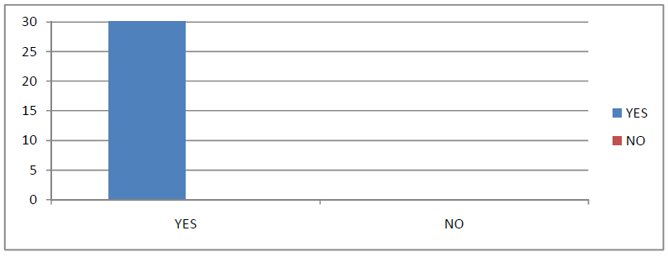

Analysis: Out of thirty respondents of 3 firms thirty respondents area unit speech communication affirmative their company organizes Quality Issue as a result of the all the 3 organizations area unit organize the coaching development program

Does your organization identify the training needs for its employees?
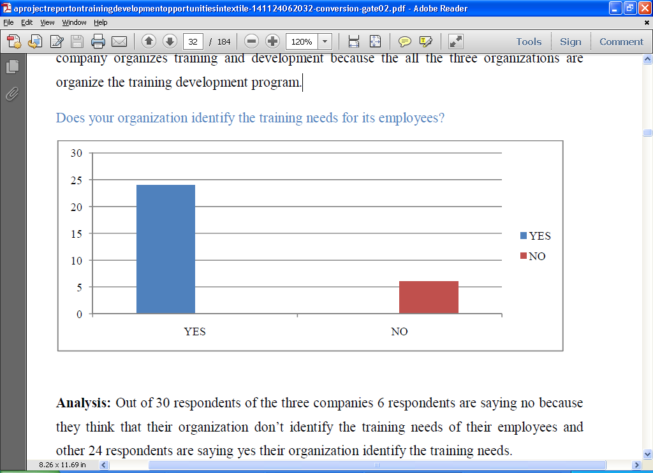

Analysis: Out of thirty respondents of the 3 firms vi respondents area unit expression no as a result of they suppose that their organization don’t establish the coaching desires of their staff and alternative twenty-four respondent’s area unit expression affirmative their organization establish the coaching desires.

The length of the Quality Issue programs at your organization?
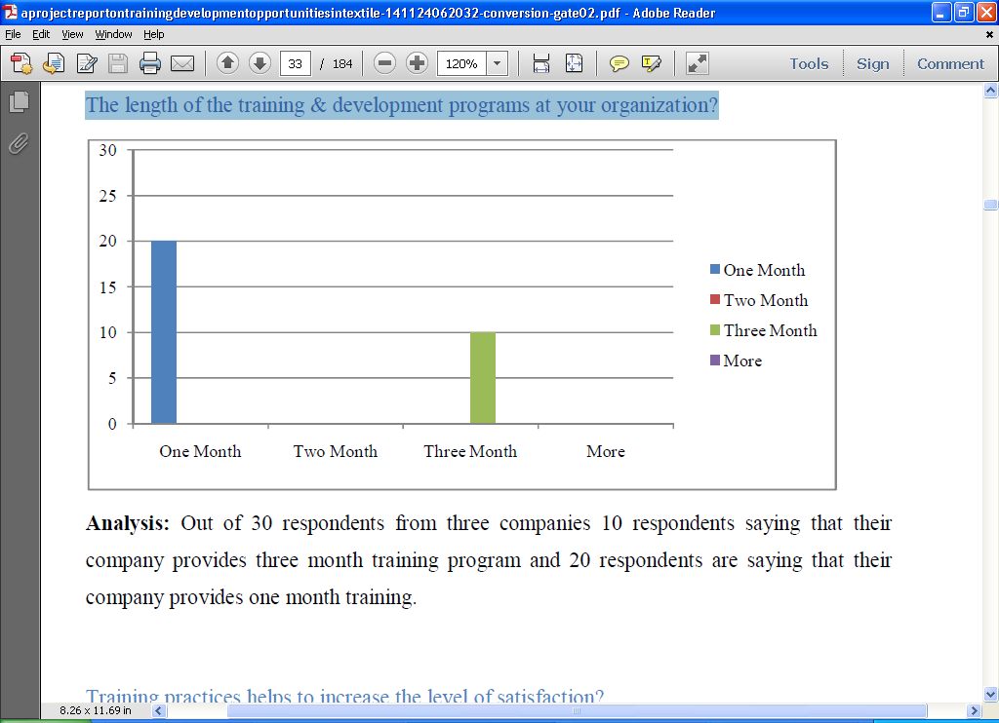

Analysis: Out of thirty respondents from 3 firms ten respondents spoken communication that their company provides 3 month educational program and twenty respondents square measure spoken communication that their company provides one month coaching.
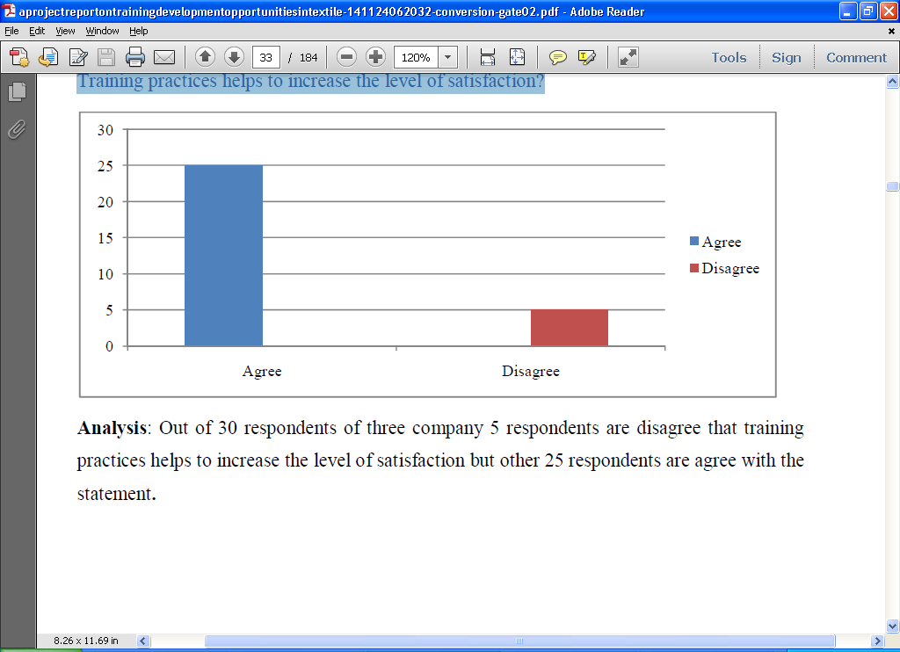
Training practices helps to increase the level of satisfaction?

Analysis: Out of thirty respondents of 3 company five respondents are disagree that coaching practices helps to extend the extent of satisfaction however alternative twenty-five respondents are believe the statement.
Does your company use latest/upgraded training method?
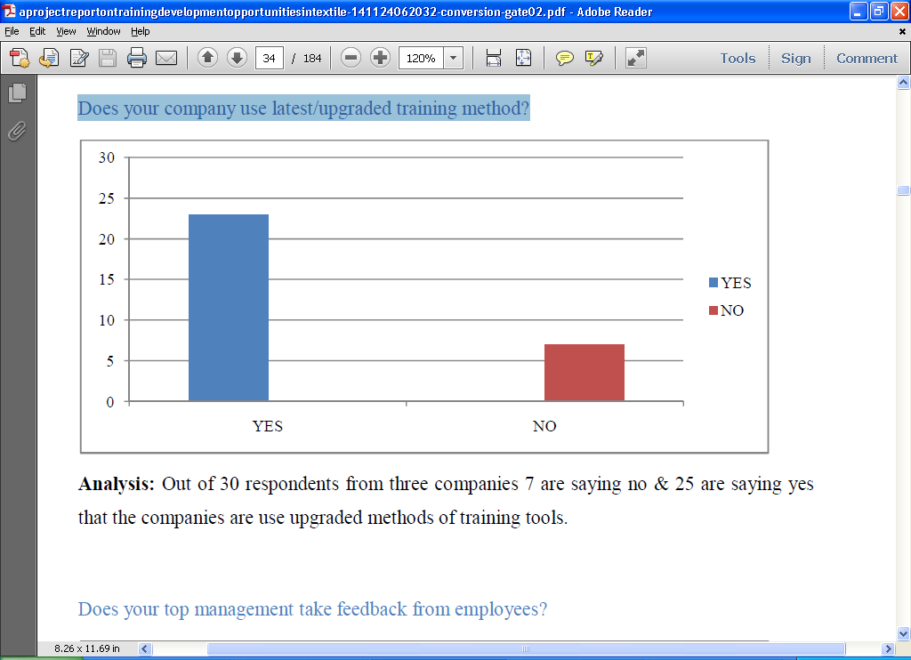

Analysis: Out of 30 respondents from three companies 7 are saying no & 25 are saying yes that the companies are use upgraded methods of training tools.
Does your top management take feedback from employees?
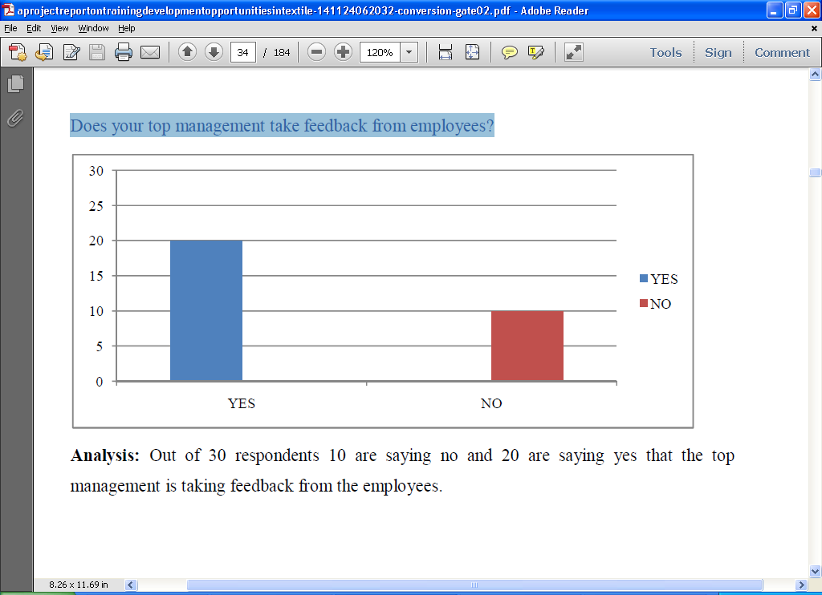

Analysis: Out of 30 respondents 10 are saying no and 20 are saying yes that the top management is taking feedback from the employees.
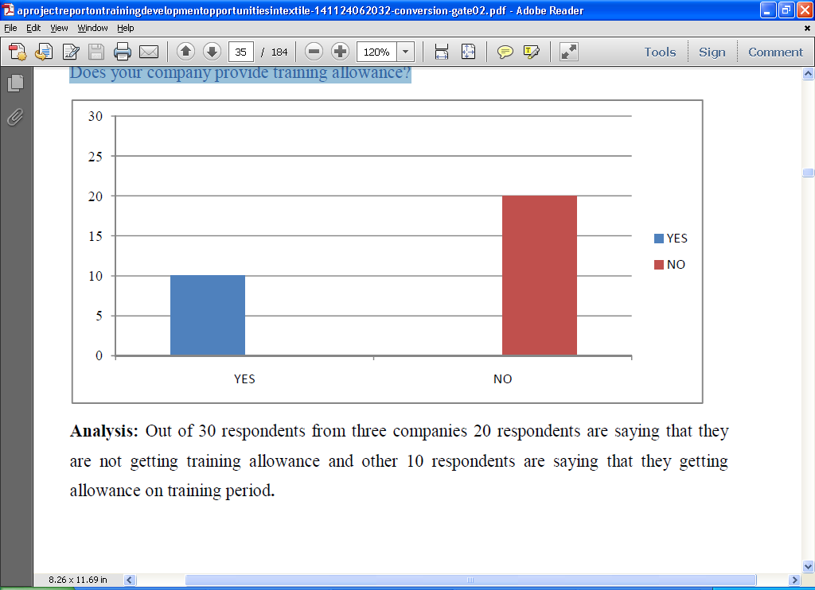
Does your company provide training allowance?

Analysis: Out of thirty respondents from 3 firms twenty respondents square measure speech that {they square measure they’re} not obtaining coaching allowance and different ten respondents are speech that they obtaining allowance on coaching amount.
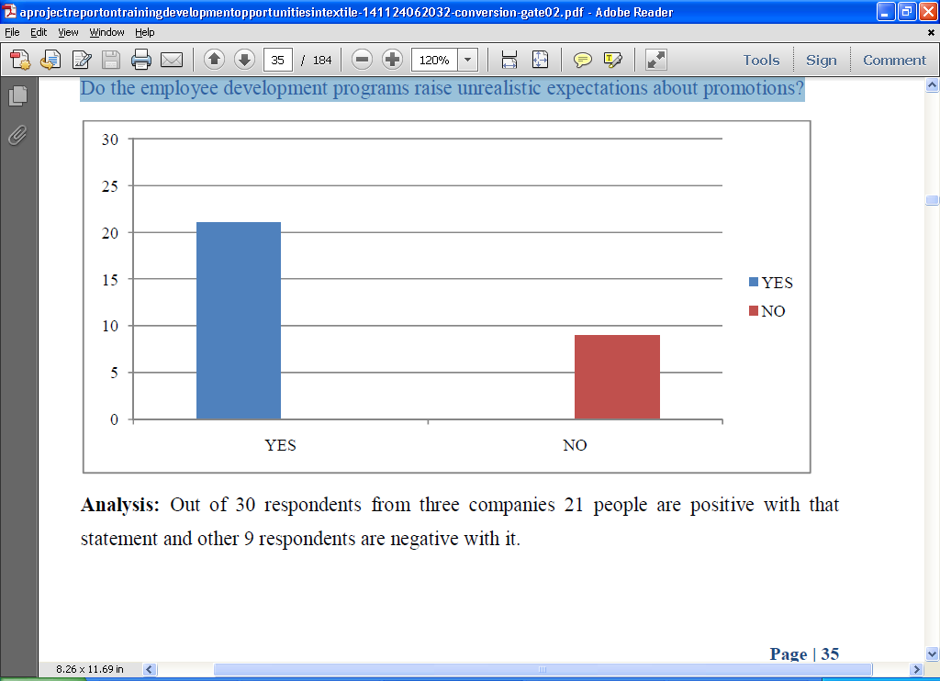
Do the employee development programs raise unrealistic expectations about promotions?

Analysis: Out of thirty respondents from 3 corporations twenty one folks ar positive therewith statement and different nine respondents ar negative with it.
Does the CEO of your organization engage developments activities for him/herself?
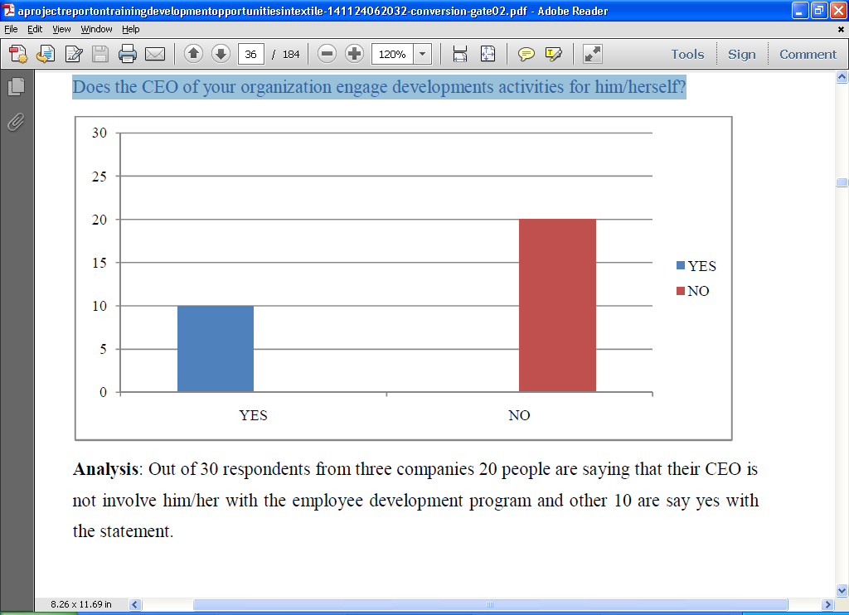

Analysis: Out of thirty respondents from 3 firms twenty individuals square measure voice communication that their corporate executive isn't involve him/her with the worker development program and different ten square measure say affirmative with the statement.
Do you think training will help you to develop your career?
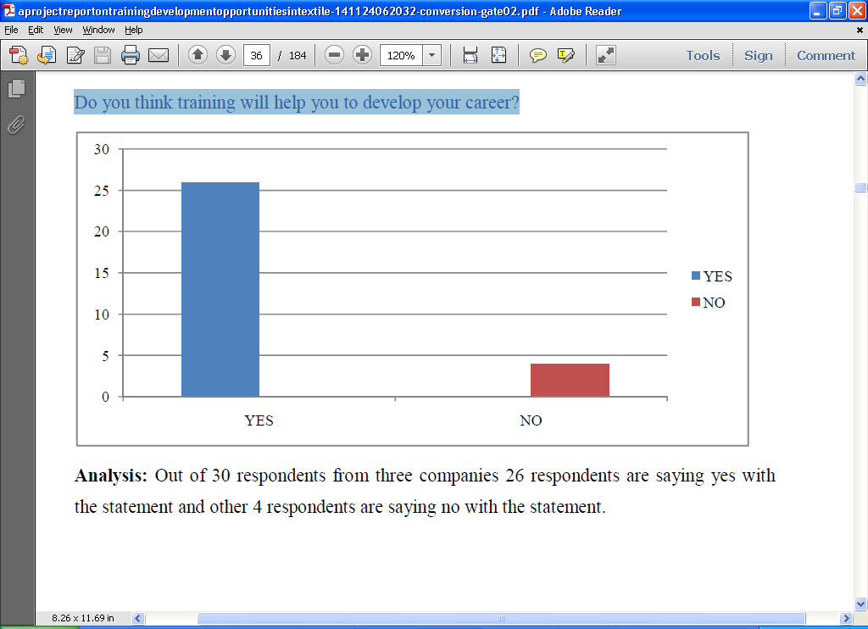

Analysis: Out of 30 respondents from three companies 26 respondents are saying yes with the statement and other 4 respondents are saying no with the statement.
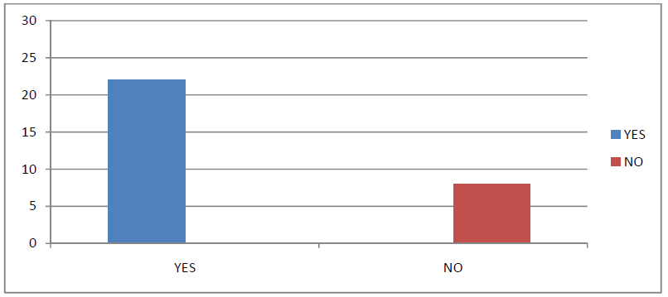
Does the practice have a consistent, timely and fair method for evaluating individual performance?

Analysis: Out of thirty respondents from 3 corporations twenty two respondents spoken language affirmative and different eight area unit spoken language no.
Do you think training helps to increase Organization productivity?
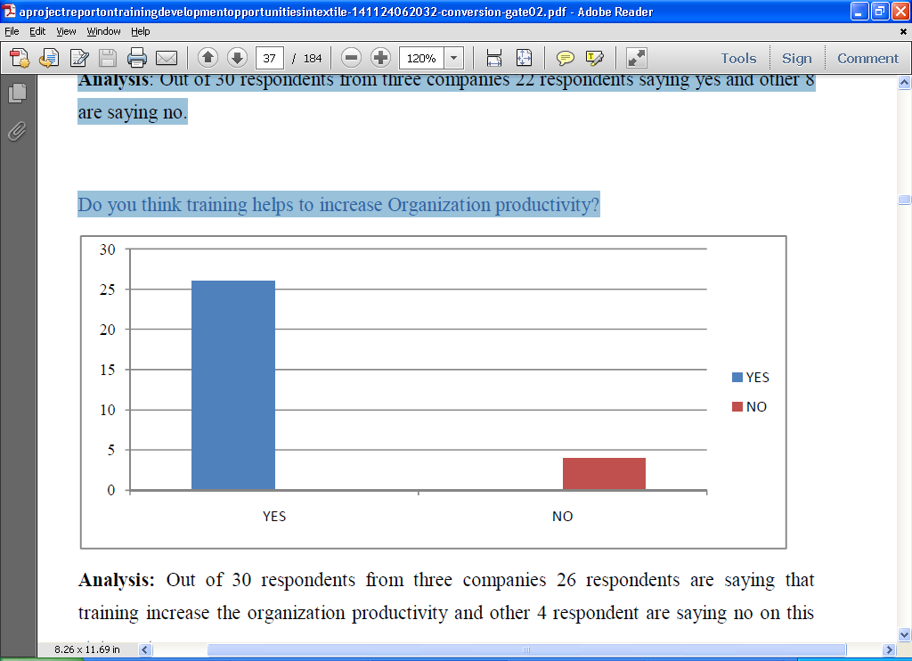

Analysis: Out of thirty respondents from 3 firms twenty six respondents square measure spoken language that coaching increase the organization productivity and alternative four respondent square measure spoken language no on this statement.
Does your company use a specific training process?
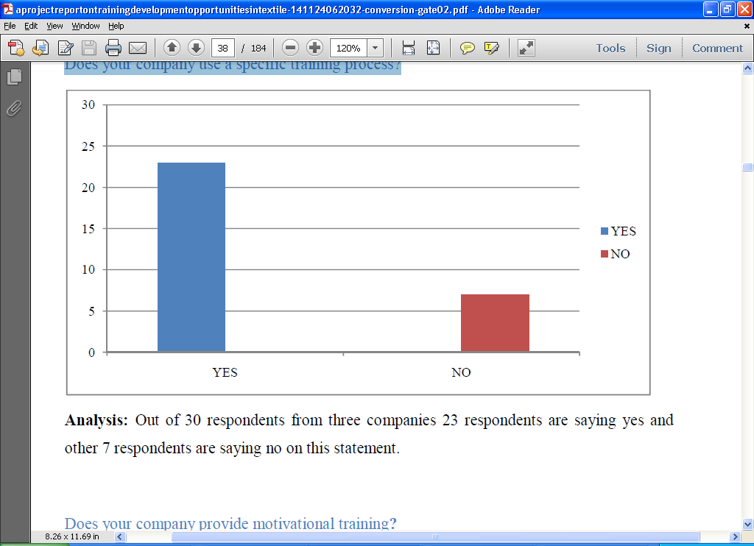

Analysis: Out of thirty respondents from 3 firms twenty three respondents square measure speech affirmative and different seven respondents square measure speech no on this statement.
Does your company provide motivational training?
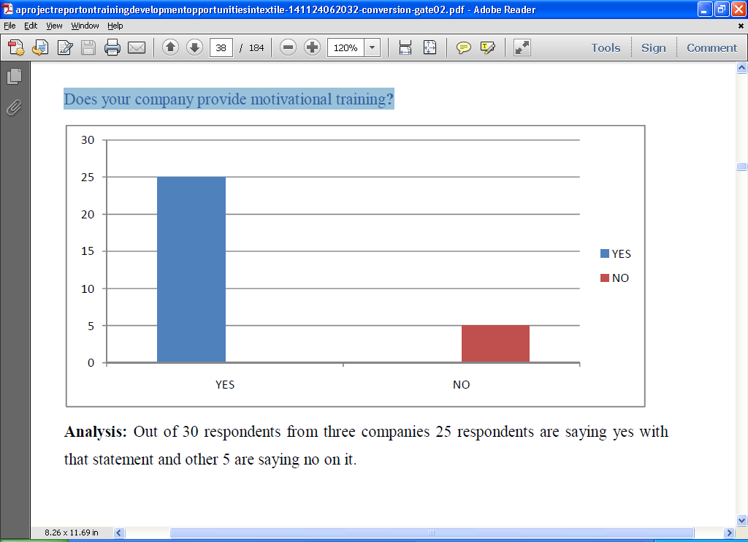

Analysis: Out of thirty respondents from 3 corporations twenty five respondents square measure language affirmative therewith statement and different five square measure language no thereon.
Are you satisfied with organizational Quality Issue program?
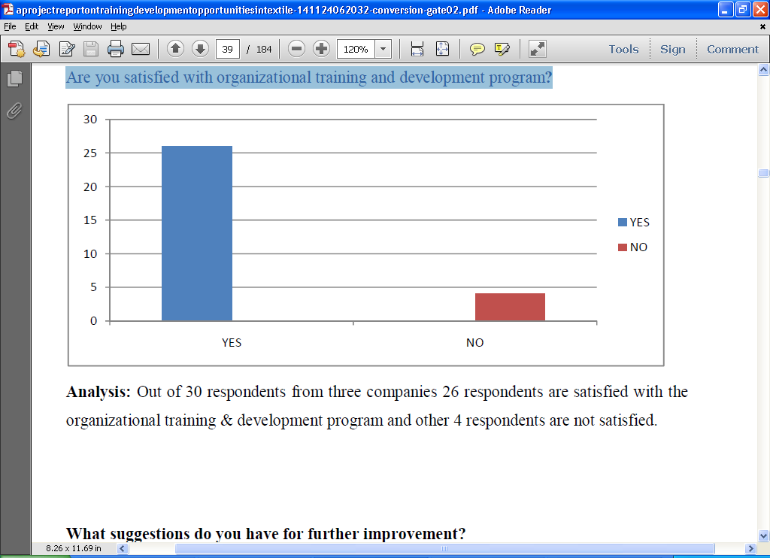

Analysis: Out of thirty respondents from 3 corporations twenty six respondents area unit happy with the structure Quality Issue program and alternative four respondents aren't happy.

Analysis: most respondents ar urged that each worker ought to given coaching once a definite amount of your time for his or her improvement. additionally recommend that once a brand new worker joins within the company he/she want a brief or long amount of your time for higher productivity of the corporate.

Chapter-5

Findings, Recommendations and Conclusion

Findings:
Training wants considering supervisors activities are known from close-ended queries filled-in by the interviewees. On the opposite hand, coaching wants considering garment manufacturing activities are known from open-ended queries moreover as comments of the interviewees. The suggested coaching courses known from the requirements extracted from the KSA analysis of garment supervisors square measure given below:
• In this study, it's tough to spot the coaching wants of the supervisor by taking interview. thus, a lot of samples could also be taken for Job analysis, task analysis and gap analysis that would offer a sensible image to see coaching wants of the supervisor.
• Even grouping knowledge through interview some areas can be known that will address to develop their performance that clearly contribute to productivity.
• Most of the garment owner provides stress on coaching, that is expounded with production. The owner should listen to social compliance to satisfy their consumers however they are doing it terribly visually with less priority.
• Despite some limitations, the entire TNA exercise is anticipated to produce loads of knowledge regarding the ability level of garment supervisors with their performance deficiencies in some specific fields, which is able to facilitate in planning future educational program for garment supervisor.
• Motivation and different attitudinal problems additionally ought to be looked into for capability building.
• Their regular payment structure ought to be increased or supported market average.
• The yearly increment must providen over 10/ p.c (Under the BEPZA all corporations square measure certain to give 10/ p.c yearly increment).
• Production accessories ought to be provided in time that generally created delay the assembly.

• Shipment date ought to be told earlier to the supervisor so they'll set up consequently.
• Basic problems associated with social compliance ought to be incorporated within the educational program for supervisors’.
• Behavioural modification Communication (BCC) problems ought to be addressed within the educational program designed for supervisors.

Recommendation:
These square measures some recommendations through that Textile business could also be beneficial:
• Training development format ought to be friendly and versatile.
• HR department of the textile corporations ought to diversify their coaching programs instead of that specialize in skilled trainings.
• There should be a transparent relation between coaching electiveness and strategic goals of the organizations
• The Textile corporations ought to update frequently their HRIS that's Human Resource data systems program.
• Approaches want to train workers ought to be chosen once careful thought of the trainees and organization wants.
• To inspire and encourage the trainee’s adequate allowance ought to be provided to trainees throughout the coaching amount.
• The Textile corporations ought to increase their coaching budget. as a result of while not an enormous budget the businesses wouldn't be able to introduce trendy technology in their coaching system.
• The coaching courses that are outlined/identified in TNA report could also be step by step enforced for all the supervisors. Priority one courses would be lined initial followed by the priority a pair of and three courses.
• The course material ought to be ready ideally in Bangla (Local). Language for delivering course content shall be acceptable with the target cluster.
• The length of the course could also be mounted in consultation with the highest management.
• Due concerns could also be created in choice of participants.
• The total of every target cluster might not be attainable to hide at intervals a brief attainable time. So, a one-day coaching course on every issue could also be organized.
• Different democratic strategies like group-discussion, question and answer; perform, etc. could also be adopted throughout the implementation of coaching courses. Use of visual aids also will be ensured within the coaching course.
• Every course could also be evaluated at reaction level so as to understand the effectiveness of coaching inputs.

Conclusion:
Quality Issue programs play a significant role in each organization. These programs improve worker performance at workplace; it updates worker information and enhances their personal skills. Quality Issue programs improve the standard of work-life by making associate degree worker confirmatory geographic point. Textile business may be a terribly business sector business in Bangladesh. Bangladesh is considering the globe second country within the prepared created clothes (RMG). Knit is additionally major raw materials of RMG. World’s most of the bands square measure creating their dress from Bangladesh. thus, it’s terribly competitive market. therein market if anyone needs to success, they have trained worker. If the organizations offer necessary coaching to their workers they'll increase their productivity. This study was a learning expertise on behalf of me and that i came to understand the standard Issue programs in Orion Kint& Textile Ltd, Rahim & Salek Textile Ltd was positive in response however still a lot of Quality Issue is required therein 3 textile business so the workers square measure motivated time by time and that they ought to grasp their strength & weakness so they'll work thereon & improve their information & skills for the betterment of their organization. In the last however not the smallest amount I conclude that each one the standard Issue programs of company square measure extremely effective & helpful to the workers in giving their best contribution to their personal growth & development moreover to satisfy the structure objective.

References:
- Stewart, J. (1996) Managing Change through Quality Issue; 2nd edition
- Robert L.M and John H.J (2004) Human Resource Management.10th Ed. Thomson (Wills, 1994; Palo et al, 2003; Robert et al, 2004. Stewart (1996)
- Bangladesh textile industry – Wikipedia, en.wikipedia.org/ wiki/Bangladesh_ textile_industry, Last date of accessed on November 15.
- Textiles & Garments - Orion Group, www.orion-group.net/construction_2.php, date of accessed on December 5.
- Salek Textile Ltd. - Knit Asia Ltd, www.knitasia.com/Company-Home-STML, Last date of accessed on December 7.
- Rahim Textile Mills Ltd. - Knit Asia Ltd, www.knitasia.com/Rahim-Textile-Mills-Ltd, Last date of accessed on December 7.

