An Internship Report
On
Cash Management System of Anjuman Group

Submitted To:
Mr. Md. Anhar Sharif Mollah
Assistant Professor
Department of Business Administration
Faculty of Business & Entrepreneurship
Daffodil International University

Submitted By:
Sihab Hosen
ID: 172-11- 475
Department of Business Administration
Faculty of Business & Entrepreneurship



Bachelor of Business Administration
Daffodil International University

Letter of Transmittal

To,
Mr. Md. Anhar Sharif Mollah
Assistant Professor
Department of Business Administration
Faculty of Business & Entrepreneurship
Daffodil International University

Subject: Submission of internship Repot on “Cash Management System of Anjuman Group”
Sir,
With due respect that I, Sihab Hosen ID: 172-11-475might need to educate you that here is the give a report of "Cash Management System of Anjuman Group " that was appointed to me submit under the internship program. It was an extraordinary joy for me to do the allocated report. I have directed my internship program in Anjuman Group., Ashulia, Savar, Dhaka, with your caring oversight. I believe that the learning and experience I accumulated during the internship time period, will be helpful in my future expert life.
I made each endeavor to set up this report exact, obvious, and thorough and attempted my estimation best to total appropriate and sharp information inside the orchestrated time and bound assets. Any deficiency in this report is totally my fault.
I have contributed each push to portray the organization's quality, capacities performed by the Anjuman Group. I will be appreciative to you on the off chance that you mercifully acknowledge this report.

Thank You.

Sincerely Yours,

Sihab Hosen
ID: 172-11- 475
Major: Finance
Department of Business Administration.
Faculty of Business & Entrepreneurship.

Letter of Authorization

This is to confirm that Sihab Hosen, ID: 172-11- 475 an understudy of the Branch of Business Organization of Daffodil Global College has finished his entry level position report titled "Cash Management System of Anjuman Group" under my watch and heading.

His Internship was at Anjuman Group. in Ashulia, Savar, Dhaka. I am satisfied to express that he has experienced all the vital and expected strides to achieve the report and the report contains every one of the information, data, examination and discoveries from legitimate sources. Accordingly, the report appears to have finished on an effective note.

………………………………
Signature of the Supervisor

Mr. Md. Anhar Sharif Mollah
Assistant Professor
Department of Business Administration
Faculty of Business & Entrepreneurship
Daffodil International University

Student’s Declaration

I, Sihab Hosen, ID: 172-11- 475, hereby announce that the following internship report titled “Cash Management System of Anjuman Group” is solely prepared by me right after the completion of my internship at Anjuman Group in Ashulia, Savar, Dhaka under the supervision of Mr. Md. Anhar Sharif Mollah, Assistant Professor , Faculty of Business and Entrepreneurship.
I guarantee that the report has been set up in light of the satisfaction of my scholastic necessity and not for some other goal albeit the concerned gatherings may think that its value for the improvement.

……………………….

Sihab Hosen
ID: 172-11- 475
Major: Finance
Department of Business Administration
Daffodil International University

Acknowledgement

The open entryway has quite recently gone to and fro to bring to the table my most significant thanks and humble settlement to the all-powerful Allah yet for whose help I would not wrap a colossal undertaking of setting up this report.

I may need to communicate my significant sensation of appreciation towards one of my Advisor Mr. Md. Anhar Sharif Mollah, Partner Professor, Department of Business Administration, Faculty of Business and Entrepreneurship, Daffodil International University for permitting me an opportunity to complete my internship report on "Cash Management System of Anjuman Group"

Honestly, no darling can achieve faultlessness without the help of a specialist. Moreover, an understudy can never be perfect without the help of a good educator. A fair teacher may be a landmark for any understudy. I'm fundamentally obliged to, I may need to unequivocal my significant sensation of appreciation towards one of my Advisor Mr. Md. Anhar Sharif Mollah, Assistant Professor, Department of Business Administration, Faculty of Business and Entrepreneurship, Daffodil International University for permitting me an opportunity to Finish my internship report on "Cash Management System of Anjuman Group" His proposals and rules Were amazingly unprecedented assistance to me.

I'm additionally Especially grateful to Md. Ariful Islam Shaheen, Manager of Anjuman Group, Kumkumari, Ashulia, Savar, Dhaka. Who permitted me to permit me in this hierarchical field. I might likewise want to communicate my heart full gratitude to all officials of Anjuman Group. Kumkumari, Savar, my companions, and my Brother for their fantastic help and appropriate direction in finishing my internship report.

Executive Summery
This report pushes and delineates on "Cash Management System of Anjuman Group". Cash Management contains a movement of activities went for capably dealing with the inflow and flood of cash. This incorporates fantastically diverting cash from where it is required. To put it another way, cash the board is to propel cash streams, equalities, and adventures. In this particular situation, cash may insinuate exchange out the kind of cash, or various reciprocals, for instance, checks, drafts, stores, etc. While associations may hold various assets that can change over to cash, cash the load up oversees liquid cash the heads and close cash assets, for instance, appealing protections and time stores that could without a very remarkable stretch changed over into cash. For three essential reasons, trade, defend, and hypothesis is crucial for associations. The piece of the cash the board is accounts compromise, cash fixation, the financial danger the heads, and liquidity the board.
This report pushes and delineates on "Cash Management System of Anjuman Group". Cash Management contains a movement of activities went for capably dealing with the inflow and flood of cash. This incorporates fantastically diverting cash from where it is required. To put it another way, cash the board is to propel cash streams, equalities, and adventures. In this particular situation, cash may insinuate exchange out the kind of cash, or various reciprocals, for instance, checks, drafts, stores, etc. While associations may hold various assets that can change over to cash, cash the load up oversees liquid cash the heads and close cash assets, for instance, appealing protections and time stores that could without a very remarkable stretch changed over into cash. For three essential reasons, trade, defend, and hypothesis is crucial for associations. The piece of the cash the board is accounts compromise, cash fixation, the financial danger the heads, and liquidity the board.
The association has a "clearing course of action" with the bank at the administrative center that consequently applies any of the resources traded from the stop towns to settle the bank's cash credit progress and decrease its charge balance. These methods achieved the association's cost of eagerness diminished and controlled. The association places the comparable in transient endeavors or instruments, for instance, Mutual Funds and Govt. at the point when the association has surplus resources. Protections.

Table of Contents

Letter of Transmittal ii
Letter of Authorization iii
Student’s Declaration iv
Acknowledgement v
Executive Summery vi

Chapter One 1
Introduction 1
1.1 Introduction 1
1.2 Components of Cash Management 1
1.2.1 Account Reconciliation: 1
1.2.2 Cash Concentration 2
1.2.3 Financial Risk Management 2
1.2.4 Liquidity Management 2
1.3 Cash Management 2
1.3.1 The Role of Technology in Optimizing Cash Management 3
1.4 Objectives of Report 4
1.5 Scope of Report 4
1.6 Methodology of the Report 4
1.6.1. Sample Information 4
1.6.2. Primary Source of Data 4
1.6.2 Primary Sources are: 4
1.6.3. Secondary Sources of Data 5

Chapter Two 6
Organizational Overview 6
2.1 About 6
2.4 Strategy to Achieve Company Mission 7

Chapter Three 10
Cash Management System at Anjuman Group 10
3.1 Cash Management System of Company 10
3.1.1 Process of Cash Management Through Banking Department 10
3.1.2 Terms and Conditions Set by Company 11
3.2 Payment System in Anjuman Group 11
3.2.1 Cheque 11
3.2.2 Processing of Cheque in Anjuman Group 12
3.2.3 Endorsement of cheques 12
3.2.4 Speed Clearing 13
3.2.5 Demand Draft 15

Chapter Four 17
Application of SAP in Cash Management System 17
4.1 Integration 17
4.2 Features 17
4.3 Displaying Cash Management & Forecast, Cash Management Position 19
4.4 Sales Order Management in SAP R/3 21
4.4.1 Organizational Elements 22

Chapter Five: 23
Agreed Terms and Conditions with Bank of Anjuman Group 23
5.1 Transfers Limited to Available Funds 23
5.2 Confidentiality: 23
5.3 Indemnity: 23
5.4 Force Majeure: 23
5.5 Change of Terms: 23
5.6 General Undertaking from Customer: 23
5.7 MIS/ Reports 24
5.8 Waiver 24

Chapter Six 25
Findings & Recommendations 25
6.1 Interpretation (SWOT Analysis) 25
6.2 Problems 26
6.3 Recommendations of the Study 27

Conclusion 28
References 29
Bibliography: 30

Chapter One

Introduction

1.1 Introduction
Cash management joins a movement of activities went for supervising cash inflow and overflowing successfully. This incorporates overwhelmingly involving cash from where it is required. To put it another way, cash management is to upgrade cash streams, equalities, and adventures. In this particular circumstance, cash may suggest cash as cash, or various partners, for instance, checks, drafts, stores, etc. While affiliations may hold various assets that perhaps be changed over to cash, cash management oversees liquid cash management and close cash assets, for instance, alluring protections and time stores that can without a very remarkable stretch be changed over into cash.
It is crucial to organizations for three main reasons:
          - Transaction: Ready cash balances are vital to routine transactions such as purchases, operating expenses, wages, and other payments such as dividends, taxes, etc.
          - Precaution: due to sudden increases in inventory costs, delays in collecting receivables, among others, there may be unanticipated cash requirements. And to deal with such unforeseen expenses, it is essential to maintain ready cash balances.
          - Speculation: reserving cash balances is also crucial when firms anticipate a decline in raw material prices, a reduction in securities buying interest rates, and the availability of early payment discounts.

1.2 Components of Cash Management

1.2.1 Account Reconciliation:

Because of the huge number of checks dealt with reliably, regulating checks, noticing their opportunity, and observing the authentic cash evening out can be an amazing task for associations. Therefore, banks offer record bargain organizations where the nuances of the checks gave step by step are moved to corporate customers. Besides, at the month's end, the bank clarification shows information about cleared and non-cleared checks. This structure is also significant in the process known as "positive compensation" that banks use to dodge dishonestly cashing keeps an eye if, despite everything that they are not on the once-over.

1.2.2 Cash Concentration
Because of the gigantic number of checks took care of reliably, directing checks, noticing their opportunity, and observing the certifiable cash evening out can be an amazing task for associations. Thusly, banks offer record bargain organizations where the nuances of the checks gave systematically moved to corporate customers. Moreover, at the month's end, the bank clarification shows information about cleared and non-cleared checks. This structure is also significant in the process known as "positive compensation" that banks use to sidestep dishonestly cashing keeps an eye in the unlikely event that they are not on the once-over.

1.2.3 Financial Risk Management
Danger management is the danger assessment methodology and strategies for administering and directing danger made and completed. Cash-related danger management expects a basic occupation in cash management, as it focuses, among others, on danger management in association with financing cost changes, thing costs, stock expenses, exchange rates. Through monetary liquidity management organizations.

1.2.4 Liquidity Management

It is fundamental to assess an association's cash needs to supervise cash streams, transient obtaining, among others, is a viable method to ensure that such cash needs can be met when and when they arise. This essential is tended to by practices releasing the hypotheses rushed into working capital, enabling it to add to higher advantages. It is like manner suggests the specific organizations that banks provide to enable their customers to upgrade their bit of leeway pay and lower premium costs.

1.3 Cash Management

        - Complete Visibility: Corporate clients are progressively expecting unrivaled cash anticipating capacity, requiring full undertaking dimension deceivability in cash adjusts and cash development. This given by banks through status reports, direct request, and solidified perspective on branch/ledgers over the globe.
        - Rich Reporting Modules: To influence corporate clients to comprehend the need to receive cash management administrations, banks are appearing on expense - advantage examination and demonstrating the advantages of cash management utilizing charts and delineations.
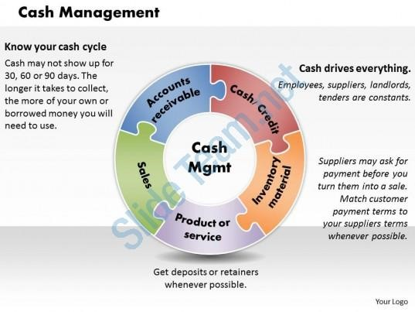
        - Integrated Services: Rather than different frameworks, corporate clients favor a solitary stage for the majority of their budgetary needs. The emphasis is in this way on incorporating cash management frameworks with other bank-related exercises. For instance, connecting ERP answers for banking frameworks encourages cash management by, among others, empowering viable procedures of exchange account and speculation management.
        - Remote Deposit Capture and Straight- Through Processing-(STP): organizations are searching for arrangements that offer legitimately through handling abilities to quicken exchanges. For instance, corporate clients are endeavoring to streamline their exchanges and lessen downtime, for which banks are putting forth STP benefits that enable organizations to electronically lead entire business procedures and installments. What's more, to all the more likely serve corporate client needs, banks look to innovation sellers who offer ideal arrangements that can make cash management progressively proficient.

1.3.1 The Role of Technology in Optimizing Cash Management
(Implementation strategy of concept in your present study)
Answers for cash management are not new. The market is creating and compelling cash management plans are offered by various banks. However, publicizing powers, monetary conditions, and changing corporate examples have made open entryways in this space for additional headway.
          - While an enormous number of these game plans have generally been established on Windows, with various corporate clients getting a handle on the web banking, a couple of banks are as of now moving to program-based courses of action. Development was the primary purpose for corporate customers to smooth out cash management plans: Browser-based courses of action support centralization of cash management as such engaging better accessibility by customers over the relationship thusly having a predominant control of cash streams.
          - Online banking and STP (Straight- Through Processing) help quicken payments, thereby accelerating business and streamlining processes by eliminating redundant manual processes.
          - 360-degree view of accounts offers greater visibility on cash position thereby improving the forecasting ability.

1.4 Objectives of Report

- To study the Cash Management System of Anjuman Group limited.
- To Study Different aspect of Cash Management system
- To understand different Payment modes; Speed clearing.
- To understand the Application of SAP in Cash Management System

1.5 Scope of Report

Cash management courses of action by and by comprehensively gotten, and consequently, the amount of vendors offering these game plans is most likely going to increase. Correspondingly, corporate customers are in like manner at risk to end up being all the mentioning, consequently developing progressively genuine shipper competition.

1.6 Methodology of the Report

1.6.1. Sample Information

Tests gathered from the Sewing Trade Section, Dying Section Store Section, and Cutting Section of Anjuman Group. Here, the examples had gotten on a critical premise. For the association part, much data had gathered from various distributed articles, diaries, handouts, and sites. All the data fused in this report has gathered both from the essential sources and just as from optional sources.

1.6.2. Primary Source of Data
Gathering information straightforwardly from the reasonable field is known as the essential wellspring of information. The strategy that was utilized to gather the essential information is as per the following:

Observation Method:

Observation method may be defined as systematic viewing according to concise Oxford Dictionary “accurate watching, nothing of phenomena as they occur in nature with regard to cause and effect and mutual relationship”. I have observed many of the activities of CMO Department.

1.6.2 Primary Sources are:
- Discussion with officials of Anjuman Group
- Face to face conversation with the clients.
- Discussions with customers over the telephone & responding to their query.

1.6.3. Secondary Sources of Data

The auxiliary information has gathered from the MIS of Standard Chartered Bank and Foreign Exchange Policy Department of Bangladesh Bank. To explain the distinctive applied issue, the web and various articles distributed in the diaries and magazines have used.

Secondary Sources are:

• Brochures of Anjuman Group
• Research papers on Textile industry
• Annual report of Anjuman Group

Chapter Two

Organizational Overview

2.1 About

Anjuman Group Established in 2000, Anjuman Group has some expertise in a wide range of Garments Buying, Sewing Thread, Pocketing Fabrics, Mesh Fabrics, Woven marks, a wide range of Furniture and Garments Accessories. Situated in an ideal place in the capital of Bangladesh, Dhaka, Anjuman Group has a decent arrangement of experienced partners who guarantee the convenient development of creation, promoting, sourcing frill, quality reviews (PP, In-line, and Final), documentation, and cargo sending until shipment.

Since 2000, Company has guaranteed a fruitful organization in working with purchasers across the globe, from the USA, Norway, Spain, and so forth Furthermore working with significant pieces of clothing in the district and abroad. For future undertakings, Anjuman Group is encouraging the long stretches of ability to accomplish and keep up the most excellent norm.

2.2 Vision

- To create suffering associations with customers across Bangladesh by giving exceptionally proficient and smoothed-out administrations at practical and serious costs.
- Boosting consumer loyalty is our objective and it will consistently be our main concern.
- To all-around progress depends on Company standards of responsibility, difficult work, and the phenomenal nature of our additional worth assets.
- Being the most confided in accomplice, in Bangladesh as well as possibly in the worldwide market

2.3 Mission

- Make a genuine, positive, and enduring change in the authoritative and vocation needs of the two associations and people.
- Creating and setting up the heads of a dynamic labor force that can fulfill business needs in Bangladesh and the past.
- To be compelling except if organizations procedures received, and there is a verifiable improvement in execution thus.
- Work with management, gatherings, and people to guarantee that our methods incorporated and keep on adequately actualized long after our mediation.
- Each association is one of a kind, and the organization guarantees that the preparation strategies utilized and the methodologies actualized coordinate your particular demands.
- A wonderful suggestion is to offer both vis-à-vis and internet instructing and preparing which conveyed at an at once of your inclination.

2.4 Strategy to Achieve Company Mission

Company Achieve by Mission:

- working intimately with customers to comprehend their necessities and after that fitting courses to address those issues
- nurturing authority, and enabling our learners, working for the administration, private and open undertakings and NGOs attracting and holding large amounts of ability in preparing and the executives
- Collaborating with pioneers in industry and with worldwide accomplices by giving bleeding edge preparing and upgraded advances in light of the changing needs of enterprises and society
- Creating a feeling of network among our understudies and urging them to have any kind of effect on the planet where they live and work
- Building a protected, secure, firm and intelligent condition with empowering advancements.
- Maintaining contact with our graduated class and our customers to manufacture generosity and addition referrals.
- Developing proficient procedures that adjusted to worldwide change.
- Aiming at greatness in the entirety of our fields of undertaking.
- Putting Customer Care as our need and perceiving in it our proportion of accomplishment.
- Making a critical effect on the nearby, local and worldwide business situations.
- Working intimately with customers to comprehend their necessities and after that fitting courses to address those issues
- Nurturing authority, and enabling our learners, working for the administration, private and open undertakings and NGOs
- Attracting and holding large amounts of ability in preparing and the executives
- Collaborating with pioneers in industry and with worldwide accomplices by giving bleeding edge preparing and upgraded advances in light of the changing needs of enterprises and society
- Creating a feeling of network among our understudies and urging them to have any kind of effect on the planet where they live and work
- Building a protected, secure, firm and intelligent condition with empowering advancements.
- Maintaining contact with our graduated class and our customers to manufacture generosity and addition referrals.
- Developing proficient procedures that adjusted to worldwide change.
- Aiming at greatness in the entirety of our fields of undertaking.
- Putting Customer Care as our need and perceiving in it our proportion of accomplishment.
- Making a critical effect on the nearby, local and worldwide business situations.

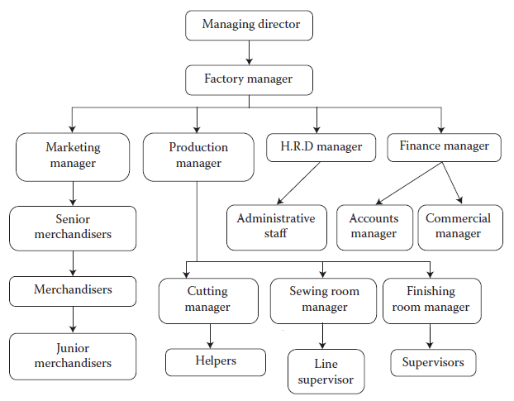
2.9 Organizational Structure

Chapter Three

Cash Management System at Anjuman Group

3.1 Cash Management System of Company

The association keeps up monetary adjusts through Depots asserted by the Anjuman Group taking all things together metropolitan territories. Checks/drafts got from customers in nearby territories shipped off accumulated resources in these records for close-by clearing. This decreased the typical aggregation period, henceforth extending the speed of cash inflows. Along these lines, holds accumulated in the stop towns traded to the administrative center or corporate monetary adjusts of the association reliably.

The association has a "getting course free from activity" with the bank at the administrative center that normally applies any of the resources traded from the station towns to settle the bank's cash credit progress and reduce its charge balance. These methods achieved the association's cost of eagerness diminished and controlled. The association places the comparable in transient hypotheses or instruments, for instance, Mutual Funds and Govt when the association has surplus resources. Qualities. Protections.

3.1.1 Process of Cash Management through Banking Department

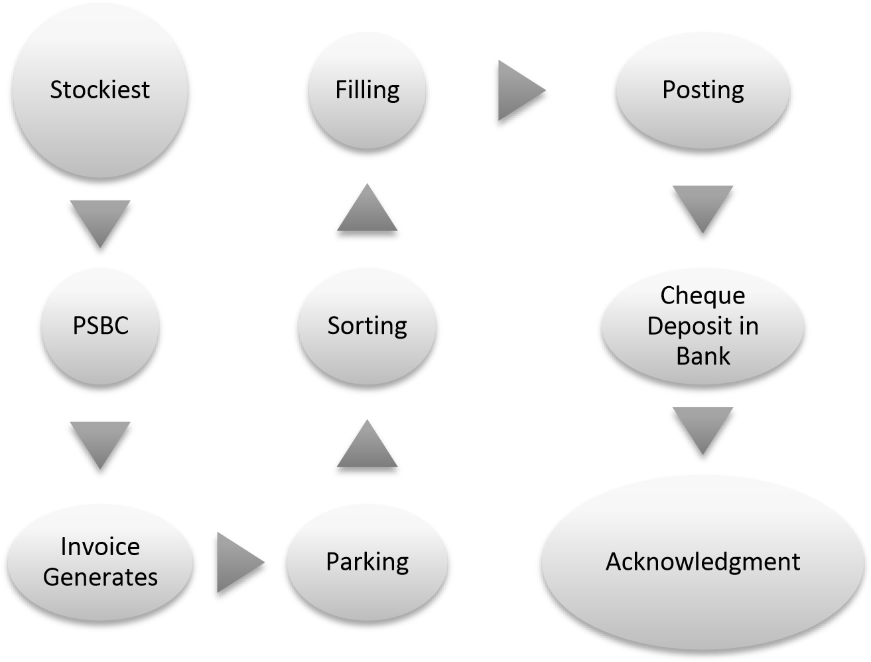

Company has “Pre-Signed Blank Cheques” (PSBC) from all the stockiest. The company receives at least 3 cheques from them. (Security Feature)

3.1.2 Terms and Conditions Set by Company
- For speed clearing (local, outside)- no charges
- For non- speed clearing (local, outside) - costlier, bank covers its expense in physically collecting cheques and compensation costs.

3.2 Payment System in Anjuman Group

These are the main three modes of Payment followed in Anjuman Group:

3.2.1 Cheque









If there is bouncing of Cheque, and then stockiest would have to pay 3 times the original amount to the company (Cheque bouncing amount). If the cheque is bounced more than 3 times the company would block that account.
Cheque Banked
Clearing next day
Bouncing Report
Reverse Document
Number
Update Bouncing File






Two Types of bouncing:

•
This means error through duplication, wrong
amount, missing Date or the Stockiest signature
etc.
Technical Bouncing
•
means signature mismatch, insufficient funds etc
Non
-
Technical Bouncing

3.2.2 Processing of Cheque in Anjuman Group


Cheque
comes in
Cheque
Inventory
Invoice Generation
PIS (Pay in Slip)
System allocates cheque against
invoice
On due date, Credit expiry report is
generated
Cheque is placed according to PIS
Next Day Posting is done
Then sent to bank

3.2.3 Endorsement of cheques

Special crossing stamp
All checks received over the bank counters for collection banded with special crossing stamps from the banks.

Dimension of special crossing stamp
Two parallel lines of length up to 2 inches between them at a distance of 1⁄4 inch. The bank name and branch to embedded in the enclosed space. Special crossing stamp position- Preferably at the top left corner with a 60-degree inclination to the base

Suggested specimen-

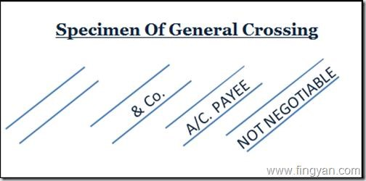

Extra Safeguard-The intersection stamp ought to be fastened in such a way, that to the degree conceivable it doesn't mutilate „A/C Payee‟ crossing made by the client.

Clearing Stamp

The clearing stamp shows details of the name of the presenting bank / branch (alpha codes), presentation date and clearing type. Encoding machines are programmed to simultaneously apply the clearing stamp on the back of the check while encoding the amount.

3.2.4 Speed Clearing

What is Speed Clearing?
The affiliation keeps up money-related changes through Depots attested by the Anjuman Group inside and out metropolitan zones. Checks/drafts got from clients in close-by zones delivered off gathered assets in these records for close-by clearing. This diminished the customary total period, subsequently broadening the speed of cash inflows. Thusly, saves collected in the stop towns exchanged to the managerial focus or corporate financial changes of the affiliation dependably.

The affiliation has a "getting course liberated from movement" with the bank at the authoritative focus that typically applies any of the assets exchanged from the station towns to settle the bank's cash credit advance and decrease its charge balance. These strategies accomplished the affiliation's expense of excitement reduced and controlled. The affiliation puts the indistinguishable in transient theories or instruments, for example, Mutual Funds and Govt when the affiliation has surplus assets. Characteristics. Assurances.

Why Speed Clearing?
A social affair of outstation checks, earlier improvement of checks from the Presentation Center (a town where the check is presented) to Drawee Center (a town where the check is payable), which expands the ideal chance for checks to be made. The objective of Speed Clearing is to decrease the time taken to perform outstation checks. Even though speed clearing stimulates the check gathering measure stood out from outstation check amassing, it pre-expect that the drawee bank office is accessible in the clearinghouse region.

What was the cycle followed by banks for the assortment of outstation checks before the presentation of Speed Clearing?
A person who used an outstation check to store it with the piece of his/her bank. This piece of the bank known as the piece of Presenting. The check shipped off the city where it was paid/drawn called Destination Center or Drawee Center for amassing. The branch that gives the organization of social occasion known as the piece of aggregation. Unending inventory of the check, the Collecting branch uses the zone of the cabinet bank office to present the actual instrument in area clearing. At the point when the check has paid, the piece of Collecting uses it to dispatch the profits to the piece of Presenting. The customer's record was a perpetual inventory of the check's execution counsel from the Collecting branch. This, thus, is the collection technique before Speed Clearing introduced.

Right when a bank recognized be careful with an aggregation premise, the record of the customer credited just after the profits made. The Presenting branch sent the check directly to the Destination branch for a portion without a clearing plan at the Destination center. Showing branch seeks after the demonstration of crediting the customer's record after tolerating the profits from the Destination branch. How much does it take to get a get-together-based outstation check credit? Dependent upon the drawee center and amassing approaches, it largely requires around seven days to three weeks to get outstation looks carried on a social event premise.

How does the Local Check Clearing Work?
In Local Check clearing insignificant focuses, checks handled by utilizing Check Truncation Systems (CTS) through the development of pictures. Matrix-based CTS set up in Dhaka, Rajshahi, and Moyamensing. Furthermore, Express Check Clearing Systems (ECCS) application bundle utilized in little clearinghouses. Nearby clearing handles just those watches that drawn on branches inside the ward of the neighborhood Clearing House. For the most part, the ward is resolved considering the coordinations accessible to genuine move to and from the Clearing House.

How Does the Speed Clearing Work?
By actualizing Core Banking Solutions (CBS), banks have organized their branches. Checks can paid to the Drawee branch at any area in the CBS climate, staying away from the requirement for their actual development. Under the Speed Clearing game plan, checks drawn on a Drawee bank's outstation CBS branches can be prepared in the Local Clearing if the Drawee bank has a branch presence at the nearby focus.

When Will the Beneficiary Get Funds Under Speed Clearing?
As of date, the nearby checks are prepared on a T+1 working day premise and clients get the advantage of the withdrawal of assets on a T+1 or 2 premises. 'T' signifies exchange day viz. date of introduction of check at the Clearing House. Thus, the outstation checks under Speed Clearing will likewise be paid on a T+1 or 2 premises like some other nearby check.

What are the Charges for Checks Cleared through Speed Clearing?
With sway from April 1, 2011, no charges will be payable for checks of huge worth up to and including TK 1.5 lakh by Savings a/c customers. Banks would permitted to fix charges for the social events of various types of records for all characteristics and from Savings a/c customers for check of critical worth above TK.1.5 lakh. Charges fixed should be reasonable, prepared on a cost notwithstanding the reason and not as an abstract level of the assessment of the instrument and to be gathered directly with due dispersal to the customers of such charges.

How is Speed Clearing an Improvement over Collection Basis?
Outstation check aggregation through social affair premise takes around one to three weeks‟ time dependent upon the drawee center. Under Speed Clearing, it would be recognized on T+1 or 2 premises, say, inside 48 hours. Further Savings Bank customers need not reason any organization charge for a collection of outstation checks (regard up to TK.1.5 lakh) in Speed Clearing, which they may have to procure if such check assembled under social event premise.

3.2.5 Demand Draft
A procedure used by individuals to make trade portions beginning with one monetary equilibrium then onto the following. Solicitation drafts publicized as a respectably secure strategy for cashing checks. The genuine differentiation between premium drafts and standard checks is that solicitation drafts do not need an imprint to cash.

The association does not have a standard credit approach that could be associated with all customers. Alternatively, maybe, indisputable credit terms offered to each social occasion dependent upon various elements, for instance, the thing, place, worth, solicitation, and contention.

(A)Stockiest in Depots Town:

70% of the Company's greatest stock is situated in or around the "terminal towns." The association uses the cash the leader's system (CMS) offered by banks at these areas, the most stacked checks assembled until the completion of multi-day are put away the next morning in the close by the monetary equilibrium of the association from which the resources are traded to the corporate record.

These stockiest used to value a credited season of 5 days' sooner, notwithstanding, now, the association has reduced the scheduled opening to one day. Arrangements are routinely made on requesting draft purpose behind new stockiest. If a Stockiest checks bounce, the social occasion will simply have to make portions by interest draft. If social affair defaults on a portion (or a get-together's checks skip) more than once, by then the get-together would be needed to make portions simply because of the well-known interest draft for most of its trades with Anjuman Group in the coming year.

(B)Stockiest in Remote Areas:

The remainder of the 30% of the most stacked turnover occurs at distant areas from the station towns with no basic admittance to banks so that reasonably the "wherever check system is silly. Such stockiest and acknowledge downtime up to 10 days may be permitted. Overall, in 3-7 days, the cash credited to the record of the association.

Chapter Four

Application of SAP in Cash Management System

SAP means "Framework, Applications, and Products". In Anjuman Group, SAP utilized to oversee Cash inflow and outpouring proficiently and effectively. SAP Cash Management utilized to screen cash streams and to guarantee that you have adequate liquidity to cover your installment commitments.

4.1 Integration
SAP Cash Management is a subcomponent of SAP Financial Supply Chain Management. SAP Cash Management is composed with an extent of other SAP parts. For example, the liquidity gauge - in a medium to long stretch liquidity design - joins foreseen drawing nearer and dynamic portions in financial accounting, purchase, and arrangements.

4.2 Features
The Incomings area covers the following topics:
- Electronic and manual bank statements
- Payments
- Lockbox
- Polling
- Electronic and manual check deposits
- Bill of exchange presentation
- Memo record
Think about installment counsel, Interest count, and Returned seller checks managed the Checks subject. Cash center can be found in the Planning subject. Organizing moreover deals with the portion program, portion requests, bill of exchange presentation, update a record, and telephone list.

The Tools point covers the scattering to cash management systems.

The Information System focuses on deals notwithstanding different things with the Liquidity guess. You can use this to get the critical information for customer and vendor cash streams. The design of the cash position and business trades that impact the cash position is furthermore portrayed here. SAP Cash Management uses the cash position to reflect advancements in monetary adjusts, while improvements in the sub-record accounts are addressed using the liquidity gauge.

Further Topics Include:

Payment Advice Journal (entered and changed planned items), Compare and Check and Reconciliation with Cash Management.

In the Environment area you will find functions for transferring market data to the SAP System. Market data can be transferred using the file interface, real-time data feed or via the spreadsheet. The areas Worklist and Change master record are also described here.
Prerequisites
=In Data Setup you can find out what needs to be done before you can go live with SAP Cash and Liquidity Management.
There are various types of SAP modules but it is according to use of different- different departments like:





SAP
-
FI
•
Finance
SAP
-
SD
•
Sales
SAP
-
MM
•
Marketing
And many more

So Sap- FI is used for CMS in Anjuman Group. To have a control over its efficiency and effectivity, certain SAP t-codes (transaction codes) are to be remembered such as

“T- CODES | DETAILS
FBL5N | Customer Line Item
FBL3N | GL Line
ZCHEQINV | Cheque Entry, Deletion and Replacement
F-02 | SAP Posting
F-29 | SAP Posting for Overdue
YVIRTUAL | RTGS Posting
ZFI_F29 | Channel Finance Posting
F-32 | Clearing
ZFB03 | Voucher Printing
ZFBL3N | Report generation after posting of cheques
YCHLEAF | Check availability of Cheques
YCBR | After Parking check details of cheques
ZCCHQ | Bank Details
YCUSTDET | Customer Details
ZAPIS_NEW | Printing of Overdue Vouchers
YPIS_NEW | Parking

4.3 Displaying Cash Management & Forecast, Cash Management Position

Use

As referenced in the past cash management process, cash management and gauge/cash management position will be refreshed all through the whole SD process - beginning with the request, at that point charging record, trailed with cash receipt. The accompanying sub-procedure will currently display the cash receipt in Cash Management Position and those adjustments in the arranging aggregates related with the cash receipt shaped by open charging.

Procedure
Call up the transaction as follows:

Menu Path | Accounting | ® Cash Management  ® Information System  ® Reports on Cash  ® Liquidity Analyses  ® Liquidity Forecast
Menu Path | ® Treasury Management
Transaction Code | FF7B

- Enter the following data:

Field | In Side Bangladesh | Out Side Bangladesh
Company code
Cash management position | Select | Select
Liquidity forecast | Select | Select
Grouping | Total (all types of receipts/expenditures and bank data) | Total (all types of receipts/expenditures and bank data)
Display as of | Date of incoming payment | Date of incoming payment
Display in | EUR | USD
- Choose.
- Enter the following data:
Field | In Side Bangladesh | Out Side Bangladesh
Delta display with balances | Select (display changes per value date – as opposed to cumulative display) | Select (display changes per value date – as opposed to cumulative display)
- Choose.
If the date you entered as the planning date falls on a public holiday, the incoming payment reproduced on the next working day dependent on the value date.
- The system displays the bank accounts on which the cash receipts recorded.
- The cash receipt you posted has flowed into the value date dependent balance of the Inside Dhaka/Outside Dhaka group on the planning date you entered.
- In DBGEING (for Europe) or CBGEING (for North America), select the amount in the column for the planning date you entered and choose.

You should be able to find the incoming payment you posted in the list of displayed documents on the Line Items (Module Pool) Screen.

Choose three times.

Finally, you still need to check whether the amount in short-term cash management (=presentation of the expected cash receipt from the billing) has been reduced because of the incoming payment.

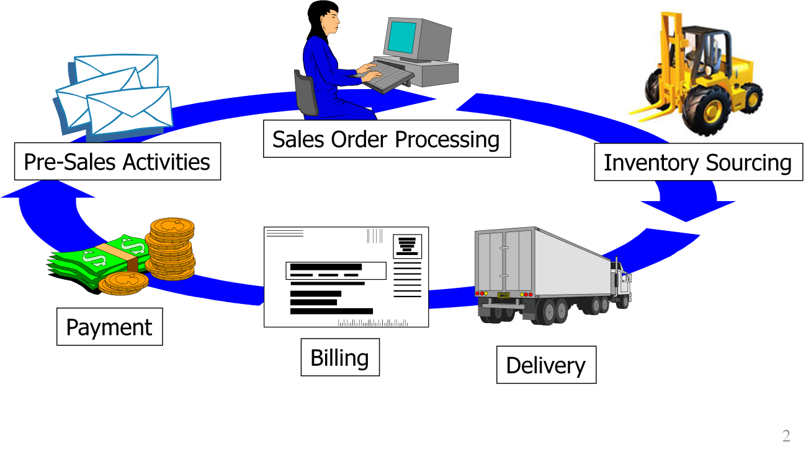
On the off chance that the date you entered as the arranging date falls on a Saturday or Sunday, the normal approaching installment duplicated on the following working day reliant on the esteem date. For outline reasons select new entry for this situation and enter the past working date as esteem date (for example short 1 or 2 days)!

- Double click on Persons.
Double-click on the F1 (FI customers/vendors) level to display the group of customers (already posted and thus billed values).
The sum displayed once again been reduced exactly by your billing amount as this is henceforth already displayed as an incoming payment on the bank account.

4.4 Sales Order Management in SAP R/3

SAP R/3 the "R" was for "Real-time data processing" and "3" was for "3-tier":

- database,
- application server, and
- Client (SAPgui).

This new architecture is compatible with multiple platforms, such as Microsoft Windows or UNIX, and operating systems. This opened SAP to an entirely new base of customers. The order to receive cash

SD: Sales and Distribution

⬥ Integrated with:

- Materials Management (MM)
- Production Planning and Execution (PP)
- Financial Accounting (FI)
- Configurable structures inside the product that speak to the legitimate as well as organizational perspectives on an undertaking
- Organizational components structure a system supporting all business exercises in the way wanted and chose for a given occurrence of the product

4.4.1 Organizational Elements

- Client
- Company Code
- Sales Organization
- Distribution Channel
- Sales Division
- Sales Area
- Plant
- Storage Location
- Shipping Point

Chapter Five:

Agreed Terms and Conditions with Bank of Anjuman Group

These terms and conditions including terms under the segment of the particular assistance oversee the CMS and by marking the CMS assignment structure or potentially by tolerating the help proposition as well as by utilizing the Banks CMS, one consents to be limited by these T&Cs consistently.

5.1 Transfers Limited to Available Funds

The bank is under no commitment to consent to any installment guidance or to make any finance move that would surpass the accessible assets in as far as possible on the Customer accounts assigned for such installment guidance.

5.2 Confidentiality:

The sharing, stockpiling, or transmission about the Customer/his record subtleties inside the HSBC gathering or with any specialist ought to be on a secret premise.

5.3 Indemnity:
However long the bank complies with common decency, the Customer will reimburse the bank and hold the bank innocuous occasionally from any or all cases brought or caused by the bank.

5.4 Force Majeure:
The bank won't be answerable for non-execution or deferral in the presentation of at least one administrations brought about by conditions outside its ability to control like fire, correspondence/framework disappointment, and so forth

5.5 Change of Terms:
The bank may adjust, end, and suspend the administrations including the present T&Cs to the client whenever with or without notice, because of progress in principles, guidelines, and laws set by charge specialists or Bank arrangements.

5.6 General Undertaking from Customer:

He agrees and confirms that-
- Completely understands and is happy with all highlights of administrations advertised.
- He is exclusively liable for the exactness, fulfillment, and idealness of guidelines predetermined by the bank every occasionally.
- He approves the bank to charge his record and/or practice the privilege of setoff for any obligation caused by the bank for and because of the execution of installment, guidance gave by the client to the bank.
- The client will guarantee the security methodology set up by the bank for confirming that the installment request or correspondence is that of the client or for distinguishing a mistake in the transmission of the substance of the asset's exchange, solicitation, or correspondence follows.
- The client therefore addresses and warrants that these T&Cs have appropriately executed and conveyed by the properly approved delegate and establishes a legitimate, substantial, and restricting commitment of the client and will be enforceable against the client.
- The „Non-Residential External (NRE)‟ client will guarantee that the bank would specify the word „SOF NRE‟ in the „Tag70‟ or „Second Party Reference‟ field as proper while starting any RTGS, NEFT, IAT installments.
- Likewise, the client consents to give the Priority Payments File notate than the concurred cut-off date and time, which is liable to change now and again.

5.7 MIS/ Reports

Bank at its sole caution gives information including information, instruments, and reports to Customer identified with any concerned financial action.

5.8 Waiver

If a bank neglects to practice any privilege or advantage gave in T&Cs will not influence the predetermined administrations and stay in full power.

Chapter Six

Findings & Recommendations

6.1 Interpretation (SWOT Analysis)

Taking all things together stop towns, the association keeps up the monetary equilibrium. Checks/drafts got from customers in nearby regions are shipped off assemble resources in these records for close-by clearing. This diminished the typical social occasion time (when appeared differently in relation to the time it would take on the off risk that customer checks were first gotten at the home office and, by then sent outstation clearing) therefore growing the speed of cash inflows. Thusly, holds accumulated in the station metropolitan networks traded every day to the monetary equilibrium of the association's administrative center (or corporate). The association has a "getting course free from activity" with the bank at the administrative center that normally applies any resources traded from the station towns to set the bank's cash credit progress and decrease its charge balance. These methods achieved the association's cost of eagerness lessened.

Strength
At the point when the organization has surplus assets, it puts the equivalent in transient speculations or instruments like shared assets and government securities. With appearance of CBS and CTS, Anjuman Group has expanded its operational productivity and diminished its overheads and expenses. Here PC programming, for example, SAP utilized to perform center tasks of banking like-

- Recording transactions
- Interest calculations
- Customer Records
- Balance of payments
- Details of Withdrawal

Opportunity

The new stage has changed the way bank framework in Anjuman Group restricted. Works. Every one of the administrations in the Cash Management System have profited the corporate office and banking offices by-
- Shorter Clearing cycle
- Superior verification and reconciliation process
- No geographical restrictions and customers alike
- Reduction in operational risk and risks associated with paper clearing

Weakness

Moreover, a Company’s Cash Position said to be a better indicator of the health of its business, rather than its profit and loss statement. Hence knowing the cash position is crucial for every business to:
- Forecast when, how, and where cash needs may arise
- Determine which would be the best source for additional cash needs, and
- Be prepared to meet cash needs when they arise
For better visibility into the cash position across banks, across borders, cash managements crucial. It empowers businesses with the ability to forecast cash flows, plan future business strategies, and manage cash accordingly.
Threats

- No authorization to use some T-codes, which were restricted to Managerial Level.
- Data access not provided, as the information was highly confidential.

6.2 Findings
- Eliminating Disparate Systems: Diverse cash management answers for different sections advertised. Likewise, as organizations develop, it is progressively turning into a test to deal with these unique frameworks. Venders ought to subsequent build up a solitary stage that can uphold distinctive cash management items and administrations as the business develops.
- Customizable Solutions: Banks today offer all corporate clients comparable arrangements paying little heed to their size and business. Merchants ought to subsequent attempt to build up an adaptable stage that can meet the particular requirements of various organizations.
- Unified System: Incorporating corporate customer structures with banking systems can be very valuable in obliging internal systems with banking systems and can support bank-customer accounts in all cases. Furthermore, this offers vendors an extraordinary degree. Today, banks impact cash the load up structures as a gadget to amass long stretch trust with corporate customers, because these systems will draw in bank customers to empowered and manage their liquidity position at some irregular time, as such structure trust and strengthening the relationship that goes past trade banking.

6.3 Recommendations of the Study

The shortfall of control over cash streams and inefficient cash management can be risky to organizations. When in doubt, it is the rash management of cash that has made associations missed the mark. Incredible cash management is in like manner a requirement for associations. Associations overwhelmingly rely upon understanding their cash position to administer working capital necessities, for instance, mentioning stock, unrefined material, or Acquisitions/expansion program, for which they need an indisputable considered how a great deal of cash is required, and when. The Efficient Cash Management System engages this.

Here are Some Areas with Scope for Improvement:

- Eliminating Disparate Systems: Distinctive money the executive’s arrangements offered for various portions. Furthermore, as organizations develop, dealing with these disparate frameworks is progressively turning into a test. Thus, organization should concoct a solitary platform, which can bolster different money the executive’s items and administrations as the business develops.
- Customizable Solutions: Company should try to come up with a customizable platform, which can cater to the specific needs of different businesses.
- Unified System: Integration of corporate client frameworks with banking frameworks can be useful in reconciliation of inner frameworks with banking frameworks, and can bolster account the board between the bank and client. What's more, this offers great degree for sellers.
Today, organization is utilizing Cash Management System as an apparatus to construct long haul trust with their clients, in light of the fact that these frameworks will engage them and oversee organizations and their situation at some random time, consequently assembling a trust and fortifying the relationship that goes past exchange banking.

Conclusion
With growing recognition of the need to adopt Cash Management Strategies, company is achieving and expecting more efficiency and effective solutions around –
- standardization,
- reconciliation,
- integrated banking systems with corporate systems, and
- Real-time reporting for overall view of the existing cash position.
In all parts of budgetary arranging and control, the fund office is included. It keeps up a quarterly score card that helps the organization in assessing worker execution as far as Company Cost (CTC). Administrative compensation comprises of a fixed pay in addition to execution put together rewards based with respect to an assortment of parameters, including keeping stock dimensions and different things of working capital inside concurred limits. The office is likewise planning MIS and imparting the equivalent to every one of the offices concerned. It additionally screens stock management, indebted individuals and loan bosses on a progressing premise to guarantee that net working capital stays inside the dimensions planned. For instance, if, because of some unavoidable conditions, the interest in stock surpasses as far as possible, it must balance by either an expansion in banks or a decrease in indebted individuals.

References

- http://www.Anjuman Groupltd.com/about_us
- "Careers in Credit - NACM North Central". www.nacmnc.org. Retrieved 2017-11-28.
- NACM. "The National Association of Credit Management: Certification Programs". nacm.org. Retrieved 2016-07-05.
- Credit Risk Management - Code of Best Practice
- Chartered Institute of Credit Management website
- Treasury Bills, TreasuryDirect.gov. U.S. Department of Treasury, Bureau of Public Debt. April 22, 2011. Retrieved May 24, 2011.
- Kenneth D. Garbade (July 2008). "Why The U.S. Treasury Began Auctioning Treasury Bills in 1929" (PDF). Federal Reserve Bank of New York, Vol. 14
- Pender, Kathleen (December 3, 2007). "Treasury takes new whack at savings bonds". The San Francisco Chronicle. Hearst. Retrieved February 14, 2007.
- Pender, Kathleen (July 13, 2011). "Treasury takes new whack at savings bonds". Treasury Department News Release. Treasury. Retrieved November 25, 2011.
- Treasury Bills, TreasuryDirect.gov. U.S. Department of Treasury, Bureau of Public Debt. April 22, 2011. Retrieved May 24, 2011.

Bibliography:
These SAP Screenshots were taken on Testing Servers
