SEISMIC PERFORMANCE STUDY
AND COMPARISON OF RC BUILDING COLUMN AT DIFFERENT ZONE IN BANGLADESH

A Thesis submitted by

SM Imrul Hasan
Student Id: 171-47-030
Mahedi Hasan Dipu
Student Id: 171-47-040
Abdullah Al Mamun
Student Id: 171-47-048

In Partial fulfilment of the requirement for the degree of
BACHELOR OF SCIENCE IN CIVIL ENGINEERING

Under The Supervision Of

ABU HASAN
Lecturer


DEPARTMENT OF CIVIL ENGINEERING
DAFFODIL INTERNATIONAL UNIVERSITY
MARCH 2021
Certification
This is to certify that this project and thesis entitled “Seismic Performance Study And Comparison of RC Building Column at Different Zone in Bangladesh” is done by the following students under my direct supervision and this work has been carried out by them in the laboratories of the Department of Civil Engineering under the Faculty of Engineering of Daffodil International University in partial fulfilment of the requirements for the degree of Bachelor of Science in Civil Engineering.

Signature of the candidates

Name: SM Imrul Hossain
ID : 171-47-030

Name: Mahedi Hasan Dipu
ID : 171-47-030

Name: Abdullah al Mamun
ID : 171-47-048

_____________________
ABU HASAN
Lecturer
Department Of Civil Engineering
Faculty of Science and Engineering
Daffodil International University

BOARD OF EXAMINERS

____________________________
Dr. Miah M. Hussainuzzaman Chairman
Associate Professor & Head
Department of CE, DIU

Dedicated to

Our Parents

CONTENTS
List of Tables | vii
List of Figures | viii-ix
Acknowledgement | x
Abstract | xi

CHAPTER 1: INTRODUCTION 1-3
1.1 General | 1
1.2 Background and present state of problems | 2
1.3 Objective with specific Aims and possible outcome | 3
1.4 Methodology | 3

CHAPTER 2: LITERATURE REVIEWS 4-9

2.1 Introduction | 4
2.2 Previous study | 4-6
2.3 Major seismic sources | 7
2.4 Seismic Activity of Bangladesh | 7
2.5 Building Frame system | 7-8
2.5.1 Moment Resisting Frame system | 8
2.5.2 Intermediate Moment Resisting Frame. | 9
2.6 Bangladesh National Building Code(BNBC) | 9

CHAPTER 3: CASE STUDY OF SELECTED STRUCTURE 10-16

3.1 General | 10
3.2 Design criteria | 10
3.3 Loads | 11
3.4 Load combinations | 11
3.4.1 Combination of earthquake loading with other loadings | 11-12
3.5 Structural system | 12
3.6 Storey displacement | 12-13
3.7 Stability | 13
3.8 models | 13-16
3.9 software | 16

CHAPTER 4 : RESULTS AND DISCUSSION 17-37

4.1 General | 17
4.2 Analysis and result | 17
4.2.1 70 feet height of structure(7 storey building) | 17
4.2.1.1 Storey Displacement | 18-22
4.2.1.2 Base shear | 23
4.2.1.3 Column reinforcement Percentage | 23
4.2.2 60 feet height of structure(6 storey building) | 24
4.2.2.1 Storey Displacement | 24-28
4.2.2.2 Base shear | 29
4.2.2.3 Column reinforcement Percentage | 29
4.2.3 50 feet height of structure(5 storey building) | 30
4.2.3.1 Storey Displacement | 30-34
4.2.3.2 Base shear | 35
4.2.3.3 Column reinforcement Percentage | 35
4.3 Storey displacement comparison of different structures | 36
4.4 Base shear comparison of different structures | 37
4.5 Reinforcement comparison of different structures | 37

CHAPTER 5: CONCLUSIONS AND RECOMMENDATIONS 38-41

5.1 General | 38
5.3 Conclusions | 39
5.2 Recommendation for the future studies | 39
REFERENCE | 40-41
LIST OF TABLES

Table # Table Caption Page#

3.1 | Load combination (BNBC,2015) | 12
3.2 | Column schedule for 7,6,5 storied building | 14
4.1 | Storey displacement of EX direction for Four seismic zone (7 storied building) | 18
4.2 | Storey displacement of EY direction for Four seismic zone (7 storied building) | 18
4.3 | Storey displacement of EX direction for Four seismic zone (6 storied building) | 24
4.4 | Storey displacement of EY direction for Four seismic zone (6 storied building) | 24
4.5 | Storey displacement of EX direction for Four seismic zone (5 storied building) | 30
4.6 | Storey displacement of EY direction for Four seismic zone (5 storied building) | 30

LIST OF FIGURES

Figure# Figure caption Page#
2.1 | Moment Resisting Frame | 8
3.1 | Column layout plan for 7.6.5 storied building | 14
3.2 | Front elevation view of 7 storied building | 15
3.3 | Front elevation view of 6 storied building | 15
3.4 | Front elevation view of 5 storied building | 16
4.1 | Displacement curve for zone-1 (EX) | 19
4.2 | Displacement curve for zone-1 (EY) | 19
4.3 | Displacement curve for zone-2 (EX) | 20
4.4 | Displacement curve for zone-2 (EY) | 20
4.5 | Displacement curve for zone-3 (EX) | 21
4.6 | Displacement curve for zone-3 (EY) | 21
4.7 | Displacement curve for zone-4 (EX) | 22
4.8 | Displacement curve for zone-4 (EY) | 22
4.9 | Base shear in four seismic zone | 23
4.10 | Reinforcement percentage of column in four seismic zone | 23
4.11 | Displacement curve for zone-1 (EX) | 25
4.12 | Displacement curve for zone-1 (EY) | 25
4.13 | Displacement curve for zone-2 (EX) | 26
4.14 | Displacement curve for zone-2 (EY) | 26
4.15 | Displacement curve for zone-3 (EX) | 27
4.16 | Displacement curve for zone-3 (EY) | 27
4.17 | Displacement curve for zone-4 (EX) | 28
4.18 | Displacement curve for zone-4 (EY) | 28
4.19 | Base shear in four seismic zone | 29
4.20 | Reinforcement percentage of column in four seismic zone | 29
4.21 | Displacement curve for zone-1 (EX) | 31
4.22 | Displacement curve for zone-1 (EY) | 31
4.23 | Displacement curve for zone-2 (EX) | 32
4.24 | Displacement curve for zone-2 (EY) | 32
4.25 | Displacement curve for zone-3 (EX) | 33
4.26 | Displacement curve for zone-3 (EY) | 33
4.27 | Displacement curve for zone-4 (EX) | 34
4.28 | Displacement curve for zone-4 (EY) | 34
4.29 | Base shear in four seismic zone | 35
4.30 | Reinforcement percentage of column in four seismic zone | 35
4.31 | Displacement of 7,6,5 storey building along x direction for four seismic zone | 36
4.32 | Displacement of 7,6,5 storey building along y direction for four seismic zone | 36
4.33 | Base shear of 7,6,5 storey building for four seismic zone | 37
4.34 | Reinforcement percentage of 7,6,5 storey building for four seismic zone | 37

ACKNOWLEDGEMENT

The author would like to thank the Almighty ALLAH for His unlimited blessing, kindness and graciousness and for giving him strength and ability to understand and complete the thesis.
The author wishes to express his sincere appreciation and gratitude to his supervisor, Abu Hasan, Lecturer, Department of Civil Engineering, DIU, for his invaluable suggestions and support, continuous guidance and inspirations, and continued encouragement throughout the progress of the research work.
The author is also grateful to Dr. Miah M. Hussainuzzaman, Associate Professor and Head and Dr. Mohammad Hannan Mahmud Khan, Assistant Professor& Associate Head, Department of Civil Engineering, DIU, for his guidance and inspiration at the initial stage of the study.
Apart from that, we would like to thank our entire friends for sharing knowledge; information and helping us in making this project a success. Also thanks for lending us some tools and equipment.
To our beloved family, we want to give them our deepest love and gratitude for being very supportive and also for their inspiration and encouragement during our studies in this University.

The authors are thankful to their well-wishers.

ABSTRACT

Bangladesh is situated in a seismically active region. Part of the country extended from Sylhet to Chittagong is in the high seismic zone whereas Dhaka lies in the moderate seismic zone and Khulna lies in low risk zone. In the present situations of construction industry, the buildings that are being constructed are gaining significance, in general, those with the best possible outcomes which are referred to members like beams and columns in multi storeys R.C structures. ETABS mainly used for structures like RC buildings, steel and concrete structures. The paper aims to analyze a RC building by considering seismic, dead and live loads. The design criteria for RC buildings are strength, serviceability and stability. The version of the software used is ETABS 2016.In the present study, we will mainly determining base shear,Storey displacement and percentage of column reinforcements on structural system are subjected and also comparing the results of seismic zones1, 2, 3, and 4. this paper we observed that when we are increased the storey height for the same zone co-efficient ,displacement ,base shear and required reinforcement are increased but stability are decreased so we can say that the building designed in the lower zone may collapse in the design in the higher zone.
Chapter-1
INTRODUCTION

1.1 General
An earthquake is a shaking of the ground caused by the sudden breaking and movement of large sections (tectonic plates) of the earth's rocky outermost crust. The edges of the tectonic plates are marked by faults (or fractures). Most earthquakes occur along the fault lines when the plates slide past each other or collide against each other. Earthquakes can range in size from those that are so weak that they cannot be felt to those violent enough to toss people around and destroy whole cities. Hence, structure in such locations need to be suitably designed and detailed ensure stability , strength and serviceability with acceptable levels of safety under seismic effect.
Civil engineers are trained for linear analysis but for seismic resistant building design seismic evaluation and design process are needed. Seismic analysis is a subset of structural analysis and is the calculation of the response of a building structure to earthquakes. So to observe the behaviour of the structure seismic analyses are important. Structural detailing depends on different loads which subjected on structural elements such as lateral and axial loads. The building should be planned in such way that complete analysis of each component is possible.

1.2 Background and present state of problems
Earthquake is a natural calamity which cause huge loss of life as well as property, many People becomes homeless, children lost their parents, women becomes widow, affects the economy of a country very adversely. it takes many years to recover and compensate the loss cause due to earthquake. Tremors of earthquake can be realized from very far distance from its occurring place.
Earthquake is one the most devasting natural calamity in which earth surface shakes due to release of seismic energy from crust along fault. Earthquake has adverse effect on the building. when seismic waves are subjected on building the base of building starts shaking and eventually gets collapse. Seismic analysis is performed to understand response of building when subjected to earthquake.
Bangladesh is situated in a seismically active region. Part of the country extended from Sylhet to Chittagong is in the high seismic zone whereas Dhaka is in the moderate seismic zone. Major metropolitan cities of our country are under serious threat because of heavy earthquake load. Rapid urbanization creates a great demand on human shelter especially in big cities like Dhaka, Chittagong etc. As a result, a lot of multi-storeyed buildings are already built in order to fulfil the demand. BNBC has different provisions for earthquake load calculation and analysis procedure. For the regular structures, the Code defines a simple method to represent earthquake induced inertia forces by Equivalent Static Force for static analysis and we will mainly work for static analysis of the RC building. For this research we have to find out the percentage of reinforcement of the column and comparing the result of four seismic zone in Bangladesh.

1.3 Objective with specific Aims and possible outcome
1.To compare the RC Building Column at Different Zones in Bangladesh.
2. Comparing the column axial forces, displacement and reinforcement requirement in different seismic zones.
It may give an idea to the users and the designers about difference the axial forces column dimensions and reinforcement requirement and Cost analysis among columns for seismic zones in Bangladesh.
1.4 Outline of Methodology / Experimental Design
This study has been conducted by considering three different heights (50feet ,60 and70 feet) of intermediate dual framing concrete structures. For structural analysis and design of this building under seismic considerations frame will consider as an intermediate reinforced concrete structure (dual system). Plan length, width and elevation of the selected (70 feet height) building are 100ft, 75 ft and 70 ft, respectively. Length to width, length to height and width to height ratio of this (70 feet height) building are 1.33, 1.42 and 1.07, respectively. On the other hand, selected other building’s (60 feet height) plan length, width and elevation height are 100 feet, 75 feet and 60 feet, respectively. Ratios of plan length to plan width, plan width to building height, plan length to building height are 1.33, and 1.25 and 1.67 respectively and last five storey building ratio is 1.33 ,2 and 1.4.Structural analysis and design of this structural will be carried out by ETABS - 2016 software. MS Excel will be used to find out the total required materials according to analysis results. Comparative study will be carried on required materials cost for major structural frames such as beams and columns, among three seismic zones. All of this comparison will be presented graphically.

Chapter-2
LITERATURE REVIEW

2.1 Introduction
Bangladesh is a moderately seismic region. It is a known fact that earthquakes do not occur just anywhere. It tends to cluster around defined areas or lines. Bangladesh and its adjoining areas are situated in the northeast part of the Indian subcontinent where earthquakes frequently occur. This region lies along the border of Eurasian and Indo- Australian plates. The Plate Tectonic theory states that the earth's crust is composed of plates which move relative to one another because of natural forces acting on these plates. Ninety percent earthquakes occur along the boundary of these tectonic plates. volcanic eruption, manmade activities such as reservoir induced, excavation; mining etc. This chapter review the Important tectonic features of Bangladesh are discussed.

2.2 Previous Study
Several studies have been carried out on seismic action in various aspects by different researches. . But very few studies have been carried out for the seismic analysis of Bangladesh. . Bangladesh has divided into four seismic zones according to BNBC -2015 which was only three zones in previous BNBC. Present study will be carried out for a comparative study on a seismic performance analysis of a four seismic zones in Bangladesh. Various researches carried out on seismic action are given below:
Kude M.D., And Sepate M.V.,(2019) stated that in tall buildings lateral loads are premier one which will increase rapidly with increase in height. In this project a residential 10, 15 and 20 story building are studied for earthquake load using ETABS 2016. Assuming that material property is linear static and Response spectrum analysis is performed. These analyses are carried out by considering different seismic zones. These analyses are carried out by considering different seismic zones. Different response like story displacements, Time Period and Acceleration.
Mohammad Yeasin (2008) conducted a research work on seismic performance assessments for concrete frame structure. The objectives of the research were to develop a probabilistic hazard curve and make a contour map of PGA for Bangladesh.
DR.Reddy K.C., And Kumar G.L.,(2019) stated that this paper mainly focuses on studying the comparison of percentage of steel in the structure , when the building is designed for loads as per IS 456:2000 & for the earthquake forces in different seismic zones as per the code IS 1893:2002 (part 1) which suggests that maximum reinforcements should be provided for higher seismic zones, but it does not provide clear information about how much percentage of reinforcement can be used for various seismic zones. According to IS-875 Part-III clause 0.3.1 earthquake load considered along with followings, dead load, imposed load, snow load, special load and load combination. The percentages of reinforcement for the structure in seismic zone 2, zone 3, zone 4 and zone 5 are calculated.
Prajapati B.D., and Panchal D.R., (September, 2013) stated that, at first they are Consider the shape of the building like ellipse so that the wind will divert smoothly. They are also considering the time history analysis for the building by taking the previous data of the earthquake. Considering the foundation design based on soil condition both seismic and wind analysis considered on structure with respect to different results are compared with different earthquake zones (II, III, IV, V) as per IS: 1893-2002 and also consider wind analysis on the structure with different wind speeds as per IS:875 (part3):1987.
Sasidhar T., Avinash P. S., and Janardan N., (2017) stated that, the analysis and design of multistoried building with and without floating columns was done using static analysis. A residential multistoried building consisting of G+5 has been chosen for carrying out project work. The work was carried out considering different cases of removal of columns in different positions and in different floors of the building. The equivalent static analysis is done on the mathematical 3-D model of building and results have been compared. All the work was carried out by using the software ETabs Version 9.7.4.
Devi Dr.G.N., et.al, (2017) stated that, Two dimensional and three-dimensional finite element modeling (2D & 3D-FEM) of frame that can be used to investigate the response of base shear value of frame. A parametric study for static analysis is performed to investigate the effect of gravity load and lateral load on frame.
Reddy N.J., (2015) stated that, Shear walls are added to the building interior to provide more strength and stiffness to the building when the exterior walls cannot provide sufficient strength and stiffness. It is necessary to provide these shear walls when the tolerable span width ratio for the floor or roof diaphragm is exceeded. It is very necessary to find the efficient and ideal location of shear walls in symmetrical buildings to minimize the torsion effect. For the analysis of the building for seismic loading with two different Zones (Zone-II & Zone-V) is considered with a soil I & soil III types. The analysis of the building is done by using equivalent static method and dynamic method. The results from the analysis obtained from both the methods are presented in tabular form and the results are compared using graphical form.
Wang, Y., Zhang, J., and Yan, G., (2013) stated that, there is a certain gap in the Actual behavioral effects for simplifying the structural analysis model so the analysis results will different with real condition such as RC section reinforcement steel layout. Building information modelling (BIM) software combined with APP program which will establish the actual section and reinforcement effect of three dimensional member model. For this paper they applied BIM software AutoDesk Revit program to build a structural model including geometry and reinforcement in RC system and then convert it into ETABS analysis software and obtain regional structure behavior and explore real structural security.
2.3 Major Seismic Sources
Bolt (1987) analyzed different seismic sources in and around Bangladesh and arrived at conclusions related to maximum likely earthquake magnitude. Bolt identified the following four major sources which are Assam fault zone, Tripura fault zone, Sub - Dauki fault zone and Bogra fault zone.

2.4 Seismic Activity of Bangladesh
Bangladesh is possibly one of the country’s most vulnerable to potential earthquake threat and damage.The Seismic activity of Bangladesh is shown in Figure 2.2. An earthquake of even medium magnitude on Richter scale can produce a mass graveyard in major cities of the country, particularly Dhaka, Sylhet and Chittagong. Construction of new buildings strictly following building code or development of future controls on building construction is the activities, which will be functional in future. However, under the present stage of human occupancy, buildings, infrastructures and other physical structures of different areas of a city will not be equally vulnerable to any such shock. Earthquake vulnerability of any place largely depends on its geology and topography, population density, building density and quality, and finally the coping strategy of its people and it shows clear spatial variations. It is thus necessary to identify the scale of such variations and take necessary measurements to cope with that Geographically Bangladesh is located close to the boundary of two active plates: the Indian plate in the West and the Eurasian plate in the East and North. As a result the country is always under a potential threat to earthquake at any magnitude at any time, which might cause catastrophic death tolls in less than a minute.

2.5 Building Frame System
Building frame system is a structural system with an essential complete space frame providing support for gravity loads. Resistance to lateral loads is provided by shear wall or braced frame separately. In seismic zone 3 and 4 shear wall must be detailed. There no special detailing requirements for the shear walls in lower seismic zones. Wall bearing system, Moment resisting frame system, Dual system and Special structural system are main types of building frame systems. Different building frame systems are described below.

2.5.1 Moment Resisting Frame
Moment resisting frames are rectilinear assemblages of beams and columns, with the beams rigidly connected to the columns. Resistance to lateral forces is provided primarily by rigid frame action that is, by the development of bending moment and shear force in the frame members and joints. By virtue of the rigid beam and column connections, a moment frame cannot displace laterally without bending the beams or columns depending on the geometry of the connection. The bending rigidity and strength of the frame members is therefore the primary source of lateral stiffness and strength for the entire frame. Figure 2.4 is an example of a moment resisting frame building. Moment resisting frame system may be classified as special moment resisting frame, intermediate moment resisting frame and ordinary moment resisting frame. Different types of moment resisting frames has described below.

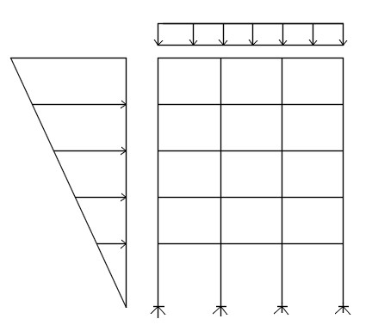

Fig
ure
: 2.1

Moment Resisting Frame.

Beam

Column

2.5.2 Intermediate Moment Resisting Frame
IMF is the next level up, designed to resist limited inelastic deformations as the result of lateral forces. As per the AISC, they must use pre qualified connections or have passed a qualifying cyclic test, proving their ability to sustain inter-story drift angle of up to 0.02 radians. Thus, IMF's are only installed in low- to mid-seismic regions.

2.6 Bangladesh National Building Code (BNBC)
The purpose of the code is to establish minimum standards for design, construction, quality of materials, use and occupancy, location and maintenance of buildings within Bangladesh in order to safeguard, within achievable limits, life, limb, health, property and public welfare. The updated BNBC- 15 has 10 parts with a total of 49 chapters. Part - 6 structural design has 13 chapter which is the maximum among all the parts. Seismic Zone expression of the proneness of a region earthquake occurrence in the historical past including the expectations in future. A region experiencing more frequent and large earthquakes has a higher seismicity compared to one with less frequent and small earthquakes. In the preparation of seismic zoning map the common data which are considered include Soil types, foundation conditions, ground structure and its dynamic characteristics, intensity distribution during past earthquakes, ground motion attenuation characteristics, envisaged development and location of major cities, economic status and simplification shape. According to BNBC 2015 the country has been divided into four seismic zones with different levels of ground motion. Figure 2.7 presents a map of Bangladesh showing the boundaries of the four zones. Each zone has a seismic zone coefficient ( Z ) which represents the maximum considered peak ground acceleration (PG) on very stiff soil/rock (site class SA) in units of g
(acceleration due to gravity). The zone coefficients (z) of the four zones are: Z = 0.12 (Zone 1), Z = 0.20 (Zone 2 ), Z = 0.28 (Zone 3) and Z = 0.36 (Zone 4)

Chapter-3
CASE STUDY OF SELECTED STRUCTURE

3.1 General
The main objective of this study is to find out the difference in analysis results and construction materials required of a structure due to seismic load in three different seismic zones of Bangladesh. The materials (reinforcement and concrete) those are generally available in Bangladesh. Three different heights ( 50ft,60ft and 70ft) of intermediate moment resisting frame structure has been considered for analysis and design to find out the variations of story displacement, base shear, maximum forces,reinforcements percentages of column in three seismic zones of Bangladesh. This chapter will discuss about design criteria, building loads, material property, structural system, response modification factor, structural stability, drift, overturning moment according to BNBC - 2015. Analysis and design of these structures have been carried out by using ETABS - 16. Various results have been discussed in chapter four.

3.2 Design Criteria
Building design criteria are those parameters which are required for analysis of a structure. Important parameters are structural element size and shape, material property, loads (dead load, live load, floor finish, partition walls loads, live load, seismic load, and wind load). Seismic zones, soil type, structural system, load combination are also most important for building analysis and design. In this study clayey sand( SC) type soil, compressive strength of concrete 3500 psi, yield stress of steel 72500 psi , intermediate moment resisting frame are considered for analysis and design of these building in four seismic zones of Bangladesh.

3.3 Loads
A building load is simply a force that a building frame needs to resist. Assessment of their effects is carried out by the methods of structural analysis. Dead loads, live loads, wind loads, and earthquake loads are load types that acting on a structure. In this study, selected live load, partition wall load and floor finish load are considered 42 psf, 40 psf and 25 psf, and 525 plf respectively.

3.4 Load Combinations
After establishing the design loads of the proposed project, the next thing to consider is to determine the appropriate design load combinations. Generally, load combination is composed of individual loads, i.e. dead load superimposed dead loads and live loads that are combined together to come up for a strength design and allowable stress design. By the ASCE7-10 (section 1.2.1) code definition, strength design is the product of the nominal strength and a resistance factor while the allowable stress design is composed of computed forces produced in the member by factored loads that shall not exceed the member design strength. Each design code and standards had a different recommendation when it comes to loading combinations. In this article, we will emphasize the design load combinations as recommended by ASCE7-10 for basic design load combinations with the touch of UBC94 seismic load combinations. Let us bear in mind that the use of design load and load combinations is depending on the approved code and standards authorize by your local authority having jurisdiction. Before we proceed into the lists of load combinations, let us take a look at the following symbols used: D= dead load, Ex = Earthquake Load, L = live load,pw=partition wall load,wx,wy=wind load.

3.4.1 Combination of earthquake loading with other loadings
When earthquake effect is included in the analysis and design of a building or structure, the provisions of load combinations are as per BNBC, 2015 presented in Table 3.1
Table: 3.1 Load Combinations (BNBC, 2015)
Serial | Basic Combination
1 | 1.4 ( D+F )
2 | 1.2 ( D+F+T) + 1.6 (L+H) + 0.5 (Lr or R )
3 | 1.2 D + 1.6 ( Lr or R ) + ( 1.0L or 0.8 W)
4 | 1.2 D + 1.6 W + 1.0 L + 0.5 ( Lr or R)
5 | 1.2 D + 1.0 E + 1.0 L
6 | 0.9 D + 1.6W + 1.6 H
7 | 0.9D + 1.0 E + 1.6 H

In which,
D = Dead load; L = Live load; E = Earthquake load; F = Lateral forces; R = Rain water load; Lr = Roof live load.
For design and analysis of this structure load combination no five has considered finding out the variation of story drift, story displacement, base shear difference, required reinforcement difference for four seismic zones in Bangladesh.
3.5 Structural System
Structural system is the particular method of assembling and constructing structural elements of a building so that individual elements transmit applied loads safely to the ground without exceeding the allowable stresses in the members. Moment resisting frames, bearing wall frames, dual system frames are basics types of structural systems. In this study a dual frames of structural system are considered.

3.6 Storey Displacement
Storey Displacement is the lateral displacement of the storey relative to the base. Story displacement is the absolute value of displacement of the storey under action of the lateral forces. The overall sway (horizontal deflection) at the top level of the building or structure due to wind loading shall be limited to 1 500 times of the total height of the building above ground.

3.7 Stability
Structure is in stable equilibrium when small perturbations do not cause large movements like a mechanism. Structure vibrates about it equilibrium position. Structure is in unstable equilibrium when small perturbations produce large movements and the structure never returns to its original equilibrium position. After analysis of a structure some parameter has been checked to see the structural stability. In this study drift, overturning moment, base shear and displacement has checked in for seismic zones in Bangladesh.

3.8 Models
For this study we considered 70ft, 60ft and 50ft of three storey building for this study Which plan and elevation shown in figure 3.1,3.2 ,3.3 and figure 3.4,3.5,3.6.same size of structural element are considered for the four seismic zone in Bangladesh. So the quantity of materials is varying for same structure in different seismic zone in Bangladesh. It is discussed chapter four.

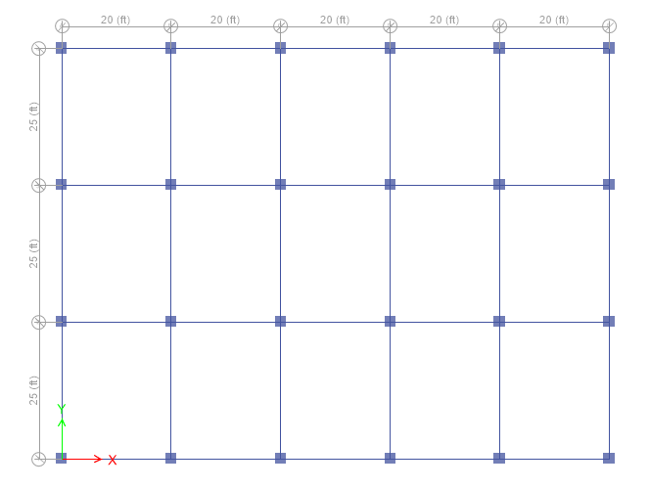
Figure: 3.1 column layout plan for 5, 6 and 7 storied building model
Number of Column | GF and 1st floor | 2nd floor to roof
C1-7 storied | 24x24 inch | 24x24 inch
C1-6 storied | 22x22 inch | 22x22 inch
C1-5 storied | 20x20 inch | 20x20 inch

Table 3.2: Column schedule for 5, 6 and 7 storied building

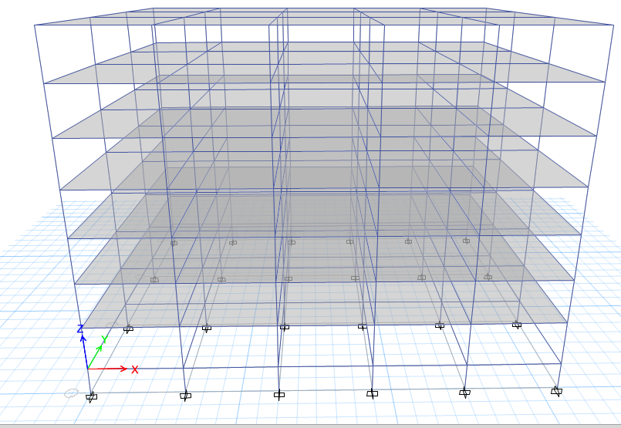
Figure 3.2: Front elevation view of 7 storeyed building

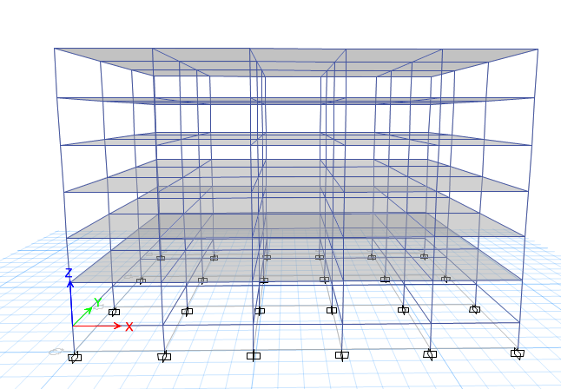
Figure 3.3: Front elevation view of 6 storeyed building

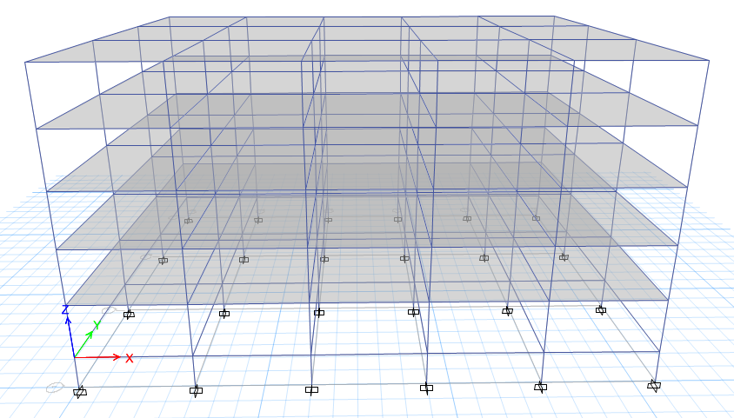
Figure :3.4: Front elevation view of 5 storeyed building

3.9 Software
Civil Engineering software encompass arrange of tools to help of civil engineers during both the design and construction process. Civil engineering software’s are Auto Cad, Revit, STAAD Pro, Sap -2000, ETABS, Rcon, Tekla, Matlab etc. Extended Three Dimensional Analysis of Buildings System (ETABS) non-leaner version 2016 has used for this study. Extended Three Dimensional Analysis of Building System (ETABS) has used for three different heights ( 50 feet,60feet and70 feet) intermediate dual frame structure analysis and design. Analysis results of story displacements discussed graphically in chapter four. Design results of structural member ( column ) also presented graphically in chapter four.
Chapter-4
RESULT AND DISCUSSION

4.1 General
Analysis and design has been carried out for three different heights of buildings (70 feet,60feet and 50 feet) are selected for this comparative study different for four seismic zones in Bangladesh. At first comparisons are carried out on analysis results such as story displacement, and base shear in four seismic zones in Bangladesh. Comparisons also carried out on design results of those structures, to find out the variation of required materials due to seismic loads in four seismic zones in Bangladesh. It is to be noted that here only column required reinforcement have been calculated for comparing of those structures. Comparisons are also carried out on required reinforcement per square feet of this structure in four seismic zones.

4.2 Analysis Results
These structures (70ft, 60ft and 50ft height) are analysed as an intermediate moment resisting frames.Load as considered as per as BNBC, 2015 which has been discussed in chapter three.Result have been compared,on storey displacement base share and require reinforcement percentage of this structures.

4.2.1 70 feet height of structure (7 stored building)
This structure is analyzed as a moment resisting frame system. Hence, constant wind velocity is considered in four seismic zones. Loads are considered as per BNBC, 2015 which has been discussed in chapter three. Results have been compared, on story deflection, story drift, base shear and required reinforcements per square area of this structure.

4.2.1.1 Storey Displacement
Storey displacement for seismic loads at X and Y direction are shown in figure 4.1,4.2,4.3,4.4,4.5,4.6,4.7,and 4.8. for four seismic zones. The maximum story displacements of this building in Zone -1, Zone - 2 and Zone -3, Zone - 4 are 1.13 inch, 1.83 inch and 2.60 inch, 3.56 inch, respectively for X direction and The maximum story displacements of this building in Zone -1, Zone - 2 and Zone -3, Zone - 4 are 1.37 inch, 2.28 inch and 3.20 inch, 4.25 inch, respectively for Y direction.

Table:4.1: Storey displacement of EX direction for four seismic zone
Zone | Maximum displacement (inch)
1 | 1.13
2 | 1.83
3 | 2.60
4 | 3.56

Table:4.2: Storey displacement of EY direction for four seismic zone
Zone | Maximum displacement (inch)
1 | 1.37
2 | 2.38
3 | 3.20
4 | 4.25

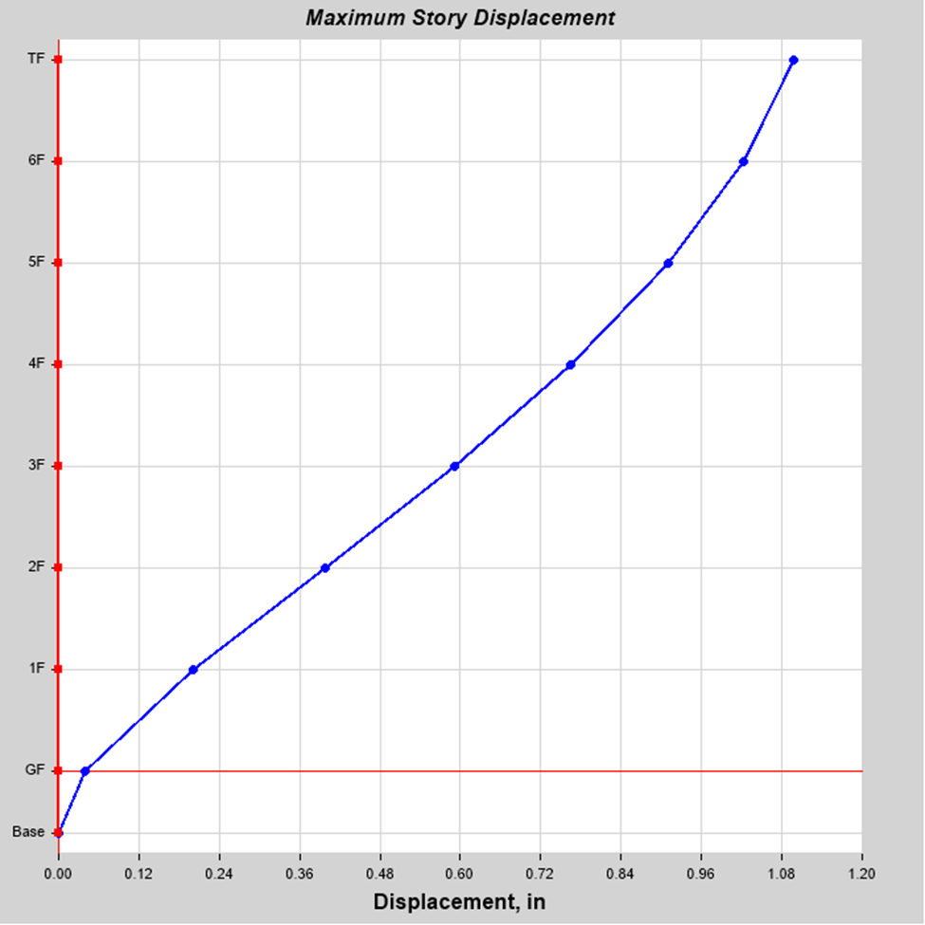
Figure:4.1 Displacement curve for zone-1 (EX)
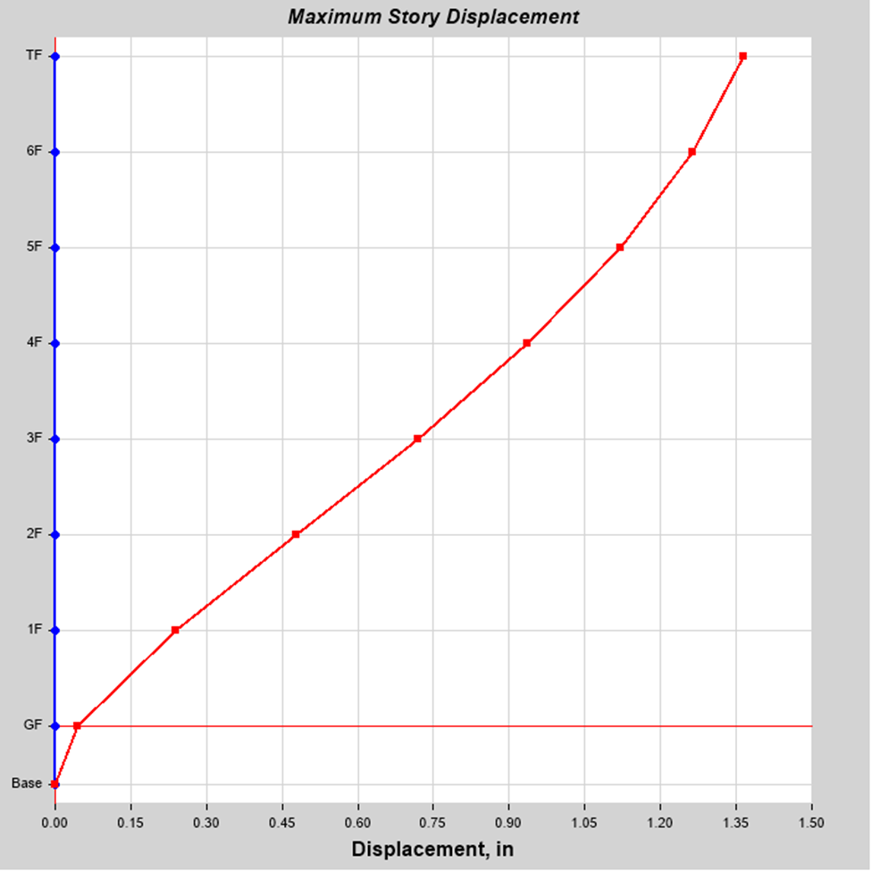
Figure:4.2 Displacement curve for zone-1 (EY)
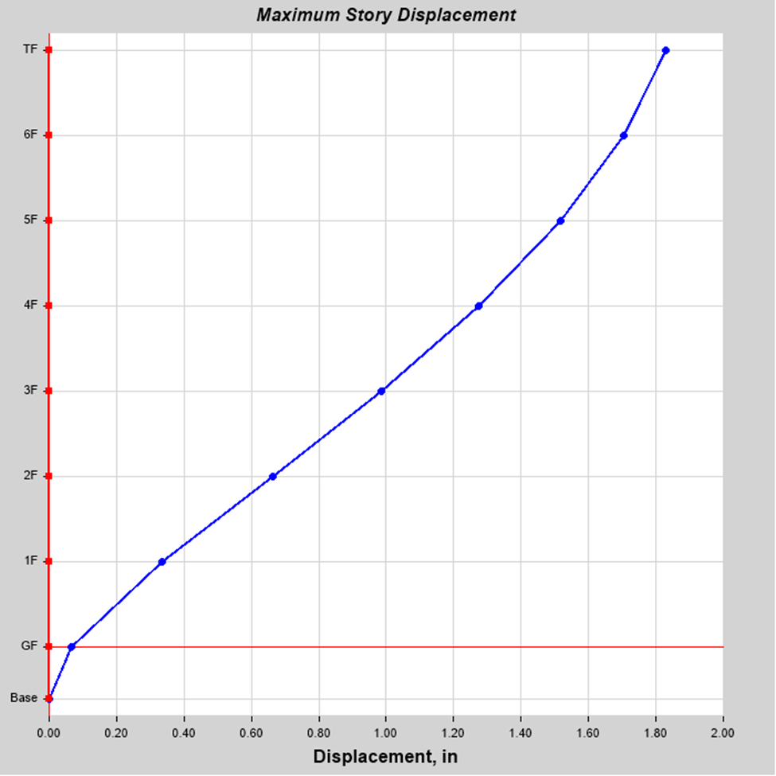
Figure:4.3 Displacement curve for zone-2(EX)
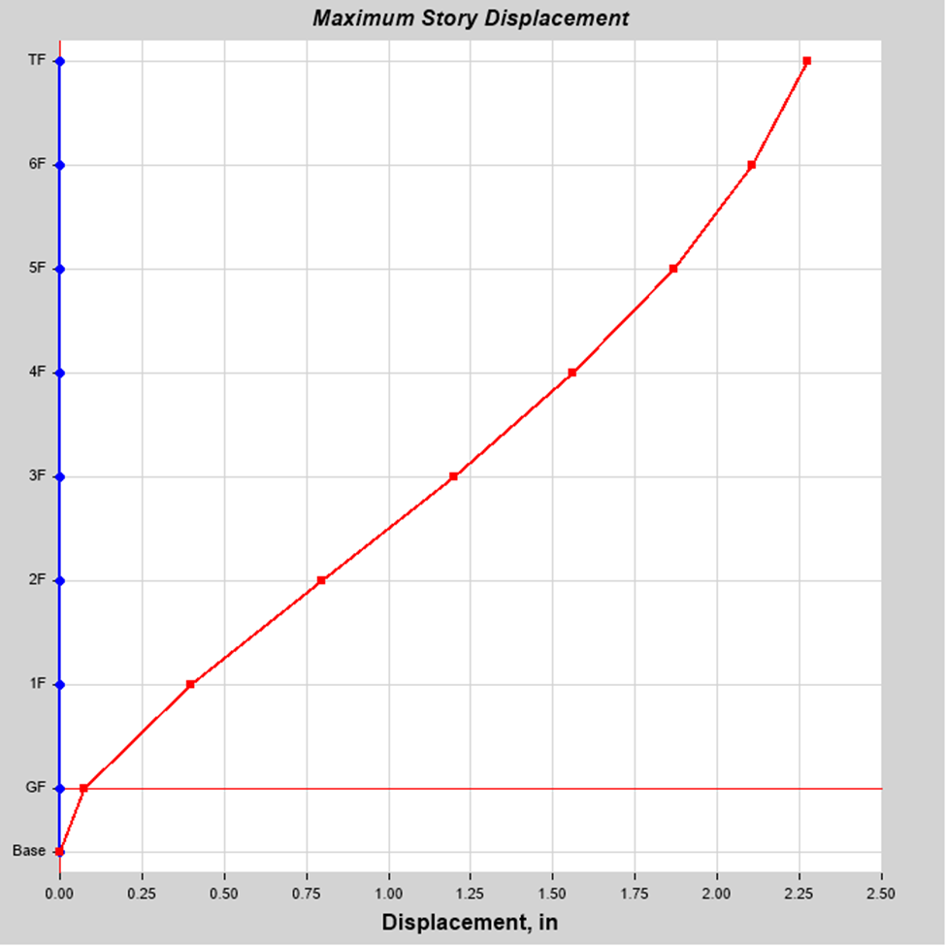
Figure:4.4:Displacement curve for zone-2(EY)
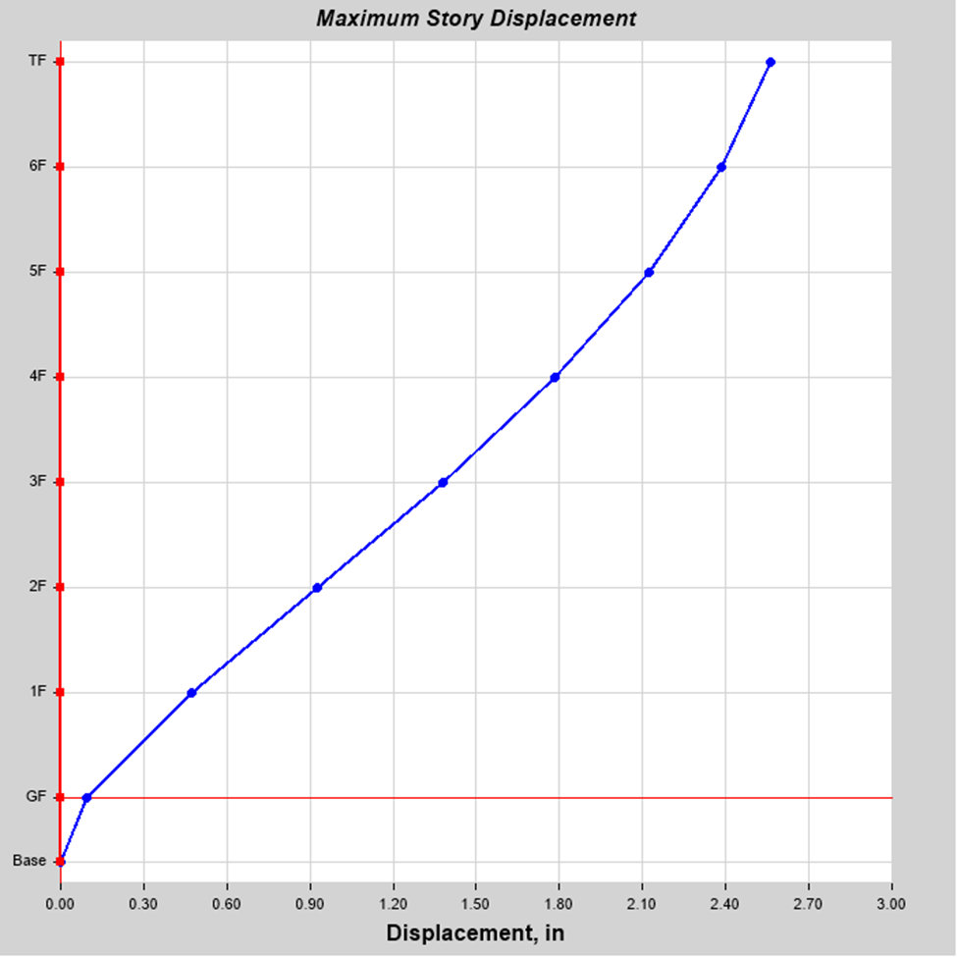
Figure:4.5:Displacement curve for zone-3 (EX)
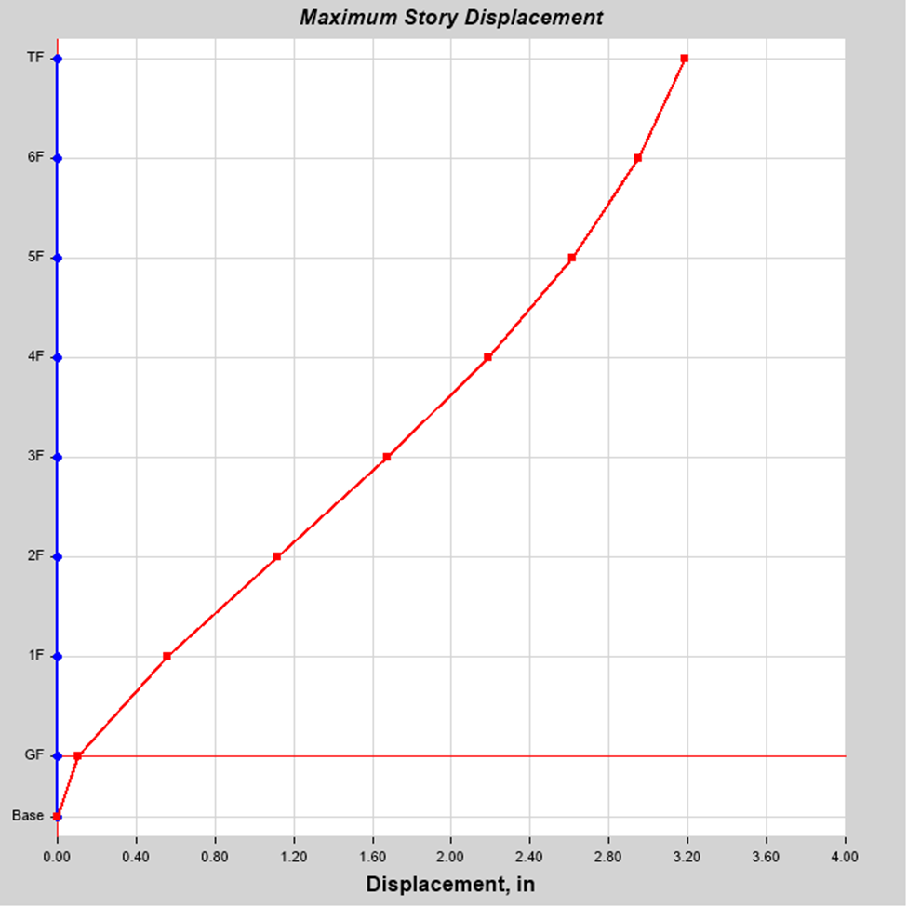
Figure:4.6:Displacement curve for zone-3 (EY)
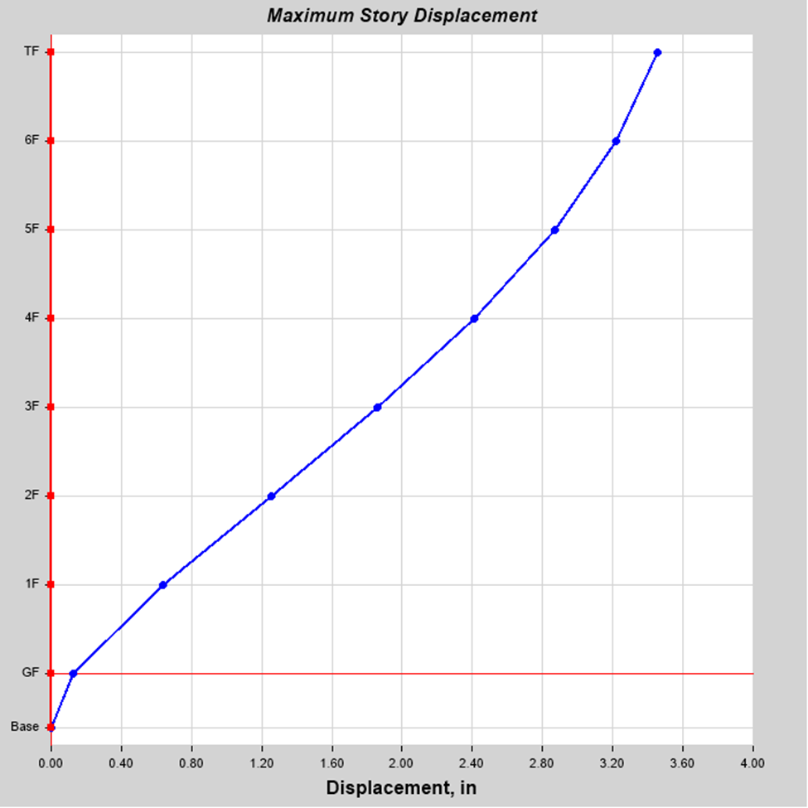
Figure:4.7:Displacement curve for zone-4 (EX)
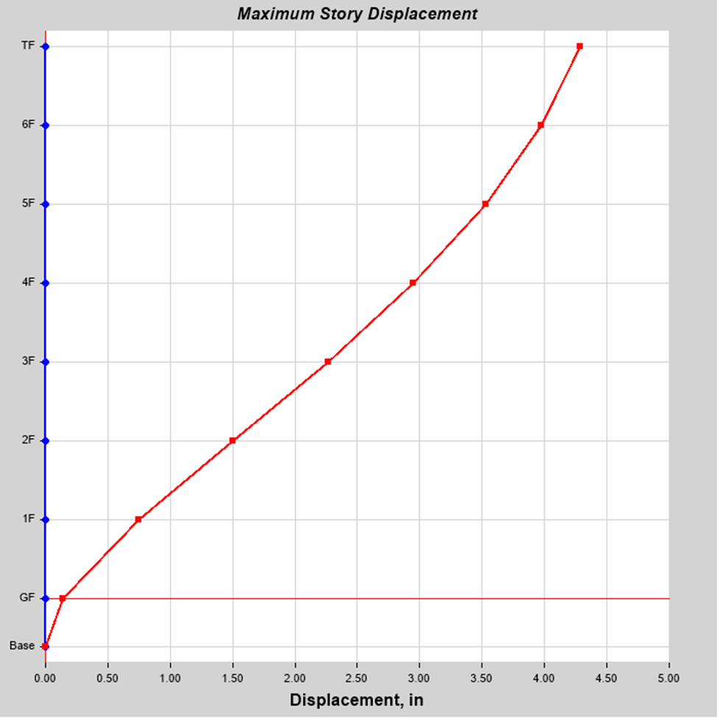
Figure:4.8:Displacement curve for zone-4 (EY)
4.2.1.2 Base Shear
Base shear is an estimate of the maximum expected lateral force that will occur due to seismic ground motion at the base of a structure. Calculations of base shear (V) depend on soil conditions at the site. Figure 4.9 shows the total base shear of this structure are 372 kips, 620 kips, 867 kips, and 1171 kips, respectively in four seismic zones.
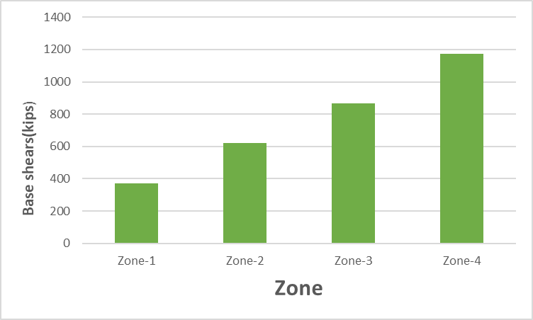
Figure:4.9 :Base shears in four seismic zone
4.2.1.3 Reinforcement percentage
It has observed that of this building due to seismic load the maximum reinforcement percentage for ground column is 2.19%,2.86%,2.98% and 4.28% respectively in four seismic zone.
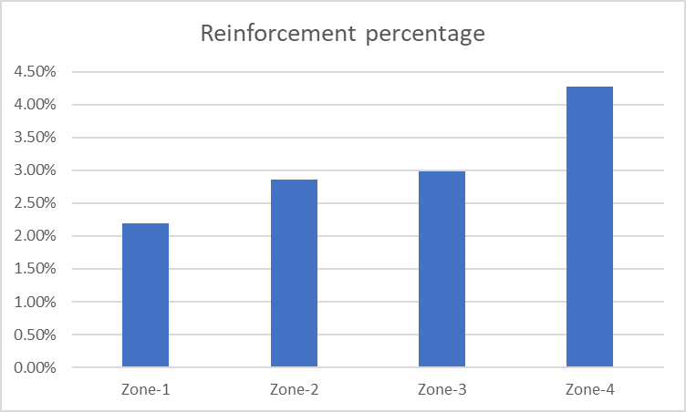
Fig:4.10 percentage of Column reinforcement in Different Seismic Zones.
4.2.2 60 feet height of structure(6 stored building)
This structure is analyzed as a moment resisting frame system. Hence, constant wind velocity is considered in four seismic zones. Loads are considered as per BNBC, 2015 which has been discussed in chapter three. Results have been compared, on story deflection, story drift, base shear and required reinforcements per square area of this structure.

4.2.2.1 Storey displacement
Storey displacement for seismic loads at X and Y direction are shown in figure 4.1,4.2,4.3,4.4,4.5,4.6,4.7,and 4.8. for four seismic zones. The maximum story displacements of this building in Zone -1, Zone - 2 and Zone -3, Zone - 4 are 0.94 inch, 1.52 inch and 2.20 inch, 2.85inch, respectively for X direction and The maximum story displacements of this building in Zone -1, Zone - 2 and Zone -3, Zone - 4 are 1.12inch, 1.85 inch and 2.65inch, 3.56 inch, respectively for Y direction.

Table:4.3:storey displacement of EX direction for four seismic zone
Zone | Maximum displacement(In)
1 | 0.94
2 | 1.52
3 | 2.20
4 | 2.85

Table:4.4:storey displacement of EX direction for four seismic zone
Zone | Maximum displacement(In)
1 | 1.12
2 | 1.85
3 | 2.65
4 | 3.56

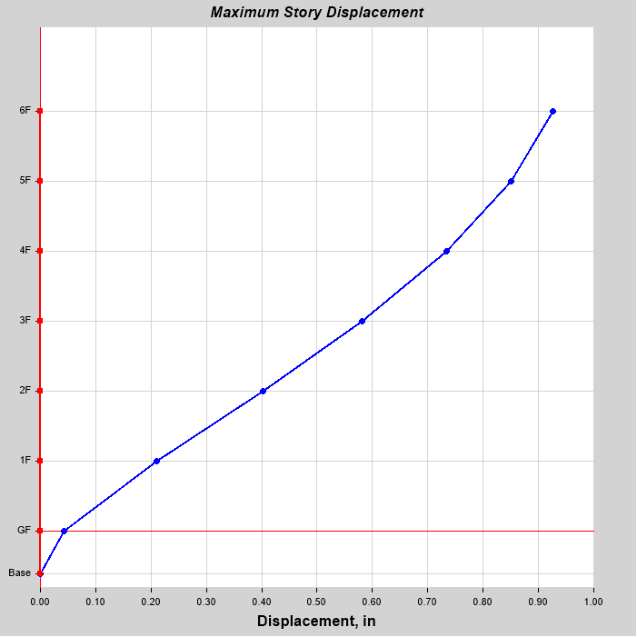
Figure:4.11:Displacement curve for zone-1 (EX)
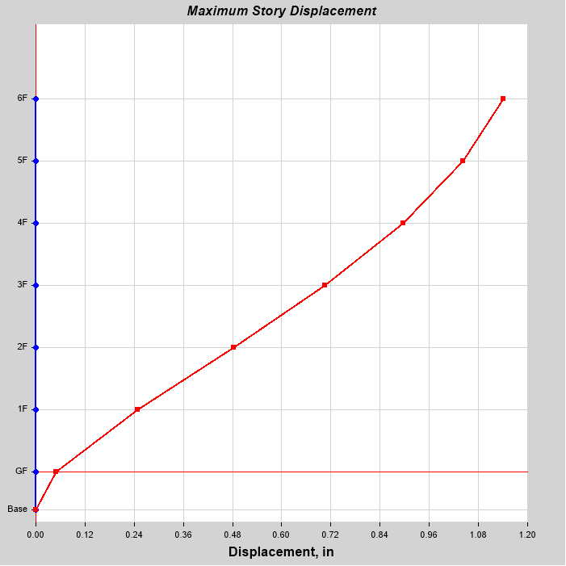
Figure:4.12:Displacement curve for zone-1 (EY)

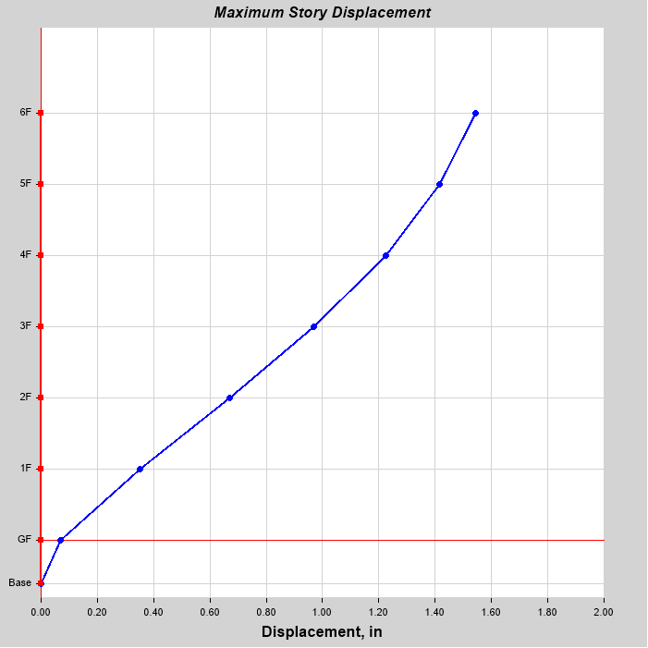
Figure:4.13:Displacement curve for zone-2 (EX)
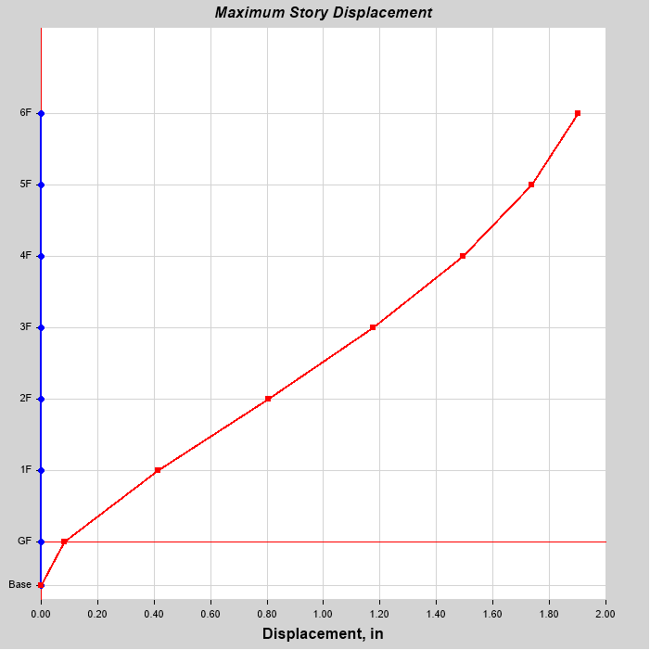
Figure:4.14:Displacement curve for zone-2 (EY)
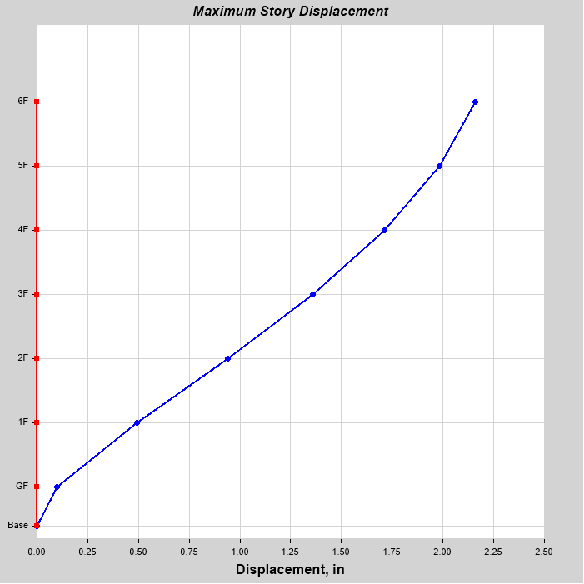
Figure:4.15:Displacement curve for zone-3 (EX)
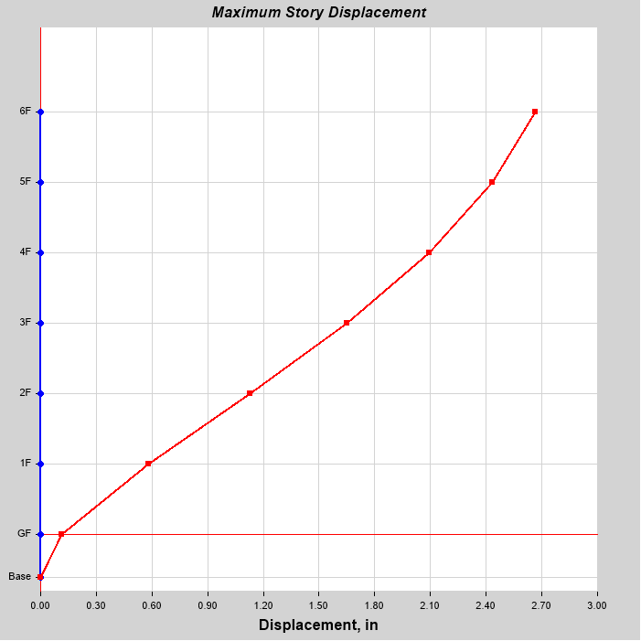
Figure:4.16:Displacement curve for zone-3 (EY)
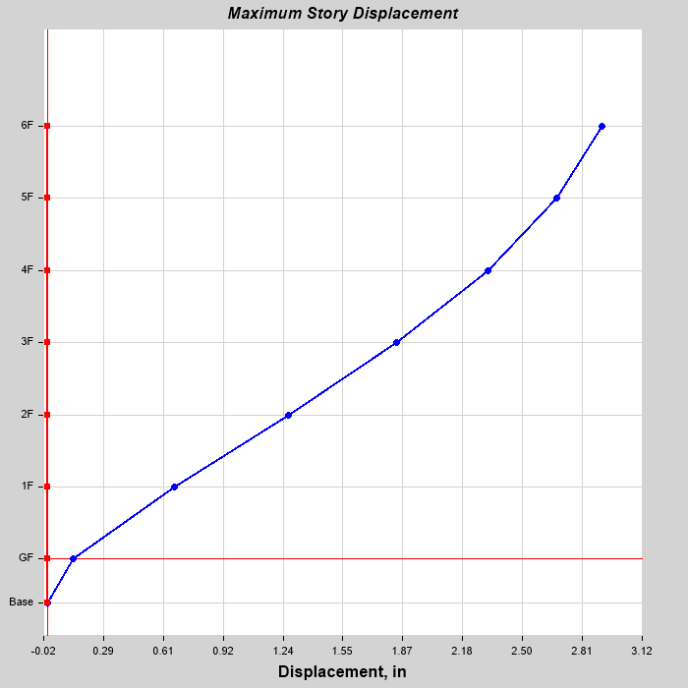
Figure:4.17:Displacement curve for zone-4 (EX)

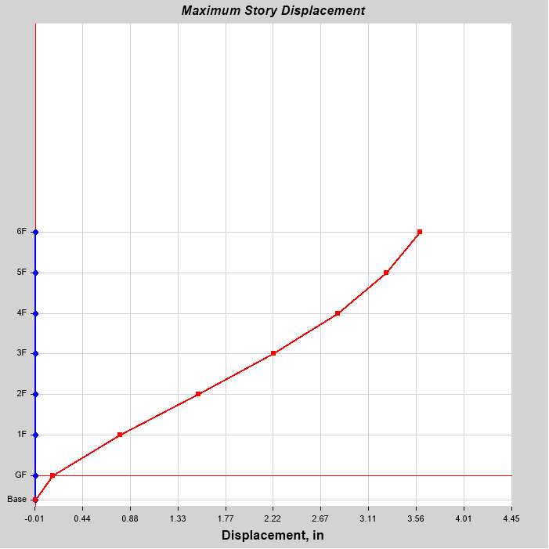
Figure:4.18:Displacement curve for zone-4 (EY)

4.2.2.2 Base Shear
Base shear is an estimate of the maximum expected lateral force that will occur due to seismic ground motion at the base of a structure. Calculations of base shear (V) depend on soil conditions at the site. Figure 4.19 shows the total base shear of this structure are 344 kips, 574 kips, 803 kips, and 1085 kips, respectively in four seismic zones.

Figure:4.19 Base shears in four seimic zone
4.2.2.3 Reinforcement percentage
It has observed that of this building due to seismic load the maximum reinforcement percentage for ground column is 2.34%,2.41%,3.49% and 4.91% respectively in four seismic zone.

Fig:4.20 Reinforcements column percentage in Different Seismic Zones.

4.2.3 50 feet height of structure (5 stored building)
This structure is analysed as a moment resisting frame system. Hence, constant wind velocity is considered in four seismic zones. Loads are considered as per BNBC, 2015 which has been discussed in chapter three. Results have been compared, on story deflection, story drift, base shear and required reinforcements per square area of this structure.
4.2.3.1 Storey displacement
Storey displacement for seismic loads at X and Y direction are shown in figure 4.21,4.22,4.23,4.24,4.25,4.26,4.27,and 4.28. for four seismic zones. The maximum story displacements of this building in Zone -1, Zone - 2 and Zone -3, Zone - 4 are 0.77inch, 1.30 inch and 1.80 inch, 2.85inch, respectively for X direction and The maximum story displacements of this building in Zone -1, Zone - 2 and Zone -3, Zone - 4 are 0.93 inch, 1.57 inch and 2.20 inch, 2.85 inch, respectively for Y direction.

Table:4.5:storey displacement of EX direction for four seismic zone
Zone | Maximum displacement(In)
1 | 0.77
2 | 1.30
3 | 1.80
4 | 2.85

Table:4.6:storey displacement of EY direction for four seismic zone
Zone | Maximum displacement(In)
1 | 0.93
2 | 1.57
3 | 2.20
4 | 2.85

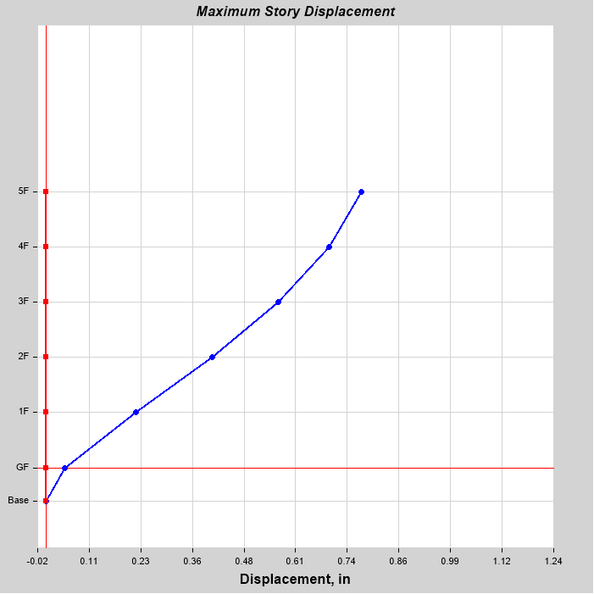
Figure:4.21:Displacement curve for zone-1 (EX)
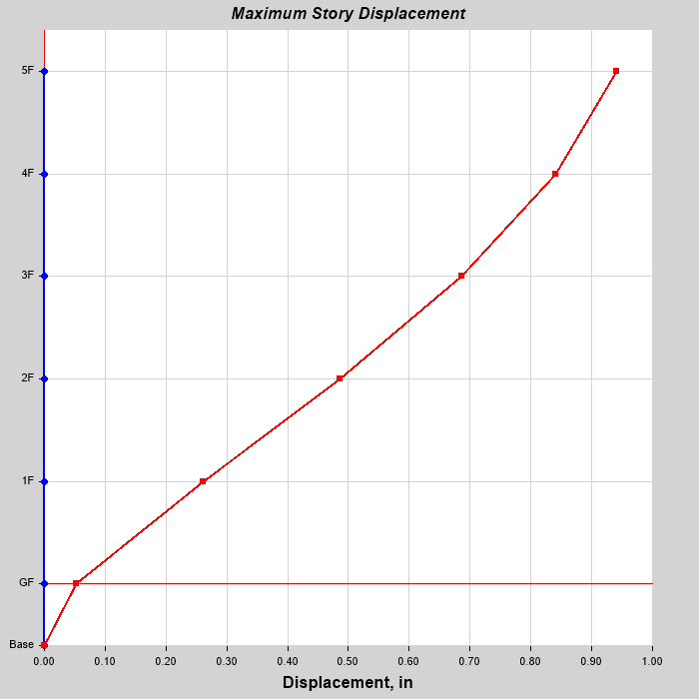
Figure:4.22:Displacement curve for zone-1 (EY)
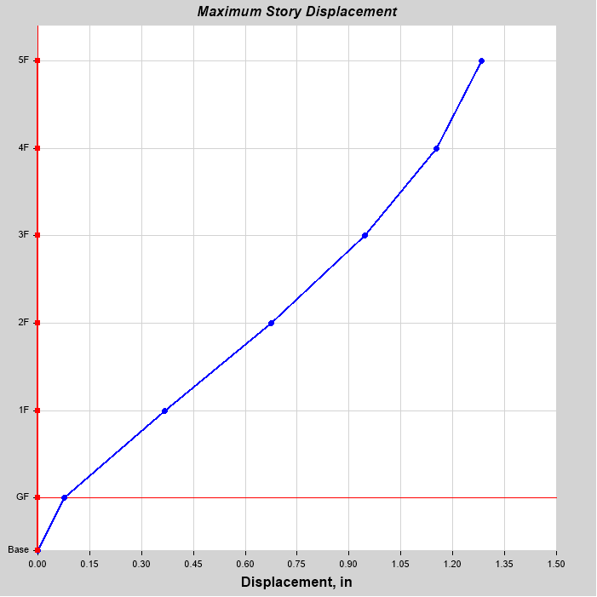
Figure:4.23:Displacement curve for zone-2 (EX)
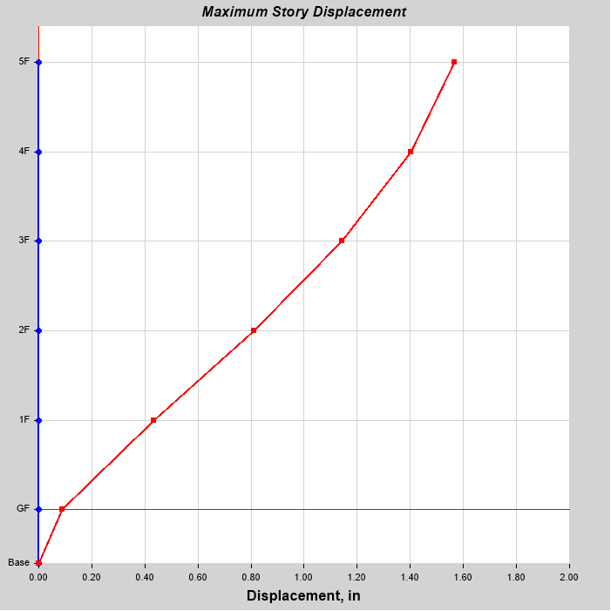
Figure:4.24:Displacement curve for zone-2 (EY)
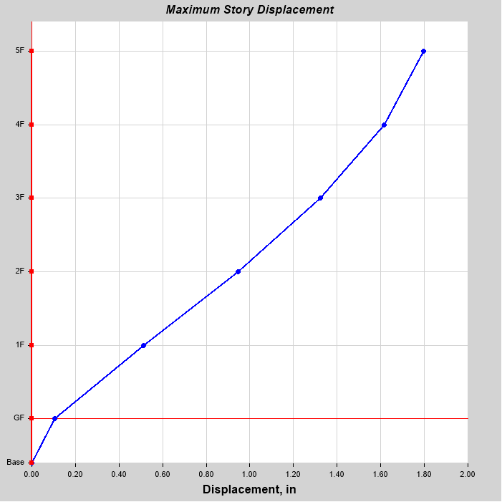
Figure:4.25:Displacement curve for zone-3 (EX)
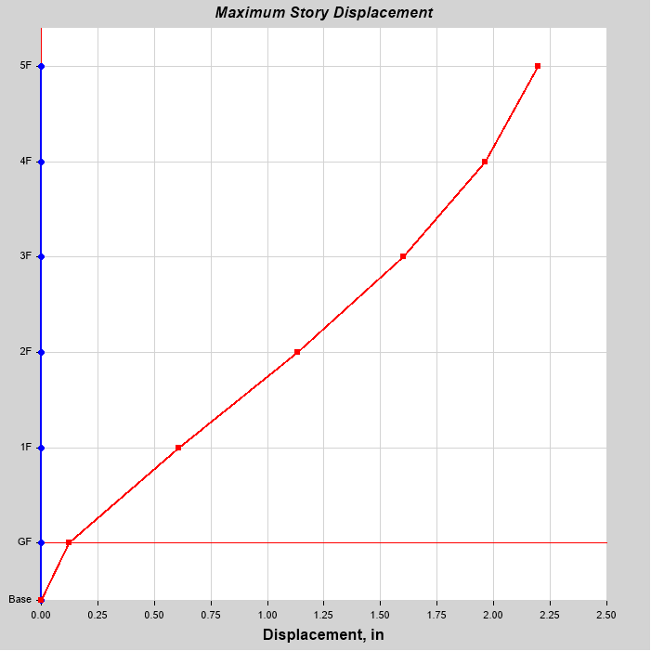
Figure:4.26:Displacement curve for zone-3 (EY)
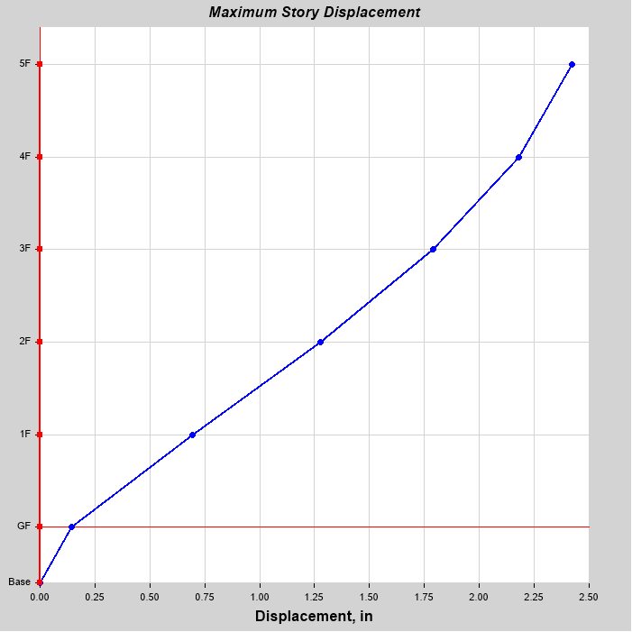
Figure:4.27:Displacement curve for zone-4 (EX)
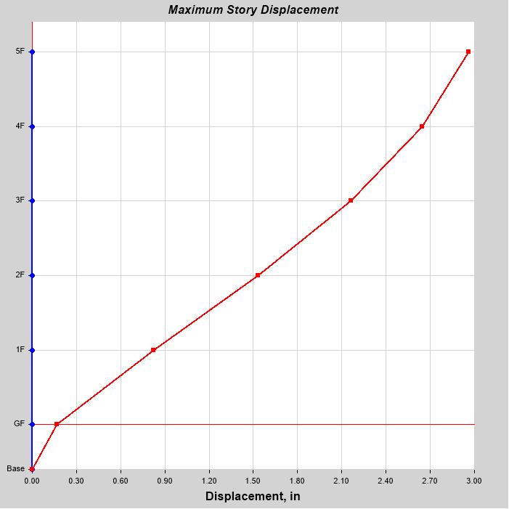
Figure:4.28:Displacement curve for zone-4 (EY)
4.2.3.2 Base Shear
Base shear is an estimate of the maximum expected lateral force that will occur due to seismic ground motion at the base of a structure. Calculations of base shear (V) depend on soil conditions at the site. Figure 4.29 shows the total base shear of this structure are 308 kips, 513 kips, 719 kips, and 971 kips, respectively in four seismic zones.

Figure:4.29 Base shears in four seismic zone
4.2.3.3 Column Reinforcement Percentage
It has observed that of this building due to seismic load the maximum reinforcement percentage for ground column is 2.45%,2.77%,4.11% and 5.73% respectively in four seismic zone.

Fig:4.30 Column reinforcement percentage in Different Seismic Zones.
4.3 Storey displacement comparison of different structures
Fig:4.31 Storey displacement comparison of different structures in X direction for four seismic zone

Fig:4.32 Storey displacement comparison of different structures in Y direction for four seismic zone
4.4 Base shear comparison of different structures

Fig:4.33 Base shear comparison of different structures
4.5 Comparison of reinforcement percentage in different structure

Fig:4.34 Comparison of reinforcement percentage in different structure for four seismic zone
Chapter-5
CONCLUSION AND RECOMMENDATION

5.1 General
Bangladesh is located in a tectonically active region close to the plate boundaries of the Indian plate and the Eurasian plate .The effect of earthquake is more severe in an underdeveloped and a densities populated country like Bangladesh than any other developed countries. According to building codes, earthquake resistant structures are intended to withstand the largest earthquake of a certain probability that is likely to occur at their location .This means the lost of life should be minimized by preventing collapse of the building for rare earthquakes while the loss of functionality should be limited for more frequent ones. Accurate historical information on earthquakes is very important in evaluating the seismicity of Bangladesh in close coincidences with the geotectonic elements. The aim of this study is to gave an idea of the structural engineer about the displacement ,base shear and rebar percentages of the structure in four seismic zones in Bangladesh.It may insist to contract proper seismic resistance building in four seismic zones of Bangladesh. To fulfil the aim of the study of three different heights (70 feet, 60feet and 50 feet) of building are considered as individually buildings are analyzed and design separately, for four seismic loads as per BNBC 2015. All these buildings are analysis considered intermediate moment resisting frame with constant wind load. Selected structures are designed by using ETABS - 2016 considering seismic loads as per BNBC 2015 in four seismic zones of Bangladesh.

5.2 Conclusions
1. Objectives of this study are to give variations of base shear, storey displacement amd required reinforcements of selected structural frames among four seismic zones of Bangladesh.
2. In this study we observed that when storeys are increased displacement are increased similarly based shear are increased but rebar percentages are decreased by the increase of stored height.

5.3 Recommendation For the future studies
1.Present study has done for intermediate moment resisting structural frames.Further study can be done for other structural systems which are given in BNBC 2015.
2.This type of study are done for regular type of structure .Further study can be done for various irregular structures.
3.Study can be carrying on varying wind load.

REFERENCES
- BNBC (2015), “Bangladesh National Building Code”, House Building and Research Institute, Vol. 1,2 & 3.

- Devi Dr.G.N., et.al, (2017), “3D frame analysis by using ETABS”, International Journal of Innovative Research in Science, Engineering and Technology, Vol.6, Issue 7.

- DR.Reddy K.C., And Kumar G.L.,(2019)," Seismic Analysis of High-Rise Buildings (G+30) by Using ETABS ", International Journal of Technical Innovation in Modern Engineering & Science (IJTIMES), Volume 5, Issue 03.

- DR.Reddy K.C., And Kumar G.L.,(2019)," Percentage of Reinforcement in the Structure for Various Seismic Zones by Using Etabs", International Journal of Management, Technology And Engineering,Volume 9,Issu 03.

- Kude M.D., And Sepate M.V.,(2019), "Influence of Zone Factor on Seismic Performance of Multi-Storied RCC Frame using ETABS 2016", International Journal for Research in Applied Science & Engineering Technology (IJRASET) Volume 8 Issue V.

- Prajapati R.M., Patel P.R., Modi U.D.,And Mehta N.S.,(2018), " Analysis and Design of Multi Storey Residential Building Using ETABS", Journal of Emerging Technologies and Innovative Research', Volume: 05 Issue: 11.

- Prajapati B.D., and Panchal D.R., (September, 2013), “Seismic and Wind analysis of a multi storey building (G+12) by using ETABS software”, international journal ofadvances in engineering &technology, ISSN:22311963, vol.3, issue 5.

- Rathod P., And Chandrashekar,(2017), " seismic analysis of multistoried building for different plans using ETABS 2015", International Research Journal of Engineering and Technology (IRJET), Volume: 04 Issue: 10.

- Sasidhar T., Avinash P. S., and Janardan N., (2017), “Analysis of multistoried building with and without floating column using ETABS”, International Journal of Civil Engineering and Technology, Vol. 8(6), 2017, pp. 91–98.

