
Faculty of Engineering
Department of Textile Engineering
GARMENT DEVELOPMENT & its DIFFICULTIES in Merchandising.

Course code: TE-4214 Course title: Thesis (project)
Submitted To:
Name: Tuhin MOlla
ID: 171-23-288
Name: Niloy Banik
ID: 171-23-296
Name: Pinak Pani Das
ID: 171-23-300
Supervised By:
Sharmin Akter
Lecturer Daffodil International University
This report submitted in partial fulfillment of the requirements for the degree of Bachelor of Science in Textile Engineering.
Advance in Apparel Manufacturing Technology
Duration: January 2021 I

Acknowledgement

At first my gratefulness goes to the Almighty “ALLAH” for giving me strength and ability to complete the Thesis Paper GARMENT DEVELOPMENT & its DIFFICULTIES in Merchandising Successfully.

We are also grateful to our supervisor Sharmin Akter, Senior Lecturer, Department of Textile Engineering, Faculty of Engineering, Daffodil international University. Her endless patience, scholarly guidance, continual encouragement, energetic supervision, constructive criticism, valuable advice, reading many inferior draft and correcting these at all stages have made it possible to complete this project.

We would like to give special thanks to the supervisors Saidul Islam Khondokar Senior Merchandiser, Hafizur Rahman , Kamrunnessa and Sander Rahman , technicians, operators and all other staffs of Liz Fashion Industry Limited, who were most cordial and helpful to us during internship.

We are also thankful to our all teachers, lab assistant, register sir, coordinators and all the employees of Daffodil International University. We are highly delighted to express our regards & gratitude to honorable Head MD Mominur Rahman for providing his best support to us.

Finally, we would like to express a sense of gratitude to our beloved parents and friends for their mental support, strength and assistance throughout completing Thesis Paper.

Declaration

I hereby declare that the work which is being presented in this report entitled, Thesis Paper entitled GARMENT DEVELOPMENT & its DIFFICULTIES in Merchandising. Is original work of my own, has not been presented for a degree of any other university and all the resources of collected information for this report have been duly acknowledged.

Name | ID | Signature
TUHIN MOLLA | 171-23-288 | 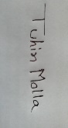
NILOY BANIK | 171-23-296 | 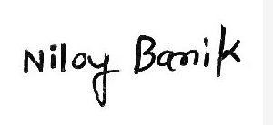
Pinak Pane Das | 171-23-300 | 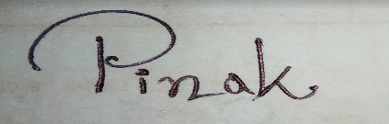

II

Latter Of Approval

It is with certified that, Tuhin Molla bearing ID: 171-23-288, Niloy Banik ID: 171-23-296 And Pinak Pany Das ID: 171-23-300 Department of Textile Engineering , Daffodil International University ,Dhaka ,Bangladesh ,has carried out their Thesis Paper entitled GARMENT DEVELOPMENT & its DIFFICULTIES in Merchandising. Under my direct supervision. They are successfully carried out their Thesis and redy to present their report, which is required in partial fulfillment of her B.Sc. degree.

I have gone through the final draft of the report and recommend its submission for the degree of Bachelor of Science in Textile Engineering.

........................................
Supervisor

Sharmin Akter
Lecturer
Department of Textile Engineering
Faculty of Engineering
Daffodil International University

Dedication

At the beginning we are dedicate our thesis report to almighty Allah. Now we finally dedicate our work to our honorable Parents, who are the strength of our life, our motivation, our strength of live, our life line, our inspiration and most importantly our Jannah.

Lastly we dedicate our thesis report to our honorable teacher, our honorable supervisor & our educational chief Sharmin Akter, Lecturer, Department of Textile Engineering, Faculty of Engineering, Daffodil international University, who create the path to prepare this thesis report successfully, as nicely as we dedicate our work to all of our honorable teachers of our entirety life.

ABSTRACT

Industrialization is a major reason for the economic development of a country. It plays a significant role in transforming the monetary structure of developing nations. Textile industry of Bangladesh is more than 500 years old. It is one of the oldest and most successful industries with its rich history. Moreover, in recent years there has been a substantial development in yarn and fabric production.
There is a significant effect of globalization on international textile and apparel trade. Today, the developed countries are hugely dependent on the developing nations for textile and garment manufacturing. At present, Bangladesh ranks second in the world as the largest apparel producers with a $20 billion business in which 80% is earned by exporting goods.
There are three fundamental factors which have boosted the growth of textile in Bangladesh. The country has plenty of resources, opportunities, and beneficial government policies. In Bangladesh large number of labor workers can be found. Also, natural gas and cost of energy is cheap. With huge population, labor is abundant, and Bangladesh has an advantage in producing labor intensive products.
The main reason for the development of the textile industry in Bangladesh is the hardworking labor force. They put in more working hours to complete the target. Therefore, in recent times the per capita income of the country and the standards of living of the people have improved. Secondly, the country acquired an advantageous opportunity to trade with America and the European countries in readymade garments segment.
Moreover, the quota-free textile rule which has been introduced since 2005 has substantially improved the textile industry of Bangladesh. The government policies that supported textile included monetary advantages and institutional help. As mentioned earlier, labor and power are cheap and easily available here compared to India, Pakistan or China. This gives them a competitive advantage against their competitors.
The new textile policies which have been introduced almost have no tariffs for the spinning sector.
However, the imported yarns and materials have high tax rates so as to encourage the use of local fabrics and yarn production. All these factors worked together in favor of the textile development in Bangladesh. Nevertheless, in the past ten years the country has witnessed the growth of spinning industry.
For continuing the study of internship in the Liz Fashion Industry we almost worked all the sections available of this company and tried to find out the activities, planning and many other things as well. In context, we have discussed about these things elaborately to let you know about.

CONTENTS

NAME PAGE

Dedication 1
Acknowledgement 2
Declaration 3
Latter Of Approval 4
ABSTRACT 2
CHAPTER 1: INTRODUCTION 5
1.1 Introduction of Garment merchandising 5
1.2 Object Garment merchandising: 7
1.3 Function of a merchandiser in merchandising 7
CHAPTER 2: LITERATURE REVIEW 9
2. Sample developing process 9
Purpose of sampling: 9
CHAPTER 3: METHODOLOGY 18
3. Product development and role of merchandiser 18
3.1Product development: 18
3.2 Product development by global buyer: 18
3.3 Fabric selection: 19
Silhouettes: 20
Proto type development: 20
Costing: 20
3.4 Product development by garment manufacturer: 21
3.5 Role of production merchandiser in product development: 21
3.6 Product development by design studio: 23
CHAPTER 4 RESULT AND DISCUSSION 24
4.1Different difficulties during sample development 24
4.2 Different Type of Garments Sample: 28
Chapter 5 CONCLUSION 32
5. Conclusions: 32
Reference: 33

CHAPTER 1: INTRODUCTION

1.1 Introduction of Garment merchandising
Merchandiser: Merchandiser is the BRIDGE between the business and the purchaser. He need to take care of each work like purchasing the crude material which is needed to complete the item, making the piece of clothing, completing the article of clothing, documentation, at long last delivery. He is the mindful individual to make the item. An article of clothing send out unit by and large has numerous office like stores, cutting, creation, pressing, checking and so on in which Merchandising office a connecting gadget of all. The occupation of a merchandiser is to arrange with the whole division in the workplace just as the clients. The merchandiser is the person who makes a decent relationship in the middle of exporter and purchaser.
Marketing:
The term marketing has been gotten from the product. Product implies merchandise that are purchased and sold. Marketing is executing a request from accepting to shipment through appropriate follow up cycle.
Essentially we can say that the way toward distinguishing and understanding what target client need also, giving their ideal material items to them in a specific cost and lead time by making a correspondence connect between the client and the organization. So merchandising process involve of at least three parties:
i. Company: who offering product to the customer
ii. Customer: who is targeted by company with the help of merchandiser?
iii. Merchandiser: merchandiser place his position between the above two partie

Flowchart of Merchandising:
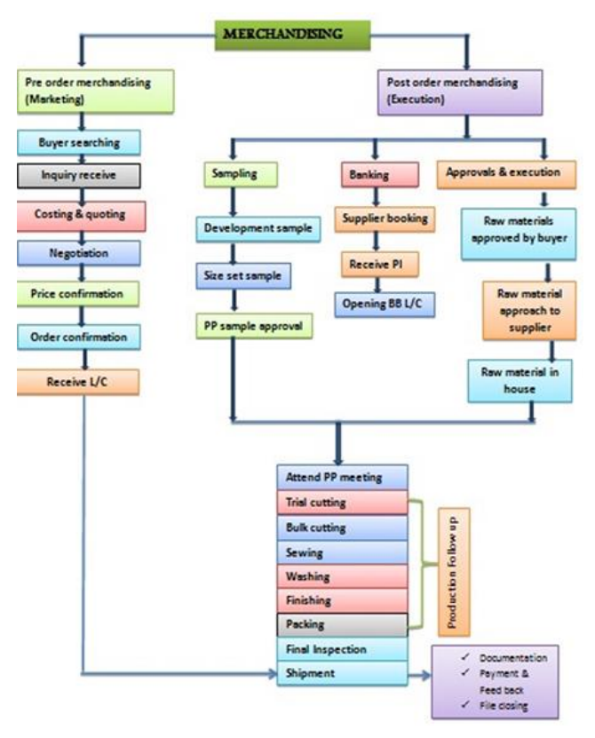

1.2 Object Garment merchandising:
Garment merchandising is done in the unit. This includes all the responsibilities from sourcing to finishing i.e. first sample onwards, the products merchandising work start and ends till shipment.

1.3 Function of a merchandiser in merchandising
Trend board/inspiration sheet& color plate
↓
Market analysis
↓
Designs develop & offer to buyer
↓
Design selection by buyer
↓
Fabric sourcing & sample development
↓
Sourcing meeting
↓
Buyer meeting
↓
Order confirmation
↓
Color / LD develop
↓
Fabric booking
↓
Fit Sample
↓
Pp. sample
↓
Fabric test
↓
Brand sample (all color)
↓
Production test (after 10% garment produce)
↓
Production running
↓
Final inspection
↓
Shipment

CHAPTER 2: LITERATURE REVIEW

2. Sample developing process
Garment sample:
The sample is a product which represents a group of product or lot. The test will mirror the quality and workmanship of the exporter or producer. Article of clothing tests are unavoidably significant piece of trading. Examining of articles of clothing is given incredible accentuation. Test of piece of clothing can either represent the deciding moment the further technique of getting orders from purchasers. Inspecting assumes an indispensable job in getting orders from the purchasers. Tests are created and tried prior to beginning the mass creation.

Purpose of sampling:
The purpose of sampling is not only to get bulk orders, but it gives some additional benefits to the exporter. Through the sampling process exporter can estimate the yarn consumption for developing the fabric and a clear idea of time and entire manufacturing cost.

Here given few purposes in scene of garments sampling -
i. To let the buyer know the potential of an exporter.
ii. To allow the buyer to judge the production capability of the exporter.
iii. To let the exporter estimate the fabric and thread consumption, and manufacturing cost of an
entire order.
iv. To provide means of making revisions in the mass production.

Here we can classify Garment development process into two ways
I. Sample development
ii .Bulk Development
Types of Sample development
Proto Sample:
Proto samples are also known as the first sample. The proto samples are normally made of matching fabric quality (weight and fabric types), as during proto sample development actual fabric are not available with the factory. The proto sample in made in one size.
1st sample
- Receive spec sheet of garments from buyer.
- Make pattern as per measurement.
- Check the pattern which has made.
- If necessary Check shrinkage, twisting, bowing before pattern making Cutting fabric as per pattern.
- Collect accessories.
- Start sewing.
- M/C specified.
- Check the sample to ensure it, ok.

- Send it to buyer for approval.

Development sample
- Make pattern as per measurement, if buyer change the measurement to observe the counter sample.
- Actual size required
- Check the pattern which has made.
- Collect fabric
- Cutting fabric as per pattern.
- Collect accessories.
- Start sewing.
- M/C specified.
- Check the sample to ensure it, ok
- Send it to buyer for approval

In buyer meeting supplier submit the costing and after negotiation order being confirmed.
Fit Sample: Fit samples are samples produced by a manufacturer so that the company purchasing the product can review the garments to make certain they fit properly to the human body. In other words, the primary function of a fit sample is to evaluate fit.
- Make pattern as per measurement.
- Actual size required
- Check the pattern which has made.
- Collect actual fabric
- Cutting fabric as per pattern.
- Collect accessories.
- Start sewing.
- M/C specified.
- Check the sample to ensure it, ok
- Send it to buyer for approval

Pp. sample (pre-production):
PP Sample is the short name of the Pre-production sample. A pre-production sample is one type of development sample. PP sample is made in garment factories prior to starting bulk production. PP sample is made with actual fabric, trims and accessories of the style.

Why factories need to make PP sample?
PP sample is made as part of the research and development of production. This sample is made to learn about the style, its construction, machine requirement and processes to be used to make a quality product. By making they can learn what all difficulties may come at the time of bulk production.
The factory takes approval for style workmanship, specs and trimming and material quality on PP sample
PP sample is an important component of PP meeting. Without approved PP sample, production meeting on the specific order/style cannot be possible.
Need sealed sample for production reference and for final inspection reference

Pp. sample:
- Make design according to estimation, if purchaser change the estimation to notice the counter example.

- Actual size required
- Check the example which has made.
- Collect real shading texture. G.S.M ought to be alright.
- Cutting texture according to design.
- Actual texture development
- Actual size Types of Sample improvement
Proto Sample:

Proto tests are otherwise called the primary example. The proto examples are regularly made of coordinating texture quality (weight and texture types), as during proto example advancement real texture are not accessible with the production line. The proto example in made in one size.

1st test

- Receive spec sheet of pieces of clothing from purchaser.
- Make design according to estimation.
- Check the example which has made.
- If essential Check shrinkage, bending, bowing before design making Cutting texture according to design.
- Collect embellishments.
- Start sewing.
- M/C indicated.
- Check the example to guarantee it, alright.
- Send it to purchaser for endorsement.
- Development test
- Make design according to estimation, if purchaser change the estimation to notice the counter example.
- Actual size required
- Check the example which has made.
- Collect texture
- Cutting texture according to design.
- Collect adornments.
- Start sewing.
- M/C determined.
- Check the example to guarantee it, alright Send it to purchaser for endorsement
- In purchaser meeting provider present the costing and after arrangement request being affirmed.

(SMS)/Salesman sample:
In garment sampling, the SMS sample stands for Salesman Sample.
The design of the SMS sample is mostly the same as the final production garments. Salesman samples are made with actual fabric and trims and accessories.
We have earlier discussed various samples made by garment factories. SMS sample in one of them.
SMS samples are ordered after fit sample approval. And normally prior to size set sample development. SMS sample requirement ordered by buyers and buyer pays to the supplier for SMS samples.
A number of SMS sample requirement is higher than the other sample need. The reason these samples are put on display in the showrooms. Buyer send SMS samples to the retails shops and based the design retailers placed an order on that particular order. Buyer later forecasts order quantity on that particular design based on the customer feedback and order placed by their retailers.

(SMS)/Salesman test:

- In article of clothing inspecting, the SMS test represents Salesman Sample.
- The plan of the SMS test is generally equivalent to the last creation pieces of clothing. Sales rep tests are made with real texture and trims and embellishments.
- We have prior examined different examples made by article of clothing manufacturing plants. SMS test in one of them.
- SMS tests are requested after fit example endorsement. Also, typically before size set example advancement. SMS test prerequisite arranged by purchasers and purchaser pays to the provider for SMS tests.
- A number of SMS test necessity is higher than the other example need. The explanation these examples are put in plain view in the showrooms. Purchaser send SMS tests to the retails shops and based the plan retailers submitted a request on that specific request. Purchaser later estimates request amount on that specific plan dependent on the client criticism and request set by their retailers.

Product advancement and job of merchandiser

Product improvement:

- Product improvement is the absolute first phase of presentation of new style. The idea of new style or configuration is created by design creator which is only a plan or sketch on the paper. Item improvement is where that sketch or configuration is changed over in to a 3D structure article of clothing, with all specialized and tasteful methodology remembering. The principal stage is of getting sorted out the musings and gathering pictures (Mood board) from fashioner. It catches the disposition or kind of the plan project, just as mirrors the objective client, once in a while plans are created target costumer remembering.
- In present worldwide situation and quick design period item improvement turns into the business procedure for the entire store network of the style business. Presently a day's item advancement is done at each phase of the design business. Regularly item advancement is finished by following foundations
- Product improvement by worldwide purchaser:
- From the purchasers perspective the item improvement is the making singular style inside the line. The regular item improvement measure at purchaser's stage can be given as,
- Product improvement measure begins secondary selling gauge, it is the way toward making every individual style inside the line. After the examination period of line improvement is finished, outlines are created, textures and trim chosen, models made, and particulars are made. The subsequent styles are examined to decide producing costs. These means are all essential for the item improvement period of the line advancement measure. The initial steps of outline advancement and texture determination are drawn closer in various manners by various planners and organizations. Numerous organizations base their lines around texture and print plans. Their originators start by choosing textures and afterward make outlines for those textures. These architects are texture driven. Different originators are outline driven.
- They configuration outlines and afterward select textures that are viable with the outlines. The two cycles accomplish a similar final product—special article of clothing styles.
- This kind of item improvement is done either by purchaser alongside purchasing house. Item improvement is the basic piece of the line advancement secondary selling estimate is finished. Without item improvement line can't be created. The fundamental pieces of item improvement are

Fabric determination:

Fabric determination is done dependent on feel just as specialized interest of the piece of clothing. Following things need to consider while choosing the texture for item improvement.

- Fiber content.
- Fabric development—fundamental structure.
- Texture and designed impacts made by weave setups and
- Yarn choices.
- Prints.
- Color range.
- Performance attributes—wear factors, care prerequisites, sewing
- Compatibility and wrap.
- Versatility for use in numerous styles.
- Price and terms.
- Availability.
- Minimum request amounts.
- For texture determination creator visits material factories, texture studio, plan studio.
Silhouettes:

- Silhouette advancement includes changing piece of clothing thoughts into conclusive piece of clothing Sketches or specialized drawings, which are hand or CAD renderings of the front and back of an article of clothing, including sewing subtleties. Specialized drawings generally do exclude body outlines and are utilized where development and styling subtleties are basic to the plan.
- Proto type improvement:
- After Silhouette is created, tech pack is created and improvement test are created. Objective is to see the stylish and assembling capacity of the proposed style.
- Costing:
- Costing is done at the phase of test advancement to see the market practicality of the item for deals and to choose the net revenue.
- Advantages of item improvement by purchaser/purchasing particular:
- Buyer makes the market estimate, thus the comprehension of market is better.
- The late patterns are chosen by purchaser.
- The tone, prints and examples are created by byer which depends on market estimate.
- Buyer is absolutely liable for the accomplishment of created style.
- Disadvantages item improvement by purchaser/purchasing determination:
- The cycle of item improvement is long and cleans measure for purchaser; purchaser doesn't have in-house creation ability.
- Buyer needs to rely upon either purchasing house or article of clothing/material producer for advancement of lab-plunge, strike-off, and tests.
- The cost of item improvement at this stage is higher.
- Though purchaser does the market gauge however purchaser may has constraint on specialized information and creation practicality of the style.

- Product improvement by article of clothing producer:
- Product advancement is the business strategy of the association which incorporates the improvement of the new plans and styles inside the association. This movement carries the more business to association, by indicating supportive of animation in plan advancement purchaser additionally intrigue. The part of creation merchandiser in this movement is assumes significant job. Creation merchandiser should keep update to purchaser time Advantages of the process:
- Buyer gets the advantage of expertise in design studio.
- Buyer need not to see the sourcing part for the product development.
- The risk is transfers to the design studio.
- With involvement of third party product development sharing of knowledge is happens.
- The resources can be combined.
- Increasing the speed of product development process as design studio does that job.
- Buyer gets the advantage of latest technology in design studio.

Disadvantages:

- More cost is incurred for buyer.
- Dependency is more on design studio.
- Design studio may not be able to understand the buyer’s perception about market though buyer shares data.
- There is reduction in knowledge gain about technology, new trends and technical aspects of product development.

- Collect actual accessories.
- Start sewing.
- M/C specified.
- Check the sample to ensure it, ok
- Send it to buyer for approval

CHAPTER 3: METHODOLOGY

3. Product development and role of merchandiser

3.1Product development:
Item advancement is the absolute first phase of presentation of new style. The idea of new style or then again configuration is created by style planner which is just a plan or sketch on the paper. Item improvement is where that sketch or configuration is changed over in to a 3D structure article of clothing, with all specialized and tasteful methodology remembering. The principal stage is of getting sorted out the contemplations furthermore, gathering pictures (Mood board) from creator. It catches the disposition or kind of the plan project, just as mirrors the objective client, now and again plans are created target costumer remembering.
In present worldwide situation and quick style time item improvement turns into the business procedure for the entire production network of the design business. Presently a day's item advancement is done at each phase of the style business. Commonly item improvement is finished by following Foundations

3.2 Product development by global buyer:
From the buyers point of view the product development is the creating individual style within the line. The typical product development process at buyer’s stage can be given as, Product development process starts after market forecast, it is the process of creating each individual style within the line. After the research phase of line development is completed, silhouettes are developed, fabrics and trim selected, prototypes made, and specifications are created. The resulting styles are analyzed to determine manufacturing costs. These steps are all part of the product development phase of the line development process. The first steps of silhouette Development and fabric selection are approached in different ways by different designers and companies. Many companies base their lines around fabric and print designs. Their designers start by selecting fabrics and then create silhouettes for those fabrics. These designers are fabric driven .Other designers are silhouette-driven. They design silhouettes and then select fabrics that are compatible with the silhouettes. Both processes achieve the same end result—unique garment styles.
This type of product development is done either by buyer along with buying house. Product development is the essential part of the line development after market forecast is done. Without product development line cannot be developed.

The essential parts of product development are

3.3 Fabric selection:
Fabric selection is done based on aesthetics as well as technical demand of the garment. Following things need to consider while selecting the fabric for product development.
Fiber content.
Fabric construction—basic structure.
Texture and engineered effects created by weave configurations and
Yarn selections.
Prints.
Color range.
Performance characteristics—wear factors, care requirements, sewing
Compatibility and drape.
Versatility for use in multiple styles.
Price and terms.
Availability.
Minimum order quantities.
For fabric selection designer visits textile mills, fabric studio, design studio.

Silhouettes:
Silhouette development involves transforming garment ideas into final garment Sketches or technical drawings, which are hand or CAD renderings of the front and back of a garment, including stitching details. Technical drawings usually do not include body silhouettes and are used where construction and styling details are critical to the design.

Proto type development:
After Silhouette is developed, tech pack is developed and development sample are developed. Objective is to see the aesthetic and manufacturing ability of the proposed style.

Costing:
Costing is done at the stage of sample development to see the market feasibility of the product for
Sales and to decide the profit margin.
Advantages of product development by buyer/ buying specification:
i. Buyer makes the market forecast, hence the understanding of market is better.
ii. The recent trends are decided by buyer.
iii. The color, prints and patterns are developed by byer which is based on market forecast.
Iv. Buyer is totally responsible for the success of developed style.
Disadvantages product development by buyer/ buying specification:
i. The process of product development is long and tidies process for buyer; buyer doesn’t have in-house production capability.
ii. Buyer needs to depend on either buying house or garment/textile manufacturer for development of lab-dip, strike-off, and samples.
iii. The cost of product development at this stage is higher.
Iv Though buyer does the market forecast but buyer may has limitation on technical knowledge and production feasibility of the style.

3.4 Product development by garment manufacturer:
Item advancement is the business strategy of the association which incorporates the improvement of the new plans and styles inside the association. This action carries the more business to association, by indicating supportive of liveliness in plan improvement purchaser additionally intrigue. The part of creation merchandiser in this action is assumes significant job. Creation merchandiser

Should keep update to purchaser time to time about the item advancement done by association. Spur the purchaser to give the plan advancement to the association as opposed to doing themselves. At whatever point purchaser visits to the association, introduction of new tone, prints, weaving designs furthermore, work area loom advancements is finished by creation merchandiser. Introduction of new plans
Created by PD office. Attempt to persuade the purchaser to choose the plans from introduction. An excellent introduction and persuading capacity regarding creation merchandiser brings more business to the organization.

3.5 Role of production merchandiser in product development:
I. Product development is become business policy of the organization, as merchandiser is the bridge between buyer and manufacturer, merchandiser can understand the buyers and the market and new development can be done accordingly.
ii. Merchandiser not only follows the export order but, he/she must be aware of the new trends in market related to fabric, color, patterns, style, designs etc.
iii. Cost calculations are the main role played by the merchandiser. At product development and sampling stage only cost is calculated and quoted to buyer.
iv. Merchandiser must insist in-house design studio (if available) or product development team to come up with new ideas and designs and style.
v. At the same time merchandiser should convince buyer to give development to the factory if capacity is available.
vi. Merchandiser knows what buyer wants hence at the time buyer visit to factory,
Merchandiser can present the new developments i.e. desk looms, lab-dips, and strike-offs, newly developed design in garment in front of buyer or send to buyer’s office for selection purpose.
vii. Merchandiser must use convincing ability to make sure that buyer will accept some designs.
viii. The important role of merchandiser plays is follow-up of buyer as well as sampling department to make sure that development should go smoothly.

Advantages:
I. Production merchandiser can control product development process in better way.
ii. Pro-activeness of merchandiser can bring the more business to the organization.
iii. The cost of product development is lesser when it takes place in manufacturing
Organization.
iv. Manufacturing organization may not charge the cost of product development to the buyer
If buyer is regularly giving orders to the organization that is the benefit to the buyer.
Disadvantages:
I. Merchandiser may not aware fully about the buyer’s requirement of style and designs for that particular season. If it is so then whole work will be wasted.
ii. The quality requirements of the buyer nay not match.
iii. There may be capacity of sampling or product development department to produce the new style, but there may be possibility that production floor may not be able to handle the style
iv. Merchandiser may have limited knowledge of the market, trends, running style, sales background of the buyer, brand image. Hence there are limitations for merchandiser to go for product development.

3.6 Product development by design studio:
In globalization era product development process is also outsourced by buyer. The typical product
Development process by design studio can be given.
The process of product development is similar to what buyer is doing but only third party or
Individual design studio is involved in the process. Buyer asks design studio to develop the new
Designs, sketches, style and color. Design studio develops designs according to market forecast
Of buyer, by keeping brand image in mind.
Advantages of the process:
i. Buyer gets the advantage of expertise in design studio.
ii. Buyer need not to see the sourcing part for the product development.
iii. The risk is transfers to the design studio.
iv. With involvement of third party product development sharing of knowledge is happens.
v. The resources can be combined.
vi. Increasing the speed of product development process as design studio does that job.
vii. Buyer gets the advantage of latest technology in design studio.
Disadvantages:
i. More cost is incurred for buyer.
ii. Dependency is more on design studio.
iii. Design studio may not be able to understand the buyer’s perception about market though buyer shares data.
iv. There is reduction in knowledge gain about technology, new trends and technical aspects of product development.

CHAPTER 4 RESULT AND DISCUSSION

Different difficulties during sample development
In sample development we faces difficulties as below-
Fabric issue: When we make sample as any color it is easy to make. But when color confirm by buyer it faces some difficulties. For local fabric we didn’t get fabric within lead team & also same cases in overseas fabric. Fabric didn’t get on time. Sometimes defect on fabric rate high so cutting don’t cut sample with marker. It causes need more fabric.
Pattern: Sometimes we faces difficulties in pattern. M-list & e-pattern didn’t found same always. Sometimes we don’t get pattern on time.
Printing Problem: It takes more time to print. Sometimes put wrong AW, not match with approved quality, spot problem, and delay delivery on printing part. Not found strike off, recipe wash report at required time frame.
Tech pack problem: sometimes because of techpack error sample development Process become delay because in techpack buyer didn’t give the clear information. Like fabrication, trims, accessories, etc.
Measurement problem : sometimes measurement of a sample from cad section comes wrong as sample shape remain defective and not Match as buyer requirement as a result sample become unapproved by buyer.
Delay in Production Start: Planning department makes production schedules but in many cases factory doesn't receive fabric before PCD (planned cut date). Line is ready with operators and machines but supervisor doesn't receive cuttings on planned date. Sometimes cutting department takes unexpectedly longer time. Delay in sewing may also happen due to delay in approvals from buyer.
Operator Absenteeism: With the operator shortage, operator absenteeism increases labor problem in sewing floor. Factories are paying attendance bonus to attract operators to present maximum days in a month.
Insufficient Information: Factories conduct PP meeting and weekly meeting. Even after meetings, complete and correct information is not passed to the production team. Due to delivery schedule pressure, bulk production is started without complete approval.
Frequent Change in Production Planning: This is often happened in factories that production team loads a style to a line and certainly gets instruction to stop the style and load one urgent style. This breaks the production momentum and reduces line performance.
High Lost Time: Many productive hours are lost by operators due to various reasons. This May happen due poor interdepartmental coordination, delay in completion of previous process, shortage of feeding, and quality issues.
Problem with Raw Materials: Production floor doesn't get materials on time. Sometimes they receive materials in urgency but with substandard quality and insufficient numbers. Cuttings fed to the lines are not as per standard.
Quality: The main problem of sample making in Quality issues. Sometimes they don’t check sample properly, don’t follow buyer comments, sometimes trims become missing in sample, delivery sample delay, all checking point not check properly.
Seam Puckering Seam puckering refers to the gathering of a seam either just after sewing or after laundering causing an unacceptable seam appearance.

Remedies:

- Feed dog, eyelets and thread guides should be checked periodically for damages.
- Machine feed mechanism must be better quality.
- Tension, SPI and presser foot pressure should not be fiddled with.

Open seam or broken seam: Portion of the garment that has not been covered by sewing thread.
Remedies:
- Clear markings for stitch line.
- Proper setting and timing between needle and looper or hook.
- Tension should be quantifiable.

Broken Stitch: Non-continuous sewing thread.
Remedies:
- Needle plate, presser foot and feed dog should be checked periodically for damages.
- Tension and threading should not be fiddled with much.
- Proper trimming.

Drop stitch/Skipped stitch: Irregular stitching along the seam
Remedies:
- Placing of needle properly.
- Needle size & thread size must be adjusted.
- The pressure of pressure foot must be adjusted accurately

Uncut/ loose thread: Extra threads or loose threads on seam line

Remedies:
- UBT/thread trimmer should be used
- Operator training.
- Garments finishing should be checked properly.
Distorted knitting: These defects can be identified by looking at the surface area; they usually appear as irregular on the fabric.

Remedies:

- Better inspection of fabric and cut piece.
- Ensure that fabric and cut pieces that are not up to standard are not put into line and production is wasted.

Seam slippage: This happens when the yarns in the fabric are pulled out of the seam and are more frequent in fabrics made from continuous filament yarns.
Remedies:
- French seam type can be tried.
- Seam width can be increased.

Needle threads breakage Thread gets trapped at the thread guide. And Irregularities or damages in needle guard, throat plate, bobbin case and needle eye.
Remedies:
- Use a foam pad or a similar device to prevent the package from tilting.
- Ensure that the re-threading is done correctly.
- Replace the needle with one of better quality.

Different Type of Garments Sample:

Buyer Name | Product Details | Product Photo
Buyer Name:  Decathlon  Product:  Sports Item | Name: Sleeveless T-shirt.  Brand : Krista  Item: Basketball  Style : 300211 | 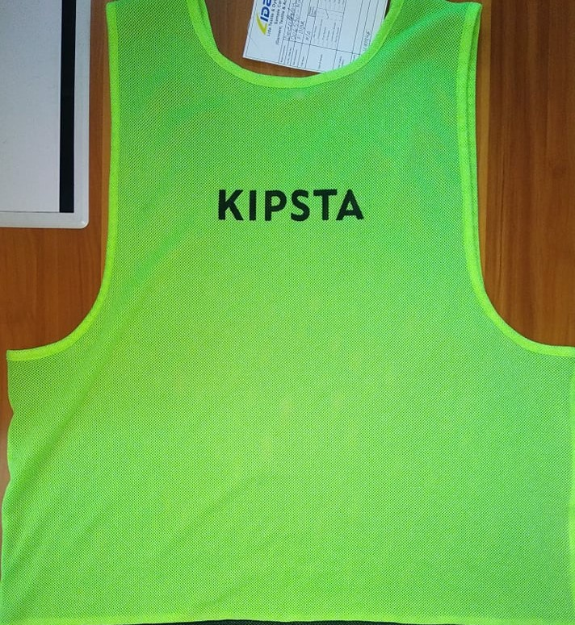
Buyer Name:  Decathlon  Product:  Sports Item | Name: Knee Cap  Brand : Tar mark  Item: Football  Style : 301245 | 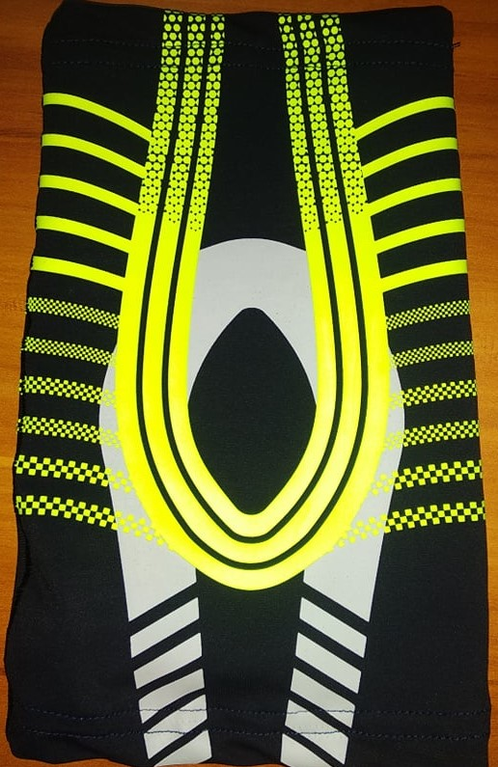
Buyer Name:  Decathlon  Product:  Sports Item | Name: Full Sleeve T-shirt Brand : Tarban Item: Free style exercise Style : 311223 | 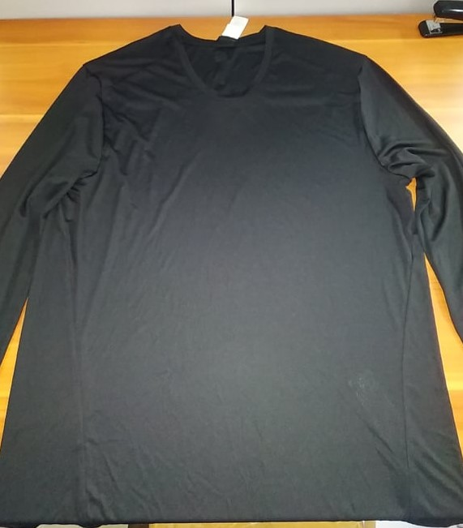

Buyer Name:  Decathlon  Product:  Sports Item | Name: Tanis Skirt  Brand : Artengo  Item: Tanis  Style : 305815 | 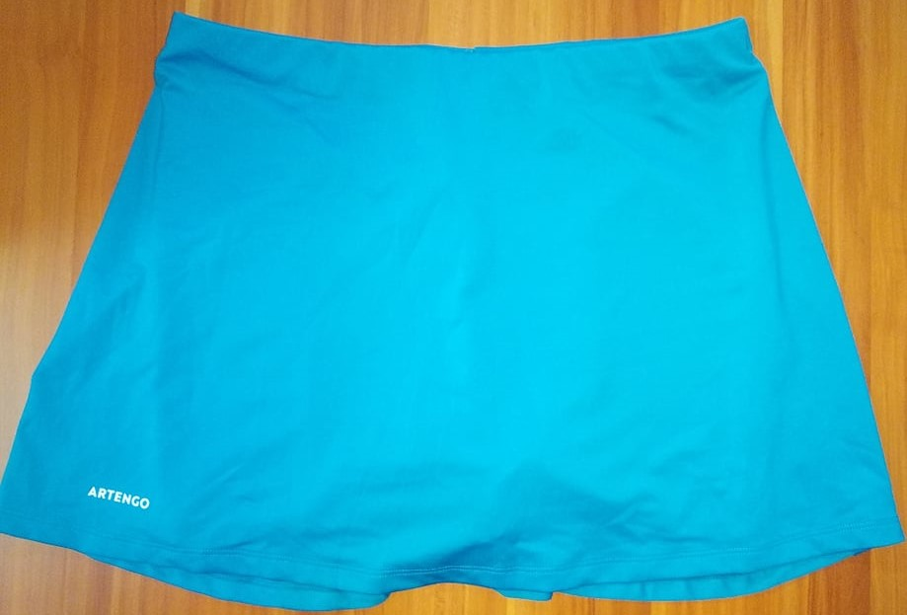
Buyer Name:  Decathlon  Product:  Sports Item | Name: Cycling Bip Short  Brand : Rockrider  Item: Cycling  Style : 306882 | 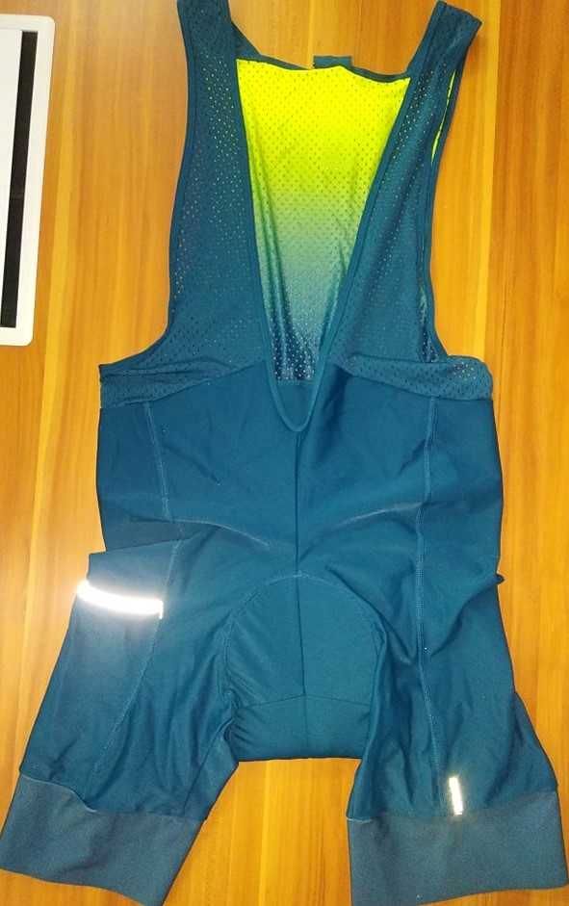
Buyer Name:  Decathlon  Product:  Sports Item | Name: Sports Bra  Brand : Dominos  Item: Yoga  Style : 311205 | 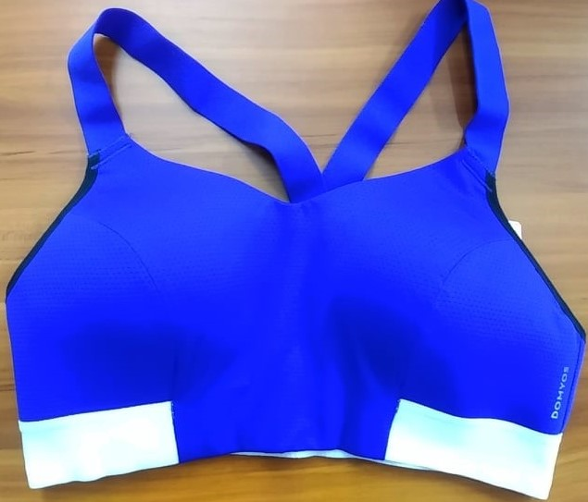
Buyer Name:  Decathlon  Product:  Sports Item | Name: Underwear  Brand : Kalen  Item: Running  Style : 302615 | 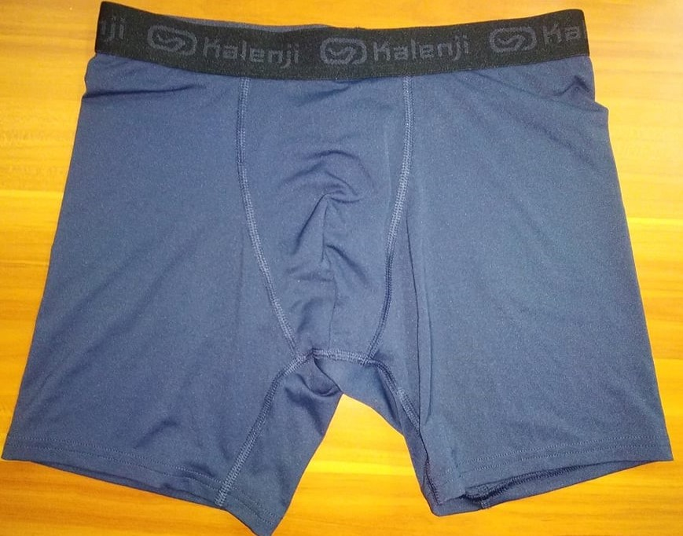

Buyer Name:  Walmart | Name: Popline Woven shirt  Brand :  Walmart Canada  Style : GRS10404MN | 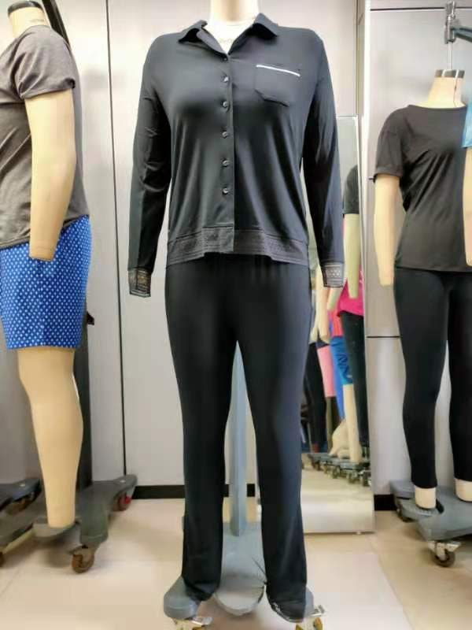
Buyer Name:  Walmart | Name:  SINGLE JERSEY LONG SLEEVE SET  Brand : WALMART CHILE  Style:  B21POLMINISANDIA | 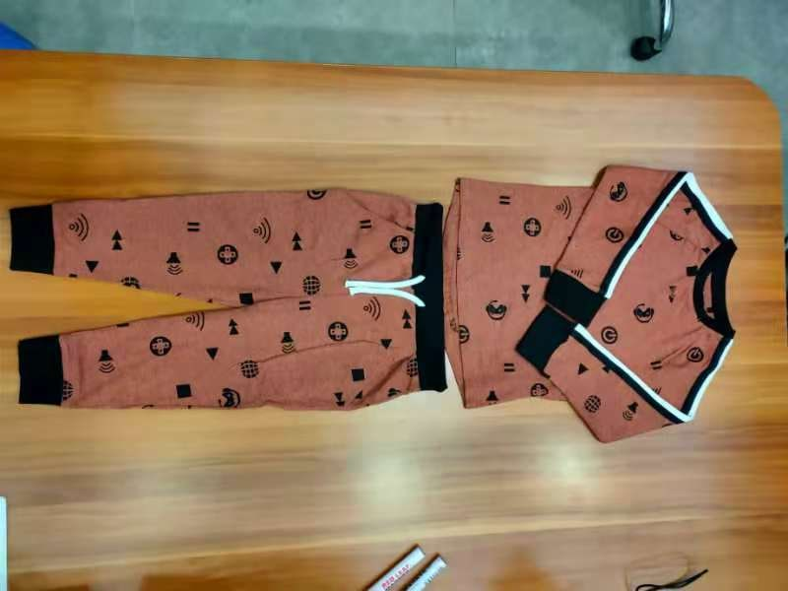
Buyer Name:  Walmart | Name: BOXER  WALMART CHILE  Style : B21TBANOR5 | 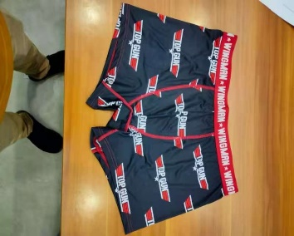
Buyer Name:  Inditex | Name: Boys Boxer  Brand :Inditex Spine | 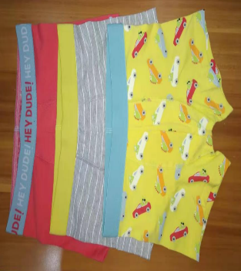
Buyer Name:  Inditex | Name: Girls panty  Brand :Inditex Spine | 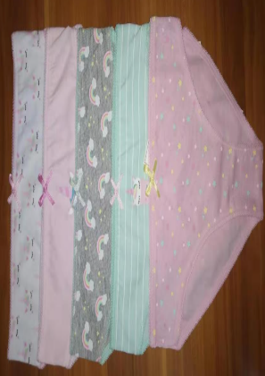
Buyer Name:  Inditex | Name:Ladyes Swimwear Top  Brand :Inditex Spine | 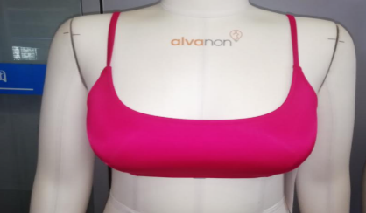
Buyer Name:  Inditex | Name:Ladyes Swimwear Bottom  Brand :Inditex Spine | 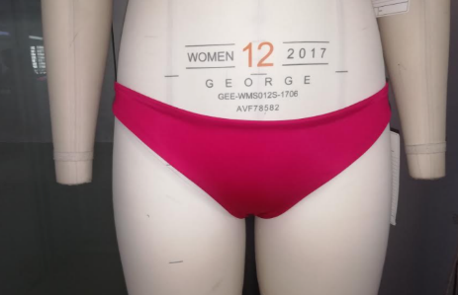
Buyer Name:  Walmart | Name: Short Sleev Relax fit t-shirt  Brand : WGS Tech  Style : 10221slf05 | 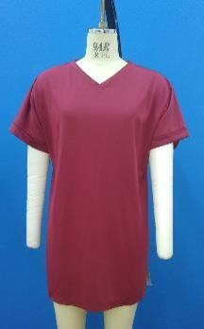

Chapter 5 CONCLUSION

5. Conclusions:
Hear we worked Garment development and its Difficulties with Accomplishment step of
Merchandising.
We present Different type of difficulties in Sample Development section and we try to discuss
How to solve the problem.
We Discuss Product development by design studio, Role of production merchandiser in product development, Product development by garment manufacturer, Product development by global buyer.
In sample Development section we face Different type of Difficulties like Fabric issue, Pattern,
Printing Problem, Sample making problem, Quality.
These All information we gathered in our practical internship time and we took help from our industrial supervisor and Google.

Reference:

1 https://www.textiletoday.com.bd/product-development-and-role-of-merchandiser/
2 http://textilemerchandising.com/sample-development-process-apparel/
3. https://www.onlineclothingstudy.com/2015/10/pp-sample-what-it-is-and-importance-of.html
4. https://www.metafuro.com/glossary/pre-production-sample-pps/
5. https://www.fibre2fashion.com/industry-article/6944/current-scenario-of-the-textile-industry-inbangladesh

