Design and Economic Analysis of Grid Connected Hybrid Solar Irrigation System

A Project and Thesis submitted in partial fulfillment of the requirements for the Award of Degree of
Bachelor of Science in Electrical and Electronic Engineering
by
Most: Ruhejannat Ripa
(ID #: 172-33-455)
Siraatul Jannat
(ID #: 172-33-507)

Supervised by
ABDULLAH AL ISLAM
Lecturer
Department of EEE



Department of Electrical and Electronic Engineering
Faculty of Engineering
DAFFODIL INTERNATIONAL UNIVERSITY
JANUARY 2021

Certification

This is to certify that this project and thesis entitled “Design and economic analysis of grid connected hybrid solar irrigation system” is done by the following students under my direct supervision and this work has been carried out by them in the laboratories of the Department of Electrical and Electronic Engineering under the Faculty of Engineering of Daffodil International University in partial fulfillment of the requirements for the degree of Bachelor of Science in Electrical and Electronic Engineering. The presentation of the work was held on 31 January 2021.

Signature of the candidates

_____________________
Most Ruhejannat Ripa
(ID #: 172-33-455)

________________________
Siraatul Jannat
(ID #: 172-33-507)

Countersigned

_______________________
Abdullah Al Islam
Lecturer
Department of Electrical and Electronic Engineering
Faculty of Science and Engineering
Daffodil International University.

The project and thesis entitled “Design and economic analysis of grid connected hybrid solar irrigation system” submitted by Most Ruhejannat Ripa (ID #: 172-33-455) Siraatul Jannat, (ID No: 172-33-507), Session: Summer 2017 has been accepted as satisfactory in partial fulfillment of the requirements for the degree of Bachelor of Science in Electrical and Electronic Engineering on 31 January 2021.

BOARD OF EXAMINERS

____________________________
Md. Sohel Rana Coordinator
Lecturer
Department of EEE, DIU

____________________________
Dr. Mohammad Tawhidul Alam Internal Member
Associate Professor
Department of EEE, DIU

____________________________
Dr. Mohammad Khalaquzzaman External Member
Chief Engineer, Bangladesh Atomic
Energy Commission

Dedicated to
Our Parents

We want to dedicate this theses paper to our parents and honorable teachers.
CONTENTS

List of Tables | vii
List of Figures | viii
List of Abbreviations | ix
List of Symbols | X
Acknowledgment | Xi
Abstract | xii

Chapter-1 1
1.1 Introduction 1
1.2 Problem statement 2
1.3 Objective 2
1.4 Methodology 3
1.5 Theses Outline 3
Chapter-2 4
Different types of irrigation 4
2.1 Diesel engine irrigation system 4
2.2 Electric pump 4
2.3 Solar Irrigation Pump 5
2.4 Several character of solar irrigation pump: 6
2.4.1 Direct SIP 6
2.4.2 Battery coupler SIP 6
2.4.3 Hybrid SIP 7
Chapter-3 8
Study Area 8
3.1 Rangpur Division 8
3.2 The main targeted area is Rangpur District for analysis 10
3.2.1 Temperature: 10
3.3 Soil classification 13
3.4 Irrigation pump and irrigated area 14
3.5 Area, temperature and number of solar pump in Rampur district 14
3.6 Current condition of solar pumps in Rangpurdistrict 15
3.7 Solar irrigation pump in BadargongUpazila,RangpurDistrict. 16
Chapter-4 18
4.1 Hybrid solar irrigation system (HSIR) with grid-connected 18
4.2 Design of irrigation system: 19
4.2.1 PV module 19
4.2.2 Inverter 20
4.2.3 Pump specification: 21
4.3 Compare to solar irrigation system to grid connecter hybrid solar irrigation system. 21
Chapter-5 23
5.1 Installation cost of hybrid solar irrigation system with grid connected. 23
5.2 Normalized productions (per installed kWp): 24
5.3 Balance and Main result: 24
5.4 Grid Electricity Cost Calculation 25
5.5 P50 –P90 evaluation of probability distribution: 26
5.6 CO2emission balance of this system 26
5.7 Economic Result of hybrid solar irrigation system 27
Chapter-6 28
6.1 Conclusion: 28

LIST OF TABLES

Table 3.1-1 Cultivable land, irrigated landand pump of Rangpur Division is show in the Table 8
Table 3.3 Soil classification: [11] 13
Table 3.4 Irrigation pump and irrigated area [11] 14
Table 3.5-1 Area, temperature and number of solar pump in Rampur district 14
Table 3.6-1 Comparison between diesel and solar pump[12] 16
Table 4.2-1 PV module 19
Table 4.2-2 Inverter 20
Table 4.3 Compare to solar irrigation system to grid connecter hybrid solar irrigation system 21
Table 5.1-1 Instalation cost of Hybrid solar irrigation system with grid connected 23
Table 5.4-1 Use Energy Irrigation One Season 25
LIST OF FIGURES

Figure 1.1-1 Cultivated land in BANGLADESH 1
Figure 2.1-1 Diesel engine pump 4
Figure 2.2-1 Electricity connected pump 5
Figure 2.4-1 Direct SIP 6
Figure 2.4-2 Design of battery coupler solar irrigation pump 7
Figure 2.4-3 Hybrid solar irrigation system 7
Figure 3.1-1 Rangpur division Map 9
Figure 3.2-1 Average Hourly Temperature of the year 10
Figure3.2-2 Hourly temperature of daylight and twilight 11
Figure 3.2-3 Theyearly sunrise and sunset time 12
Figure3.2-4 Incident shortwave solar energy 12
Figure 3.2-5 Average high and low temperature 13
Figure 4.2-1 Proposed Design of Hybrid Solar Irrigation System with Grid Connection 20
Figure 5.2 Normalized productions (per installed kWp) 24
Figure 5.3-1 Balance and Main result 24
Figure 5-55.5-1 probability distribution 26
Figure 5.6-5.6-1 CO2 emission balance 26
Figure 5.7-0-1 details economic result (BDT) 27

List of Abbreviations

SIS |  | Solar Irrigation System
HSIS |  | Hybrid Solar Irrigation System
IDCOL |  | Infrastructure Development Company Limited
SIP |  | Solar Irrigation Pump
PV |  | Photovoltaic
AC |  | Alternating Current
DC |  | Direct Current
LC |  | Collection Loss
Yf |  | System Yide
LS |  | System Loss
ROI |  | Return On Investment
NPV |  | Net Present Values

List of Symbols

λ |  | Wavelength
λ_{B} |  | Bragg wavelength
n_{eff} |  | Effective index
Z |  | Position along the grating
N |  | Mode index
F |  | Fundamental Frequency
ω |  | Angular frequency
M |  | Modulation Index
T |  | Fundamental Time Period

ACKNOWLEDGEMENT

First of all, we give thanks to Allah or God. Then we would like to take this opportunity to express our appreciation and gratitude to our project and thesis supervisor, Abdullah Al Islam, Lecturer Department of EEE for being dedicated in supporting, motivating and guiding us through this project. This project can’t be done without his useful advice and helps. Also thank you very much for giving us opportunity to choose this project.

We also want to convey our thankfulness to Dr. Md. Alam Hossain Mondal, Associate
Professor for his help, support and constant encouragement.

Apart from that, we would like to thank our entire friends for sharing knowledge; information and helping us in making this project a success. Also thanks for lending us some tools and equipment.

To our beloved family, we want to give them our deepest love and gratitude for being very supportive and also for their inspiration and encouragement during our studies in this University.

ABSTRACT

Bangladesh is a developing and agricultural country. The shortage of electricity in Bangladesh is increasing day by day. Irrigation is a problem due to rising electricity prices and rising diesel prices. To solve this problem, the land has been irrigated with the help of solar energy. Using solar energy we can irrigate the land through solar irrigation pumps .Irrigation has already started in Bangladesh using solar pumps. This thesis paper highlights the design of 5kW hybrid solar irrigation system and its financial condition. This system uses a hybrid inverter, which converts DC current from PV panel to AC current. The design is simplified through a hybrid system and is a long-term project. This system increases the operating time, so that the land can be watered properly. The system has been added to the national grid to make the system profitable and for the benefit of the farmers. Adding to the national grid the energy that was wasted by the panel in the off-season will go to the grid, allowing farmers to earn from the grid. Irrigation period of 4 months. Assume, grid electricity cost 7.70 BDT/kWh. The system produces about 8.162MWh of energy per year and adds about 5.192MWh of electricity to the grid except during the irrigation season. Economic analysis shows that the system is profitable and the return on investment is 192%.

INTRODUCTION

Introduction

Bangladesh is a developing country. And it is an agricultural country. Most of the people here depend on agriculture for their livelihood. Agriculture is their only occupation. The total area under cultivation is 8.52 million hectares [1]. Irrigation is required in 59% of the total agricultural land [2]. And we do this irrigation work with diesel and electric pumps. The number of irrigation pumps in the country is about 1.75 million. As a result, 18% of the irrigation pumps in the year are powered by electricity which consumes 1400 MW of electric energy and 82% of the pumps are powered by diesel engines which cost 1.08 million tons of diesel [3].Which is a very expensive cost. Due to high price of diesel and lack of electricity, it is difficult for farmers to irrigate their land at the right time. Not being able to irrigate the land at the right time reduces crop production, which harms the farmers. This problem needs to be solved, as Bangladesh is a major agricultural country.
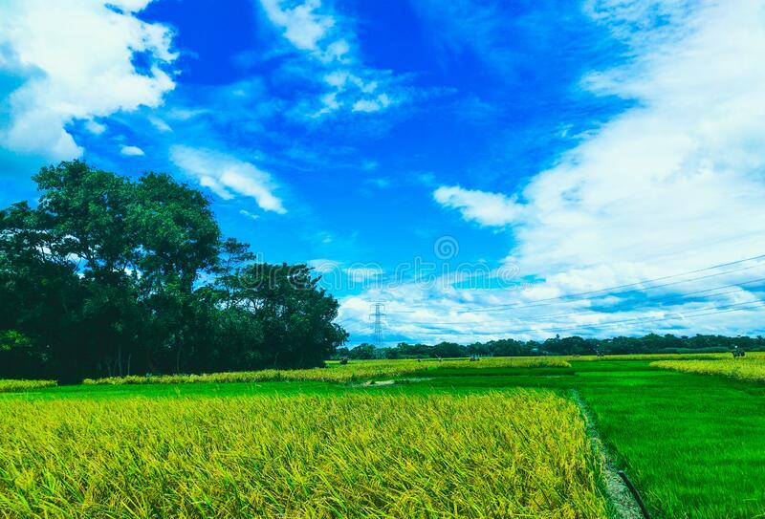
Figure 1.1-1 Cultivated land in BANGLADESH

Problem statement

Since diesel and electricity are very expensive, the researchers used renewable energy as an alternative energy. It is a conventional energy source. This is solar energy. The temperature in Bangladesh is between 20 ° 34´-26 26 38´ north latitude and 88 ° 01´-92 ° 41´ east longitude [1]. So Bangladesh has enough temperature to use solar energy. So we can use solar energy instead of diesel and electricity for irrigation in agriculture. This method has been introduced in other countries for a long time. IDCOL Company launched a project on solar irrigation in Bangladesh in 2010 and started a project in 2013 to install 1500 solar pumps by 2018. So far 1429 pumps have been approved and 1186 are already operational and the rest are under construction. It now aims to install 50,000 solar irrigation pumps by 2025 [4].

Objective

Many types of solar irrigation pumps have already been introduced in Bangladesh. Many technologies have been introduced in them. Most solar irrigation systems run without grid connect. These systems are used only during the irrigation season, but not on most days. This reduces the profit rate from this project. And all the systems that are connected to the grid are running on the previous technology. As technology is constantly changing, this system also needs to be updated to keep pace with the times.

- Through this paper we will update the solar irrigation system and use new technology. Through the new system we will introduce grid connected hybrid solar irrigation system. So that we get enough water at the right time to irrigate the land. And the electricity that will be generated from the solar panels in the off-season will be connected to the national grid through the grid, which will benefit the farmers.

- To find out how much the system will benefit in the next 20 years by comparing it with diesel through economic analysis.

Methodology

First we collect a few thesis papers from Bangladesh, and journal papers through which we get an idea about this system. We have collected secondary data from various web sites like Google, Wikipedia, Yahoo.com, Newspapers, reports, YouTube. We have discussed this topic with honorable teachers. And we have discussed with my friends. Then we analyzed the data through some software like Microsoft Word, PVSYST and Mendeley, calculated and created the thesis paper.

Theses Outline

As diesel and electric pumps become more expensive, solar irrigation pumps have started to be used. Usually solar pumps are not connected to the grid. In our research paper we have created a grid connected hybrid model. This is a simple model, can be used practically. This is a long term system. We analyzed and found that the system is profitable. And we tested the software to see if the system was economically viable. Physically this system can be seen using.

Different types of irrigation

Diesel engine irrigation system

Until 2010, the only irrigation system in Bangladesh was diesel-powered irrigation pumps and some electric-powered irrigation pumps. Diesel-powered irrigation pumps were more commonly used to irrigate crops during the dry season. There are still 1.35 million diesel pumps in Bangladesh [1]. The Bangladesh government imports 1.06 million tons of diesel for irrigation every year [5]. Diesel engine pumps are powered by diesel fuel. At present the price of diesel is 65 Taka per liter (https://www.globalpetrolprices.com/Bangladesh/diesel_prices/). As the price of diesel is increasing day by day, it is very expensive for the farmers to work on irrigation in this system. It affects the environment. The diesel engine produces large amounts of CO2 and toxic gases [6].

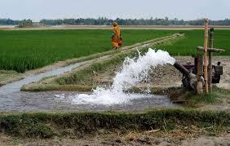
Figure 2.1-1 Diesel engine pump

Electric pump

The importance of electricity in moving towards economic growth and development in Bangladesh is immense [15].During the dry season, about 3.20lakh pumps are used to irrigate a total of 54.48 lakh hectares of crop land. As a result, 1700-1800 MW of electricity is used for irrigating paddy fields [15]. Electric pumps are powered by electricity through the national grid. There is a great lack of electricity in Bangladesh due to which the electric irrigation pumps cannot supply the required amount of water to the land at the right time. This causes a lot of damage to the crop.
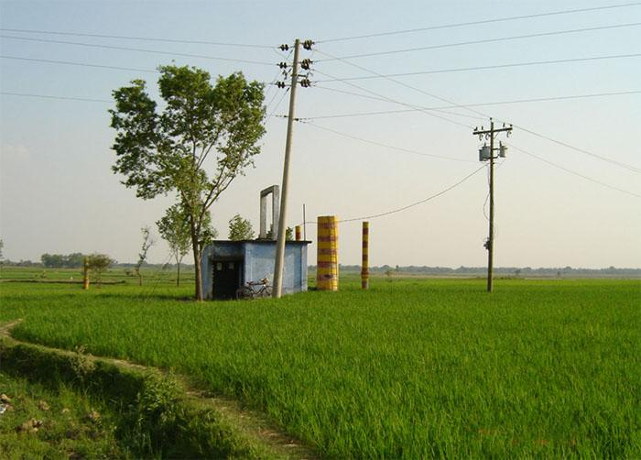

Figure STYLEREF 2 \s 2.2 SEQ Figure \* ARABIC \s 2 1 Electricity connected pump

Solar Irrigation Pump

Since diesel and electric pumps are very expensive, we can use renewable energy for irrigation. We can do irrigation work by converting solar energy into electrical energy. Solar irrigation pumps are powered by electricity generated from the sun. It has no effect on the environment. Solar energy is an environmentally friendly energy. It plays a huge role in agriculture. Most people are now becoming more interested in using solar pumps due to financial growth and lower costs. A farmer can irrigate one bigha of land with diesel or electricity pump for one season irrigation at a cost of 3,000Tk to 4,000 Tk, whereas at a solar irrigation pump it costs 2,500Tk to 2,800Tk. There is huge potential for solar irrigation system in Bangladesh. As of October 2019, IDCOL has approved 1630 solar irrigation pumps, of which 1323 pumps are operational, generating 32 MW of electricity and the rest are under construction (https://idcol.org/home/solar_ir). IDCOL has set a target of installing 50,000 solar pumps by 2025 for irrigation and improvement in agriculture (https://idcol.org/home/solar_ir).

Several character of solar irrigation pump:

Direct SIP

In a direct solar irrigation system, water is pumped from a direct PV panel. This system is a very simple system. This is done through a PV panel, pump control and a DC pump. It works during the day. It depends on the temperature of the sun, when the temperature is high it gets close to 100% energy and the water accelerates. But when the sun's temperature drops in the morning and afternoon, it gives water at a speed of 25% and less. To solve this problem, the PV panel and the motor need to be adjusted and the system needs to be improved [2].

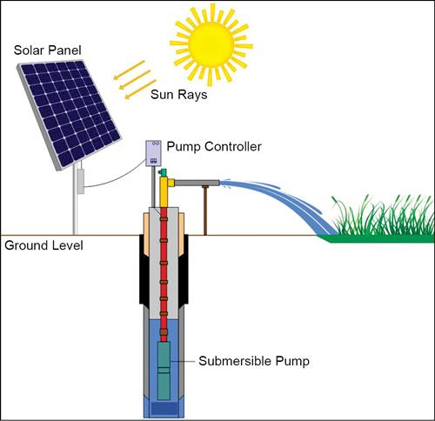
Figure 2.4-1 Direct SIP

Battery coupler SIP

Battery couple Solar Irrigation Pump consist PV module, control, battery and pump motor, can have storage tank as required. It runs the motor directly from the PV panel during the day. And stores the charge in the battery for night or bad weather so that it can be irrigated as required and at the right time [7].
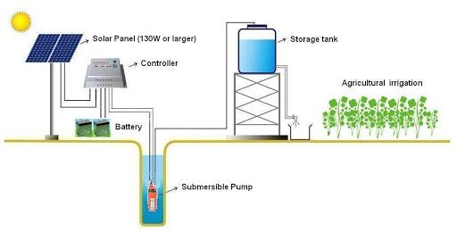
Figure 2.4-2 Design of battery coupler solar irrigation pump

Hybrid SIP

Hybrid solar irrigation system works in two ways on-grid and off-grid. Batteries can be connected to this system if desired. Connecting the national grid to this hybrid system. This system has more operating time. The pump will run from the panel during the day and can be operated at night with electricity from the grid if required [1] . When the grid connection is turned off, the solar pump can be run with the required energy from the battery.

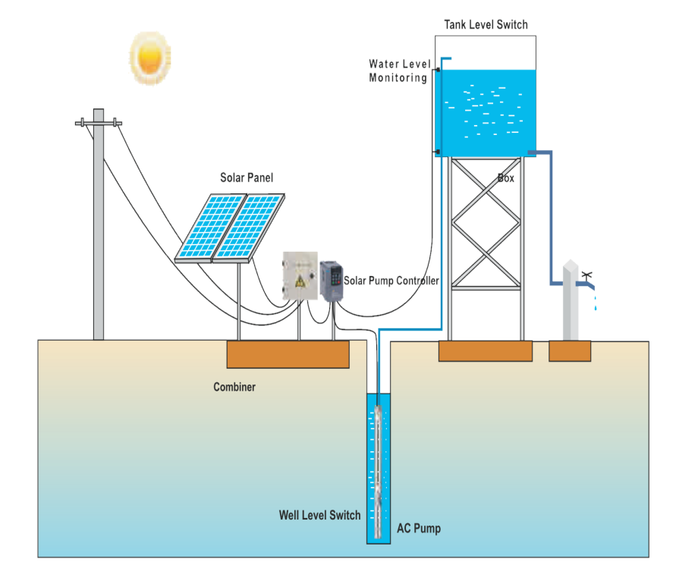
Figure 2.4-3 Hybrid solar irrigation system

Study Area

Rangpur Division

Rangpur Division is another division of Bangladesh. It was formed on 25 January 2010 as the 7th Division of Bangladesh. Earlier it was under Rajshahi division. Rangpur division consists of eight districts. There are 58upazilas under these eight districts. Rangpur has a total area of 16,184.99 km² in the northern part of Bangladesh and a population of 15,665,000 as per 2011 census (https://en.wikipedia.org/wiki/Rangpur_Division).

Table 3.1-1 Cultivable land, irrigated land and pump of Rangpur Division is show in the Table
District | Area km  square | Cultivable land  hectare | Irrigated land hectare | Deep tube  Well | Shallow tube well | Low lift pump | Solar irrigation pump(IDCOL) | Solar pump capacity mw(IDCOL)
Rangpur | 2400.56 | 170113.5 | 130647.06 | 708 | 12501 | 12 | 216 | 2.872
Dinajpur | 3444.30 | 527440 | 10284.82 | 3304 | 72318 | 720 | 395 | 10.364
Nilphamari | 1643.70 | 1285.15 | 45000 | 123 | 2423 | 488 | 2 | 0.008
sKurigram | 2245.04 | 121462 | 167467 | 204 | 42449 | 155 | 0 | 0
Gaibandha | 2179.27 | 160397 | 139640 | 347 | 41266 | 83 | 50 | 1.338
Thakurgaon | 1781.74 | 151841 | 141305 | 1242 | 47214 |  | 223 | 7.88
Panchagarh | 1404.62 | 108200 | 55256 | 34 | 3700 | 03 | 94 | 3.34
Lalmonirhat | 1247.37 | 100984 | 99975 | 258 | 42518 | 94 | 2 | 0.055
Source the data: Bangladesh national portal site from Google.

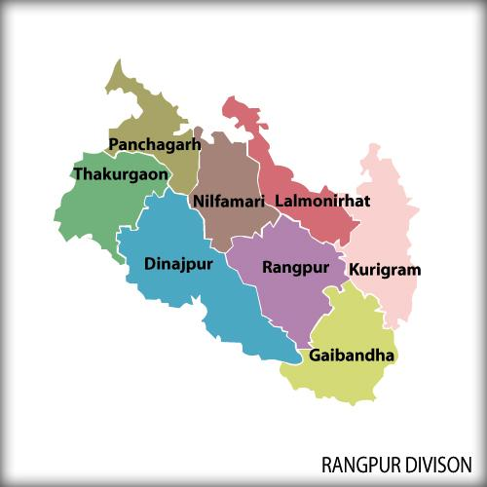
Figure 3.1-1 Rangpur division Map

The main targeted area is Rangpur District for analysis

Rangpur Division another district is Rangpur District. It consecrated in 1772 [9].It is located in Northan, Bangladesh. Rangpur district consists of 8 upazilas [9]. They are Badarganj, Pirganj, Mithapukur, Gangachara, Kaunia, Pirgachha, Rangpur Sadar, Taraganj. The average temperature here ranges from 32 degrees Celsius to 11 degrees Celsius. Total area is 2400.56km square.

Temperature:

The temperature of this district coordinate latitude 25° 44′ 0″ N and longitute89° 15′ 0″ E.

Average hourly temperature

The figure below shows that characterization of the entire year of hourly average temperature. Horizontal axis is the day of the year and vertical axis is the hour of the day.

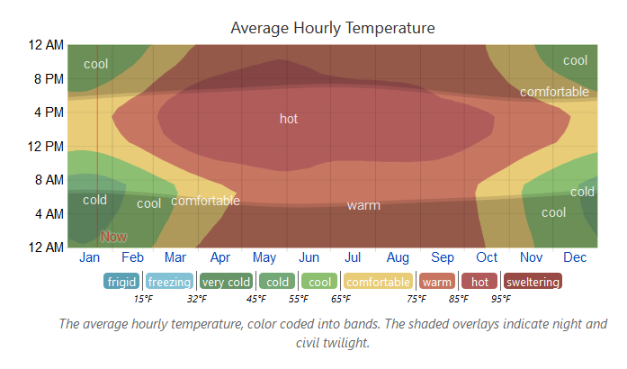
Figure 3.2-1 Average Hourly Temperature of the year

Hourly temperature of daylight and Twilight

In this figure show that November to February month daytime less than night time. And may to August month daytime high. And September to October and March to May day and night average time.

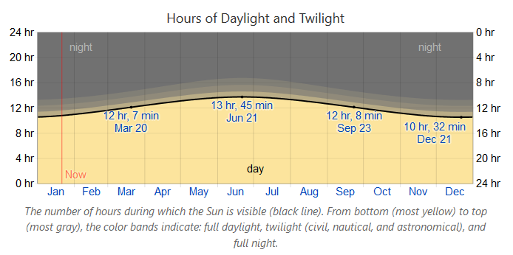
Figure3.2-2Hourly temperature of daylight and twilight

Yearly sunrise and sunset with twilight

In this figure show that the yearly average sunrise time is 5:10am to 6:51am and average sunset time is 5.11pm to 6:58pm.
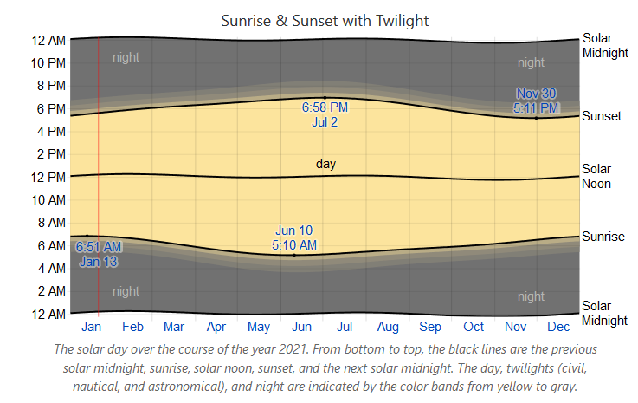
Figure 3.2-3 The yearly sunrise and sunset time

Incident shortwave solar energy

Figure 3.2-4 shows the incident of shortwave solar energy. It produces the most energy in mid-May and around 7.2 kWh to 7.8 kWh in early June. And produces the least energy from the end of November to the end of January.

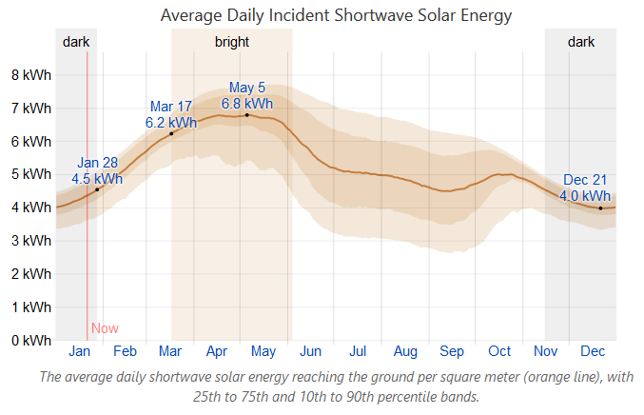
Figure3.2-4 Incident shortwave solar energy

Average high and low temperature
The hot season of the month is May 20 to June 22 and average temperature is 91 to 97 degree farad [10]. And cold season of the month is December 5 to February 6 and average temperature is 51 to57 degree farad.
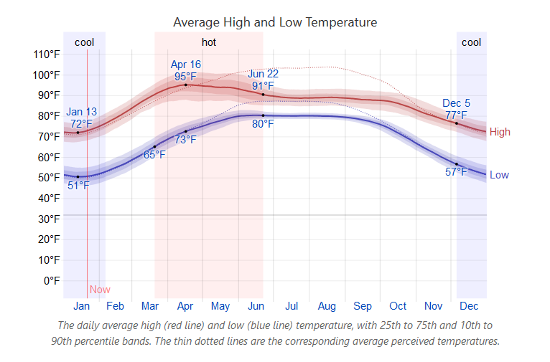
Figure 3.2-5: Average high and low temperature

Soil classification

Table 3.3 Soil classification [11]
upazila | Soil classification |  |  |  |  |  |  | Total
upazila | Doash | Bele |  |  | etel | kangkor | others | Total
Badargonj | 53846 | 49 |  | 13706 |  | 0 | 0 | 70404
Gangachara | 24468 | 12878 |  | 27044 |  | 0 | 0 | 51990
Kaunia | 23940 | 9960 |  |  |  | 0 | 1330 | 30181
Mithapukur | 75780 | 10300 |  | 39575 |  | 0 | 0 | 120257
Pirgacha | 31139 | 12400 |  | 18600 |  | 0 | 0 | 64804
Pirganj | 60867 | 5072 |  | 10146 |  | 25361 | 0 | 104088
Rangpursadar | 75113 | 2346 |  | 110 |  | 0 | 0 | 77216
Taragang | 18111 | 190 |  | 3500 |  | 0 | 9131 | 25602
Total | 363264 | 53195 | 112681 |  |  | 25361 | 10461 | 544542

3.4 Irrigation pump and irrigated area

Table 3.4 Irrigation pump and irrigated area [11]
Upazila | Electric pump | Diesel pump | Irrigated area (acre)
Badargonj | 2450 | 4925 | 36864
Gangachara | 818 | 7520 | 42165
Kaunia | 2650 | 2315 | 33204
Mithapukur | 1102 | 16912 | 87796
Pirgacha | 1471 | 6529 | 47689
Pirganj | 1473 | 11000 | 56933
Rangpursadar | 1810 | 10900 | 70570
Taragang | 1500 | 5600 | 28900
Total | 13274 | 65701 | 404121

Area, temperature and number of solar pump in Rampur district

Table 3.5-1 Area, temperature and number of solar pump in Rampur district
Upazila | Area(km square) | Temperature | Solar pump | Capacity(kW)
Badargonj | 301.29 | 25° 40′ 0″ N, 89° 3′ 0″ E | 196 | 2597.77
Gangachara | 272.28 | 25° 51′ 0″ N, 89° 13′ 0″ E | 0 | 0
Kaunia | 147.6 | 25° 46′ 12″ N, 89° 25′ 0″ E | 2 | 50.2
Mithapukur | 515.62 km² | 25° 32′ 30″ N, 89° 17′ 0″ E | 13 | 166.47
Pirgacha | 265.32 km² | 25° 34′ 48″ N, 89° 24′ 0″ E | 0 | 0
Pirganj | 409.37 km² | 25° 24′ 54″ N, 89° 19′ 0″ E | 5 | 58.56
Rangpursadar | 330.33 km² | 25° 45′ 30″ N, 89° 14′ 0″ E | 0 | 0
Taragang | 128.64 km² | 25° 48′ 42″ N, 89° 1′ 0″ E | 0 | 0
Total | 2,400.56 km² |  | 216 | 2873

https://en.wikipedia.org/wiki/Rangpur_District&http://www.renewableenergy.gov.bd/index.php?id=01&i=4&s=&ag=&di=32&ps=&sg=&fs=&ob=1&submit=Search

Current condition of solar pumps in Rangpur district

The use of solar pumps is increasing day by day in Rangpur. Farmers are now more interested in using solar pumps instead of diesel engine pumps. As a result, about 21 crore fuel oil is being saved every year. Even a few years ago, farmers had to rely on diesel engine pumps in this area. You don't have to do that anymore. Farmers' energy dependence has been eliminated in many parts through solar pumps. Now there is no extra chair for diesel, no need for frequent load shedding and worries. Rather any farmer has saved electricity and fuel. Irregularly matching irrigation facilities. Now in the Boro season it costs six and a half thousand rupees per acre for irrigation and two thousand four hundred rupees per acre. The cost of Rabi season is only one thousand Taka. Abu Bakkar, a farmer in the Ramnathpur area of Badargong in Rangpur, used to use a diesel engine pump to irrigate his land. He told Barta24 that he used to take a machine from home every day, go to the market to buy diesel, and there was frequent load shedding. But now there are many benefits and many savings for solar pumps. According to various solar plant service companies, a 15 kW solar pump with half subsidy costs 45lakh Taka. And a 45kW solar irrigation pump costs 52lakh Taka. At present 26,000 acres of land in Rangpur division is irrigated by solar palms. There are seven and a half thousand acres under IDCOL.

According to IDCOL's theory, 60,500 acres of land in Rangpur district is under solar pump. As a result, 75,000 farmers are getting irrigation facilities. Selim Reza, Divisional Manager, IDCOL, said that IDCOL has been providing solar pumps in 10 districts since 2015.There are more plants in Rangpur district.

He added that 7402kW of electricity is being saved annually due to solar energy. The value of which is about 4 crore rupees. And 7005 solar pumps save 31 lakh liters of diesel per year. The cost of which is 20crore 30lakh Taka. An average of 80-90 farmers are getting irrigation facility from one solar plant. MD Moniruzzaman, Deputy Director, Additional Agriculture Extension Department, Rangpur District, said the use of solar power has increased. However, if the government gives more subsidy to the farmers, the cost will come down and the production will increase [14].

Table 3.6-1 Comparison between diesel and solar pump [12]
Item | Diesel pump |  | Solar pump
Land area | 1bigha |  | 1bigha
irrigation | 1 time |  | 1time
Cost  1bigha and irrigation | Engine rate | Diesel price | 3month,total 50times irrigation cost=3500tk
Cost  1bigha and irrigation | 200tk | 70tk/lit*2 | 3month,total 50times irrigation cost=3500tk
Cost  1bigha and irrigation | Total=340tk |  | Only 70tk
Cost season per bigha(boro) | 25 irrigations (200*25)-(50*70)=8500tk |  | 50 irrigations Only 3500tk
Labor | 1 |  | None
Quality of Crop | Good |  | Better
Availability of water | Not Available |  | Available

Solar irrigation pump in Badargong Upazila,Rangpur District.

In Badargong Upazila in Rangpur District of Rangpur Division, it can be seen that the temperature here is in harmony with the environment. Average daylight 10-14 hours and sunlight 10-12 hours. And the average daily incident shortwave solar energy of 5kwh is enough to use 6 kWh of solar energy. Then if we look at the soil, the soil is very good for crop production there are 3 types of soil doash, Beleand Etel soil. Doash and Etel soils have high water holding capacity and these soils are good for rice production. So we can easily irrigate using solar pumps. Rangpur district has the highest number of solar pumps in Badargonjg upazila. It costs 7,000 Tk to irrigate a farmer's one acre of land with solar pump in one season and 12,000-13,000Tk with diesel pump [13]. So, farmers are more interested in using solar pumps. So IDCOL Company has taken the target to install 50000 solar pumps by 2025 ,replacing 200000 to 250000 diesel rum pump [13].

Design and Calculation of Hybrid Solar Irrigation System

Hybrid solar irrigation system (HSIR) with grid-connected
Hybrid Solar Irrigation is an advanced method of solar irrigation system. It is a grid connected system. This is a combination of on-grid and off-grid, meaning it can be done in two ways. This increases the operating system. Solar irrigation systems only worked on On-grid or off-grid. In the case of on-grid, irrigation could be done during the day with solar panels. Irrigation could not be provided at night or on cloudy days, but irrigation could be provided with electricity from the grid when there was electricity in the national grid. And the batteries were connected to the off-grid so that after irrigating during the day and if irrigation was required at night, the pump could be run by charging from the battery to irrigate the land at the right time. But due to high battery cost, this system is for costly farmers.

To solve these problems use hybrid solar irrigation system. The system is connected to the national grid with a bi-directional meter. Energy can be transferred through this meter. The reason for adding to the national grid is that in the off-season when solar energy is not needed, the energy will go to the national grid. As a result, the power and grid in the national grid will be reduced a bit and the farmers will benefit from it. And this system has hybrid solar panels, hybrid inverters and submersible pumps. The reason for using hybrid panels is that the more kW more panels are installed from this panel, the more kW of electricity will be available, no more power will be wasted and the capacity will be much better.

A hybrid inverter has been used. The job of the inverter is to convert the DC current of the panel to AC current and run the pump through this AC current and connect it to the national grid. Using this inverter does not require any battery later. This expensive equipment like battery will not be used in it. Works on-grid and off-grid without batteries. During the day the solar panel will run for 8-10 hours. Since the average solar temperature in Bangladesh is 8-10 hours. Normally 14-16 hours of solar pumps do not work at night. The hybrid system can also be run at night. Irrigation can be done with electricity from the grid at night. If there is no electricity, it is possible to give some backup by this inverter. It is possible to irrigate more land through this system.

Design of irrigation system

PV module
Table 4.2-1 PV module
parameter | unit
Manufacture | Generic
Model | CS1V-250ms
Unit nominal power | 250 Wp
Number of PV module | 20 unit
Nominal STC | 5.0kWp
Module | 2 strings*10 In series

Calculation of PV module:

Total power=5000W
Each panel power=250W
Module number=20
Per watt cost=70 Taka
So,1 panel cost, 250*70=17500
And, Total PV panel cost =per module cost*module number
=17500*20
=350000Taka

Inverter
Table 4.2-2 Inverter
Parameter | Unit
Manufacture | Generic
Model | Solar Inverter RPI H5A
Unit nominal power | 5.0KWac
Number of Inverter | 1unit
Total power | 5.0KWac
Operating Voltage | 100-500 V
Prom ratio (DC:AC) | 1.0
Cost of Hybrid Inverter: 220000Taka.

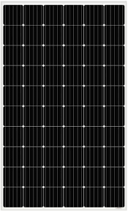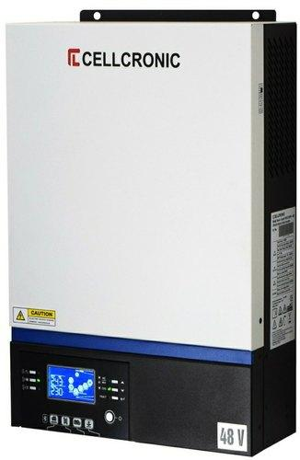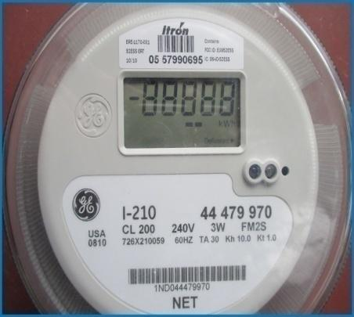

monocristalline Pv panel Hybrid Inverter Bi-directional Meter

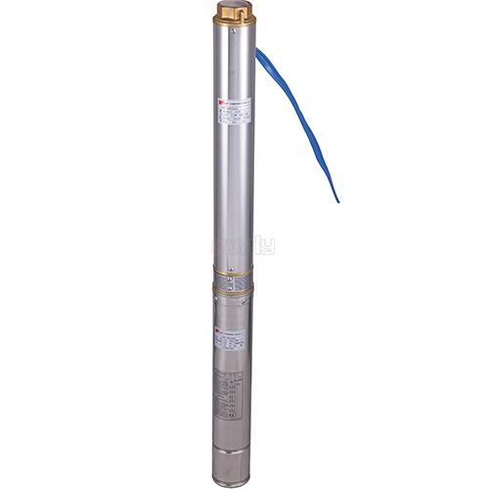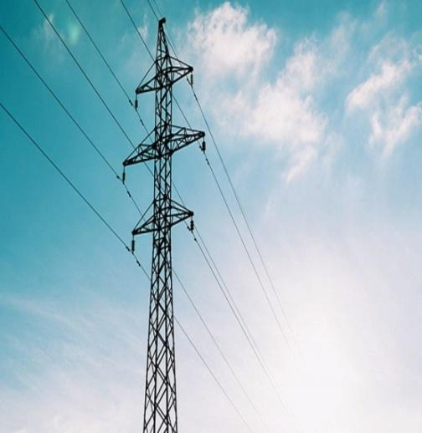
submersible Pump Grid connection

Figure 4.2-1 Proposed Design of Hybrid Solar Irrigation System with Grid Connection

Pump specification

Particular |  | Description
Solar pump |  | 5HP
Solar pump type |  | AC Submersible
Pump head |  | 60-120 meter
Open circuit voltage |  | 90-140V DC
Maximum peck voltage |  | 110V DC
Maximum input current |  | 40 Amps
Output voltage |  | 30 – 85V
Input voltage |  | 3000W dc
Protection |  | Over current, high and low voltage, dry run, overflow etc.
Discharge |  | 45000-100000liters\day
Warranty |  | 10 years
Pump Price |  | 65000taka

4.3 Compare to solar irrigation system to grid connecter hybrid solar irrigation system.

Table 4.3 Compare to solar irrigation system to grid connecter hybrid solar irrigation system

 | Solar irrigation system | Hybrid solar irrigation system with grid
Panel | 7.5kw | 5kw
pump | 5hp dc submersible pump | 5hp ac submersible pump
grid | No connect | Connected
Panel control | 1 controller | Hybrid inverter
Operating time | Day | Day , Night
Capacity | 75% | 86%
Lifetime | 20years | 30years
warranty | Setup 10 years and panel 20 years | Setup 20 years and panel 30 years
Discharge water | 100000 liter per day | 100000 liter per day
Return on investment | unavailable | Available
quality | good | Batter

Economic Analysis

Installation cost of hybrid solar irrigation system with grid connected.

We know that the main problem in solar pump system is installation cost. When installing diesel and solar irrigation pumps, it is seen that the cost of installing solar pumps is higher than that of diesel. But the demand for solar irrigation pumps is increasing day by day due to lack of maintenance cost and environmental friendliness. According to various sources, farmers are more interested in solar irrigation pumps. But because the solar pumps are off grid, the solar panels are useless in the off season and the operating hours are less, the irrigation work is stopped at night in the one season. So we will replace the solar irrigation pumps with grid connected hybrid solar irrigation pumps. We select an area and analysis use PVSYST software where there are solar pumps but not connected to the grid and see if this system is viable compare to diesel and solar pumps.

Table 5.1-1 Installation cost of Hybrid solar irrigation system with grid connected
Item | Quantity  Unit | Cost  BDT | Total  BDT
PV module (CS1V-250MS) | 20 | 175000 | 350000
Inverter(solar inverter RPI H5A | 1 | 220000 | 220000
Wearing | 1 | 5000 | 5000
setting | 1 | 5000 | 5000
Grid connected | 1 | 10000 | 10000
Pump | 1 | 65000 | 65000
Total |  |  | 655000
Depreciable assist |  |  | 570000

Normalized productions (per installed kWp):

In this figure we show that normalized energy expressed as (kWp/kWp/day). There are Lc(collection loss) array losses of PV panel every day 0.79 kWh/kWp/day. The system loss (LS) Yr-Yf, include inverter losses in grid connected system in standalone is 0.14kWh/kWp/day. Yf =system yide, daily useful energy referred to the nominal power, inverter output 4.47kWh/kWp/day.

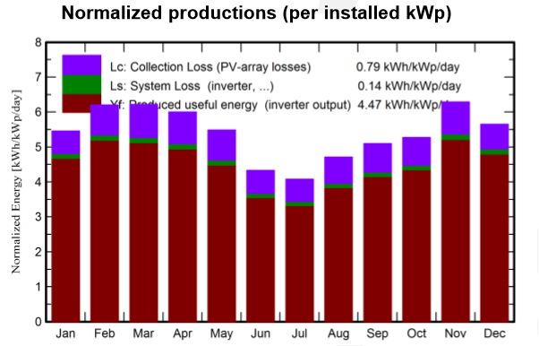
Figure 5.2 Normalized productions (per installed kWp)

Balance and Main result:

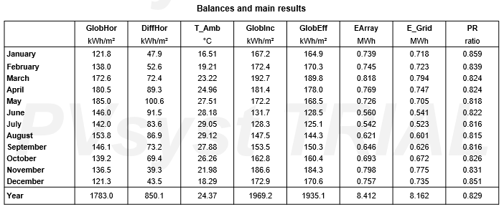
Figure 5.3-1 Balance and Main result
This table show that yearly Global horizontal irradiation is 1783.0. Energy injected into grid 8.162MWh and performance ratio o.829.In this system energy produced 8.16 MWH/year and specific production 1632kWh/kWp/year. Its investment global 655000BDT and specific 131Wp, payback period 10.4 years. Performance Ratio 82.89%. So, 10.4 years later thy system totally free.

Grid Electricity Cost Calculation

Let,
Grid Electricity/Tariff Cost =7.70 BDT/kWh
Total Yearly Energy Produced=8.162MWh
Assume,
One season 4 month use energy for irrigation that December to March
December

Table 5.4-1 Use Energy Irrigation One Season
Month | Power
December | 0.735MWh
January | 0.718MWh
February | 0.723MWh
March | 0.794MWh
Total Energy Consumption | 2.97MWh

Total Yearly Save Energy/ National Grid Connected = Total Energy Produced –Energy Consumption
=8.162MWh - 2.97MWh
=5.192MWh

So, 1years energy cost = Total Energy *Tariff
= (8.162*1000*7.70) kWh
= 62847.4 BDT
Then, 20years energy cost = 62847.4*20
=1256948 BDT

P50 –P90 evaluation of probability distribution:

The P50-P90 evaluation is a probabilistic approach for the interpretation of the simulation result over several years. the graph shows the year to year viability (variance) 2.5%. Global variability ( quadratic sum) 3.1%. Annual production Probability viability 0.25 MWH, P50 8.16 MWH e-grid probability 0.04 and P90=7.84MWH where probability 0.18.
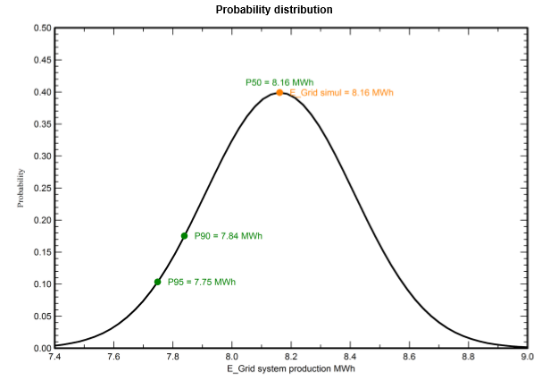
Figure 5-55.5-1 probability distribution

CO2emission balance of this system

In this solar irrigation system lifetime is 30years.and energy produce 816.2MWh.Replace emission 143.0t CO2. Generated emission 18.29t CO2. Total 105.8 tCO2
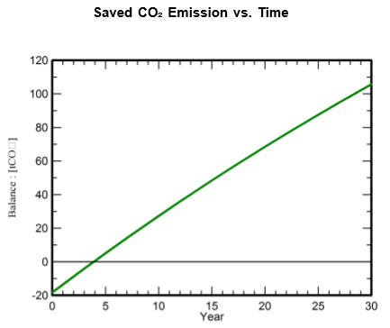
Figure 5.6-5.6-1CO2 emission balance

Economic Result of hybrid solar irrigation system

This project life time 20years.Start time 2022. This table show that return on investment is payback period 10.4 years, net present value(NPV) is 12,57,342.37 BDT. Return on Investment (ROI) 192.0%. So, understood that show this table this project is profitable.

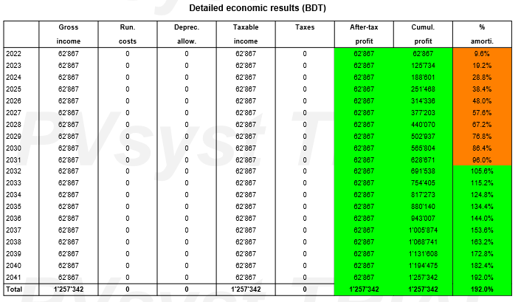
Figure 5.7-0-1details economic result (BDT)

Conclusion

Conclusion:

Many have researched it, their systems were good but there were old models and their effectiveness was low. We have used new technology through our system to increase the efficiency of the system. In the new system we have used hybrid / monocrystalline solar panels. Its efficiency is much higher and more watt panels can be installed in less space. And I have used a hybrid inverter which is a good device for irrigating the land with more operating time, it can also be used for irrigation day and night. I have used a Bi-directional meter which is connected to the grid and it will transfer electricity. And a submersible pump has been used. The system has been made much simpler. We know that the installation cost of solar irrigation pump is very high but very easy to use and it does not affect the environment.

And we have selected an area where there are already solar pumps, replacing those pumps and adding them to the grid using new technology. And by targeting 20 years, we analyze the data through software and see if the project is profitable. We run the system with a grid electricity cost of 7.70 BDT per kWh. And we can analyze that the payback period of the system was 10 years, that means we can see that in 10 years we can run the irrigation pump for free for the next 10 years without costing our initial cost. It is more effective than others. If we use it in practically, we will be able to understand it better. And it will play a very important role in the future. More research can be done on this system in the future and more analysis on real data can be done later.

Reference

[1] M. A. Hasnat, M. N. Hasan, and N. Hoque, “A brief study of the prospect of hybrid solar irrigation system in Bangladesh,” Int. Conf. Mech. Ind. energy Eng., pp. 25–26, 2014.
[2] J. B. Joynal, N. T. Raka, H. M. Mithu, and L. T. Iqbal, “Design & Economic Analysis of a Solar Powered Water Pumping System for Crop Irrigation,” p. 74, 2017.
[3] Z. Tasneem, S. I. Annie, and K. M. Salim, “Economic analysis of a 3KW solar based irrigation system and comparison with its diesel based counterpart,” 2015 IEEE Int. WIE Conf. Electr. Comput. Eng. WIECON-ECE 2015, pp. 14–17, 2016, doi: 10.1109/WIECON-ECE.2015.7443939.
[4] S. A. Chowdhury, “Grid Integration of Solar Irrigation Pumps Technical and Financial Solutions Final Report Submitted to: Programme Specialist Environment Sustainability and Energy Project Manager-SREPGen United Nations Development Programme (UNDP),” no. December, 2018, [Online]. Available: https://www.undp.org/content/dam/bangladesh/docs/Projects/srepgen/2018.11.11 - Report on Solar Irrigation Pump Integration.docx.pdf.
[5] S. B. Mahtab and A. Morshed, “Achievements of a Pilot Solar Powered Irrigation Project in Bangladesh,” Iarjset, vol. 5, no. 9, pp. 1–4, 2018, doi: 10.17148/iarjset.2018.591.
[6] N. I. Sarkar, A. I. Sifat, N. Rahim, and S. M. S. Reza, “Replacing diesel irrigation pumps with solar photovoltaic pumps for sustainable irrigation in Bangladesh: A feasibility study with HOMER,” 2nd Int. Conf. Electr. Inf. Commun. Technol. EICT 2015, pp. 498–503, 2016, doi: 10.1109/EICT.2015.7392004.
[7] J. W. Santrock, “No 主観的健康感を中心とした在宅高齢者における健康関連指標に関する共分散構造分析Title,” Diaria da República, no. March, pp. 111–127, 2011.
[8] A. Roy, W. Islam, S.M.Hasan, and S. M. N. Hoque, “Prospect of Solar Pumping in the Northern Area of Bangladesh,” vol. 1, no. 4, pp. 172–179, 2015, [Online]. Available: https://www.researchgate.net/publication/282249291_Prospect_of_Solar_Pumping_in_the_Northern_Area_of_Bangladesh.
[9] M. O. F. Planning, G. Of, T. H. E. People, and S. R. Of, “District Statistics 2011 Barguna District Statistics 2011,” no. December, 2013.
[10] “Rangpur Division - Wikipedia.” .
[11] M. Zaman, S. Pramanik, N. Parvin, and A. Khatun, “Crop Diversification in Rangpur Region,” Bangladesh Rice J., vol. 21, no. 2, pp. 255–271, 2018, doi: 10.3329/brj.v21i2.38210.
[12] S. Zaman, S. Matin, and A. M. Bin Gholam Kibria, “A Study on Present Scenario of Child Labour in Bangladesh,” IOSR J. Bus. Manag., vol. 16, no. 6, pp. 25–36, 2014, doi: 10.9790/487x-16632536.

[13.] Bhuiyan, A. H. (2018, july 24). Financial Express . Retrieved from solar pumps cutcoasts ofirrigation forfarmers .
[14.] Faruk, F. (2020, february 29). Barta 24. Retrieved from Solar irrigation saves Tk 25 crore per year.
[15.] Kanojia, C. ( 2019 , march 18). https://thefinancialexpress.com.bd/img/logo.png. Retrieved from Solar power to revolutionise Bangladesh irrigation.

Appendix-A

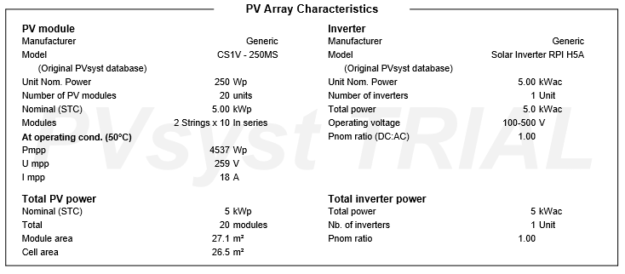

Appendix- B

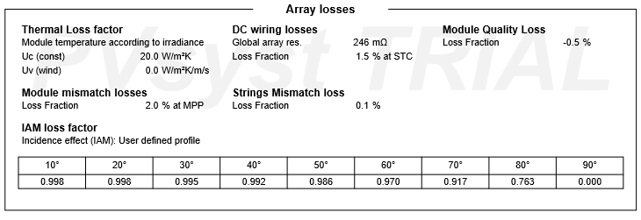

Appendix-C

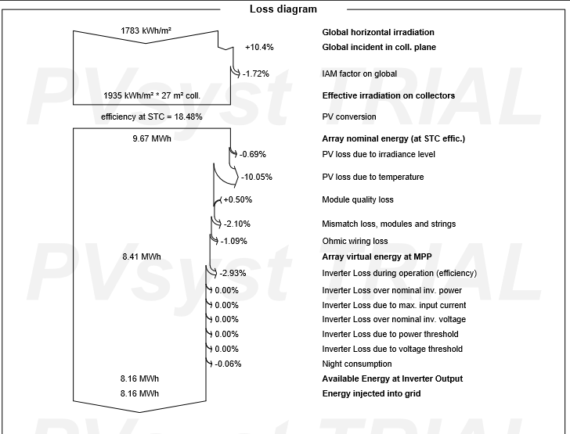

Appendix –D
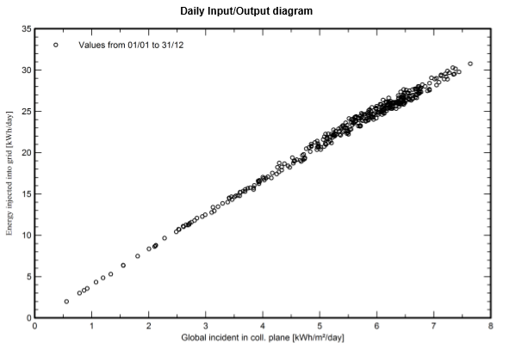

Appendix-E
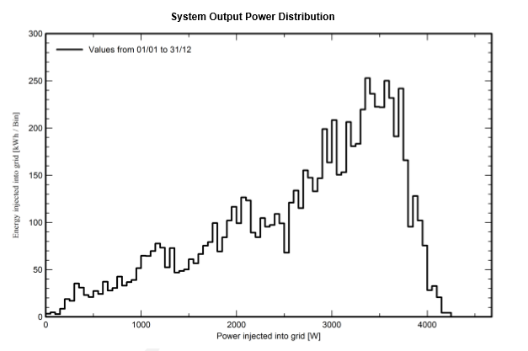

Appendix –F
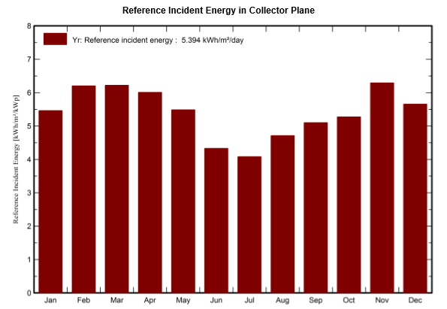

Appendix-G

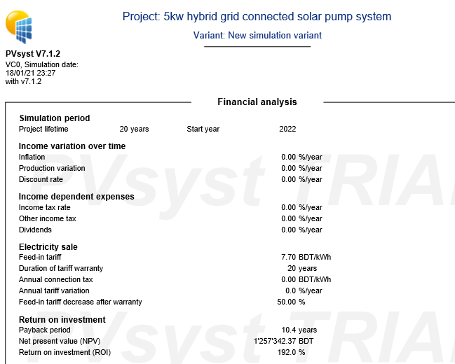
Appendix-H