Smart MSW: Collection of Waste to Energy

Conservation that Mitigates the Demerits on the

Environment and Human

A Project and Thesis submitted in partial fulfillment of the requirements for the Award of Degree of Bachelor of Science in Electrical and Electronic Engineering

Submitted by

Ahad Ali

(ID#: 172-33-463)

Dewan Shohanur Rahman

(ID#: 172-33-486)

Supervised by

MD. ASHRAFUL HAQUE

Assistant Professor

Department of EEE


DEPARTMENT OF ELECTRICAL AND ELECTRONIC ENGINEERING

FACULTY OF ENGINEERING

DAFFODIL INTERNATIONAL UNIVERSITY

January, 2021
Certification

This is to certify that this project and thesis entitled “Smart MSW: Collection of

Waste to Energy Conservation that Mitigates the Demerits on the Envi-ronment and Human” is done by the following students under my direct supervision and this work has been carried out by them in the laboratories of the Department of Electrical and Electronic Engineering under the Faculty of Engineering of Daﬀodil Inter-national University in partial fulfillment of the requirements for the degree of Bachelor of Science in Electrical and Electronic Engineering. The presentation of the work was held

on ............. .

.........................................

Name: Ahad Ali

ID#: 172-33-463

.........................................

Name: Dewan Shohanur Rahman

ID#: 172-33-486

Countersigned

.........................................

Md. Ashraful Haque

Assistant Professor

Department of Electrical and Electronic Engineering Faculty of Science and Engineering Daﬀodil International University.

The project and thesis entitled “Smart MSW: Collection of Waste to Energy

Conservation that Mitigates the Demerits on the Environment and Hu-

man”, submitted by Ahad Ali, ID No: 172-33-463, and Dewan Shohanur Rahman, ID No: 172-33-486, Session: Summer, 2017 has been accepted as satisfactory in partial fulfill-ment of the requirements for the degree of Bachelor of Science in Electrical and Electronic Engineering on ........... .
BOARD OF EXAMINERS

.....................................

Name:

Designation:

Department of EEE, DIU

Chairman

.....................................

Name:

Designation:

Department of EEE, DIU

Internal Member

.....................................

Name:

Designation:

Department of EEE, DIU

Internal Member

Dedicated to

Our Parents
Acknowledgment

In this very special moment, first and foremost we would like to express our heartiest gratitude to the almighty Allah for allowing us to accomplish this Bachelor study success-fully. We are really thankful for the enormous blessings that the Almighty has bestowed upon us not only during our study period but also throughout our life.

In achieving the gigantic goal, we have gone through the interactions with and help from other people, and would like to extend our deepest appreciation to those who have contributed to this dissertation itself in an essential way.

We would like to express our heartfelt thanks to all of you for being with us with immense support and care and to make this work success.

Ahad Ali

Dewan Shohanur Rahman

January, 2021

Daﬀodil International University i

Contents

Acknowledgment |  |  | i
Contents |  |  | ii
List of Figures |  |  | iv
List of Tables |  |  | v
Abstract |  |  | vi
1 | Introduction |  | 2
 | 1.1 | Overview . . . . . . . . . . . . . . . . . . . . . . . . . . . . . . . . . . . . | 2
 | 1.2 | Motivation . . . . . . . . . . . . . . . . . . . . . . . . . . . . . . . . . . . | 2
 | 1.3 | Problem Statements . . . . . . . . . . . . . . . . . . . . . . . . . . . . . | 3
 | 1.4 | Objectives . . . . . . . . . . . . . . . . . . . . . . . . . . . . . . . . . . . | 3
 | 1.5 | Contributions . . . . . . . . . . . . . . . . . . . . . . . . . . . . . . . . . | 4
 | 1.6 | Organization . . . . . . . . . . . . . . . . . . . . . . . . . . . . . . . . . | 4
2 | Background Study |  | 6
 | 2.1 | Introduction . . . . . . . . . . . . . . . . . . . . . . . . . . . . . . . . . . | 6
 | 2.2 | Types of Waste in Bangladesh . . . . . . . . . . . . . . . . . . . . . . . . | 6
 | 2.3 | Dump Storage Area . . . . . . . . . . . . . . . . . . . . . . . . . . . . . . | 7
 | 2.4 | Waste to Energy (WtE) . . . . . . . . . . . . . . . . . . . . . . . . . . . | 8
 | 2.5 | Aﬀect on the Globe . . . . . . . . . . . . . . . . . . . . . . . . . . . . . . | 8
3 | Literature Review |  | 10
 | 3.1 | Introduction . . . . . . . . . . . . . . . . . . . . . . . . . . . . . . . . . . | 10

ii

3.2 | Feasibility of Waste to Energy from MSW . . . . . . . . . . . . . . . . . |  | 10
3.3 | Smart Waste Management . . . . . . . . . . . . . . . . . . . . . . . . . . |  | 12
3.4 | Energy Content Estimation . . . . . . . . . . . . . . . . . . . . . . . . . |  | 13
3.5 | Summary . . . . . . . . . . . . . . . . . . . . . . . . . . . . . . . . . . . |  | 15
4 Proposed Architecture and Design |  |  | 18
4.1 | Introduction . . . . . . . . . . . . . . . . . . . . . . . . . . . . . . . . . . |  | 18
4.2 | Main Architecture . . . . . . . . . . . . . . . . . . . . . . . . . . . . . . |  | 18
 | 4.2.1 | Waste Separator Unit . . . . . . . . . . . . . . . . . . . . . . . . . | 20
 | 4.2.2 | Thermal Room . . . . . . . . . . . . . . . . . . . . . . . . . . . . | 21
 | 4.2.3 | Biological Room . . . . . . . . . . . . . . . . . . . . . . . . . . . | 22
 | 4.2.4 | Recycling . . . . . . . . . . . . . . . . . . . . . . . . . . . . . . . | 23
4.3 | Smart Collection of MSW . . . . . . . . . . . . . . . . . . . . . . . . . . |  | 24
 | 4.3.1 | Smart Bin . . . . . . . . . . . . . . . . . . . . . . . . . . . . . . . | 24
5 Estimated Results and Analysis |  |  | 27
5.1 | Introduction . . . . . . . . . . . . . . . . . . . . . . . . . . . . . . . . . . |  | 27
5.2 | Ultimate and Proximate Analysis . . . . . . . . . . . . . . . . . . . . . . |  | 28
 | 5.2.1 | Moisture Content . . . . . . . . . . . . . . . . . . . . . . . . . . . | 28
 | 5.2.2 | Volatile Matter . . . . . . . . . . . . . . . . . . . . . . . . . . . . | 29
 | 5.2.3 | Ash Content . . . . . . . . . . . . . . . . . . . . . . . . . . . . . . | 30
5.3 | Energy content Computation . . . . . . . . . . . . . . . . . . . . . . . . |  | 30
5.4 | Analysis of the Estimation . . . . . . . . . . . . . . . . . . . . . . . . . . |  | 31
5.5 | Impact on the Environment . . . . . . . . . . . . . . . . . . . . . . . . . |  | 32
6 Conclusion and Future Work |  |  | 34
6.1 | Introduction . . . . . . . . . . . . . . . . . . . . . . . . . . . . . . . . . . |  | 34
6.2 | Conclusion . . . . . . . . . . . . . . . . . . . . . . . . . . . . . . . . . . . |  | 34
6.3 | Direction of Future Works and Limitations . . . . . . . . . . . . . . . . . |  | 35
Bibliography |  |  | 36

Daﬀodil International University iii

List of Figures

2.1 | Diﬀerent types of Waste in Bangladesh . . . . . . . . . . . . . . . . . . . | 7
4.1 | Proposed Architecture . . . . . . . . . . . . . . . . . . . . . . . . . . . . | 19
4.2 | Waste Separator Unit . . . . . . . . . . . . . . . . . . . . . . . . . . . . . | 20
4.3 | Thermal Treatment . . . . . . . . . . . . . . . . . . . . . . . . . . . . . . | 21
4.4 | Biological Treatment . . . . . . . . . . . . . . . . . . . . . . . . . . . . . | 23
4.5 | Proposed Design of a simple Smart Bin . . . . . . . . . . . . . . . . . . . | 24

iv

List of Tables

1.1 | Growth of Solid Waste Generation in Urban Cities of Bangladesh . . . . | 3
3.1 | Summary of Literature Reviews . . . . . . . . . . . . . . . . . . . . . . . | 16
5.1 | Results of Ultimate Analysis [17] . . . . . . . . . . . . . . . . . . . . . . | 28
5.2 | Results of Proximate Analysis [17] . . . . . . . . . . . . . . . . . . . . . . | 29
5.3 | Estimation of Contents . . . . . . . . . . . . . . . . . . . . . . . . . . . . | 31
5.4 | Inferential Cost of a Plant . . . . . . . . . . . . . . . . . . . . . . . . . . | 32

v

Abstract

As a human being, we produce adverse amount of waste from our daily life chores. From preparing food to running an industry, everywhere some wastes are being disposed. To keep our environment pollution free and healthy, we should think about the disposal of Municipal Solid Waste (MSW). Otherwise, our land could be unsuitable for living. In this work, we considered our beloved city, Gazipur which is one of the largest district in Bangladesh. We evaluated the volume of waste that are generated in a particular day by a single person. In sum, we saw that around 475,000 kg of solid waste is produced in the area of 2.5 million population. To process the waste, we proposed an architecture where they will undergo some procedures indoor and hence the environment will not be polluted any more. Moreover, We designed a smart dustbin to accelerate the collection process of the MSW and it will also help to lessen the moisture content from the waste. Besides, we have done a rough estimation of the cost to run the plant and the earning. We showed that there will be an approximate profit of 185,500 BDT per day after a successful production from the waste created a day in whole Gazipur. We approached upgraded version of Anerobic digestion and Pyrolysis for Biological and Thermal treatment respectively. The numerical values of diﬀerent contents were taken from Ultimate and Proximate analysis.

Keywords: Municipal Solid Waste, Anerobic, Pyrolysis, Ultimate and Proximate analysis.

vi

Chapter 1

Introduction

Chapter 1

Introduction

1.1 Overview

In daily life, we produce a adverse amount of waste through various activities. From preparing food to industrial works, each and every tasks create some sorts of waste. Apart from the industrial, The normal waste that are produced in home areas, are known as municipal solid waste (MSW). Since the generation of waste is increasing with the population of our country, we should think about the waste to energy technologies so that the environment and society can get some profit from the feedstock. This MSW can be transferred into renewable energy and some other useful products. In this first chapter, we introduce our work and provide our motivation briefly.

1.2 Motivation

From time to time, researchers have taken initiatives to process the municipal waste for the profit of mankind but most of them pulled back for not having enough motivations. We have studied some statistics regarding the waste generation in our country over some periods.

It is very clear from Table 1.1 that the amount of wastage are going skyscraping. If it is possible to convert the waste into energy and any other useful materials, It could lead the economy of our country to a better condition. According to the table, in 2025, 47064 ton waste will be generated in the urban cities in Bangladesh.

2

Table 1.1: Growth of Solid Waste Generation in Urban Cities of Bangladesh

Year | Population | Urban Popu- | Waste | pro- | Total | waste
 |  | lation (% total) | duction | rate | production
 |  |  | (kg/cap/day) |  | (ton/day)
1991 | 20872204 | 20.15 | 0.49 |  | 9873.5
2001 | 28808477 | 23.39 | 0.5 |  | 11695
2004 | 32765152 | 25.08 | 0.5 |  | 16382
2025 | 78440000 | 40.0 | 0.6 |  | 47064

1.3 Problem Statements

After studying some previous works done in the field of waste to energy conversion tech-nologies, we have come to know a lot of challenges and problems for what the implemen-tation can not be done in real life. Each problem needs a dedicated research team to find the solution. We have selected some problems among them that could be summarized by the questions below:

- How to deal with the huge amount of waste produced everyday which causes dif-ferent problems on environment blending Artificial Intelligence and IoT devices?

- How to utilize the garbage places across the country to process the scraps more eﬃciently so that pollutions could be reduced in our surroundings?

- How the process of Energy conservation from the waste could be cost eﬀective?

1.4 Objectives

After analyzing the literature reviews and problem statements, we determined ourselves to develop some ideas to process the municipal waste along with the mitigation of the pollution from the environment. Our objective is to -

- Provide an environment friendly architecture of waste processing center which could be built in the areas where the garbage is gathered outside.

Daﬀodil International University | 3

- Design a smart bin so that the garbage collection process can be accelerated and semi-automated.

- Estimate the expenses to implement the Smart MSW and the amount of energy could be produced, to evaluate the eﬀectiveness of the system.

1.5 Contributions

At the end of the work, we summarized our contributions. In this whole research, we designed some architectures to take care of the municipal waste including a smart dustbin and estimated the approximate profit from the initiative. The contributions could be listed as below:

- We provided an environment friendly architecture of waste processing center which could be built in the areas where the garbage is gathered outside.

- A smart dustbin is designed so that the garbage collection process can be accelerated and semi-automated.

- We have estimated the expenses to implement the Smart MSW and the amount of energy could be produced, to evaluate the eﬀectiveness of the system.

1.6 Organization

The rest of the book is organized in diﬀerent chapters like:

- Chapter 2 contains the background study.

- Chapter 3 discusses the related works.

- Chapter 4 illustrates the main architecture and other designs.

- Chapter 5 is the analysis of the numerical estimation.

- Chapter 6 is the conclusion and future scope.

Daﬀodil International University 4

Chapter 2

Background Study

Chapter 2

Background Study

2.1 Introduction

In this chapter, the background knowledge about our thesis will be be covered with some short description. Without prior knowledge, no research can be done. For this reason, we studied diﬀerent article and gather cognition about the latest waste to energy technologies and diﬀerent types of wastes in our country.

2.2 Types of Waste in Bangladesh

The types of waste is almost same in all over the world. It depends on the area and the lifestyle of the people who live in that area, For instance, Industrial areas produce chemical and textile waste in general. On the other hand, residential area creates a lots of food waste including on time used plastics.

Fig. 2.1 shows diﬀerent kinds of wastes generated in our country. The waste can be divided into several area like food waste, plastics, papers, metals, cloths, wood waste, electronic waste etc. Among them, People disclose food waste at a high rate, as we need to take food everyday that contains a lot of unused part. In daily life, we use plastics for many purposes, these plastics are thrown away after finishing it’s utility. Although they could be used multiple times but most of the people throw them to the dustbin. Without plastic bottles, we use plastic bags and other substances made from plastics in pour daily life. So it is in the second position in the measurement of volume. Many unused metal and glass objects could be recycled and reused.

6
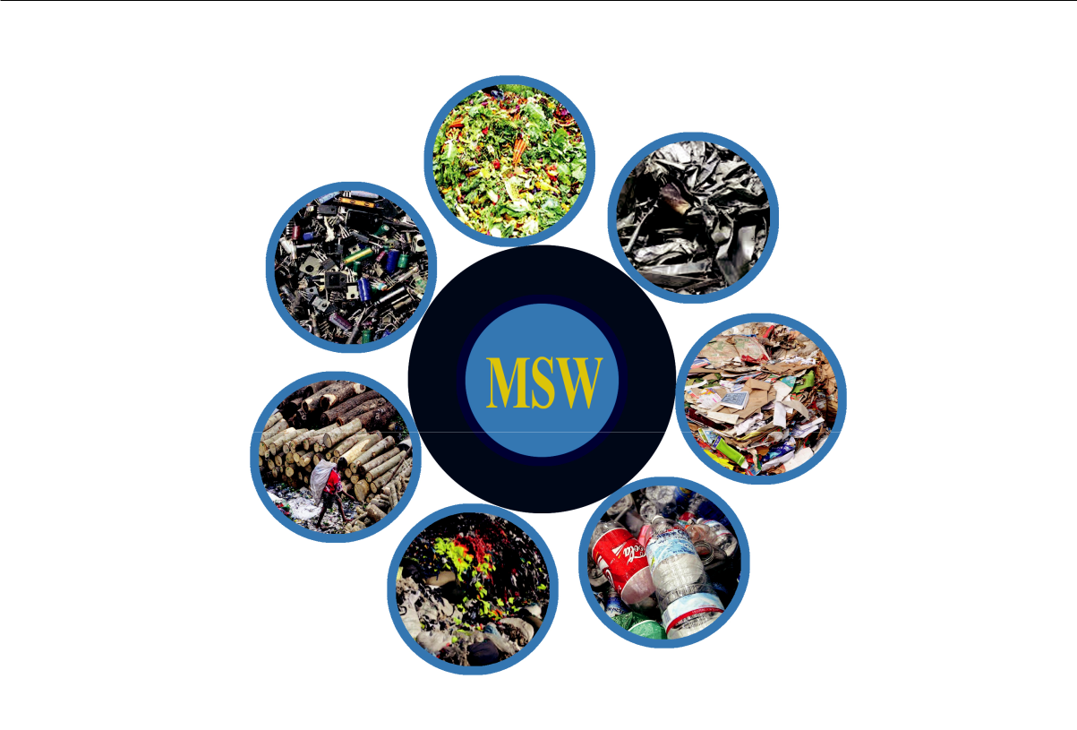

Figure 2.1: Diﬀerent types of Waste in Bangladesh

2.3 Dump Storage Area

In general, the waste are collected by the authority of an area after taking a particular charge from each family and stored in a dump storage. If we notice our surroundings, surely, we will find some places where the municipal wastes are kept outdoor that causes huge environmental pollution including air pollution and water pollution. Some area of Dhaka and Gazipur city are suﬀering a lot from such kind of activity. For example, the life of people in Konabari area of Gazipur is in danger beacuse of the dump storage by the roadside. Even the goers of the high road cannot breath properly at the time of crossing the area. The children of the place suﬀer from health issues.

However, it is a very normal scenario of our country that our environment is getting polluted by the waste we generate to lead our lives. The workers of city corporation collect the wastage on time but it is never being happened to process them in a proper way. The waste started to gangrene at a time and then spread a very bad smell. No energy is produced from the current treatment of the wastes in our country. So it will be very useful and profitable to take some steps to turn the wastes into energy so that our country could survive from the stroke of the pollution.

Daﬀodil International University | 7

2.4 Waste to Energy (WtE)

Waste to Energy (WtE) is not a very recent term. People are thinking about the tech-nologies that could be used in this sector since many years. On the contrary, it is true that actualizing these techniques in real life is challenging because of the lacing of expert people and the initial fund.

Recent works developed diﬀerent methods to generate energy from the waste. If we mention some from the natural process, digestion system could be the first one. It is very common where septic waste are separated and placed in a tank and they are naturally digested and natural bio gas is generated and used for domestic works. Anerobic digestion is one of the melioration of this method. Incineration and Pyrolysis are the two methods where municipal waste is processed by heat. In the first one, the waste is burnt with the help of Oxygen and next one does not need any Oxygen. These are the thermal treatment for the solid waste. It is very fruitful but it depends on the moisture content of the waste. The produced gas from such kind of techniques could be used in co-generation. Here co-generation means to generate electricity and heat from the gas along with the domestic use.

2.5 Aﬀect on the Globe

The eﬀect of pollution on the earth is visible everywhere. From soil to water and forest to desert, we can easily notice the demerits of pollution. Since high quantity of waste causes environment pollution, it can be said that human produced waste is the most responsible factor in this event.

After rotting the food waste, the bad smells pollute the air and sometimes people get aﬀected by diﬀerent diseases. The liquid disposed from the waste, gets mixed with water resources. Then it causes water pollution. Besides, the current procedure to dispose the solid waste is harmful for our home land. The burning process reveals various toxic gas in the atmosphere that can cause acid rain and destroy the Ozone layer which is in action to protect our land from the dangerous ultra violate rays. To mitigate these problems and also get some advantages from our unused thrown materials, the feasibility study and waste to energy are very essential.

Daﬀodil International University | 8

Chapter 3

Literature Review

Chapter 3

Literature Review

3.1 Introduction

We have studied a bunch of previous works related to the Waste Management System and Municipal Solid Waste to energy production. In this section, We have mentioned the literature reviews of the works. The section is divided into several parts.

3.2 Feasibility of Waste to Energy from MSW

Moya et al. discussed about diﬀerent waste to energy technologies that could be used to produce some products like heat, electricity, bio-fuels etc. using the municipal waste but it is not being possible in developing countries because the process of collecting, transporting and disposing is very challenging [1]. They listed the biological, thermal, biorefineries and so on. Although developed countries are applying these techs to process their MSW, there are some concerns about the public health and environmental problems but MSW has become a pricy source of renewable energy. The authors here collected samples of waste form diﬀerent area over a year and analyze them to find out the types of municipal waste and their content to study the feasibility of the production of electricity from MSW [2]. They used Homer pro simulating software to perform the energy production operation and got an encouraging result from that. It was done for a city of Iraq. They investigated the current waste management also to get an idea of cost that was needed by time in the city. Refuse Derived Fuel (RDF) is the output of prior processing of municipal solid waste that cut down the amount of landfill in the operation of pyrolysis and gasification.

10
It also could be refered as RDF Valorisation [3]. The authors studied the mass transition of RDF including the gas production and composition. They found that pyrolysis is more useful at 750o C temperature. The rise of temperature level, in the operational condition of gasification and pyrolysis results in an improved gas production. Ma et al. reviews the current biological treatments to convert the food waste into energy and tried to find out the drawbacks and a way to solve the challenges [4]. Then they proposed a zero-solid discharge driven method to recover the energy and other products concurrently from the Food Waste (FW). Through this process, green agriculture could be implemented as some fertilizers will be produced as side products. But it is diﬃcult because of the sustainability of the environment and economic viability. Pandya et al. reviewed the pyroelectric energy conversion system as it is being considered as an approach to turn the waste energy into useful energy [5]. They also talked about the components that are part and parcel for the process with the pyroelectric cycle. It works with the principal of polarization and depolarization.

To produce the highly demanded electricity, in Dhaka city, the adverse amount of wastes could be used the recovery system, as Dhaka is a densely populated city in Bangladesh and they produce a lot of municipal waste [6]. In this article, the authors assessed the quality of the waste and analyze the opportunity to actualize the system. Diﬀerent types of waste to energy recovery techniques were also discussed in their paper. Mala Babagana Gutti recognised the potential solid wastes that could be used in the field of constructions, and he also elaborately pointed out the necessity of utilizing and reusing the waste instead of using in just land filling [7]. Here, he illustrated that how essential is it in sustainable development and building. Potential waste could be transferred into concrete, fibers, polymeric composites. In the article of K.M. Nazmul Islam, evaluated 6 individual WtE technologies with respect to Dhaka and Chittagong which are the two biggest city in Bangladesh [8]. From municipal solid waste (MSW), not only the burnable methane but also some other energy like heat, electricity can be reproduced. The most sensitive part of the solid waste is the moisture content according to his discussion. The reduction of carbon dioxide is also considered with the production of various economic materials.

Daﬀodil International University 11

3.3 Smart Waste Management

To make a city smarter, the electronic supplies should be managed in a smart way. In this article, they said not to use the electric consumer goods in the landfill projects because the devices and machineries can contain a lot of chemicals and heavy, precious metals

- That’s why the utilized products could be recycled and reused. The authors of this article, presented a smart waste management system where the garbage collector will be notified by smart phones to dispose the wastes when a box will be filled by 80% with the electric products known as smart e-waste. The authority will collect the box in a smart way. An ultrasonic sensor was used in their architecture. Likotiko et al. proposed a smart waste collection architecture based on multi-agent where the collector truck will get an optimized route to collect the municipal wastes [10]. Here, general public will be involved in the process to make city cleaner and healthier. They simulated a couple of models to get a stable and optimal solution. According to their architecture, the waste could be monitored and collected in real time by the authority. The challenge in this model is the need for high speed internet connection. A network architecture based on LoRa gateway, is projected in this article [11]. A novel sensor with low power and low cost was described in the system to manage the waste in a smart city. Their main target was to save the energy by extending the lifetime of power sources and reducing the power consumption. An wireless sensor network was proposed in this work.

A notification to the waste collectors and stakeholders in timely fashion, could result in a better management system of the municipal waste in smart cities. In this article, the authors proposed a cloud based mechanism to handle the waste smartly where the bins are equipped with sensors capable of sending data to the cloud about their status (full or not) [12]. The stakeholders can access the database and take further steps to process the upcoming waste. They conceived diﬀerent waste bins for diﬀerent types of waste which is more challenging to manage. By 2050, almost two-third of the total population of the earth will live in urban cities. For this reason, the management of the cities should be more smart utilizing the communication technologies and converging the information. Marques et al. demonstrated an infrastructure architecture for such kind of cities with evaluating the waste management where 3902 bins could be handled simultaneously [13]. They considered the waste separation with the smart collection procedure. They assumed

Daﬀodil International University | 12

three diﬀerent bins that will separately collect diﬀerent types of waste. A case study was done considering both indoor and outdoor scenario but the implementation should be done in greater scale. The increasing garbage is destroying the natural beauty and also aﬀecting human health polluting the environment, so it became a major issue to be solved. In this research work, a team of three people reviewed some waste management systems that were developed on the base of Internet of Things (IoT) with the basic discussion of the components of IoT [14]. Most of the existing systems are concerned about the smart collection but not with the further processing as their conclusion. IoT can provide some security to the bins by informing about theft.

The innovative waste to energy plant takes care of the pollutants that are released from the gasification of the solid wastes but some secondary pollutants discharge also from the processes. Schiavon et al. investigated the significance of these types of materials and found that it is also a matter of thinking [15]. The management of incoming waste can also produce some harmful gases as well as from the ash which is stored after the combustion. New Waste to Energy plants should have plane for the secondary emissions and use an upgrade version of combustion technology. Cabrera et al. applied some renewable energy strategies in a series to locate a transition of the methods from the current energy system in the island of Gran Canaria, Spain [16]. They concluded that 75.9% of renewable energy could be found utilizing the current technologies available but it will be more if some certain technologies get mature in the future. Some factors were also analyzed by the team. Their new method is to widen the share of the renewable energy in the Islands.

3.4 Energy Content Estimation

One possible way to estimate the Higher Heating Value (HHV) of Municipal Solid Waste (MSW), is bomb calorimeter which is very expensive to use. That’s why Rominiyi et al. collected some samples from MSW and following some methods, they estimated out some percentages of possible components remaining in the MSW like Moisture, Carbon, Sulfur etc [17]. Eﬀect of diﬀerent temperature is also taken into account. The authors claimed that the amount of HHV could be estimated using the result found from their proximate and ultimate analysis. The eﬀect of moisture content could be reduced from drying the

Daﬀodil International University | 13

wastes where sunshine is applied by the authors. The Ryield and Rgibbs module was combined by Deng et al. to simulate the Pyrolysis including the gasification process in the analysis of Municipal Solid Waste using Aspen plus computer program [18]. Their proposed model examines the target performance parameters syngas composition, LHV etc. They found 0.4 as the best ratio of water vapor as the gasification agent. They assumed that there is no loss of thermal energy through the process and the pressure is uniform all over the area. For several gasification temperature and ratio of gasifying agent, the model was tested to fine tune the values of parameters. They suggested a way where the water vapor and flue gas could be reused as a gasifying agent that are produced by the process itself. In this article, the authors modeled a correlation regression to compute the heating value from the ultimate analysis of C, H, O, N, and S [19]. They also ensured that the eﬀectiveness of Carbon and Hydrogen is most important and It will not cause a significant error if someone calculates the HHV using the ultimate analysis of Carbon only. Two diﬀerent model was finalized by this team. It costs very high to do the sampling and chemical analysis of the complex MSW. They used multiple stepwise linear regression to find the empirical correlation coeﬃcients. Evaluation of the models were performed on the samples with and without dry basis. Azam et al. inquired into the generation to assessment of the MSW in Lahore which is one of the biggest city in Pakistan [20]. Biologically degradable waste is on the top of the city as they investigated where 14 types of combustible and noncombustible wastes could be found. Higher rate of plastic and paper can produce a higher amount of energy in the process of Waste to Energy because they bring out less ash and high heating value. The percentage of Moisture component leads the process to several concerns. The incineration process of MSW with high amount of moisture components requires supplementary fuel which is an additional costs. Researchers should understand the physical and chemical composition of Municipal Solid Waste.

Boumanchar et al. developed an empirical model to predict the MSW Higher Heat-ing Value (HHV) from ultimate analysis [21]. C, H, N, S and O are considered as the constituents of the ultimate analysis. Sometimes the density of the components is also taken under consideration. They compared multiple regression to genetic programming and showed that the second one resulted in a higher accuracy and in the end two re-gression equations were developed with diﬀerent correlation coeﬃcients. In this article,

Daﬀodil International University | 14

after applying the torrefaction process to the solid wastes, a linear correlation model is suggested to use to predict the characteristics of the MSW [22]. The Torrefaction pro-cess diminishes the challenge of having higher amount of moisture content and low HHV into the raw materials of the gasification. This is the combination of drying and partial pyrolysis. The amount of fixed Carbon increases with the temperature of torrefaction while Hydrogen and Oxygen including other components declines. Thus the gasification procedure became fruitful as the moisture is diminished.

On the other hand, Zhou et al. gave an overall idea about the characteristics of phys-ical and chemical composition of solid municipal waste, especially in China [23]. Some drawbacks of thermal treatment of MSW are mentioned in the paper as the composition of MSW is aﬀected by many factors like, time, region, lifestyle, etc. To evaluate the feasibility of the energy recovery, the proximate and ultimate analysis is greatly impor-tant. They discussed some models to predict the ultimate and proximate analysis values of diﬀerent components. Finally, various types of wastes were listed out in descending order. To predict the energy content of wastes utilizing the ultimate analysis of physical composition and multiple regression, an anticipator is proposed in this research work

- They tried proximate analysis to predict the HHV but failed. SYSTAT is computer application which works with the statistical model was used to test the proposed model. 34 samples with R2 = 0.967 while alpha was 0.05 at the time of modeling on the basis of physical composition. Water is the most crucial factor of energy content followed by plastics, paper and garbage as they concluded. On the other hand, in ultimate analysis, 40 samples were used. However, in this two model the output was almost same as the output of actual experiment.

3.5 Summary

We have studied a bunch of articles published recently. We tried to understand the current situation of Municipal Solid Waste (MSW) in diﬀerent area of the glob and took a decision to do some research on the point of view of Bangladesh. In Table 3.1, we summarized the related works. The most important articles are mentioned in the table to take an overview of the previously done works regarding the feasibility study and waste management system.

Daﬀodil International University | 15

Table 3.1: Summary of Literature Reviews

 | Article |  |  |  | Works Done |  | Limitations
 | Moya et al. [1] |  |  |  | Discussed about diﬀerent waste |  | It is | not |  | being |  | possible
 |  |  |  |  | to energy technologies that could |  | in developing countries be-
 |  |  |  |  | be used to produce some products |  | cause the process of collect-
 |  |  |  |  | like heat, electricity, bio-fuels etc. |  | ing, transporting and dis-
 |  |  |  |  | using the municipal waste |  | posing is very challenging
 | Ma et al. [4] |  |  |  | Proposed a zero-solid discharge |  | But it is very diﬃcult be-
 |  |  |  |  | driven method to recover the en- |  | cause | of | the sustainability
 |  |  |  |  | ergy and other products concur- |  | of the environment and eco-
 |  |  |  |  | rently from the Food Waste (FW) |  | nomic viability
 | Marques | et | al. |  | Demonstrated an infrastructure |  | They assumed three dif-
 | [13] |  |  |  | architecture for such kind of cities |  | ferent bins that will sepa-
 |  |  |  |  | with evaluating the waste man- |  | rately collect diﬀerent types
 |  |  |  |  | agement where 3902 bins could be |  | of waste
 |  |  |  |  | handled simultaneously
 | Rominiyi | et | al. |  | Estimated out some percentages |  | Suggested |  |  | to | leave |  | the
 | [25] |  |  |  | of possible components remaining |  | wastes |  | in | a | sunny |  | out-
 |  |  |  |  | in the MSW using proximate and |  | side | area |  | before |  | further
 |  |  |  |  | ultimate analysis |  | processing

Daﬀodil International University 16

Chapter 4

Proposed Architecture and

Design

Chapter 4

Proposed Architecture and

Design

4.1 Introduction

We proposed an architecture to store and process all the wastes that produced in an area. By processing the wastes, a huge amount of energy could be found and this energy will be used in diﬀerent sectors of our country. In this chapter, we are going to discuss about the architecture and a smart dustbin. Each and every part of the main architecture will be discussed one by one.

4.2 Main Architecture

In general, the domestic garbage collecting truck, collects the waste from diﬀerent area and store them in a empty places which is not indoors. As a result, the natural world became unfit for living especially for the inhabitants who live near the stack of the wastes. The area stinks (smells bad) a lot because of the rotten waste. It happens cause the collected waste are stored in the place for a long time without any further processing. Even the passers-by feel very ill when they cross the area by walking and even by any transportation.

So, it is very clear that we need some indoor area to store and process the municipal solid waste. To get rid of this problem, we are presenting an architecture of a closed

18
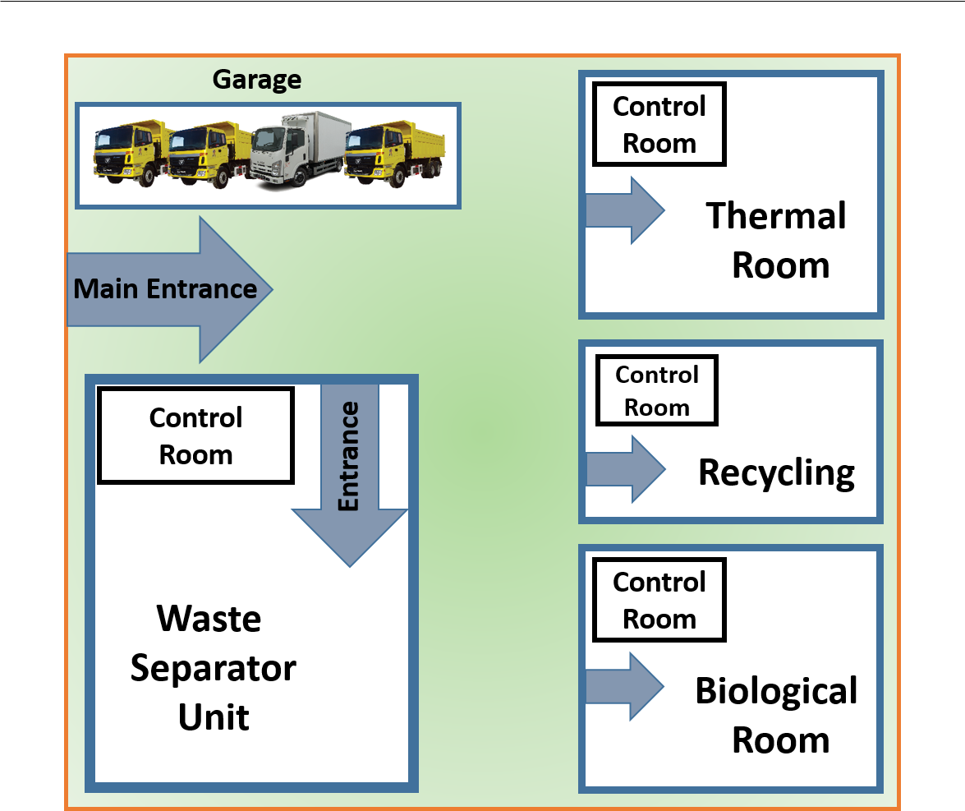

Figure 4.1: Proposed Architecture

area which could be built to implement the Waste to Energy technology in our country in diﬀerent areas where already such kind of storage have been made but without any infrastructure.

In Fig. 4.1, we can see the proposed architecture of the main construction where the waste could be stored and processed further. The main construction includes 4 diﬀerent units, which will perform a specific task. Each unit has a control room from where the full process could be controlled and monitored. We will embed intelligent machineries where applicable. The full collection of wastes will be separated at first, then according to their class, the wastes will be sent to the thermal, biological, and recycling room to get diﬀerent treatments. Each of the parts are described through the next sections.

Daﬀodil International University 19
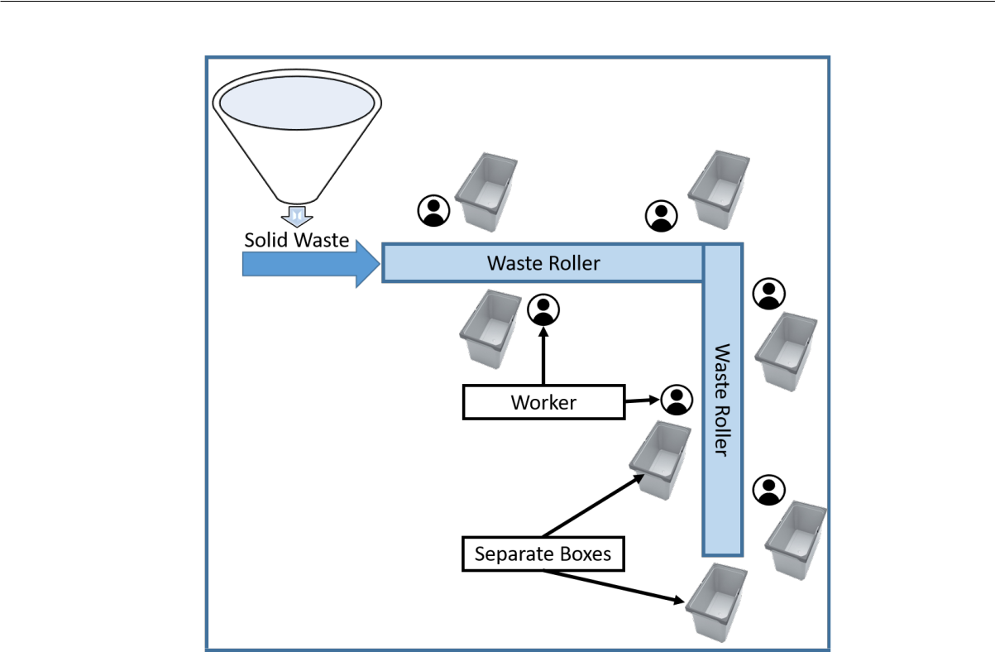

Figure 4.2: Waste Separator Unit

4.2.1 Waste Separator Unit

The collection authority manages the system to collect municipal waste and drops them into the separator unit in each waste processing center. They take the smart bins full of feedstock to the nearest place for further processing. At first, the liquid waste that were assembled in the bottom of or designed smart dustbin, is separated into a diﬀerent tank which will be sent for digestion in Biological unit.

Apart from the fluent part, the solid waste will be passed through a wate roller as shown in Fig. 4.2. The roller will move by a moderate speed and 6-8 worker will separate diﬀerent types of waste from the roller. They will identify and diﬀerentiate the wastes manually into diﬀerent containers. Thus the food waste, other septic waste, plastic, papers, glass, metal etc. will be discriminated in individual boxes. Each worker will be assigned to pick a particular item from the waste roller. The filled containers with various types of municipal waste will be sent to the corresponding unit to process according to the types of waste. If any waste is found that could be reused or recycled like metal, electrical waste or some other unused materials, they will be directed to the recycle room. Plastic or other burnable materials will be transferred to the Thermal unit as we showed in Fig. 4.1. And the food waste will be oﬀered to the Biological Unit.

Daﬀodil International University | 20

4.2.2 Thermal Room

There are a lot of wastes that are burnable, among them, plastics holds the top position. Generally, Incineration and Pyrolysis are two diﬀerent procedures to turn them into valuable products like fuels, gases, and then electricity. In incineration, the materials undergo through the combustion with the appearance of Oxygen. This process creates a lot of harmful gases that contribute to the detraction of our environment. Because of this issue, researchers are trying to move onto an another solution but it is an easier process to implement.

So, we consider the pyrolysis process, where the materials are melted without Oxygen. In this process, the produced products are more useful and fresh. We graphically illustrate the pyrolysis process in Fig. 4.3. After throwing the wastes into the Pyrolysis chamber, a high temperature will be applied so that the raw materials of the operation could melt and create the gases. The created mixtures of diﬀerent gases flow through a tunnel and follow
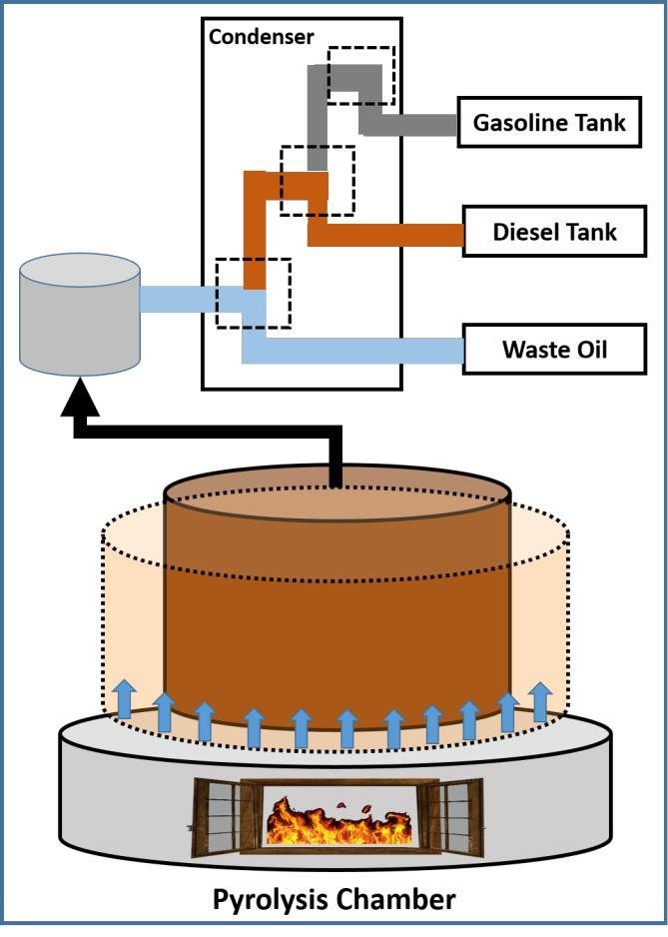

Figure 4.3: Thermal Treatment

Daﬀodil International University | 21

a condenser. The condenser consists of 3 individual compartments where the temperature is dissimilar. At first, while the temperature is relatively high in the condenser, some portion of the mixture become liquid and stored in a tank. This product is the waste oil which is used in many diﬀerent sectors. Cooling the rest of the gases by some more degrees of heat, we can get diesel as liquid. Now we all know about the benefits of diesel. The remaining part of the produced gas is then totally cooled oﬀ by another part of the condenser after what, fresh gasoline can be found. The gasoline from this process is more fresh and useful. From the outcomes, many other application can be done.

4.2.3 Biological Room

It is one of the most important treatment mostly applied to the digestive waste. The lion share of municipal solid waste is septic waste including food waste. These sorts of wastes are turned into renewable energy through diﬀerent types of biological process. Aerobic composting is one of the popular method to convert the waste into good fertilizer using various kind of bacteria and fungus. But it is unsustainable to the environment because of the adverse amount of moisture content in the food waste. Anerobic digestion is another variant of biological process to take care of these types of substances. The target of this method is to reduce the volume of the waste and produce energy from it. It gets hampered by the low hydrolysis eﬃciency.

However, we borrowed the idea of bio-plant, where food wastes are stored for fermen-tation and mixed up with water and other materials to produce natural gas. This gas is used in the housing to cook food and to light up the night. Since the digestives contains some materials that stays after the digestion process, it could be better to remove the grounds before sending the waste into the digester. Fig. 4.4 depicts the scenario of the biological treatment where we have made a fusion of normal digestion system of Bio-plant and the hydrolysis procedure. In the beginning, the digestive waste that were separated in the Waste Separator Unit, is sent to the Biological room. The waste will be put into the Hydro Blender for the hydrolysis adding some reactors into the tank. Here everything will be smashed and cutting down into tiny pieces to bring out the liquid from the waste. The blending blade will cut the materials and bang up them under pressure. Then the liquid part flows to the digester and the grounds are kept for using as biofertilizer. From these biofertilizer, further products could be produced. In the Digester the liquid part

Daﬀodil International University | 22

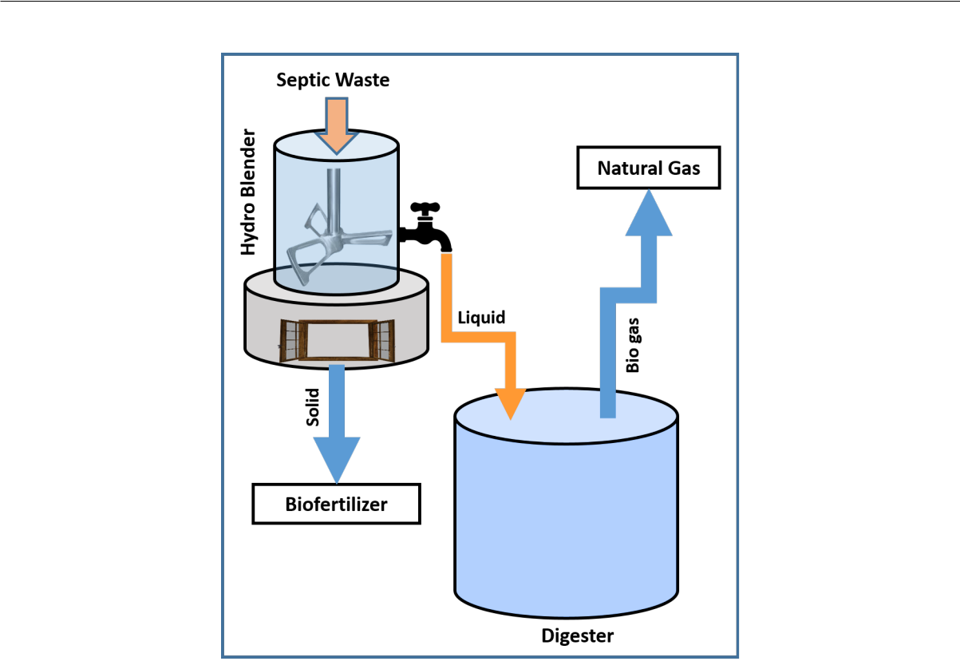

Figure 4.4: Biological Treatment

will be fermented for several days. Then natural gas is produced from this tank and the gas is collected through a collection process. Natural gas could be supplied for domestical utilization or for co-generation where the gas could be turned into electricity and heat.

4.2.4 Recycling

We throw away a significant number of materials that could be reused after a slight modification. This process includes metal and glasses mainly. From the unused metal and glasses new useful materials are made and traded. Some plastic products are recycled if possible. In the waste separator room, such kind of goods will be selected for recycling. The glasses might be turned into show pieces, old metallic objects could be used to build new stable things to use in our daily life. Some valuable ancient substances are found in the garbage. There are people who collected them and stored them as a hobby. Recycling can be done in three ways. Some are used as they were before after polishing a little bit. On the contrary, some are changed into a complete diﬀerent useful things. People may do this process at home instead of throwing their staﬀs. For example we can make paper weight from plastics and decorate our home using various materials.

Daﬀodil International University | 23

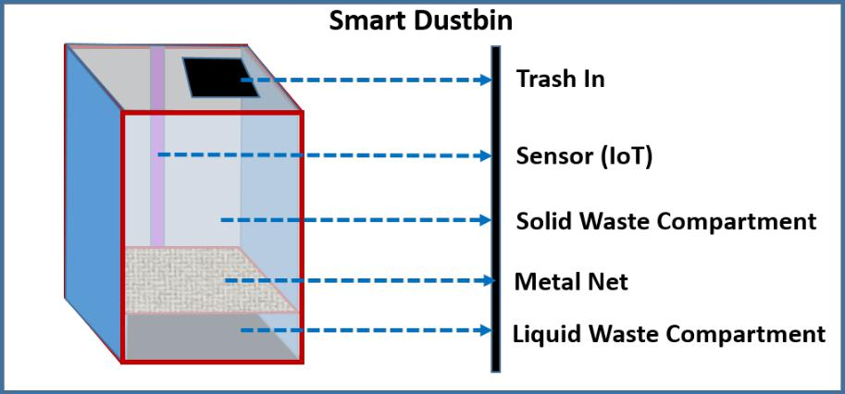

Figure 4.5: Proposed Design of a simple Smart Bin

4.3 Smart Collection of MSW

Collection of waste is also a drawback in the current situation. Sometimes, the full bucket of waste stays for days instead of getting collected on time. So, we thought about a dustbin which will send a signal to the nearest collector about the filling situation of the dustbin. The detail is provided in the later section.

4.3.1 Smart Bin

Collection of municipal waste from all over the area is the very first thing to do. If the collection process is very clean and easy, the environment will not be polluted. As we can see people throw the unused things here and there and although there are some dustbins beside the road but general people hardly used them to throw the trash in that, our surroundings became dirty within a snap. So in the beginning, we need to take care of the collection process. To add a dimension in this phenomena, we proposed a design of a Smart Dustbin to store the unwanted things from food waste to heavy materials and liquids all together.

Fig. 4.5 illustrates the full design of the bin. For simplicity the shape is something like boxed-shape and the size is respective. The first technology is to look at is the IoT sensor (Ultrasonic sensor for example) which will check the bin is full or not. If the dustbin became full by a certain percentage (ie, 90%), it will use the capability of the sensor and send a notification to the nearest collectors authority. On the notification, the authority truck will collect the bin and replace with another empty smart dustbin. It will send the

Daﬀodil International University | 24

information via Internet in real time.

The trash bin is divided into two compartments, one is for the solid waste and the other is for the liquids that will be separated by the eﬀect of gravity. There is a metal net between the two compartments to prevail the hard waste to go into the liquid area. Since the moisture content disturbs the process of Waste to Energy technology, we designed the smart bin with the facility of diﬀerentiating between substantial and fluent wastes.

Daﬀodil International University 25

Chapter 5

Estimated Results and

Analysis

Chapter 5

Estimated Results and

Analysis

5.1 Introduction

For the energy recovery systems, we need to analyze the energy content of the wastes available in an area. Basically there remains almost same kinds of components in the municipal solid waste that could be listed like these:

- Moisture Content (Water/Liquid)

- Volatile Matter (VM)

- Ash Content from the fuel

- Some elemental compositions:

– Total carbon (C)

– Hydrogen (H)

– Oxygen (O)

– Nitrogen (N) and

– Sulfur (S) content

Now in this chapter, we will discuss about the contents briefly and the way to compute the contents from the sample of waste collected from distinct areas. Then the process of finding out the energy content which is the center piece of analysis.

27

5.2 Ultimate and Proximate Analysis

Using Ultimate Analysis, the elemental contents (ie; C, H, O, N, and S) while the amount of water and liquid in the form of Moisture content including Ash content are found from the Proximate Analysis. These analysis is very crucial for the energy recovery systems [25]. Let’s elaborate the contents shortly:

5.2.1 Moisture Content

The success of thermal treatment like gasification, pyrolysis, incineration depends on the Moisture content of the feedstock. It is the amount of water and the total amount of Hydrogen and Oxygen as we know that water is chemically consisted of this two molecules. High quantity of moisture disturbs the thermal treatment in case of eﬃciency. It is very diﬃcult to manage the prominent moisture content while it produces lower heating value and if any gas or fuel is planed to bring forth, the quality of the products became very poor [26].

Table 5.1: Results of Ultimate Analysis [17]

 | Components | C (%) | N (%) | S (%) | H₂ + O₂ (%)
 | Bones |  | ND
 | Bones | 73.55 | ND | 0.08 | 26.37
 | Food waste | 86.44 | 1.40 | 0.06 | 12.10
 | Rubber and Leather | 66.94 | 2.69 | 0.19 | 30.18
 | Polythene products waste | 87.41 | 0.36 | 0.16 | 12.07
 | Paper and Card boards | 57.85 | 0.45 | 0.13 | 41.57
 | Textiles waste | 88.32 | 1.16 | 0.07 | 10.45
 | Leaves and Vegetables | 67.94 | 1.43 | 0.26 | 30.37
 | Animals’ dungs and Excreta | 70.00 | 1.61 | 0.19 | 28.20
 | Wood waste | 81.88 | 0.71 | 0.06 | 17.35
 | Charcoal | 81.71 | 1.15 | 0.05 | 17.09
 | Fruit waste | 75.98 | 5.88 | 0.14 | 18.00
 | Coconut and Palm kernel waste | 86.31 | 0.89 | 0.03 | 12.77

Daﬀodil International University 28
The desirable percentage of this component is below 15 so that the economical energy plant can be run without any trouble. To limit the measurement of Moisture content, we have designed the smart bin where the liquid matters will be separated there. We may apply some sun burn to decrease the percentage of this particular element.

5.2.2 Volatile Matter

At the temperature of 100 - 150oC, the pyrolysis process in the thermal treatment, a mixture of water, oil, tar etc. are reduced from the fuel. It makes some major problems in the combustion system. Higher the volatile matters cases higher amount of tar which makes the internal diﬃculty. So before hitting into the main burning process, we need to analyze the amount of Volatile matter (VM).

Wood waste contains the maximum portion of the constituent while charcoal has the lowest volatile matter [26].

Table 5.2: Results of Proximate Analysis [17]

 | Components | Moisture | Volatile | Fixed | Ash (%)
 | Components | Content (%) | Matter (%) | Carbon (%) | Ash (%)
 | Bones
 | Bones | 3.58 | 67.12 | 6.43 | 64.27
 | Food waste | 5.90 | 9.49 | 76.95 | 7.66
 | Rubber and Leather | 0.86 | 53.05 | 13.89 | 32.20
 | Polythene products waste | 0.82 | 9.18 | 78.23 | 11.77
 | Paper and Card boards | 5.57 | 36.88 | 20.97 | 36.58
 | Textiles waste | 1.80 | 6.70 | 81.62 | 9.88
 | Leaves and Vegetables | 12.79 | 24.87 | 43.07 | 19.27
 | Animals’ dungs and Excreta | 11.33 | 24.00 | 46.00 | 18.67
 | Wood waste | 9.40 | 12.24 | 69.64 | 8.72
 | Charcoal | 6.73 | 11.50 | 70.21 | 11.56
 | Fruit waste | 9.55 | 20.60 | 55.38 | 14.47
 | Coconut and palm kernel waste | 8.91 | 7.94 | 78.37 | 4.78

Daﬀodil International University 29

5.2.3 Ash Content

It is the mineral ingredient of the fuel which remains after finishing the full combustion process. It also comprises some unburned fuel. The ash content makes trouble to the reactor of gasification that results in a lower production of energy. The rate of Ash in the waste varies from fuel to fuel [26].

The results of these Analysis are used to estimate the energy content that could be produced by the wastes. The later section will elaborately hash out the best way of estimation among some techniques to predict the energy content. Rominiyi et al. experimented the ultimate analysis and Proximate analysis on the samples of municipal waste in Nigeria [17], according to their classification, this analysis could be used to anticipate the targeted variable.

5.3 Energy content Computation

The most popular and useful factor to calculate the approximate energy that could be generated from municipal solid waste is higher heating value (HHV) in diﬀerent waste to energy technologies. This estimation depends on the significant amount of Carbon (C) and Hydrogen (H) [19].

HHV = 5751.94 + 52.67C + 75.9H − 4.14N − 1044.03S − 97.68O | (5.1)

The above equation was developed with the help of 29 samples of data using multi regression analysis and it results almost the same as the manual measurements in the unit of kcal per kg. But all of the independent variables are not very correlated with target variable. So the equation could be simplified like this -

HHV = −1737.55 + 143.33C | (5.2)

We will substitute the values of the variables after computing the amount of wastage and the contents remaining there. We choose Gazipur city for example to analyze the cost and profit. We evaluated some families nearby, and it is found that each person generates 190 grams of solid waste on an average per day. Gazipur is a district with 2.5 million people [27]. It is very hard to calculate the total generated waste in this area.

Daﬀodil International University | 30

Table 5.3: Estimation of Contents

 | Waste (% in total) | Weight (kg) | C | HHV from eqn 5.2
 |  |  |  | (kcal/day)
 | Organic (74.4)
 | Organic (74.4) | 353400 | 305479 | 43782567.52
 | Paper (9.1) | 43225 | 25005.6 | 3582315.1
 | Plastic (3.5) | 16625 | 14532 | 2081134.01
 | Textile (1.9) | 9025 | 7970.8 | 1140717.2
 | Metal (1.5) | 7125 | NA | NA
 | Leather and Rub- | 3800 | 2543.7 | 362850.97
 | ber (0.8)
 | Glass (0.8) | 3800 | NA | NA
 |  | Total |  | 50949584.8

Following a simple multiplication, we can find out that, in Gazipur, approximately 475 000 kg per day. Using this total, we have computed the amount of diﬀerent contents. The percentage of diﬀerent types of waste was estimated in [25]. Table 5.3 shows the values for the contents that could be found from the individual kind of waste in MSW. Information from Table 5.1 is also used in the calculation.

From Table 5.3, we find the total HHV of 50,949,584.8 kcal/day. We can also do the estimation of energy in kwh. After the conversion we get 59214.74 kwh per day. If we consider 7 bdt for a single kwh electric energy, it can be earned 414,503 bdt in total per day.

5.4 Analysis of the Estimation

We have accounted an approximate value in monetary term which could be gained from the municipal waste of a single day in Gazipur district. But to produce the outcomes, we need some man power and workers. In another word, we have to spend our money in this project. In this section, the financial cost and profit from this event will be analyzed and discussed in a brief. Table 5.4 demonstrates the inferential cost to run a single plant according to our plan. We did a rough estimation about the workers needed to run the

Daﬀodil International University | 31

Table 5.4: Inferential Cost of a Plant

 | Name of Post | Quantity | Salary per | Total Salary per
 |  |  | month (BDT) | month (BDT)
 | Managing Director
 | Managing Director | 1 | 120,000 | 120,000
 | Product Manager | 5 | 70,000 | 350,000
 | Plant Expert | 10 | 70,000 | 700,000
 | Indoor Worker | 150 | 18,000 | 2,700,000
 | Outdoor Worker | 150 | 18,000 | 2,700,000
 | Total salary per month |  |  | 6,570,000
 | Miscellaneous Cost per month |  |  | 300,000
 | Total Cost per month |  |  | 6,870,000
 | Total Cost per day |  |  | 229,000

solid waste processing task. The monthly salary was chosen after getting some ideas from the other energy plant companies. In the previous section, we saw that the total earning from the plant in a particular day is 414,500 BDT on an average. Now we have to spend about 229,000 BDT per day. We can easily compute the profit from this numerical values and the net profit could be 185,500 BDT. This is a huge amount so far.

5.5 Impact on the Environment

Storing the huge amount of solid waste in here and there is surely harmful for the sur-roundings. The current way to dispose such kind of waste is to burn them and use in land filing. The consequences of the burning process are known to all of us. Our atmo-sphere are becoming toxic as various gases including CFC gas are revealed and mixing up with the fresh air. In the proposed architecture, no toxic gases will be disposed into the environment. Moreover, the area will not be polluted as the waste will be processed inside and as early as possible. Even the continuous process will be able to clear oﬀ the waste within the day. People will be more conscious to keep our home neat and clean and they also can receive some profit from the authority by providing a significant amount of waste.

Daﬀodil International University | 32

Chapter 6

Conclusion and Future Work

Chapter 6

Conclusion and Future Work

6.1 Introduction

We have reached at the end of our work. This chapter will discuss the conclusion as a summary of the entire work. We have also directed some future work in the following section.

6.2 Conclusion

As we know, in our country, wastes are stored outside and there are some huge feedstock in almost every districts.So our proposal is to deploy the main architecture in the area of feedstock in each district to process the MSW. In our work

- We have proposed a full architecture with a special type of smart dustbin to collect the scraps.

- We have gone through some studies related to the Waste to Energy technology.

- We showed that we gave a cost eﬀective architecture where a several types of useful products will be produced with energy.

- The final architecture is environment friendly as the toxic chemicals that will be produced by the Waste to Energy technology are prevented to be revealed in the atmosphere.

34
If we can deploy such kind of industries all over the country where needed, we will find our motherland free of pollution and The economy will be financially healthy from the approximate profit.

6.3 Direction of Future Works and Limitations

We considered only Gazipur for our estimation. In future, we could do the analysis for the whole country. It is not very easy to build up the industry in real world, for this reason, more studies and brain storming will be needed. We borrowed some methods and values of ultimate and proximate analysis that was done for countries other than Bangladesh, collecting samples from diﬀerent area of Bangladesh, the analysis could be done in future.

Although the HHV estimation is standard but some researches should be done in this sector. The full process needs expert human resources to reach it’s peak of success. So, there may need some training and workshops regarding to work in this field. However, it will open a lot of job opportunities for the people even who are not enough educated.

We select the salary and the number of posts roughly, there could a sight diﬀerence and modification and hence the profit could be fluctuated over a time period. But the business will be suitable for developing countries like ours.

Daﬀodil International University 35

Bibliography

- D. Moya, C. Ald´as, G. L´opez, and P. Kaparaju, “Municipal solid waste as a valuable renewable energy resource: A worldwide opportunity of energy recovery by using waste-to-energy technologies,” Energy Procedia, vol. 134, pp. 286–295, 2017.

- O. M. Anssari, E. A. Alkaldy, N. Almudhaﬀar, A. N. AlTaee, and N. S. Ali, “A feasibility study of electrical energy generation from municipal solid waste in iraq: Najaf city case study,”

- A. Ribeiro, M. Soares, C. Castro, A. Mota, J. Ara´ujo, C. Vilarinho, and J. Car-valho, “Waste-to-energy technologies applied for refuse derived fuel (rdf) valorisa-tion,” in International Conference on Innovation, Engineering and Entrepreneur-ship, Springer, 2018, pp. 641–647.

- Y. Ma and Y. Liu, “Turning food waste to energy and resources towards a great environmental and economic sustainability: An innovative integrated biological ap-proach,” Biotechnology advances, vol. 37, no. 7, 2019.

- S. Pandya, G. Velarde, L. Zhang, J. D. Wilbur, A. Smith, B. Hanrahan, C. Dames, and L. W. Martin, “New approach to waste-heat energy harvesting: Pyroelectric energy conversion,” NPG Asia Materials, vol. 11, no. 1, pp. 1–5, 2019.

- M. J. Alam and D.-I. W. Boie, “Energy recovery from municipal solid waste in dhaka city,” in Proceedings of the international conference on mechanical engineering, Dhaka, 2001, pp. 125–130.

- M. B. Gutti, “A feasibility study on waste utilization in construction and review of waste generation,” 2018.

36
- K. Islam, “Municipal solid waste to energy generation in bangladesh: Possible sce-narios to generate renewable electricity in dhaka and chittagong city,” Journal of Renewable Energy, vol. 2016, 2016.

- K. D. Kang, H. Kang, I. Ilankoon, and C. Y. Chong, “Electronic waste collection systems using internet of things (iot): Household electronic waste management in malaysia,” Journal of Cleaner Production, vol. 252, p. 119 801, 2020.

- E. D. Likotiko, D. Nyambo, and J. Mwangoka, “Multi-agent based iot smart waste monitoring and collection architecture,” arXiv preprint arXiv:1711.03966, 2017.

- M. Cerchecci, F. Luti, A. Mecocci, S. Parrino, G. Peruzzi, and A. Pozzebon, “A low power iot sensor node architecture for waste management within smart cities context,” Sensors, vol. 18, no. 4, p. 1282, 2018.

- M. Aazam, M. St-Hilaire, C.-H. Lung, and I. Lambadaris, “Cloud-based smart waste management for smart cities,” in 2016 IEEE 21st International Workshop on Computer Aided Modelling and Design of Communication Links and Networks (CAMAD), IEEE, 2016, pp. 188–193.

- P. Marques, D. Manfroi, E. Deitos, J. Cegoni, R. Castilhos, J. Rochol, E. Pignaton, and R. Kunst, “An iot-based smart cities infrastructure architecture applied to a waste management scenario,” Ad Hoc Networks, vol. 87, pp. 200–208, 2019.

- K. Fallavi, V. R. Kumar, and B. Chaithra, “Smart waste management using internet of things: A survey,” in 2017 International Conference on I-SMAC (IoT in Social, Mobile, Analytics and Cloud)(I-SMAC), IEEE, 2017, pp. 60–64.

- M. Schiavon, L. Adami, V. Torretta, and M. Tubino, “Environmental balance of an innovative waste-to-energy plant: The role of secondary emissions,” International Journal of Environmental Impacts, vol. 3, no. 1, pp. 84–93, 2020.

- P. Cabrera, H. Lund, and J. A. Carta, “Smart renewable energy penetration strate-gies on islands: The case of gran canaria,” Energy, vol. 162, pp. 421–443, 2018.

- O. Rominiyi, T. Olaniyi, T. Azeez, J. Eiche, and S. Akinola, “Synergetic eﬀect of proximate and ultimate analysis on the heating value of municipal solid waste of ado–ekiti, metropolis, southwest nigeria,” Current Journal of Applied Science and Technology, pp. 1–12, 2017.

Daﬀodil International University | 37

- N. Deng, D. Li, Q. Zhang, A. Zhang, R. Cai, and B. Zhang, “Simulation analysis of municipal solid waste pyrolysis and gasification based on aspen plus,” Frontiers in Energy, vol. 13, no. 1, pp. 64–70, 2019.

- A. Khuriati, W. S. Budi, M. Nur, I. Istadi, and G. Suwoto, “Modeling of heating value of municipal solid waste based on ultimate analysis using multiple stepwise regression linear in semarang,” ARPN Journal of Engineering and Applied Sciences, vol. 12, no. 9, pp. 2870–2876, 2017.

- M. Azam, S. S. Jahromy, W. Raza, N. Raza, S. S. Lee, K.-H. Kim, and F. Winter, “Status, characterization, and potential utilization of municipal solid waste as re-newable energy source: Lahore case study in pakistan,” Environment international, vol. 134, p. 105 291, 2020.

- I. Boumanchar, Y. Chhiti, F. E. M’hamdi Alaoui, A. Sahibed-dine, F. Bentiss, C. Jama, and M. Bensitel, “Municipal solid waste higher heating value prediction from ultimate analysis using multiple regression and genetic programming techniques,” Waste Management & Research, vol. 37, no. 6, pp. 578–589, 2019.

- N. A. Jamin, S. Saleh, and N. A. F. A. Samad, “Properties prediction of torrefied municipal solid waste using linear correlation model,” Energy Procedia, vol. 158, pp. 836–841, 2019.

- H. Zhou, A. Meng, Y. Long, Q. Li, and Y. Zhang, “An overview of characteristics of municipal solid waste fuel in china: Physical, chemical composition and heating value,” Renewable and sustainable energy reviews, vol. 36, pp. 107–122, 2014.

- J.-I. Liu, R. D. Paode, and T. M. Holsen, “Modeling the energy content of mu-nicipal solid waste using multiple regression analysis,” Journal of the Air & Waste Management Association, vol. 46, no. 7, pp. 650–656, 1996.

- O. Rominiyi, “Evaluation of energy content of municipal solid waste in ado-ekiti metropolis, ekiti state, m,” Eng Research Thesis, Department of Mechanical% N Specific Energy Content (kJ/kg) x, vol. 1000, 2015.

- T. Omoniyi and A. Olorunnisola, “Experimental characterisation of bagasse biomass material for energy production,” International Journal of Engineering and Technol-ogy, vol. 4, no. 10, pp. 582–589, 2014.

Daﬀodil International University 38
- A. Al-Muyeed, Sfd lite report of gazipur city corporation, bangladesh, November, 2018. [Online]. Available: https://www.researchgate.net/publication/333402241_ SFD_Lite_Report_of_Gazipur_City_Corporation_Bangladesh.

Daﬀodil International University 39

