"Analysis of Multi-Storied Building by Response Spectrum Analysis in Different Seismic Zone"

A Project and Thesis submitted in partial fulfillment of the requirements for the Award of Degree of Bachelor of Science in Civil Engineering

A Thesis Submitted by
MD MEHEDI HASSAN
Student ID: 172-47-060
MT.AFRIN NAHER
Student ID: 172-47-066
MD.MASUM MIAH
Student ID: 163-47-014
MD.MIZANUR RAHMAN JIM
Student ID: 172-47-073

Supervised By
Mr. Shihab Ahammed
Lecturer

Department of Civil Engineering
DAFFODIL INTERNATIONAL UNIVERSITY February 2021

Approval

This is to certify that this project and thesis entitled "Analysis of Multi-Storied Building by Response Spectrum Analysis in Different Seismic Zone" is done by MD MEHEDI HASSAN, Student ID: 172-47-060. MT. AFRIN NAHIR, Student ID: 172-47-066. MD.MASUM MIAH, Student ID: 163-47-014. MD. MIZANUR RAHMAN JIM, Student ID: 172-47-073 under my direct supervision and this work has been carried out by them in the laboratories of the Department of Civil Engineering under the Faculty of Engineering of Daffodil International University in partial fulfillment of the requirements for the degree of Bachelor of Science in Civil Engineering. The presentation of the work was held on 06 March 2021.

………………………………
SHIHAB AHAMMED
Lecturer
Department of Civil Engineering
Daffodil International University

Certification

This is to certify that this project and thesis entitled "Analysis of Multi-Storied Building by Response Spectrum Analysis in Different Seismic Zone" is done by the following students under my direct supervision of Shihab Ahammed Lecturer and this work has been carried out by them in the laboratories of the Department of Civil Engineering under the Faculty of Engineering of Daffodil International University in partial fulfillment of the requirements for the degree of Bachelor of Science in Civil Engineering. The presentation of the work was held on 27 March 2021.

………………………………………..
MD MEHEDI HASSAN
ID: 172-47-060
MT.AFRIN NAHER
ID: 172-47-066
MD.MASUM MIAH
ID: 163-47-014
MD.MIZANUR RAHMAN JIM
ID: 172-47-073


ACKNOWLEDGEMENT

First of all, we give thanks to Allah or God. Then we would like to take this opportunity to express our appreciation and gratitude to our thesis supervisor Md. Shihab Ahammed, Lecturer, Department of Civil Engineering for being dedicated in supporting, motivating, guiding, inspiring and continued encouragement throughout the progress of the research work. This research can’t be done without his useful advice and helps. Also thank you very much for giving us opportunity to choose this thesis.
The author is also grateful to Dr. Mohammad Hannan Khan, Assistant Professor & Associated Head, Department of Civil Engineering, DIU, for his guidance and inspiration at the initial stage of the study.
Apart from that, we would like to thank our entire friends for sharing knowledge; information and helping us in making this thesis a success.
To our beloved family, we want to give them our deepest love and gratitude for being very supportive and also for their inspiration and encouragement during our studies in this University.

Thank you, ALLAH, for always being there for us.

Abstract

Earthquake is the foremost lamentable and erratic characteristic wonder which causes colossal destruction to human lives as well as foundation. Seismic strengths created amid earthquake leads to serious harm to auxiliary components and now and then basic disappointment. Therefore, investigation and plan of the buildings considering the impact of sidelong strengths is very important angle. Within the display think about 3,4,5 & 6 storied building was analyzed through the response range investigation utilizing three diverse computer computer program i.e. ETABS 2009. The relocations of joints, pivotal strengths, time period and mass partaking factors were considered. The plan reaction range bend recommended by the IS: 1893 Part-1 for seismic plan is utilized to perform the energetic examination. It was found that the considered building is solid for seismic tremor excitation as modular mass support figure is more than 90 percent. The joint uprooting in X- course is found more as compared due to the

Dedications

This thesis dedicated to all of our parents and teachers who inspired us for made this effort possible.



Table of Contents
Approval ii
Certification iii
ACKNOWLEDGEMENT iv
Abstract v
Dedications vi
Chaper-1 5
Introduction 5
1. INTRODUCTION 5
Chapter-2 7
Literature Review 7
2.1General 7
2.2 Response Spectrum Analysis 8
2.3 ORIGIN OF THE RESPONSE SPECTRUM METHOD 8
2.4 Factor Influencing Response Spectra 9
2.5Seismic Zone 9
2.6 Base Shear Method 10
2.7 Why use Response Spectrum Analysis 10
Chapter 3 11
3.1 General Description of Structure 11
3.2 Material Property 11
3.3 Three storied RCC building 11
3.4 Three storied RCC building Design by Response Spectrum Analysis 13
3.5 Four storied RCC building 14
3.6 Four storied RCC building Design by Response Spectrum Analysis 15
3.7 Five storied RCC building 16
3.8 Five storied RCC building Design by Response Spectrum Analysis 17
3.9 Six storied RCC building 18
3.10 Six storied RCC building Design by Response Spectrum Analysis 19
Loading Condition 20
Chapter-4 21
Results and Discussion 21
4.1 General 21
4.2 Comparison of Base Shear in 3 storied building in different zone 21
4.3 Comparison of Base Shear in 4 storied building in different zone 22
4.4 Comparison of Base Shear in 5 storied building in different zone. 22
4.5 Comparison of Base Shear in 6 storied buildings in different zones. 23
4.6 Comparison of Base Shear in different story 24
4.7 Modal Participatory Ratio in Different Zones. 25
Chapter-6 26
Conclusions 26
Conclusions 26
References 27

List of Figure

Figure # | Figure Caption | Page #
1.1 | Design Response Spectrum for different soil (5% damping) | 8
2.1 | Seismic Zoning Map of Bangladesh | 9
3.1 | Plan of RCC Building (3 story) | 12
3.2 | Column Schedule (3 story) | 12
3.3 | Plan of RCC & Response Spectrum Analysis Building (3 story) | 13
3.4 | Column Schedule (3 story) | 13
3.5 | Plan of RCC Building (4 story) | 14
3.6 | Column Schedule (4 story) | 14
3.7 | Plan of RCC & Response Spectrum Analysis Building (4 story) | 15
3.8 | Column Schedule (4 story) | 15
3.9 | Plan of RCC Building (5 story) | 16
3.10 | Column Schedule (5 story) | 16
3.11 | Plan of RCC & Response Spectrum Analysis Building (5 story) | 17
3.12 | Column Schedule (5 story) | 17
3.13 | Plan of 6 Storied RCC Building | 18
3.14 | Column Schedule (6 story) | 18
3.15 | Plan of 6 Storied RCC & Response Spectrum Analysis Building | 19
3.16 | Column Schedule (6 story) | 19

List of Table

Table # | Table Caption | Page #
2.1 | Seismic Zone Factor Z | 9
4.1 | Comparison of Base Shear in 3 storied building in different zone | 21
4.2 | Comparison of Base Shear in 4 storied building in different zone | 22
4.3 | Comparison of Base Shear in 5 storied building in different zone | 23
4.4 | Comparison of Base Shear in 6 storied buildings in different zones | 24
4.5 | Comparison of Base Shear in different story | 24
4.6 | Three Storied Building Modal Participatory Ratio in Different Zones | 25
4.7 | Four Storied Building Modal Participatory Ratio in Different Zones | 25
4.8 | Five Storied Building Modal Participatory Ratio in Different Zones | 25
4.9 | Six Storied Building Modal Participatory Ratio in Different Zone | 25

Chaper-1

Introduction

1. INTRODUCTION
Earthquake is a natural calamity which cause huge loss of lifestyles as well as property, many humans becomes homeless, kids misplaced their parents, girls become
Widow, impacts the economic system of a United States of America very adversely. It takes many years to get better and compensate the loss brought about due to earthquake. Tremors of earthquake can be realized from very far distance from its occurring place. Earthquake is one of the most devastating natural calamity in which earth surface shakes due to release of seismic energy from crust along fault. Earthquake has unfavorable impact on the building. Seismic waves are generated from crust and travelled toward earth surface, seismic waves are measured using Seismograph and Richter scale .when seismic waves are subjected on constructing the base of constructing starts shaking and finally receives collapse. Seismic analysisis carried out to understand response of building when subjected to earthquake. Construction of multi-storied buildings has turn out to be inevitable each for residential and as well as office purposes. The high raised structures are now not correct designed for the resistance of lateral forces. It may additionally reason to the entire failure of the structures. The earthquake resistance structures are designed based on some factors. The elements are natural frequency of the structure, damping factor, type of foundation, significance of the constructing and ductility of the structure.

  - OBJECTIVES AND SCOPE OF THE STUDY:
1. Comparison of base shear in 3, 4, 5 and 6 storied buildings in different seismic zones by Response Spectrum Analysis.
2. Checking modal participatory ratio of those buildings according to BNBC 2006

  - Methodology
The aim of the study is to find the difference of base reactions, modal participation factors and periods and frequencies using software ETABS 2009 and BNBC 2006.

Chapter-2

Literature Review

2.1General
Earthquake motives the random ground motions in all directions, radiating from the epicenter. These ground motions reasons structure to vibrate and induces inertia forces in them. For the structure to perform better all through the earthquakes, it must be analyzed and designed as per the Indian seismic code IS 1893 (Part 1) 2002. In the past, various predominant earthquakes have uncovered the shortcomings in buildings, which had triggered them to harm or collapse. It has been observed that ordinary shaped structures operate better at some point of earthquakes. Earthquakes cause ground to vibrate and constructions supported on ground are subjected to this motion. Thus the dynamic loading on the shape for the duration of an earthquake is not an exterior loading, but due to movement of support. The constructing can be designed to resist earthquake with certain amount of damage, but barring causing the crumple and affecting the livelihood. The response spectrum represents an interaction between floor acceleration and the structural system, via an envelope of quite a few one of a kind ground action records. In order to function the seismic analysis and design of a shape to be constructed at a precise location, the real time records document is required. However, it is no longer possible to have such documents at each and every location. Further, the seismic analysis of structures can't be carried out absolutely based totally on the peak fee of the ground acceleration as the response of the structure depend upon the frequency content material of ground movement and its own dynamic properties.

2.2 Response Spectrum Analysis
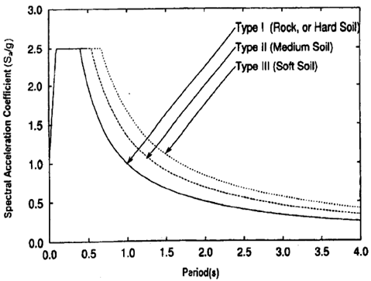
The reaction range strategy (RSM) was presented in 1932 within the doctoral thesis of Maurice Anthony Biota at Caltech. It is an approach to finding seismic tremor reaction of structures utilizing waves and vibration mode shapes. The concept of the “response spectrum” was applied in plan necessities within the mid-20th century in building codes of different nations. The computational preferences in utilizing the reaction range strategy of seismic examination are the forecast of relocations and part powers in auxiliary frameworks. The strategy includes the calculation of as it were the most extreme values of the relocations and part powers in each mode utilizing smooth plan spectra that are the normal of a few seismic tremor movements.
Figure.1.1 Design Response Spectrum for different soil (5% damping)

2.3 ORIGIN OF THE RESPONSE SPECTRUM METHOD
In 1971, with the event of the San Fernando, California, seismic tremor, the advanced era of RSM was propelled. • This seismic tremor was recorded by 241 accelerographs, and by combining these information with all past strong-motion records it became conceivable to perform the primary comprehensive observational scaling examinations of response ghostly amplitudes.

2.4 Factor Influencing Response Spectra
The reaction ghostly values depends upon the following parameters,
•I) Vitality discharge instrument
•II) Epicentral separate
•III) Central profundity
•IV) Soil condition
•V) Richter size
•VI) Damping within the framework
•VII) Time period of the system

2.5Seismic Zone
Bangladesh is divided into three seismic zones as per BNBC. The table below shows the values of zone coefficients of Bangladesh.
Zone | 1 | 2 | 3
Zone Factor Z | 0.075 | 0.15 | 0.25

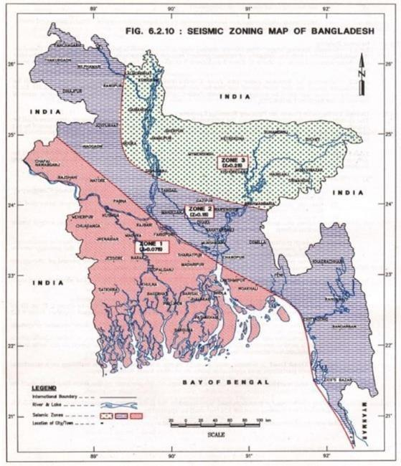
Table 2.1: Seismic Zone Factor Z

Figure 2.1: Seismic Zoning Map of Bangladesh

2.6 Base Shear Method

Base shear is the maximum lateral force that will occur due to seismic ground motion at the base of a structure.

Total design base shear’s formula is...
V = (Cv.I / R T) * W

Here ,
Cv = Coefficient of seismic zone.
I = Importance of seismic.
R = Response modification factor.
T = Time period of seismic structure.
W = Total dead load.

2.7 Why use Response Spectrum Analysis
Cleary buildings planned with extraordinary procedures to stand up to harm amid seismic action have taken a higher toll of development than typical buildings but for security against disappointments beneath seismic strengths it could be a prerequisite. Response range examination is valuable for plan choice making since it relates basic sort segments to energetic execution. Structures of shorter period encounter more noteworthy speeding up whereas those of longer period involvement more noteworthy displacement. Response range could be a direct energetic investigation.

Chapter 3

3.1 General Description of Structure
Four structures representing low, medium and high rise RCC concrete buildings are considered in this study. For the present study 3, 4, 5 and 6 stories buildings are chosen.

3.2 Material Property
Modulus of Elasticity of Concrete, Ec = 3600 ksi
Poisson’s Ratio of Concrete = 0.2
Minimum Yield Strength of Steel, Fy = 60 ksi
Concrete Compressive Strength, f’c = 4 ksi
3.3 Model Geometry
The structures analyzed are 3, 4, 5 and 6 storied buildings. Geometry of these structures are the same.

3.3 Three storied RCC building
Number of bays along X-direction = 4
Number of bays along Y-direction = 4
Base to ground floor height = 6
Feet Story height =10 feet
Bay width along X-direction = 17 Feet
Bay width along Y-direction = 17 Feet

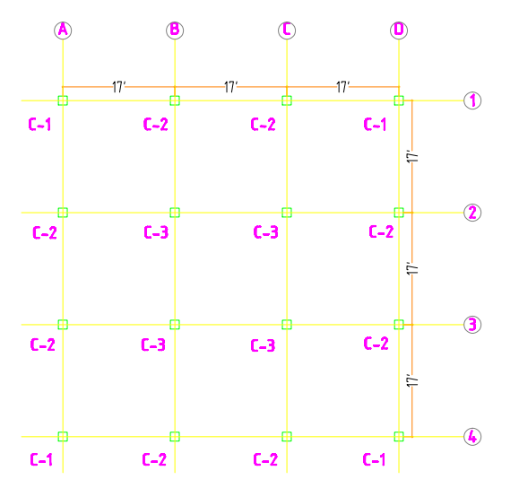
Plan of Three storied building is given below:

Figure 3.1: Plan of RCC Building (3 story)
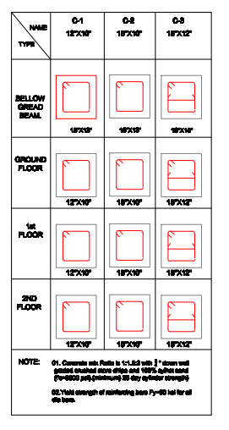
Figure 3.2: Column Schedule (3 story)

3.4 Three storied RCC building Design by Response Spectrum Analysis
Number of bays along X-direction = 4
Number of bays along Y-direction = 4
Base to ground floor height = 6 feet
Story height = 10 feet
Bay width along X-direction = 17 feet
Bay width along Y-direction = 17 feet
Plan of Three storied building is given below:
Figure 3.3: Plan of RCC Building in Response Spectrum Analysis(3 story)

Figure 3.4: Column Schedule (3 story)

3.5 Four storied RCC building
Number of bays along X-direction = 4
Number of bays along Y-direction = 4
Base to ground floor height = 6 feet
Story height = 10 feet
Bay width along X-direction = 18 feet
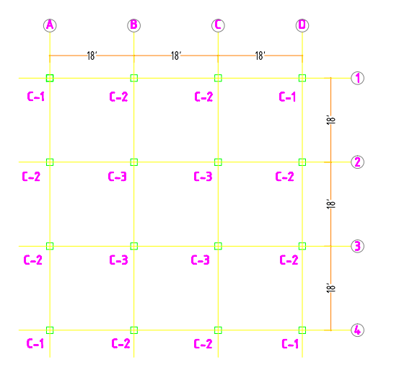
Bay width along Y-direction = 18 feet
Plan of Three storied building is given below:
Figure 3.5: Plan of RCC Building (4 story)

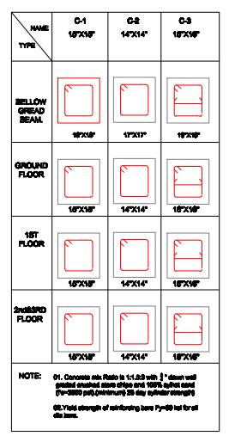
Figure 3.6: Column Schedule (4 story)

3.6 Four storied RCC building Design by Response Spectrum Analysis
Number of bays along X-direction = 4
Numberof bays along Y-direction = 4
Base to groundfloor height = 6 feet
Story height = 10 feet
Bay width along X-direction = 18 feet
Bay width along Y-direction = 18 feet
Plan of Four storied building is given below:
Figure 3.7: Plan of RCC Building in Response Spectrum Analysis (4 story)
Figure 3.8: Column Schedule (4 story)

3.7 Five storied RCC building
Number of bays along X-direction = 4
Numberof bays along Y-direction = 4
Base to groundfloor height = 6 feet
Story height = 10 feet
Bay width along X-direction = 20 feet
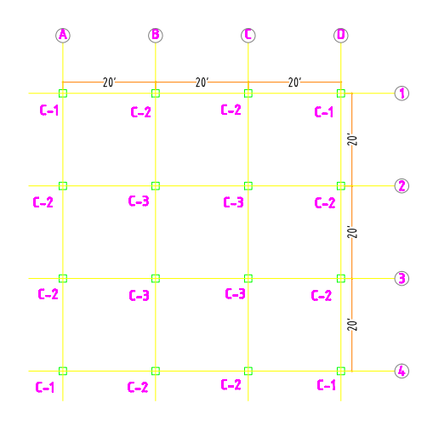
Baywidth along Y-direction = 20 feet
Plan of Five storied building is given below:
Figure 3.9: Plan of RCC Building (5 story)
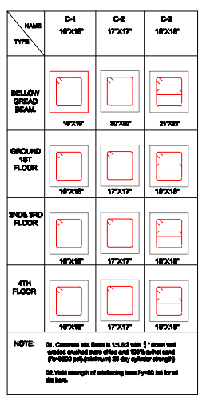
Figure 3.10: Column Schedule (5 story)

3.8 Five storied RCC building Design by Response Spectrum Analysis
Number of bays along X-direction = 4
Number of bays along Y-direction = 4
Base to ground floor height = 6 feet
Story height = 10 feet
Bay width along X-direction = 20 feet
Baywidth along Y-direction = 20 feet
Plan of Five storied building is given below:

Figure 3.11: Plan of RCC Building (5 story)

Figure 3.12: Column Schedule (5 story)

3.9 Six storied RCC building
Number of bays along X-direction = 4
Number of bays along Y-direction = 4
Base to ground floor height = 6 feet
Story height = 10 feet
Bay width along X-direction = 19 feet
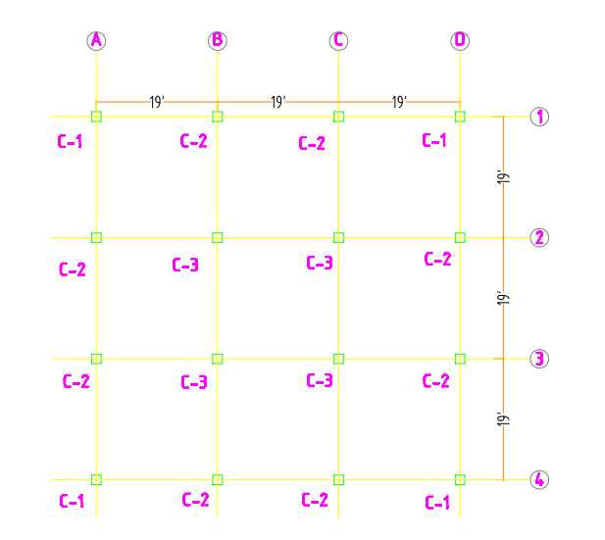
Bay width along Y-direction = 19 feet
Plan of Five storied building is given below:

Figure 3.13: Plan of 6 Storied RCC Building
Figure 3.14: Column Schedule (6 story)

3.10 Six storied RCC building Design by Response Spectrum Analysis
Number of bays along X-direction = 4
Number of bays along Y-direction = 4
Base to ground floor height = 6 feet
Story height = 10 feet
Bay width along X-direction = 19feet
Bay width along Y-direction = 19 feet
Plan of Five storied building is given below:
Figure 3.15: Plan of RCC Building in Response Spectrum Analysis (6 story)
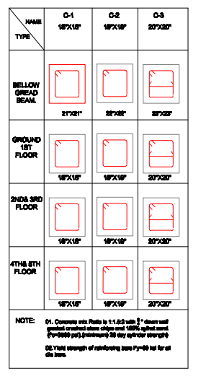
Figure 3.16: Column Schedule (6 story)

Loading Condition
Floor Finish = 25psf
Partition Wall = 80psf
Dead Load = 120 psf
Live Load = 50 psf
Wind load is automatically calculated by program as per UBC94. As per BNBC
Site location = Dhaka

Basic wind speed = 141 km/hr Exposure = A
Structure importance factor = 1.00

Seismic load is automatically calculated by program as per UBC94. As per BNBC

Site location = Dhaka Zone = 2
Seismic zone factor, Z = 0.15
Seismic zone factor, Z = 0.20
Seismic zone factor, Z=0.075 Site coefficient, S = 1.5
Structure importance factor, I = 1.00
Seismic modification factor for RCC building, R = 8 (IMRF)
Time period for RCC building, Ct (ft) = 0.030

Chapter-4

Results and Discussion

4.1 General
This chapter presents the results of "Analysis of Multi-Storied Building by Response Spectrum Analysis in Different Seismic Zone" used by ETABS software. First analysis was Comparison of Base Shear in 3,4,5,6 storied buildings in different zones and then Comparison of Base Shear in different stories at last we check our Building Modal Participatory Ratio at ETABS in Different Zones.

4.2 Comparison of Base Shear in 3 storied building in different zone
Normal Base Shear of Static Analysis value must be >90% Response Spectrum Analysis Base Shear value, according to BNBC 2006. Hear we see, when Z=0.075 the Base Shear of Static Analysis is 51.47and Response Spectrum Analysis Base Shear is 51.5 which is >90% so the result is ok according to BNBC 2006.
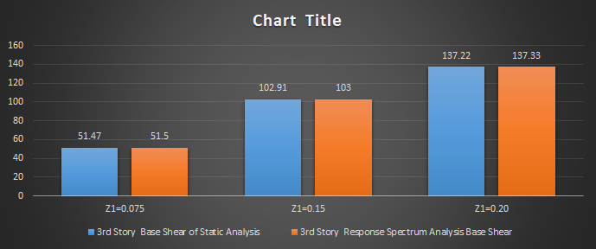
Table 4.1: Comparison of Base Shear in 3 storied building in different zone
Zone Factor | Base Shear of Static Analysis | Response Spectrum Analysis Base Shear | Remark
Z=0.075 | 51.47 | 51.5 | >90%(ok)
Z=0.15 | 102.91 | 103 | >90%(ok)
Z=0.20 | 137.22 | 137.33 | >90%(ok)
Figure 4.1:Comparison of Base Shear in 3 storied building in different zone

4.3 Comparison of Base Shear in 4 storied building in different zone
Normal Base Shear of Static Analysis value must be >90% Response Spectrum Analysis Base Shear value, according to BNBC 2006. Hear we see, when Z=0.075 the Base Shear of Static Analysis is 79.26 and Response Spectrum Analysis Base Shear is 79.63 which is >90% so the result is ok according to BNBC 2006.

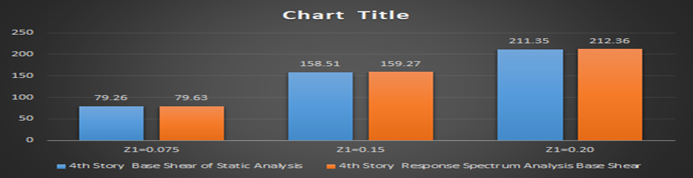
Table 4.2: Comparison of Base Shear in 4 storied building in different zone
Zone Factor | Base Shear of Static Analysis | Response Spectrum Analysis Base Shear | Remark
Z=0.075 | 79.26 | 79.63 | >90%(ok)
Z=0.15 | 158.51 | 159.27 | >90%(ok)
Z=0.20 | 211.35 | 212.36 | >90%(ok)
Figure 4.2: Comparison of Base Shear in 4 storied building in different zone

4.4 Comparison of Base Shear in 5 storied building in different zone.
Normal Base Shear of Static Analysis value must be >90% Response Spectrum Analysis Base Shear value, according to BNBC 2006. Hear we see, when Z=0.075 the Base Shear of Static Analysis is 79.26 and Response Spectrum Analysis Base Shear is 79.63 which is >90% so the result is ok according to BNBC 2006.

Table 4.3: Comparison of Base Shear in 5 storied building in different zone
Zone Factor | Base Shear of Static Analysis | Response Spectrum Analysis Base Shear | Remark
Z=0.075 | 113.7 | 114.02 | >90%(ok)
Z=0.15 | 227.4 | 240.66 | >90%(ok)
Z=0.20 | 303.2 | 308.04 | >90%(ok)
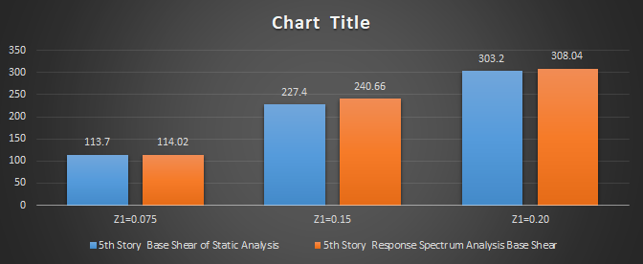
Figure 4.3: Comparison of Base Shear in 5 storied building in different zone

4.5 Comparison of Base Shear in 6 storied buildings in different zones.
Normal Base Shear of Static Analysis value must be >90% Response Spectrum Analysis Base Shear value, according to BNBC 2006. Hear we see, when Z=0.075 the Base Shear of Static Analysis is 103.7 and Response Spectrum Analysis Base Shear is 125.14 which is >90% so the result is ok according to BNBC 2006.
Table 4.4: Comparison of Base Shear in 6 storied buildings in different zones
Zone Factor | Base Shear of Static Analysis | Response Spectrum Analysis Base Shear | Remark
Z=0.075 | 103.7 | 125.14 | >90%(ok)
Z=0.15 | 260.19 | 240.66 | >90%(ok)
Z=0.20 | 347.18 | 328.09 | >90%(ok)
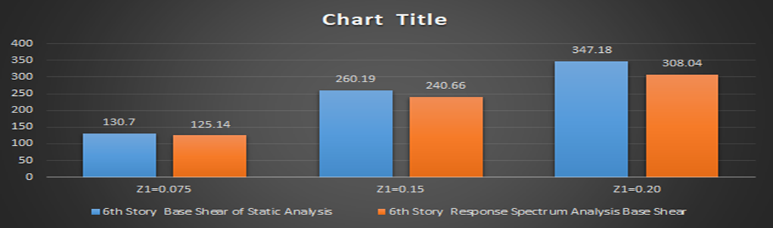
Figure 4.4: Comparison of Base Shear in 6 storied buildings in different zones

4.6 Comparison of Base Shear in different story
Table 4.5: Comparison of Base Shear in different story
Story Level | Response Spectrum Analysis max Base Shear
3 storied | 137.33
4 storied | 212.36
5 storied | 308.04
6 storied | 328.09
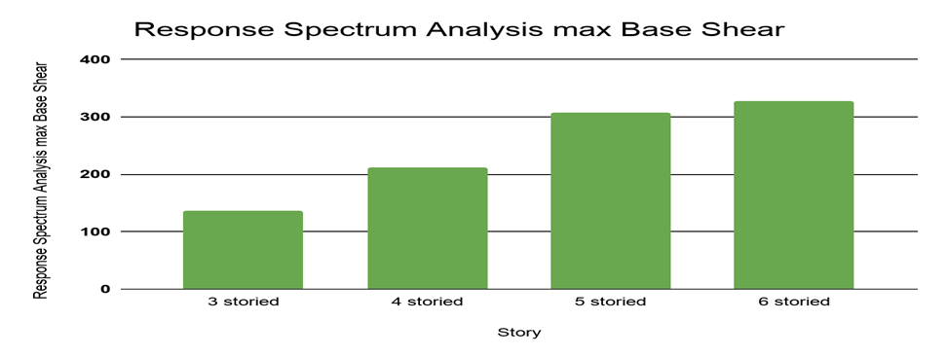
Table 4.5: Comparison of Base Shear in different story

4.7 Modal Participatory Ratio in Different Zones.

Modal participatory ratio means, how many portions of Building participate in the process. According to BNBC -2006 it should be >90%. In the table every storied building modal participatory Ratio 100% at every zone.
Table 4.6: Three Storied Building Modal Participatory Ratio in Different Zones
3 Storied | Percentage of Modal | Remark
Z=0.075 | 100% | >90%
Z=0.15 | 100% | >90%
Z=0.20 | 100% | >90%

Table 4.7: Four Storied Building Modal Participatory Ratio in Different Zones
4 Storied | Percentage of Modal | Remark
Z=0.075 | 100% | >90%
Z=0.15 | 100% | >90%
Z=0.20 | 100% | >90%

Table 4.8: Five Storied Building Modal Participatory Ratio in Different Zones
5 Storied | Percentage of Modal | Remark
Z=0.075 | 100% | >90%
Z=0.15 | 100% | >90%
Z=0.20 | 100% | >90%
6 Storied | Percentage of Modal | Remark
Z=0.075 | 100% | >90%
Z=0.15 | 100% | >90%
Z=0.20 | 100% | >90%
Table 4.9: Six Storied Building Modal Participatory Ratio in Different Zone

Chapter-6

Conclusions
  - General
Nonlinear pushover analysis has now been considered as an effective tool for understanding the performance of structure under different condition. When the structure is subjected to specific levels of seismic motion, there are some desired levels of seismic performance. Acceptable performance is measured by the level of structural and non-structural damage expected from the earthquake shaking.
In this study the main goal was to present the performance base analysis of RCC structures of 3,4,5 and 6 storied buildings and their seismic performance was evaluated in a detail way.

Conclusions

1. When the value ​​of Z increases, so does the value of the base shear increases.
2. When the story level increases, so does the base shear is increased.
3. The value of base shear in Response Spectrum is above 90% of base shear found in Equivalent StaticAnalysis. It is Ok according to BNBC.
4. Modal Participatory Ratio will be more than 90%. Therefore it is Ok according to BNBC 2006.

References

1 . Brajesh Kumar Tondon Student, Civil Engineering, Saveetha School of Engineering , Saveetha University, Chennai, Tamil Nadu, India ,jan-feb 2018
2 . S. R. Kangle 1M.E Civil-Structure Student, Department of Civil Engineering, JSPM’s Rajarshi Shahu College of Engineering Tathawade, Pune-411033, India (September-2020)
3 . D. S. Yerudkar 2Associate Professor,Department of Civil Engineering, JSPM’s Rajarshi Shahu College of Engineering Tathawade, Pune-411033, India (September-2020)
4 . Dr. Jagadish. G. Kori Professor & Head Civil Engineering Department Govt. Engineering College, Haveri-581110

