

Faculty of Engineering
Department of Textile Engineering

Color Fastness Evaluation of Different Fabrics Dyed with Similar Dyes at Different shade% (eg. Cotton, Viscose, Jute Fabrics with Reactive Dyes)

Course Code: TE-4214; Course Title: Project (Thesis)
Submitted By:
Name: | ID:
Md. Muzahidul Islam | 173-23-365
Md. Ahsan | 173-23-374
Md. Bakhtiar Hasan | 173-23-389

Supervised By:

Name: Md. Kamrul Islam
Lecturer
Department of Textile Engineering
Daffodil International University

Bachelor of Science in Textile Engineering
Advance in Wet Processing Technology

DECLARATION

We hereby declare that, this project has been done by us under the supervision of Md. Kamrul Islam, Lecturer, Department of Textile Engineering, Faculty of Engineering, entitled with “Color Fastness Evaluation of Different Fabrics Dyed with Similar Dyes (eg. Cotton, Viscose, Jute Fabrics with Reactive Dyes)” Daffodil International University. We also declare that, neither this report nor any part of this has been submitted elsewhere for award of any degree.

Md. Muzahidul Islam
ID: 173-23-365
Department of TE

Daffodil international University

Md. Ahsan
ID: 173-23-374
Department of TE

Daffodil international University

Md. Bakhtiar Hasan
ID: 173-23-389
Department of TE

Daffodil international University

LETTER OF APPROVAL

This project report prepared by Name: Md. Muzahidul Islam, (ID:), 173-23-365, Name: Md. Bakhtiar Hasan (ID:), 173-23-389, Name: Md. Ahsan (ID:) 173-23-374 is approved in Partial Fulfillment of the Requirement for the Degree of BACHELOR OF SCIENCE IN TEXTILE ENGINEERING. The said students have completed their project work under my supervision entitles with “Color Fastness Evaluation of Different Fabrics Dyed with Similar Dyes (e.g. Cotton, Viscose, Jute Fabrics with Reactive Dyes)”. During the research period I found them sincere, hardworking and enthusiastic.

-----------------------------

Md. Kamrul Islam

Lecturer

Department of textile engineering

Faculty of engineering

Daffodil international university

ACKNOWLEDGEMENT

At first, we are grateful to almighty Allah for this Divine blessing make us possible to ready
the project.
We are also grateful to our supervisor Md. Kamrul Islam, Lecturer,
Department of Textile Engineering, Faculty of Engineering, Daffodil International
University. His endless patience, scholarly, guidance, continual encouragement, energetic
supervision, constructive criticism, advice, reading many inferior draft and correcting these
all stages have made it possible to complete this project.
We also thankful to our all teachers, lab assistant, register, coordinators and all the employees
of Daffodil International University. We are very happy to express our regards to honorable
Assistant Professor & Head (In-Charge) Mr. Md. Mominur Rahman for providing his best support to us.
Finally, we would like to express a sense of gratitude to our parents and friend for their
mental support, assistance throughout writing the project.

DEDICATION
“This Projects Report is dedicated to our dignified Parents and Teachers may they
live long”

ABSTRACT

This project report present study about Color fastness evaluation of different fabrics (eg. cotton, viscose & jute) dyed with reactive dye. During this report we collect data from Daffodil international University textile lab. This report, helps us to understand about Color fastness of cotton, viscose & jute fabrics) with reactive dye. They are dyeing process and fastness properties. From this experiment we also learn that the auxiliary need for dyeing is a smaller amount than reactive dye. Rubbing fastness of dry reactive fabric is best.
Contents
DECLARATION i
LETTER OF APPROVAL i
ACKNOWLEDGEMENT ii
DEDICATION i
ABSTRACT i
Chapter One 3
Introduction 3
1.1 Introduction 4
1.2 Objectives of the Study: 5
1.3 Limitation of the Study: 5
Chapter Two Literature Review 6
2.1 Reactive dye: 7
2.2History of reactive dye: 7
2.3 Classification of Reactive Dyes 8
2.3.1 Cold Brand Reactive Dyes 9
2.4 Recent Classification Of Reactive Dyes 9
2.5 Types of Fixation Reaction 10
2.6 The dyeing or wet processing flow chart is given below 10
2.7 Properties of Reactive dye: 11
2.8 Chemical structure of reactive dye: 12
2.9 Classification of Reactive dye: Error! Bookmark not defined.
2.10 Dyeing mechanism of material with reactive dye: 12
2.10.1 Color variation of reactive dye: 13
2.10.2 Reactive blue (light shade) 13
2.10.2 Reactive blue( Medium shade) 13
2.10.3 Reactive blue (Dark shade) 14
2.10.4 Shade variation of reactive dye: 14
2.11 Basic Principle of Dyeing with Reactive Dyes 15
2.12 Advantages of Reactive Dyeing 16
2.13 Disadvantages of Reactive Dyeing 16
2.14 Precautions for Reactive Dyeing 16
2.15 Jute Fiber with Reactive Dye 22
Chapter 3 Material & Method 24
3.1 Specification of the sample: 25
3.2 Experimental procedure: 25
3.3 Basic difference between reactive dye 25
3.4 Recipe of Reactive Dye: 26
3.5 Sample Preparation Jute fabric 28
3.5.1 Recipe Formulation 29
3.5.2. Dyeing Procedure 29
3.5.2 Dyeing Performance Test 29
3.6 Process flow Chart of Reactive dyeing: 30
3.7 Dyeing sample: 31
3.7.1. Dyed fabric with reactive, knit fabric (lightshade) 31
3.7.2 Dyed fabric reactive dye with reactive dye woven fabric and knit fabric (Dark shade): 31
3.7.3 Fastness to Perspiration 32
3.7.4 Fastness to Washing 34
3.7.5 Rubbing Fastness: 35
3.7.6 Principal: 35
3.7.7 Types of rubbing fastness: 35
3.7.9 Procedure: 35
3.7.10 Assessment technique: 36
Chapter 4 Result and discussion 37
4.1 Data analysis and Finding 38
4.2 Assessment of Fastness to Perspiration for cotton fabric 38
4.3 Assessment of Fastness to Washing for cotton fabric 38
4.4 Assessment of rubbing fastness to rubbing for woven and knit fabric 39
4.5 Comparisons between rubbing fastness of reactive 43
4.6 Result in chart of rubbing fastness of reactive dye (Woven fabric) 43
4.7 Result in chart of rubbing fastness of reactive dye (Knit fabric) 44
4.8 Assessment of wash fastness to washing for woven and knit fabric 45
4.9 Dyeing Jute Fiber with Reactive Dye after Treating with Chitosan 48
Chapter 5 Conclusion 50
5.1onclusion 51
References: 52

Chapter One

Introduction

1.1 Introduction
Cotton is vastly used fiber in textile sector. It is a characteristic cellulosic fiber. Cellulose contain 44% carbon, 6.2% Hydrogen and 49.4% oxygen (1). Cotton is the world's most mainstream fiber for material creation (2). A wide scope of material items can be made by utilizing this cotton strands. To deliver overwhelming or lighter texture cotton fiber are utilized. Overall cotton is most well known as a result of its less cost. The material items which are made by cotton are reasonable for utilizing all the year both in home and mechanical employments. Cotton texture are agreeable to wear as a result of its high dampness sponginess ability and fast dampness discharge capacity. For the most part cotton fiber length ranges from ½ crawls to 2 inches and it's dampness recover presentence is 8% and its quality is increment 10 % when it became wet (1). There are numerous kinds of cotton fiber discovered everywhere throughout the world, they are Asiatic cotton, Egyptian cotton, Canton cotton, Sea Island cotton, American Upland Cotton, Organic Cotton, Pima cotton , French Terry cotton, Bamboo cotton and so forth. There are numerous sorts of completing procedure should be possible in cotton texture, for example, water repellent completion (3), mold finish, simple consideration finish, Antiseptic completion, Flame safe completion and so on. Cotton items can be used in both home materials and articles of clothing item. Viscose is a type of rayon. Originally known as artificial silk and later named as rayon because of its brightness and similarities in structure to cotton (rayon is a combination of sunray and cotton).Viscose is made from wood pulp, making it a cellulosic fiber, like cotton or linen. It is often regarded as only partially manmade. Chemical structure of viscose is same as that of cotton i.e. Cellulose, But the polymer chains are much shorter. The degree of polymerization value of rayon is 400 – 700 while that of cotton is 5000. It is used in apparel, home furnishings and industrial uses. Jute is long, soft and shiny, with a length of 1 to 4 m and a diameter of from 17 to 20 microns. Jute fibers are composed primarily of the plant materials cellulose (major component of plant fiber) and lignin (major components of wood fiber). The fibers can be extracted by either biological or chemical retting processes. Given the expense of using chemicals to strip the fiber from the stem biological processes are more widely practices. Biological retting can be done by either by stack, steep and ribbon processes which involve different techniques of bundling jute stems together and soaking in water to help separate the fibers from the stem before stripping. After the retting process, stripping begins. In the stripping process, non-fibrous matter is scraped off, leaving the fibers to be pulled out from within the stem. Jute fibers are used in curtains, chair coverings, carpets, hessian cloth, and backing for linoleum. It can also be used in floor coverings, home textiles, high performance technical textiles, Geotextiles, composites, and more.
Reactive dye is suitable for cotton fabric. But it can be used for viscose and jute fabric also. There are various kinds of reactive dyes. Among them Mono-chlorotriazine-vinyl sulphone (MFT/VS), Mono-chlorotriazine-vinyl sulphone (MCT/VS) and Tri-Fluoro-Pyridine-Vinyl Sulphone (TFP/VS) were utilized during this project to identify their color strength, color diﬀerence and color fastness to wash. Strength of any colorant (dyestuﬀ / pigment) is claimed to absorption property. We measure reﬂectance and not absorbance. It’s known to us that when reﬂectance is more, absorbance may be a smaller amount and when reﬂectance may be a smaller amount, absorbance is more. Here the dye contains a reactive group and this reactive group makes bond with the fiber polymer and act as an integral a neighborhood of fiber. This bond is formed between the dye molecules and thus the reform the terminal –OH (hydroxyl) group of cellulosic fibers on between the dye molecules and therefore the terminal –NH 2 (amino) group of polyamide or wool fibers. During a reactive dye a chromospheres contains a substituent that reacts with the substrate. Reactive dyes have good fastness properties thanks to the bonding that happens during dyeing. Reactive dyes are most commonly utilized in dyeing of cellulose like cotton or ﬂax, but also wool is dye able with reactive dyes. Reactive dyeing is that the foremost vital method for the coloration of cellulosic fibers. Reactive dyes can also be applied on wool and nylon; within the latter case they're applied under weakly acidic conditions. Reactive dyes have a coffee utilization degree compared to other kinds of diestrum, since the functional group also bonds to water, creating hydrolysis.

1.2 Objectives of the Study:
- to know about dyeing process of cotton, viscose & jute fabric with reactive dye
- to know the color fastness of cotton, viscose & jute fabric to wash, Rubbing & perspiration
- to analyze the Study on Color Strength of Different Reactive Dyes
- to evaluate the test result of color fastness of cotton, viscose & jute fabric to wash, Rubbing & perspiration.

1.3 Limitation of the Study:
A thesis paper needed Practical result where a researcher shown their papers test elements, result, output, and discuss about their result supported topic, But during this situation of whole world we are affected on COVID-19 for that reason we cannot do lab test for our research and don’t give any output for our paper. Here we showed just possibility of result.

Chapter Two
Literature Review

2.1 Reactive dye:
Reactive dyes are commonest dye in textile industry. Most natural fibre dyeing is completed by Reactive dye. Reactive dyes have acceptance to the dyeing technologist for dyeing cotton. The dyeing of natural fibre with reactive dye energy consumption is a smaller amount than dyeing with other dye. Reactive dyes make chemical bond with fiber. Formula of Reactive dye are often written by
D-X-Y
D=color producing group
X= bridge (covalent bond)
Y=functional group
Cell-OH+HO-=Cell-O+H2O
Cell-O+ Dye –Cl -=Cell-O- Dye+ Cl
2.2History of reactive dye:
Reactive dyes were first utilized in 1956,it was invented by steepens and Retteein Blackly in 1954,while they were performing on ICI company(UK). Reactive dye is hottest system for coloring cellulosic fibers.it are often used on nylon and wool dyeing. These fiber have low utilization property from other dyestuff.
These dyes is especially created to dyed cellulosic fiber. The dye were invented in 3 types and name of these are-
Procion Yellow R
Procion brilliant Red 2B
Procion Blue 3G
For this invention they were award trophy of the society of dyes and colorists in 1960.
These dye arrived in our country in mid-60’sand become much popular during 80’s.

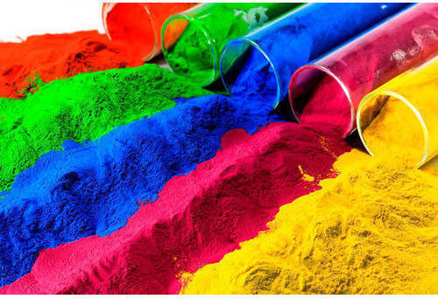
Figure 2.1: Reactive dye

2.3 Classification of Reactive Dyes
- On the basis of reactive group
  - Halogen
    - Triazine group:procion,cibacron
    - pyrimidine group:reactone
    - Quinoxaline group:Levafix
  - Activated vinyl compound:
    - Vinyl sulphone:remazol
    - Vinyl acrylamide: primazine
    - Vinyl sulphonamide: levafix
- On the basis of reactivity
  - Lower reactive dye: here pH is maintained 12-12.5 using NaOH in bath
  - Medium reactive dye: pH is maintained 11-12 by Na₂CO₃
  - Higher reactive dye: pH is maintained 10-11 using NaHCO₃
- On the basis of dyeing temperature

2.3.1 Cold Brand Reactive Dyes
These types of dyes contain reactive groups of high reactivity. So dyeing can be done in lower temperature i.e. 32-60°C. For example: PROCION M, LIVAFIX E
- Medium Brand Reactive Dyes
This type of dyes contains reactive groups of moderate reactivity. So dyeing is done at higher temperatures than that of cold brand dyes i.e. in between 60-71°C temperatures. For example, Remazol, Livafix are medium brand dyes.
- Hot Brand Reactive Dyes
This type of dye contains reactive groups of least reactivity. So high temperature is required for dyeing i.e. 72-93 °C temperature is required for dyeing. For example PROCION H, CIBACRON are hot brand dyes.

2.4 Recent Classification of Reactive Dyes
Type | Reactivity | Condition | Temperature | Reactive Group
Salt Controllable | Low reactivity in alkaline conditions | Appreciable substantivity, careful addition of salt is required. | 80°C temperature. | Monochloro Triazine, Monofloro Triazine, Trichloro Pyrimidine.
Alkali controllable | High reactivity | Moderate substantivity, careful control of the addition of alkali is required. | Applicable at low temperature. | Dichloro Triazine, Diflorochloro Pyrimidine, Vinyl Sulphone.
Temperature controllable | – | Can be applied in neutral conditions | Applicable in high temperatures. | NT.

Table 2.1 Recent Classification of Reactive Dyes

2.5 Types of Fixation Reaction
There are mainly two types of reactions that occur. These are –
Neucleofilic Substitution Reaction
Cell–OH + HO– ⇒ Cell–O– + H₂O
Cell–O–+ Dye–Cl ⇒ Cell–O–Dye + Cl–

Neucleofilic Addition Reaction
Cell–O–+ Dye–SO₂–CH=CH₂ ⇒ Dye–SO₂–CH=CH₂–O–Cell

Wash-off of Reactive Dyes
As the dyeing is completed, a good wash must be applied to the material to remove extra and unfixed dyes from material surface. This is necessary for level dyeing and good wash-fastness. It is done by a series of hot wash, cold wash and soap solution wash.

2.6 The dyeing or wet processing flow chart is given below
Before dyeing a fabric or yarn some pre-treatment and after treatment is needed. A flowchart is drawn here by combining these:

Grey Fabric Inspection

↓

Sewing or Stitching

↓

Singeing

↓

Desizing

↓

Scouring

↓

Bleaching

↓

Mercerizing

↓

Dyeing

↓

Printing

↓

Finishing

↓

Final Inspection

This is the foremost comprehensively used wet handling stream diagram on the contemporary material industry. In any case, every so often on certain preparing plants, the scouring and blurring are done at an equivalent time.
In this paper, i will be able to discuss on shading of cotton stock with open hues, as I even have worked with responsive hues and its speed properties. Responsive hues are notable within the Bangladesh material industry. Here I even have given some ordinary musings on responsive hues. Delivery

2.7 Properties of Reactive dye:
Reactive dyes are water soluble dye
- Reactive dye create chemical bond with fiber.
- Dye has good light fastness property around 6.
- These dye cheap in cost.
- These dye have moderate rubbing fastness.
- These dyes have good perspiration fastness rating is about 4-5.
- Fixation is completed in alkali medium. are often found in print paste form, powder form and liquid form

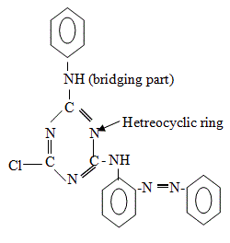
2.8 Chemical structure of reactive dye:

Fig: chemical structure of reactive dye

2.10 Dyeing mechanism of material with reactive dye:
Dye absorption:
When fiber is immersed into dye liquor, an electrolyte is added to help the exhaustion of
dye. Here NaCl or glauber salt used as a electrolyte. This electrolyte neutralize absorption
Fixation:
Fixation of dye means the reaction of reactive group of dye with terminal-oH or NH2 group
of fiber and thus forming strong chemical bond with the fiber. These phase is extremely important.
In this phase PH maintain by adding alkali.
Wash off:
As the dyeing is complete, an honest wash must be applied to the fabric to get rid of extra and
unfixed dye. Wash is need for level dyeing and good wash fastness. It’s done by a series
of hot wash, cold wash and soap solution wash.

2.10.1 Color variation of reactive dye:
Light (0.25%)
Medium (1%)
Dark (2%)

2.10.2 Reactive blue (light shade)

Figure 2.2: Reactive blue (light shade)

2.10.2 Reactive blue (Medium shade)

Figure 2.3: Reactive blue (1%)

2.10.3 Reactive blue (Dark shade)
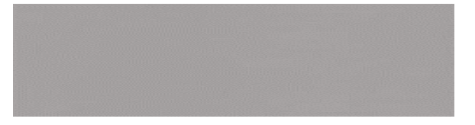
Figure 2.4: Reactive blue (2%)

2.10.4 Shade variation of reactive dye:
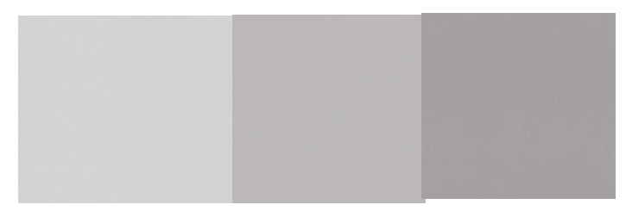
Light Medium dark

2.11 Basic Principle of Dyeing with Reactive Dyes
Start dyeing in neutral solution in presence of salt or gradually promote to exhaustion
No reaction of dye with fiber takes place only absorption and migration of dye in the fiber
The appropriate alkali is added
Acidic dissociation of cellulose takes place producing cellulose ion
This start the dye fiber reaction
Dyeing continue until no dye is taken up
Through washing to remove the absorbed but infixed and hydrolyzed dye

Figure 2.5: Basic Principle of Dyeing with Reactive Dyes

2.12 Advantages of Reactive Dyeing
- Brilliant, bright colors
- Permanency of the color
- Covalent fixation – high Wash Fastness (WF)
- Various temperatures, including low energy (cold dyeing)

2.13 Disadvantages of Reactive Dyeing
- Incomplete fixation (problem with hydrolysis)
- Need for wash-off (for high WF)
- Need for high concentrations of salt
- Color is not easily removed by effluent treatment processes and in many cases, the dyes are not readily biodegradable

2.14 Precautions for Reactive Dyeing
- Hot water shouldn't be used for top reactive dyes because there'll be an opportunity of hydrolysis.
- Prepared dye solution can't be stored for later use also due to dye hydrolysis.
- For making print paste, low reactive dyes are used.
- It is dangerous if there's the inhalation of the dust of reactive dyes, so a protective mask is required.
- A limited storage period is applicable to most of the reactive dye.

Definition of Fastness: Fastness is the resistance of textile materials to resist a load or destructive factor such as abrasion, heat, light, perspiration, wearing, acidic and alkaline conditions.

Categories of Fastness:
- Producers fastness
- Users fastness

Color Fastness Testing Method:
- Washing fastness
- Rubbing fastness
- Perspiration fastness

Test for Strength
  - Breaking Strength
  - Tearing Strength
  - Bursting Strength
  - Seam Strength etc

Test for Performance:
  - Pilling Resistance
  - Abrasion & Pilling
  - Water Repellency
  - Flammability etc

Objects of fastness testing:
- Research
- Selection of raw material for manufacturing
- Process Control
- Process Development
- Product development as per standards
- Specification testing etc.
What Kinds of changes a colored substrate may undergo:
- Change in depth
- Change in hue
- Change in luster

Factor affecting change in color and stunning:
The shading changes when dyed or printed materials are exposed to a specific are because of either of the accompanying two fundamental driver. The first is simply the breakdown of the colorant inside, the texture, whereby, it is changed over dismal or distinctively hued compound. The second is the unit of them as such from the fiber. There might be an adjustment in the shade of the fiber which will prompt change in the shade of the dyeing perspective. It is critical to underline that colorfastness is a property of shaded material and not of a colorant in seclusion. The degree in the adjustment in shade of hued material and recoloring of nearby on presenting to the specific condition is controlled by various attributes of the colorant and fiber in relationship with one another in the dyeing or print. There are sure factors that influence practically all the speed tests. They are:
- Chemical structure of the colorant
- The state of the colorant in the fiber
- The amount of the colorant in the fiber
- The fiber
- Foreign Substances
In the cases of fastness to light, there are few additional factors, they are
- The spectral composition and intensity of the incident radiation
- The external atmospheric condition
- Relative humidity and air temperature
- Contaminants such as oxides of nitrogen sulphur on ozone in the air.

The effects of the some of the factors are discussed:
The Chemical Structure of the color
The deterrent of the shading or shade to a creation or photochemical ambush is truly related to its substance fasten. By then, the for the most part rapid to the light of shading of anthraquinone hues on wool and the defenseless light speed to triphenylmethane destructive hues on a comparative substrate are clearly credited to the quality of one and precariousness of the other photochemical ambush.
Also, the incredible snappiness to oxidizing whitening authorities of anthraquinonoid tank hues on cellulosic filaments is related to the high steadfastness of such blends to oxidation.
Exactly when in any event one hues are accessible in the fiber one may catalyze the breakdown of another. A bit of the colorant molecule may revive the offering of the fiber and the weakening of the material.

State of Colorant in the fiber:
The state of the colorant in the fiber is plainly huge. The transcendence of responsive hues over the quick hues in respect of speed to wet treatment on cellulosic strands in the prompt outcome of the covalent association of the open shading to the fiber appeared differently in relation to the association of the quick shading through reversible forces, for instance, hydrogen bond and other discretionary charming forces.

In the shading or print of responsive shading, the colorant molecule becomes one component and part simply under extraordinary conditions. By virtue of the shading of direct hues on the cellulosic fibers reversal of the shading, the technique is sensibly begun since shading ingestion and upkeep are a result of delicate forces of interest which are viably endure. The incredibly rapid to wet treatment of shading and prints for instance of tank hues, azoic blend and other ingrain hues is a direct result of the way that the shading inside the fiber is an as modestly gigantic particle of the insoluble colorant are ordinarily impenetrable to departure during wet treatment. At the same time the closeness of the colorant in the fiber in these results in progress in its security of compound ambush.

Amount of colorant present on the fiber:
The colorfastness of a profound shading on print of a particular shading consistently differentiates particularly from that of pale shading on print of the equal a comparable shading on a comparable fiber when the standard effect of prologue to explicit condition is to convey a modification in the shade of the material for instance concerning the circumstance with prologue to light it is ordinarily found that the more profound the shading on print (for instance the more noticeable the proportion of shading present on the fiber, the higher is the snappiness in respect of progress in concealing introduction.)
In explicit cases, the speed to the light of profound shading may be at any rate two centers (on the 1 – 8 scale) than that of the pale shading of a comparable shading. This is explained somewhat by the way that the more profound the shading more unmistakable the proportion of the shading which must be crushed before calculate change the shade of the material gets clear. The condition is befuddled by the way that the colorant is accessible
In the fiber as colossal particles of shade for the circumstance even a pale shading or print contains a respectably immense proportion of colorant is a state (all out structure) where it is less frail to photo chromic ambush and thusly, the effect of the profundity of concealing on light speed is impressively less verbalized or event missing. The high briskness to the light of pale shading of reasons for conceal pitch clung to the fiber is a by and large great instance of this.
For this circumstance of condition washing, water, dry warmth (dissipate shading) the speed of the shading of print with respect to recoloring of close by materials decreases of as profundity of shading additions. This is viably fathomed since the more imperative the proportion of shading present practically certain is it that during introduction sufficient to cause recoloring will be isolated from the material.
It is significant presently to disguise some light regarding the matter of standard profundities and standard scale.
Since the concealing pace of shading or print is related to the profundity of concealing it is routinely essential to show the profundity of the shade of the imperative to exhibit the profundity of the shade of the shading or print under test.
This particularly so while deciding the snappiness characteristics of a colorant. To enable this to be done impartially the ISO proposed extent of twenty reference tones named standard profundities covering the range yellow to dim.
Aside from maritime power blue and dim each concealing is appeared in six profundities, implied as 2/1, 1/1, 1/3, 1/6, 1/12 and 1/25 standard profundity independently For the circumstance of maritime power blue dim only two standard profundities are supported the lighter maritime power blue and dull are doled out Nb/L and B/L and hazier maritime power blue and dim being appointed Nb/Dk and B/Dk.
The standard profundities are given by the British standard association reproduced on a matt texture (wool coat) and a splendid material (breathtaking gooey rayon)
The profundity of the shade of the material under test is reviewed by visual connection with the plan of standard profundities of appropriate concealing.

The Fiber:
The colorfastness of colored textiles is related to the chemical structure and physical characteristics of fiber itself. The wet fastness of disperse dye on polyester fiber is much higher than the secondary cellulose acetate materials. This is because of polyester fiber are much more compact in structure are consequently diffusion of dyes within them proceeds much more slowly under given conditions.
Fastness varies with moisture regain properties of different fiber. This is particularly so in case of light fastness which depends on effective humidity that depends on moisture regain.
The fastness properties of basic dyed or printed on acrylic fiber is much better than those on basic dyed / printed silk or wool.
Finally physical dimension of the fibers or filaments may be a determining factor. The higher fastness to light of certain direct dyes on high filament denier viscose staple fibers for carpets in attributed to the lower surface volume ratio compound with that of the low filament denier yarn used for other textile process.

Some common color fastness definition:
Colorfastness to wash:
This method is designed to determine the effect of washing on the color fastness of the textile. A specimen of the colored textile in contact with one or two specified adjacent fabrics is mechanically agitated under specified conditions of time and temperature in a soap solution, then rinsed and dried. The change in color of the specimen and the staining of the adjacent fabric are assessed with the grey scale.
The degree of fading and staining depends on:
- Temperature
- The types of detergent used
- The amount of detergent used
- Mechanical action (No of steel ball used)
- The washing liquor ratio
- The hardness of water
The rinsing, drying or pressing method used to restore the sample after the washing.
Colorfastness to Rubbing:
The Test is designed to determine the degree of color which may be transferred from the surface of a colored fabric to specific test cloth for rubbing (Dry & Wet). The Crock meter provides a rubbing motion simulating the action of a human finger and forearm.

Colorfastness to Perspiration:
The garments which come into contact with the body where perspiration is heavy may suffer serious local discoloration. This test is intended to determine the resistance of color of dyed textile to the action of acidic and alkaline perspiration. Determine the effect of acid & alkali perspiration on the colorfastness of textile materials.

2.15 Jute Fiber with Reactive Dye
Jute is a natural cellulosic fiber obtained from the bark of jute plant. The main chemical constituent of jute fiber is α-cellulose along with hemicelluloses and lignin. This fiber is popular due to its bio-degradability, high tensile strength, low extensibility and better breathability. In recent times, due to the improvement of people’s living standards and need for environmental protection, the demand of natural biodegradable and eco-friendly fibers like jute is increasing day by day.
According to Bashar and Khan, the introduction of cationic sites within the cellulose is an effective way to increase the dye adsorption. Cationic sites can be introduced either by aminization or cationization. Treatment of jute with chitosan is an aminization technique to introduce cationic site within the fiber polymer (Figure 1) structure and
Increase the hydroxyl group in the fiber for dye absorption. Chitosan [β-(1-4)-2-amio-2-deoxy-D-glucopyranose] is a nontoxic and biodegradable biopolymer, abundantly found in nature; specially in the exoskeletons of crustaceans arthropods and mollusks as well as the cell walls of certain fungi in the form of chitin. Chitin is deacetylited in alkaline medium to obtain chitosan. Chitosan can be applied on cellulosic fiber in various methods. Cellulosic fibers form a crosslink with chitosan, resulting positive dye sites on the fiber surface. Chitosan can easily adsorb anionic dyes such as direct, acid and reactive dyes by electrostatic at-traction due to its cationic nature. The application of chitosan on jute fiber offers the pos-sibility of increasing the hydroxyl group for the forma-tion of covalent bond with reactive dye and develop de-sired level of exhaustion. The current paper investigated the dyeability and color performance of chitosan treated jute fabric dyed with reactive dye and compared the re-sults with the fabric dyed without chitosan treatment.

Chapter 3
Material & Method

3.1 Specification of the sample:
Fabric type | EPI | PPI | GSM | WPI | CPI
100% cotton woven fabric | 62 | 60 | 82
100% cotton knit fabric single | 62 | 60 | 185 | 38 | 50

Table 3.1: Specification of the fabric sample:

3.2 Experimental procedure:
Our Experimental project support reactive dye of Dark shade. Firstly we collect knit fabric from Knit composite factory. Then knit fabric is dyed. After dyeing and finishing process the material is tested for color fastness to wash, rubbing and perspiration.

3.3 Basic properties reactive dye
Sl No. | Reactive Dyeing
Mechanism | Covalent bond formation with fiber
Solubility | Soluble in water
Charge | Negatively charge
Fastness property | Rubbing: moderate  Washing: Good  Perspiration: Good
Cost | Cheap in price
Temperature | 60-90°C
PH | 7-11
Table 3.2 properties of reactive dye

3.4 Recipe of Reactive Dye:
Process parameter | Unit | Dossing
Reactive blu | % | 0.25
Sal (NaCI) | g/1 | 25
Soda ash | g/1 | 10
Wetting agent | g/1 | 0.25
Sequestering agent | g/1 | 0.25
Temperature | °C | 60
Time | minute | 60
M:L |  | 1:40
Fabric Type (woven)
Fabric type weight | gm | 5
Fabric type (knit)
Fabric weight | gm | 5

Table 3.3: Recipe of reactive dyeing light shade (0.25%)

Recipe for reactive dye medium shade (1%)
Process parameter | Unit | Dossing
Reactive blu | % | 1%
Sal (NaCI) | g/1 | 30
Soda ash | g/1 | 15
Sequestering agent | ml/L | 0.25
Leveling agent | ml/L | 0.25
Temperature | °C | 60
Time | minute | 60
M:L |  | 1:40
Woven Fabric | gm | 5
knit fabric | gm | 5

Recipe for reactive dye medium shade (1%)

Recipe for reactive dye dark shade (2%)
Process parameter | Unit | Dossing
Reactive blu | % | 2%
Sal (NaCI) | g/1 | 60
Soda ash | g/1 | 15
Sequestering agent | ml/L | 0.25
Leveling agent | ml/L | 0.25
Temperature | °C | 60
Time | minute | 60
M:L |  | 1:40
Woven Fabric | gm | 5
knit fabric | gm | 5

Process curve for Reactive dye dark shade (2%)

3.5 Sample Preparation Jute fabric
Scoured, bleached 100% plain hessian jute fabric (261 GSM) was used in all the experiment. The fabric samples were treated with 4 g/l caustic soda solution for 20 min-utes at 90˚C prior to dying and neutralized with acetic acid solution. Chitosan chips (color off white, deacetyla-tion > 70%) were collected from the laboratory of Insti-tute of Radiation and Polymer Technology (IRPT), Bangladesh Atomic Energy Commission, Dhaka, Bang-ladesh. Chitosan solution was prepared by dissolving chips in distilled water in the presence of 2% acetic acid. Then the fabric samples were treated in chitosan solution for 60 minutes at 60˚C temperature, squeezed to remove excess solution and dyed. The dyeing was carried out in Sandolab infrared lab dyeing machine (Copower Tech-nology Ltd., Taiwan) by using a commercial reactive dye Novacron Red FN2BL form Swiss Colours BD). Deter-gent (Imeron PCLF) and leveling agent (Drimagen E3R) were collected from (Clariant, Bangladesh) and used as received. Sodium hydroxide, soda ash and acetic acid were used as received and all were commercial grade. For the ease of identification, all the test fabrics were coded as shown in Table 3.4.

3.5.1 Recipe Formulation
Fabric samples were dyed with Novacron Red FN2BL at 1% (on the weight of fabric) shade. Five different concentration of chitosan (0.5%, 1%, 2%, 3% and 4%) were used for fabric treatment. Recipes are given in Tables 4.13.1 and4.13.2.

3.5.2. Dyeing Procedure
5.0 g (± 5%) fabric samples were dyed treating with chitosan and without chitosan in exhaust dyeing method. The dyeing procedure is shown in Figure 2.

3.5.2 Dyeing Performance Test
The color properties of dyed goods were analyzed by spectrophotometer (Data color D650). Colorfastness to washing and rubbing was measured according to standard testing method ISO-105-C03 and ISO-105-X12. Wash fastness tester (Gyro wash model no: 415/8), rubbing fastness tester (Crock meter, model no: 670) from James H Heal & Co, UK were used for the respective fastness testing.

3.6 Process flow Chart of Reactive dyeing:
Collection of pre-treated sample

ET water level

Add dye solution

Add soda ash

Add fabric sample

Raise Temperature to 60°C

Run Time for 20 minute

Bath drop

Rinsing

Hot wash at 90°C for 10 Minute

Dry

3.7 Dyeing sample:

3.7.1. Dyed fabric with reactive, knit fabric (lightshade)

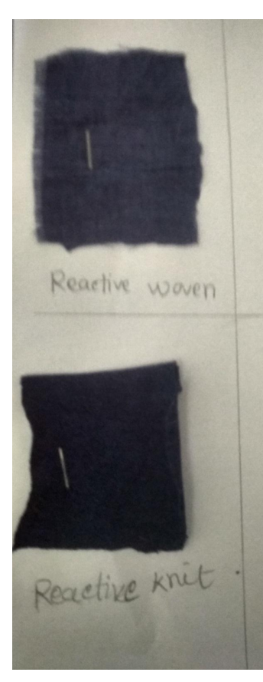
3.7.2 Dyed fabric reactive dye with reactive dye woven fabric and knit fabric (Dark shade):

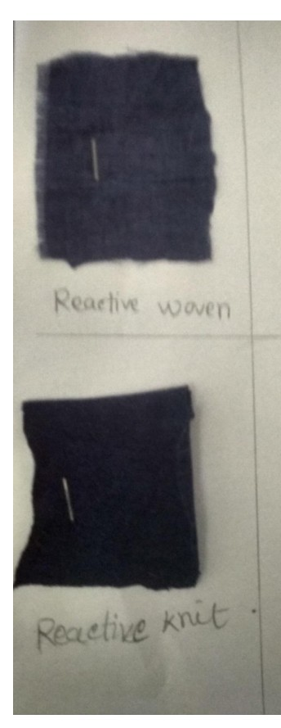
Fig. Reactive woven fabric

Fig. Reactive Knit fabric

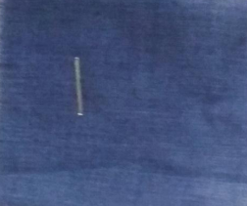

Fig. Reactive woven fabric

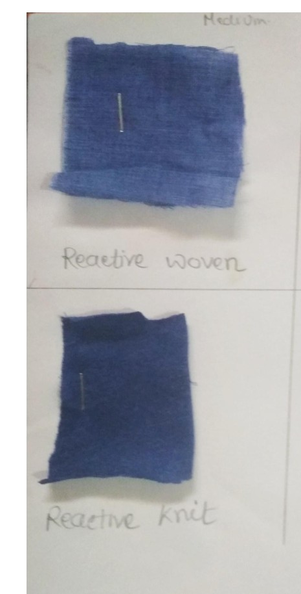

Fig. Reactive Knit fabric

3.7.3 Fastness to Perspiration
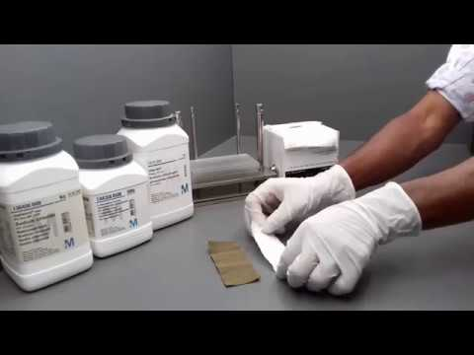
Fig 3.3: Fastness to Perspiration
Specimens of the size 10×4 cm were cut. The multi-fiber adjacent fabric of the size equal to the test specimens was attached by sewing specimens along one of the shorter sides with the multi-fiber fabric to prepare composite test specimens.
For acid perspiration test, the solution containing the following ingredients was prepared:
l-Histidine mono-hydrochloride | : | 0.5g
mono-hydrate(C₆H₉O₂N₃HCl.H₂O) | : | 5.0g
Sodium chloride (NaCl) | : | 5.0g
Disodiumhydrogen orthophosphate | : | 2.2g
(Na₂HPO_{4.}2H₂O) | : | 1000 mL
Distilled water | : | 1000 mL
pH (adjusted by NaOH) | : | 5.5

The composite test specimen was wetted in the above-mentioned acid perspiration test solution at room temperature for 30 min, maintaining the fabric-to-liquor ratio at 1:50. Excess solution was poured off and this composite test specimen was placed between two glass plates under a pressure of 5 kg and then heated in an oven for 4 h at 37 ± 2°C. The specimen was then removed and dried in open air. The contrast between the treated and the untreated samples was compared with the grey scale and staining of color on a adjacent multi-fiber fabric with the staining grey scale

3.7.4 Fastness to Washing

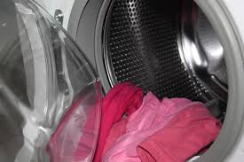
Fig 3.4: Fastness to washing

The fabric (10×4 cm) was sewed along all four edges with the same size of multi -fiber fabric. The composite specimen was washed in a washcator (washing vessel) at 50, 70 and 90° C for 30 min using the detergent solution (5 g/L) with 10 steel ball, maintaining the fabric- to-liquor ratio at 1:50. The change in color of the specimen and the staining of the adjacent fabric were assessed by grey scale
3.7.4.1 Fastness to Chlorinated Water
The separate specimens (each 10×4 cm) were put into steel containers and then sodium hypochlorite solution containing 100, 50 and 20 mg of active chlorine was added at 7.5 pH and 1:100 fabric -to-liquor ratio. In each test, the closed container was put into the mechanical device (Gyro wash) and agitated at 27 ± 2°C for 1 h in dark. Then the specimen was removed, squeezed and air dried at room temperature. The change in color of the specimen was assessed with the grey scale.¹⁹

3.7.5 Rubbing Fastness:
Rubbing fastness is one among the foremost important test within the color fastness of textile, meaning degree of fading after friction. This test is meant to work out the degree of color which is transferred from the color fabric to the test cloth.

3.7.6 Principal:
Sample of textile is rubbed with dry rubbing cloth and with wet rubbing cloth by rubbing
finger. The staining of rubbing cloth is assessed with grey scale for staining. The procedure
followed by (ISO-105-X12)

3.7.7 Types of rubbing fastness:
 Dry Rub
 Wet rub
3.7.8 Apparatus Need:
 Crock meter
 Grey scale for staining

3.7.9 Procedure:
- The test sample (15Cm×5Cm)is placed on the crock meter
- A square of white test fabric (5cm×5cm) that's de sized, bleached but without finish cotton fabric is taken for test
- Test cloth attached to the finger of crock meter.
- This finger is employed in rubbing action on the sample specimen.
- Rubbing is completed to and fro, 10 cycle at 10 second, figure pressure on the specimen is 9 N.
- Rubbing is completed both warp and weft way of the a sample
- For dry and wet rubbing test separate sample is employed
- For wet rubbing M: L ratio maintain 1:50, after wetting fabric is squeezed.
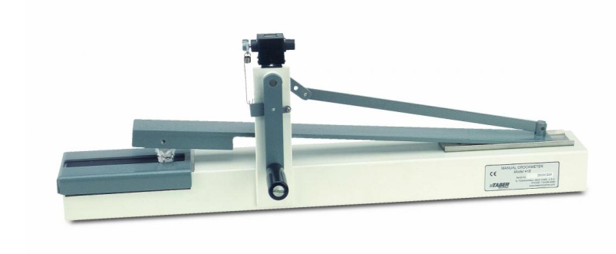
Fig 3.3: crock meter

3.7.10 Assessment technique:
- The tested sample is compared with dyed sample and under light box using D65 light and rated by the assistance of color change gray scale.
- The Dry rubbed crock cloth also visually assessed under light box with D65 light and rated with the assistance of color staining gray scale.
- In case of wet rubbed cloth initially it assessed after drying the crock cloth the procedure was same as dry rubbed crock cloth
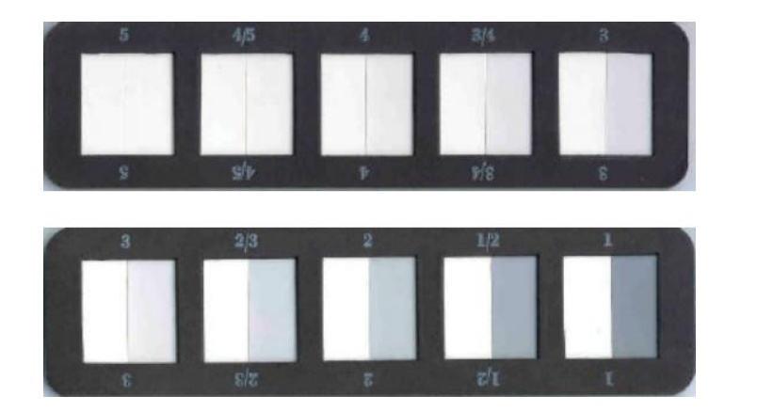
Fig3.4: grey scale

Chapter 4
Result and discussion

4.1 Data analysis and Finding

4.2 Assessment of Fastness to Perspiration for cotton fabric
Table4.1 Fastness to Perspiration for cotton fabric

 | Fastness to perspiration (acid)
Shade | 4-3 | Light red | 5-4 | Yellow
Staining | 4 | Slightly light red | 4 | Slightly light yellow

4.3 Assessment of Fastness to Washing for cotton fabric
Table4.2 Fastness to Washing for cotton fabric

Washing temp., °C |  | Fastness to washing
50 | 5 | Bright red | 5 | Bright yellow
70 | 5-4 | Red | 5 | Bright yellow
90 | 4 | Slightly light red | 5-4 | Yellow

4.4 Assessment of rubbing fastness to rubbing for woven and knit fabric
Table4.3 color fastness to rubbing for light shade
Sample | Shade | Color staining for woven fabric (light shade)
Sample | Shade | Reactive | Reactive
Sample | Shade | Dry conditions | Wet conditions
01 | 0.25% | 4/5 | 4
02 | 0.25% | 4/5 | 4
03 | 0.25% | 4/5 | 4

Table4.4: color fastness to rubbing medium shade woven fabric

Sample | Shade | Color staining for woven fabric (medium shade)
Sample | Shade | Reactive | Reactive
Sample | Shade | Dry conditions | Wet conditions
01 | 1% | 4/5 | 4
02 | 1% | 4/5 | 4
03 | 1% | 4/5 | 4

Table 4.5: color fastness to rubbing dark shade woven fabric

Sample | Shade | Color staining for woven fabric (dark shade)
Sample | Shade | Reactive | Reactive
Sample | Shade | Dry conditions | Wet conditions
01 | 2% | 4 | 3
02 | 2% | 4 | 3
03 | 2% | 4 | 3

Table 4.6: Assessment for rubbing fastness of knit fabric (light shade)

Sample | Shade | Color staining for knit fabric (light shade)
Sample | Shade | Reactive | Reactive
Sample | Shade | Dry conditions | Wet conditions
01 | 0.25% | 4/5 | 4
02 | 0.25% | 4/5 | 4
03 | 0.25% | 4/5 | 4

Table 4.7: Assessment for rubbing fastness for medium shade
Sample | Shade | Color staining for woven fabric (light shade)
Sample | Shade | Reactive | Reactive
Sample | Shade | Dry conditions | Wet conditions
01 | 1% | 4/5 | ^{3/4}
02 | 1% | 4/5 | ¾
03 | 1% | 4/5 | ^{3/4}

Table 4.8: Rubbing fastness for dark shade

Sample | Shade | Color staining for knit fabric (light shade)
Sample | Shade | Reactive | Reactive
Sample | Shade | Dry conditions | Wet conditions
01 | 2% | 3/4 | 3
02 | 2% | 3/4 | 3
03 | 2% | 3/4 | 3

4.5 Comparisons between rubbing fastness of reactive
Table 4.9: comparison of rubbing fastness between reactive dyes

Color Staining for women fabric |  |  | Color staining for knit fabric
Shade | Reactive dry | Reactive wet | Reactive dry | Reactive wet
Light | 4/5 | 4 | 4/5 | 4
Medium | 4/5 | 4 | 4 | 3/4
Dark | 4 | 3 | 3/4 | 3

4.6 Result in chart of rubbing fastness of reactive dye (Woven fabric)

Graph 4.1: Rubbing fastness result of reactive dye of woven and knit (dry and wet)

A comparison rubbing fastness of woven fabric dyed with re-active dye and that with
is shown in graph 4.1. It can be noticed that both dry and wet rubbing fastness are poor in comparison to reactive.

4.7 Result in chart of rubbing fastness of reactive dye (Knit fabric)

Graph 4.2: Rubbing fastness result of reactive dye of woven (dry and wet)

A comparison of rubbing fastness of knit fabric dyed with re-active dye shown in graph 4.2. It can be noticed that both dry and wet rubbing fastness of comparison to reactive dye

4.8 Assessment of color fastness to washing for woven and knit fabric
Table 4.10 Color fastness to washing for light shade (0.25%)

Sample | Shade | Color staining for woven & knit fabric light shade (0.25%)
Sample | Shade | Reactive (Woven) | Reactive (Knit)
01 | 0.25% | 4 | ¾
02 | 0.25% | 4 | ¾
03 | 0.25% | 4 | ¾

Table 4.11 Color fastness to washing for medium shade (1%)
Sample | Shade | Color stating for woven & knit fabric medium shade (0.75%)
Sample | Shade | Reactive (Woven) | Reactive (Knit)
01 | 1% | ¾ | 3
02 | 1% | ¾ | 3
03 | 1% | ¾ | 3

Table 4.12.Color fastness to washing for dark shade ( 2%)

Sample | Shade | Color staining for woven & knit fabric dark shade (2%)
Sample | Shade | Reactive (Woven) | Reactive (Knit)
01 | 2% | 3 | 2/3
02 | 2% | 3 | 2/3
03 | 2% | 3 | 2/3

Table: 4.12.1: Color fastness to washing for light shade (0.25%)

Sample | Shade | Color changing for woven & knit fabric light shade (0.25%)
Sample | Shade | Reactive (Woven) | Reactive (Knit)
01 | 0.25% | 4/5 | 4
02 | 0.25% | 4/5 | 4
03 | 0.25% | 4/5 | 4

Table 4.12.2: Color fastness to washing for medium shade (1%)

Sample | Shade | Color changing for woven & knit fabric medium shade (1%)
Sample | Shade | Reactive (Woven) | Reactive (Knit)
01 | 1% | 4 | 3
02 | 1% | 4 | 3
03 | 1% | 4 | 3

Table 4.12.3 Color fastness to washing for dark shade (2%)

Sample | Shade | Color changing for woven & knit fabric medium shade (2%)
Sample | Shade | Reactive (Woven) | Reactive (Knit)
01 | 2% | 4 | 2/3
02 | 2% | 4 | 2/3
03 | 2% | 4 | 2/3

4.9Dyeing Jute Fiber with Reactive Dye after Treating with Chitosan
Dye exhaustion may define as the leaving of a dye from
Table 4.13.1 Table Test fabric coding.

Test fabric type | Code
Normal fabric without any chitosan treatment | U
Fabric treated with 0.5% Chitosan solution | A
Fabric treated with 1% Chitosan solution | B
Fabric treated with 2% Chitosan solution | C
Fabric treated with 3% Chitosan solution | D
Fabric treated with 4% Chitosan solution | E

Table 4.13.2 Recipe for 1.0% (on the weight of fabric) shade without treatment the fabric with chitosan.
Ingredients Dyes (%) Salt g/l |  |  | Soda | Wetting | Leveling | M:L*
 |  |  | ash g/l | agent g/l | agent g/l
Amount | 1.0 | 20.0 | 8.0 | 1.0 | 1.0 | 1:30

Table 4.13.3 Recipe for 1.0% (on the weight of fabric) shade treating the fabric with chitosan.
Ingredients | Sample-1 | Sample-2 | Sample-3 | Sample-4 | Sample-5
Chitosan (%) | 0.5 | 1.0 | 2.0 | 3.0 | 4.0
Dyes (%) | 1.0 | 1.0 | 1.0 | 1.0 | 1.0
Soda ash (g/l) | 8.0 | 8.0 | 8.0 | 8.0 | 8.0
Salt (g/l) | 20.0 | 20.0 | 20.0 | 20.0 | 20.0
Wetting Agent (g/l) | 1.0 | 1.0 | 1.0 | 1.0 | 1.0
Leveling Agent (g/l) | 1.0 | 1.0 | 1.0 | 1.0 | 1.0
M:L* | 1:30 | 1:30 | 1:30 | 1:30 | 1:30

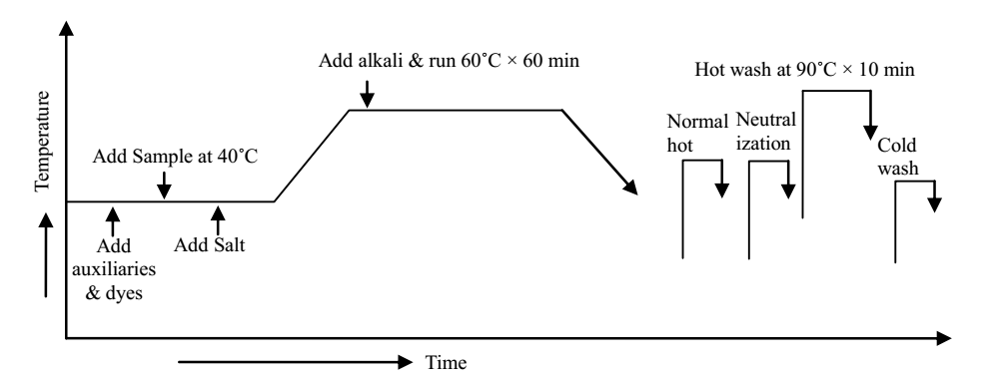
Figure 4.13.1 Dyeing scheme.

Chapter 5
Conclusion

5.1 Conclusion
In our research we used 100% Cotton, viscose & jute fabric with reactive dye to watch the rating of color fastness to rubbing, color fastness to washing &color fastness to perspiration. We've found that color fastness to rubbing and color fastness to scrub is best in reactive dye. Some information are given below.
1. just in case of rubbing fastness of woven dyed fabric with reactive: In light, medium and dark shade the rubbing fastness of reactive dyed fabric dry condition(4/5,4/5,4) and wet condition(4,4,3) which show that rubbing fastness of reactive dyed fabric is best just in case of reactive dye the dye create chemical bond with fabric.
2. just in case of rubbing fastness of knit dyed fabric with reactive: In light, medium and dark shade the rubbing fastness of reactive dyed fabric dry condition(4/5,4,3/4) and wet condition(4,3/4,3) that rubbing fastness of reactive dyed fabric is best .
3. just in case of wash fastness of woven& knit dyed fabric with reactive:
In light, medium and dark shade the Wash fastness of reactive dyed woven fabric (4,3/4/5,3) and reactive dyed knit fabric(3/4,3,2/3) that wash fastness of reactive dyed fabric is best .

References:
Books and Journals
Bledzki A K & Gassan J, Handbook of Engineering Polymeric Materials, edited by N P Charamwasinoff (Marcel Dekker Inc., New Jersey) 1997, 787.
M. Lewin, “Handbook of Fiber Chemistry,” 3rd Edition, Taylor & Francis, New York, 2010.
H. Q. Yu, M. Dang and C. W. Yu, “A Preliminary Study on Chemical Degumming of Jute and Kenaf Fibers,”
Plant Fiber and Products, Vol. 25, No. 1, 2003, pp. 190-192.
P. Ghosh, A. K. Samanta and G. Basu, “Effect of Selective Chemical Treatments of Jute Fiber on Textile-Related Properties and Processible,” Indian Journal of Fibers &Textile Research, Vol. 29, No. 1, 2004, pp. 85-89.
W.-M. Wang, Z.-S. Cai and J.-Y. Yu, “Study on the Chemical Modification Process of Jute Fiber,” Journal of Engineered Fibers and Fabrics, Vol. 3, No. 2, 2008, pp. 1-
E. P. G. Gohl and L. D. Vilensky, “Textile Science,” 2nd Edition, Longman Cheshire, New Delhi, 1983.
V. A. Shenai, “Chemistry of Dyes and Principles of Dyeing,” 4th Edition, Sevak, Mumbai, Vol. 2, 1983.
S. Houshyar and S. H. Amirshahi, “Treatment of Cotton with Chitosan and Its Effect on Dyeability with Reactive Dyes,” Iranian Polymer Journal, Vol. 11, No. 5, 2002, pp. 295-302
Textile Dyeing and coloration
Textile color fastness property
Dr.V.A shenal:technology of textile processing vol-2
International Standard WASO 105 E04: 1994.
International Standard WASO 105 E02: 1994.
Cocket S R & Hilton K A, Dyeing of Cellulosic Fibre and Related Processes (Leonard Hill books Ltd. London), 1961, 212.

 https://en.wikipedia.org.//reactive
 http://www.iso.org/standard/3803.html
 https://textileapex.blogspot.com

