
Internship Report On Financial Performance Analysis of Grameen Bank
Submitted To Dr. Md. Abdur Rouf Associate Professor Department of Business Administration Faculty of Business & Entrepreneurship Daffodil International University

Submitted By Ashraful Islam ID: 172-11-5582 Program: BBA Major in Finance Department of Business Administration Faculty of Business & Entrepreneurship Daffodil International University

Date of Submission:
Letter of Transmittal
February, 2021 Dr. Md. Abdur Rouf Associate Professor Department of Business Administration Faculty of Business & Entrepreneurship Daffodil International University
Subject: Submission of the Internship Report on ‘‘Financial Performance Analysis of Grameen Bank’’.
Dear Sir,
I respectfully asked to submit my internship report on ‘‘Financial Performance Analysis of Grameen Bank’’. This is a necessary requirement for complete my BBA program. I gave every effort to work sincerely and make this report informative. I started my internship program from 25th October to 24th January, 2021 under international program department at Grameen Bank.
The reports I have done enhanced my practical and general knowledge about Grameen Bank with micro credit financial activities and also create my job or corporate level knowledge that may help me in future. I hope that the report will be able to fulfil your expectations too.
I have worked sincerely to make this report informative and as precise as possible. I thank you for the unique opportunity to work on this report.
Sincerely,
..........................
Ashraful Islam ID: 172-11-5582 Program: BBA Major in Finance Department of Business Administration Faculty of Business & Entrepreneurship Daffodil International University
Certificate of the Supervisor
This is to confirm that Ashraful Islam, ID: 172-11-5582, a student of Department of Business Administration of Daffodil International University completed the internship report titled ‘‘Financial Performance Analysis of Grameen Bank’’ under my supervision. I am satisfied to express that he has worked hard to complete this report. The information and discoveries introduced in the report appear to be legitimate.
I wish his every success in life.

........................................
Dr. Md. Abdur Rouf Associate Professor Department of Business Administration Faculty of Business & Entrepreneurship Daffodil International University

Acknowledgement
At first, thanks the almighty Allah for my life and knowledge. He has given me the strength and all the benefits to live in this world.
My first and greatest indebtedness is to my respectable teacher & internship instructor Dr. Md. Abdur Rouf, Associate Professor, Daffodil International University for his guidance in carrying out of my intern report. I can humbly tell that without his meticulous care, valuable suggestion and instruction it would not have been possible for me to complete the report. He has continuously & properly guided me and timely direction & sincere cooperation helped me a lot to design & organize this report. His valuable opinion on the topic enriched my knowledge to carry out research and portray the information in a logical sequence.
I would also like to thank Md. Humayun Kabir coordinator, Grameen Bank, Head office, for his continuous support & inspiration regarding completion my internship report.
I want to thank to those people who were helped me and upheld for creation of this report.

Executive Summary
The report is based on an analysis of Grameen Bank financial statements. In this report, the results are based on the criteria in the analysis in which we have identified the simple measurements, the sample values, the cost comparison, the results obtained benefit etc. In this report, we analyze the revenue from Grameen Bank from 2016 to 2020. The main activities of the bank are divided into two sections called deposits and loans. The main purpose of the bank is collecting the remaining funds and submits the funds to the grievance committee. So, from fundraising, I find that they work very well Compare all the private and government funds in Bangladesh with the existing ones. They have raised 208,022 million taka as investment by 2020 and it is still growing day by day. But, unfortunately, saving is a change in financial education. They also have to run other changes and have to use the money they save and lend to customers so that they can make money, which is the goal or end of any organization. business. So in order to generate income and engage with more rich people, they need to borrow money and get more income. Moreover, their performance in some areas we have mentioned before and we have discussed them in detail in this report, and in some areas their performance is not good. , as stated in this report. In the end, I hope they do well next year.

Table of Contents
Chapter name | Contents | Page no
 | Cover page | i
 | Letter of Transmittal | ii
 | Certificate of the Supervisor | iii
 | Acknowledgement | iv
 | Executive Summary | v
Chapter-01 Introduction | 1.1Introduction | 02
Chapter-01 Introduction | 1.2Origin of the study | 02
Chapter-01 Introduction | 1.3Objective of the study | 02
Chapter-01 Introduction | 1.4Methodology of Data | 02-03
Chapter-01 Introduction | 1.5Limitation of the study | 03
Chapter- 02 Overview of the Organization | 2.1 Historical Background | 05
Chapter- 02 Overview of the Organization | 2.2 Mission of Grameen Bank | 05
Chapter- 02 Overview of the Organization | 2.3 Vision of Grameen Bank | 05
Chapter- 02 Overview of the Organization | 2.4 Principles of Grameen Bank | 05-06
Chapter- 02 Overview of the Organization | 2.5 Nature of Organization | 06
Chapter- 02 Overview of the Organization | 2.6 Achievements of Grameen Bank | 06
Chapter- 02 Overview of the Organization | 2.7 Grameen Bank at a Glance | 06-07
Chapter- 02 Overview of the Organization | 2.8 SWOT Analysis of GB | 08-09
Chapter- 03 Analysis and Findings | 3.1 Financial Performance Analysis | 10
Chapter- 03 Analysis and Findings | 3.2 Current Ratio | 10-11
Chapter- 03 Analysis and Findings | 3.3 Debt Ratio | 11-12
Chapter- 03 Analysis and Findings | 3.4 Total Asset Turnover Ratio | 12-13
Chapter- 03 Analysis and Findings | 3.5 Net Profit Margin | 13-14
Chapter- 03 Analysis and Findings | 3.6 Return on Asset (ROA) | 14-15
Chapter- 03 Analysis and Findings | 3.7 Return on Equity (ROE) | 15-16
Chapter- 03 Analysis and Findings | 3.8 Cost Income Ratio | 16-17
Chapter- 03 Analysis and Findings | 3.9 Major Finding | 17
Chapter- 04 Recommendations & Conclusion | Recommendations | 19
Chapter- 04 Recommendations & Conclusion | Conclusion | 20
 | References | 21

Chapter-01
Introduction

  - Introduction
This report is about Grameen Bank's Financial Performance Review. Most locals call it a rural town. The people of the highest class are the landless and the less fortunate. Bangladesh's economy depends on urban development. Grameen Bank is committed to providing good services to its clients and contributing to the GDP growth of the country throughout the economy and economy, reducing poverty, increasing the process depends on the low incomes and general health economy of the country. To complete the BBA, you must work part-time. In this work, we can build our confidence in the work of life. Work is an important part of the BBA degree; I started my work at Grameen Bank, Office, International Office, Mirpur-2, for a three month extension. This report is based on my ideas and theoretical knowledge about Grameen Bank's performance monitoring.

  - Origin of the study
The practical and professional environment is a necessary part of completing the BBA program. After completing all my BBA courses at UIU, I was required to complete my BBA program.
I started my internship in the International Programs department, headed by Grameen Bank, and my undergraduate studies took about three months. While working at Grameen Bank, I learned a lot about microfinance. These relationships helped me develop my financial skills and knowledge. I gained more knowledge and experience by going to work.

  - Objective of the study
- To Analysis the financial performance of Grameen Bank
- To Analysis the liquidity flow and debt ratio of Grameen Bank in loan sector
- To find out the profitability by activity ratio of Grameen Bank from different sector

  - Methodology of Data
Two sources of Data collection
Primary Sources
- Face to face conversation with employee
- Face to face interview with supervisor
- Activities of Grameen Bank
- Practical knowledge or information
Secondary Sources
- Annual report of Grameen Bank
- Website of Grameen Bank
- Previous report of online
- Online reports, journals, Books, Magazine etc

  - Limitation of the study
- Some record are not available
- In some cases, interviewed staff members do not respond well
- Some records are not written correctly due to their security concerns.
- All information was not collected
- The dissatisfaction of the busy people, the collection of important information was difficult
- Time limitation

Chapter- 02
Overview of the Organization

2.1 Historical Background
October 2, 1983 This company was transformed into an external bank by the government of Bangladesh. As a result of this established business, the bank is starting to have strong demand from foreigners around the world who want to learn more about Grameen Bank's operations as well as meet its employees and consumers.
Due to strong foreign demand, Grameen Bank's headquarters have developed an “international curriculum. Initially, this training was intended for foreigners to enjoy research on banking operations and consequences, Small loans according to international standards. 1987 The manager started working in the Grameen Bank training program.
With the implementation of Grameen microcredit standards for the development of the global platform, the curiosity and need for this new process has shifted away from standard research and policy. To meet the growing educational needs of the global community, Grameen Bank established the Office of International Education.
Since its inception, the Global Office has carefully developed the curriculum available to anyone who wants to not only deepen their knowledge of how Grameen Bank works but also to spread new ideas, ideas and innovations to the world. The International Office now provides information on the structure of Grameen key courses, job presentations, international workshops, research, internships, conferences and news.
2.2 Mission of Grameen Bank
By providing comprehensive financial services, empowering the poor to realize their potential and break out of the vicious cycle of poverty.
2.3 Vision of Grameen Bank
Banking for poor
2.4 Principles of Grameen Bank
Four principles of Grameen Bank are,
- Discipline
- Unity
- Courage
- Hard Work
2.5 Nature of Organization
Grameen Bank is about more than just a bank. It is a separate independent bank. Although Grameen Bank policy states that it is not a full bank or NGO. There are differences in features. In fact, it is different from other banks and acts as an NGO.
2.6 Achievements of Grameen Bank
- SWITZERLAND: Aga khan Award for Architecture-1989
- BELGIUM: King Baudouin International Development Prize-1993
- BANGLADESH: Independence Day Award-1994
- MALAYSIA: Tun Abdul Razak Award-1994
- UNITED KINDOM: World Habitat Award-1997
- INDIA: Gandhi Peace Prize-2000
- U.S.A: Petersburg Prize-2004
- NORWAY: Nobel Peace Prize- 2006
- MCCI Award
- ICMAB Awards 2015
2.7 Grameen Bank at a Glance
Name of the Company | GRAMEEN BANK
Founder | Prof. Muhammad Yunus
Chairman | Prof. Muzammelhaque
Acting Managing Director | Ratan Kumar Nag
Date of Inauguration | In October, 1983
Number of Branches | 2568
Number of Employees | 22000
Number of Members | 7.07 million US $
Registered Office | Grameen Bank Bhaban, Mirpure-2, Dhaka-1216
Authorized Capital | 10000000000
Paid up Capital | 734049100
Phone | +88029031138, +88029007596
Fax | +88029033559
E-mail | giprog@grameen.com
Website | www.grameen.com

2.8 SWOT Analysis of GB
Strengths
- Nobel prize winner
- High payback rates
- Outstanding Market Share
- Solidarity Lending
- Women empowerment
- Community development

Weakness
- Rural are people negative thought
- Loan recovery system
- Job dissatisfaction
- Clash in rural families
- Opposition from traditional society
- Money supply shortage
Opportunities
- Banking consultancy service for poor
- Exploration in other services
- Lack of awareness
- Untapped & unbanked rural population
Threats
- Local money lenders( Changing high rate of interest)
- New entrance into the market
- Greater conflict & power imbalance in orthodox families
- Higher level of violence towards female recipients of Grameen Bank

Chapter- 03
Analysis and Findings

3.1 Financial Performance Analysis
Grameen Bank's financial analysis often measures its performance in the business and generates revenue. They measure how their bank can use their assets and make the most of their assets. Financial analysis measures Grameen Company Financial Institutions overall over time. Grameen Bank meets with its subsidiaries Asa Bank and other small lenders. Grameen Bank financially evaluates its financial performance, stability and capital of the Bank. The financial analysis of Grameen Bank is led by experts of its relationship using reports that use information from their balance sheets and other financial statements. Performance measurement measures are provided help seniors manage to make decisions for the future. This assessment measures or clarifies the role of the organization. Financial analysis is the interpretation of Grameen Bank balances and earnings information. Here is the relationship and mediation balance sheet and measure income.
3.2 Current Ratio
It shows that the investor can repay his debts with his current assets. The higher the current ratio, the better the smooth conductivity of the fixed surface,
Current ratio= Total current asset/Total current liabilities
Year | 2020 | 2019 | 2018 | 2017 | 2016
Current ratio | 1.44 | 1.47 | 1.56 | 1.37 | 1.49

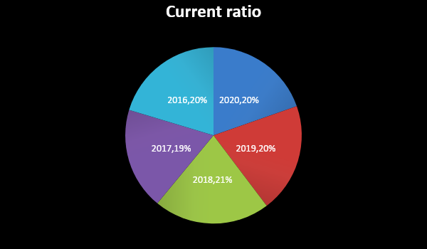
The higher the current ratio, the greater it is liquid. The chart shows that the current statement of Grameen Bank changes from year to year
3.3 Debt Ratio
Debt projects identify other people's money used to make a profit. In general, the greater the debt used by Grameen Bank in relation to its total assets, the greater the value of the profit.
Debt settlement measures the share of a paying company's total investment income. The higher the ratio, the more the other person will spend to make a profit.
The formula of Debt ratio,
Debt ratio= (Total liabilities/ Total assets) x 100
Year | 2020 | 2019 | 2018 | 2017 | 2016
Total Liabilities | 225330 | 217015 | 209658 | 190318 | 168542
Total Assets | 239619 | 229360 | 220885 | 200961 | 178936
Debt Ratio (%) | 94.04 | 94.62 | 94.92 | 94.70 | 94.19

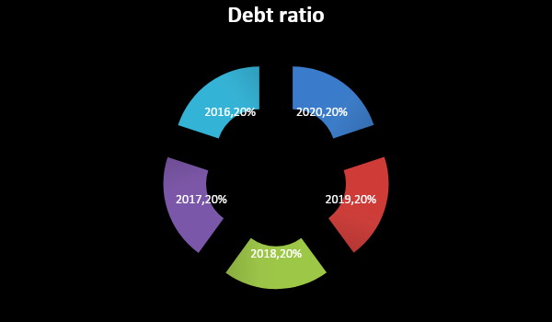
The debt ratio GDP measures a company's financial leverage. The chart shows a fluctuating trend in the GB debt ratio GDP ratio. However, the debt ratio GDP ratio decreased from 94.19% in 2016 to 94.04% in 2020.
3.4 Total Asset Turnover Ratio
All asset exchanges have highlighted the success of Grameen Bank, that the company could use its assets to generate sales. But for banks, we choose other ways of earning more money than sales.
The formula of Total asset turnover,
Total Asset Turnover= Operating income/Total asset
Year | 2020 | 2019 | 2018 | 2017 | 2016
Total Operating income | 19315 | 16935 | 15330 | 14015 | 13579
Total asset | 239619 | 229360 | 220885 | 200961 | 178936
Total asset Turnover | 8.06 | 7.38 | 6.94 | 6.97 | 7.59

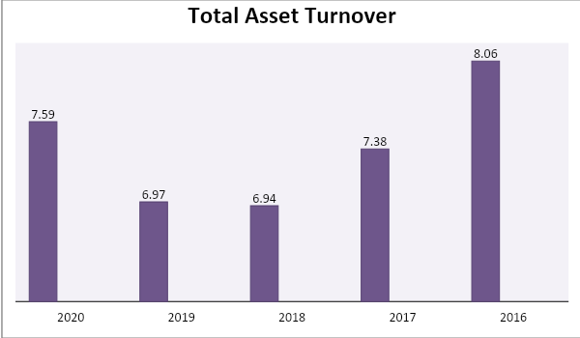
Total asset turnover replacement is the operation of Grameen Bank, in which the company can use all of its capital to generate revenue. The graph shows that each GB value over the past five years has changed. However, total assets increased from 7.59 in 2016 to 8.06 in 2020.
3.5 Net Profit Margin
Earnings actually measure the percentage of income after all expenses, including taxes, are deducted. The higher the profit margin, the better the company.
The formula of net profit margin,
Net Profit Margin= (Net profit after tax/ Net sales or operating income) x 100
Year | 2020 | 2019 | 2018 | 2017 | 2016
Net profit after tax | 2275 | 1392 | 24 | 436 | 1332
Net sales | 19315 | 16935 | 15330 | 14015 | 13579
Net Profit Margin (%) | 11.78 | 8.22 | 0.16 | 3.11 | 9.81
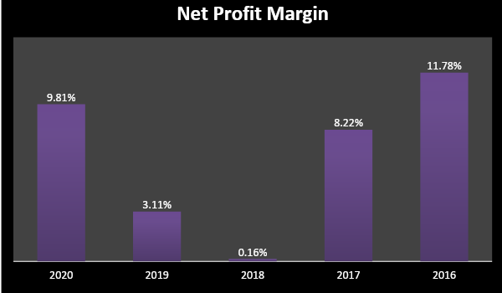
The graph shows that GB's gross profit margin changes every year. The high interest rate decreased from 9.81% in 2016 to 0.16% in 2018. However, interest income increased from 0.16% in 2018 to 8.22% in 2019.
3.6 Return on Asset (ROA)
Return on asset Grameen Bank provides an idea of how the bank's income can be used to make a profit. Return on assets is calculated by dividing annual income by total assets.
The formula of ROA
ROA= (Net profit after tax/ Total asset) x 100
Year | 2020 | 2019 | 2018 | 2017 | 2016
Net profit after tax | 2275 | 1392 | 24 | 436 | 1332
Total asset | 239619 | 229360 | 220885 | 200961 | 178936
Return on asset (%) | 0.95 | 0.61 | 0.01 | 0.22 | 0.74

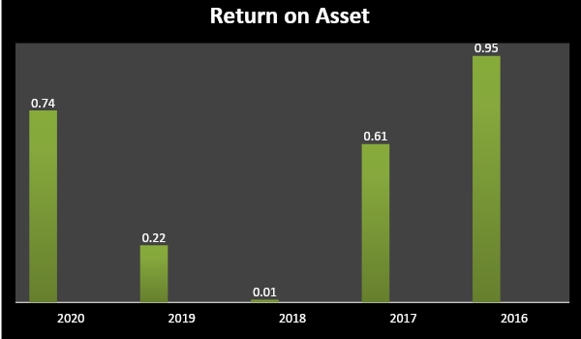
The impact on heritage has changed over the years. The profitability of the property was the highest in 2020, at 0.95%. However, the return on assets decreased from 0.74% in 2016 to 0.01% in 2018.
3.7 Return on Equity (ROE)
The return on Equity at the same cost is measured by the value of the participant's contribution, how much he earns. And how much capital contributes.
The formula of ROE
ROE= (Net profit after tax/ Shareholders equity) x 100
Year | 2020 | 2019 | 2018 | 2017 | 2016
Net profit after tax | 2275 | 1392 | 24 | 436 | 1332
Shareholder’s equity | 14288 | 12345 | 11227 | 10642 | 10394
ROE (%) | 15.92 | 11.28 | 0.21 | 4.10 | 12.81

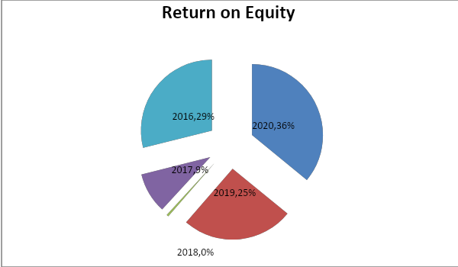
The return on equity ratio has fluctuated over the years. The return on assets was the highest in 2020, with 15.92%. However, the return on assets decreased from 12.81% in 2016 to 0.21% in 2018.
3.8 Cost Income Ratio
The cost income ratio (CIR) or income tax rate is the relationship between income and the cost of receiving income. The lower the CIR interest rate, the better the savings.
The formula of cost income ratio,
Cost Income Ratio = (Total operating expenses/Total operating income) x 100
Year | 2020 | 2019 | 2018 | 2017 | 2016
Total operating expenses | 14421 | 13552 | 10111 | 8808 | 8134
Total operating income | 19315 | 16935 | 15330 | 14015 | 13579
Cost Income Ratio (%) | 74.66 | 80.02 | 65.96 | 62.85 | 59.90

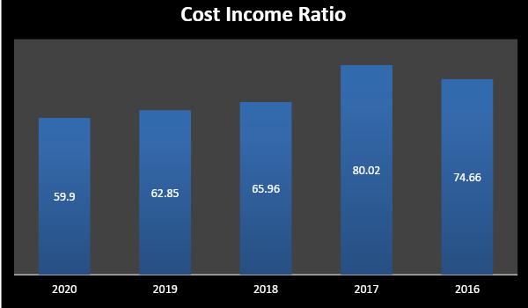
The value model as a measure of the efficiency of debt management. The chart shows that Grameen Bank's value-added earnings are positive for that year. However, the sampling rate increased from 59.9% in 2016 to 74.66% by 2020. This indicates that the bank did not have enough money to reduce its value relative to income.
3.9 Major Finding
Financial analysis of Grameen Bank reveals the following major findings:
- The current Grameen Bank ration has fluctuated over the years. However, the company's current ratio is 1.49 in 2016 to 1.44 in 2020
- GRAMEEN BANK reduced its leverage by reducing its debt ratio from 94.19% in 2016 to 94.04% in 2020
- Total operating income increased from 7.59 in 2016 to 8.06 in 2020.
- Return on assets and return on assets may change from the valuation year.
- The cost income ratio of Grameen Bank increased 59.9% in 2016 to 74.66% in 2020.

Chapter- 04
Recommendations & Conclusion

Recommendations
The following recommendations can be developed to improve the financial performance of GRAMEEN BANK.
- A gradual change in the current ratio will increase the risk of the investment company. Therefore, the bank can increase its current capital to expand its current ratio, taking into account the comparison of the revenue trend.
- The bank must reduce the value of the funds to have an assumption of unemployment.
- Grameen Bank needs to reduce operating costs to reduce revenue

Conclusion
Bank savings for the poor cannot be guaranteed worldwide It micro-credit a story. No other bank provides access to the poor. Grameen Bank and only Grameem Bank have turned it into reality. There is no liquidity problem. It has more current assets than current expenses. So there is no fate without forgiveness. There is no financial risk. This study shows that a bank uses its assets well to generate revenue. Its path to change has increased significantly in recent years. Price management is an important part of the bank. Managing the cost, the bank has not done enough. The value-added indicator shows that the cost of bank loans has increased over the years. Leaders can do better in this area. As for income, the study found that in 2018, banks had the lowest income interest rate, which is 0.16%. For the next two years he jumped. It is 8.22% in 2019 and 11.78% in 2020. It shows that the last two years the bank has been successful. The return on assets and returns on inventories also have the same impact as on income. Both were lowest in 2018 and then jumped in 2019 and 2020. This is because they all have an impact on post-tax earnings. As post-tax revenues increase in 2019 and 2020, ROA and ROE increase. It shows that the bank has done better in the last two years compared to previous years.

References
- http://www.grameen.com/
- https://en.wikipedia.org/wiki/Grameen_Bank
- Prospectus of GRAMEEN BANK
- GITMAN, L.J. (2013), “Principles of Management Finance”, 12 th Edition
- GRAMEEN BANK Annual Report.

