SMART AUDITORIUM WITH SECURITY SYSTEM

by
Md. Amir Hossen
ID: 173-15-1702

Most. Mahfuja Aktar
ID: 173-15-1633

This Report Presented in Partial Fulfillment of the Requirements for the Degree of Bachelor of Science in Computer Science and Engineering.

Supervised By

Dr. S. M. Aminul Haque
Associate Professor
Department of CSE
Daffodil International University

Co-Supervised By

Ms. Zarintasnim Shejuti
Lecturer
Department of CSE
Daffodil International University



DAFFODIL INTERNATIONAL UNIVERSITY
Dhaka, Bangladesh
14th JANUARY 2021

APPROVAL
This Project titled “Smart Auditorium with Security System”, submitted by Md.Amir Hossen, Most. Mahfuja Aktar to the Department of Computer Science and Engineering, Daffodil International University, has been accepted as satisfactory for the partial fulfillment of the requirements for the degree of B.Sc. in Computer Science and Engineering and approved as to its style and contents. The presentation has been held on 5 Dec, 2020.

Board of Examiners

Dr. Touhid Bhuiyan Chairman
Professor and Head
Department of CSE
Faculty of Science & Information Technology
Daffodil International University

Dr. S. M. Aminul Haque Internal Examiner
Associate Professor and Associate Head
Department of CSE
Faculty of Science & Information Technology
Daffodil International University

Dr. Md. Ismail Jabiullah Internal Examiner
Professor
Department of CSE
Faculty of Science & Information Technology
Daffodil International University

Mr. Md. Reduanul Haque Internal Examiner
Lecturer (Senior Scale)
Department of CSE
Faculty of Science & Information Technology
Daffodil International University

Dr. Mohammad Shorif Uddin External Examiner
Professor
Department of CSE
Jahangirnagar University
Declaration

We hereby declare that, this project has been done by us under the supervision of Dr. S. M. Aminul Haque, Associate Professor, and Department of CSE Daffodil International University. We also declare that neither this project nor any part of this project has been submitted elsewhere for award of any degree or diploma.

Supervised by:

Dr. S. M. Aminul Haque
Associate Professor
Department of CSE
Daffodil International University

Co-Supervised by:

Ms. Zarintasnim Shejuti
Lecturer
Department of CSE
Daffodil International University

Submitted by:

Md. Amir Hossen
ID: 173-15-1702
Department of CSE
Daffodil International University

Most. Mahfuja Aktar
ID: 173-15-1633
Department of CSE
Daffodil International University
ACKNOWLEDGEMENT
First, we share our sincere thanks and appreciation to God Almighty for His divine blessing, helping us to successfully complete the final year project/internship.

We really grateful and wish our profound our indebtedness to Dr. S. M. Aminul Haque, Associate Professor, Department of CSE Daffodil International University, Dhaka. Deep Knowledge & keen interest of our supervisor in the field of “IoT and Microcontroller” to carry out this project. His endless patience ,scholarly guidance ,continual encouragement , constant and energetic supervision, constructive criticism , valuable advice ,reading many inferior draft and correcting them at all stage have made it possible to complete this project.

We would like to express our heartiest gratitude to Dr. Touhid Bhuiyan, Professor, And Head, Department of CSE, for his kind help to finish our project and also to other faculty member and the staff of CSE department of Daffodil International University.

We would like to thank entire course mate and elder brothers in Daffodil International University, who took part in this discuss while completing the course work.
Finally, our parents' continuous encouragement and patients must be remembered with proper regard.
ABSTRACT

Automation may in general be defined as a process with little to no human effort following predetermined sequential steps. Different cameras, suitable for monitoring manufacturing procedures, actuators and various techniques and instruments, are used for automation. The automation device built in this investigation is an automated lamp with an automatic fan in the intelligent auditorium. The microcontrollers are used to process all of these processes. A microcontroller uses sensors attached to it to acquire the physical conditions values. Sensors were needed to detect the LDR (Light Based Resistor) light in the automatic lamp system. During the automatic fan device, the sensors needed to detect the sensor's temperature and fire detector. Lamps and fans can operate correctly in testing. When the sun starts to darken, the lamp will automatically switch on the light will automatically switch off when the light is bright again. Moreover the reading of LDR sensors outside the room varies from the reading of LDR sensors mounted in the room. The calculation effects are different. The LDR sensor in the room blocks the strength of light obtained by the wall or by other objects. This is because and when the temperature is greater than 27°C, 28°C and the fan speed can be mounted, it can also turn on automatically for a ventilator. When the temperature is less than 27 °C, 28 °C the fan can also be automatically turned off and the sensor monitoring LCD monitor can also automatically be displayed with fire detector and visitor counter. Path light guide the audience when a person enters into auditorium the path light will guide the person into the vacant seat starting from the first row. Using IR sensor and we see the display which row are vacant or full inside the auditorium top front of the entry gate in the LCD display controlling sensor.

CONTENTS | PAGE
Approval | ii
Declaration | iii
Acknowledgements | iv
Abstract | v
Table of Content | vi
List of Figures | viii
List of Abbreviation | x
TABLE OF CONTENTS

CHAPTER 1 | INTRODUCTION | 1-3
1.1 | Introduction | 1
1.2 | Purpose of This Project | 2
1.3 | Project Scope | 3
1.4 | Problem Statement | 3
1.5 | Expected Project Out come | 3

CHAPTER 2 | OVERVIEW OF THE PROJECT | 4-8
2.1 | Introduction | 4
2.2 | Automatic Light Control | 5
2.3 | Automatic Temperature Controlled Fan Using Thermistor | 5
2.4 | Automatic. Fan Speed Control System Using Microcontroller PIC16F72 | 5
2.5 | Fire Detector | 6
2.6 | Automatic Visitor counter | 6
2.7 Metal detector 6

CHAPTER 3 | HARDWARE COMPONENT | 9-31
3.1 | Component and Accessories | 9
3.2 | Buzzer | 9
3.3 | Power supply | 10
3.4 | Voltage Regulator | 11
3.5 | Light Dependent Resistor | 11
3.6. | Resistor | 13
3.6.1 | Variable Resistor | 14
3.6.2 | Tips for Reading Resistor Code | 15
3.6.3 | Resistor Color Code Chart. | 16
3.6.4 | Four Band Resistor | 17
3.6.5 | Five Band Resistor | 17
3.7 | Capacitor | 18
3.7.1 | The Capacitance of a Capacitor. | 18
3.7.2 | Standard Units of Capacitance | 18
3.8 | Diode | 19
3.9 | LED | 19
3.9.1 | Types of Light Emitting Diodes | 20
3.10 | LCD | 20
3.11 | Battery | 21
3.11.1 | Introduction of battery | 21
3.12 | IR Transmitter | 22
3.13 | IR Receiver | 22
3.14 | Temperature Sensor | 23
3.15 | Connector | 23
3.16 | Oscillator | 24
3.16.1 | Application | 24
3.17 | OP-Amplifier | 24
3.17.1 | Application | 25
3.18 | Microcontroller | 25
3.18.1 | Programmable Integrated Circuit | 27
3.18.2 | PIC16F72 Microcontroller | 27
3.18.3 | Pin Diagram | 27
3.19 | Circuit Diagram | 29
3.20 | Block Diagram | 30
3.21 | Cost Estimate | 31

CHAPTER 4 | DSIGN AND IMPLEMENTATION | 32-33
4.1 | Design | 32

CHAPTER 5 | RESULT AND DISCUSSION | 34
5.1 | Result | 34
5.2 | Project view | 34
5.3 Discussion 34
CHAPTER 6 | CONCLUSIONS | 35
6.1 | Conclusion | 35
6.2 | Limitations of the Work | 35
6.3 | Future Scopes | 35

Reference |  | 36
Appendix A |  | 37-39

LIST OF FIGURES
Fig 2.5 | Fire Alarm System Block Diagram | 6
Fig 2.7 (a) | Metal Detector | 7
Fig 2.7 (b) | Circuit diagram of metal detector | 7
Fig 3.2 | Buzzer | 10
Fig 3.4 | Pin Diagram of IC 7805 | 11
Fig 3.5(a) | LDR | 12
Fig 3.5(b) | Symbol of LDR | 13
Fig 3.5(c) | Practical LDR | 13
Fig 3.6 | Resistor | 14
Fig 3.6.1 | Variable Resistor | 14
Fig 3.6.3 | Color code chart of Resistor | 16
Fig 3.6.4 | 4-Band Resistor Color Code | 17
Fig 3.6.5 | 5-Band Resistor Color Code | 17
Fig 3.8 | Diode | 19
Fig 3.9(a) | LED Function | 20
Fig 3.10 | LCD Display | 22
Fig 3.12 | IR Transmitter LED | 22
Fig 3.13 | IR Receiver | 22
Fig 3.14 | Temperature sensor | 23
Fig 3.15 | Connector | 24
Fig 3.17 | OP –Amplifier comparator mode working
Fig 3.18 | PIC6F72 Microcontroller Chip | 25
Fig 3.18.2 | Pin Diagram of PIC16F72 Microcontroller | 27
Fig 3.19 | Circuit Diagram | 29
Fig 3.20 | Block Diagram | 30
Fig 5.2 | Project View | 34

List of Abbreviations

DC | Direct current
AC | Alternating Current
LED | Light emitting Diode
LCD | Liquid Crystal Display
LDR | Light Dependent Resistor
nF | Nano Farad
pF | Pico Farad
mF | Micro Farad
IR | Infrared Ray

CHAPTER 1
INTRODUCTION

1.1 Introduction
The 21st century is endeavoring hard to spare electrical energy. Lights are fundamental, yet costly, accordingly there is have to advance the framework such that it is reasonable and proficiently monitors energy. Physically controlling the lights is a period taking and monotonous cycle. Working in such way could at times bring about huge fiascos and decimations. The principle issue that manual controls on the lights face is that there would be a great deal time taking during night times when they are to be turned ON and a critical misuse of energy is done at morning at all couldn't be killed together without a moment's delay. Another manner by which the wastage is done is that at midnights lights shine at full force
The “Smart auditorium with security system” The key objective of the project is to direct an individual through preferred seating arrangements separated into block and electrical equipment power. The key aim is to reduce the power waste generated when the auditorium is not complete because of unnecessary electricity supplies. It also shows the number of individuals sitting at entrance and exit doors using sensors. Only when the entry sensor detects the entry of an individual is the guiding device triggered. The LED that fits this row is permanently deleted when a single row is filled.
The principle behind this is very simple: turn the fan on when the temperature is high, and turn the fan off when the temperature is low, which increases or decreases the value of the resistance. This revolutionary approach saves much of the time and resources so it is possible to achieve a modern method of automated fan speed regulation using the temperature controls conventionally used fan speed can be controlled by using the old and burdensome system regulators. And since the temperature needs to be controlled over long time periods, this form of use becomes unreliable. Build a product or hardware that can regulate the fan speed dependent on temperature
The digital visitor counter is a trustworthy circuit which accurately accounts for the number of people/visitors. As anyone enters the room, one raises the counter, and when someone exits the room, one reduces the counter. The total number of people is shown on liquid crystal displays within the room. The microcontroller performs the above work by receiving the sensors' signals. This project consists of a microprocessor, IR and photo diode and LCD. The signal is continually generated by the IR sensor and the signal is detected by the photo diode if any barriers exist between the IR and PHOTO diode. The photo diode output is supplied to the microcontroller.
Metal indicator is set at the section of the hall to give security. In our day by day life, we have used to observe numerous locators that identify metallic gadgets like weapons, bombs and. also include fire alarming system using buzzer. The light will lead the person to the empty seat from the first row as the person enters the auditorium.

1.2 Purpose of This Project
Purpose is that the main criteria for any project, without it one would find during a maze.. Our first goal was to repair the goal when we began our project. We were drawn to this automated light control and temperature control fan, visitor countering LCD display Fire detector in a auditorium based project that contribute to the modern society there are many auditorium in Bangladesh where electricity is wasted manual ways such as the lights are on but there is no man on the other hand the fans are control by temperature. On the other side, the fans are automatic on the automated visitor counter used to count the latest visitor seen on the LCD monitor and even the fire alarm used. For fire safety and guiding the crowd from the first row on to the un-occupied line. With efficient and competitive use this project is low-cost. This device is designed to be more user-friendly and automated to run the project, and has also been designed to use minimal hardware at the lower processing level to further work vision. These systems are targeted at particular applications and are designed to rotate at a rate proportional to electricity.

1.3 Project Scope
To carry out the objectives of the project, several scopes had to be outlined. Bidirectional Guest Counter automated space lighting can be used to turn on the light in a room automatically when a person enters and switches off the light when the person exits the auditorium. The scope of this project includes the development of a smart auditorium system. It is a member of the automatic lighting system and may even be the project dubbed as a Bidirectional Visitor Counter. With LEDs, the project can be changed and the number of LEDs turning ON also changes as the number of people in the space increases. Then used an LCD screen to monitor the Temperature, visitor counting. The track light will lead the individual into the empty seat starting from the first row when a person enters the auditorium. The coding was design in microcontroller the reading of microcontroller will be compared to other monitoring system.

1.4 Problem Statement
In today's world, many establishments consist of many commercial buildings in which the light and fan of the space are not controlled automatically at all. In other words, in many buildings, manual mechanisms are used where the auditorium lighting and fans have to be turned on and off. When leaving the auditorium, a person can often fail to put off the lights and fan.

In order to control this this project investigates an automatic light and fan control system for the auditorium to mitigate the stemming problem for various organizations, enterprises and government departments. The ability to control lights and fans automatically will allow users to feel relaxed without controlling them physically. The use of automatic control here will further allow people who are sick, handicapped or aged to use such devices.

1.5 Expected Project out come
At the end of this project, suitable coding for Microcontroller can be made. Hence, the user will be able to monitor the auditorium temperature, light intensity, fire detector, and visitor counter using Microcontroller. This is an efficient program for a smart auditorium.

CHAPTER 2
OVERVIEW OF THE PROJECT

2.1 Introduction
Automatic smart auditorium Device is a project focused on the microcontroller that triggers or disables the light automatically. Fan and visitor in, visitor out, visitor present counting system also guide the audience for setting arrangement in an auditorium Electricity must be treated wisely, as one of the most valuable tools. We sometimes fail Switch off lights or fans while we're leaving an auditorium. Through using this system we would intentionally neglect the system's lights.

Automatically taking care of them. We're in the modern age live enables to use different technologies to execute those functions automatically. In many areas such as energy consumption, minimizing human efforts, raising living conditions, etc., such automation is very useful. The project introduced there is one such project that automatically controls the microcontroller-base system auditorium lighting, fans, etc. The most critical electronic equipment at home or auditorium or some other location where there is a likelihood of fire accident is a It is possible to define the fire alarm circuit as an electronic circuit used to identify fire accidents and alerts. Thus we can prevent financial damage by using the fire alarm circuit and thus rescue individuals from serious fire incidents. And we have become accustomed to witnessing many detectors in our everyday lives that detect metallic devices including Pistols, rockets, etc. Surveillance device to deter the illegal entrance of weapons and explosives into public areas. The device is created by using a proximity sensor to design different electronic projects. So a, any current metal that is nearby is detected by the metal detector. A metal detector is a metal detector that in several locations, such as theatres, shopping centers, restaurants, etc., electronic devices are used Identify any metallic items that are hidden within, such as scissors, guns or any other explosives. Baggage of a person with bad motives. Transporting them; Metal detectors like these are particularly useful to detect the existence inside artifacts of concealed things.

2.2 Automatic Light Control
The key feature The IR Sensor is part of the project and four were used. It is important to position the sensors as it decides the project's working. The sensor placed on row 1 of the auditorium is called Sensor 1 and the sensor placed on row 2 The sensor is named 2. And when an entity tries to enter the room, Sensor 1 first detects the human, and then Sensor 2 is called Sensor 3. And the sensor 3, then. This behavior shows the OP-Amplifier that is reached by the person in rows 1,2, and 3.

2.3Automatic Temperature Controlled Fan Using Thermistor
The Thermistor was used in this paper to detect the temperature. It also explained how, depending on the temperature sensor, the speed of a fan can be regulated. A type of transducer is a sensor. A transducer is often defined, in a broader context, as any system that converts from one shape to another, electricity. Furthermore the part that makes up the temperature sensor is referred to as the thermistor. Thermistor is a type of resistor dependent on temperature and depending on the temperature, the resistance varies. It may also be used to regulate the temperature of the auditorium, depending on the Thermistor property.

2.4Automatic.Fan Speed Control System Using Microcontroller PIC16F72
For the key controlling device, a Microcontroller was used. The LM35 sensor is used for temperature sensing. What one can translate and transform written instructions to electrical signals? Then the microcontroller will go through and follow these instructions One at a time. As an example of this a microcontroller can be used to monitor the speed of the fan according to the temperature of the auditorium. Rather than hard cabling a variety of logic gates together the microcontroller was used to execute certain feature use orders to electronically wire the gates. A software is called the set of those instructions given to the microcontroller.

2.5 Fire Detector
The fire alarm project is aimed at creating a thermistor-based temperature control device. By following simple steps, this simple fire alarm circuit using a thermistor can be built on your own on a solder less breadboard. It can also be treated as a mini-project fire alarm.

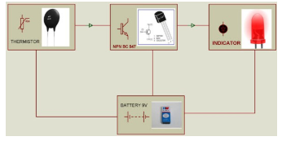

Fig 2.5: Fire Alarm System Block Diagram
2.6 Automatic Visitor counter
The digital counter may be a trustworthy circuit that correctly accounts for the amount of persons / tourists within the room. As anyone enters the space, one raises the counter, and when someone exits the space, one decreases the counter. The entire number of individuals is shown on liquid displays within the space. The microcontroller does the above role by receiving the sensors' signals. This project consists of a microcontroller, an IR and a photodiode and an LCD.IR sensor continuously emits a sign and a photodiode observes a sign if any obstacles appear between the IR and therefore the PHOTO diode, the output of the photodiode is given to the microcontroller and therefore the count value is displayed on the LCD.

2.7 Metal Detector
In our lifestyle, a security system was developed to design different electronics projects by using a proximity-sensor. We have not to see many detectors detecting metallic devices like weapons, bombs, etc. to stop any unauthorized access of weapons and bombing publicly. Therefore a metal detector is used to detect any nearby metal. A detector is an electronic device used to detect metal objects, like clothing, guns or the other explosive objects kept hidden from a person carrying them with bad intentions, in a wide range of places, such as theatres, shops, hotels, etc.; metal detectors are especially useful for the detection of hidden objects.
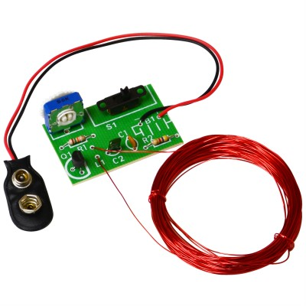

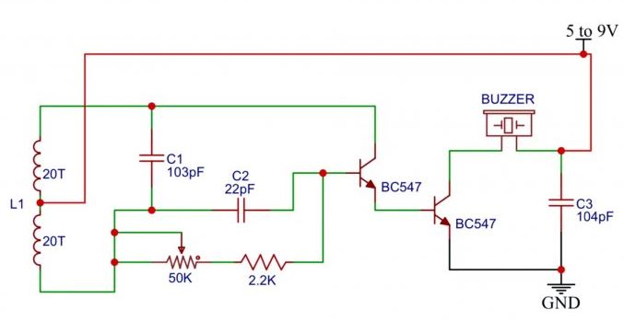
Fig.2.7 (a): Metal detector [Retrieved from: https://shop.elenco.com/consumers/metal-detector.html]

Fig.2.7: (b) Circuit diagram of metal detector
2.8 Working Explanation
The above circuit diagram is made with a single BC548 transistor and a low-cost metal detector. The ancient radio. This is just a Colpitts oscillator running with a radio to the medium band frequency to a frequency of the same. Second, the radio and the circuit are mounted close together then the radio is tuned in such a way that there’s no tone on the stereo here. In this case, the antenna and the circuit are in the same state. To produce no tone, frequency and the same frequencies beat off. Here's the setup. Now when, when, then when you position this circuit metal detector near some metal object from which you can hear a hissing sound. Your AM radio, signaling a metallic material identification. L1 is equivalent to 60 enameled turns, on a 1cm PVC tube copper wire twisted. The power source for the circuit should be a 5V battery.
Applications
- There are metal detectors in areas like airports, federal offices, office buildings, Schools and jails to keep a gun from being taken onto the grounds of someone.
- They serve a variety of functions, such as security scanning, unintended authentication, etc. The presence in food items of unwanted metallic parts.
- Industrial metal detectors are found in fields such as food, drink, textiles, clothes, Industries of chemicals, pharmaceuticals, wood, plastics, and packaging.
- They are also used for various hobbies like beachcombing, coin shooting, prospecting for valuable metals like gold and silver
CHAPTER 3
HARDWARE COMPONENT

3.1 Component and Accessories
- LCD DISPLAY
- MICROCONTROLLER PIC 16F72
- CAPACITORS
- RESISTOR
- DIODE
- BUZZER
- CONNECTOR
- AC POWER SUPPLY
- SOME WIRES
- PCB BOARD
- SWITCH
- LED
- LDR SENSOR
- IR SENSOR
- DC BATTRY
- OP-AMPLIFIER
- TEMPERATURE SENSOR

3.2 Buzzer
A buzzer or beeper may be an electronic, electromechanical or piezo-electrical sound instrument. The regular use of balls and beepers involves alarm gadgets, clocks and consumer feedback affirmations such as keystrokes or ticks.

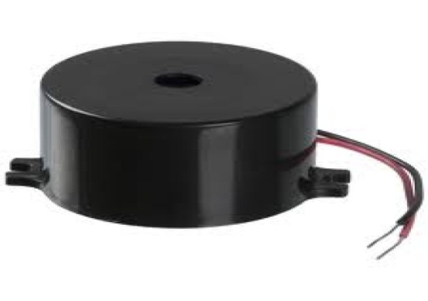

Fig.3.2: Buzzer [Retrieved from: https://potentiallabs.com/cart/buzzer]

3.3 Power Supply
Power supply is the source of energy that is taken into account. An effect supply unit is called a device or device that delivers electrical or other kinds of energy to an output load. The term is that energy sources are the most often used, less often to mechanical ones, and occasionally to others. This portion of the power supply is necessary to convert the AC signal to a DC signal, and also to reduce the signal amplitude. The usable voltage signal from the mains is 220V/50Hz, which is an AC voltage, except for different applications, the defined is DC voltage (no frequency) with an amplitude of +5V and +12V. We have a transformer, bridge rectifier, serially connected during this segment, and voltage regulators for +5V and +12V (7805 and 7812) are connected parallel by a capacitor (1000μF) as seen in the circuit diagram below. Every transformer output is connected again to the value capacitors (100μF, 10μF, 1 μF 0.1 μF) connected in parallel to which the c is connected.
3.4 Voltage Regulator
Usually, we begin with an unregulated 9 volt to 12 volt DC power supply. The IC 7805 voltage regulator, as shown in the figure, was used to create a 5 volt power supply.
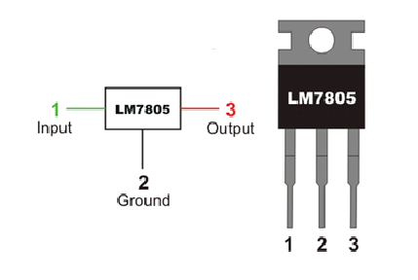

Fig. 3.4: Pin Diagram of IC 7805
[Retrieved from: https://www.onubaelectronica.es/fuente-alimentacion/]

In a circuit, voltage sources which have variations that result in set voltage outputs not being produced. The output voltage is maintained by a voltage regulator IC at a constant value. A common integrated circuit voltage regulator is the 7805 IC, a part of the 78xx family of fixed linear voltage regulators used to maintain such fluctuations (IC). The xx in 7805 displays the voltage of the output it produces. The 7805 IC offers a controlled power supply of +5 volts with provisions to incorporate a heat sink.
3.5 Light Dependent Resistor
Light-based LDRs or resistors are especially useful in circuits with light/dark sensors. The LDR resistance is normally very high, often as high as 1000000 ohms, but when illuminated with light resistance, it decreases dramatically. The instruments that change their electrical features are electronic sensors in the presence of visible or invisible light. The light dependent resistor (LDR), the photo diode and the photo transistors are the best-known devices of this kind for resistance variety, light-dependent resistors, as the name implies, focus on light.

By depositing cadmium, LDR is processed. sulphide or cadmium solenide film with no or very little free electrons in a ceramic substratum, unlit. The longer the strip, the greater the intensity value.

At the point when light falls on the strip, the obstruction diminishes. Without light the obstruction can be in the request for 10K ohm to 15K ohm and is known as the dim resistance. Depending on the introduction of light the opposition can tumble down to estimation of 500 ohms. The force evaluations are generally more modest and are in the reach 50mW to 0.5W. In spite of the fact that delicate to light, the exchanging time is high and consequently can't be utilized for high recurrence applications. They are utilized in chopper intensifiers. Light reliant resistors are accessible as plate 0.5cm to 2.5cm. The opposition ascends to a few Mega ohms under dim conditions. The underneath figure shows that when the light is turned on, the obstruction of the LDR falls, permitting current to go through it is appeared in figure.

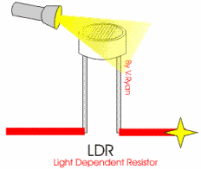

Fig.3.5 (a): LDR.
[Retrieved from: https://www.efxkits.us/tutorial-ldr-light-dependent-resistor-applications/]

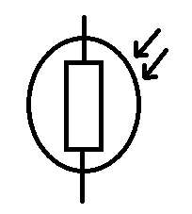

Fig. 3.5(b): Symbol of LDR

The simple construction and the LDR symbol are seen in the figures above, respectively. The unit is made up of a pair of contacts of metal film separated by a snakelike trail of
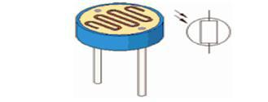

Fig. 3.5(c): Practical LDR

Cadmium sulphide film, which is engineered to provide the two metal films with the highest possible contact field. The structure is located in a translucent case of plastic or resin, to
3.6 Resistor

A resistor is a uninvolved two-terminal electrical segment that actualizes electrical opposition as a circuit component. In electronic circuits, resistors are utilized to lessen current stream, change signal levels, to isolate voltages, predisposition dynamic components, and end transmission lines, among different employments.
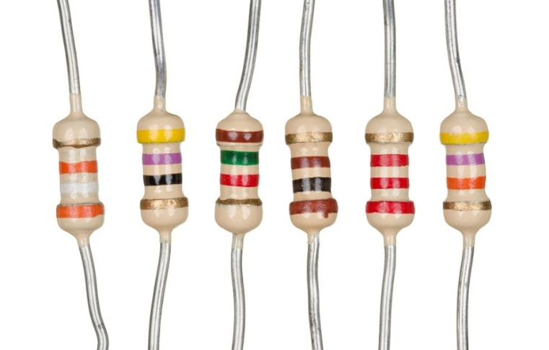

Fig. 3.6: Resistors
[Retrieved from: https://microohm-eg.com/en/product/resistors-560k-ohm-1-4-watt-10pcs/]

As part of motor controls, in power distribution systems or as test loads for generators that can dissipate many watts of electrical power as heat, high-power resistors can be used. Set resistors have resistors that change in temperature, time or operating voltage only slightly. Variable resistors can be used to adjust the circuit elements (such as a sound switch or light dimmer) or to adjust the circuit elements. to track heat, light, moisture, force, or chemical reaction.
Its resistance determines the electrical role of a resistor: typical industrial resistors are fabricated over a spectrum of more than nine orders of magnitude. The nominal resistance value falls below the tolerance of manufacture indicated on the component.
3.6.1 Variable Resistor
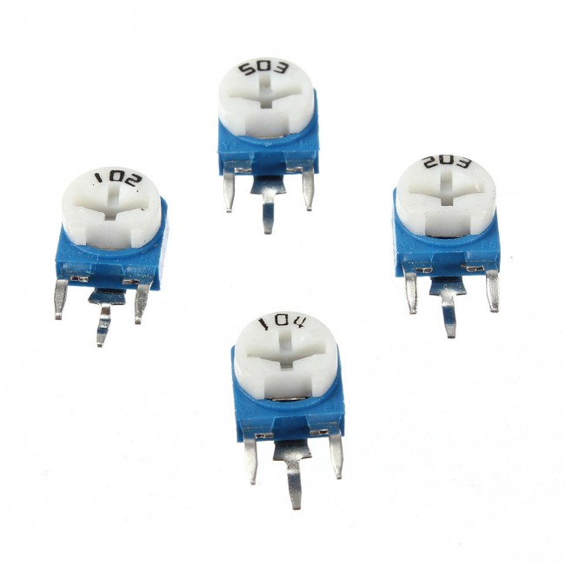

Fig. 3.6.1: Variable Resistor

Without shutting the current off a resistor limits current flow in an electrical circuit. By adjusting the quantity of resistance, a variable resistor gives more power over current flow. The amount of current that is permitted to flow in a circuit reduces as resistance increases in a variable resistor. Variable resistors make up two fundamental elements. The first part is the resistive material and it is called the element.
The second part is used to set the resistance, called the wiper or brush, which is often operated by a knob or sliding lever. There are many types of variable resistors. We stock many of the most common types at Future Electronics, classified by form, number of turns, tolerance, rating power, nominal resistance and type of packaging. Based on the appropriate criteria, the parametric filters on our website will help optimize the search results.

For Rated Electricity, the most common sizes are 250 MW and 500 MW. We also bear Rated Power variable resistors of up to 37 W. Potentiometer, Trimmer or. Variable resistors may be
Turns Counting Dial type.
Variable Resistors can be found in:
- Audio control
- Television
- Motion control
- Transducers
- Computation
- Home Electrical Appliances
- Oscillators

3.6.2Tips for Reading Resistor Code
Examples for different numbers of bands are given in the following pages, but first some tips are given. To read the color code:
- The direction of reading could not always be obvious. The expanded space between bands 3 and 4 often gives away the direction of reading. In comparison, the first party is typically the nearest to the lead. The last band is often a gold or silver band (tolerance).
- Check the paperwork of the vendor is a safe idea to make sure that this might also be the best way to work out the resistance; for example, when the color bands are burned off.
3.6.3 Resistor Color Code Chart

The chart below shows how resistance and tolerance can be measured for resistors. The table can also be used for deciding the color of the bands when the values are identified. An automated resistor calculator may be used to find the resistor values quickly.

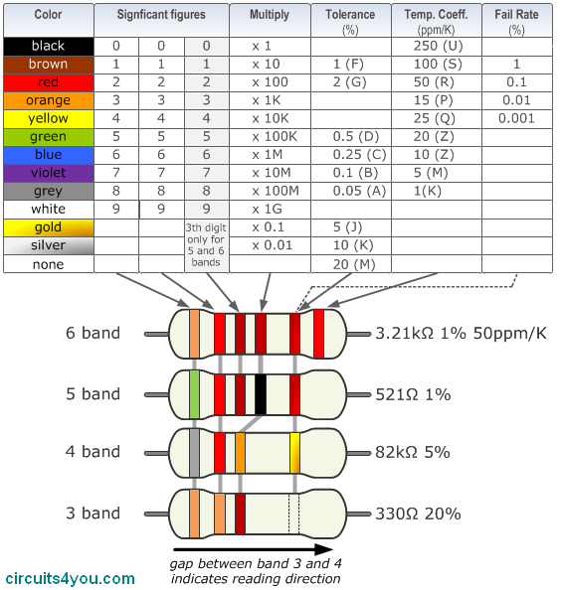

Fig.3.6.3: Color Code Chart of Resistor
[Retrieved from: http://home.ragubathy.online/electrical/resistor]

3.6.4 4-Band Resistor
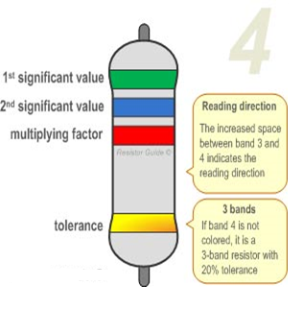

Fig. 3.6.4: 4-Band Resistor Color Code

The most well-known variation is the four band shading code. There are two sets of these resistors for the obstruction calculation, one multiplier and one resilience unit. These classes are orange, blue, red and gold in the design on the left. One learns that green reflects 5 and blue for 6 by using the shading code outline. Therefore, the value is 56•100 = 5600Ω. The genius band indicates that the resistor has a 5 percent resilience. In this way, the obstruction estimate falls anywhere in the region between 5320 and 5880Ω. If the resistance band is left clear, a 3-band resistor is the consequence. This means that opposition esteem remains as before, but resilience is 20%

.3.6.5 5-Band Resistor
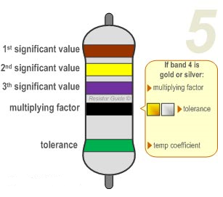

Fig.3.6.5: 5-Band Resistor Color Code

To show a third important digit, High-precision resistors have an additional band,. The first three bands thus represent the important digits, while the fourth band is the significant digits. Multiply factor, and resistance is defined by the fifth unit. Exceptions to this are available. For eg, the extra band often shows the rate of failure (military specification) or coefficient of temperature (older or specialized resistors). For more detail, Please read the 'Exceptions to color code' section. Examples shown: brown (1), yellow (4), purple (7), black (x1), green (0.5%): 147 ⁇ 0.5%.
3.7 Capacitor
The capacitor is a section which has the limit or "breaking point" to store energy as an electrical charge making a normal differentiation (Static Voltage) over its plates, much like a little battery-fueled battery. There are different kinds of capacitors open from small capacitor dabs used in resonation circuits to colossal power factor amendment capacitors, anyway they all accomplish something fundamentally the same as, and they store charge. In its crucial structure, a capacitor contains at any rate two equivalent conductive (metal) plates which are not related or reaching each other, yet are electrically confined either by means of air or by some sort of a good ensuring material, for instance, waxed paper, mica, terminated, plastic or some kind of a liquid gel as used in electrolytic capacitors

3.7.1 The Capacitance of a Capacitor
Capacitance is the electrical property of a capacitor and is the calculation of the ability of a capacitor to hold an electrical charge on its two plates, with the capacitance Unit named after Michael Faraday was the Farad (abbreviated to F). Capacitance is known as the capacitance of a capacitor when a One Coulomb charge is deposited on the plates by a One Farad capacitance. Please note that C is still fine at value and does not have negative units. However, Farad is a very broad measuring device to use by itself, such that sub-multiples of the Farads like microfarads, nan farads and Pico-farads are commonly used.
3.7.2 Standard Units of Capacitance
- Micro-Farad (ft.) 1μF = 1/1,000,000 = 0.000001 = 10⁻⁶ F
- Nano-Farad (nF) 1nF = 1/1,000,000,000 = 0.000000001 = 10⁻⁹ F
- Pico-Farad (pF) 1pF = 1/1,000,000,000,000 = 0.000000000001 = 10⁻¹² F

3.8 Diode
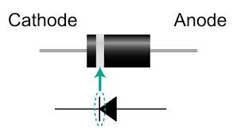
A diode is an electrical element with two electrodes called the anode and the cathode. Many diodes are constructed from semi-conducting materials like silicon, germanium or selenium. Any diodes comprise of metal anodes in a chamber that is removed or loaded up with an unadulterated rudimentary gas at low weight. The diodes can be used by means of correction devices, signal control equipment, tension control, switches, and modulators of signal, signal mixers, disabilities resulting and oscillators.

Fig. 3.8: Diode
3.9 Light Emitting Diode (LED)

A light-emanating diode (LED) is a semiconductor that radiates visible light if the electric flux passes through it. The LED production varies from red (about 700 nanometers frequently) to blue-violet (around 400 nanometers). Some LEDs relay infrared (IR) energy (830 nanometers); this device is known as an infrared diode (IRED). The LED or IRED consists of two components known as semiconductors of type P and semiconductors of type N. Any of these are.
They are put into close contact, creating an area called the junction of the P-N. The LED orIRED resembles most other forms of diodes in this regard, but there are major variations. A translucent kit is provided for the LED or IRED, allowing visible or IR energy to flow through. There is also a wide PN-junction region in the LED or IRED whose form is adapted to the application.

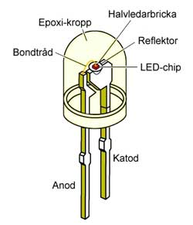

Fig.3.9 (a): LED Function
3.9.1 Types of Light Emitting Diodes
Different forms are present with light emitting diodes and some are discussed below.
- Infrared arsenide gallium (GaAs).
- GaAsP – red to infrared, green, orange Phosphide GalLIAL Arsenides
- Arsenide Phosphide Aluminum Gallium (AlGaAsP) – crimson, orange-red, orange and yellow-high-brightness.
- GA (red, purple and green) Gallium Phosphide
- Phosphide aluminum gallium (AlGaP) - orange
- Green, emerald, green Gallium Nitride (GaN).
- Nitride gallium (GaInN) – near UV, light-green and blue.
- Carbide Silicon (SiC), blue as a substratum
- Selenide zinc (ZnSe) - blue.
- Ultraviolet Nitride aluminum gallium (AlGaN)
3.10 LCD
The LCD (Liquid Crystal Display) screen is an electronic display which is available in numerous applications. The simplest module is a big 16 x 2 LCD monitor.

Different implementations and circuits have been discovered. A 16 x2LCD means that 16 letters can be shown per line, and 2 of them are displayed.

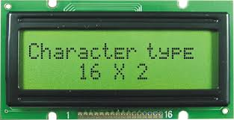

Fig.3.10: LCD Display

3.11 Battery

3.11.1 Introduction of battery
Batteries in PV frames are frequently used to store electricity provided during the day by PV exhibits and to gracefully store them at various electrical loads (during the night and times of overcast climate). Various explanations are used in photovoltaic frameworks to run a PV display near its strongest power, to control electricity at steady voltages and to flexibly flood electricity and converter. In certain cases, battery charging regulators are used to protect against cheat and release in these systems.
3.12 IR Transmitter
An infrared transmitter is a diode emitting light that (LED), which emit infrared radiation. However they are referred to as IR LEDs. Whereas an IR LED is like a regular LED, it is opaque to the human eye to contain radiation. The Infrared LED image is below.
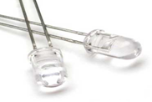

Fig. 3. 12: IR Transmitter LED
3.13 IR Receiver
The modulated Infrared waves are received by TSOP17XX and its performance varies. In several frequency ranges, such as TSOP1730, TSOP1738, TSOP1740, etc., TSOP is available. The last two digits indicate the frequency of modulated IR rays that TSOP responds to in KHz). TSOP1738, for instance, responds as it absorbs modulated IR radiation at 38 KHz. It means the IR that turns on and off at the rate of 38 KHz is observed. The output of TSOP is active low, meaning that its output stays HIGH when there is no IR, and when it detects it becomes low.
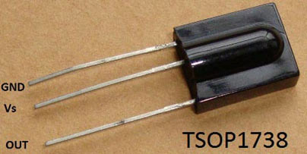

Figure 3.13: IR Receiver (TSOP1738)
IR radiation operates at a specific frequency, except for the modulated IR of a different frequency, meaning that all IRs in the atmosphere do not interfere. It has three pins, Field, Power Vs and Pin output.
3.14 Temperature Sensor
The LM35 is an IC temperature accuracy sensor with a zero-degree temperature yield. The hardware of the sensor is set and then it is not subjected to oxidation and various cycles. With LM35, it is possible to measure the temperature more accurately than with a thermistor. It also has low self-warming which does not allow temperatures of more than 0.1 oC to increase in still air. The range of working temperatures is from -55 ° C to 150 ° C. Due to each oC rise/fall in the surrounding temperature, the yield voltage varies by 10mV

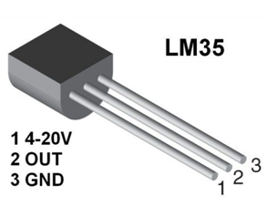

Fig.3.14: Temperature sensor

3.15 Connector
A connector is a component which is used to connect electrical circuits and is also known as an electrical connector.
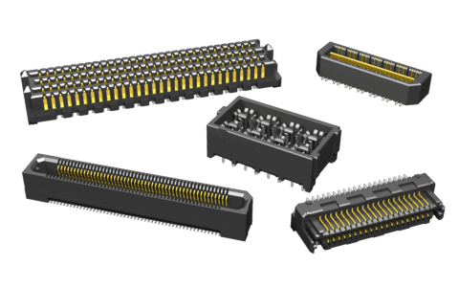

Fig 3.15: Pic Connector
3.16 Oscillator
A precious oscillator in stone is an electrical oscillator circuit that allows an electric pulse of an exact recurrence by the mechanical reverberation of a vibrating pleasure of piezoelectric content.

3.16.1 Application
Crystal stone oscillator is utilized to give clock to miniature regulator. Clock is utilized to convey all the capacity that miniature regulator gives. You need not give any different voltage on the grounds that the miniature regulator has committed pin which energizes Crystal oscillator.

3.17 OP-Amplifier
An electronic circuit which analyzes two voltages of information and tells you which of them is more noticeable. It's anything but difficult to make a voltage comparator from an operation amp, in light of the fact that the extremity of the operation amp's yield circuit relies upon the extremity of the distinction between the two information voltages.

3.17.1 Application
Comparator Circuit Working and Applications. By and large, in gadgets, the comparator is utilized to analyze two voltages or flows which are given at the two contributions of the comparator. That implies it takes two information voltages, at that point analyzes them and gives a differential yield voltage either high or low-level signal.
3.18 Micro Controller (PIC16F72)
A microcontroller is a solitary chip microcomputer. This ensures that a microcontroller chip has a microchip (CPU) much like those peripherals that are also used. To regulate a certain period or part of the atmosphere, a regulator is used.
An ordinary the application of the microcontroller is a house observer. The regulator opens the windows as the temperature increases. On the off chance that the temperature goes over a specific edge, the climate control system is enacted.
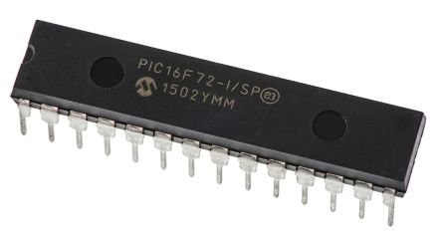

Fig. 3.18:PIC6F72 Microcontroller Chip

In light of the fact that the scaling down period proceeded, all the segments required for a regulator were directly collected into one chip. One processor or a microcontroller has been introduced into the universe. A microcontroller may be a very inserted PC, which includes all of the most parts required on one chip for a regulator. A microcontroller can be regarded as a 1 chip arrangement.
Includes typically:
- CPU full name (Central Processing Unit or the microprocessor)
- EEPROM / PROM / ROM (Read Only Memory for the program code)
- Still (Random, Access Memory for the program code)
- I/O machines (Enter/Output) (serial, parallel, ADC, DAC etc.)
- Timers
- Controller Interrupt
- Controller integrated
- ADC.
- Calculator
- Generator of PWM functions

An integrated controller is just an embedded controller in an expanded system. You're here could state that an inserted regulator is controller(or PC that is implanted into some gadget for some reason other than to give universally useful processing Microcontrollers are also used in installed applications as in a PC. In the extension to monitor applications for example, the above home observing system. Among multiple use devices (microwaves, fridges, TV and VCRs), at least one can be found, sound systems), vehicles (motor control, demonstrative, atmosphere control), ecological control (nursery, processing plant, home), instrumentation, aviation, power electronic controlling and a great many different employments.

An extraordinary Information recording is an application that microcontrollers are suitable for. Please place one of these chips in or up the middle of a paddy field and document ecological boundaries. (Temperature, mugginess, downpour, and so on) Little size, low force utilization, and adaptability make these gadgets ideal for unattended information observing and recoding.

You can use A microcontroller that is 4-bit, 16-bit, or 32-bit depending on the power and functions available. In addition, there are several customized models that provide communications-specific functions, keyboard management, Production of signals, processing of images and other tasks.
3.18.1 Programmable Integrated Circuit
PIC controllers are a family of small RISC controllers used in embedded software. The corporation "Microchip" manufactures PIC controllers. You can access literature From the website Microchip. The growth in the market share of the 8-bit MCU is a testament to the ability of PIC micro MCUs to fulfill the requirements of many. The PIC micro architecture has grown to be One of the top three architectures available on the general market at present. This creation has been fuelled by the vision of the Microchip.
3.18.2 PIC16F72 Microcontroller
The PIC16F72 is part of the mid-range PIC micro system family..

3.18.3 Pin Diagram
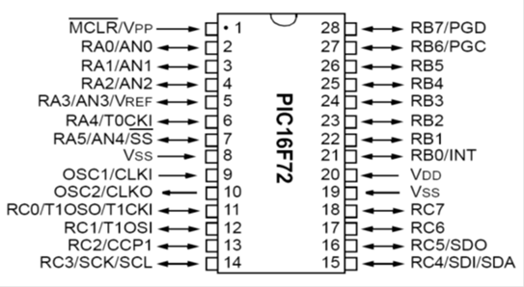

Fig. 3.18.2: Pin Diagram of PIC16F72 Microcontroller

Pin Number | Description
1 | MCLR/VPP - Simple Reset Master
2 | RA0/AN0 - The A-port.
3 | RA1/AN1 – The A. Port
4 | RA2/AN2 - The A. Port
5 | RA2//VREF AN3 - The A. Port.
6 | RA4/T0CKI - The A. Port.
7 | RA5/SS/AN4 - The A. Port.
8 | Ground.-Vss
9 | OSC1/CLKI - Input Oscillator.
10 | OSC2/CLKO - Oscillator Output.
11 | RC0/T1OSO/T1CKI - Port C.
12 | RC1/T1OSI - Port C.
13 | RC2/CCP1 - Port C.
14 | RC3/SCK/SCL - Port C.
15 | RC4/SDI/SDA - Port C.
 | 27
16 | RC5/SDO - Port C
17 | RC6 - Port C  23
18 | RC7 - Port C.
19 | Vss – Ground.
20 | Vdd - Positive Power Supply.
21 | RB0/INT - Port B.
22 | RB1 - Port B.
23 | RB2 - Port B.
24 | RB3 - Port B.
25 | RB4 - Port B.
26 | RB5 - Port B.
27 | RB6/PGC - Port B.
28 | RB7/PGD - Port B.

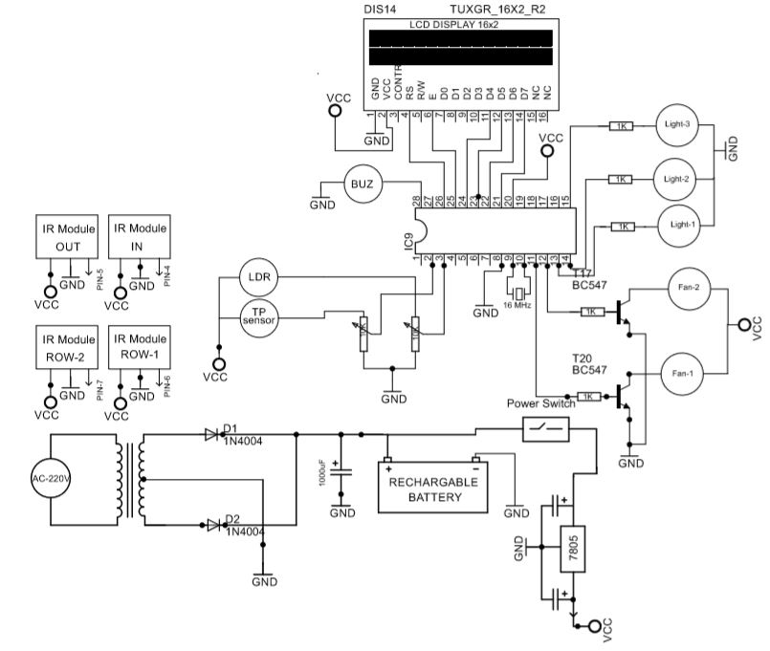
3.19 Circuit Diagram

Fig 3.19(a): Circuit Diagram
3.20 Block Diagram

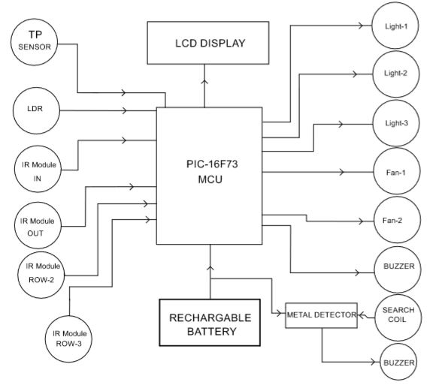

Fig.3.20.Block diagram: Automatic Light intensity And Temperature Control Fan with metal detector

3.21 Cost Estimate
Component Name | Cost
Buzzer | 50 Taka
LCD | 50 Taka
Capacitor | 36 Taka
Resistor | 30 Taka
Diode | 30 Taka
Microcontroller 16F72 | 250 Taka
Push Switch | 45 Taka
Fan | 30 Taka
PCB Board | 80 Taka
Some wire | 25 Taka
LED | 20 Taka
LDR | 50Taka
OP-Amplifier | 20Taka
IR Sensor | 30Taka
OP-Amplifier | 20
Etc | 100
Total | 866 Taka

CHAPTER 4
DESIGN AND IMPLEMENTATION

4.1 Design
Fig 4.1: Circuit Diagram of Automatic light intensity control and temperature control fan with metal detector etc.

In this project we utilized step down transformer ,LCD, Microcontroller ,IR module ,Fan,LED,Buzzer ,LDR,12 V battery, Power switch, capacitor ,Variable resistor,. From the start we use venture down transformer, for 220v proselyte to 10-12 v .Then DC Battery associated with it .Then we can source in circuit by utilizing a voltage controller at 5 v .it is simply like vcc.Then we associated vcc at microcontroller 20 pin and GND at pin 8 .For recurrence oscillator .it is associated with 9 and 10 pin for running the microcontroller the pin 2,3connected with variable resistor of LDR and associated temperature sensor .The LED and fan associated with pin 3,14 and 11,12 and furthermore associated signal with pin 15.The LCD show with associated with pin 21,22,23,24,25,26 then again ,The column light framework open and simple OP-Amplifier of comparator hub .The amplifier connected with IR sensor.

CHAPTER 5
RESULT AND DISCUSSION

5.1 Result
We are Properly connection do this project and finally we gate automatic auditorium light intensity control ,and fan control depend on temperature we can easily see our LCD Display auditorium in and out going with which row are vacant or full we see the display in side auditorium top front of gate. And also use fire alarming system.
5.2 Project View
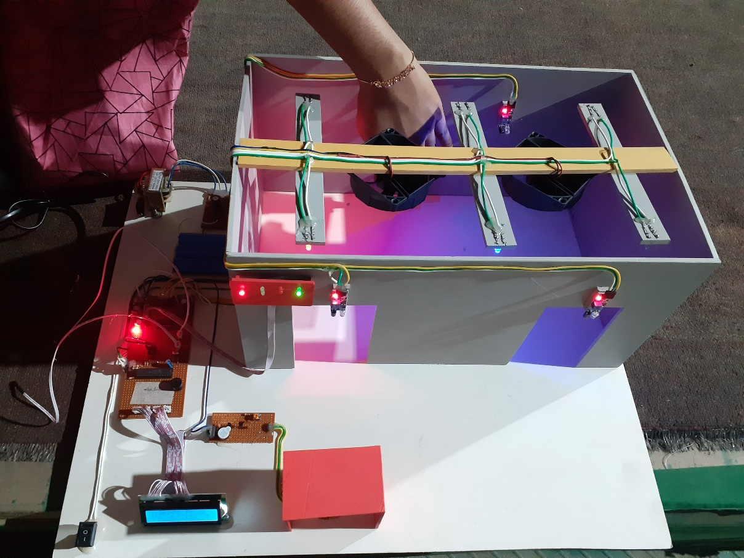

Fig.5.2: Project view

CHAPTER 6
CONCLUSIONS

6.1 Conclusion
In this project, we develop a general purpose of electronic circuit design that can Show the automatic light intensity control and fan control temperature based LCD display shown the temperature and visitor counter it can be also used fire detector and alarm circuit and metal detector with which row are vacant or full we see the display in side auditorium top front of gate. This project is the overview of smart auditorium with system The project is successfully developed and met the stated objectives.
6.2 Limitations of the Work
This project's working process is very basic, but we face certain limitations in doing this project. Such as problem coding, program drafting, PCB board relation, eventual commendation, etc.
6.3 Future Scopes
- The Automated Room Lighting can be used to naturally turn the auditorium on when a person goes into and off when the person exits the room. Bidirectional Guest Counter can be used for lighting.
- The project should also be named a bi-directional guest tracker, an integral part of the circuit for automatic room lighting.
- The project is also updated with LEDs and the amount of LEDs turning ON often changes as the number of people in the room increases.
- The project can be guiding the audience to the un-occupied rows starting from the first row.
- Automatically controlling fan depend on temperature. We set default 28º C for fan-1 and 29º C for fan-2
- Also use metal detector and fire alarming system using buzzer.

REFERENCES:

[1] A. K. Gupta, S. K. Arora (2007), Industrial Automation and Robotics, 348 pages, Laxmi Publications, ISBN-10: 8131801810
[2] J. Burroughs (2010), “X-10 Home Automation Using The PIC16F877A” Lamp, vol. 10, article 10
[3] Nikita Bagali,Prof.Geeta Navalyal.“Automatic Fan controlling System and power consumption Analysis”,International Journal of Advanced Research in computer and communication Engineering vol.5,Issue 6,June 2016 ISSN:2231-28.
[4] SukanyaReddy, Rajesh Kaki, Venkataramana Sarparapu, Kranthi Kumar. “Design smart power saving system in auditorium by using Atmel AT89S52 Microcontrollers”, International Journal of Advance Research in Science and Engineering Vol. No.4, Issue 04, April 2015 ISSN-2319-8354(E).
[5] Sunil Kumar.Matangi, Sateesh. Prathapani, “Design of Smart Power Controlling and
Saving System in Auditorium by using MCS 51 Microcontrollers”. Nishitha College of
Engineering&Technology 2Research Scholar - University of Hyderabad.
[6] Reinhard Mullner, Andreas Riener (2011), “An Energy Efficient Pedestrian Aware Smart Street Lighting System”, International Journal of Pervasive Computing and Communications, Vol. 7, No. 2, pp. 147-161
[7] D. A. Devi and A. Kumar (2012), “Design and Implementation of CPLD based Solar Power Saving System for Street Lights and Automatic Traffic Controller”, International Journal of Scientific and Research Publications, Vol. 2, Issue11, November 2012.

Appendix A
Programming code:
#include <16F72.h>
#use delay (clock = 16000000)

#define FAN1 PIN_C0
#define FAN2 PIN_C1
#define LOD1 PIN_C2
#define LOD2 PIN_C3
#define LOD3 PIN_C4
#define BUZ PIN_B7

void setup(void);
void LOD_CTRL(void);
void adc_read(void);
void lcd_show(void);
unsigned int COUNT,COUNT1,LDR,IR1,IR2,IR3,IR4,IN,OUT,PRESENT;
float tp=0,
///////////////////////////////////////////////////////////////////////////////
///////////////////////////////////////////////////////////////////////////////
lcd_gotoxy(1,1);
printf(lcd_putc, " WELCOME TO ");
lcd_gotoxy(1,2);
printf(lcd_putc, " DIU ");
delay_ms(1500);
lcd_gotoxy(1,1);
printf(lcd_putc, " SUBMITTED BY: ");
lcd_gotoxy(1,2);
printf(lcd_putc, " AMIR HOSSEN ");
delay_ms(500);
printf(lcd_putc, " ");
printf(lcd_putc, " MOST. MAHFUJA ");
delay_ms(500);
}
}
////////////////////////////////////////////////////////////////////////////////
void adc_read(void)
{
set_ADC_channel(0);
delay_ms(1);
tp = read_adc();

set_ADC_channel(1);
delay_ms(1);
LDR = read_adc();
}
////////////////////////////////////////////////////////////////////////////////
void LOD_CTRL(void)
{
if( TP > 28 )
{
output_high(FAN1);
}
if( TP > 29 )
{
output_high(FAN2);
}
if( TP < 28 )
output_LOW(FAN1);
output_LOW(FAN2);
}
if( TP > 40 )
{
adc_read();
lcd_show();

output_HIGH(BUZ);
delay_ms(100);
output_LOW(BUZ);
delay_ms(100);
}
}

////////////////////////////// VISITOR COUNTER

IR1 = input(PIN_A2);
IR2 = input(PIN_A3);
IR3 = input(PIN_A4);
IR4 = input(PIN_RA5);
IF(IR1==1)
{
IN++;delay_ms(500);
}
IF( IR2==1 )
IOUT++;delay_ms(500);
}
PRESENT= ( IN - OUT );

//////////////////////////////////////

IF(PRESENT >= 1 )
{ output_HIGH(LOD1);}

{
if( LDR < 400 && IR3)
}
{ output_HIGH(LOD2);}

{
if( LDR < 400 && IR4)

}
{ output_HIGH(LOD3);}
ELSE
{ output_LOW(LOD1);output_LOW(LOD2);output_LOW(LOD3);}
}

}
//////////////////////////////////////
void lcd_show(void)
{
lcd_gotoxy(1,1);
printf(lcd_putc, "T:%2.1f%cC ",TP);
lcd_gotoxy(10,1);
printf(lcd_putc, "P:%3u ",PRESENT);

lcd_gotoxy(1,2);
printf(lcd_putc, "IN:%3u OUT:%3u ",IN,OUT);
}
////////////////////////////////////////////////////////////////////////////////

