

Project Title: Daffodil Hotel Management

Submitted by
Refat Ahammed Reyad
ID: 191-35-2759
Department of Software Engineering
Daffodil International University

Supervised by
SK. Fazlee Rabby
Lecturer
Department of Software Engineering
Daffodil International University

This Project report has been submitted in fulfillment of the requirements for the Degree of
Bachelor of Science in Software Engineering.

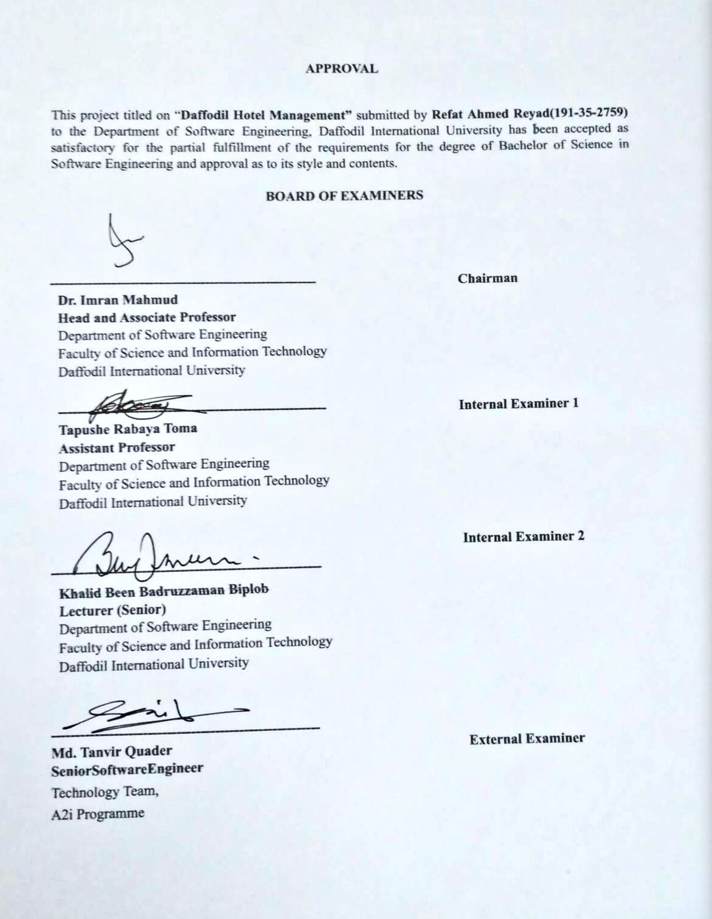
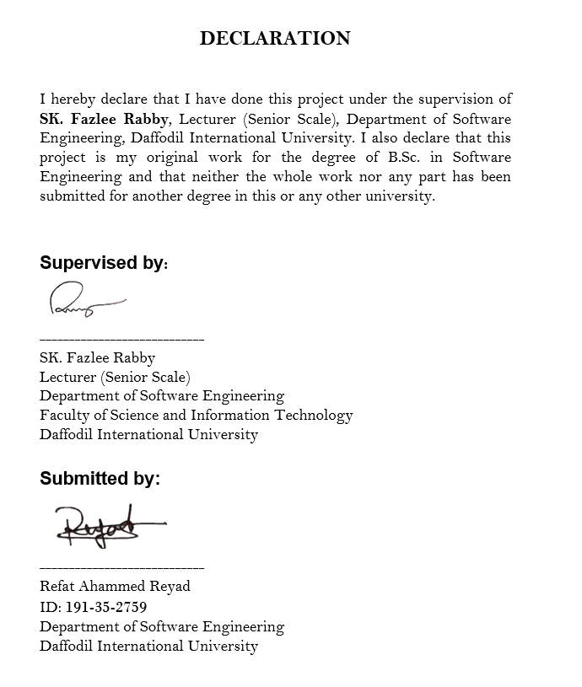

ACKNOWLEDGEMENT
In this day and age of contest there is a race for endurance where they have come for progress. The venture is an extension for hypothetical and pragmatic work. It is with this want that I join this extraordinary task. Above all else, I might want to say thanks to All-powerful Allah who has obviously directed me to make the best decision throughout everyday life. Without His effortlessness this task could never have a reality. What's more, my folks whom I very obligated for getting me this stage with affection and consolation
I feel a sense of urgency to discuss the chance to learn at Daffodil Global College. I might want to say thanks to Prof earnestly. Dr. Imran Mahmud, Top of the Division of Computer programming. Loaded with all regarded educators who appreciate showing me in a fascinating and justifiable manner. I'm thankful for having them on my excursion.
I'm particularly committed to direct Daffodil Global College to direct them through the consistent management of SK. Fazlee Rabby sir to give the essential data as well as to respect the drive and moreover their assistance in finishing the venture.
At long last, I might want to communicate my adoration for my group mate, an individual from DIU, for the caring collaboration and relief that has assisted me with achieving this undertaking.

ABSTRACT
This framework will offer types of assistance to any individual in closest area. A moment administration will be offered by the assistance supplier. The guide will assist individuals with finding their closest lodging administration focus. At the point when somebody will require a crisis support, "Daffodil Lodging the executives Framework" can be utilized to handily get backing or reinforcement. Using this framework, individuals will get a ton of help when they need it. From any area they can utilize the guide to find the closest specialist organization focus and get administrations. Emotionally supportive network requesters from disagreeable circumstance

APPROVAL………………………………………………………………………………….……………..………….…………..…ii
DECLARATION………………………………………….………………………………………………………...………….…..iii
ACKNOWLWDGEMENT............................................................................................iv
ABSTRACT..................................................................................................................v
CHAPTER 1:
INTRODUCTION........................................................................................................01
1.1 Project Overview................................................................................................02
1.2 Project Purpose ..................................................................................................03
1.3 Background ........................................................................................................04
1.4 Benefits & Beneficiaries......................................................................................04
1.5 Stakeholders.......................................................................................................04
1.6 Proposed System Model.....................................................................................05
1.7 Modules of Service assistant…….........................................................................06
1.8 Project Schedule.................................................................................................07
1.8.1 Gantt Chart........................................................................................... 07
1.8.2 Release Plan or Milestone.....................................................................08
1.9 Objectives.......................................................................................................... 09
CHAPTER 2:
REQUIREMENT ENGINEERING..................................................................................10
2.1 Functional Requirements (FR)............................................................................ 11
2.2 Non-functional Requirement…...........................................................................12
CHAPTER 3:
SYSTEM ANALYSIS, DESIGN & SPECIFICATION..........................................................13
3.1 Development Model…........................................................................................14
3.2 Use Case Diagram………..................................................................................15-16
3.2.1 Use Case Description………….............................................................17-18
3.3 Activity Diagram……......................................................................................19-23
3.4 Sequence Diagram........................................................................................24-26
3.5 Class Diagram.....................................................................................................27
3.6 Entity Relationship Diagram...............................................................................28
CHAPTER 4:
SYSTEM TESTING......................................................................................................29
4.1 Feature Testing…………….....................................................................................30
4.1.1 Features to be tested…..........................................................................30
4.2 Test Strategies……………......................................................................................31
4.2.1 Test approach……………...........................................................................31
4.2.2 Testing Schedule.....................................................................................36
CHAPTER 5:
USER MANUAL………............................................................................................37-43
CHAPTER 6:
CONCLUSION............................................................................................................44
6.1 Project Summary................................................................................................45
6.2 Tool and platform…….........................................................................................46
6.3 Limitations……....................................................................................................47
6.4 Future Scope…....................................................................................................47

CHAPTER 1: INTRODUCTION

  - Project overview

The "Daffodil Hotel management System" is a moment online assistance the board framework. This framework will offer a wide range of types of assistance to an individual in any area any time. A moment administration will be offered by the assistance supplier. The guide will assist individuals with finding their closest inn administration focus. At the point when somebody will require a crisis support, "Daffodil Hotel management System" can be utilized to effortlessly get backing or reinforcement. This framework will offer types of assistance to the clients by the specialist co-op. Requesters can send demand for their crisis administrations. Specialist co-op will get the solicitation and track down the requester by track their area. Anybody can take their administrations even in a disagreeable spot moreover.

  - Project Purpose
The reason for "Daffodil Hotel management System" is to serve clients any kind of administrations. Food, wellbeing, and home these administrations are accessible in this framework. The principal motivation behind this framework is to help clients in any time. They have looked through their ideal help which they need and send a solicitation to the requester so the requester can track down the client. The requester has the position to acknowledge or drop the solicitation from the requester. Functionalities gave by "Daffodil Hotel management System":
• A moment online helps the executive’s framework.
• Requesters can send solicitation to the suppliers for taking their administrations.
• Suppliers have the position to acknowledge or drop the solicitation.
• Clients can by any pieces of their connected administrations from the specialist co-ops.

1.3 Background
In light of some help the board framework I need to make an easy-to-use framework where both the requester and supplier have the position to pick their administrations. I attempted to make a full framework, which will be dependable, secure, or more all easy to use.
1.4 Benefits and Beneficiaries
This framework will be useful for the people who are caught in a horrendous circumstance halfway and need assistance, the specialist organizations of this framework will help clients by telling the requester's solicitation.
1.5 Stakeholders
A partner is somebody who can be impacted or impacted by an association, methodology or venture. They can be inward or outside and they can be at senior or junior level. I have suppliers and requesters as the partners of this framework.
- Suppliers
- Requester

1.6 Proposed System Model
I planned this model to make an easy-to-use interface in this framework. I fabricated this model to picture and control the framework engineering.
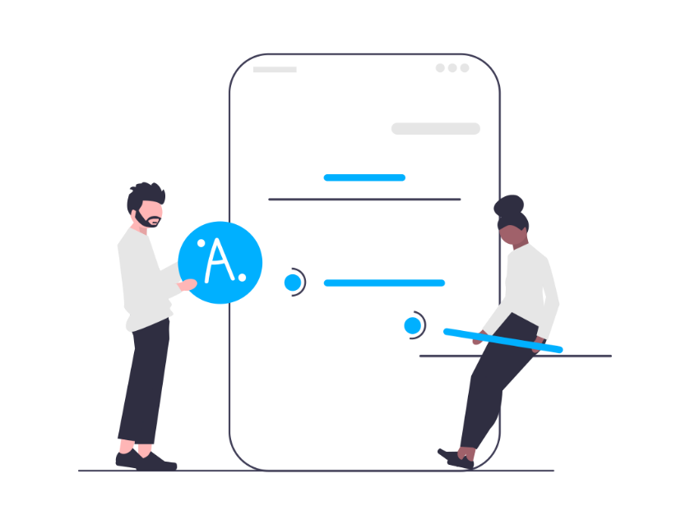

Requester  - Search specialist co-op  - Submit demand  - Purchase administration | Provider  - Acknowledge demand  - Sell parts  - Make a move

Figure 1.1: Proposed System Mode

1.7 Modules of Service Assistant
• Login module: utilized for client verification
• Enlistment module: utilized for overseeing clients of the framework
• Administration module: utilized for administration related capabilities
• Requester module: utilized for dealing with the data and subtleties of the requester.
• Supplier module: utilized for dealing with the data and subtleties of the supplier

1.8 Project Schedule
Taking into account a brief time frame, I really want to prepared a booking intend to complete the undertaking on time. It likewise alludes to make correspondence with what undertaking should be finished inside a brief time frame.

1.8.1 Gantt Chart

Activities | W1 | W2 | W3 | W4 | W5 | W6 | W7 | W8 | W9 | W10 | W11 | W12
Research
Specification
Planning
Design
Development
Testing
Assessment
Documentation

Table 1.1: Gantt Chart

1.8.2 Release plan and Milestone
The release plan and milestones are given below:
Activities | Duration in Week | Total Week
Research | W1,W2 | 2
Specification | W2,W3,W4 | 3
Planning | W3,W4 | 2
Design | W4,W5 | 2
Development | W4,W5,W6,W7 | 4
Testing | W7,W8 | 2
Assessment | W9,W10 | 2
Documentation | W10,W11,W12 | 3
Software release | W12

Table 1.2: Release Plan

1.9 Objective
The primary goal of this task is to serve individuals with a wide range of administrations. This is a moment online help the board framework.
• Essentially: The product should be steady and can be worked by individuals with normal insight.
• Effectiveness: This includes precision, practicality and extensiveness of the result.
• Cost: It is alluring to go for the gold with a base expense subject to the condition that it should fulfill every one of the necessities.
• Movability: The web application ought to be compact to all conditions.
• Security: This significant part of configuration covers areas of actual security of information. This could be given by a login office empowering username and secret key for the client and executive. In this manner it makes the administrator work straightforward with 100 percent productively

CHAPTER 2: REQUIREMENT ENGINEERING

2.1 Functional Requirements
Useful prerequisites characterize a framework for its part. It indicates "how should the framework respond?" Client determines useful prerequisite. Meeting these requirements is compulsory. It is caught in the utilization case.
The useful prerequisites of "Daffodil Hotel Management System" are:
▪ Registration
▪ Log in
▪ Accept request
▪ Submit request
▪ View available rooms
▪ View types of rooms.
▪ View other services
▪ Add requester
▪ Search provider
▪ Check status
▪ Report
▪ Change password

2.2 Non-functional Requirements
Non-utilitarian prerequisites characterize the quality trait of a framework. It indicates "How might the framework satisfy the useful prerequisites?" non-practical necessities are determined by specialized individuals or programming designers. Meeting these requirements is compulsory. It is caught as a quality property. The non-useful prerequisites of "Daffodil Hotel Management System" are:
▪ Compliance
▪ Documentation
▪ Privacy
▪ Quality
▪ Stability
▪ Authority
▪ Response time
▪ Reliability

CHAPTER 3: SYSTEM ANALYSIS, DESIGN & SPECIFICATION

3.1 Development Model
To foster the task "Daffodil Hotel Management System" we have taken on an Iterative upgrade model. This model eliminates the inadequacy of the cascade model. These models function admirably when the undertaking incorporates a few free units that don't depend on different units to work. The two models under the gradual interaction models are the iterative upgrade model and the quick application model. The iterative upgrade model looks like the cascade model with the exemption that it permits a few emphases of the plan cycle. After each cycle, there is an item delivered. The examples learnt feed into the following cycle.

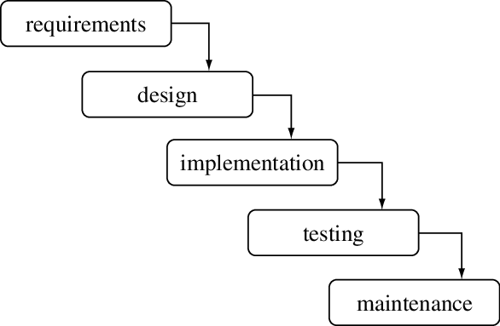

Figure 3.1: Iterative Enhancement Model

3.2 Use Case Diagram
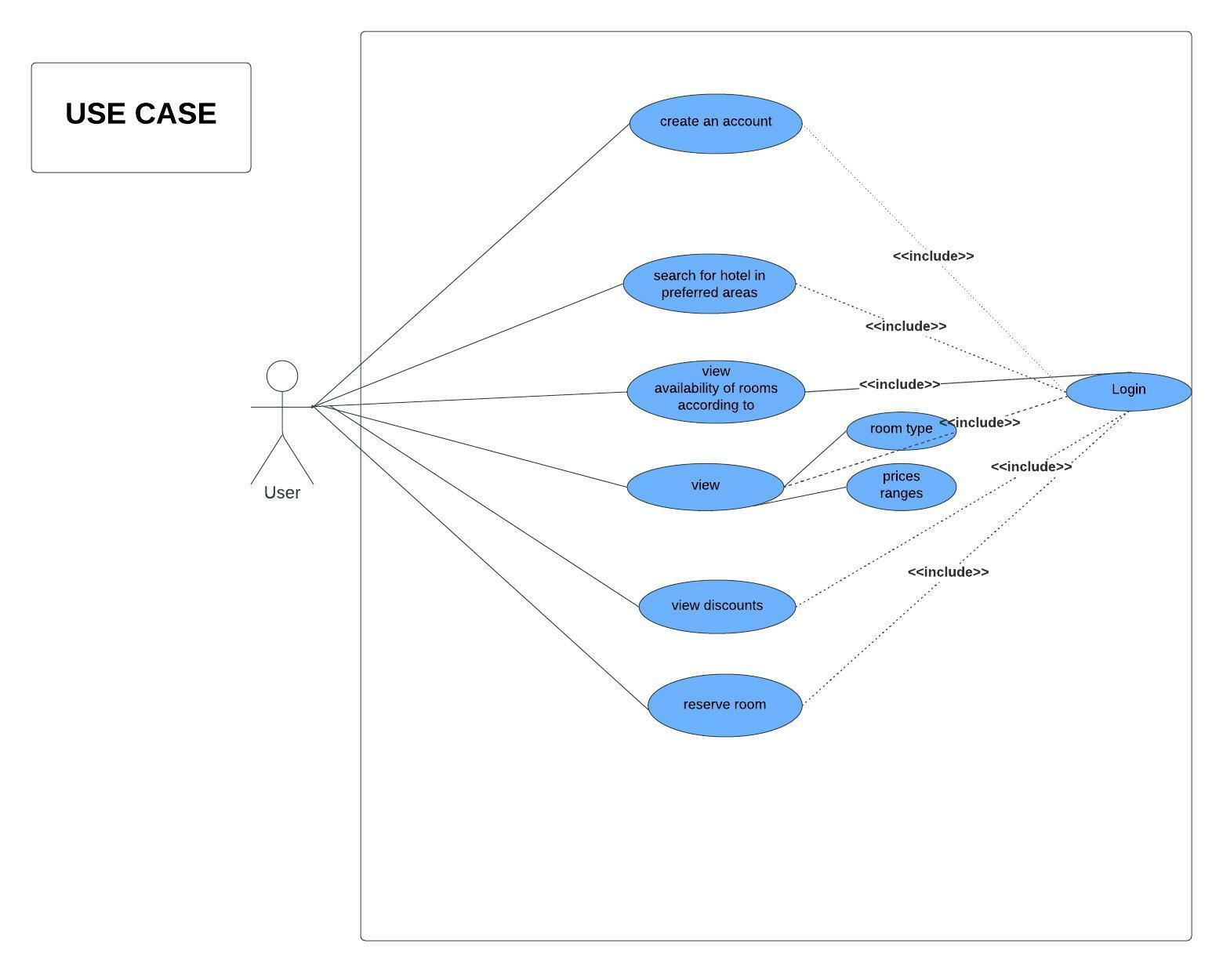

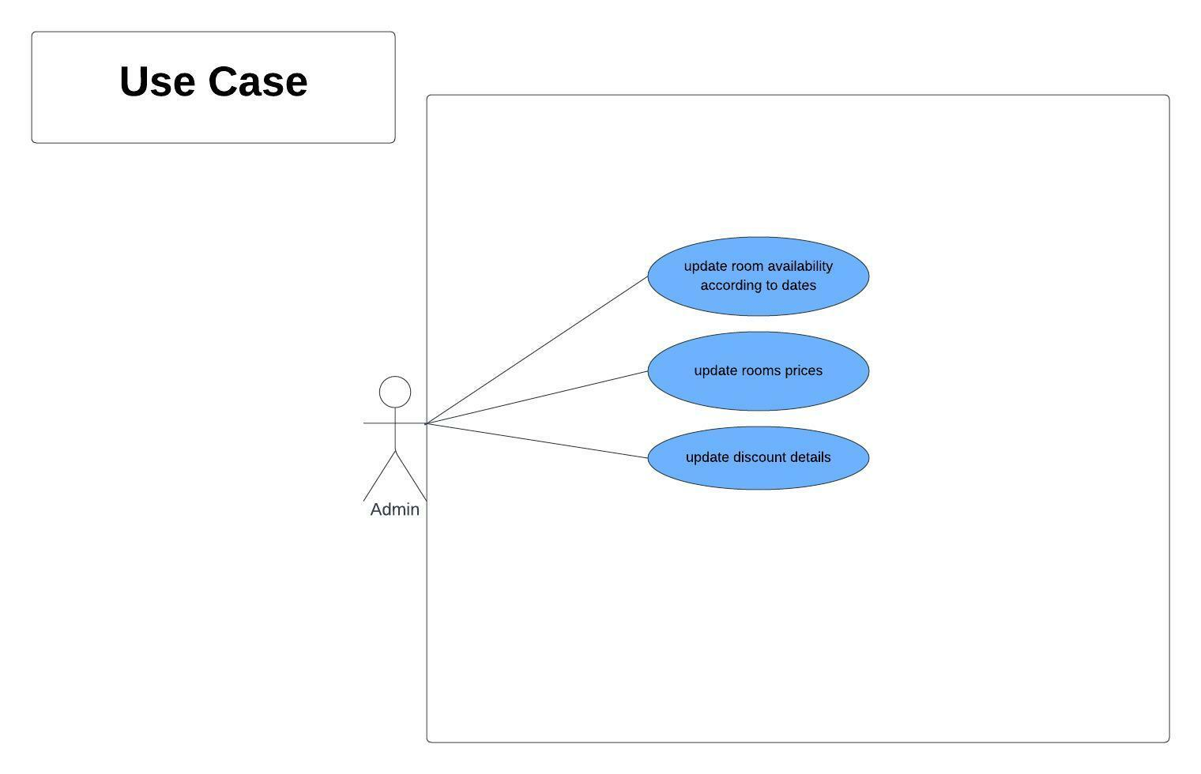

Use case Description:

3.2.1 Registration
Description | This framework gives an enrollment structure where clients/requesters can enlist themselves and submit administration demands.

3.2.2 Log In
Description | This module is utilized to login/information exchange in the rundown of the Help Partner.

3.2.3 Search for Hotel in preferred area
Description | This module is utilized to look for the closest inn nearby. By this supplier will be inform about the solicitation.

3.2.4 View availability of rooms according to dates
Description | This module is utilized to see the accessibility of rooms on that day which are you looking for.

3.2.5 View
Description | This module is utilized for survey the room types and value scopes of rooms.

3.2.6 View Documents
Description | This module is utilized for to really take a look at the records of the client and store them.

3.2.7 View Discount
Description | This module is utilized for survey assuming there is any markdown offer contingent upon event.

3.2.8 Reserve Room
Description | This module is utilized for survey in the event that there is any booking.

3.2.9 Update Room Availability According dates.
Description | Assuming that there is any room held it will be refreshed to the framework.

3.2.10 Update Room Prices
Description | This module will refresh the value scopes of rooms rely upon season.

3.2.11 Update Discount prices
Description | This Module is utilized for is there any update at markdown costs.

Activity Diagram
Registration
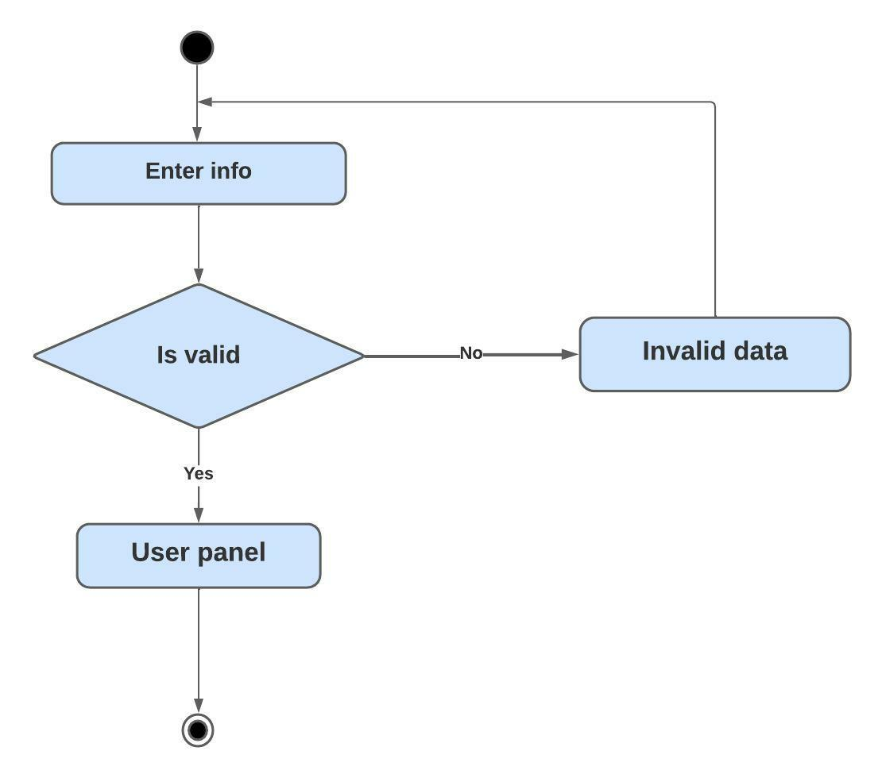

Login
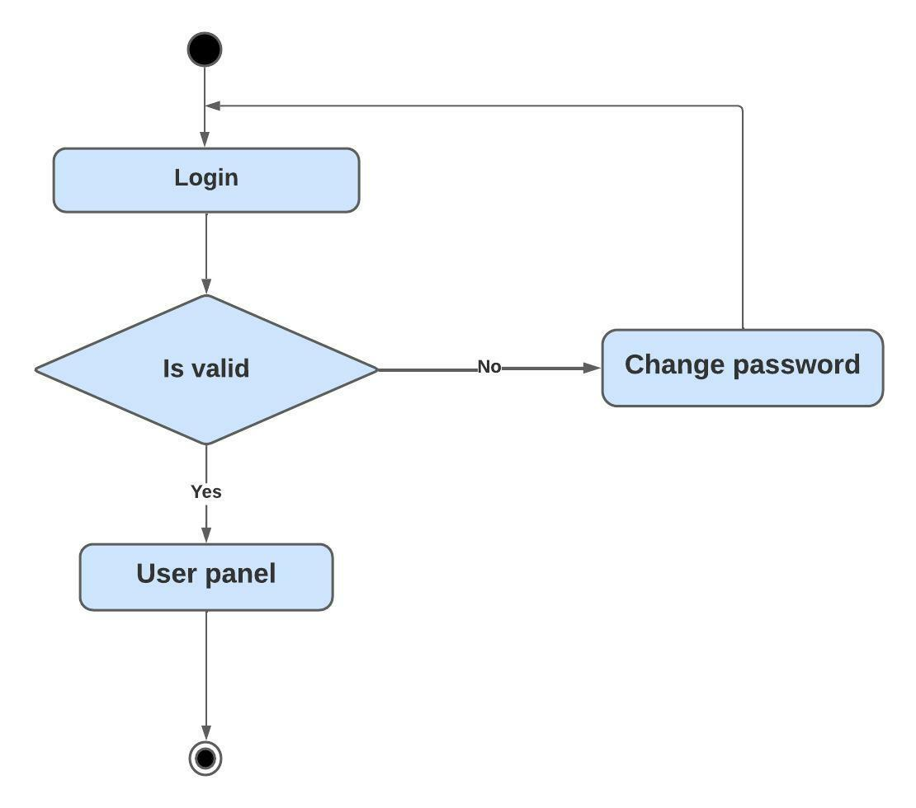

Search Hotel
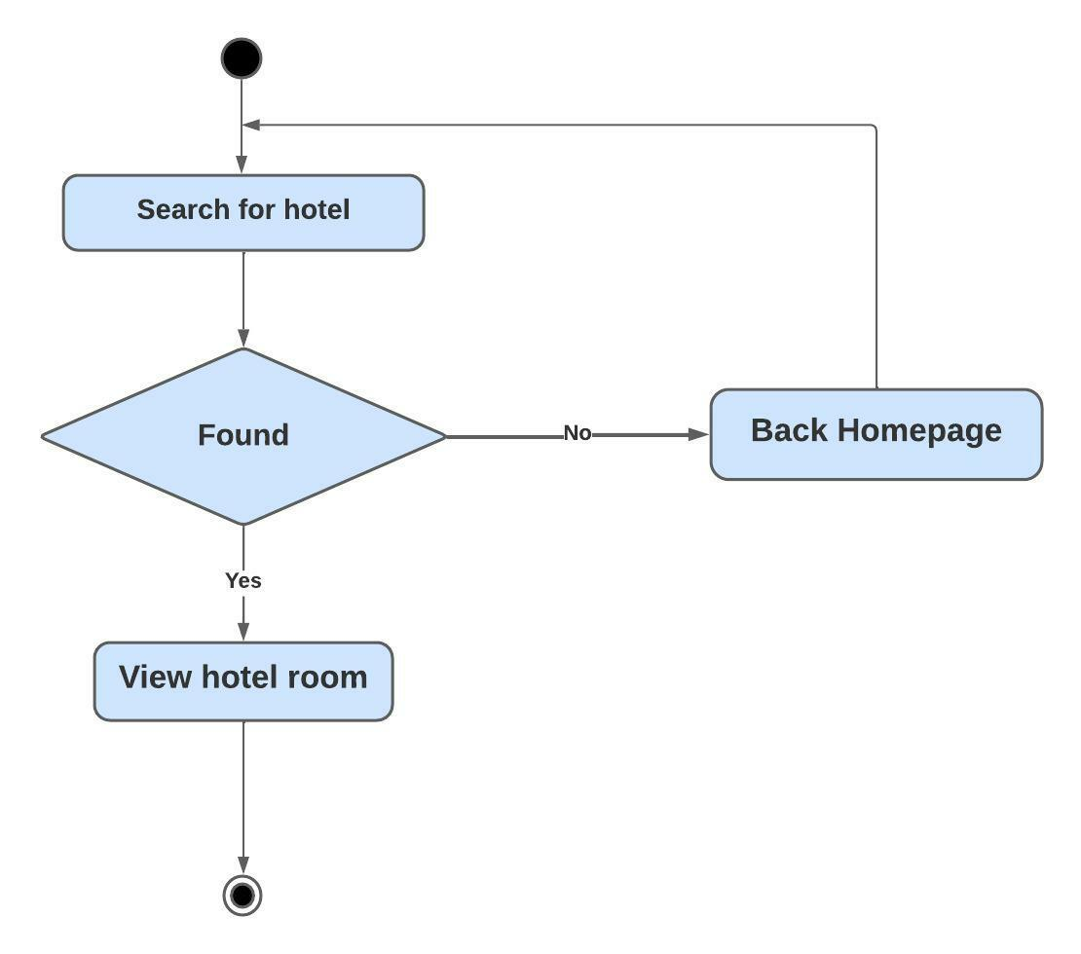

View Availability of Rooms
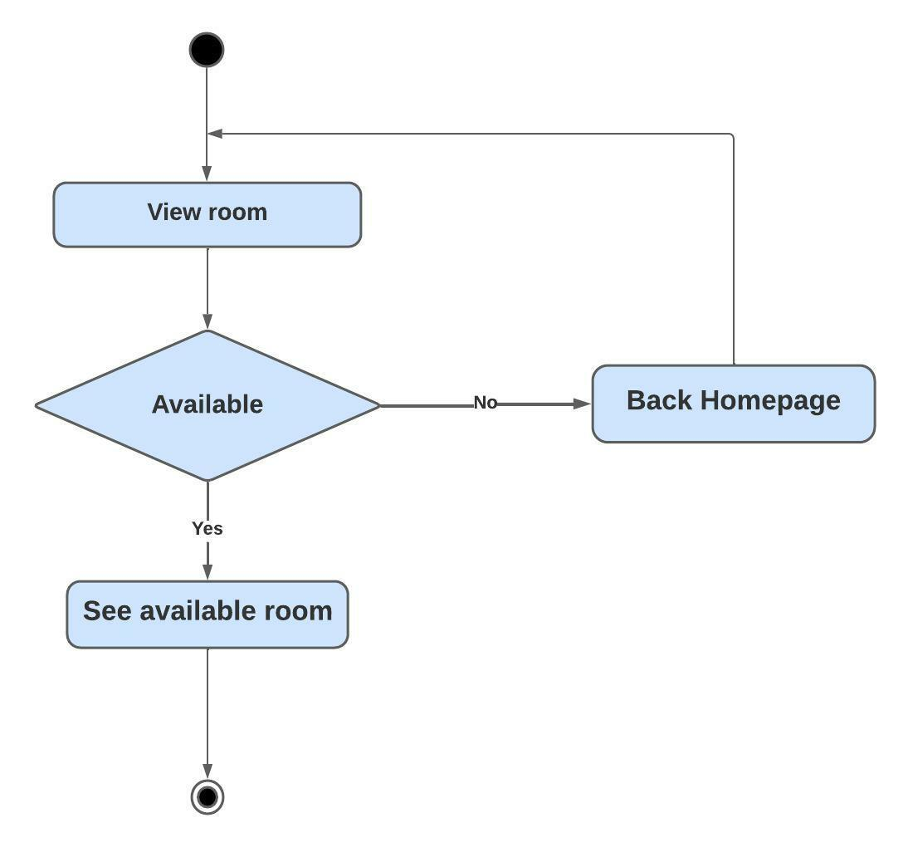

View
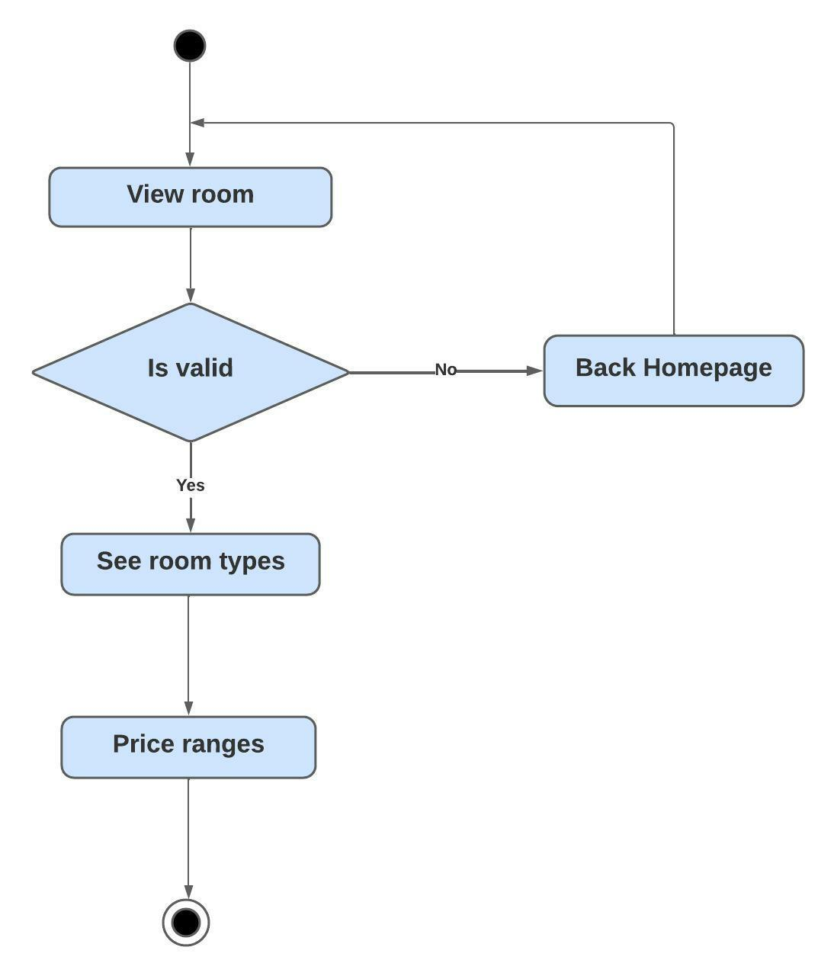

View Discount
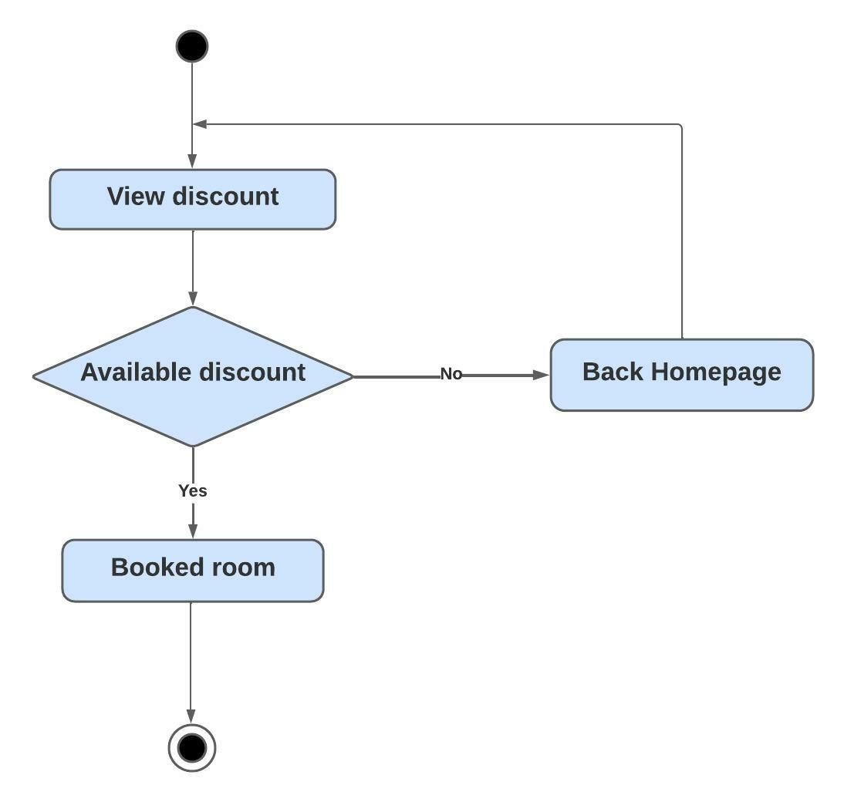

Update Room
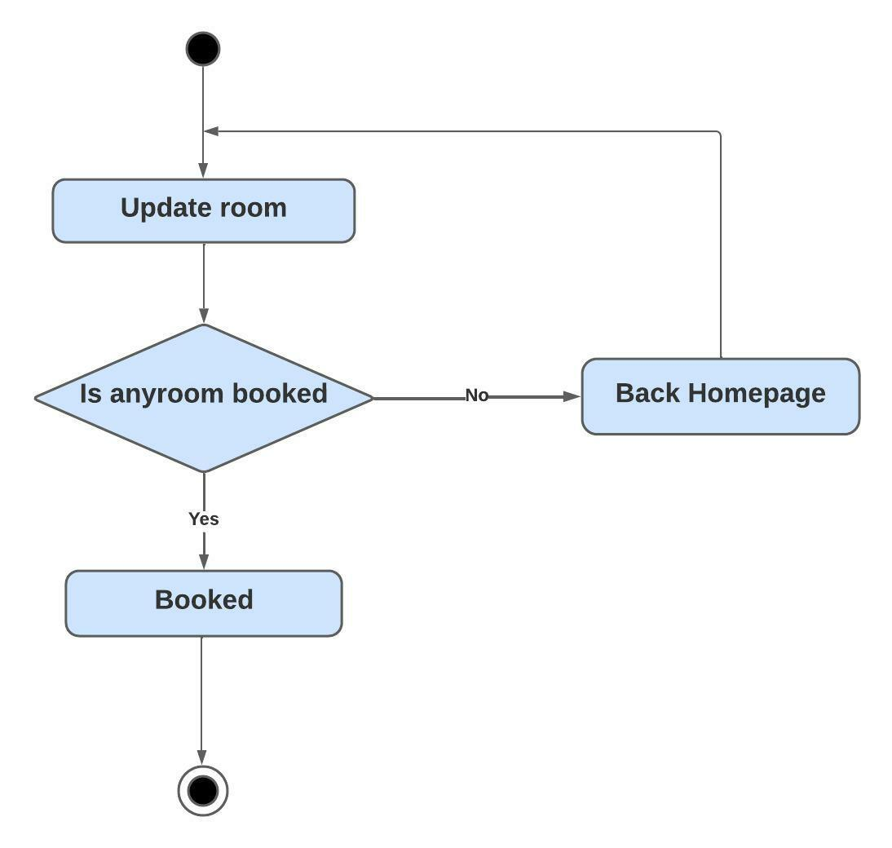

Update Price
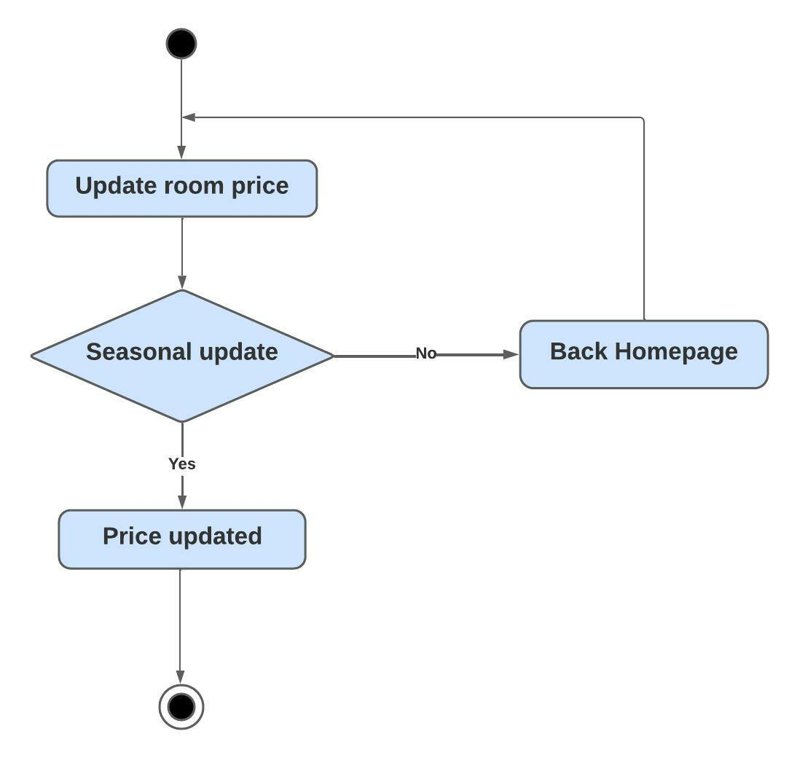

Update Discount
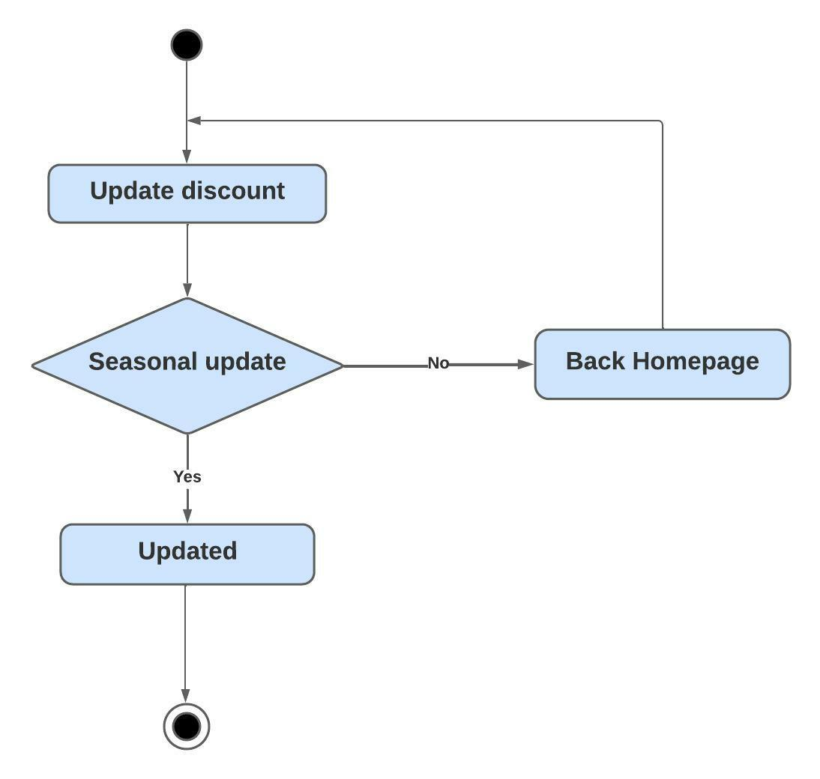

3.4 Sequence Diagram

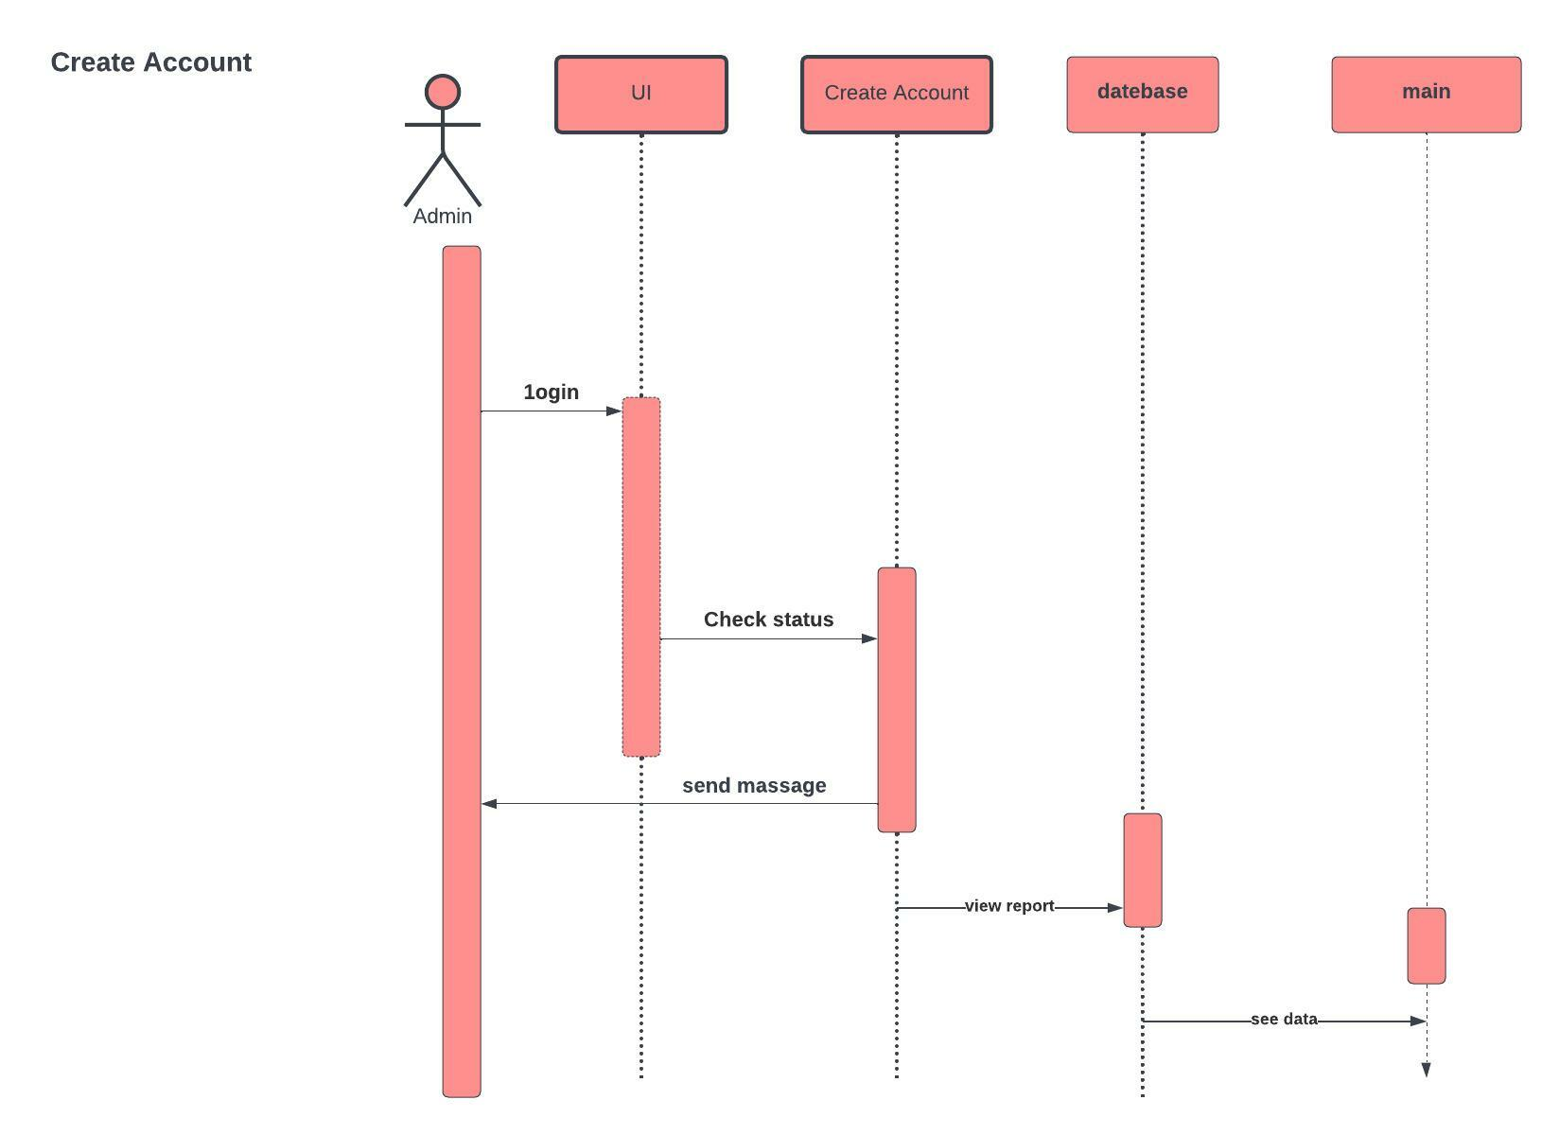

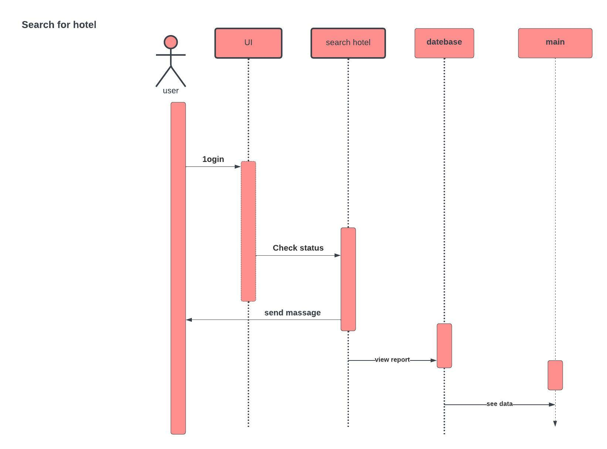

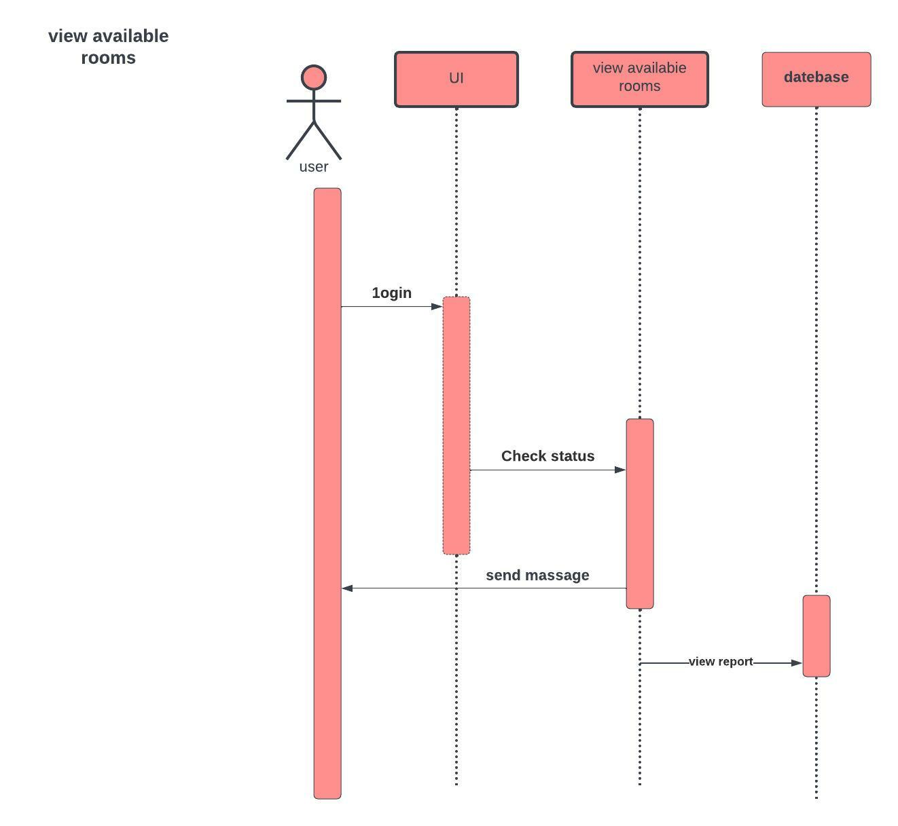

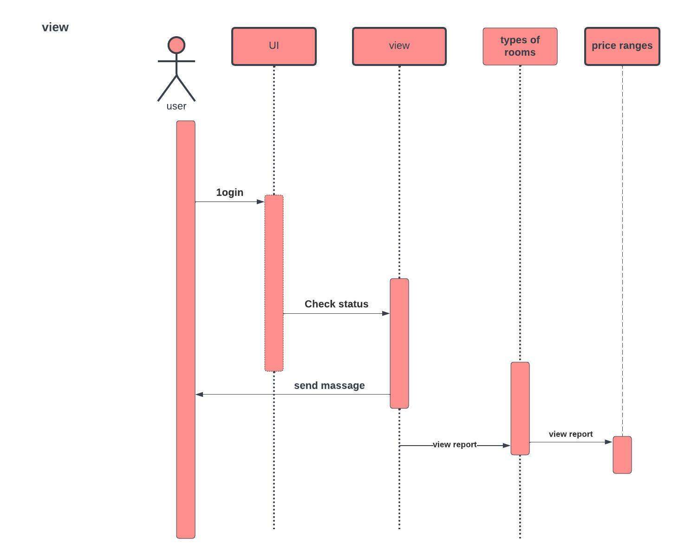

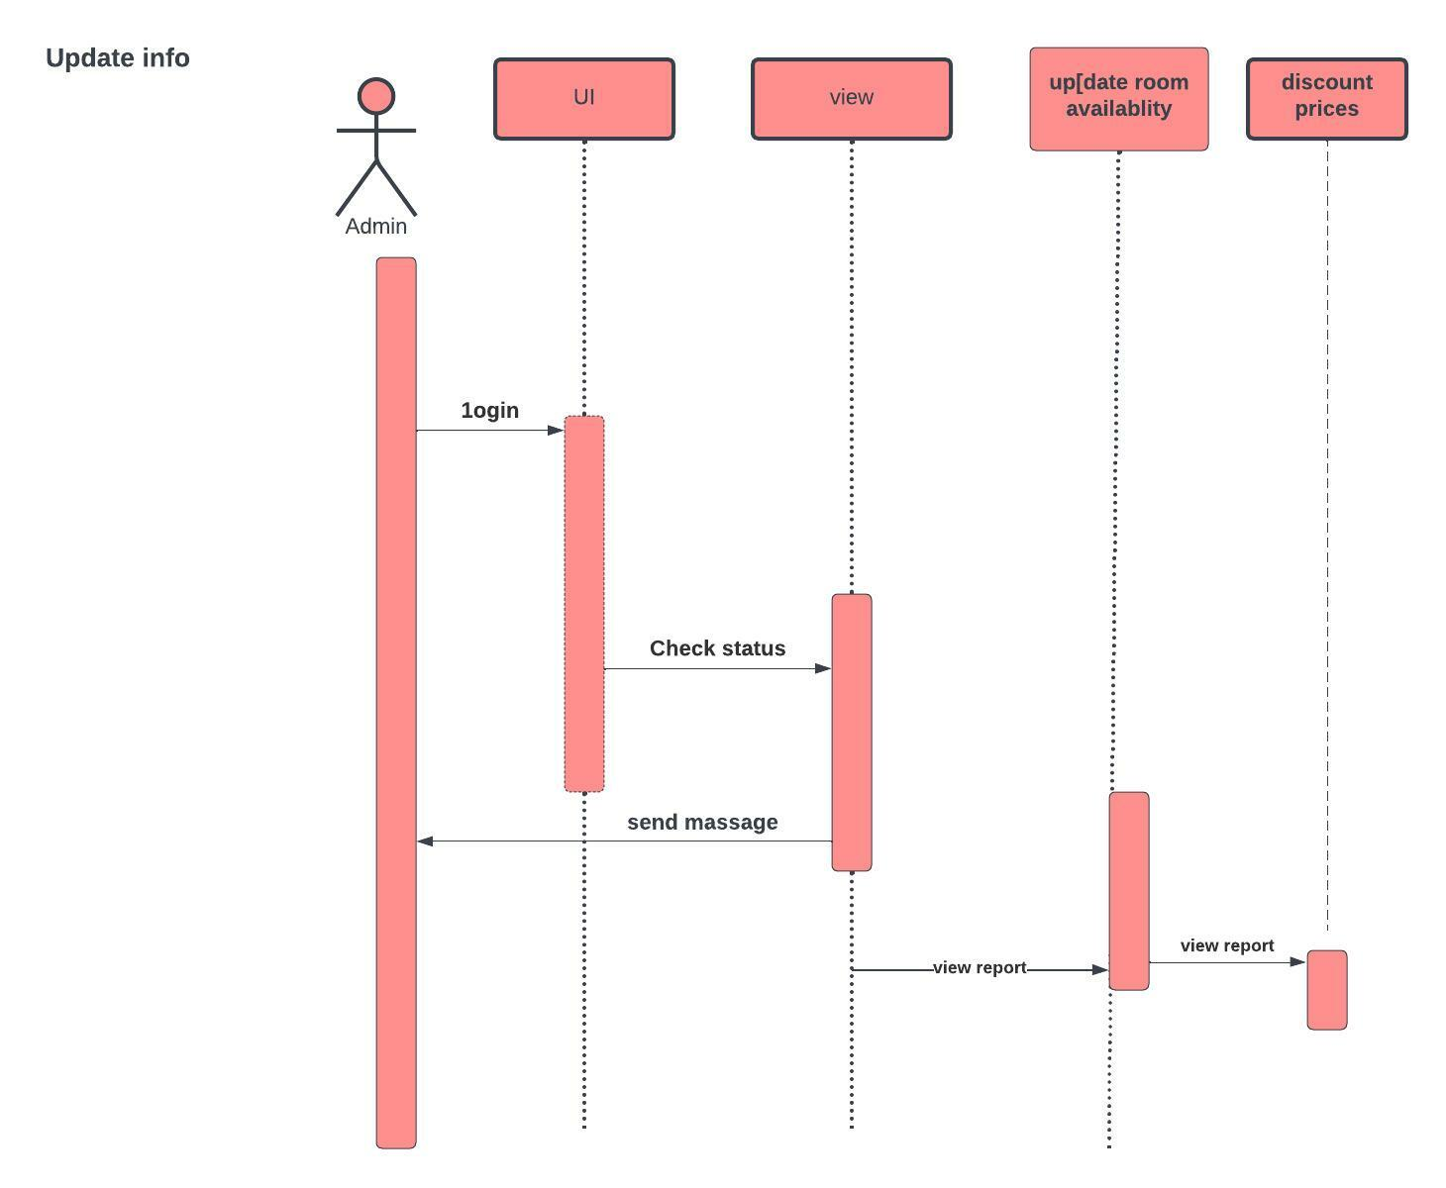

3.5 Class Diagram:

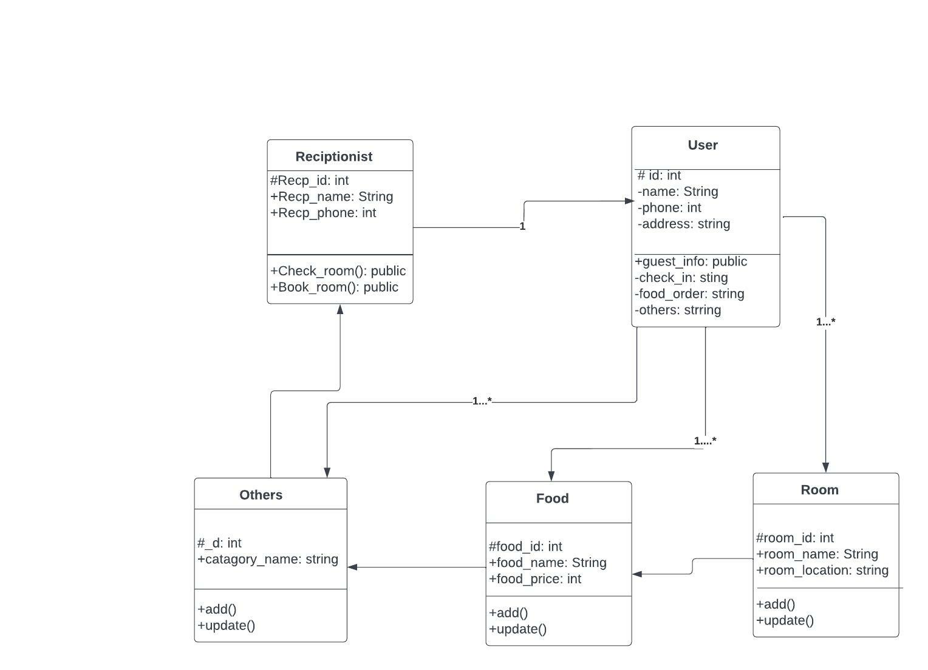

3.6 Entity Relationship Diagram

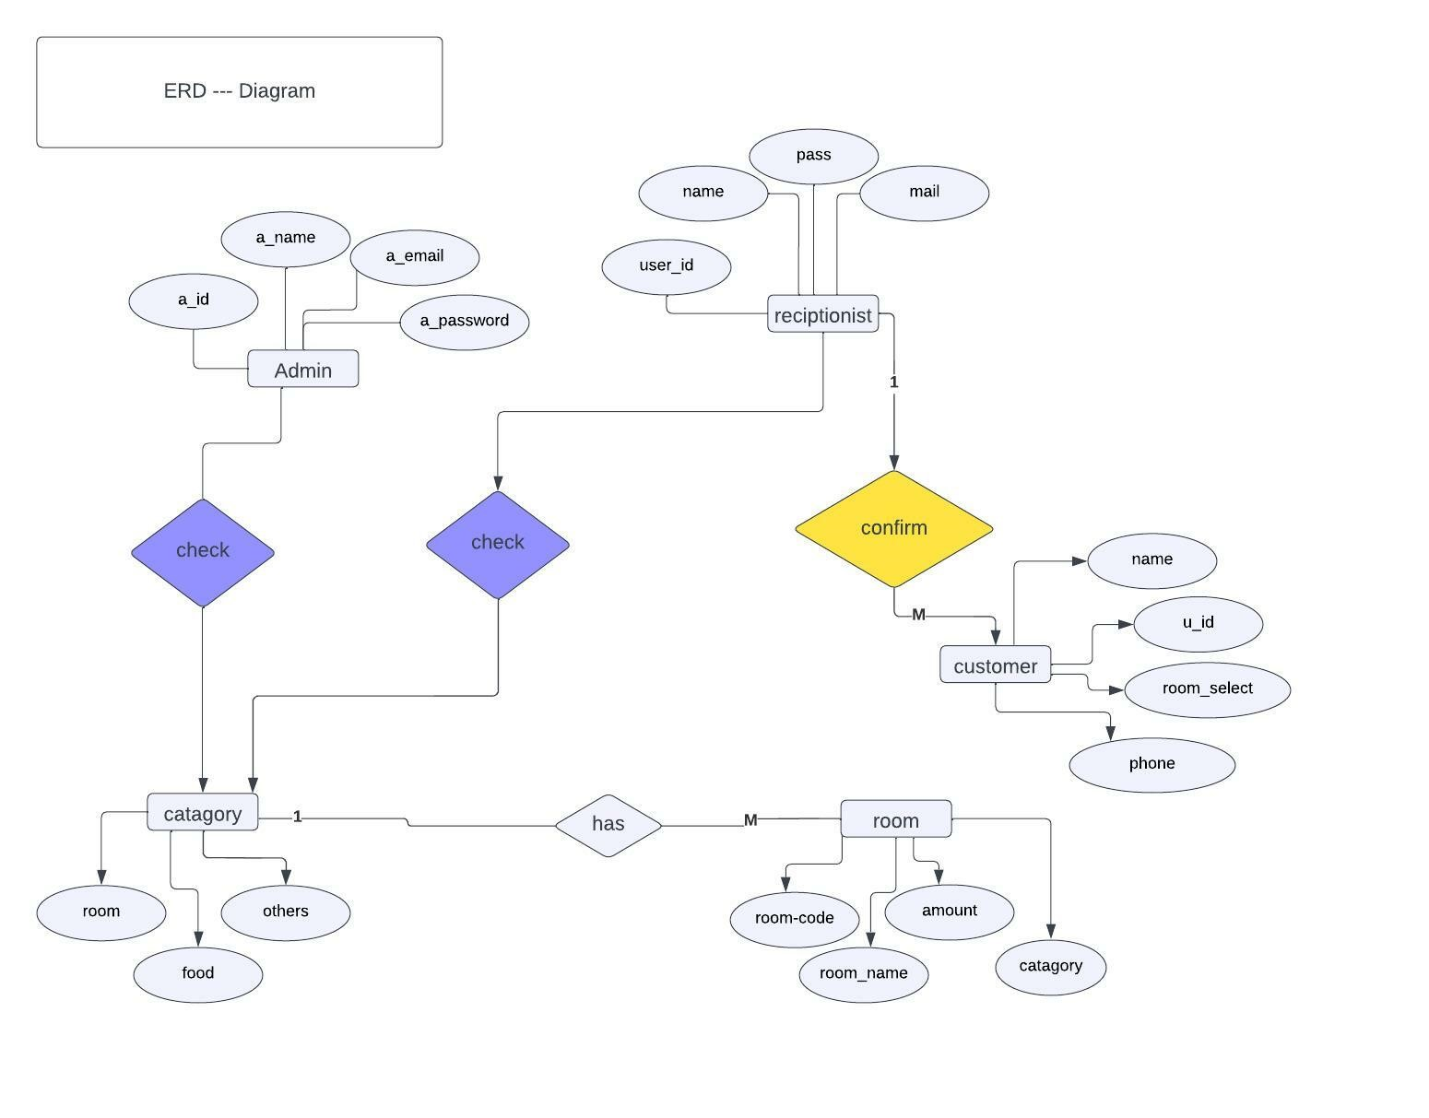

CHAPTER 4: SYSTEM TESTING

4.1 Feature Testing
Include testing is considered to add and alter the element arrangement of the new highlights. New usefulness of the framework will be shown up at with the highest framework. Also, the fundamental. Those are intended to make the web application more productive, valuable, solid, compelling and secure.

4.1.1 Features to be tested
Feature | Priority | Description
Log in | 1 | The client should be confirmed by the administrator.
Log out | 3 | The meeting should be obliterated after log out.
Registration | 2 | Client data should be saved appropriately.
Check schedule | 1 | Requesters should be present their solicitation to the specialist organizations.
Confirmation | 1 | Specialist organizations will affirm demand by the requesters.
Search provider | 3 | Requesters need to scan specialist organization for taking their administrations.
Change Password | 2 | Clients can be changing their secret key when required.

Figure 4.1: Features priority table

4.2 Test Strategies
4.2.1 Test approach
I have utilized two unique kinds of testing to guarantee the nature of my framework. I zeroed in on useful testing and underlying testing chiefly.
▪ Discovery Testing (likewise called utilitarian testing) will be trying that overlooks the interior component of a framework or part and spotlights exclusively on the results created in light of chosen data sources and execution conditions.
▪ White-box testing (likewise called primary testing and glass box testing) will be trying that considers the inward instrument of a framework or part.
4.2.2 Testing Schedule
Test phase | Time
Testing plan create | 1 week
Unit testing | During development time
Component test | During development time
Testing user interfaces | 1week
Performance testing | 1week
Accessibility testing | 1week

CHAPTER 5: USER MANUAL

Home:

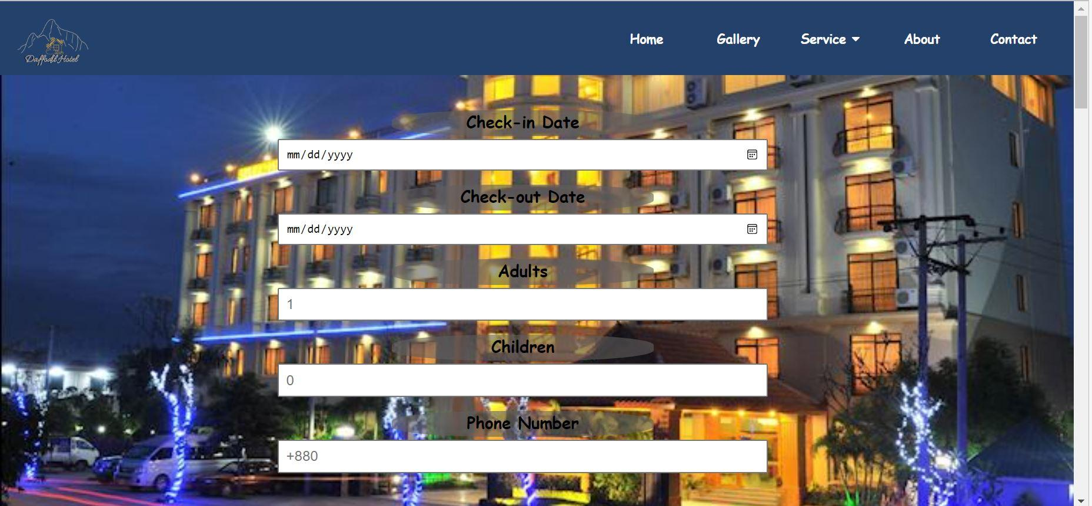

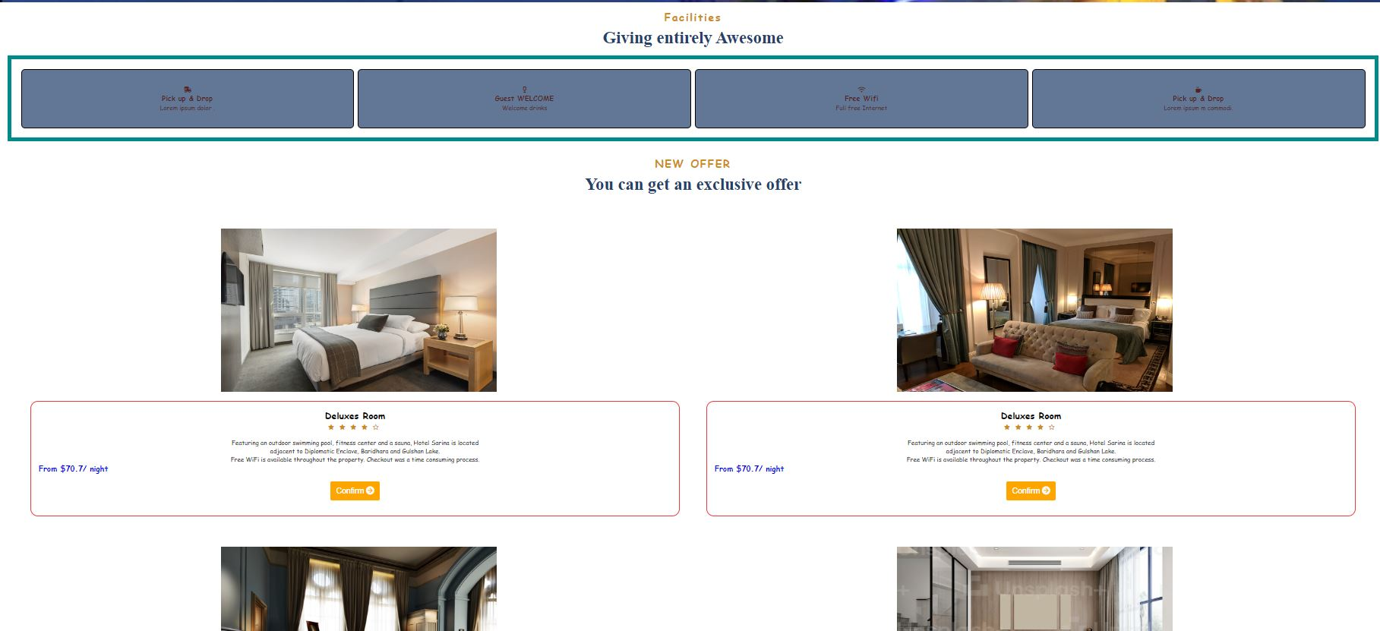

Gallery:

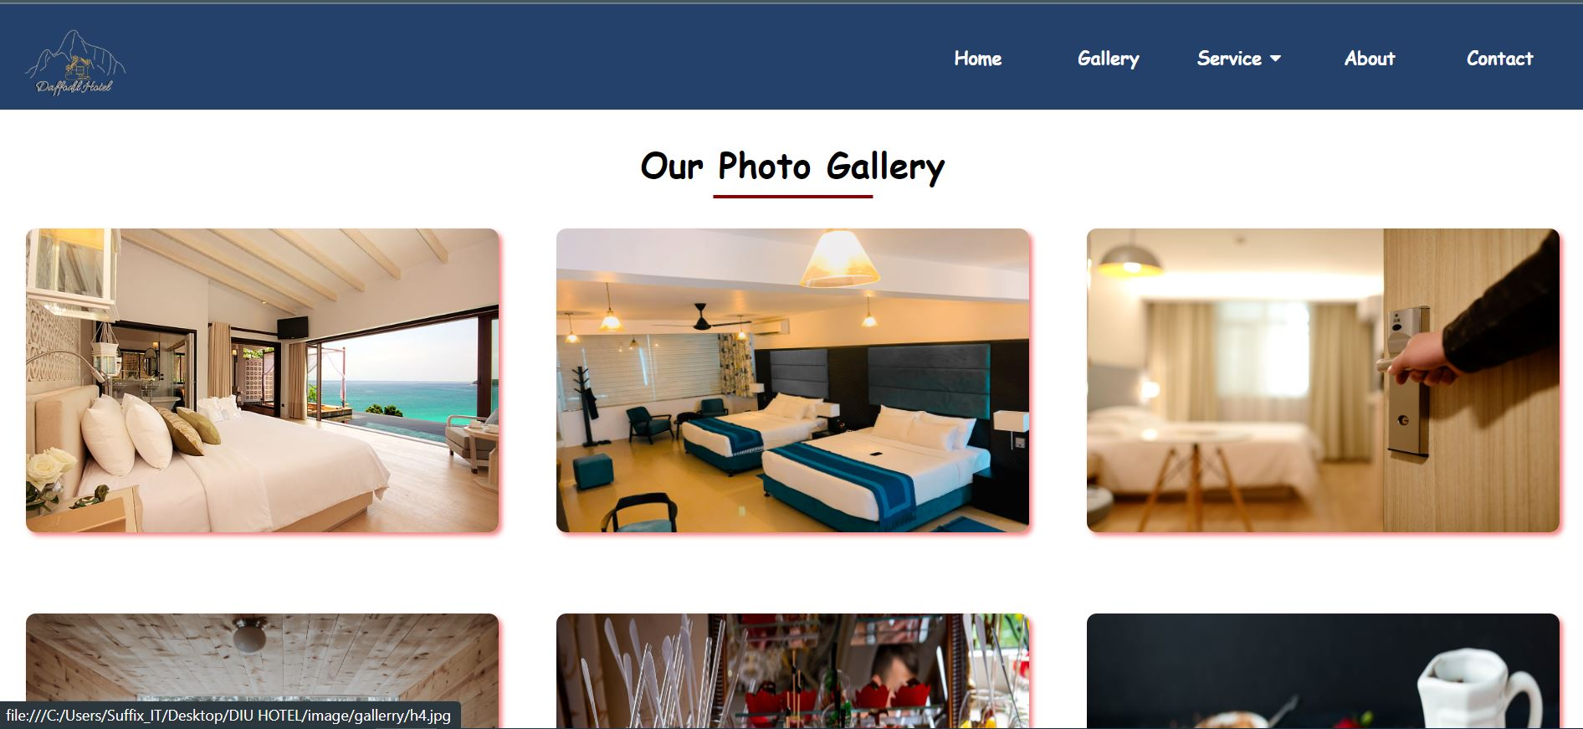
Food:
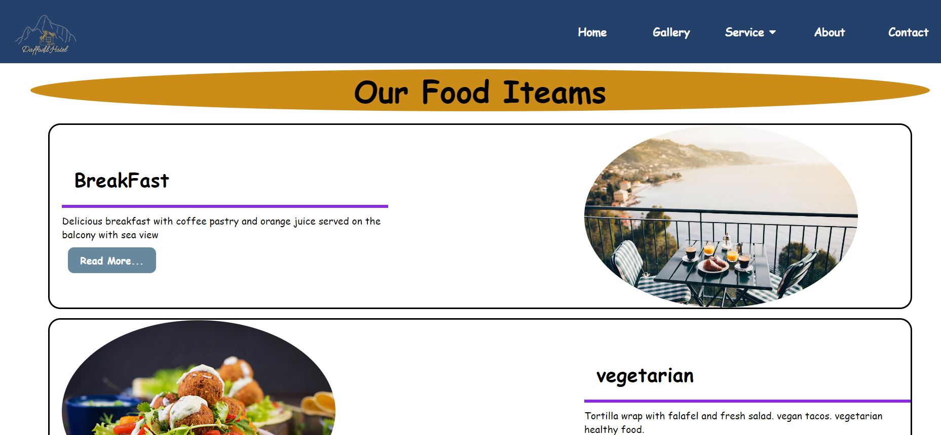

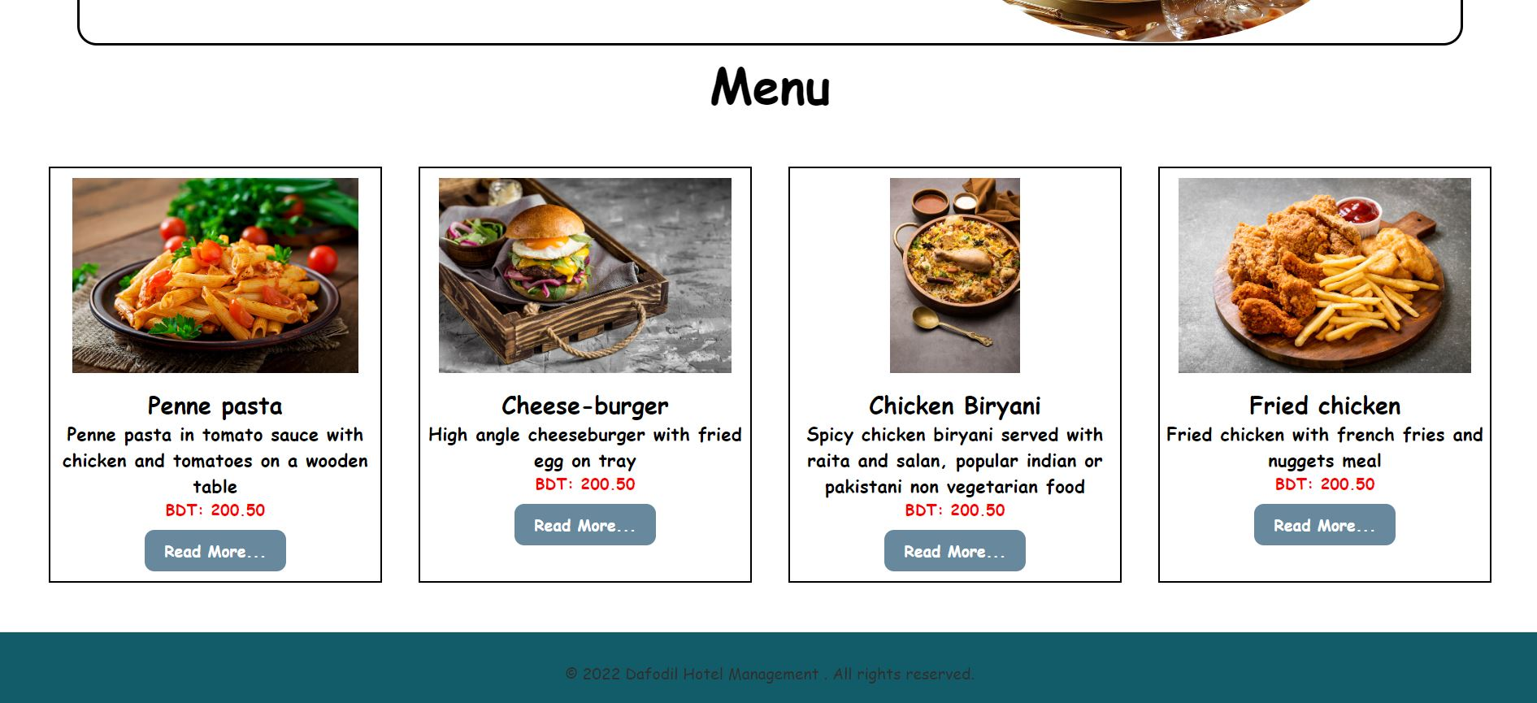
Room:
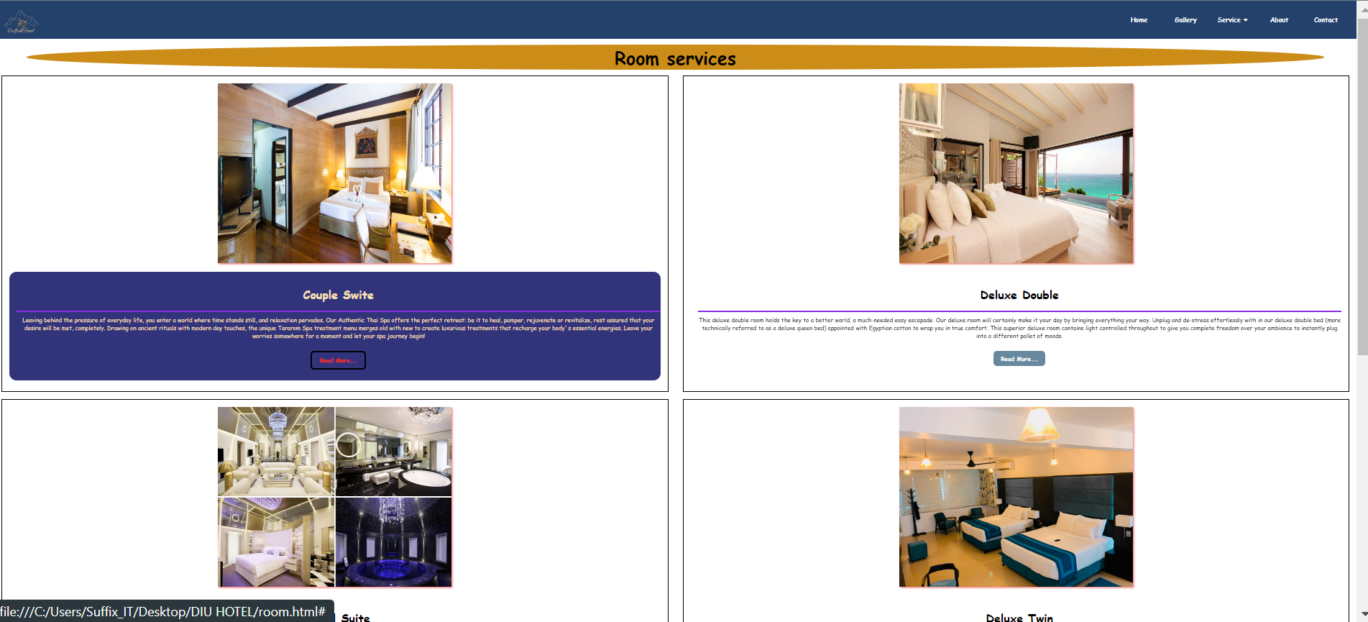

Others:

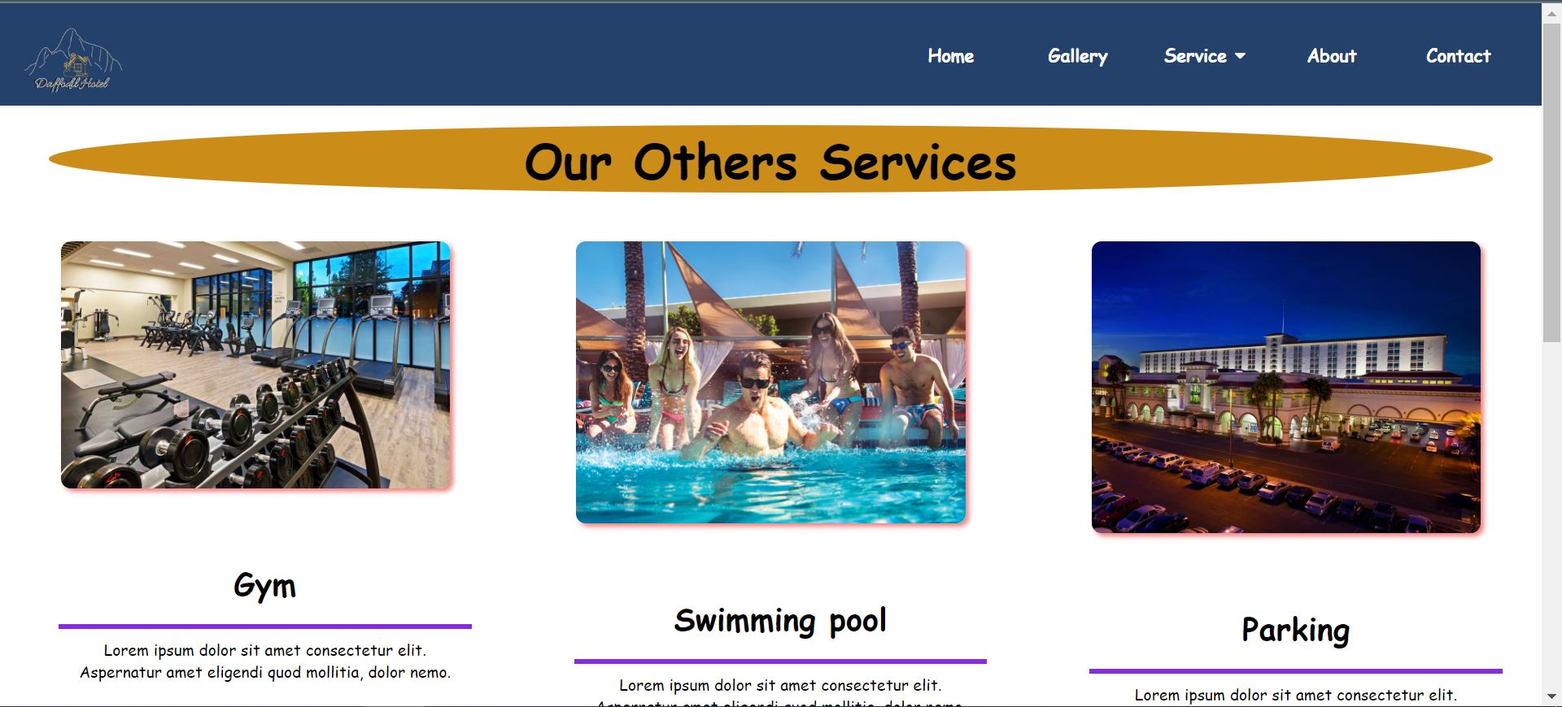
About:

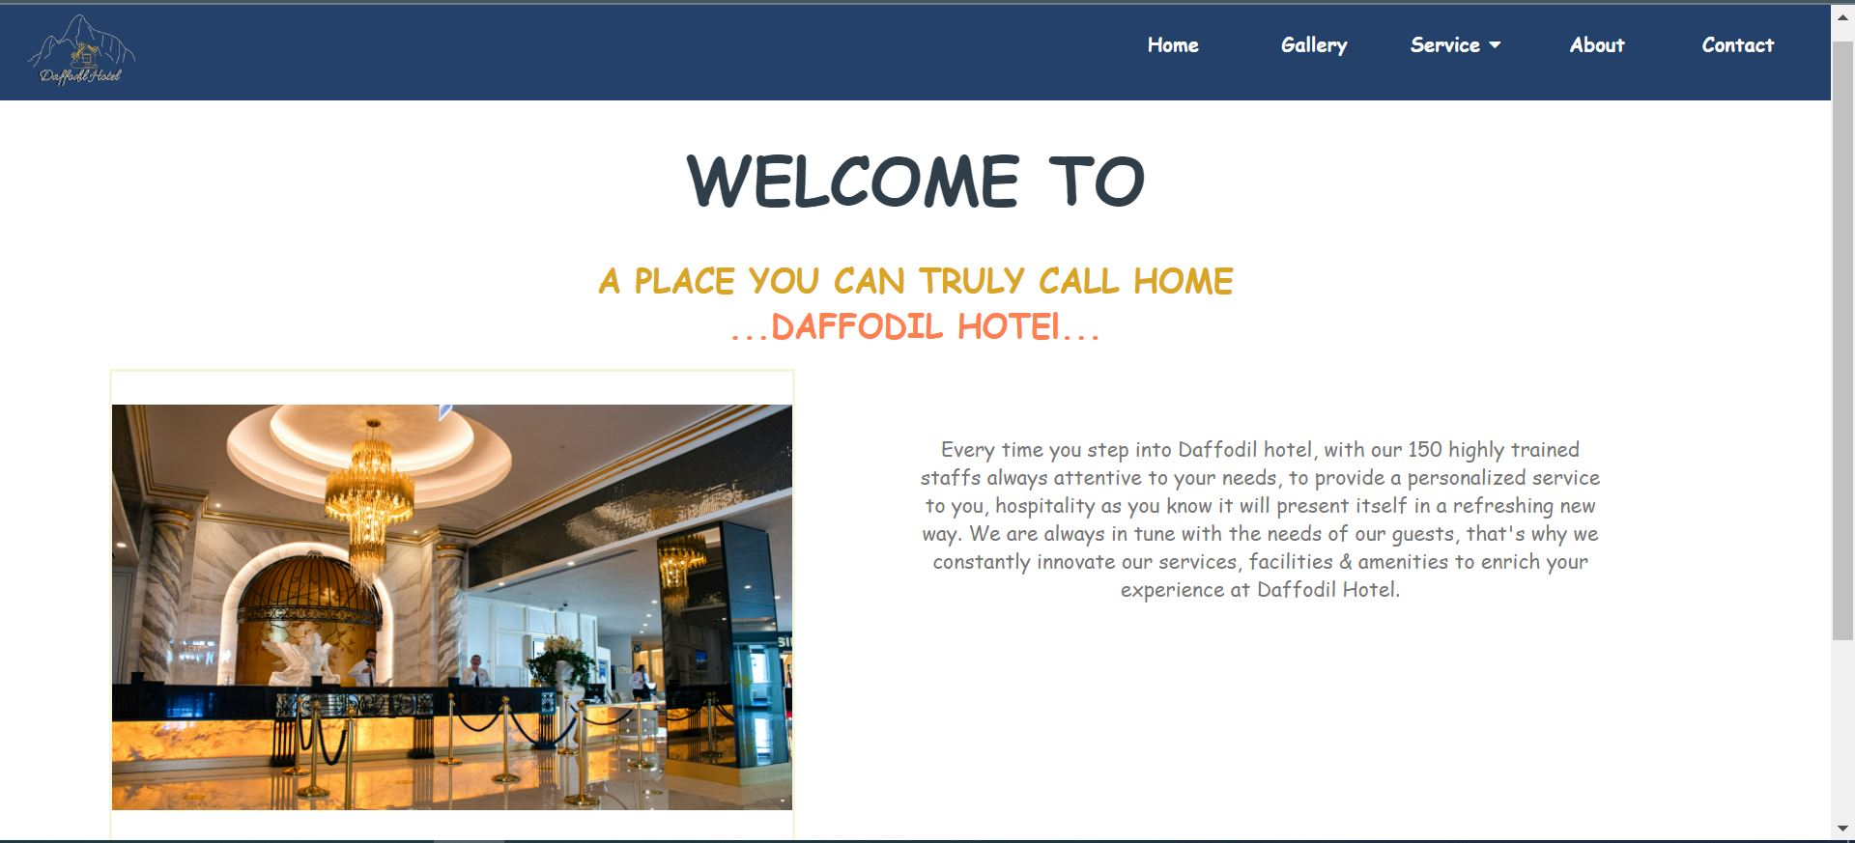

Contact:

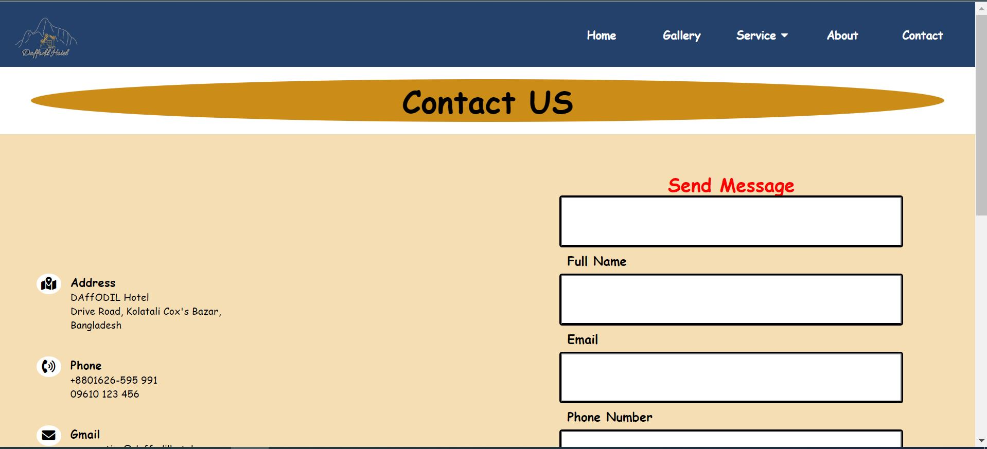
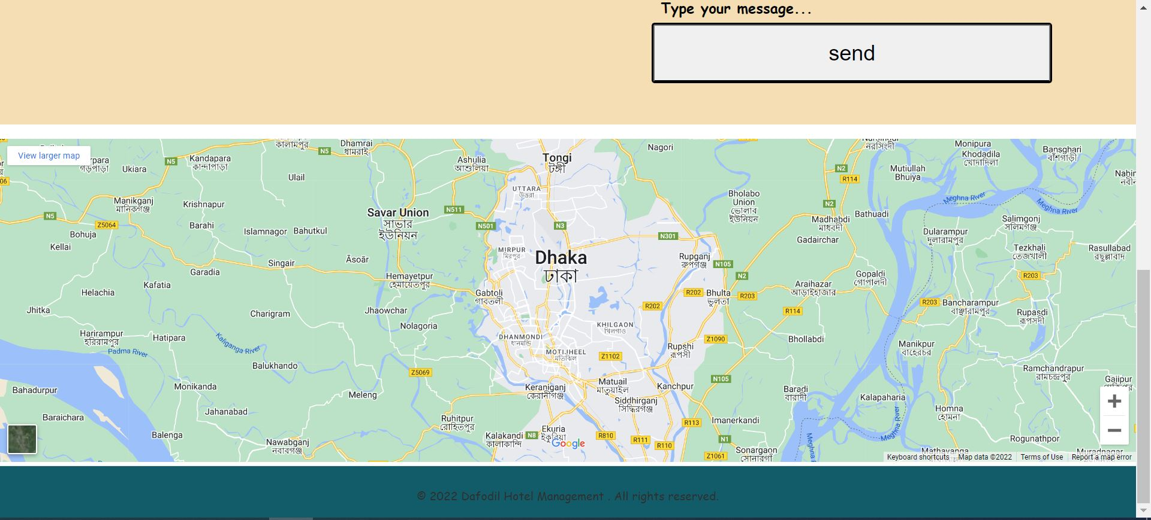

Admin Dashboard:

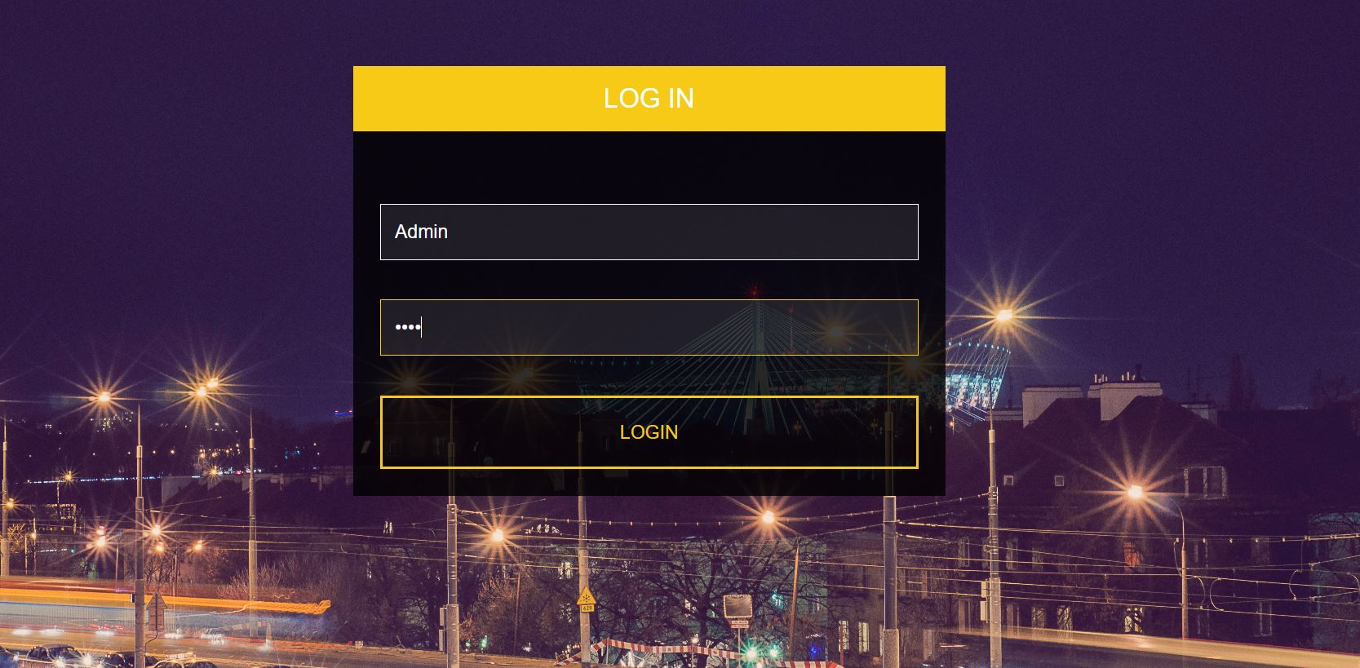

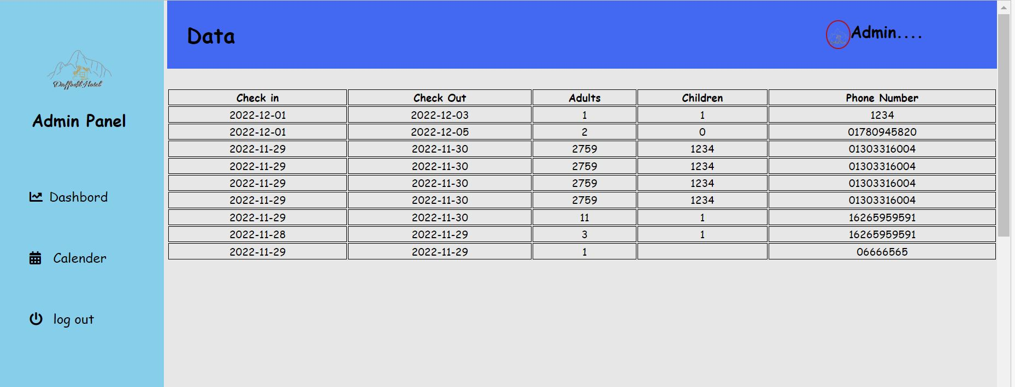

CHAPTER 6: CONCLUSION

6.1 Project Summary
"Daffodil Hotel management system" is a moment online assistance framework. At the point when a client registers to this framework there will be a choice to choose date, time and various classifications of space to play out their ideal program. Lodging the board project gives room booking, food administration and other vital inn the executives highlights. The framework permits the supervisor to post accessible rooms in the framework. Clients can view and book rooms on the web. Administrator has the force of one or the other endorsing or disliking the client's reserving demand. Other lodging administrations can likewise be seen by the clients and can book them as well.
I have finished this task from wanting to advancement inside a tight period and finished the framework prepared to utilize. This framework ought to be refreshed routinely as the undertaking advances.

6.2 Tool and platform
Hardware specification:
processor | 1.6 GHz or faster process
Ram | 1.5GB
Disk space | 4GB of available hard disk

Software specification:
Operating system | Windows 10
Front End | HTML, CSS, JS
Frameworks | React
Back End | PHP
Text Editor | Visual studio code
Database | MySQL
Web browser | Google chrome
Web server | Apache
Drawing tools | Visual Paradigm Online

6.3 Limitations
• SMS ready office isn't accessible.
• Entry isn't Website design enhancement agreeable.
• Enlistment Email check not accessible.
• Risk unapproved openness.

6.4 Future Scope
The different things can be simplified and easy to understand. As by expanding a portion of the coding we can work on its usefulness. Further develop correspondence and cooperation. Accomplish the venture targets inside the given requirements. Remain proactive to relieve takes a chance ahead of time.
Deal with partner's assumptions. Augment your commitments. By as the following headway we can make it ready to package the reinforcement office so one can perform tasks in view of past records. As the innovation arises, it is feasible to update the framework and can be versatile to the ideal climate. In view representing things to come security issues, security can be further developed utilizing arising advancements.

