
Report on Industrial attachment at:

Kanchpur, Narayangonj
Course code: TE-410
Academic supervisor:
Dr. S.M. Mahabubul Haque Mazumder Prof. of TE & Dean
Faculty of FSIT
Daffodil International University

Submitted by:
Md. Mohidul Islam 091-23-1378
Arfana Rahman 091-23-1390

Date of submission: 28-11-2012

Abstract:

The aim of Industrial Training is to know the practical knowledge about Textile Wet Processing. It is a complete solution of a Trainee Textile Engineer as a way of job working. It helps to acquire knowledge about production, management, work description, inventory control, quality control, ETP, WTP & necessary information about textile processing.

Thus the part of a course credit of Textile Engineering at Daffodil International University, I have chosen my Industrial Training in Sinha Textile Group. And it helps me to know the theoretical knowledge in practical.


ACKNOWLEDGEMENT:
At first our gratefulness goes to Almighty Allah to give us strength & ability to complete this project. We have made our life more bountiful.
A number of people have made significant contributions to the preparation of this report. Their insights, advice and suggestions helped us a lot.
Firstly, we are very much thankful to our head of the department Prof. Dr. Md. Mahbubul Haque for his encouragement and valuable suggestions for incessant improvement of the report.
We would also like to thank our supervisor & dean of TE, Prof. Dr. S.M. Mahbubul Haque Majumder for all necessary information delivery as well as for many technical help.
We would like to thank the Chairman, Managing Director, General Manager, Deputy General Manager, Manager, Assistant Manager, Senior Production Officer, Production Officer, Assistant Technical Officer, Technical Officer Of Sinha Textile Group, who gave us scope & helped for doing industrial attachment in the factory as well as for giving scope to work in their respective section.
Being working with them we have not only earned valuable knowledge but was also inspired by their innovativeness which helped to enrich our experience to a greater extent. We believe this report could not be finished if they did not help us continuously.
We are also very much grateful to Sinha Textile Group authority for giving us opportunity to do our internship work in their factory.Finally we want to give thanks for all the workers, supervisors who have assisted, helped &inspired us to complete this report at various stages.

Content:
Chapter no | Topics | Page no
01 | Introduction | 1-4
02 | Company profile | 5-13
03 | SDFL | 14-23
04 | Raw materials | 24-28
05 | Pretreatment | 29-50
06 | Dyeing | 51-61
07 | Printing | 62-66
08 | Finishing | 67-86
09 | Dyeing lab | 87-93
10 | Quality control system | 94-118
11 | Maintenance | 119-125
12 | Utility | 126-129
13 | ETP | 130-136
14 | Conclusion | 137-138
 | Appendixes  - List of figures  - List of tables  - List of Abbreviations  - List of symbols | 139-141

Chapter: 01
Introduction


Exclusive summary:

The internationally recognized Buyers or clients are looking for those countries for producing their apparel products where different types of mills have established as a one stop source forthe global apparel market ,satisfy and meet customer’s expectation by developing andproviding products and services on time , which offer value in terms of Quality, Price ,Safetyand Environmental impact. & also assure complete compliance with the international qualitystandards and also to provide the employees internationally acceptable workingconditions/standards.

In Bangladesh, there are different types of Textile Industry those areproducing high quality textile and apparel products. Sinha Textile Group. Is one of them?

Sinha Textile Group is a Composite knit Garment, having all state of the art facilities with the annual turnover more than US$ 100 Million last year. They have different types of Knitting, Dyeing, Cutting, Sewing, and Finishing machines supplied by mostly Germany, Spain, Belgium, U. K, U. S. A, France, Norway etc. Which are very latest?

It has high production where Metric Tons of Dyed and Finished fabrics are produced per day. The production is controlled by technical persons. All of the decision marks of production sectors in Sinha Textile Group are Textiles Graduates.

All the chemicals and dyes use for dyeing and finishing are well branded. They produce their product for their buyer and client those are coming from international market like U.K, Sweden, Nether and, France, U.S.A, Germany, Spain. Their customer profile is big and top end such as New Wave (Sweden), Umbro (U.k), Jara(Spain), etc. They follow all the system for their machines maintenance, so production can not hamper.

In this report, we have tried to give some information about Sinha Textile Group and we have observed that Sinha Textile Group. Produce high quality fabric and fulfill the special requirements from the different types of buyers by following different internationally recommendedstandard method.

Introduction:

Textile technology education is based on industrial ground. Theoretical background is not sufficient so, industrial training is an essential part of study to make a technologist technically sound in this field. We as the gratitude’s of textile technology must acquire adequate practical knowledge to coup up with the challenge that we will face in future. Industrial training provides us that opportunity to gather practical knowledge.
The main objective of this project is to acquire knowledge about dyeing &present condition of dyeing market in Bangladesh. It also enables us to orient ourselves with the practical environment that will work in future. we systematically learned about various steps of dyeing process & market.
Sinha Textile Group is a truly integrated undertaking. The textile division has the capability to offer a complete product range for the export & domestic textile markets. The goal of the textile division is to become the preferred partner for sourcing high quality fabrics & clothing from Bangladesh. With high advanced technology & an emphasis on developing local human resources, the textile division has the potential to make an important contribution to the nation’s growing readymade garments export sector.
The rationale behind the existing structure & future expansion of the textile division is to capture value added at each stage of the textile manufacturing process. Despite Bangladesh’s lack of indigenous cotton production capability, STG has leveraged Bangladesh’s labor cost advantage & export competitiveness to maximum level.

.

Brief description of textile:-

The term ‘Textile’ means originally a woven fabric, but textile & the plural textiles are now also applied to fiber, filament & yarn. Natural & manufactured & most products for which these are a particular raw material.
This definition embraces, for example fiber- based products in the following categories: threads, cords, ropes & braids; woven, knitted & non woven fabrics, lace, nets & embroidery; hosiery knitwear & made up apparels; household textiles, soft furnishing & upholstery; carpets & other floor coverings; technical, industrial & engineering textiles include geo textiles & medical textiles.
Some necessary terms in textile processing & production are given below-
FIBRE:Textile raw materials generally characterized by fineness, flexibility&higher ratio of length to thickness.
YARN: A product of substantial length & relatively small cross section consisting of fiber(s) and/or filament(s) with or without twist.
FABRIC: A manufactured assembly of fibers and/or yarns that has substantial surface area in relation to its thickness& sufficient cohesion to give the assembly useful mechanical strength. Common processes of fabricmanufacturing are weaving, knitting & non woven.
- Weaving: The action of producing fabric by interlacing of warp & weft threads.
- Knitting: The process of manufacturing of fabric by the intermeshing of loops of yarn.
- Non-woven: The process of producing of fabrics by chemical bonding of fibers.



Chapter: 02
Company profile


Company profile:
Name of the factory: Sinha Textile Group(STG)
Owner of the mill: Mr. Anisur Rahman Sinha
Location of the mill: Kanchpur, Sonargaon, Narayanganj
Status:Private Limited Company
Total area of the industry: 140000 sq. feet
Head office: Mohakhali Tower
82, Mohakhali C/A
Dhaka-1206, Bangladesh
Year of establishment: 1991
Commercial production: 1997
Total production: 5000 m/day (woven) &5 ton/day (knit).
Physical infrastructure: -single storied building (only dye warehouse is double storied)
-concrete structure (about 30 ft high)
Business line: Manufacturing & Marketing of high quality yarn & fabric.

- Different dept.:
- Production oriented department:
-production planning &control
-yarn
-weaving
-knitting
-batch preparation
-Dyeing
-finishing
-lab & quality assurance
-dye warehouse
-maintenance
-utility
-finished warehouse
- Supporting department:
-personal administration
-procurement
-marketing
-IT
-HRD
-finance & accounting
- Different department:
To turn the factory smoothly, there is some department in the factory. They are given below:
Dyeing section:
-batch section
-dye house
-dyeing lab
-quality control
-finishing

Maintenance:
-electrical
-mechanical
Accounts & commercial section:
Admin section:
-time section
-cleaning
-security
- Store

Total turnover:

Vision:Building a true marketing led enterprise with motivated workforce, innovative vision, and strong revenue based product portfolio, customer satisfaction & understanding of global market.
Mission: Each of the activities must benefit & add value to the common wealth of our society. We firmly believe that, in the final analysis we are accountable to each of the constituents with whom we interact; namely our employees, our customers, our business associates, our fellow, citizens & our shareholders.
To attain these objectives, the management of Sinha Dyeing & Finishing Ltd. Has decided to adopt the following-
- To increase awareness regarding customers requirements throughout the organization.
- By providing training to develop efficiency of the employee.
- To collect customer’s feedback regularly to know about their conception about their company & to take timely appropriate action.
- To reduce the percentage of wastage /rejection minimum by 2% per annum’s implement & monitor ISO 9001:2000 quality management system within the organization.
- Production of export quality woven fabric.

List of Buyers:





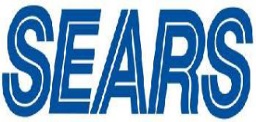

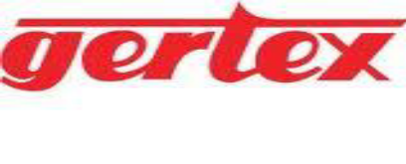

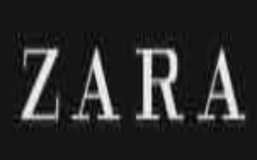

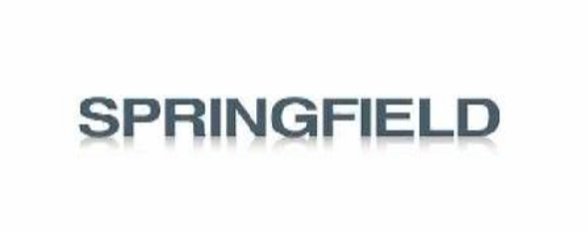



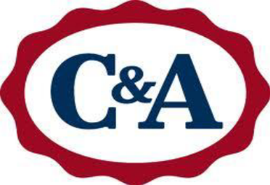


Management System:

The company has skilled administration, management and marketing team guided byProficient, dexterous & experienced leaders of offer right solution for the consumers with the right eminence & with the shortest lead-time for the export market in Bangladesh.
The best use of continuous development of human resources by providing them Internationalstandard equal opportunity is the keys achieving comprehensive competence in all of theorganization hierarchy.

- Management Organogram:

Chairman

Director

Deputy General Manager/ Executive Director

Prod. Quality Maint. Utility Store Accounts Admin. Marketing Security

Prod. Quality Maint. Utility Store Accounts Admin. Marketing Security
Mngr Mngr. Mngr. Mngr. Mngr. Mngr. Mngr. Mngr. Officer

Assist. Senior Maint. Utility Senior Accounts Admin. Marketing Assist.
Mngr Officer Engr. Engr. Officer Officer Officer Officer Officer

Senior Sub Officer Cashier Assist. Security
Prod. Officer Foreman Assist . admin. Guard
Officer Engr. Helper Officer.

Prod. Lab. Fitter Worker Worker
Officer Assist.

Assist. Lab. Helper
Prod. Boy
Officer Worker

M/c
Operator

Helper

Worker

Shift change:

Per shift 8 hours
1st Shift= 6.00A.M.-2.00P.M
2nd Shift=2.00P.M.-10.00 P.M.
3rd Shift=10.00P.M.-6.00A.M

General Shift= 8.00A.M.-4.00.P.M

Duties & responsibilities of production officer:

- To collect the necessary information & instruction from the previous shift for the smooth running of the section.
- To make the junior officer understand how to operate the whole production process.
- To match production sample with target shade.
- To observe dyed fabric during finishing running & also after finishing process.
- To identify disputed fabrics & report to PM/GM for necessary action.
- To discuss with PM about overall production if necessary.
- To sign the store requisition & delivery in the absence of PM.
- To execute the overall floor work.
- To maintain loading/uploading paper
- Any other assignment given by the authority.

Duties & responsibilities of production officer:

- Overall supervision of dyeing & finishing section.
- Batch preparation & p^{H} cheek.
- Dyes & chemicals requisition issue & cheek.
- Write loading/uploading time for machine.
- Program making, sample checking, color measurement.
- Control the supervisor, operator, asst. operator & helper of dyeing machine.
- Any other work as & when required.

Duties & responsibilities of DGM (production):

- Overall supervision of dyeing & finishing section.
- Check the sensitive parameters of different machines for smooth dyeing.
- Check the different log books in different areas & report to management.
- Check the plan to control the best output.
- To trained & motive the subordinates how to improve the quality production.
- Control the supervisor, operator, asst. operator & helper of dyeing m/c.
- Maintenance the machinery & equipments.
- Any other work as & when required.

Chapter: 03

Sinha dyeing & finishing limited



Dyeing & finishing section:

GM

DGM

PM

SPO Batch in-charge Finishing in-charge lab in-charge

PO Sewing man sewing man lab Technician

APO Turing m/c squeeze Q.C
Operator Operator Technician
Supervisor
Helper dryer Helper
Sr. Operator Operator

Asst. Operator Sanforizing
Operator
Operator

Helper

Layout of Sinha Dyeing & Finishing Limited:

FFS MR EXIT ER RFS GFS

T

A

A

D
1

E
1

P

F3

F2

F1

C

C

I

K

S
3

S
2

S
1

D
2

B

B

E
2

H

L

R

E

PS DR QC TL CR DT Pr.M DM AdM SPZ ST

Sinha Dyeing & Finishing Limited:
Here,
A- Singeing & Desizing Machine
B- Continuous Scouring & Bleaching Machine
C- Mercerizing Machine
D1- Thermosol Dyeing Machine
D2- Pad Steam Machine
E1- Electrolyte Control Dyeing Machine
E2- Washing Machine
P- Screen Printing Machine
K- Color Kitchen
L- Loop Steamer
S- Stenter Machine
F- Sanforizing Machine
I- Brush Machine
H- Peach Machine
R- Calendaring Machine
T- Inspection & Rolling Machine
FFS – Finished Fabric Store
MR – Mechanical Room
ER-Electrical room

RFS – R&D Fabric Store
GFS – Grey Fabric Store
\
PS - Printing Section
DR – Design Room
QC – Quality Control Section
TL – Textile Testing Laboratory
CR – Conference Room
DT – Director (Technical) Room
Pr.M- Printing Manager’s Room
DM – Dyeing Manager’s Room
Ad.M- Administration Manager
SPZ – Spare Parts Zone
– Emergency Exit Way
- Fire Extinguisher
ST-StaffToilet
Daily production of Sinha Dyeing & Finishing Limited:
Woven Dyed Fabric-- 45000m/day
Yarn Dyed Fabric-- 10000m/day
Printed Fabric-- 20000m/day

Sinha Textile Group is running with strong manpower in total. At present about 58,000 people involved here. Every section of STG has sufficient manpower to ensure its smooth running of production in every shift.
As I completed my industrial training on Sinha Dyeing & finishing sector so here I am giving the section-wise manpower of that section-
Total manpower of Sinha Dyeing & Finishing sector is 307.
Manpower of SDFL:
Section | Manpower
Pretreatment | 66
Dyeing | 63
Finishing | 57
Printing | 27
Inspection & rolling | 22
Quality control | 14
Testing laboratory | 12
Maintenance | 32
Accounts | 06
Store | 08
total | 307

Process Flowchart:
Though Sinha Textile Group is a composite mill. For that reason, grey fabrics are come from four weaving unit (Somet1, Somet2, Toyota & Picanol) in SDFL (Sinha dyeing & finishing limited). Fabrics are inspected in weaving section & 2nd time inspection is not held. In Sinha Dyeing & Finishing Ltd. scouring-bleaching is done in one machine.
Flow chart in wet processing (for solid dyed fabric):-
Singeing & De-sizing

Continuous Scouring & Bleaching

Washing

Drying

Mercerizing

Dyeing Printing

Stenter finishing

Sanforizing

Inspection & Rolling

Packing Delivery

Flow chart for white fabric………………………………………….
Singeing & De-sizing

Continuous Scouring & Bleaching

Re-bleaching

Washing

Drying

Mercerizing

Stenter finishing

Sanforizing

Inspection & Rolling

Packing Delivery

Flow chart for yarn dyed fabric………………………
Inspection
Singeing & De-sizing

Washing

Drying

Mercerizing

stenter finishing

Sanforizing

Inspection & Rolling

Packing Delivery

Machineries of Sinha Dyeing & Finishing Limited
Types of m/c | Manufacturer | Origin | Quantity
Singeing & Desizing | Parex Mather | Belgium | 01
Singeing & Desizing | Bejimac sa-luxembourg | Germany | 01
Scouring & Bleaching | Benninger | Switzerland | 01
Scouring & Bleaching | Kuster | Germany | 01
Mercerizing | Sando | Switzerland | 01
Pad Thermosol M/C | Monforts Thermex | Germany | 01
Pad dye M/C | Benninger | Switzerland | 01
Pad Dry pad Steam M/C | Monforts Thermex 6500 B-C-C. | Germany | 01
Washing M/C | Kuster | Germany | 01
Printing M/C | Stork | Holland | 01
Loop Steamer | Stork | Holland | 01
Stenter M/C | Monforts Montex | Germany | 02
Stenter M/C | Icomatex | Spain | 01
Sanforizing M/C | Monforts Montex | Germany | 02
Sanforizing M/C | Morison | America | 01
Piech M/C | Gessener | Italy | 02
Piech M/C | Danti – paolo | Italy | 01
Piech m/c | Lafer | Italy | 01
Brushing M/C | Santex | Italy | 01
Raising M/C | Lamperty | Italy | 01

Chapter: 04
Raw materials

Raw materials, dyes, & chemicals:
Raw material is a unique substance in any production oriented textile industry. It plays a vital role in continuous production & for high quality fabric.
Types of raw material:
- Yarn
- Fabric
- Dye stuff
- Chemical & auxiliaries.
- Yarn products:
- Count-ranging from 20-120
- Fiber-cotton(combed, carded)
- CVC-60% cotton, 40% polyester
- TC-65% polyester, 35% cotton
Exam: -rayon, viscose etc.
- Fabric products:-
Solid dyed | Yarn dyed | finishing
- Poplin  - Twills  - CVC fabric  - PC fabric  - Lycra twill fabric  - Canvas fabric  - Oxfords  - Meddler  - Herringbone  - Canvas etc. | - Stripes  - Pinpoints  - Dobie’s  - Oxfords  - Sateen | - Wrinkle free  - Peach finish  - Water repellent  - Taplon finish  - D.W.R finish  - Fire proofing  - Stiff finish  - anti bacteria  - moth proofing  - stain release

- Dye products:-
Name of dyes | Stock in Kg
Bezathren blue RCL | Nil
Bezathren navy S-BL | 185
Bezathren brown BR | 19
Bezathren brown R | 30
Bezathren orange 3G | 30
Bezathren grey RBN | 04
Bezathren olive green MW | 97
Bezathren olive T | 260
Bezathren red F3B | 19
Bezathren scarlet EFR | 22
Bezathren yellow 3RT | 85
Bezathren yellow F3GC | 165
Drimaren blue HF-RL | 100
Dychufix black GR | 316
Levafix amber CA | 729
Levafix blue CA | 977
Levafix red CA | 1093
Levafix yellow CA | 659
Novacorn blue CR | 779
Novacorn navy CR | 2594
Novacorn red C2-BL | 298

Novacorn yellow C-RG | 372
Novacorn black W-AE | 4672
Novacorn yellow S-3R | 985
Novacorn red S-B | 788
Reactive black ST-5 | 1562
Reactive red ST-3BS | 12
Reactive yellow ST-3RS | 283
Reactive yellow ST-4G | 692
Remazol blue RGB | 30
Remazol brill. blue R-SPCL | 92
Chemical
Name of chemicals | Stock in Kg
Pretreatment chemicals
Acetic acid | 1940
Caustic soda flakes | 164200
Felosan RG-N | 25525
Heptol EMG | 775
Hydrogen peroxide | 34500
Megnashium chloride | 167
Persoftal L | 226
Stabiol ZM | 13575

Dyeing chemicals
Avolan IS | 3100
Common salt | 900
Cotoblanc NSR | 337
Hostapal EH | 435
Hydrose | 10
Kollasol IND | 1270
Kollasol CARN | 05
Ludigol Gr | 300
Soda ash | 900
Sodium Bi-carbonate | 18000
Tenede MIP | 4440
Finishing chemicals
Adasil SM | 5750
Ceralub SVN | 3720
Formex W | 280
Hydrophbol XAN | 40
Knittex RCT | 1195
Monorex NRD | 20
Nuva HPC | 660
Oleophobol 7713 | 110
Oleophobol CO | 25

Chapter: 05
Pre treatment

Theory of Pretreatment:
The term “Pretreatment” covers all operations of preparing textile material for subsequent dyeing, printing & finishing processes. There is saying in textile “well dyeing depends on well pretreatment”
Objective:
The preparation of goods for dyeing & printing is a far important process then the production of white goods. Textile material to be dyed or printed must have the following properties-
- High & uniform dye uptake &absorptive.
- Completely free from husks.
- High degree of polymerization of the cellulose.
- Adequate degree of whiteness to permit faultless dyeing of pale shades.
Flow chart of pretreatment:
Singeing & de-sizing

Scouring & bleaching

Mercerizing
Singeing:
Singeing is the process of burning of the fiber hairs projecting through the fabric surface. There are three types of singeing machines-
- Gas singeing machine
- Plate singeing machine
- Roller singeing machine
Object:
- To obtain a uniform & smooth fabric surface by removing hairiness.
- To ensure uniform optical reflectance throughout the fabric surface in subsequent fabric wet process.

Summary and Solution to Problem in Singeing:
Problem | Possible Cause | Countermeasure
In complete singeing | 1. Too low flame intensity.  2. Too fast fabric speed.  3. Too far distance between  Two burners.  4. In appropriate singeing  Position (not severe enough).  5. Too much moisture in the  Fabric incoming for singeing. | 1. Optimum flame intensity.  2. Optimum fabric speed.  3.Optimum distance betweenthe fabric and the burner.  4. Optimum singeing position.  5. No excess moisture in thefabric incoming for singeing.
Uneven singeing  (Widthways) | 1. Non-uniform moisture  content across the fabric  Width.  2. Non-uniform flame  intensity across the fabric  Width.  3. Uneven distance betweenthe burner and the fabric. | 1. Uniform moisture content  Across the fabric width.  2. Uniform flame intensity  Across the fabric width.  3. Uniform distance between the burner and the fabric.
Uneven singeing  (Lengthways) | Non-uniform moisture  Content along the fabric length.  2. Non-uniform flame  intensity along the fabric  Length.  3. Change in fabric speed  During singeing.  4. Change in the distance  between the fabric and the  Burner along the length. | 1. Uniform moisture content  Along the fabric length.  2. Uniform flame intensity  Along the fabric length.  3. Uniform fabric speed  During singeing.  4. Uniform distance betweenthe fabric and the burner alongthe length.
Required parameters:
- Steam-steam is supplied to the steam box of the m/c.
- Compressed air- the standard air supply pressure requirement is 4 kg/cm²
- Water- the standard water supply pressure requirement is 1-1.2kg/cm²
- Natural gas- the standard gas supply pressure requirement is 3kg/cm²

M/c setup (singeing):
Setup parameters | range | Set value
Speed(m/min) | 0-200 | 80-150 per cotton  80 for PC/CVC
Potentiometer setting | 0-200 | 80 -90 for cotton fabric  60-70 for CVC/PC
Burner in use | 1 or 2 | 2
Bath temp(⁰c) | 70-80 | 70
Flame height(cm) | 1-8 | 6 for white & light shade fabric & 6.5 for medium & dark shade fabric
Flame angle with the direction of fabric | 60º – 80⁰ | 45⁰ for blends & 90⁰ for cotton
Flame intensity | Low/normal/high | Low-not used  Medium-for white & light shade  High- for medium & dark shade
Singeing fault:
- Singeing line-due to the un-uniform joint of bricks by cement, there become gaps between flames & thus singeing line is formed.
- Uneven singeing-one to uneven flame height uneven singeing is occurred
De-sizing:De-sizing is a process of removing starch or sized material from the surface of the cloth. These sizing material are starch, polyvinyl alcohol, carboxy methyl cellulose, polyamides,polyacrylates etc.De-sizing is a chemical process & the rate of this process can be controlled.
It is necessary to remove the size (i.e. to de-size) from the cloth; other the hydro-phobicity of the wax & the fallow hinder the subsequent dyeing & printing processes. Chemically starch is poly-alpha-glucopyranose in which straight chain (amylase) & branched chain (amyl pectin) polymers are present.
Both the constituents of starch are insoluble in water, but they can be solubilised by hydrolysis of these long chain compounds to shorter ones. Thus under suitable conditions starch can be progressively hydrolyzed to the following stages-
Starch (insoluble) Dextrin (insoluble) soluble dextrin (soluble)
Maltose (soluble) Alpha-glucose (soluble)

In de-sizing, the hydrolysis reaction is carried out up to the stage of soluble dextrin only & no further to alpha-glucose.
Object of de-sizing:
- Remove starch from the fabric
- To increase the absorbency of the fabric
- To reduce the stiffness & make the fabric soft
- To make fabric ready for the subsequent process.
Classification of de-sizing methods:
Hydrolytic Methods:Oxidative Methods:
--Rot steep --Chlorine
Enzyme steep --Chlorite
--Acid steep --Bromite
Other methods of de-sizing:
- Solvent de-sizing
- Low temperature plasma treatment
Factors that influence de-sizing:
Size removal depends essentially on the following factors:
- Viscosity of the size in solution.
- Ease of dissolution of the size film on the fiber
- . Amount of size applied.
- Nature and amount of the plasticizers.
- Fabric construction.
- . Method and nature of washing-off.
- Temperature of washing-off.
Recipe of de-sizing:

Wetting agent (Violon NBO 50) =4g/l
Sequestering agent (feloin R-GN) =5g/l

In sinha, singeing & de-sizing is done in one m/c.

There are two gas singeing machines in Sinha Dyeing & Finishing sector. Machines are:-
Machine no.1: Parex-mather
Manufacture: 1995
Origin: Manchester, England
Air pressure at cabinet/injector: 410mm WG
Gas pressure at inlet to controller: 100-150mm WG
No of burner: 2
Capacity of singeing: Both of face side and face & back side
Flame height: 2-3 inch
Speed of the machine: 60m/min
Distance burner to product: 6m
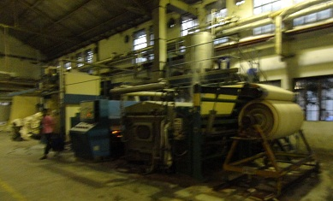Fig: Parex Mather singeing & de-sizing m/c

Before singeing After singeing
Fabric const. :( 40×40^{s})× (40×40^{s})/100×80 Fabric const.:40× 40/100×83

Process control in de-sizing:
Nature of size: Starch
Wet pick up during de-sizing: 100 %( adjusted by pressure)
Concentration of de-sizing agent: 0.8%
Batching time: 6-8 hours
De-sizing efficiency: Should be 80%
No of R/r in different unit:
Brushing unit= 2
Singeing unit = 10
Calendar unit = 2
De-sizing unit =15
Quality Parameters (Singeing /De-sizing):

Fabric  Weight inGSM | Speed  m/min | Flame  Intensity | Burner  Position | Padder  Pressure | Pickup  (%) | Bath  Temp  ⁰C | Bath  pH
100-200 | 80 | 9 | 2 | 1.2-1.5 | 70-80 | 60-65 | 6-6.5
210-300 | 70 | 11 | 2 | 1.2-1.5 | 70-80 | 60-65 | 6-6.5
310-400 | 60 | 12 | 2 | 1.2-1.5 | 70-80 | 60-65 | 6-6.5
410-  above | 60 | 12 | 2 | 1.2-1.5 | 70-80 | 60-65 | 6-6.5

Summary and Solutions to Problems in De-sizing:
Problem | causes | Counter measure
In complete de-sizing | 1. Inappropriate de-sizing bath  pH  2. Inappropriate de-sizing bath  Temperature.  3. Insufficient fabric pick up.  4. Insufficient digestion time.  5. Poor enzyme activity.  6. Deactivation of enzyme due  to presence of metals or other  Contaminants.  7. Ineffective wetting agent.  8. Incompatible wetting agent. | 1. Optimum pH.  2. Optimum temperature.  3. Optimum squeeze pressure.  4. Use of wetting agent.  5. Optimum digestion time.  6. Use of good enzymes.  7. Use of soft water.  8. Use of appropriate  Sequestering agents.  9. Use of good and effective  Wetting agents.  10. Use of compatible wetting Agent.

Uneven de-sizing  (Width ways) | 1. Uneven pad pressure.  (across the width)  2. Non-uniform pad  temperature  3. Non uniform chemical  Concentration in the bath. | Uniform squeeze pressure.  2. Uniform bath temperature.  3. Uniform chemical  Concentration.
Uneven de-sizing  (Length ways) | 1. Uneven pick-up.  (along the length)  2. Preferential drying of outer  Layers of the batch.  3. Temperature variation  During digestion. | Uniform pick-up along the  fabric length.  2. Covering the batch with  polythene or other suitable  sheet.  3. Keep the batch rolling.
Uneven de-sizing  (Random) | 1. Poor wetting agent.  2. In1. Use of effective and  Compatible wetting agent.  2. Optimum bath temperature.  3. Use of appropriate  Deformers.  4. Uniform liquor distribution  during padding.  5.Thorough and uniform  washing after | 1. Use of effective and  compatible wetting agent.  2. Optimum bath temperature.  3. Use of appropriate  Deformers.  4. Uniform liquor distribution  during padding.  5.Thorough and uniform  washing after de-sizing.

Scouring& Bleaching:
Scouring:
The process of removing oil, wax, soluble impurities and any particulate or solid dirt adhering to the fibers from the surface of the fabric is called scouring. The process consists essentially of treatment with a detergent with, or without, the addition of an alkali. When soap is used a good supply of soft water is essential but this is of less importance with the synthetic detergents, which now occupy such a prominent position.
After the cloth stillcontains fats and waxes (both natural and added), due to the presence of which the cloth becomes non-absorbent. These are removed from the cloth by scouring, also called kiering, kier-boiling, boiling out etc.

Objective of scouring:
- To remove the natural as well as added impurities as completely as possible to from textile material.
- To produce hydrolytic characteristics.
- To leave the materials in a highly absorptive condition without undergoing physical and chemical damage.
- To increase absorbency of fabric.
- To remove natural nitrogenous coloring materials, dirt, dust, husk, broken seed, protein, leaf, etc by oxidizing on chemical treatment.
Scouring process:
- Batch or Discontinuous process (e.g. Kier boiling process)
- Continuous process( e.g. Scouring in J-box)
- Semi- continuous process (e.g. Pad-roller process)

The main processes occurring during scouring are:
- Saponification of fats into water-soluble soap and water-miscible glycerin under alkaline condition,
- Hydrolysis of proteins into water-soluble degradation products,
- Dissolution of hydrolysis to ammonic of simpler amino compounds,
- Conversion of pectin and into their solution salts,
- Dissolution of mineral matter,
- Emulsification of unsaponificable oils and waxes, and
- Removal of dirt particles from the kier liquor by the detergent present therein.
Factors involved in scouring:
When cleaning solid surfaces, five variables become involved that interact during scouring and they are as follows:
- The nature of the surface to be c leaned.
- The nature of the dirt or soil.
- The chemicals to be used.
- The nature of the water or solvent.

Chemical & their use in scouring:
Chemical | Use
Caustic(NaOH) | Neutralize acidic materials, saponify glycerides (Waxes and Oils,) and solubilize silicate.
Sodium Silicate | Penetrate and break down lignins in motes.
Surfactant | Reduces surface tension and minimize interfacial tensions.
Detergent | Emulsify oils, fats, and waxes; remove oil borne stains; suspend materials after they have been removed.
Chelating(Sequestering) agent | Deactivate metal ions.
Builder(Salt) | Cause detergents to become increasingly effective.
Solvent | Assist emulsification by dissolving oily materials.
Table: chemicals and their purposes
Bleaching:
The process of removing natural color from the fabric damaging its properties to make it whiter is called bleaching. Bleaching is not a cleaning process in the sense of scouring; bleaching does not remove dirt.
An efficient bleaching process must ensure:

1. A pure and permanent white.
2. Level dyeing properties (over-bleaching or under bleaching adversely affects the dye
Absorption properties of the fabric).
3. The fabric does not undergo tendering (chemical damage or degradation, which results in loss
In tensile strength and hence the durability is affected during bleaching)..
Objective of bleaching:
- To produce a clean material by adding alkali.
- To make the fabric suitable for the next process.
- To obtain pure & permanent white color.
In Sinha Dyeing & Finishing sector “Continuous Method” is used for Scouring & Bleaching (here scouring & bleaching is done in two stages in one m/c.)

Recipe for scouring:
Wetting agent (RGN) = 4g/l
Caustic soda = 26(⁰ be)

Recipe for bleaching:

Caustic soda = 12(⁰ be)
Stabilizer =7g/l
H₂O₂ =30 g/l
Wetting agent (RGN) = 5g/l
Sequestering agent (Ladiquist) =1 g/l

Basic principle:
The oxidizing agent most commonly used today in bleaching is hydrogen peroxide. Owing to its dissociation constant of 1.5 X 10-12 at 20c , hydrogen peroxide is a very week acid. In alkaline solution, there is a certain amount of hydrogen peroxide anions above the equilibrium (1), and those anions are the source of the active oxygen that has the bleaching effect (2). In a secondary reaction (3) there always a certain formation of molecular oxygen which develops no efficiency
for bleaching.
1. H₂O₂ + OH- H₂o + HO₂
2. HO₂ OH + O
3. 2 H₂O ₂ 2H₂O + O₂
A higher concentration of OH- ions has an activating effect; with increasing amount of hydrogenperoxide anions available in the liquor, the bleaching effect increases.

The advantages of bleaching with peroxide are:

- No need for severe pre cleaning processes.
- No need for toxic materials of construction, but iron and copper must not be used.
- Environmentally acceptable; no AOX even in the presence of salt.
- Decomposition products are oxygen and water.
- Excellent storage stability.
- Compatible with most dyes and FBAs.
- Produces a stable white fiber with good absorbency.
- Allows route shortening by combining stages (de-size with scour, scour with bleach and de-size with scour and bleach).
- Some water is always transported.

- 2. Sensitivity to metallic transported.
- 3. Multichemical baths which need control.
- 4. Comparatively expensive.
In Sinha Dyeing & Finishing sector two machines are used for scouring-bleaching purpose. Machines are:-
Machine No.1:-Benninger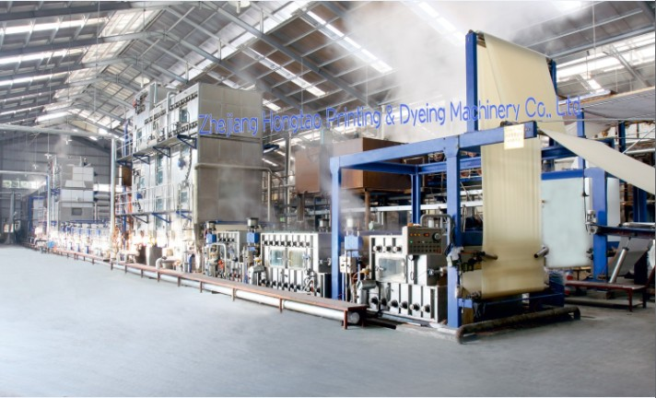
Fig: Benninger scouring & bleaching m/c

After scouring after bleaching
Fabric const^{n}: 30×30/183×85 Fabric const^{n}:20×10/112×16

Manufacture: 1995
Origin: Switzerland
Speed of machine:55.3/min (generally used)
Speed of machine: 80m/min (maximum)
Number of washing bath: 2 (at first stage)
Number of washing bath: 4 (at last stage)
Number of dry cylinder: 24
Name of chemical padding bath: Impacta
Number of chemical tank: 2

Some details about this machine:

Number of roller in first washing bath: 24
Number of supporting roller in first washing bath: 6
Number of roller in second washing bath: 18
Number of supporting roller in second washing bath: 6
Number of roller in third washing bath: 17
Number of supporting roller in third washing bath: 5
Number of roller in fourth washing bath: 17
Number of supporting roller in fourth washing bath: 5
Number of roller in fifth washing bath: 17
Number of supporting roller in fifth washing bath: 5
Number of roller in sixth washing bath: 18
Number of supporting roller in sixth washing bath: 6
Number of dry cylinder in first stage: 12
Number of dry cylinder in second stage: 12
Number of padder: 2
Number of squeezer: 6
Number of winder: 1
Temperature in first washing bath---- 50⁰-70⁰C
Temperature in last four washing baths:
Number of supporting roller in first washing bath:
Bath No.1---- 95⁰C
Bath No.2---- 95⁰C
Bath No.3---- 85⁰C
Bath No.4---- 40⁰C
Temperature in steamer---- 100⁰C
Temperature in dry cylinder---- 140⁰C
No of dancer-16

Vapor pressure in steamer---- 65⁰C
Reaction time in steamer for scouring---- 16 min
Reaction time in steamer for bleaching---- 10min
Fabric stored in steamer at a time---- 100 meter
Production capacity per day---- 50000meter
Total time a fabric pass from input to output= 26 min
Total backing in the m/c= 450 m

P^{H} effect in bleaching:In Sinha Dyeing & Finishing sector
P^{H} used in bleaching---10.5-11.8
Perfect P^{H} for bleaching--- 10.5

Machine No.2:

Name of machine: Kuster

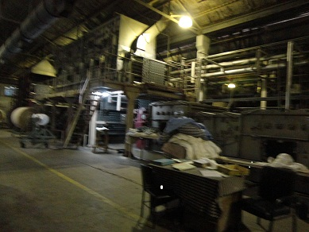

Manufacture: 2004
Origin: Germany
Speed of machine: 60-80m/min (generally used)
Speed of machine: 100m/min (maximum)
Number of washing bath: 2 (at first stage)
Number of washing bath: 5 (in last stage)

Number of dry cylinder: 22
Name of chemical padding bath: Flexnip
Number of chemical tank: 6

Some details about this machine:

Number of roller in first washing bath: 12
Number of roller in second washing bath: 12
Number of roller in third washing bath: 13
Number of roller in fourth washing bath: 22
Number of roller in fifth washing bath: 22
Number of roller in sixth washing bath: 12
Number of roller in seventh washing bath: 6
Temperature in first washing bath---- 45⁰-55⁰C

Temperature in last four washing baths:
Bath No.1---- 95⁰C
Bath No.2---- 95⁰C
Bath No.3---- 95⁰C
Bath No.4---- 80⁰C
Bath No.5---- 40⁰C

M/C set up requirement:
Steam pressure: 3-5 bar
Air pressure: 4-4.5 bar
Temperature in steamer:100⁰C
Vapor pressure in steamer: 65⁰C
Fabric stored in steamer at a time: 80 meter
Temperature in dry cylinder: 140⁰C
Reaction time in steamer: 20 min

Bleaching performance:

- Whiteness
-for continuous dyeing: 72-75⁰c
- For dark shade: 60-65⁰c
- Whiteness less because of less dozing of H₂O₂

- Absorbency test
-Wicking test: 30-50mm/min
-drop test: Drop must be circular, if elliptical the absorbency will not be good.
- Residual H₂O₂on fabric(range 0.017)
-ResidualH₂O₂more after washing the dyeing will be uneven.
- Tegwa test: 8-9
Main fabric fault in bleaching:
- Bed mark
- Crease mark
- Spot
- Selvedge mark
- Pin hole damage
- Uneven absorbency
- Tendering of cloth

Function of different parts:
- Supporting roller:
- To maintain tension.
- To maintain fabric width.
- squeezer:
- To squeeze & wash out extra water.
- Dancer:
- To control fabric tension.
- Brand roller:
- To maintain fabric tension
- To remove fabric crease.
- Hot wash:
- To remove the chemical from the bath so that it cannot harm the process.
- Cold wash:
- Make the fabric cold so that temperature cannot damage the fabric.

Stabilizer:
- Stabilizer make a quartine coating around the H₂O₂ So that NaOH cannot react with H₂O₂up to a certain point.
Online quality test for scouring & bleaching:
- Water hardness test:
Recipe:
Buffer solution =5 ml
Black T = 2 -3 drop
EDTA = 1 drop
Water =20 ml

Procedure:
Stirring buffer solution + black T +water (violet color)
Add 1drop EDTA (turn blue color)
Result:
The no of drops the solution turn into blue color, then multiply the drops into 2, toget the water hardness.
Acceptance range =10-12 ppm

Absorbency test for caustic soda:
Water =10 ml
NaOH =1 ML
Phenoptholin =2-3 drop
HCL =15 ml

Procedure:
Stirring water +NaOH
Add 2-3 drop Phenoptholin(to get pink color)
Add HCL (to remove color)

Result:
The no of drops the solution removes color, & then multiplies the drops into 4 for bulks.
Online Quality Control Parameter for bleaching:
Fabric  weight  in GSM | Speed  m/min | Doctor  Blade  position | Steamer  pressure | Dwell  time  in  min | Pre washing  Tank temp  ºC |  |  | Washing Tank temp ^{O}c
100-200 | 70 | 1.5-2 | 102 | 20 | 90 | 90 | 80 | 90 | 90 | 90 | 80 | 60
210-300 | 60 | 1.5-2 | 102 | 20 | 90 | 90 | 80 | 90 | 90 | 90 | 80 | 60
310-400 | 40 | 1.5 | 102 | 20 | 90 | 90 | 80 | 90 | 90 | 90 | 80 | 60
400-above | 35 | 1 | 102 | 20 | 90 | 90 | 80 | 90 | 90 | 90 | 80 | 60

Mercerizing:
Mercerizing is a physic –chemical process in which cotton fabric is treated with concentrated solution of caustic alkali & subsequently stretched & washed under specified conditions.
Mercerization requires higher concentration of caustic soda (12⁰Be-24⁰Be). Caustic soda solution swells cotton fibers breaking hydrogen bonds & weak Vander wall forces between cellulose chains.. Because of fiber thickening the fiber becomes denser, stronger & more elastic. Held under tension, the coiled shape of the fiber is straightened & characteristic lumen almost disappears.
Object of mercerizing:
- To fix dimensional stability of the fabric.
- To improve dye absorbency of the fabric.
- To increase strength of the fabric.
- To increase smoothness of the fabric.
- To increase luster effect of the fabric.
- To remove crease from the fabric.

Features:
- Auto dozing of NaOH solution.
- Be’s indicator.
- Auto acid dozing & P^{H} controller.
- Auto stop motion
- Width & moisture controller.
Basic principle:
- The basic principle is
- 1. Saturation with mercerizing-strength caustic soda solution near to its boiling point.
- 2. Controlled hot stretching.
- 3. Controlled cooling.
- 4. Tradition tension-controlled washing followed by final washing.

Mercerization process:

- Mercerization (for luster) can be carried out in two ways:
- 1. By unrestricted swelling (by treating the cotton with sodium hydroxide solution, allowing it to
- Shrink to the maximum extent), following by stretching to the original width or length.
- 2. By restricted swelling (by treating the cotton under tension, with strong sodium hydroxide
- Solution without allowing it to shrink and then washing while still in the stretched condition).

Factors that affect the luster:

- The luster of mercerized cotton depends on various factors:
- 1. Cross-section of the fabre.
- 2. Staple length of the fabre.
- 3. Wall thickness of the fibre.
- 4. Concentration of sodium hydroxide.
- 5. Temperature of the mercerizing solution.

Mercerization recipe:
Caustic soda = 26⁰Be
Acetic acid = 2oo kg/ drum
Name of machine:SANDO
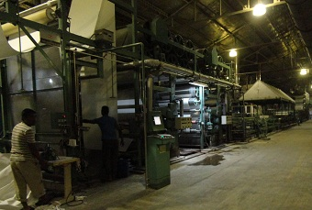
Fig: SANDO mercerization m/c

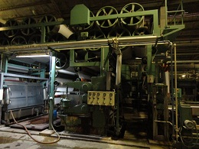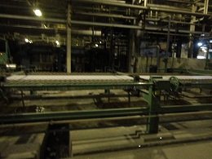
Break R/r & time R/r Rail

Before mercerization after mercerization
Fabric const.:20×20/112×16 Fabric const.:40×40/100×50

Origin: Switzerland
Speed of machine: 50m/min (generally used)
M/C Specification:
Temp of wash bath = 95⁰c
Temp of acetic acid bath = 25⁰c
Temp of steam =80⁰c
No of dryer =30
Temp of dryer = 110⁰c
Pressure of time R /r =0.15 Mpa
No of brand R/r =17
No of dancer =5

Parameter:

Fabric  weight  in GSM | Speed  m/min | Alkali  Concentration  (Be) in  Impregnation  Tank ºC | Temperature  e of  Impregnation  n  Tank ºC | Washing Tank temp ^{O}c |  |  |  | pH
100-200 | 60 | 1.5-2 | 102 | 90 | room | 90 | 90 | 7-7.5
210-300 | 40-50 | 1.5-2 | 102 | 90 | room | 90 | 90 | 7-7.5
310-400 | 40 | 1.5 | 102 | 90 | room | 90 | 90 | 7-7.5
400-above | 30 | 1 | 102 | 90 | room | 90 | 90 | 7-7.5

Function of m/c parts:

- Sigar
- To prevent shrinkage
- To retain dimensional stability.
- To wash off mercerizing chemicals from the fabric by spraying water on it
- Padder pressure
- To squeeze & drive the fabric to a little extent otherwise there is a risk of forming edge line at two sides of fabric.
- Water valves
- Supply water to washing tank.
- Steam valves
- Steam valves supply steam to washing chamber
- Rail
- To remove crease.
- Bulb
- To control the flow of fabric.
Mercerizing process fault:
- P^{H} variation
- Crease
- Water drop mark
- Spot
- Problem from sigar
- Holes
- Distortion of dimensional stability

Chapter: 06
Dyeing

Dyeing:
- The process by which reaction takes places physically and chemically and when light reflects from that materials makes it colorfully is called dyeing.
- Dyeing is the process of adding color to textile products like fibers, yarns, and fabrics. Dyeing is normally done in a special solution containing dyes and particular chemical material.
- After dyeing, dye molecules have uncut chemical bond with fiber molecules. The temperature and time controlling are two key factors in dyeing. There are mainly two classes of dye, natural and man-made.
- Acrylic fibers are dyed with basic dyes, while nylon and protein fibers such as wool and silk are dyed with acid dyes, and polyester yarn is dyed with disperse dyes
In Sinha Dyeing & Finishing sector reactive dyes are used maximum.
There are three machines in dyeing sector. Two dyeing machines & one washing machine. There are two types of dyeing machines here. Machines are:-
- Pad-dry-pad-steam
- Pad-dry-thermofix
- Machine Details:
Type of machine: Pad-dry-pad-steam
Padding zone:
- Name of machine: Kusters
- Origin: Germany
- Mnufacture: 1996
- Model No: E.u.A Kombi
Drying zone:
- Name of machine: Monforts
- Origin: Germany
- Manufacture:1995
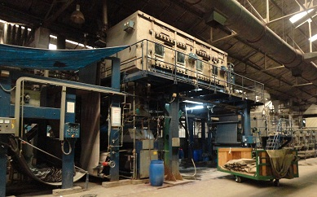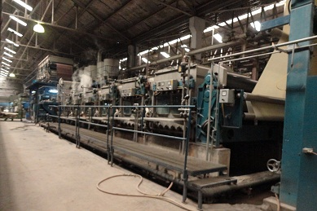
Chemical bath & steam washing zone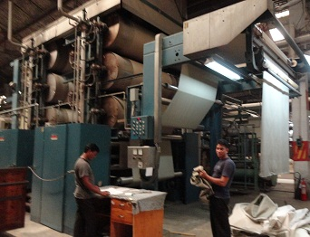
Fig Pad-dry-pad-steam m/c

Before dyeing After dyeing
Fabric const: 40×40/100×50 Fabric const: 20×10+70D/128×68

Pad steam zone:
Name of machine: Benninger
Origin: Switzerland
Manufacture: 1995
Model: CH-9240 uzwill
Process sequence of pad-dry-pad-steam:
Padding the fabric with salt & dye solution
Partial drying the fabric in IR section
Complete drying the fabric in Dryer with gas burner
Padding
Fixation of the dye with alkali in pad steam
Washing out of unfix dye
Dry in dry cylinder
Chemical used in pad-dry-pad-steam:In first time padding:
- Dyes= x,y, z g/l
- Wetting agent (EH)= 1g/l
In second time padding:
- Anti-migrating agent (MIP)= 10-20 g/l
- Acetic acid
- NaOH= 1g/l
- Salt= 36 (⁰be)
- Wetting agent

Temperature of different zone:
First padding bath -- 35-40⁰C
Second padding bath -- 35-40⁰C
Dryer -- 170-180⁰C
Steamer -- 100⁰C
Dry cylinder -- 140⁰C

Temperature of wash bath:
First wash bath -- 95⁰C
Second wash bath -- 95⁰C
Third wash bath -- 95⁰C
Fourth wash bath -- 95⁰C
Fifth wash bath -- 95⁰C
Sixth wash bath -- 95⁰C
Seventh wash bath -- 40⁰C

Others information about pad-dry-pad-steam:
Speed of machine: 30m/min (for lycra) & 25 m/min (without lycra )
Speed of IR: 40 m/min
Water removed by IR: 40%
Number of dry cylinder: 15
Number of steaming roller in steamer: 48
Reaction time in steamer: 1 min

Type of machine: Pad-dry-thermo-fix
Name of machine: Monforts
Origin: Germany
Manufacture: 2005

Information about pad-dry-thermo-fix:

Number of padding bath: 1
Number of gas burner: 2
Temperature of dryer: 100⁰C (maximum)
Temperature of dryer: 120⁰C (minimum)
Percentage of steam used: 30%
Liquor concentration of pad-dry steam: 4:1

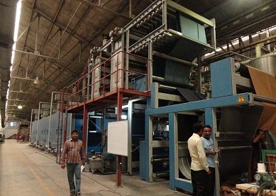
Fig Pad-dry-thermo-fix m/c

Before dyeing After dyeing
Fabric const: 20×20/100×50 Fabric const: 20×16/116×58
This machine is also called “E-control” i.e. electrolyte control. Because of dyeing without electrolyte it is saying that “E-control”.
In “E-control” process only dye, soda is used for dyeing instead of dye, soda, salt, alkali, caustic) which is required in pad –dry-pad-steam. The work of Alkali, caustic& salt is done in “E-control” by IR, steam, burner.
Type of machine: Washing machine:
Name of machine: Kusters
Origin: Germany
Number of washing bath: 10
Speed of washing bath: 80 m/min (maximum),
Normally used45-60 m/min.
Temperature of every washing bath:
First washing bath -- 40⁰C
Second washing bath -- 50⁰C
Third washing bath --60⁰C
Fourth washing bath --60⁰C
Fifth washing bath --90⁰C
Sixth washing bath --95⁰C
Seventh washing bath --95⁰C
Eighth washing bath --80⁰C
Ninth washing bath --70⁰C
Tenth washing bath -- 40⁰C
Without hot water no other thing used in washing bath

Type of machine: Jigger dyeing
Jigger dyeing process:
Jigger dyeing process is a exhaust method by which textile substrate is immersed in liquor containing dyestuff & chemicals & they are transferred to textile substrate in proper manner.
Process requirement:
- Sewing M/C
- Rod stirrer
- A frame
- The golden jigger dyeing m/c
- Mixer bucket
- Filter

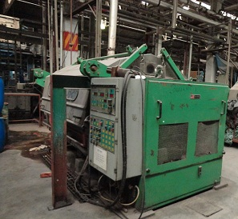
Fig Jig-Matic dyeing m/c
Name of machine: Jig-Matic
Origin: U.S.A
Speed of machine: 40-80 m/min (maximum), normally 40-80 m/min is used.

Materials &chemicals used in jigger dyeing:
- Dyestuff = x g/l
- Salt =20 g/l
- Soda ash=5 g/l
- Detergent (for soaping)= 0.5-1.0 g/l
- Wetting agent (dekol SN, kieralon OS) =0.25-0.5 g/l
- Caustic soda =1.5 g/l
- Reducing agent = 9-10 g/l
- Oxidizing agent =2 g/l
- Compressed air = as required
- Steam/ water = as required
- M/C Set up:
Machine set up parameters | Actual parameter range | m/c set up value
Temp | 58⁰-60⁰c  88⁰-90⁰c | 60⁰/90⁰c
Chemical level | 500-520 liter | 520 liter
Fabric position | face | face
A –frame position | Set properly | Set properly
Speed | 40-80m/min | 40-80m/min
Stripping:
Stripping is carried out to remove uneven shade or to reduce dark shade.
In SDFL Stripping is done for 100% cotton.
Recipe:
Anti-creasing agent=1 g/l
Sequestering agent =1g/
Caustic soda=120 g/l (36⁰be)
Hydrose =30 g/l
Soaping agent=1g/l

Dyeing fault: Dyeing fault are given below-
Telling:
If the temperature increase & decrease suddenly & for that reason the shade of the fabric does not match from one side to another is called telling.
Side centre problem:
- Due to padder pressure
- Temperature variation
- Time variationSide center problem
Water spot:
If the fabric is wetted in some portions by water before dyeing then in that portion dyes are not properly fixed. Shade variation occurs.
Color spot:
- Due to padder pressure
- Temperature variation
Patchy effect: Water spot
- Entanglement of fabric
- Faulty injection of alkali
- Faulty color addition
- Due to hardness of water
- Due to impure salt additionColor spot
Remedies :By partial or full stripping of dyed fabric
Roll to roll variation/meter to meter variation:
- Yarn lot mix
- Faulty heat setting& m/c speed
- Hardness of water

Dye stain:
- Un-dissolved dye particle in bath
- Un-dissolved caustic particle in bath
Remedies: By partial or full stripping.
Rubmark:
- Due to reel cracking
- Due to sharp deliver roller
Crease mark:
- Overloading
- Low fabric speed in the m/c
- Working at high temperature & not using an inhibitor for crease mark.
- Liquor ratio is low or high.
Remedies:
- In effective inhibitor should be use.
- Overloading should not do.
- Fabric speed should accurately maintain.
Oil stain:
- Over lubrications in the m/c parts
Remedies:
- A hot washing can remove this over lubrication

Chapter: 07
Printing

Printing:
The textile printing is the art of design by mechanical & chemical application. It entails the localized of dye of pigment the design being created by different color or motives. Or By the term “textile printing” we mean the localized application of dyes or pigments & chemicals by any method which can produce particular effect of color on the fabric according to the design.
In Sinha the printing is done in rotary screen method.
Flow chart of printing:
Computer design
Engraving section
Develop sector (styck off)
Printing (dyed fabric/ white fabric)
Curing (180⁰c)
Finishing
Sanforizing
Rolling
Packing
Delivery
The function of different parts:
Computer design: Buyer send the print through software(abode Photoshop) or the CAD, which size is normally (5/10) or (6/10) inch & then transfer to computer through scanner. After that the repeat size is identified to determine what we given compared to buyer repeat size.
300 pixel= 1 inch
1cm= 118 pixel
Screen dia =64.15 cm =25.26 inch =7578 repeat size

- The side solid marks are given to maintain the shape of the figure
Engraving section:
At first, the screen is prepared by hand screen method.
Recipe for hand screen:
SCR-100=85%=850 g
SCR 101=5%= 50 g
Water =10 %=100 g

Keep the hand screen with the above chemical at 4⁰c under the halogen light 2000w & squeeze through a squeezer. After that the procedure of engraving section is:
Coating m/c
Climator
Exposing m/c
Washing
Screen tray
Screen inspection m/c
Polymerization
- Coating m/c:screen height= 1750 mm & Screen dia = 640 mm
Mesh = 125(max =200, min =40) .Time taken from up to down 12 min.
- Climator:cold & hot air
- Exposing m/c:Model(SCR-70)
- Polymerization:Model(SCR 283-9- 1850)
Polymerization is done 1st time at 160 ⁰temp for 1 hour in wearing form & then ^{2nd} time 180⁰c for 2 hour.
- Screen inspection m/c:If there is jam or mark in screen it is cleaned by pressure.

Gum used in rotary screen printing:
SCR53=5 g/l
SCR53C=4 g/l
Recipe:
Lotezal HIT=6%
Glycerin=0.6%
Helizarin Binder TOW=10%
Liquor ammonia = 0.7%
Respunit BU = 0.3%
Fixer =0.5%
Function of different chemical:
- Lotezal HIT= Increase the color density
- Glycerin= Increase viscosity
- Helizarin Binder TOW=Fix the color
- Liquor ammonia = Remove dust, impurities.
- Respunit BU = Anti foaming agent
- Fixer= Leveling agent
Procedure:
Put chemical on screen
Put film on the fabric the
Light pass on the fabric (light pass through the white portion & block the black portion of the film)
Chemical is permanent in white portion
And chemical is gone from black portion by washing
Black portion become hole so that print paste pass through black portion
- In printing for 2 screen design 4 roller is used-
- 2 roller used for the desired color
- 1st roller is used to remove the dust particle of the fabric with the help of gum attached to the roller
- 2nd roller is used to reduce shrinkage & resist moving the fabric.

- In screen, roller set according to the shade
-deep shade =3 roller & light shade =4 roller
- Blanket contain gum so that fabric cannot move & it depend on design of the fabric
Light design =less gum & deep design = more gum
- For make the shade light =paste is added
For make the shade dark= color is added
- Mesh =critical design
Mesh = normal design
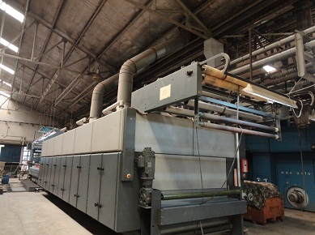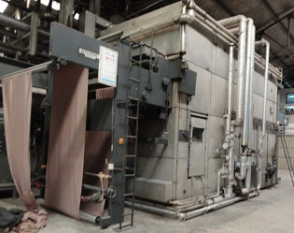
Fig: Stork printing m/cFig: curing m/c

Printed samples

Chapter: 08
Finishing

Finishing:
Finishing:
A fabric finishing process is a process for providing specific quality to the fabric that is required by the customer like soft wrinkle free finish, peach finish, stiff finish, water repellent finish.
Types of finishing:
Finishing

Mechanical chemical
E.g. raising, sanforizing, calendaring E.g. stiff finish, water repellent
Peach finish etc. Resin finish, wrinkle free finish etc

Classification of finishing:
Finishing

Regular Special
Peach finish
Wrinkle free (pre cure,
Soft stiff post cure)
(By softener) (By stiffing agent) Water repellent
Taplon finish
D.W.R finish
Fire proofing
Anti bacteria
Moth proofing
Stain release
Soil release
Some finishing m/c
-Stenter m/c - Sanforizing m/c
-Peach m/c - Calendaring m/c
-Rolling & Inspection m/c

Flow chart of finishing process:
For TC & CVC Fabric:

Fabric in trolley after dyeing

Singeing

Stenter m/c

Raising m/c (if required)

Inspection table

Fabric rolling

Delivery
For 100 % cotton:
Fabric in trolley after dyeing

Singeing

Stenter m/c

Raising m/c (if required)

Sanforizing m/c

Inspection table

Fabric rolling

Delivery

Purpose of stentering:
- To control width of fabric.
- To increase smoothness on fabric surface.
- For heat setting in case of lycra fabric.
- Sometimes topping is also done.
- To control moisture of fabric.
- To control shrinkage of fabric.
Machine Specification:
Number of stenter machine: 3
Machine No. 1:

Name of machine: Icomatex
Origin: Spain
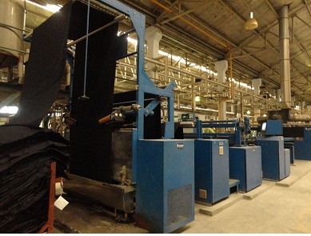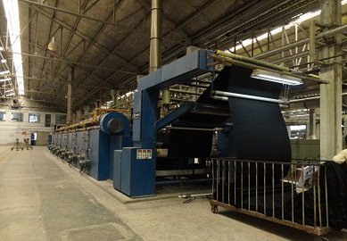
Fig:Icomatex stenter m/c

Before shrinkage: After shrinkage:
Fabric const.: 60×60/130×90 Fabric const.: 60×60/130×90

Manufacture: 2007
Model: Terassa (FL2)
Used fabric type: Woven
Number of drying chamber: 4
Number of gas burner: 8
Speed range:30-61 m/min
Used utilities:water, air, gas, electricity, hydraulic oil.
No of motors: 47
Temperature of every chamber:-
First -- 80⁰C
Second -- 100⁰C
Third -- 120⁰ C
Fourth -- 180⁰C
Fifth -- 180⁰C
Soxth -- 180⁰C
Seventh -- 180⁰C
Eighth -- 140⁰C

Machine No. 2:
Name of machine: Monforts
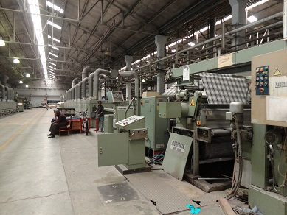

Fig monforts stenter m/c

Origin: Germany
Manufacture: 1994
Model: E+A Komb
Used fabric type: Woven & knit
Number of drying chamber: 6

Number of gas burner: 12
Two special rollers are used for removing crease of knit fabric.
Machine No. 3:
Name of machine: Monforts
Origin: Germany
Manufacture: 1996
Model: E.u.A Kombi
Used fabric type: Woven
Number of drying chamber: 6
Number of gas burner: 12
One special roller is used in this machine for removing crease in case of yarn dyed fabric.
Chemical used in stenter m/c:
Persoftal Bk (Cationic softener) =20 g/l
Rupofin GSQ =80 g/l
Persoftal L=30-40 g/l
a.acid= 0.5 g/l

Speed of machine:35 m/min maximum & normally 45m/min is used.
Topping temperature: 80⁰C, 100⁰C, 120⁰C.
Different section of stenter machine:
- Padder pressure:
In the padder section the fabric is treated with chemicals especially with softener & acid in two tanks.
- Weft straightener:
The main function of weft straightner is to control the bowing& skewness of the fabric.
- Width setting chamber:
The chamber controls the width of the fabric by clip of 10 pin.
- Heating chamber:
This chamber controls the shrinkage & GSM of the fabric.
Temperature range: Cotton -150⁰ c-170⁰ c
Polyester- 165⁰c- 185⁰c
With lycra-175⁰c-190⁰c
- Cooling chamber:
Thechamber cooled the hot fabric before reach the delivery zone
- Exhaust motor:
The specific part used to exit the steam produced in the chambers & also exit the extra temperature from the m/c.
- Delivery zone:
The zone delivered the fabric in a folded form. In this zone the fabric has to pass through several rollers in order to prevent the formation of crease mark in the finished fabric.
Softener is used:-
- On the basis of buyer requirement.
- On the basis shade.
There are three types of softener:
- Persoftal BD -- Cationic softener
- Adasil SM -- Anionic softener
- SBN -- Non-ionic softener
Sanforizing :
Sanforizing is a controlled comprehensive shrinkage process, which is applied on woven fabric to achieve shrinkage before making the garments. aftersanforizing the residual shrinkage of woven fabric may be zero. In sanforizing process shrinkage is achieve by passing the cotton fabric onto a movable elastic felt blanket.
In this process cotton fabric forced to compression. To prevent shrinkage sanforizing machine used known as zero- zero per shrinkage m/c.

Function of sanforizing m/c:
- To control residual shrinkage.
- To give compression on the cotton fabric.
- Giving steaming treatment to the cotton fabric.
- To control GSM.
Machine Details:
Total number of machine: 3
Machine No. 1 & 2:
Name of machine: Monforts
Origin: GermanyManufacture: 1996
Model: Monfortex
Model no: 71T67135
Speed range: 35-40 m/min
Temp range: thick fabric =50⁰c
Thin fabric= 20-30⁰c
No of motors: 05
Used utilities: water,air, gas, electricity, hydraulic oil.
Max production capacity: 4000 m/day

Machine No. 3
Name of machine: Morrison Textile Machinery Co.
Origin: U.S.A
Model no: T133
Manufacture: 2005
Temp range: thick fabric =50⁰c
Thin fabric= 20-30⁰c
Speed of machine: 40 m/min
No of motors: 05
Used utilities: water, air, gas, electricity, hydraulic oil.
Max production capacity: 115200 m/day
Pressure & temperature is used for control shrinkage

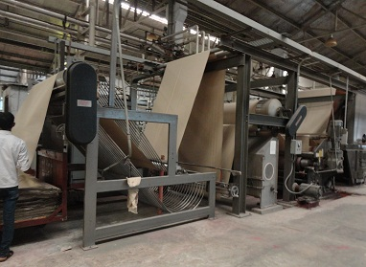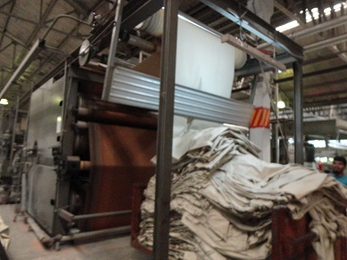
Fig: Morison Sanforizing m/c
Working procedure:
Fabric in trolley from steamer

Conditioning (slightly steam used)

Fabric through clip expander

Fabric between squeezing rubber belt cylinder

Calendar or dryer
Peach Finish:There are 4 types of peach finish are-
- Light peach
- Micro-sand peach
- Normal peach
- Heavy brush peach
Features of peach finish are:-
- Light peach: Smoothness or peach effect is low.
- Micro-sand peach: Smoothness effect is greater than light peach & lower than normal peach.
- Normal peach: By using this type of peach fabric can be smooth much.
- Heavy brush peach: Smoothness effect is more than any other type of peach
Varieties grade sand paper is used in peach finish:
Name of peach | Sand paper ingrade
Light peach | 220, 400, 600
Normal peach | 220, 400, 600, 320 (2 times used)
Microsand peach | 220, 320, 400, 600
Heavy brush peach | 80, 120, 320
- “Sand papers” are rapped on sand roller.
- “Sand paper” takes a major part in peach finish.
Machine Details:
Number of machine: 6(5peach machines & 1 calendaring machine)
Machine No. 1 & 2:
Name of machine: Gessner

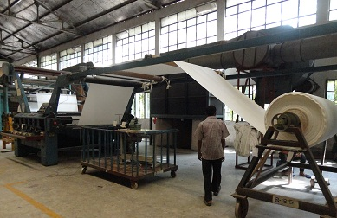

Origin: U.S.A
Manufacture: 2003
Model: Sander
Model no:FSM104
Speed of machine: 20-25 m/min for both of peach.
Number of sand roller: 4
Number of brush roller: 1
Machine used for: Normal peach, heavy brush peach.

Machine No. 2:
Name of machine: Gessener
Origin: U.S.A
Manufacture: 2003
Model: Sander
Model no: FSM103
Speed of machine: 20-25 m/min for normal & heavy brush peach, 20-35 m/min for micro-sand peach.
Number of sand roller: 4
Number of brush roller: 1
Machine used for: Normal peach, micro-sand peach, heavy brush peach.

Machine No. 3:

Name of machine: Santex
Origin: U.S.A
Manufacture: 2005
Model: Plurima
Speed of machine: 20-25 m/min for normal peach, 20-35 m/min for micro-sand peach & 35-40 m/min for light peach.
Number of sand roller: 4
Speed of sand roller: 1100 m/min
Number of brush roller: 1
Machine used for: Light peach, normal peach & micro-sand peach.

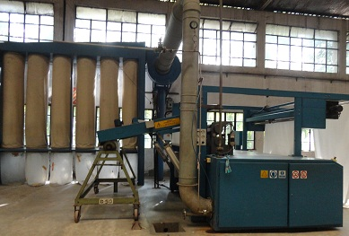

Fig: Santex peach m/c

Machine No. 4:
Name of machine: Danti paolo
Origin: Italy
Manufacture: 2007
Model: S1000
Number of diamond roller: 2
Number of brush roller: 4
Number of dancing roller: 2 (it is used for maintain fabric tension)

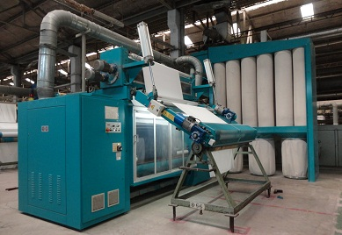
Fig: Danti paolo peach m/c

Peach fabric
Calendaring:
- Calendaring may be defined as the modification of the surface of a fabric by the action of
heat and pressure.
- The finish of obtained by passing the fabric between heated rotating rollers when both
speed of rotation and pressure applied are variable.
- The surface of rollers can be either smooth or engraved to provide the appropriate finish to fabric.
- The rollers may be made of various materials from hardened steel to elastic thermoplastic.
Objects of Calendaring:
- To improve the fabric handle and to impart a smooth silky touch to the fabric.
- To compress the fabric and reduce its thickness.
- To reduce the air permeability by closing the threads.
- To increase the luster.
- To reduce the yarn slippage.
- To increase the opacity of the fabric.
- Surface patterning by embossing.
Function:
- To produce a smooth, glossy, & highly luster appearance on the fabric.
- To reduce fabric thickness.
- To reduce water & air permeability of fabric by changing its porosity.

Rising:
Rising is a permanent mechanical finishing process of lifting a layer of fibers from the body of the fabric which stand out from the surface.
Object of rising:

- To obtain a softy handle effect in fabric
- To obtain fleecy appearance.
- To create pile or cover on fabric surface.
- To produce warm cloth.

Name of machine: Lamperti
Origin: Italy
Manufacture: 1998
Speed range: 20-40 m/min
Temp range: room temp
Used utilities: electricity, air
No of motors: 11
Production /day:According to buyer requirement.

Final inspection:
Inspection refers to an investigation process of accepting or rejecting the final finished fabric from the bulk. It is an observation of finding out each & every visible fault in the fabric.
Responsibilities:
- 100 fabric inspection
- Joint inspection with buyer
- Problem rectification
- Fabric transfer to store.
Equipment used:
- Nazer inspection m/c, Pakistan
- Verivide day light box,China

M/c specification:
Machine name: rolling & inspection m/c(no 1 to 4)
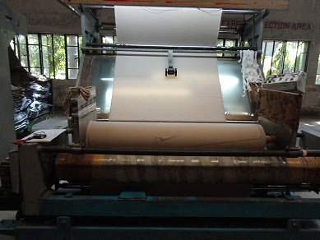

Fig: Nazer inspection m/c
Brand name: Nazer
Country of origin: Pakistan
Model no: B.I.S.G.
Speed range: 30- 40 m/min
Temp range: room temp
Used utilities: electricity, air
No of motors: 11
Following faults are detected& identified in final inspection:
- Penalty point legend:
H=Hole
OS =Oil stain
CS =chemical stain
W=Water spots
FY= fly yarn
YC=yarn contamination
WX= white specks
IS =insect spots
R= rub mark
DS= dye stain
D=dirt stain
RS=rust stain
- Faulty appearance:
US= uneven shade
N= Neps
CR= Crease mark
P=Patches
HR=hairy
MS=Machine stoppage
N= Neddle line
BR= Barre mark
CM= Crumple mark
DC=Dead mark
BW= Bowing
Besides this role to role & meter to meter variation is cheeked
Four point system:
In Sinha Textile Group the fabric inspection is done by 4 point inspection system. The details of it given below.
Size of defect | Penalty
3 inches on less | 1 point
Over 3, but not over 6 | 2 point
Over 6,but not over 9 | 3 point
Over 9 inches | 4 point
<1 inch(holes) | 2point
Over I inch | 4 point
- Inspection of fabric by 4 point system:-
Yarn fault Penalty points:
Thick/thin | The yarn is thick/thin than normal yarn | 1 to 4
Slub | Bunch of fiber in the yarn | 1
Coarser yarn | Thicker than normal yarn | 1 to 4

Uneven yarn | Thick/thin yarn continuously at random interval in yarn. | 1 to 4
Contamination | Jute, hair color fiber etc. foreign fiber presence in the yarn/fabric. | 1
Neps | Entanglement of fiber in the yarn | 1
Weaving fault:
Warp way Penalty points:
Missing yarn | 1 or more yarn missed from the cloth. | 1 to 4
Float | No interlacement of warp and weft. | 1 to 4
Stitches/Warp float | 1 or more warp yarn not properly interlaced with weft for some distance. | 1 to 4
Double end | 1 extra warp yarn woven along with regular warp yarn. | 1 to 4/Reject more than 1 yd.
Tight/Loose warp | 1 or more warp yarn having more tight/loose than normal yarn. | “
Wrong drawing | Warp yarn wrongly drawn through heald wire. | “
Wrong denting | Warp yarn wrongly drawn in the reed.  (Line mark visible in the warp way) | “
Reed mark | Reed is having more gap than the normal.  (Warp way line mark visible) | “
Bad leno bending | Lino yarn broken & loom not stopped few cm | Segregate separately

Temple mark | Along with temple 1 or more pin mark visible. | 1 to 4/  Reject
Ball formation | Due to improper sizing, warp fluff forms as a ball and woven in the cloth. | 1
Multiple warp back | More than three warp broken. | 1 to 2
Weft way Penalty points:
Crack | More than 3 pick missing gap on weft way. | 1 to 4/  Reject more than 1 yd.
Starting mark | 1 or 2 pick missing or no gap on weft way only line mark visible. | 4
Thick place | 1 or more pick closer (crammed) on weft way (no gap) | 1 to 4
Broken pick | Pick less tha full width. | 1 to 4
Double pick | Full width 1 extra pick in the cloth. | 4
Slough off/Snarling | Bunch of weft yarn in 1 place. | 1 to 2
Weft loops | Weft yarn loosely placed and form loops on the cloth surface. | 1
Generated fluff/gout | Fluff interwoven in the cloth. | 1
Size particles | Full width or spot type hard/color variation in the cloth. | De-sizable
Short/Drop pick | RHS of the cloth missing for few cm. | 1
Reverse pick | RHS extra weft yarn for 2 cm length. | 1 to 2

GeneralPenalty points:
Improper mending | Removing extra yarn from the cloth and not mended properly. | 1 to 4
Wrong color | Weaver put wrong color cone. | Reject
Wrong design | Wrong placement of color/wrong drawing order by the weaver. | Reject
Acceptance calculation:
Points per 100 Sq. Yards=
Actual Points Counted 36
Actual Roll Length (Yds)× fabric width ×100

Classification of Inspection fabric:
< 25points =A
25-40 Points= B41 above =Reject
Collar & cuff inspection:
After dyeing & finishing operation measure collar & cuff size width & compare with buyer requirements.
Some definitions of yarn fault:
- Neps :Neps may be termed as small light balls of tangled fibers.
- Contamination: when yarn contains hair, foreign matter, other fiber speed pot etc along with fiber, it is called yarn contamination.
- Dead cotton & hairiness: Hairiness arises from the fibers that protrude outside the fabric surface, it causes pilling. Cotton width are dead cannot absorb dye.
- White speaks: Undyed area due to unwanted fiber mixed with cotton.

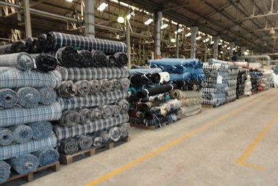
Fig: store of roll
Some definitions of weaving fault:
- Oil mark:when excess lubricant use for weaving m/c then oil mark arises on fabric.
- Hole: faulty or damage yarn creates hole in fabric.
- Starting mark: 1 or 2 pick missing no gap on weft way only line mark available.
- Barre mark: different lot mixing causes this problem.
- Snarling: bunch of weft yarn woven in one place.
Some definitions of dyeing fault:
- Crease mark: uneven heat control during process.
- Unevenness:If dyestuff are not fixed with fabric ultimately causes this problem`.
- Patches: this problem causes due to different color on some portions of fabric.
- Crumple mark: this problem is as like crease mark but looks meeting effect over PC fabric.
- Dye stain : marks of color on fabric surface cause this problem
- Dirty mark: this mark can appear anywhere in fabric.
- Rub mark: caused by friction with metallic component of m/c.
- Water spots:one to accumulation of water.
- Chemical stain:stain caused by chemical during dyeing & finishing.
- Rust stain:if m/c is affected by rust then rust stain appears on fabric.
- Bowing: bowing means ratio of bow depth at highest point of arc to fabric width. It is expressed as percentage

Chapter: 09
Dyeing lab

Dyeing lab:
- The lab where shade is matched with the swatch according to recipe of different brand of dyes.
- The shade is normally the combination of three subtractive color of required concentration which is assessed in spectrometer by CCMS or color matching cabinet visually to check either the sample is match with swatch or not.
- If matched .then the recipe is used for bulk production with (+ or -) 5%, to match the shade.
Laboratory Equipment for Fabric Dyeing:
SL.No. | Types Of Equipment | Company | Origin
01 | Spectrophotometer (1,2) | Macbeth | U.S.A
02 | Padder | Rapid Labortex Co. Ltd | Taiwan
03 | Dryer | Rapid Labortex Co. Ltd | Taiwan
04 | Chemical padder | Mathis | Switzerland
05 | H.T. Stimer | Mathis | Switzerland
06 | Electronic Balance | Ohaus | Switzerland
07 | Universal Press | Monforts | Germany
08 | Color Assessment Cabinet | Verivide | U.K

Color used in dyeing textiles:
- There are three primary color in subtractive color mixing Red, yellow, blue.
- Secondary color: orange, green, violet.
- Tertiary color: Olive, Grey, Khaki, Brown, Maroon, Burgundy, Navy, Black.
Orange = red + blue.
Green=blue+ yellow
Violet =blue+ red

Ratio of red, yellow, blue in a tertiary color:
Tertiary color | blue | red | yellow
Olive | 1 | 0.5 | 1
Grey | 1 | 0.5 | 0.5
Khaki | 1 | 0.5 | 2
Brown | 1 | 1 | 1

Dyes brand taken in this way according to depth of shade:Reactive dye procedure:
- From pastel to light shade:
- Levafix blue CA/red CA amber CA in case one light source
- Novacorn blue CR/red C2BL/Yellow CRG in case Two light source
- From light shade from 5g/l-10g/l

- Levafix blue CA/ red CA/amber CA in case one light source
- Novacorn blue CR/red C2BL/Yellow CRG in case Two light source
- Medium shade from 10g/l-25g/l:

- Novacorn blue CR/red SB/ Yellow S3R
- Nova.navy CR/red for blue,reds,yellow SB/ Yellow S3R medium navy,greys
- Dark shade from 25g/l-100g/l

- Novacorn black WAE/red SB/ Yellow S3R for blacks,DK,greys
- Nova.navy CR/red SB/ Yellow S3R navy, DK,greys
- Remazol.turq blue G/brill.blue R.sol turq,royal blues
- Remazol.turq blue / brill.blue R.sol/nova.yell C5G brill, Greens, Peacock blue

Name of Shade Normally Develop in SDFL Lab:

- Red Family
- Blue Family
- Green Family
- Orange Family
- Violet Family
- Indigo Family
- Purple Family
- Navy Family

Name of Dyes Normally Used in Lab:

Dyes Name | Manufacturer
Drimarine | Clarinet
Levafix | Daystar
Rema | Daystar
Cibacet | Ciba
Dychufix | Dysin Chem.
Calculation of dyes in continuous process:
- If the concentration is greater than 1 then stock solution% is not used & dyes are measured in a digital weight balance

Dyes = amount of dyes × amount of water taken in recipe

Amount of total water in ml
- If the concentration is less than 1 then stock solution% is used so that dyes are taken accurately by pipette & get the desired shade
.
Dyes = amount of dyes × amount of water taken in recipe

Amount of total water in ml × stock solution %
Recipe:
Pad dry chemical:
Ludigol (sequestering agent)= 1g/l
MIP (Wetting agent) = 40g/l

Steam chemical:
Glauber salt =200g/l
Soda ash=20 g/l
Caustic (solid) =10 g/l
Flow-Char of laboratory work:
Research of Buyer Standard

Spectrophotometer, to find out color composition

Costing

Recipe Preparation

Dyeing in Computerized Programmable M/C

Match the lab dip with the original STD by spectrophotometer

Check the Wash, Rubbing & Light fastness test by the ISO STD

Every parameter is OK/NOT

Submit the lab dip to buyer in four options to choose the best one

Self shade of Leva yellow CA:

0.25 g/l 0.5 g/l 1g/l 1.5g/l

2g//l 2.75 g/l 5g/l 10 g/l

15 g/l 20 g/l

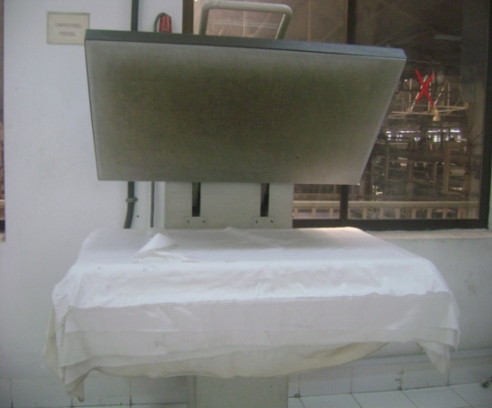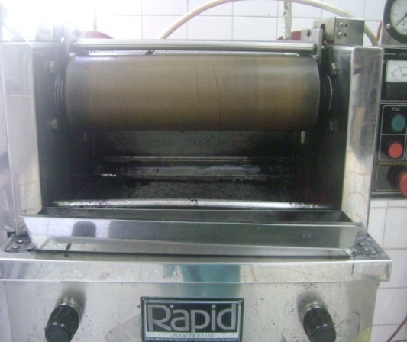
Press dryer dyes padder
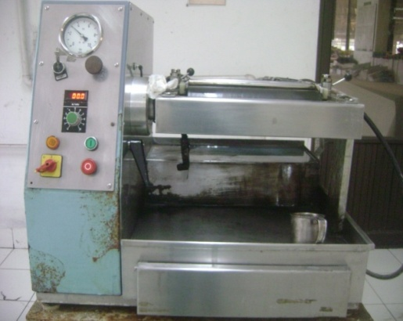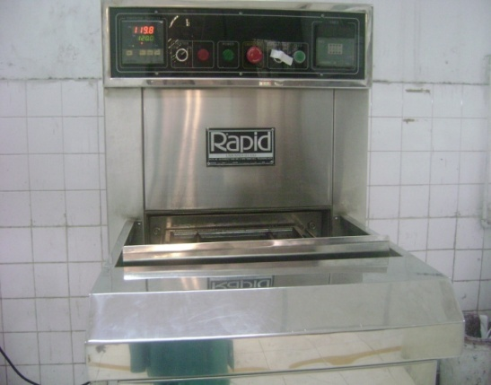
Chemical padder dryer
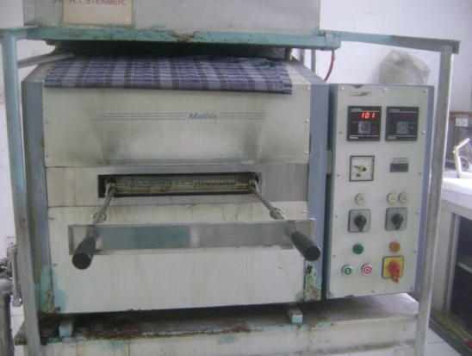
Steamer

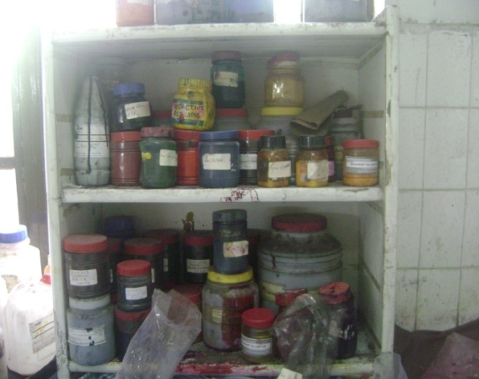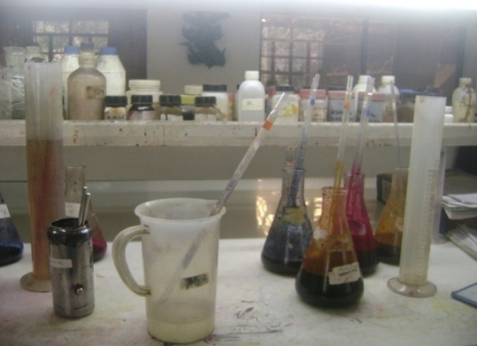
Stock of dyes in dyeing labWorking elements for dyeing in lab

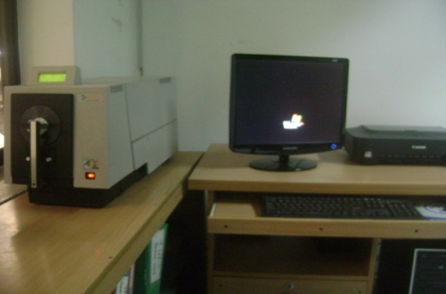
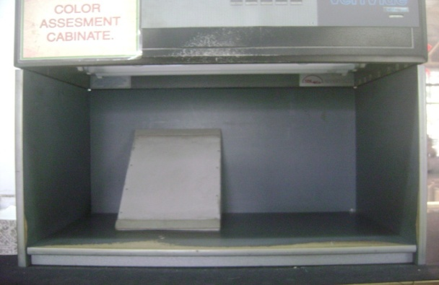
Spectrophotometer color matching cabinet

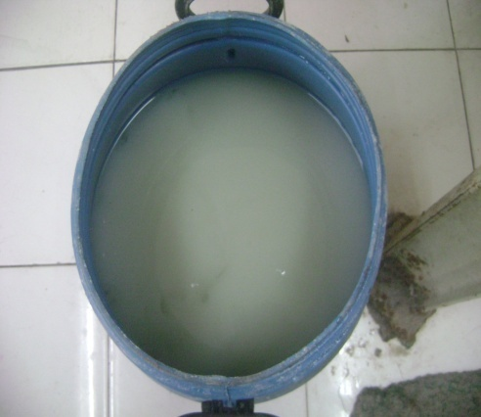
Mixture of Salt & Soda for padding

Chapter: 10
Quality control system

The Quality Management of Sinha Textile Group is done by the Quality Assurance Department. Quality Assurance Department is assigned to maintain consistently uniform quality of the material in process & various stages of its manufacturing.

Quality:
- The totality of features & characteristics of a product or service that bear on its ability to satisfy stated or implied needs.
- The degree of excellence that a product posses.
- Quality refers to the characteristics of a product or service that defines its ability to consistency meet or exceeds the customer demand.

Quality control:
- Quality control can be defined as cheeking, verification, & regulation of degree of excellence of an attribute or property of something.
- The operational technique & activities that are used to fulfill requirements of quality.

Quality policy:
It is the policy of the Sinha dyeing & finishing ltd to produce quality dyed fabrics that meet or exceed customer’s expectation & needs. To implement this policy the top management of SDFL is committed to provide adequate resources in terms of good raw materials & trained personal & continually improve its processes & systems.

Textile Testing:

Textile Testing is the application of science and knowledge to evaluate the performance of textile products.

Textile Testing can be performed at different stages of textiles. Very brief details are given below:
1). Fiber: maturity, fiber length etc.
2). Yarn: Twist, evenness, imperfection, strength, elongation, count etc.
3).Fabric: Strength, color fastness, performance and chemical properties.
4). Garment: Seam slippage, appearance, D.P. rating etc.
5). Trims & accessories.
Various Standards used in Textile Testing:
- ISO-International Organization for Standardization
- AATCC-American Association of Textile Colorists & Chemists

- ASTM-American Society of Textile and Materials
- BIS-Bureau of Indian Standard
- BS-British Standard
- SDC-Society of Dyers and Colorists
- JIS-Japanese Standard
- CAN-Canadian Standard
Most common standard among above are AATCC & ISO Standard.
Selection of test method depends on the country of destination or approved by the buyers.
Sl no | Name of equipments | manufacturer | Country | model | Noof equipments
01 | Flat Dryer | WAGNER | Germany | 2475 | 01
02 | Extensometer | PARAMOUNT | India | - | 01
03 | Crease recovery angle tester | PARAMOUNT | India | NEW MODEL | 01
04 | Wrinkle recovery tester | PARAMOUNT | India | - | 01
05 | Hygrometer | PARAMOUNT | India | - | 01
06 | Martindale abrasion cum Pilling tester | PARAMOUNT | India | - | 01
07 | Tearing strength tester | PARAMOUNT | India | - | 01
08 | Flammability Tester | ATLAS | USA | AFC | 01
09 | Fade-o-Meter | SDL | UK | C-54307 | 01
10 | Xenon fade –o-meter | ATLAS | USA | CI-300F | 01
11 | Tensile strength tester | HOUNTSFIELD | UK | H5KS | 01
12 | Color assessment cabinet | SDL | UK | - | 01
13 | P^{H} meter | DENVER | USA | 3004068.1 | 01
14 | Crock meter | ATLAS | USA | CM-1 | 01
15 | Crock meter | SDL | UK | - | 01

16 | Spray tester | Local | - | - | 01
17 | Double yarn twist tester | PARAMOUNT | India | - | 01
18 | Laundry meter | MIELE | Germany | WS- 5425 | 01
19 | Wash fastness tester | MATHIS LABOMAT | Switzerland | CH- 8155 | 01
20 | Quick wash plus | ATLAS | USA | EC-300 | 01
21 | Wash fastness tester | ATLAS | USA | - | 01
22 | Beasley’s balance | PARAMOUNT | India | - | 01
23 | G.S.M Cutter | SDL | UK | - | 01
24 | Perspiration tester | SDL | UK |  | 01
25 | Thread density counter | PARAMOUNT | India | 714032002 | 01
26 | Titan | JAMES HEAL | UK | 710 | 01
27 | BURSTING | PARAMOUNT | India |  | 01

Available tests in Sinha dyeing and finishing Ltd QC dept.:
SL No | Name of test | Testing method | Instrument | Testing frequency
01 | Color fastness to light | AATCC16E | Xenon fade-o-meter | New construction color
02 | Color fastness to wash | AATCC61 & ISO 105C03 | AATCC & ISO Instrument | New color
03 | Color fastness to crocking & Rubbing | AATCC08 & ISO 12 | Crock meter | New color
04 | Color fastness to perspiration | AATCC |  | On request
05 | Color fastness to chlorine & non- chlorine | AATCC/ISO |  | New color
06 | Dimensional stability & Spirality | AATCC135 & ISO | Launder –o- meter | Every batch/ 1000 mtr
07 | Stretch & growth tester | ASTM D3107 | Extensometer | Every New color
08 | Crease recovery angle testing | AATCC | Crease recovery angle tester | Every New color

09 | Wrinkle recovery testing | AATCC | Wrinkle recovery tester | Every New color
10 | Abrasion cum pilling test | BS | Abrasion cum pilling tester | Every New color
11 | Flammability test | AATCC-1610 | Flammability tester | On request
12 | Tensile strength testing | ASTM –D5034 & ISO | Tensile strength tester | New construction & Lot
13 | Tensile strength testing | ASTMD | Tensile strength tester | New construction & Lot
14 | Construction & Weight test(EPI, PPI , GSM) | ASTMD | GSM cutter & pick glass | Every New color
15 | Piled tarn twist test(TPI Test) | ASTMD | Piled tarn twist tester | New construction
16 | Yarn count testing | ASTMD | Yarn count tester | New construction
17 | Core p^{H} value testing | AATCC | Core p^{H} value tester | New lot
18 | Spray testing or water repellency | AATCC | water repellency | New lot
19 | Brusting strength testing | BS or ASTMD-3789/87 | Brusting strength tester | New lot
Inspection area:
- Shade match of fabric.
- G.S.M
- Fabric diameter.
- Shrinkage (%)
  - Length wise
  - Width wise
- Fiber type
- Wash fastness
- Light fastness
- Rubbing fastness
- Faults
- -dyeing faults
  - Weaving faults

Faults are found in QC department :( weaving fault)
- Crack
- Starting mark
- Broken pick
- Snarling
- Thick place
- Thin place
- Neps
- Stripe
- Missing yarn
- Contamination
- Light -medium -deep

Dyeing fault:
- Uneven shade
- Running shade

Finishing fault:
- GSM variation
- Shrinkage control
  - Length wise
  - Width wise
Quality assurance system:
Quality control

On line Off line
On line test:
- GSM of the fabric
- Exact diameter & width.
- Grey fabric inspection( 4 point)
- Shade cheek
- Bias & bowing.
- Visual appearance
- Stripe
Off line test:

All the off line tests for finished fabrics can be grouped as follows-
- Physical test
- Chemical test

Physical test:
- GSM of fabric.
- Rubbing fastness or crocking
- Abrasion & Pilling test
- Diameter & width
- Tensile strength
- Tearing test
- Bursting test
- Light fastness test
- Stretch & growth
- Wrinkle
- Crease recovery
- EPI & PPI test
- Seam strength
Chemical test:
- Shrinkage & spirality
- Color fastness to wash
- Color fastness to perspiration
- Color fastness to saliva
- Color fastness to rubbing or crocking
- Color fastness to light
- Color fastness to water
- Color fastness to chlorine bleach
- Color fastness to non chlorine bleach
Some washing test:
- Stretch & growth
- Shrinkage
- Washing
- Spiral
- P^{H} test

Basic chemical:
- Salt (NaCl)
- Soda(Na₂CO₃)
- Soda ash(caustic)
- H₂SO₄
- HCl
- Hydrose(Na₂S₂O₄)
Name of test & Procedure:
- Color fastness to wash:
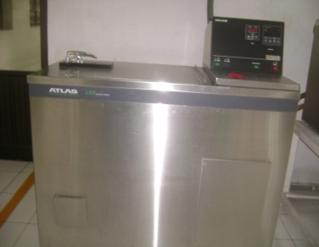
Chemical:
AATCC reference detergent =0.75 g/l
Water =200ml
No of steel ball=10
Time 30 min temp =60⁰c speed =60m/min

Procedure:
At first solution is made with 200 ml water & 0.75 ml detergent
10 steel balls is added
The fabric is keep in the solution
Then it keeps in the m/c for 30 min at temp 60⁰c

- Shrinkage test by quick plus m/c:
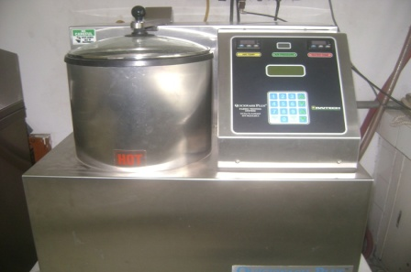
Water temperature =60⁰c total time =20 min
3wash 3drain every process time=6min
7 step in one cycle
Procedure:
Filling (3 ltr) [RNS/Dry cycle 1 to 3]

Agitating(45 sec)
Draining(30 sec)
Spinning(hydroextractor)(35 sec)
Spindown
Drying- high (1 min, air temp =55⁰c
Air pressure =4 bar)
Drying- medium (1 min, air temp =51
Air pressure =3.46 bar)
Drying- low (2 min, air temp =49⁰c
Air pressure =2.98 bar)
Filling (3 ltr) [RNS/Dry cycle 2 to 3]

Agitating (45 sec)
Draining(30 sec)
Spinning (35 sec)
Drying- high (1 min, air temp =56⁰c
Air pressure =4 bar)
Drying- medium (1 min, air temp =54⁰c
Air pressure =3.46 bar)
Drying- low (2 min, air temp =51
Air pressure =2.98-3 bar)
Filling (3 ltr) [RNS/Dry cycle 3 to 3]

Agitating45 sec)
Draining(30 sec)
Spinning(35 sec)
Spindown
Drying- high (1 min, air temp =60⁰c
Air pressure =4 bar)
Drying- medium (1 min, air temp =58⁰c
Air pressure =3.46 bar)
Drying- low (2 min, air temp =55
Air pressure =2.98 bar)
Cool down (temp =35⁰c)

Stretch&growth tester: (ISO /AATCC method)

Before length =25 cm
After value-before value
Stretch & growth%= ×100%
Before value

Stretch acceptance range: 20-22%
Growth acceptance range: 6%
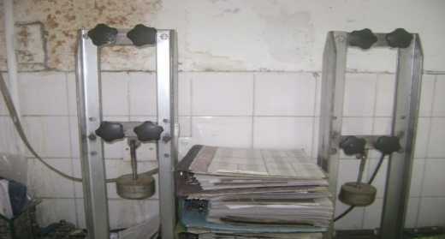

Fig: stretch & growth tester
Procedure:

Cut the fabric 25cm by shrinkage scale

Fabric attached fixed jaw one side and other side attached move jaw with weight 1461 gm

Stretch % found by formula

Fabric keeps in the stretch tester for 30 min

Relax the fabric up to 60 min

Then calculation growth % according to the formula

Spray test: (AATCC 22 method)
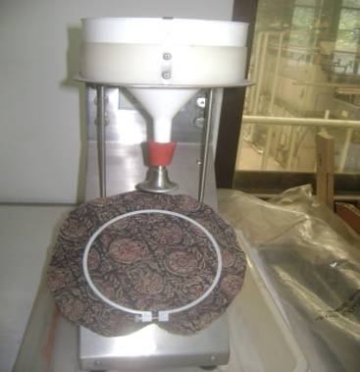

Frame dia: 150mm
Flannel holes:19
Frame to nozzle distance: 200mm
Water: 250ml
Procedure:
Water repellency fabric cut into (18*18) cm²
Fabric attached with frame which is place 45 angle to nozzle
Take 250ml water in flannel which contain nozzle with 19 holes
Water drop on the fabric within 30 sec
Water repellency measured by compare with tested sample&replica
Tearing test: (ISO method/AATCC)
Acceptance range: 6%
Procedure:
Cut the fabric according to template dimension

Both warp& weft direction taken

Fabric attached to fixed jaw and move jaw

Cut the fabric 2cm from bottom

Tearing the fabric

Value are taken

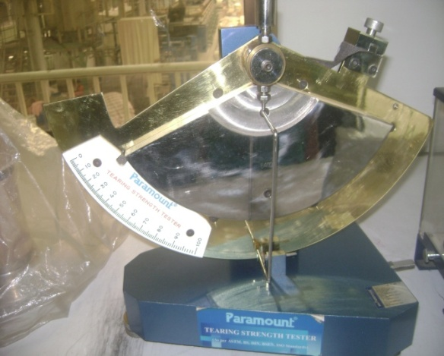
Fig: tearing tester
Tearing calculation:
Scale attached weight: 3200 gm
Half circular weight: 1600+1600 =3200 gm
Total weight: 6400gm
No of scale: 100

Per square value = 6400/100 =64 gm

Tearing value:

=Pressure ×64 gm
=Pressure × (641000) kg
=pressure× (64×2.204/1000)lb

Wrinkle recovery tester:(method AATCC 128)

Sample size: 15×28 cm
Weight:3500 gm
Time: 20 min

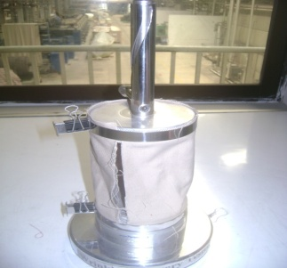
Procedure:
At first the fabric is tested is making crease free
The face side is keep in the outer portion &wound around the m/c
A load of 3500 gm is given onto the fabric for 20 min
Load is taken up from the fabric
Then the fabric is hang in a clip hanger in a directi0on of warp for 24 hours
Compare with the replica
Crease recovery test: (Method: AATCC 66)
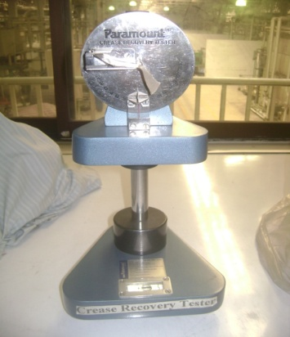

Minimum recovery: 10 degree
Scale reading: 20-180 degree

Procedure:
Cut 8 sample into (5×2.5) cm
Crease create on fabric by 10 N pressure applied for 5 min
Scale set first 90 degree and crease fabric attached on machine fix exact to fabric then take time
Scale show change of fabric position
Value taken
Flammability tester: (AATCC-CFR1610):

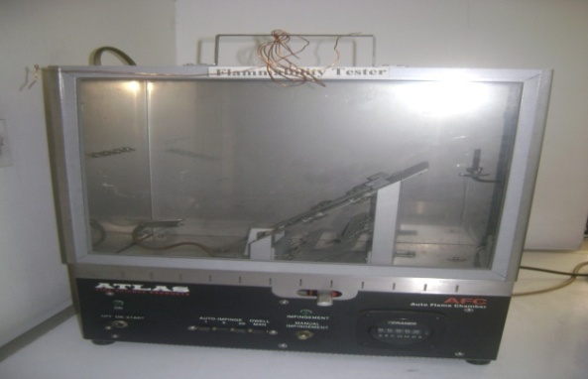
Sample size: (16×16) cm
Gas:butane
Accepted range: 7
Procedure:
At first a sample is taken of (16×16) cm
Placed the fabric between the plate with the help of clip
A yarn of 17 Ne is wound in a load 35 gm & then spiral in the clip
Then the gas is on & the time taken to burn is measured
Burst tester:(Method: ASTDM 3786)

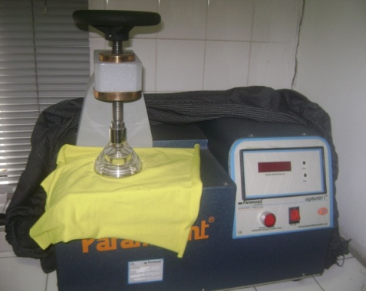
Burst test:used for knit fabric

Capacity: 0-70 kg/cm2
Rate of fluid displacement: 95cc/m
Test fluid: glycerin (98% purified)
Glycerin: 160ml
Density (D20/4):1:25-1:26

Procedure:
Fabric placed under the frame
Rubber ball contain under fabric which including glycerin
When pressure applied rubber ball move upward through fabric, due to pressure of glycerin
When fabric burst then value taken
Twist tester
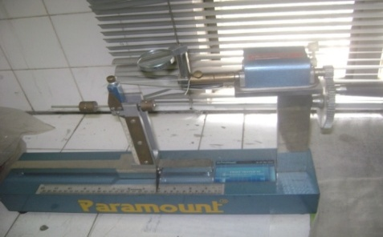
Tensile strength (ISO method/ AATCC):
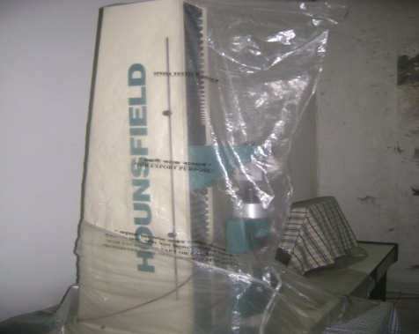
Procedure:
Cut the fabric according to template dimension
Fabric attached to fixed jaw and move jaw
Move the jaw fabric and when fabric tears then value taken
Value taken both warp& weft direction
The lowest result are taken
Color matching cabinet
It is used to check the shade of the sample with the swatch.
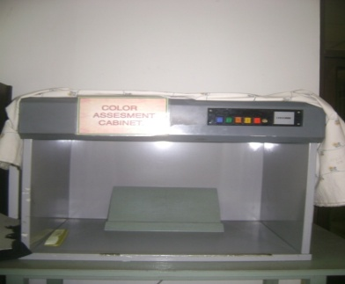

Light source:
- D65 daylight 6500k
- A incandescent light C.T 2848/2856k
- CWF cold white flour sense 4000k
- TL83 Philips triphosphore flour sense length
- UV ultraviolet back light
- TL84 departmental store lighting 4000k
Color fastness to rubbing:
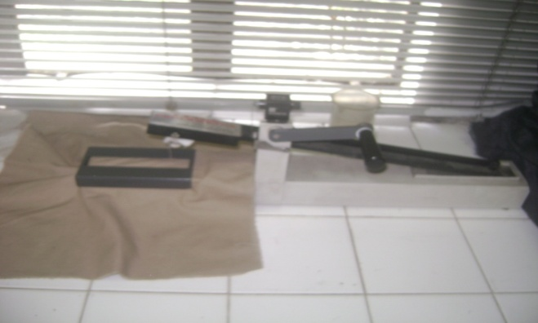
Procedure:
Sample cut (15×5) cm is taken
Then sample placed on the base of the crock meter
A square of white fabric (5*5) cm is taken which is de-sized,bleached cotton
White cloth attached to finger of the crock meter
Rubbing is done, 10 cycles at 10 second with 9 N pressure applied
Rubbing is done both for warp way and weft way
Then sample are compare with grey scale

Color fastness to light: (Xenon light fastness tester)
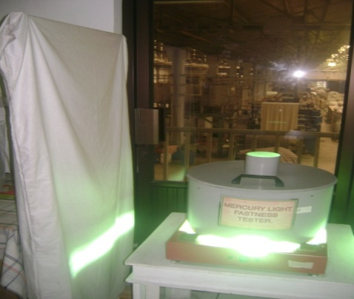
Shrinkage test: (ISO method/AATCC)
Acceptance range: 5
For Lycra Fabric,
Weft shrinkage=7%
Warp shrinkage=5%
Procedure:
Fabric are marked warp&weft both direction in 3 times (50cm)by shrinkage scale

Fabric washed with hot water at 60c for a hours

Fabric is dry by dryer

Fabric finally marks and compare dimension before wash &after wash. Then most value count.
P^{H} test:
10g fabric cut into very small size
Add distilled water 250 ml in bath
Temp raise at 90c for 10 min
String water % fabric for 10-15 Take water from bath &add universal indicator scale for PH4-11 including color scale
Now achieved color in solution then compare color to color scale

Tegwa test: Tegwa test is done for determine sizing chemical remaining in fabric after de-sizing process.
Tegwa solution:
KI 10gm
I 0.65gm
CH2-COOH 200ml
H2O 810ml
Total = 1000ml
Procedure:
Cut the fabric into (5×5) cm
Drop the solution onto the fabric
If violet color comes the fabric remain sizing material
If no color comes the fabric remain no sizing material
Yarn count measurement:
Process:
Take yarn from fabric both warp&weft direction
Take 20 yarns which length 20 cm
Weight of the total yarn
Yarn count measurement
No of yarn ×length yarn×0.0059
Yarn count=
Weight if yarn

Pick up%:
Wet weight-dry weight
Pick up% = ×100%
Dry weight
Procedure:
Cut the fabric after dyeing immediately
Weight takes of the dyeing fabric
Dry the dyeing fabric
Weight takes of the dyed fabric
Calculation pick up%
Color fastness to perspiration:
Perspiration solution preparation:
chemicals | Solution alkali | Solution acid
l-histidine mono hydrochloride mono hydrate | 0.5gm | 0.5gm
Sodium chloride | 5gm | 5gm
di-sodium hydrogen othophosphate | 2.5gm | 2.2gm
Distilled water | 1000ml | 1000ml
pH | 8 | 5.8

Procedure:Sample cut (10×4) cm is taken
Sample is placed &sewed between another 2 fabric
One will be same fabric undyed &other will be multifibre
Solution are taken 50 times the sample for 30 min at room temperature
Liquor is drained then sample place between glass plates
4.5 kg pressure applied
Keep pressure for 4 hours at temp 37⁰c+2^{O}C
Sample takes out &washed with water and unsewed
Then compare with grey scale
Color fastness to water:
Procedure: Sample cut (10*4) cm is taken
Sample is placed &sewed between another 2 fabric
One will be same fabric undyed &other will be multi-fiber
Water is taken in a 250 ml 50 times the sample
Immersed well for 15 min at room temp
then sample place between glass plate
4.5 kg pressure applied
Keep pressure for 4 hours at temp 37c
Sample takes out &washed with water and unsewed
The sample arw dried at air at 60c temp
Then compare with grey scale
Saliva fastness test: (DIN 53160-1964)
Saliva solution:
NACL 4.5g/l P^{H =}2.5
KCL 0.3g/l Time: 15-30 min
Na₂SO₄ 0.3g/l
NH₄CL 0.4g/l
Urea 0.2g/l
Lactic acid 3g/l

Procedure:
Sample cut (10×4) cm is taken
Sample is placed &sewed between another 2 fabric
One will be same fabric undyed &other will be multifibre
Solution are taken 50 times the sample for 30 min at room temperature
Liquor is drained then sample place between glass plates
4.5 kg pressure applied
Keep pressure for 4 hours at temp 37⁰c+2^{O}C
Sample takes out &washed with water and unsewed
Then compare with grey scale
Color fastness to chlorine:
Chlorine: 200 cctime: 30 min
Speed: 60 temp: 60⁰c
No of steel ball: 10

Making of Cl₂:
Here Cl₂ is not given directly. Here 10 ml Cl₂ is added in 1000ml water. From this solution, 200 cc Cl₂ is taken for test.
Procedure:
At first 200 cc Cl₂ is taken
10 steel balls is placed into the bath
The fabric is added
The bath is placed into the wash fastness m/c for 30 min& 60⁰ c
The fabric is dried & assessed by grey scale
Color fastness to non- chlorine:
Sodium per borate (NaBO₂.H₂O₂. 3H₂O): 1gm
Water: 200cc
Speed: 60
No of steel ball: 10
Time: 30 min
Temp: 60⁰c
Procedure:
At first solution is made with 1 gm Na & 200 cc water
10 steel balls is placed into the bath
The fabric is added
The bath is placed into the wash fastness m/c for 30 min& 60⁰ c temp
The fabric is dried & assessed by grey scale

All test for a fabric:
Buyer: Next
Fabric construction: 60×60/130× 90
After testing the required test of buyer, following
results are come:-
Color: c/p to wash fastness
Color fastness to rubbing:
Dry rub: 4
Wet rub: 4

Shrinkage:
Warp (Wp): -5%
Weft (Wt):-2.5%

Width:
B/W: 59.75ʺ
A/W:58.25ʺ
GSM:
B/W:094
A/W:099

Tearing strength test:
Warp (Wp): 1.69 lbs
Weft (Wt): 1.11lbs

Tensile strength test:
Warp (Wp): 19 kg
Weft (Wt): 15 kg

Abrasion resistance (10,000 rev): No fabric rupture

Chapter: 11
Maintenance

Maintenance of machinery:
Maintenance of machinery for is very essential mechanical effort for achieving smooth running of different machines. Maintenance is a process by which equipment is looked after in such way that trouble free. Services & increased machine life can be ensured & specific product quality required by the customers is sustained. On time maintenance increase m/c lifetime &ensures trouble free services.
There are two types of maintenance are done-
- Break down maintenance
- Routine maintenance
Maintenance

Preventive maintenance break down maintenance

Mechanical Electrical Mechanical Electrical
Maintenance Maintenance Maintenance Maintenance

Break down maintenance:
Break down maintenance is done instantly when problem arises in m/c. In this case, repairs are made after the equipment is out of order & it cannot perform its normal functions.
Preventive maintenance:
After a particular little the m/c are clear & recorded, that is routine or schedule maintenance .PPC does it once in a month. Schedule maintenance varies, time in time & also depends on situation according to types of machines, because maintenance is directly related to production.
Most of the time all the screws, nut, bolts & levers are checked, lubrication is also done. Workers inform about the problem areas of the m/c. Depending on their information, maintenance analyses the m/c records & take steps according to requirements.

Monthly preventive mechanical maintenance:
Check list for scouring & bleaching:
- Cloth feeding device FE:
  - Free movement of deflector roller
  - (1) Free movement of break roller
(2) Manage T Break
  - Break, Pressure spring
  - Beater Roller
  - Fabric Break
  - Fabric Guide
  - Curved Expand Roller
  - Squeeze
  - Splash Plate:
    - Clean nicely
  - Oscil Roller:
    - Free movement
    - Check pneumatic cylinder & air line
  - Scray (Tray)
    - Clean nicely
    - Clean reflector
    - Clean light barrier

- Washing compartmental with integrated squeezer:
- DRAIN:
- Check value cone.
- Check pneumatic cylinder.
- Check breakage.
- WINDOW:
- Check all window (A the time of product
- SEQUEEZE:
- Check free movement of both drive and squeeze.
- Check chain wheel & grouse screw.

- DEFLECTOR ROW (7 NOS.)
- Check free movement.
- Check leakage from sliding bush.
- BOTTOM ROLLS (6 NOS.) (6 NOS.) =12 NOS.
- Check free movement.
- Check leakage from sliding bush.
- UPPER ROLLER (PRESSURE ROLLER).
- Check free movement.
- Check condition of rubber roller.
- Check chain wheel & grouse screw.
- SPECIAL THREADED EXPAND ROLLER:
- Check free movement.
- Check clutch.
- Check chain wheel & grouse screw.
- WATER SUPPLY (& steam supply)
- Check pneumatic cylinder.
- Check glass (floor meter) if needed.
- Check all gasket of steam inlet.

- SLIDING CLUTCH(CHAIN)
- Check in clutch.
- Orifice of air line.
- DRIVE STAND:
- Check all nut & bolts.
- Check tension of V. Belt.
- Check oil leek of gear box.
- Screw of universal joint.
- TOP COVER:
- Check taplon bush (4 nos.)
Washing compartmental:
- DRAIN:
- Check valve cone (rubber).
- Check leakage

- DEFLECTOR ROLL (8 Nos.)+ Bottom Roll (7 Nos.)
- Check free movement.
- Clean.
- Cheek brakeage
- DRIVE & CLUTCH:
- Check all nut & bolts of drive stand.
- Check tension of V. Belt.
- Screw of universal joint.
- Check oil leak of gear box
- Check in clutch.
- Check all chain wheel
- Check tension of drive chain.

- OSCILL ROLL:
- Free movement.
- Free movement of shaft.
- CURVED EXPAND ROLLER:
- Check free movement.
- Check any damage.
- WATER SUPPLY:
- Check all pneumatic valve.
- Check all manual valve.
- Check the flow meter glass, clean if dirty.
- Also check the spraying pipe.
- Squeezing mangle:
- Check the rubber roller (drive).
- Check cepper roller & movement.
- Check & clean air bellows (both side)
- Check cover & splash plate for any touch with roller.
- Expression test.

- Impectaap:
- Check lifting device of displacer & oil level & check clutch.
- Check movement of bottom roller.
- Check replacement bush then change.
- Check limiting stop.
- Check proximate switch holding screw.
- Check squeeze roller both drive & pressure.
- Oil level of gear box.
- Screw of universal joint & groove screw.
- Check parametric cylinder.
- Check free movement of deflector roller (2 nos.)
Liquor circulation:
- Fill water in tank & check leakage.
- Check free movement of deflector roller (3 nos.)
- Expression test of squeeze nip
- Steamer DL 100T3E:
- Free movement deflector roller.
- PLAITING DEVICE:
- Free movement of both roller.
- Chain wheels with bolts.
- Tension of drive chain.
- Check clutch 7 pneumatic cylinder & wooden block.
- Check all cir clips.
- Check two groove ball bearings.
- WALZEN ANGETRIBEN:
- Round belt pulley Z& belt.
- Chain all wheel.
- Free movement of all roller

- GUIDE ROLLER:
- Free movement (64 nos.)
- TRACTION ROLLER:
- Free movement

- Check chain wheel
- Check Allen screw of chain wheel
- ROLLERS- ROLLER BED:
- Free movement of all roller(64 nos)
- Check chain wheel
- Check tension of chain
- Check the drive chai wheel
- Check gear box oil
- Check tension of V Belt
- PRESS ROLLER:
- Free movement
- Check circlip
- Check pneumatic cylinder and air connection
- CLOTH DREW OFF:
- Check pneumatic cylinder and air connection
- Check air clip
- Check hand wheel & spindle
- Check position of limiting stop
- DRIVE:
- Check foundation bolt
- Check lock screw of pulley
- Check tension of V Belt
- Check chain wheel
- MEASURE ROLLER:
- Free movement
- Check measuring amplifier
- STEAM CONDENSING UNIT:
- Check all pneumatic connection of steam condexing unit
- Check all pneumatic value

Chapter: 12
Utility service

Production and profit are closely related. In order to get a quality final product, so it needs to input fresh raw materials as well as well as effective manpower and machinery in good working condition. Utility in conjunction with three M’s play a vital role to maximize the production aswell as the profit.
Utility Department of Sinha Dyeing and finishing is related to the following things:

Power supply:

1. by Generator.
2. from Rural Electrification Board (REB).
- Water pump.
- Gas supply TITAS.
- Steam supply (by boiler).
- Compressed air supply (by air compressor).
- Chiller.

Generator:
M/c specification:

Brand:WartsilaFrance
Model number: VHP 5904GSID
Cylinder used: 16
Overall efficiency:80%
Weight:17600 kg
Rpm:1000
Ignition pressure:90 bar
Source of energy: Natural gas
Stroke of engine: 176 mm
Cylinder capacity: 71.6 dm3

Steam supply (Boiler):

Brand: Omnical
Type no. DDHI 12.0.10.0
Serial no. 18353
Maximum working pressure gauge: 10 bar

:

Maximum heat capacity: 7-8 mw
Water content up to”NW”:17-8m³
Maximum steam output: 12 ton
Maximum temp.:183⁰c
Year of:1995
Origin: Germany
Energy: Gas

Air compressor:

Process sequence of air compressor:

FGFDG

Air compressor

Supply pipe

Relwar tank

Dryer

Loom section
Specification:

Machine: Air compressor
Brand:Atlas capco, Belgium
Model: ZT200
Capacity: 774 Lit air/compressor/sec
Maximum working pressure:10 bar
Input power: 193 kw
Rpm: 1485
Year of manufacture: 2005
Capacity:1746 per hour
Energy: Electricity

Chiller:

A chiller can be generally classified as a refrigeration system that cools water. Similar to an airconditioner, a chiller uses either a vapor compression or absorption cycle to cool. Once cooled,chilled water has a verity of application from space cooling to process use.

There are two types of chiller:
1. Vaporization Chiller
2. Absorption Chiller

Specification:

Brand:Thermax absorption chiller, India
Model: N_{G}-13ml
Chiller water flow rate: 90.7m³/h
Maximum water pressure for chilled water system:0.8 Mpa
Cooling water flow rate: 150 m³/h
Maximum water pressure for cooling water system: 0.8 Mpa
System consumption:645 Kg/h
Refrigeration capacity: 527 KW
Chiller water inlet/outlet temp. : 12-7⁰C
Cooling water inlet/outlet temp:. 32-37⁰C
Electric source: 3 amp, 400V, 50Hz
Manufacturing date:June, 2006
Chemical used:Shell Turbo-T-68
: Grease
Naclo 7328& 7330

Chapter: 13
ETP

Effluent treatment plant:
Effluent treatment plant of Sinha Textile group is based on combined method, ie biological and physicochemical treatment is accomplished together. This plant can treat 350 cubic meter of raw effluent per hour. The raw character of this plant is described below,
Basic characteristics of raw material:
Sl no | Chemical characteristics
 | Parameters | Unit | Amount
1 | pH |  | 11.8
2 | Suspended solids | Mg/l | 378.8
3 | Biological oxygen demand(BOD) | Mg/l | 416
4 | Chemical oxygen demand(COD) | Mg/l | 850
Physical characteristics
5 | color |  | Brown to black
6 | odour |  | Not distinct
7 | Temperature | ⁰c | 40⁰c

Process Description:
The effluent is first passed through a Manual Bar Screen Channel / Chamber to remove any floating debris. The effluent is then collected is a Equalization Tank where it is equalized with respect to its characteristics and flow. The content is kept in mixed conditions with the help of air blower.
The equalized effluent is then pumped to flash mixing tank followed by a Flocculation Tank. Chemicals like lime and FeSO₄ are dosed in the flash mixing tank to aid coagulation and color removal. Anionic Polly-electrolyte (type-1) is dosed in the Flocculation Tank to aid in the agglomeration of the particles. The flocs formed are removed in the downstream Primary Claritubesttler -1. The effluent will further flow by gravity to a P^{H} correction tank where requisite quantity of acid will be dosed and PH will be adjusted as per the requirement.

Diagram of ETP:
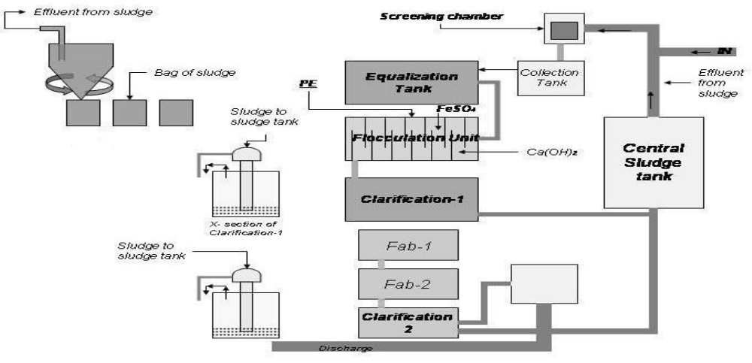
After the primary treatment effluent flows by gravity to the FAB Rector for reduction of BOD / COD aerobically. The air is supplied by means of fine bubble diffusion. The generated are removed in the Secondary Claritubesettler – 11.
The clarified effluent polished and disinfected by dosing sodium hypochlorite in the Chlorine Contact Tank.The disinfected effluent is suitable for disposal.
Chemicals are used in ETP-1:
Ferric chloride
Polyelectrolyte
De-coloring agent
As a preservative-
NaOH
H₂SO₄
Na₂SO₄

Chemicals are used in ETP-2 &3:
Lime
Ferrus Sulphate
Polyelectrolyte
HCl- 5% solution
Sodium or Calcium hypochlorite- 5% solution.
There are 3 “Effluent Treatment Plant” in Sinha Textile Group”. This are-
- ETP 1
- ETP 2
- ETP 3
Process sequence of ETP 1(“It’s a physiochemical plant”) :
Capacity- 150m³/hour
All kind of dyeing water came from different dyeing unit
Rotary screen filter
Equalization tank
Chemical reactor
Flotation unit
Sludge
Clean water
To river
Step discussionsAll kind of dyeing water comes from different dyeing section:
In this segment water comes from different dyeing section. Like-
- Woven dyeing section
- Knit dyeing section

- Yarn dyeing section etc.
- Rotary screen filter: Suspended solid quartz material removed by using this step.
- Equalization tank:To equalize the effluent quantitatively & qualitatively. Material takes approximately 10 hours time to get clean. Its capacity is 1560 m³.
- Flotation unit:Chemical dozing (Fecl₃, polyelectrolyte, de-coloring agent). After flotation unit water goes two sides. One is sludge & another is clean water which is gone into river.
Process sequence of ETP 2(“It’s a biological plant”):
Capacity- 350m³/hour
Combined effluent from various units
Mechanical bar screen
Collection tank
Pumping
Equalization tank
Flash mixing tank (by pumping)
Flocculation tank
Primary claritubesetteler tank
P^{H} correction channel
FAB reactor 1
FAB reactor 2
Secondary claritubesettler tank
Chlorine contact tank
To river
Step discussions:
- Combined effluent from various units:In this segment water comes from different dyeing section. Like-
- Woven dyeing section
- Knit dyeing section
- Yarn dyeing section etc.

- Mechanical bar screen: To removing the coarse solids.
- Equalization tank:To equalize the effluent quantitatively & qualitatively. Material takes approximately 10 hours time to get clean. Its capacity is 1560 m³.
- Flash mixing tank:2 nos for rapid or uniform mixing of dosing chemicals with the effluent.
- Flocculation tank:For coagulation & flocculation of solids. Polymer increases the size of dust particles.
- Primary claritubesetteler tank:To remove the inorganic flocs formed.
- P^{H} correction channel:To correct inlet p^{H} by HCl dosing.
- FAB reactor:Treatment of organic matter to reduce BOD/COD aerobically.
- Secondary claritubesettler tank:To remove the biological solid generated.
- Chlorine contact tank:For polishing & disinfections. Calcium or sodium hypochlorite dozing.
- Sludge sump:To collect the thickened sludge.
- Centrifuge:For mechanical dewatering of sludge.
Process sequence of ETP 3(“It’s a biological plant”):
Capacity- 150m³/hour
Rotary screen
Effluent collection tank
Chemical dosing
Clarifie

P^{H} correction channel
Biotower
Aeration tank
Lamella clarifier 1, 2
Chlorine contact tank
Mult-igrade filter
To river
Step discussions:
- Rotary screen filter:Suspended solid quartz material removed by using this step.
- Equalization tank:To equalize the effluent quantitatively & qualitatively. Material takes approximately 10 hours time to get clean. Its capacity is 1560 m³.
- Chemical dosing:Lime, Fe (SO₄)₃, polyelectrolyte are added in this stage.
- P^{H} correction channel:To correct inlet p^{H} by HCl dozing.
- Biotower:Atmospheric air is blown in this stage.
- Chlorine contact tank:For ploishing & disinfections. Calcium or sodium hypochlorite dozing.

Chapter: 14
Conclusion

Conclusion:

Industrial attachment program provide us to the expected destiny of practical life. The completion of two month industrial attachment at Sinha Textile Ltd we got the impression that the factoryis one of the most modern woven dyeing projects in Bangladesh. Though it was established only few years ago, it has earned very good reputation for its best performance over any other wovendyeing project.
During our industrial attachment program we tried our best to done the duty. Our supervising
Officer also satisfied to us& offer co-operation in every steps. It is completely a new experience in our life, which will be very effective in our service life. During our training period we realized that practical experience is more valuable for service life.

At the end:

We are enough fortunate that we have got an opportunity of having a training in this mill. During
the training period we are received co-operation & association from the authority full & found all
man, machines & materials on appreciable working condition. All stuffs & officers are very
sincere & devoted their duties to achieve their goal.

List of Figures:
Fig no | Topics | Page no
01 | List of buyers | 9,10
02 | Layout of SDFL | 16
03 | Parex Mather singeing m/c | 34
04 | Benninger Scouring &Bleaching m/c | 40
05 | Kusters Scouring &Bleaching m/c | 42
06 | Sando Mercerization m/c | 48
07 | Pad Dry Pad Steam m/c | 53
09 | Monforts Pad Dry Thermofix | 56
10 | Jig Matic dyeing m/c | 58
11 | Stork Printing & Curing m/c | 66
12 | Icomatex Stenter m/c | 70
13 | Monforts Stenter m/c | 71
14 | Morison Stenter m/c | 75
15 | Gessener Peach m/c | 76
16 | Santex & Danti paoloPeach m/c | 78
17 | Nazer Inspection m/c | 81
18 | Storage of Rolling fabric | 86
19 | Dyeing Lab m/c & Instrument | 92-93
20 | Washing m/c | 101
21 | Quick Plus washing m/c | 102
21 | Stretch & growth Tester | 104
22 | Tearing Tester | 106
23 | Wrinkle &Crease recovery tester | 107
24 | Flammability Tester | 108
25 | Brusting &Twist Tester | 109
26 | Tensile Strength Tester | 110
27 | Color Matching Cabinet | 110
28 | Rubbing Tester | 111
29 | Xenon Light Fastness Tester | 112

List of Tables:
SL no | Topics | Page no
01 | Manpower of SDFL | 19
02 | Machineries of SDFL | 23
03 | Fabric Products | 25
04 | Dye & Chemicals Products | 26-28
05 | Problem & Remedies of Singeing | 31
06 | M/C setup of Singeing | 32
07 | Quality Parameters (Singeing /De-sizing) | 35
08 | Summary &Solution of De-sizing | 35-36
09 | Chemical & their use in Scouring | 38
10 | Online quality control parameter for Bleaching | 46
11 | Mercerization m/c parameter | 49
12 | Jigger m/c set up | 59
13 | Variable grade sand paper used in peach m/c | 76
14 | Four Point system & Yarn fault penalty point | 82
15 | Weaving(warp way) penalty point | 83
16 | Weft way penalty point | 84
17 | General penalty point | 85
18 | Laboratory equipment for Fabric dyeing | 88
19 | Ratio of Tertiary Color | 89
20 | Names of dyes | 90
21 | Equipment name & country of QC m/c | 96
22 | Available test & method used in QC | 97-98
23 | Recipe of color fastness to perspiration | 114
24 | Basic characteristics of raw material of ETP | 129

List of Abbreviation:
- ISO:International Organization For Standardization
- STG:Sinha Textile Group
- SDFL:Sinha Dyeing & Finishing Limited
- CVC:Chief Value Cotton
- TC:Tetron/Cotton(Trade name of PC)
- PC:Polyester/cotton(60% cotton/40% polyester)
- EDTA:Ethylene Di-amine Tetra Acetic Acid
- GSM:Gram per Square Meter
- IR:Infrared Radiation
- AATCC:American Association of Textile Chemists & Colorists
- SDFL Layout abbreviations. (Page no: 17-18)
List of Symbols:
- Arrow

