

FACULTY OF SCIENCE & INFORMATION TECHNOLOGY
DEPARTMENT OF TEXTILE ENGINEERING

“Studyon illusion and relevant facts in fashion design”

Submitted By:
Md.Mostofa Zia; 091-23-1221
Md.Anisur Rahaman; 091-23-1295
Mamtaj Jahan Rimu; 091-23-1188

Supervisor: Dr.S.M. Mahbub-Ul-Haque Majumder
Professor & Dean
Faculty of Science & Information Technology
Daffodil International University

Dissertation submitted to the Department of Textile Engineering of Daffodil International University in partial fulfillment of the requirement for the Degree of Bachelor of Science in Textile Engineering

DECLARATION

We hereby declare that the work which is being presented in this thesis entitled, “Study on illusion and relevant facts in fashion design” is original work of our own,has not been Presented for a degree of any other university and all the resource of materials used for this thesis have been duly acknowledged.

Md.Mostofa Zia………………………..
Md. Aniur Rahman…………………….
Mamtaj Jahan Rimu …………………..

This is to certify that the above declaration made by the candidates is correct to the best of my knowledge.

Prof.Dr.S.M. Mahbub-Ul-Haque Majumder Date
(Supervisor)

ACKNOWLEDGEMENT

Above all, we praise the almighty Allah who gave us his enabling grace to successfully complete this research work.
With sincerity, we extend our warm and deep appreciation and gratitude to our supervisor, prof. Dr. S.M. Mahbub-Ul-Haque Majumder for his unreserved guidance and support to come up with this research work. Being working with him, we have not only earned valuable knowledge but were also inspired by his innovativeness which helped to enrich our experience to a greater extent. His ideas and way of working was truly remarkable. We believe that this research could not be finished if he did not help us continuously.
We are thankful to prof.Dr.Md. Mahbubul Haque, Head of the Textile Engineering Department of Daffodil International University and Biplob Saha founder of ‘Rang’ fashion house.
We would also like to thank all who responded to our questionnaires and interviews, which helped us in coming up with this research.
We are grateful to our friends for their encouragement for this research work.
Finally we express our sincere gratitude to our father mother brother sister for their continuous support, ideas and love during our studies.

-Authors

Abstract:
This study firstly reveals the most important factor preferred by purchaser to purchase a brand dress and also analyze the suitable illusive design that can be implemented on garments to adjust the figure having different proportion. It also makes a notion about the linkage of fashion via human brain to the matter or energy. Through this study it has been found out that outlook and comfort are responsible to choose a dress firstly, and in case of illusion the Golden ration is the perfect ratio to observe the dress as it is. Two structured questionnaires were formed to find out the factor of choosing a dress and to find out the effect of golden ratio to make the appearance fine-looking. This study suggests using the golden ratio in dress designing as well as it has analyzed the illusions with relevant facts to be implemented in dress designing; furthermore it proves that variation of choices in fashion follows the theory of relativity.

 | TABLE OF CONTENTS  ACKNOWLEDGEMENT…………………………………………………….. | iii
 | ABSTRACT…………………………………………………………………… | iv
 | TABLE OF CONTENTS……………………………………………………… | v
 | LIST OF TABLES…………………………………………………………….. | vii
 | LIST OF FIGURES…………………………………………………………… | vii
 | 1. INTRODUCTION………………………………………………………….. | 1
 | 1.1. Background of the study………………………………………………. | 2
 | 1.2. Objective of the study…………………………………………………. | 3
 | 2. LITERATURE REVIEW…………………………………………………... | 4
 | 2.1. Recent studies…………………………………………………………. | 4
 | 2.2. Relevant fashion study………………………………………………… | 5
 | 2.3. Color sense…………………………………………………………….. | 7
 | 2.3.1. Factors for color vision…………………………………………. | 7
 | 2.3.2. Color wheel……………………………………………………... | 11
 | 2.4. Golden ratio analyzed before………………………………………….. | 11
 | 2.4.1. Artificial………………………………………………………… | 12
 | 2.4.2. Natural………………………………………………………….. | 12
 | 2.5. Human psychology……………………………………………………. | 14
 | 3. METHODOLOGY…………………………………………………………. | 15
 | 4. ANALYSIS OF WORK……………………………………………………. | 16
 | 4.1. Really man prefers design or outfit……………………………………. | 16
 | 4.1.1. Analysis of data………………………………………………… | 16
 | 4.2. Length/width ratio illusion and effect………………………………... | 18
 | 4.2.1. Length and width ratio………………………………………….. | 18
 | 4.2.2. Illusion due to length/width ratio……………………………….. | 18
 | 4.2.3. A Statistical analysis……………………………………………. | 20
 | 4.2.4. Design created by golden ratio…………………………………. | 22
 | 4.2.5. Line effect………………………………………………………. | 24
 | 4.3. Color illusion and effect………………………………………………. | 25
 | 4.3.1. Suitable color for different complexion………………………… | 26
 | 4.3.2. Tinting…………………………………………………………... | 26
 | 4.3.3. Color contrast…………………………………………………… | 29
 | 4.3.4. Illusion due to contrast………………………………………….. | 31
 | 4.3.5. Illusion due to light or dark color………………………………. | 32
 | 4.4. What is illusion or perception or seeming…………………………….. | 33
 | 5. FINDINGS AND DISCUSSION…………………………………………… | 37
 | 5.1. Influencing factors to purchase a dress..….…………………………… | 37
 | 5.2. Suitable design and illusions…………………………………………... | 37
 | 5.3. Illusion or perception or seeming……………………………………... | 38
 | 6. CONCLUSION…………………………………………………………….. | 39
 | 7. REFERENCES……………………………………………………………... | 40
 | 8. APPENDIX…………………………………………………………………. | 41
 | 8.1. Appendix-1……………………………………………………………………. | 41
 | 8.2. Appendix-2……………………………………………………………………. | 43

 | LIST OF TABLES
 | Table-1: Study on wages of fashion designer………………………………… | 6
 | Table-2: Study on Job area of fashion designer………………………………. | 7
 | Table-3: Warm and cool variation of color…………………………………… | 8
 | Table-4:Criterion of a garments influence to purchase………………………. | 16
 | Table-5: Comparative ratios and appearance of body top……………………. | 20
 | LIST OF FIGURES
 | Figure-1: Different artificial and natural creature following golden ratio……. | 14
 | Figure-2: Criterion of a garments influence to purchase for male……………. | 17
 | Figure-3: Criterion of a garments influence to purchase for female………….. | 17
 | Figure-4: Responsible part of brain to observe a dimension…………………. | 18
 | Figure-5: Illusion due to only variation of length…………………………….. | 19
 | Figure-6: Comparative ratios and appearance of body top…………………… | 21
 | Figure-7: Illusion due to line present in dress………………………………... | 24
 | Figure-8: Illusion due to dark color…………………………………………... | 25
 | Figure-9: Tinting effect of a colored dress…………………………………… | 26
 | Figure-10: Tinting effect on the body………………………………………… | 27
 | Figure-11: Analysis of illusion in more contrast……………………………... | 28
 | Figure-12: Illusion due to color contrast……………………………………… | 29
 | Figure-13: Illusion due to light and dark color……………………………….. | 30
 | Figure-14: Linking fashion with big bang……………………………………. | 32

- Introduction:
In modern civilization human are used to wear garments not only for protect their shame also for exposing style and others additional purpose. To meet the demand of this huge quantity of garments to the consumer lot of industry and retailers have been created and continuously serving their products. Among them brand is the part and parcel to fulfill the human demand and it also keep a continuous and uniform relation between consumer and producer. Brand gives consumer either quality or mental satisfaction or both with other reasons due to which consumer tends to purchase their garments from brand. We believe and hope that through this study we will able to find the reasons which really influence the consumer topurchase brand garments.
There are different reasons for purchasing a brand dress; design comes first among all of them. Fashion is a vital criterion to choose a dress at the first glance. Fashion makes a man different and expresses himself differently in the society. The fashion has a great impact in society for example; in the Second World War and the world recession in 2008 (Almond 2011). So fashion is that thing which has the influence in the society, economy, and psychology and in various aspects around us. Considering these factorsthe dress is designed to create different value in the society.
The relation between dressing and the idea of individual expression is complex. It may be perceived in people’s daily life through recurrent use of the same clothing colors, brands, and fashion tendencies etc. Many people use contrasts and colors that express feelings according to their state of mind. Thus the products’ properties, like design, comfort, individuality, have a decisive role on apparel’s buying behavior, which may vary depending on a set of factors, mainly on sex (Arnold, 1994).
Design concept can come from many ways; it can be nature, psychology, environment and many other ways. It is a wider field to collect a specific fashion and to incorporate in a dress precisely. To accomplish the total process dress designing, manufacturing, merchandising and different education and training system are maintaining their contribution to produce a creative product. Now a day the crossover phenomena of fashion is being practiced between the high fashion and mass fashion, or between fashion and art, crossover phenomena between fashion design and product design; and crossover phenomena between fashion design and environmental design(Kim & Ha 2010). So now fashion takes a wider field along with itself and influencing the human a lot which is now a great concern in various fashion cities such as Paris, New York, Milan, Hong Kong, London etc.

  - Background of the study:
Brand is the thing which serving us garments according to our demand. Brand bridges between consumer and producer resultant we get our desired product. It is the perfect means to utilize our money on garments purchasing with not at all or little deception, so consumer can be reliable on it and reliability is the main reason to conduct any types of business. In case of garments/apparel selling reliability on product can be ensured by brand by providing our desired quality so it is required to find out the most desired quality considered by human such as design, performance, comfort, fittings etc where fashion plays a vital role to purchase the garments.

Indonesia, Philippines, China, Bangladesh, South Korea, Spain, Germany, Brazil and India act as producing country of fashion but laggard in dress design. So it is important to create an impetus to produce some creative design in Bangladesh and different study on fashion design can resolve this issue. Most of the countries such as Italy, United States, United Kingdom, Hong Kong, France etc have been contributing lot in progressing fashion design. They have been conducting different types of education system for fashion reaches up to web based fashion education ( Kwon & Brinthaupt2012) but Bangladesh is really slacker in this aspect.

To establish a higher technology in fashion design it is dearly needed to do more research work on that sector. The backward linkage of dress designing such as sketching is also not well practice in this country whereas developed countries have already been using the three dimensional body scanning technology exceeding the normal manual sketching (Zong & Lee 2011).
Without exact fashion design most of relevant work is being accomplishing to make this sector reach. Such as the work about the influence of precise cutting has been conducted to attain the precise design, this cutting technology belongs to the textile sector so textile has a great influence to make an appealing design (Almond 2010). From that respective view this study has been accomplished for the betterment of fashion design in Bangladesh.
Design is the first quality of a product which can influence a person to approach the garments at the first sight. Design is only the characteristics which firstly distinguish a person from other person of the society where texture, performance, comfort etc come later in act. So it has been discerned to conduct a study on fashion design.

  - Objective of the study:
- To find out the important criteria of a dress influence the consumer to purchase.
- To analyze the beauty that a person feel in a particular design.
- To find out the suitable illusive design for various person.
- To explore the reason behind the illusive phenomena.
- To analyze the illusion created by different fashion design.
- To present the illusion and variation of choice physically.

2. Literature review:
The mentionable research about illusion created by fashion design has not been done yet as per we searched in the journals, books, and different articles. But there are many works about the fashion and relevant fashion element. As in this study length/width ratio as well as size ratio and color effect has been analyzed so different output and result of these types of studiesconducted before has been discussed sequentially.
2.1. Recent studies:
According to the research paper of (Apeagyei 2008) induced by persuasive social settings, the dilemma of what is considered as an ideal size, shape and body image continue to impact decisions consumers make regarding clothing selection and fashion. Body image has been identified as crucial to clothing provision and fashion consumption (Sproles and Burns 1994). In presenting methodological considerations in researching body cathexis for fashion products, Apeagyei et al. (2007) observed that body measurements alone is not the panacea to solving consumer sizing and fit problems and draw attention to the tension between body image and geometry. Generally, women are self-conscious about body cathexis (degree of satisfaction/dissatisfaction) with their physical forms. This does not only impact garment fit assessment and preferences but also affect self-evaluations relating to body image. Instigated by the media, the desire to emulate celebrities and remain fashionable has been the current focus of consumers, as some try to fit into the socially construed ideal body type of ‘the skinny trend’.

Another paper discusses research undertaken to identify and compare design theories of European and Japanese fashion designers. Various influencing factors, including historic, cultural, aesthetic and psychological influences, methods of generating ideas, and design process were analyzed. Research questions which were posed were subsequently answered using a range of methodologies, and models representing design theories were formulated. The similarities and differences between the two groups of fashion designers were observed in each of the relevant, cultural settings. It is believed that the findings of the research can be used to further understand the relationships between causes, conditions, and consequencesdesign process of fashion designers of different cultural backgrounds when creating new fashion (Taylor and Newton 2009).
One more paper proposes an innovative, integrated design method for the design of practical and sophisticated compliant mechanisms. The approach consists of two optimization methods, topology and shape optimization, plus a scheme to implement designer input of ideas. In the first step, a designer explores the most fruitful design concepts for mechanisms that achieve the design specifications, by combining compliant mechanisms created by the topology optimization with additional mechanisms prepared by the designer. In this first step, a support method based on the visualization of the designer's thinking processes assists the designer in his or her exploration of new ideas and design concepts. In the second step, the shape optimization yields a detailed optimal shape based on the design concept. The combination of compliant mechanisms with the additional mechanisms enables the creation of devices having increased capability or higher performance than would be possible using a single compliant mechanism designed by topology optimization alone. Executing the shape optimization after initial design concepts have been explored facilitates the determination of a detailed optimal shape, and also enables to consider non-linear analysis and stress concentration and to make accurate quantitative performance evaluations, which topology optimization cannot provide (Kobayashi et al 2009).
2.2. Relevant fashion study:
Fashion designer sketch design of clothing, footwear, and accessories. Fashion designers create original clothing, accessories, and footwear. They sketch designs, select fabrics and patterns, and give instructions on how to make the products they designed.A fashion designer is seen as a creative individual who will acquire and utilize knowledge by using her intelligence to form concepts (Bell & Jerrard). Fashion designers attempt to design clothes which are functional as well as aesthetically pleasing. They must consider who is likely to wear a garment and the situations in which it will be worn. They have a wide range and combinations of materials to work with and a wide range of colors, patterns and styles to choose from. Though most clothing worn for everyday wear falls within a narrow range of conventional styles, unusual garments are usually sought for special occasions, such as evening wear or party dresses.
Earnings in this occupation can vary widely based on experience, employer, and reputation. Starting salaries in fashion design tend be very low. Salaried fashion designers usually earn higher and more stable incomes than self-employed, freelance designers. However, a few of the most successful self-employed fashion designers earn many times the salary of the highest paid salaried designers. In May 2010, the wages of fashion designers in the industries employing most of the occupation were as follows:
Areas | USD
Management of companies and enterprises | 70,660
Apparel manufacturing | 65,790
Apparel, piece goods, and notions merchant wholesalers | 63,750
Specialized design services | 60,900
Performing arts, spectator sports, and related industries | 44,130
Table-1: Study on wages of fashion designer
Most fashion designers work full time; however, some work part time. Occasionally, fashion designers work long hours to meet production deadlines or prepare for fashion shows. Designers who freelance generally work under a contract and tend to work longer hours and adjust their workday to their clients’ schedules and deadlines (Designer pay report 2012).

The following table shows the industries that employed the most fashion designers in 2010:
Area | Recruit%
Apparel, piece goods, and notions merchant wholesalers | 29
Apparel manufacturing | 14
Management of companies and enterprises | 7
Specialized design services | 4
Performing arts, spectator sports, and related industries | 2
Table-2: Job area of fashion designer
Most designers travel several times a year to trade and fashion shows to learn about the latest fashion trends. Designers also sometimes travel to other countries to meet suppliers of materials and manufacturers who produce the final products (Designer recruit report 2012).
2.3. Color sense:
Color is a result of an interaction between a chromophores group or color bearing group & light (Sayeed 2011).
2.3.1 Factors for color vision:
- Light
- Substrate
- Observer
There is a formula, a scientific theory, to determine your own coloring. How does it work? And how can you have color sense?
According to color theory, all colors are derived from the three primary colors – red, yellow and blue. Taking it one step further, all colors have a temperature, i.e. a yellow base (warm) or a blue base (cool). Your skin undertone also is warm or it is cool. This is the basics of color analysis for the individual
How do you know whether you have cool or warm skin tone?
This is not something that can be determined 100% through a written formula, as we all have our unique combination of colors, and so a visual consultation is required to understand your own blueprint accurately. But, by comparing color temperature and understanding basic color theory, there is a way to give you a quick sense of what may be right for you.

Step One
Taking the primary colors - yellow, red, and blue, and the secondary colors, which are a combination of the primary - orange, green and violet, we have the foundation of all color.

Examples of warm and cool variations:
Hue | Cool | Warm
Blue | Royal Blue | Turquoise
Yellow | Lemon | Mustard
Red | Cherry | Brick
Green | Jade | Apple
Orange | Acid orange | Amber
Violet | Lavender | Violet
Table-3: Warm and cool variation of color
What base are you drawn to most?
Wear warm colors for warm skin tones and cool colors for cool skin tones.
Step Two
Adding white (a tint) or black (a shade) or grey (a tone), you are able to create all the colors that exist in the world.
Example:
Blue with black Navy
With white Powder Blue
With grey Airforce Blue
A primary Royal Blue

Which depth of tone are you drawn to?
Wear the depth of color that matches your complexion and to which you are drawn.

Step Three
Color analysts split colors into different color palettes to help define a person’s unique coloring.
Some us seasonal differentiation:
Winter - Cool and clear - lightest tints, darkest tones, strongest primaries
Summer - Cool and soft - blend of soft tints and tones
Spring - Warm and clear - light tints, strong primaries, few shades
Autumn - Warm and soft - few tints, few primaries, blend of rich shades

Some use tonal differentiation:
Light - tints, Dark - shades
Soft - tones, Clear - primaries
Warm - yellow based, Cool - blue based

When you look in the mirror, which of the above terms best describes your complexion?
Keep the colors that you wear to one palette. They not only will all flatter you, but they will also harmonies with each other, optimizing on how they reflect and their affect.

Step Four
All colors have a psychological effect on the wearer and a psychological effect on the onlooker. Color is commonly used in the medical and business world to evoke a physiological and psychological reaction. Physically color is often used to heal, such as doctors using colored lights to heal newly born babies of jaundice. Psychologically color is used to create a sense of trust, reassurance, energy and calm.

Psychological meanings of primary and secondary colors:
Red - Extroversion, strength, stimulates physical; can be overbearing if too strong
Blue - Introversion, stimulates intellect, concentration; reflection, calm, soothing Very dark conveys high authority - as in a uniform)
Yellow - Extroversion, stimulates emotion; creativity, optimism
Orange - Energy, lively; derived from yellow and red
Green - Balance, peace, nature; combination of two main primary colors of opposite polarities
Violet - Spirituality, meditation, the whole; combination of all primary colors red, yellow and blue
White - Clinical, innocence, purity
Black - Intensity, experience; can be depressive and overbearing
Grey - Simplicity, subdued, subtle
Choose the colors that you wear to reflect your character, your mood and to impact how you feel and people you come into contact with.

Step Five
Combine your colors correctly. Imagine an artist painting in the same color palette e.g. cool shades, then adding a warm light line across his painting. If he wanted to draw all the attention from the rest of the painting to that line, then this would be the way to do it.

Likewise, if you wish to detract all attention away from you, then the best way is to wear a complete opposing palette to your own natural skin tone. Wearing colors that don’t match with you can make you look cold, older, tired, sallow, puffy, green and also completely out of context.

Inappropriate color combinations can distort the finished look and invade the other colors in the palette, draining them of their true hue or making them look a different color altogether. This is one of the most important rules associated with color theory. It is not about simply knowing what best suits your color tone, but implementing it effectively and using color from your own palette across your whole outfit.

Wearing light/color is a necessary part of any outfit. Taking a black t-shirt and changing it to a blue, green or red of your color base, you will not only physically look better, but you will also feel differently.
Walk yourself through the steps and start to consider what your own color palette may be and bring it to life.
Without it we got-
Warm- red, red orange, yellow
Dark-dark brown, black, or midnight blue,
Bright- orange
Warm tints -such as red, shades of rose, a gray color having a tint of pink

2.3.2.Color wheel:
The color wheel is a useful pictorial representation of the spectrum of colors and can be used to simplify the understanding of the interaction of colors used in a painting. It can also help with selection of a palette of colors, color mixing, the natural greying of colors, and color perspective (also called aerial perspective). The simplified wheel opposite consists of the primary, secondary and tertiary colors explained in Fig 5.5. The three primary colors Red, Yellow and Blue are shown in the large circles. Between each of the primary colors are the secondary colors, shown in the middle sized circles, which result from mixing the two adjacent primaries. The tertiary colors obtained from mixing the primaries with their respective secondary colors are shown in the small circles. As the colors progress around the wheel in any direction, each one is a gradual change from its adjacent color. The colors on the right of the wheel shown opposite are known as cool colors - colors which are blue or have a leaning towards blue (yellow-green to blue-violet) The colors on the left, are known as warm colors - colors which are red or have a leaning towards red (yellow-orange to red-violet)
- Orange is the complementary of Blue.
- Green is the complementary of Red and
- Violet is the complementary of Yellow,

2.4. Golden ratio analyzed before:
At least since the 20th century, many artists and architects have proportioned their works to approximate the golden ratio especially in the form of the golden rectangle, in which the ratio of the longer side to the shorter is the golden ratio, believing this proportion to be aesthetically pleasing, artificial and natural ratios are following:
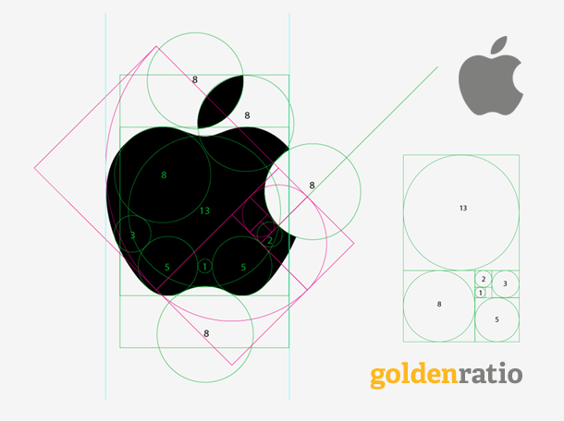
2.4.1.Artificial:
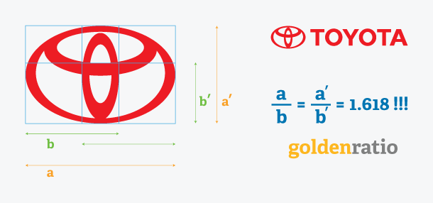
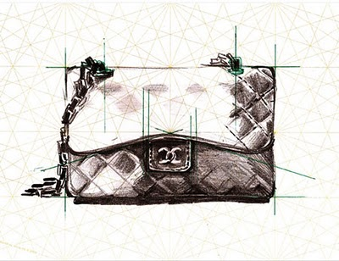
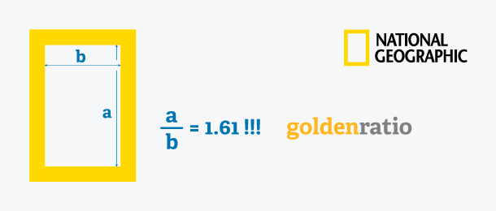

2.4.2.Natural:
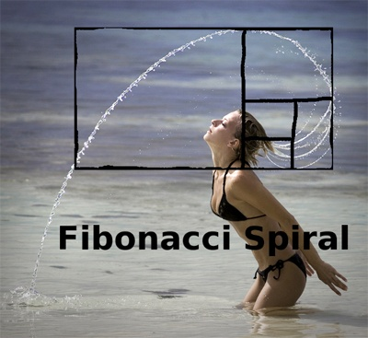
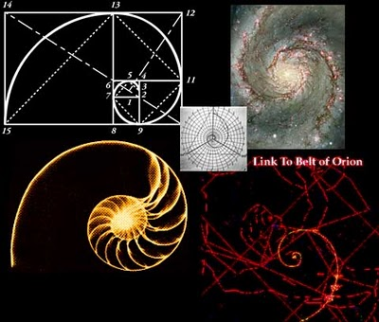

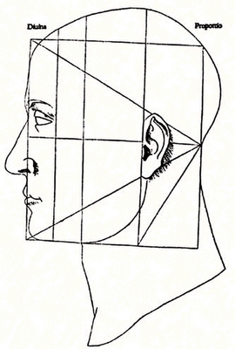
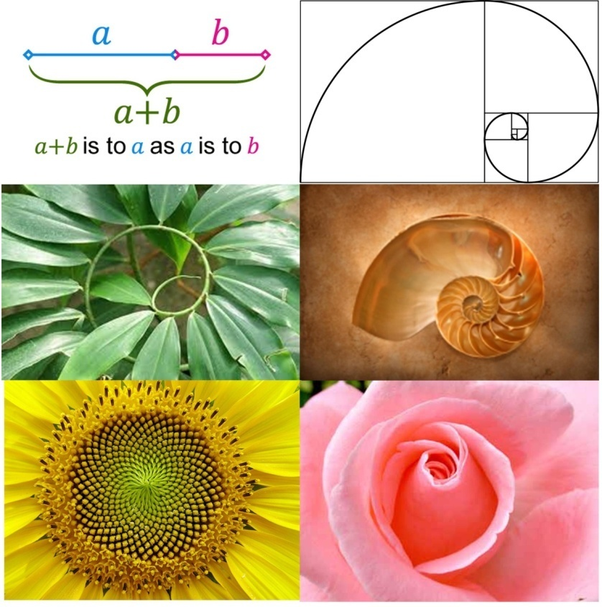
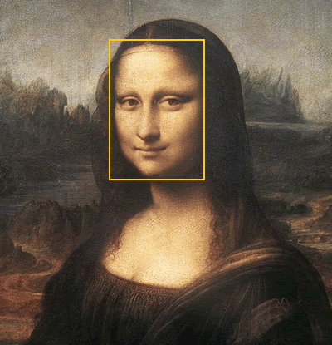
The Monalisa:

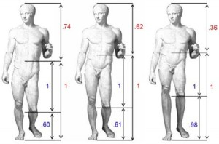

Figure-1: Different artificial and natural creature following golden ratio

2.5. Human Psychology:
Brain is the main center of operating the total bodily function and responsible of taking information by five sensory organs such as- nose, eyes, ears, tongue, skin (Selim 2012).
At the molecular level, sensory receptors located on the cell membrane of sensory neurons are responsible for the conversion of stimuli into electrical impulses. The type of receptor employed by a given sensory neuron determines the type of stimulus it will be sensitive to. For example, neurons containing mechanoreceptors are sensitive to tactile stimuli, while olfactory receptors make a cell sensitive to odors.
Dr. Allerton recognized that in order for the brain to function properly and for the neurotransmitters in the brain to receive messages, the hypothalamus must be working correctly, since it is the functioning center for four of the brains most powerful hormones (neurotransmitters) that affect the mind; Serotonin, Dopamine, Norepinephrine and acetylcholine. It was his feeling that improper Hypothalamic function could be the cause of most of the mental problems/chemical imbalances that affect children and adults.
The Hypothalamus (with the Cerebral Hemispheres) is intimately involved in the integration of all physiological stimulation, all 5 senses, including taste, smell, sight, sound, and touch, which it then translates, distills and assembles into one discernible "package," relating all the attributes of an experience, all the associated stimulation into one clear harmonious concept, one memory, one experience. Thus yielding a succinct emotionally satisfying understanding and judgment of the experience itself.

3. Methodology:
In order to achieve the objectives of this study both qualitative and quantitative research methods have been used. Data from both primary and secondary sources were collected. Secondary sources include reports, documents, magazines, books, journals, various newspapers, and subject related websites and research documents. Primary data were collected through conducting surveys from the target respondents such as general people in shopping mall and offices. A total of 50 and 29 respondents respectively for effect of outlook and golden ratio were interviewed using structured questionnaire who selected through random sampling. Primary data found by questionnaire was analyzed by typical statistical rules used for graphical representation, pie chart and bar chart to show the explicit illustration of effect of outlook and golden ratio in garments purchasing and designing. The opinions of some eminent educationists have also been incorporated in this study which draws out the unambiguous results of the study.

4. Analysis of work:

4.1.Really man prefers design or outfit?
Why human goes to the brand such as ‘Rang’ only due to their design or outfit nor other cause, we thought outfit is mostly responsible and what others quality should be considered by brand in dress manufacturing and dress selling.

Now we will try to find which specific quality more actuates us to purchase garments in our city. To find it we did a short survey where we took 50 persons opinion. In that survey people ranked the quality of garments which they desire from garments. For example I purchase brand dress because firstly I get good performance from brand dress so performance is ranked 1, then secondly I get style from the brand so it is ranked 2, then I get comfort so it gets 3……..

4.1.1.Analysis of data:
For male |  |  | For female
Quality | Number of person influenced 1st | Percentage (%) | Quality | Number of person influenced 1st | Percentage (%)
Outlook | 10 | 40 | Outlook | 9 | 36
Comfort | 6 | 24 | Comfort | 9 | 36
Style | 3 | 12 | Style | 2 | 8
Social status | 2 | 8 | Social status | 0 | 0
Fitting | 1 | 4 | Fitting | 0 | 0
Time saving | 0 | 0 | Time saving | 3 | 12
Performance | 3 | 12 | Performance | 2 | 8
Economic status | 0 | 0 | Economic status | 0 | 0
Total | 25 | 100 | Total | 25 | 100

Table-4:Criterion of a garments influence to purchase.

Figure-2: Criterion of a garments influence to purchase for male.

Figure-3:Criterion of a garments influence to purchase for female.
4.2.Length/width ratio illusion and effect:
4.2.1.Length and width ratio:
Length and width is the basic shape of any dress which determines the measurement of body as well as appearance. Size and shape of human body may vary according to physical, biological, and environmental parameters. Although the body measurements varies but there are some common and significant measurement of dress which is perfectly applicable for all sizes of body measurement. Among those measurements length and width of the dress is most vital measurement which explicitly expresses the beauties and compatibility of dress to the respective body.
So the length and width ratio is prominently considered and important for the dress designing. But “how this ratio can be determined and what would be the perfect ratio?” this question is answered in this study. The answer is the “golden ratio” which has already been described before, now the logic of implementing golden ratio and the illusion created by other ratios except golden ratio in dress designing is described subsequently.
4.2.2.Illusion due to length/width ratio:
Before establishing the logic in favor of golden ratio firstly “what is illusion?” it must be discussed. “So what is illusion and how illusion is happened in length width ratio?” so it occurs in following way-
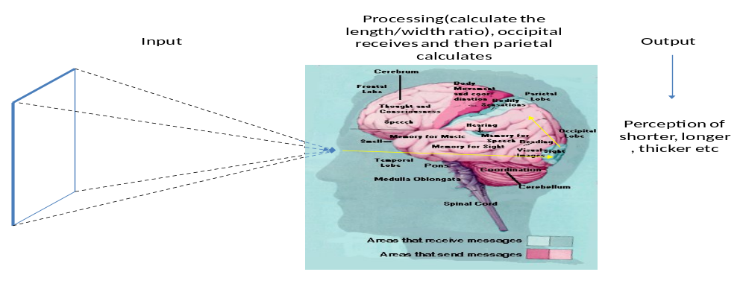Figure-4: Responsible part of brain to observe a dimension.
In the fig-4 when reflected light ray of total length and width of dress reach on our eyes then the sensation is transmitted to the occipital lobe of brain which is responsible for watching and eye hallucination. After that the sensation is again transmitted to the parietal lobe of brain which is responsible for calculation, language, movement, and size and shape judgment.
The occipital lobe receives the length and width of the dress and then the parietal lobe calculate the ratio and gives the decision whether it is thinner or thicker. If we consider three rectangles having same width but different lengths as fig-5 then the parietal lobe calculates the length/width ratio of three rectangles and gives three result,
For fig-Bthe occipital lobe receives the length and width and parietal lobe gives the result of length/width ratio is 1.618 which is the golden ratio. So then the brain judges the dress is perfect without any illusion and the dress has good measurement.
But in fig-Cthe length of dress decreases keeping the width same then occipital receive the length and width and parietal lobe calculates length/width ratio and gives result lower than 1.618 resultant human brainsperceives the dress as wider.
And if the parietal lobe gets higher length as fig-A, but having the width same then parietal lobe gives the result of length/width ratio higher than 1.618 resultant human brains perceives the dress as slender.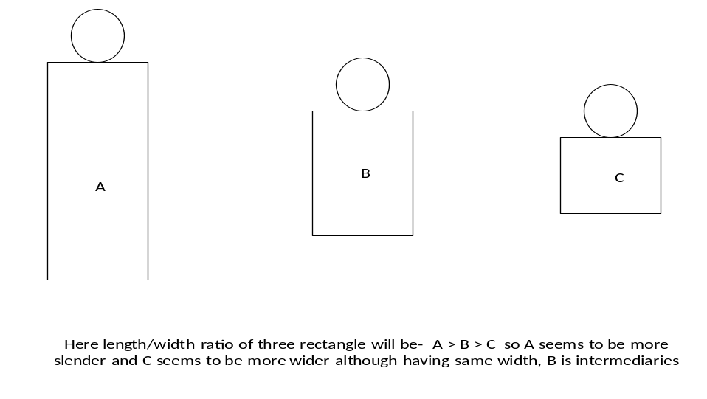
Figure-5: Illusion due to only variation of length.
4.2.3.A Statistical analysis:
So in case of golden ratio the illusion is not occurred so the human brain gives the perfect judgment. Now “do human really follow the golden ratio in his clothing?”“Does it increase the beauty of human?” Yes it does. Human wears shirts formally inserting their shirts hem into the pant which makes him smart. But why insertion of shirts hem into pant waist makes a man beautiful?Because it takes a shape of golden ratiorectangle. If human wear Panjabi or shirt without insertion the hem into the pant waist then the length of golden ratio rectangle appears more in the body dress, resultant the perfect golden ratio 1.618 is not achieved the result appears more than 1.618.
A typical survey was conducted with 29 respondents to measure the length(as front view from HPS to waist) in the state of insertion of shirt hem into the waist belt of pant and width is the front view of waist belt. The statistical analysis of length/width ratio measurement of front view of body top of those people in the state of insertion of shirt into the waist belt as following: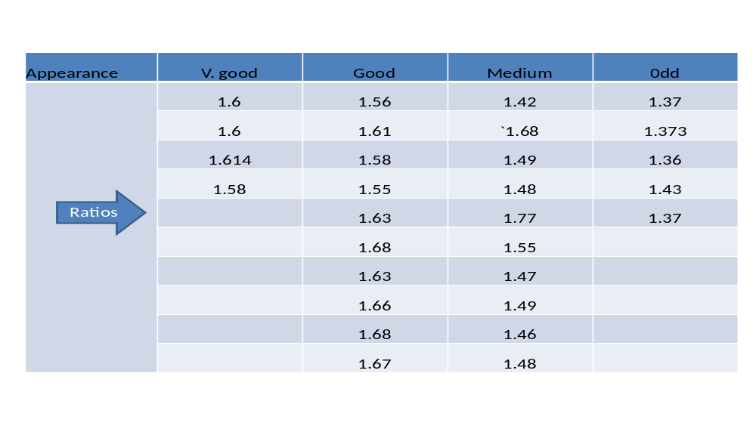
Table-5: Comparitive ratios and appearance of body top.
In the avobe table we can see that the ratios of “very good” appearance is very closer to 1.618 it just little more or less of 1.618, similarly “good” appearance are just more scattered than “very good” ratios, “medium” is further scattered than “good” and “odd” is again further scattered than “medium”. So gradually from “very good” to “odd” the ratios also scattered from the golden number 1.618.
It can be illustrated in bar chart below,where ratios are placed in the Y axis and X axis contains the bar of individual persons ratio, in bar chart the bars of ‘very good’ ratios reaches almost the 1.6 axis, ‘good’ ratios are little below than the 1.6 axis, ‘medium’ bars areless height than ‘good’ bars and bars of ‘odd’ ratios are taken lowest heights. So it shows that “very good” appearances posses the ratios closer to golden ratio and the odd apperances are very far from the golden ratios see fig-6.
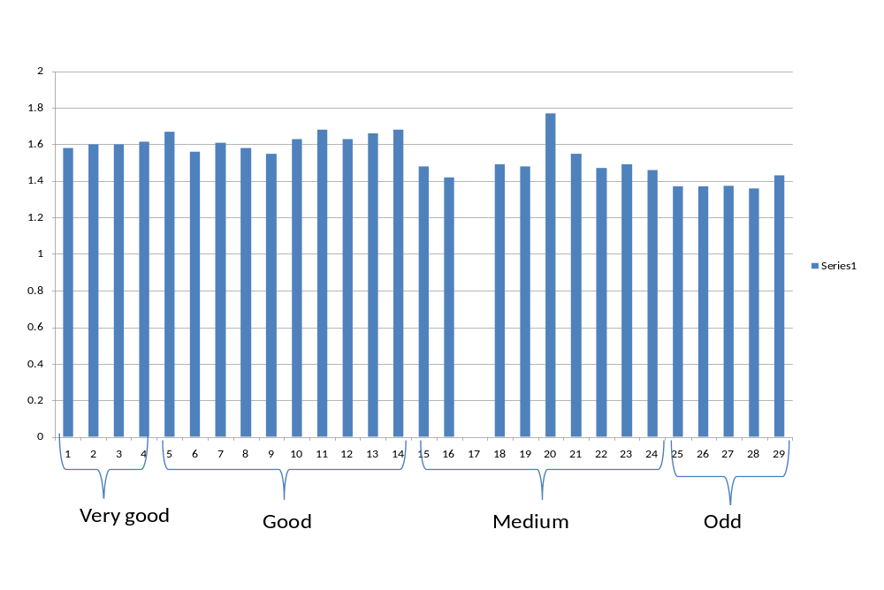Figure-6: Comparitive ratios and appearance of body top.
4.2.4.Design created by golden ratio:
It is already proved that golden ratio is very significant in appearance of human smartness, but “how it can be used in dress designing?” It is the unique ratio which automatically expresses the satisfaction of customer. If a fashion designer does not know how to create a beautifull design in a dress and how a new design can be implemented on a dress he can take help of golden ratio. Golden ratio gives the satisfactory design and measurement involving circles, rectangles, triangles, and all other shapes make the dress beautifull. Placement of design, length and width of design can be set precisely in dress by mantaining golden ratio.
In this study a T-shirt is designed considering the golden ratio as following:

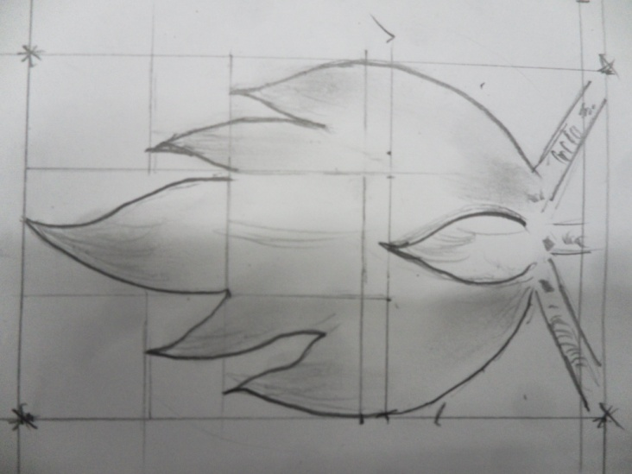
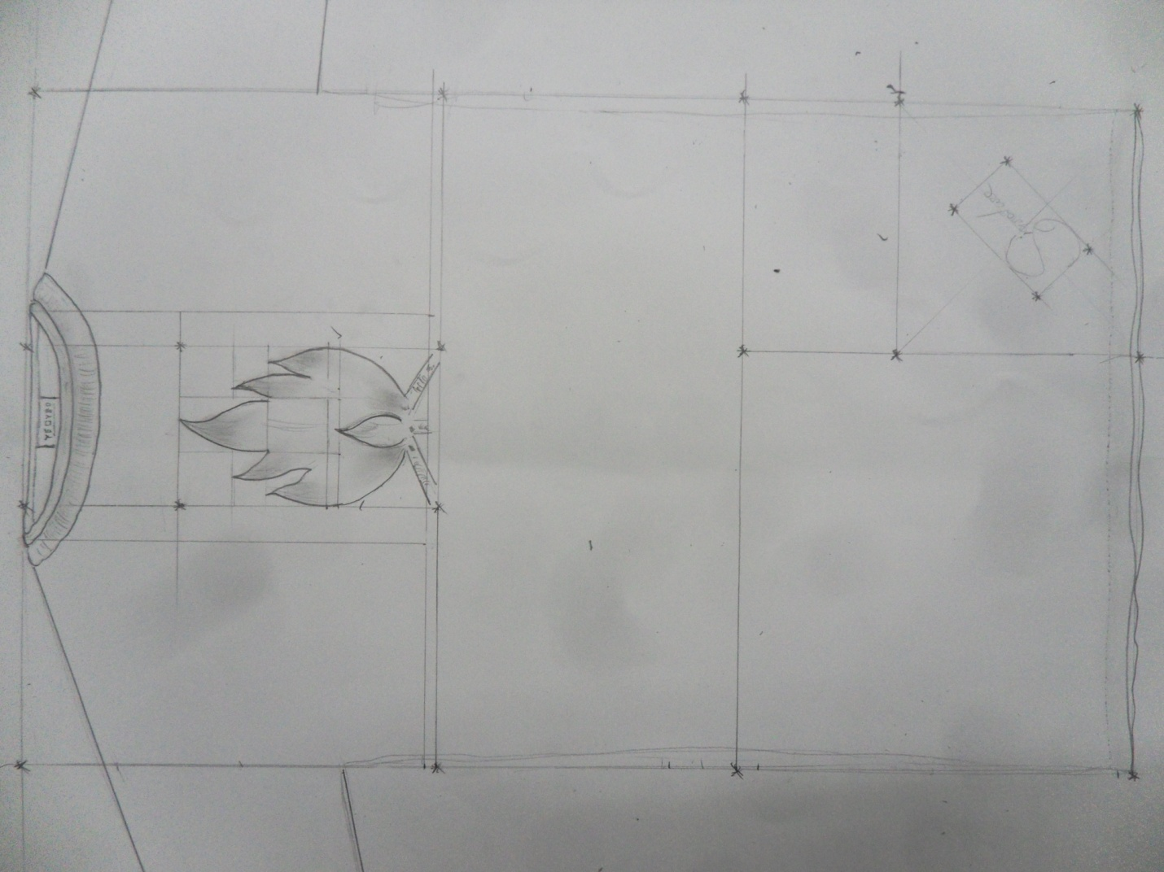

In this study a T-shirt is designed considering the golden ratio, a picture of a flame has to be placed on the chest of the T-shirt, so at first the total lentgh and width of T-shirt is determined according to golden ratio. Now two horizontally golden rectangle are drawn at the bottom and top of the the T-shirt resultant we got the place where the base of flame to be placed, it will beplaced just avove the bottom line of top golden rectangle as above figure, then considering all the golden rectangles drawn in the figure we determined the lenth and width of flame, bottom right corner ‘signature’ and all the things required to design the dress. It is mentionable that to design this T-shirt we had not to be a designer we had to just follow the golden ratio.
So the perfect ratio can be expressed by equation-
=> l $∝$ w, (if lentgh increases width also increases so the relation is directly proportional)
- l = $G^{r}$w, (here l=lentgh, w=width,$G^{r}$=golden ratio=1.618)

- l= 1.618 X w

4.2.5.Line effect:
Line provide the visual dimension of lentgh and width. Line also responsible for the thinner or thicker appearances. In this study mainly two types of line has been discussed as following:
- Horizontal line
- Vertical line
This two lines is mainly responsible for the thicker and thinner illusion as well as height and width. It may be created by-
- Stripes in weaving and knitting,
- Printing in a straight line,
- Contrasting color by dress wearing or dyeing,
- Providing dirts or pleats in garments.
It is very important consideration in dress designing specially for those people have excess height or less height. Truly it works as following:
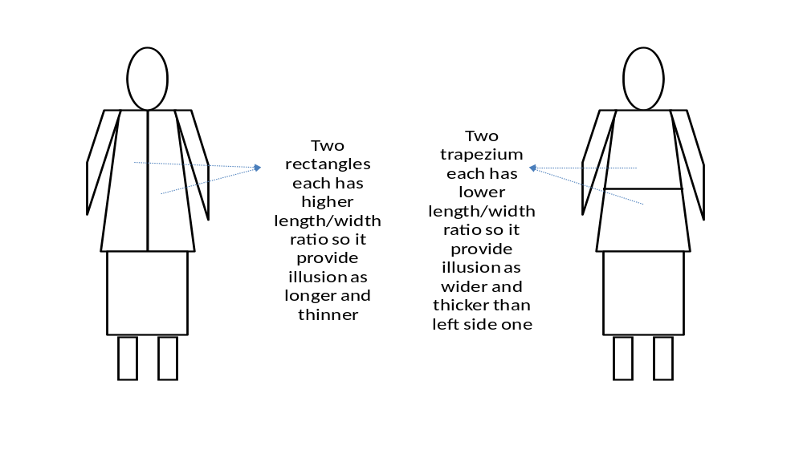Figure-7:Illusion due to line present in dress.
So in that case the illusion is occurred and which is responsible due to length/width ratio as discussed before. In case of vertical line asfig-7in left side, the total body appears as two splited vertical rectangles both of them have higher lentgh but lower width , so the length/width ratio of each rectangles will be more higher which is judged by our brain and brain seems the body as longer and thinner. And in case of horizontal line as fig-7 in right side the total body appears as two horizontally splited trapezium having relatively less lentgh than the firstone as left side figure, so the length/width ratio of each splited trapezium will be lower resultant the human brain perceive it as thicker and shorter, as discussed before in length/width ratio illusion.

4.3.Color illusion and effect:
‘Color’ the word when we hear we think some think nice appears in nice color. Color has the great influence power in human life in most of the phases. So the color has become the basic component in fashion designing, a fashion designer can not think any design without a suitable color to that respective design. So to be a good designer he must have the appropiate color sense which will be the compatible with human complexion. Color also create some illusion in the figure size so that the following things should be considered during selection of color-
- Hair color
- Skin color
- Eye color
- Body size
4.3.1.Suitable color for different complexion:
Skin color is most important among these factors, according to skin color the color of dress should be selected, this can be analyzed by following segments;
4.3.2.Tinting:
The blonde or fair complexioned person can wear almost every color but the dark or black complexioned can not wear all the color, and the person who has some yellow tone or red tone on their face they should avoid the yellow and red color respectively.
The explanation of such types of phenomena can be given as following:
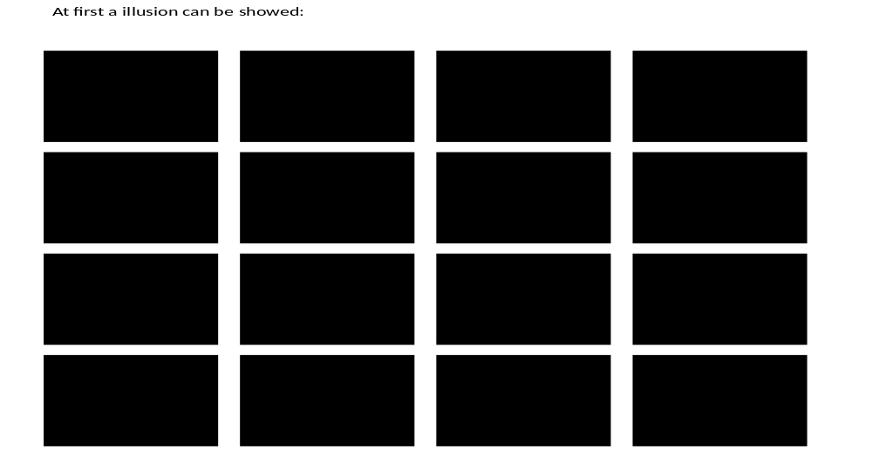Figure-8: Illusion due to dark color.
In the avobe figure the junction of four corner of four black rectangles looks little black and the gap among rectangles also appears black tinted. This illusive phenomena is occurred due to our brain,our brain watch the black rectangles and percieves the color of rectangle is black. This black color remains in our brain for very few times almost one tenth of a second, within this time untill brain keep the perception as black if we look to the adjacect corner of rectangles it appears as black, because the black perception is still present into our brain means it has not been abolished yet so we perceive it black. It is also true phenomena for another colors and the brain makes the illusion like this.
Another explanation of this phenomena can be given that- as we keep watching the black rectangles so some wave length of black are scattered from the rectangles and the white areas through the rectangles is tinted by blackwhich our brain perceive. This tinting also occurred in case of other color especially in the presence of sun light. If we place a colored fabric in the sunlight then it reflects and tints it surroundings with its own color. It can be illustrated as followingfigure-9:
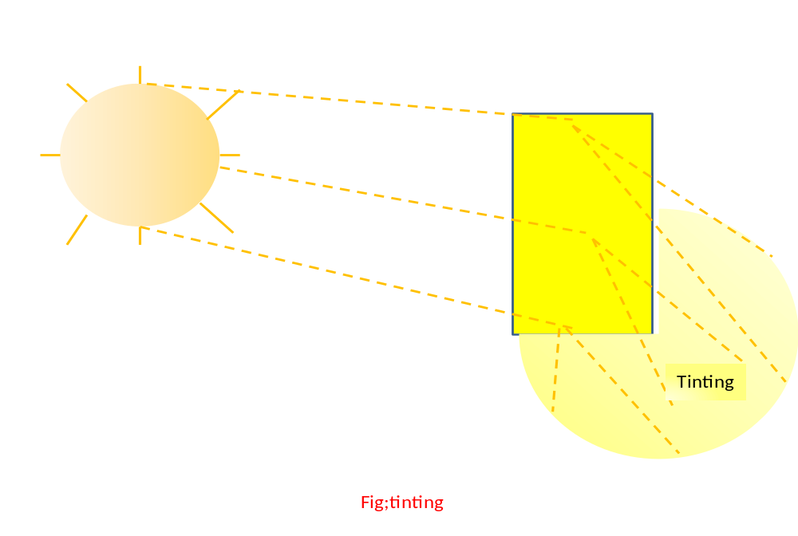Figure-9: Tinting effect of a colored dress.
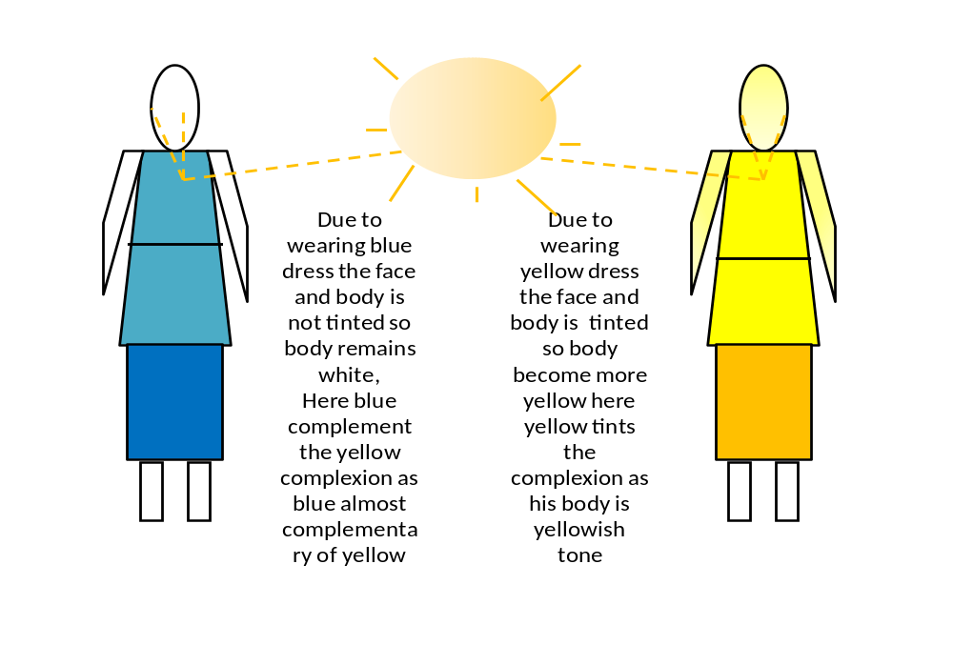Figure-10: Tinting effect on the body.
According to fig-10 when light falls on the fabric then fabric reflects and scattered the light and tints its surroundings so if anybody have reddish, yellowish or other complexion so they should avoid reddish and yellowish color. Colors should complement the complexion. A complexion that tends to be sallow (yellow tones) should wear colors that bring out the pink/red tones of the skin. A complexion that is florid (red/blue tones) should avoid colors that emphasize the redness of the skin.

4.3.3.Color contrast:
In case of white which is the light color can not suit the dark complexioned person because the complexion of that person and the white makes a greatest contrast, which emphasis the dark color of the person so he looks like more darker. It is related with color contrast and color contrast is responsible to findout the perfect matching of color:
Why a dark complexioned person should not wear light colors?
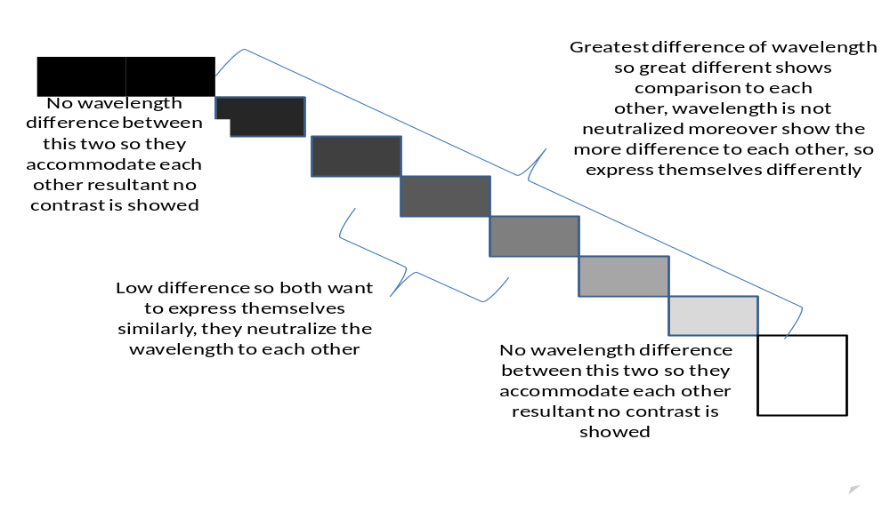Figure-11: Analysis of illusion in more contrast.
In the fig-11 there are ten rectangles first two are black and last two are white but there are no difference between two white and two black because the wavelentgh are same of two respective pairs.
But there are a wavelength difference between first black and last white rectangle, as wavelength is different so it shows higher contrast. If we consider intermediate two rectangles they show little contrast because the wavelentgh is little different. But “why a dark color show more contrast beside a white color?” when two wavelength of white an black comes to our brain then human brain receive two different wavelength and judge each wavelength with comparison to each other and get higher difference. So each color express itself more strongly against other wavelength that is why black seems to be more black beside white and white seem to be more white beside black.
“But what happens between black-grey or white-grey contrast?’Grey is the intermediate color between black and white, it does not show more contrast to black or white. The reason is grey posses the half similar wavelentgh of black and half from white. So when grey is paired with black or white it complement the black and white as well as resembles black and white.
4.3.4.Illusion due to contrast:
The colour wheel has already been described in this study before which expressed the complementary and contrasting color. Due to contrast some illusion is occurred, for example if any body wear top and bottom dress both have greatest contrast and the colors complement each other then the total body appears in two parts looks splited horizontaly due to top and bottom contrast. Then two complement wave lentgh to each other of top and bottom come to our eyes and we sense the great difference between this two color as fig-12. This two color gives two horizontally splited trapezium as like as horizontal line effect described before. So the brain calculate the lentgh/widtgh ratio of this two contrasting colors trapezium and gives lower result than golden ratio, resultant the person appears as shorter and thicker.
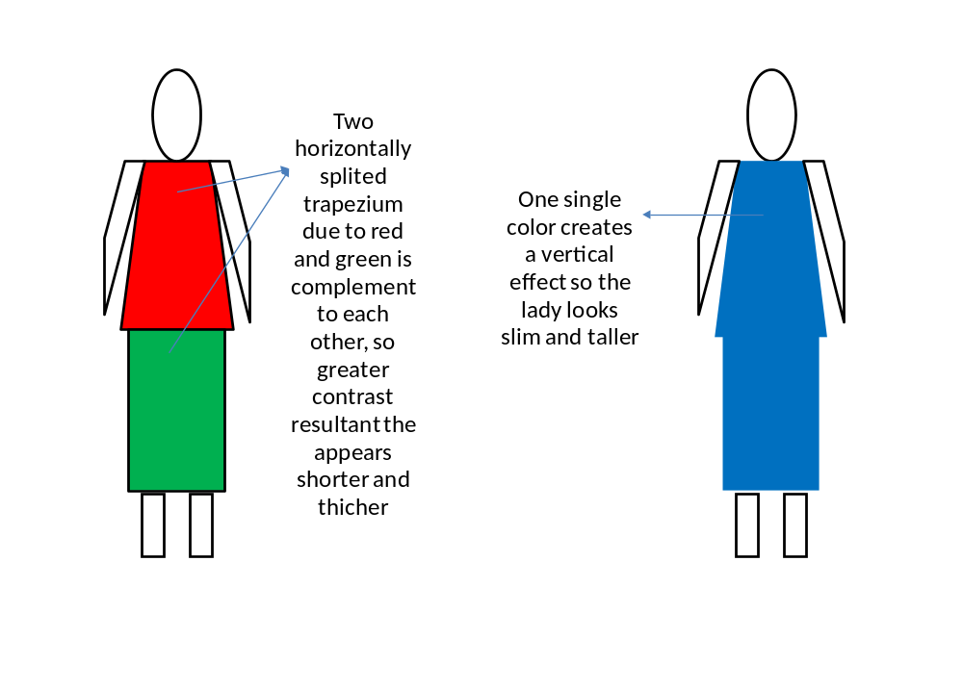Figure-12: Illusion due to color contrast.
In fig-12 Two horizontally splited trapezium due to red and green is complement to each other, so greater contrast resultant the appears shorter and thicker wheareas one single color creates a vertical effect so the lady looks slim and taller. So a short person can wear one single color for top and bottom to show him taller wheareas a tall person can use great contrast in top and bottom.

4.3.5. Illusion due to light or dark color:
In case of light color light edge line is produced against the background so it is not confined and appears as larger.
In case of dark color sharp edge line is produced against the background so it is confined and appears as smaller as fig-13.
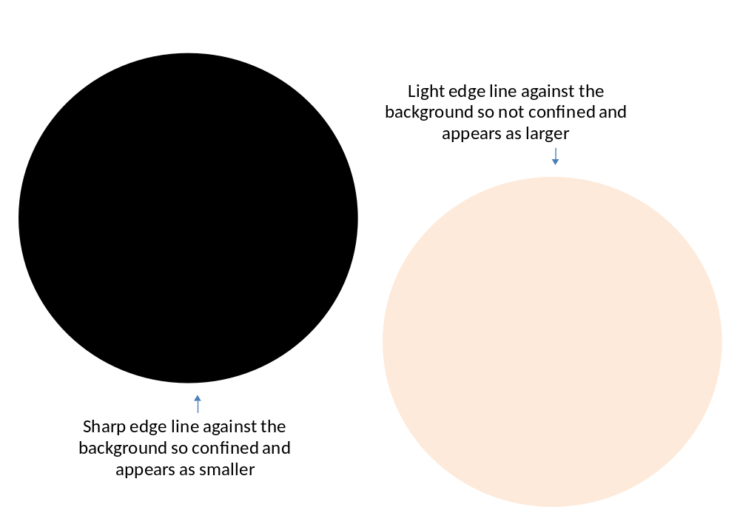Figure-13: Illusion due to light and dark color
4.4. What is illusion or perception or seeming?
In the above discussion we have many times mentioned the word ‘illusion’ or ‘perception’ or ‘seeming’ but ‘what is illusion or perception or seeming?’ And ‘what is human choice?’ or ‘why fashion choice varies man to man?’ It totally depend on human brain elements as each visual sensation of any dress reaches to our eyes and then accepted by our brain; finally the brain takes decisions that whether it is nice or odd, taller or shorter, thinner or thicker. So it should be discussed what happens into our brain which is responsible for our decision taking resultant the variation of choices can be revealed.
Neurotransmitter receive message and it process massage by hypothalamus which is responsible for various hormone secretion.These different types of hormone and quantity of secretion with electrical impulses created by visual message decide different decision that human take. So perception of good or bad, longer or taller and other illusion completely related with different types of hormone and quantity of their secretion with electrical impulses. So choice, perception, illusion varies man to man due to presence, absence or quantity of hormone and electric impulse which are actually some matter. So it follows the theory of relativity because everyone’s perception is true from their respective observation due to their specific respective elemental activities (due to matter in brain),because matter makes the person bound to think on that way. So there nothing is called illusion, it is just an elemental phenomena occurred due to specific elemental activities. Due to variation of specific matter characteristics /elemental phenomena variation of choice and illusion is occurred so that everyone’s perception is true from their respective observation and choice is varied relative to other choices due to different matter characteristics.
As matter does that so each illusion and each choice of variation is just nothing they can be defined as differentevent/circumstance/incident occurred due to different matter characteristics. This specific different incident (illusion, variation of choice) is specific work done by energy. One work means one incident occurred by observer-object interaction where both are matter, and no incident is occurred without observer. The relation among energy, work and choices can be described as following-
We know,
W= F $×$ s
- W= m $×$ a $×$ s [as F=ma]
- $W=\frac{E x a x s}{c^{2}}$ [as, E=m$c^{2}$]
As each incident is each work and depends on energy so we can write-
- $I=\frac{E x a x s}{c^{2}}$ , here I = incident
- I$c^{2}$= E $×$a$×$s
- I $∝$ E $×$a$×$s, as $c^{2}$ is constant
- I $∝$ E, neglecting a$×$s as it is very little into our brain.
So if energy changes then incident changes means work changes means variation of choice changes.
The logic of influencing energy and big bang in choice of design:
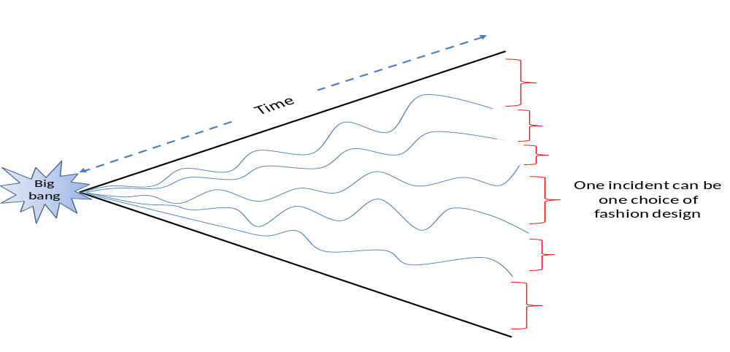Figure-14: Linking fashion with big bang.
In the above figure there are 6 incidents indicated by red second brackets, there are infinity incidents occurring like these six incidents come from big bang. The curved line shows the influence of adjacent curve line, the more the line is curved means it is more influenced by other adjacent curves and adjacent two curves mutually adjust their place together. The curve is mainly formed by influence of matter or energy, as influence of matter or energy varies so formation of each curve is different and finally make each different sizes of incident at the ends of each curve showed by red brackets. One of them can be specific choice of a design which is generated due to influence of different energy and matter. Most interesting thing that-it also follows the quantum mechanics.

5. Findings and discussion:
5.1. Influencing factors to purchase a dress:
This section analyzes data collected from respondents regarding their perceptions and understanding about the factor that influence in dress choosing. After analyzing the report we can express the following decision:
- Most of the people are influenced by the outlooks of branded garments (male 40%, female 36%). Males are satisfied on outlooks of brand dress more than females.
- Secondly they choice the brand dress for comfort (male 24%, female 36%), it is mentionable that female prefer comfort and outlook equally.
- The outlooks and comfort criteria of brand almost equally satisfy the female consumer which is 36% in both cases.
- Both style and performance for male is 12%, whereas for female it is 8%. Style and performance takes position just after the comfort and outlooks.
- In case of time saving female are more influenced than male,about 12% female respondents consider time saving where male respondents is 0%.
- Social and economic status has 8% response in case of male but female responses are very few which are negligible.

5.2. Suitable design and illusions:
Length/width ratio:
The statistical analysis of length/width ratio measurement of front view of body top of those people in the state of insertion of shirt into the waist belt reveals-
- The bars of ‘very good’ ratios reaches almost the 1.6 axis, ‘good’ ratios are little below than the 1.6 axis, ‘medium’ bars are less height than ‘good’ bars and bars of ‘odd’ ratios are taken lowest heights. So it shows that “very good” appearances posses the ratios closer to golden ratio and the odd apperances are very far from the golden ratios.
- The golden ratio 1.618 is the perfect ratio for all rectangles, circle, curve or any other design.No one needs to know good sketching or thinking to implement a normal design if he knows about golden ratio; the design implemented by golden ratio will be automatically eye soothing. He must follow the equation-l=1.618Xw
- The thin man should wear the dress having relatively less length than width to make the length/width ratio less; so that he seems to be fat.
- The plump man should wear the dress having relatively high length than width to make the length/width ratio more; so that he seems to be slender.
- The thin man should wear the dress having horizontal line to make the length/width ratio less; so that he seems to be fat.
- The plump man should wear the dress having vertical line to make the length/width ratio more; so that he seems to be slender.
Color:
- A complexion that tends to be sallow (yellow tones) should wear colors that bring out the pink/red tones of the skin. A complexion that is florid (red/blue tones) should avoid colors that emphasize the redness of the skin.
- A short person can wear one single color for top and bottom to show him taller wheareas a tall person can use great contrast in top and bottom.
- In case of light color light edge line is produced against the background so it is not confined and appears as larger.
- In case of dark color sharp edge line is produced against the background so it is confined and appears as smaller.

5.3. Illusion or perception or seeming:
It has been found out that occipital lobe and parietal lobe is jointly responsible to judge an object. And choosing any design and illusion occurs due to matter (chemical balance/imbalance) as well as with electric impulse. So each illusion and each choice of design is each separate incident occurs due to specific elemental activities. These activities directly related with matter equals to energy for example, sunlight which is responsible with object and human matter to occur a specific incident; may be a choice of design. Finally both activities come from big bang.
6. Conclusion:
With the help of this study we could find some of the important reasons of purchasing brand garments. This data helps both us and sellers to consider the important factor to fulfill the consumer demand ultimately to achieve the profit and global market. We know quality holds the consumer so we should know what is quality? How and what types of quality effects on consumer. This concern is also needed to launch a new business of garments and these types of analysis are very conducive to the entrepreneurs.As outfit is mainly responsible to attract any dress; this output of this study can give the people a new conception during buying as well as during producing the products.
Since outfit or design is the main important factor so it is also important to do some work about design which has been accomplished through this study. Many people are too much concerned about their body fittings and suitable size, shape, color of their chosen dress. They are sometimes perplexed to select their suitable dress; this dilemma can be eliminated if they know about their body characteristics and about different design. The information of design and suitability of dress can reach up to consumer and seller via some dependable study which can draw out their expectation and can quench their demand. This study tried to answerer those topics which were in the mind of designer and seller from the initiation of design. It reveals the suitability of dress especially for those people do not possess the perfect body size and shape and fair complexion. Different illusive phenomena can adjust the physical imbalance of those people so that they can be satisfied and can present themselves normally in the society.
This study discloses the connection of fashion to the human brain and physics which is the new initiative in design field and urged for the further research on that platform. As physic and matter is behind all of the things so it is very conducive to work with physics to satiate the desired expectation.Most of research work about physics and design has already been done till today but the relationship among them has been established through this study as well as extends those researches about design and illusion with respective reasons which demonstrates a wide field of fashion. So in this perspective finally we can say “fashion really matter”.

7. References:
Alam, N. (2008), Sushtho Deho Sushtho Maan, Books Fair Publications, p.74 &109.

Almond, K. (2011), Fashion in peril: an investigation into how fashion mirrored change in UK society; International Journal of Fashion Design, Technology and Education, Volume 4, Issue 1, pg-21-30

Almond, K. (2012), Insufficient allure: the luxurious art and cost of creative pattern cutting; International Journal of Fashion Design, Technology and Education, Volume 3, Issue 1, pg-15-24

Apeagyei, P. R. (2008), Significance of body image among UK female fashion consumers: The cult of size zero, the skinny trend; International Journal of Fashion Design, Technology and Education, Vol- 1, Issue 1, pg- 3-11

Designer pay report 2012, retrieved from http://www.bls.gov/ooh/Arts-and-Design/Fashion-designers.htm#tab-5 on 30-5-2012, at 6.49 p.m.
Designer recruitment report, Bureau of Labor Statistics, U.S. Department of Labor,http://www.bls.gov/ooh/Arts-and-Design/Fashion-designers.htm#tab-3 retrieved on 30-5-2012 at 6.33 p.m.
Jerrard, B. & Bell, S. (2008), The fashion designer in the technological workplace; Digital Creativity, Volume 9, Issue 2, pg 91-100

Kobayashi, M. et al (2009), An innovative design method for compliant mechanisms combining structural optimizations and designer creativity, Journal of Engineering Design, Volume 20, Issue 2, pg-125-154

Kim H. Y. & HaJ. S.(2010), Korean fashion crossovers; International Journal of Fashion Design, Technology and Education, Volume 3, Issue 1, pg- 33-41

Kwon H. J. & BrinthauptT. M.(2012) ,Teaching the social aspects of clothing in an online course; International Journal of Fashion Design, Technology and Education, Volume 5, Issue 2, pg-129-134
Newton , E. W. et al (2009), How are European and Japanese Fashion Designers Inspired?; Journal of the Textile Institute, Volume 94, Issue 1-2, pg 12-31
Sayeed, M. A. (2011), General Knowledge in Textile & Garments,Granthaneer Publication, pg-54

Selim, M. A. (2012), Human Brain, Manojagat, Vol. 12, p-47

Sproles, G. B. & Burns, L. S. 1994. Changing appearances: understanding dress in contemporary society, New York: Fairchild Publications.

Zong, Y. & Lee, Y. (2011), An exploratory study of integrative approach between 3D body scanning technology and motion capture systems in the apparel industry; International Journal of Fashion Design, Technology and Education, Volume 4, Issue 2, pg 91-101

8.1. APPENDIX-1
Survey of criterion of a garments influence to purchase
Person | Sex | Age | Outlook | Economic status | Fitting | Performance | Comfort | Style | Social status | Time saving
P1 | M | 21 | 1 |  |  | 3 | 4 | 5 | 2
P2 | M | 21 | 1 |  |  |  | 2 | 3
P3 | M | 21 | 1 |  | 3 |  | 2 |  |  | 4
P4 | M | 21 | 1 |  |  | 2 | 3 |  |  | 4
P5 | M | 22 | 1 |  | 3 |  | 4 | 2 | 5 | 6
P6 | M | 23 | 1 |  | 4 |  | 3 | 2
P7 | M | 21 | 4 |  | 6 | 3 | 2 | 5 | 1
P8 | M | 21 | 5 | 7 | 6 | 4 | 2 | 3 | 1
P9 | M | 21 | 3 |  |  | 3 | 1 |  | 2 | 4
P10 | M | 22 | 3 |  | 5 | 2 | 1 | 4 | 6
P11 | M | 20 | 5 | 6 | 3 | 2 |  | 1 | 4 | 7
P12 | M | 21 | 2 | 4 | 1 | 5 | 3 | 6 | 7
P13 | M | 21 | 3 |  |  | 3 | 2 | 1 | 4
P14 | M | 20 | 3 | 4 | 4 | 4 | 1 | 2
P15 | M | 22 | 2 | 6 | 7 | 1 | 3 | 4 | 5
P16 | M | 21 | 3 | 6 | 5 | 1 | 4 | 2 | 7
P17 | M | 24 | 3 | 5 | 4 |  | 2 | 1
P18 | M | 32 | 1 | 7 | 2 | 6 | 5 | 4 | 3
P19 | M | 33 | 3 |  | 2 |  | 1 |  |  | 4
P20 | M | 34 | 5 |  | 3 | 4 | 1 | 2
P21 | M | 30 | 1 | 5 | 2 | 6 | 3 | 4 | 6 | 7
P22 | M | 36 | 1 | 5 | 4 | 7 | 2 | 3 | 6
P23 | M | 19 | 1 |  | 2 |  | 3 | 4 | 5 | 6
P24 | M | 36 |  |  | 2 | 4 | 1 | 3 |  | 5
P25 | M | 22 | 3 |  |  | 1 |  |  | 2
P26 | F | 21 | 1 |  | 3 | 5 | 4 | 2 | 6
P27 | F | 21 | 1 |  | 2 |  | 5 | 4 | 3
P28 | F | 20 | 4 |  |  | 3 | 2 | 1
P29 | F | 21 | 1 |  | 6 | 4 | 3 | 2 | 5
P30 | F | 20 | 2 | 7 | 3 | 5 | 4 | 1 | 6 | 8
P31 | F | 43 | 2 |  |  | 1 | 3
P32 | F | 45 | 2 |  |  | 3 | 1 | 5 | 4
P33 | F | 26 |  |  | 2 |  | 1 | 3
P34 | F | 24 |  |  | 2 |  | 1 | 3
P35 | F | 30 | 5 |  | 3 | 4 | 1 | 2 |  | 6
P36 | F | 26 |  | 3 | 2 | 4 | 1 | 5 | 6
P37 | F | 30 |  | 3 | 2 | 4 | 1 | 5 | 6
P38 | F | 26 | 1 | 6 | 4 | 5 | 2 | 3 | 5 | 7
P39 | F | 25 | 1 |  | 5 |  | 2 | 4 | 3
P40 | F | 28 | 6 | 8 | 7 | 2 | 1 | 3 | 4 | 5
P41 | F | 40 | 2 |  | 4 |  | 1 | 3
P42 | F | 19 | 3 | 7 | 5 | 1 | 2 | 4 | 6
P43 | F | 22 | 1 | 8 | 6 | 5 | 4 | 2 | 3 | 7
P44 | F | 22 | 1 | 5 | 2 | 6 | 3 | 4 | 7 | 8
P45 | F | 22 |  |  | 5 | 6 | 2 | 3 | 4 | 1
P46 | F | 20 | 4 | 2 | 7 | 6 | 5 | 3 |  | 1
P47 | F | 20 | 3 | 3 | 8 | 5 | 6 | 2 | 3 | 1
P48 | F | 23 | 1 | 8 | 2 | 3 | 7 | 4 | 5 | 6
P49 | F | 30 | 1 | 6 | 3 |  | 2 | 4 | 5 | 4
P50 | F | 30 | 3 | 7 | 2 | 4 | 1 | 6 | 8 | 5

8.2. APPENDIX-2

Survey of Effect of golden ratio in appearance

Measurement ratio of a human body dress worn
Sl. Number | Length | Width | Ratio | Appearance
1 | 49 | 35 | 1.48 | M
2 | 48 | 35 | 1.37 | ODD
3 | 50.5 | 31.5 | 1.6 | V.G
4 | 52 | 31 | 1.67 | G
5 | 51.5 | 33 | 1.56 | G
6 | 44 | 32 | 1.37 | ODD
7 | 46 | 33.5 | 1.373 | ODD
8 | 51.5 | 32 | 1.6 | V.G
9 | 50 | 35 | 1.428 | M
10 | 50 | 31 | 1.612 | G
11 | 48 | 28.5 | 1.684 | M
12 | 54 | 33.5 | 1.614 | V.G
13 | 49 | 31 | 1.58 | G
14 | 41 | 30 | 1.36 | ODD
15 | 52 | 33.5 | 1.55 | G
16 | 50 | 33.5 | 1.49 | M
17 | 48 | 32.5 | 1.48 | M
18 | 51.5 | 31.5 | 1.63 | G
19 | 53 | 31.5 | 1.68 | G
20 | 53 | 30 | 1.77 | M
21 | 53 | 32.5 | 1.63 | G
22 | 50.5 | 32.5 | 1.55 | M
23 | 54 | 32.5 | 1.66 | G
24 | 51.5 | 30.5 | 1.68 | G
25 | 51.5 | 35 | 1.47 | M
26 | 48 | 34.5 | 1.391 | M
27 | 41 | 30 | 1.36 | Odd
28 | 50 | 34.9 | 1.43 | M
29 | 46 | 33.5 | 1.37 | Odd

List of survey places:
- Metro shopping mall, Dhanmondi, Dhaka,
- Yagi Bangladesh Garments, Ashulia, Dhaka,
- Daffodil International University, Shukrabad, Dhaka.
- Top Ten Fabrics and Tailors, Bata Signal, Elephant road, Dhaka.

http://en.wikipedia.org/wiki/Fashion_designretrieved on 30-5-2012 at 6.25 p.m.
http://www.bls.gov/ooh/Arts-and-Design/Fashion-designers.htm#tab-2 retrieved on 30-5-2012 at 6.30 p.m.
http://en.wikipedia.org/wiki/Fashion_design retrieved on 30-5-2012 at 6.25 p.m.
http://www.wardrobeshrink.com/WS/Coloursense.html retrieved on 15-10-2012 at 9.01 pm
http://en.wikipedia.org/w/index.php?title=File:Golden_ratio_line.svg&page=1 , retrieved on 3-10-2012, at 2.19 p.m
Retrieved from http://www.wikipedia.org/wiki/Sensory_nerve on 17-9-2012 at 8.30pm
Retrieved from http://www.incrediblehorizons.com/balance-Hypo%20function.htm on 15-10-2012 at 5.43 pm
Alam, Dr. N. (2008) , Sushtho Deho Sushtho Maan, 1st ed, chap-8, pg-74 and 109
Hypothalamus Function retrieved from http://www.incrediblehorizons.com/balance-Hypo%20function.htm on 15-10-2012 at 5.43 pm
Sensory nerve, Retrieved from http://en.wikipedia.org/wiki/Sensory_nerve on 17-9-2012 at 8.3o p.m.

