

Department of Textile Engineering

Faculty of Science & Information Technology

Project
On
Study on knitting Machineries

Course Title: Project/Thesis
Course Code: TE-407

Supervised By:
Dr.Md Mahbubul Hoque
Head of the Department of TE
Faculty of science and information Technology
Daffodil International University

Submitted By:

SL. | Name | ID | Major subject
01 | Md.Ruhul Amin | 083-23-1100 | FMT
02 | Md.mahmudul Hassan | 091-23-1210 | FMT
03 | R-Rahman | 091-23-1182 | FMT

Date of submission: 12/12/2012

STUDY ON KNITTING MACHINARIES

ACKNOWLEDGEMENT

First we express our heartiest thanks and gratefulness to almighty Allah for His divine blessing makes us possible to complete this project successfully. We fell grateful to and wish our profound indebtedness to our Supervising teacher Dr.Md Mahabubul Haque Head of the Department of TE, Daffodil International University, Dhaka.

Deep Knowledge & keen interest of our supervisor in the field of knitting machineries to us to carry out this project .His endless patience ,scholarly guidance ,continual encouragement , constant and energetic supervision, constructive criticism , valuable advice ,reading many inferior draft and correcting them at all stage have made it possible to complete this project.

We would like to express our heartiest gratitude again him for his kind help to finish our project and also to other faculty member and the staff of TE department of Daffodil International University.

We would like to thank our entire course mate of Daffodil International University, who took part in this discuss while completing the course work.

We would like to thanks Md.Anwar Hossain GM, Anlima Knitting Industries Ltd.
He helped us by supporting to collect sample fabric in deferent sections from his factory
And providing others important information.

Finally, we must acknowledge with due respect the constant support and patients of our parents.

DECLARATION

We declare that this thesis paper is submitted in partial fulfillment of the requirement of B. Sc in Textile Engineering degree of Daffodil International University. The total thesis work is written on our own language and on the basis of our thesis work and by the help of our honorable sir Dr.Md Mahabubul Haque There is no part of this paper consists of borrowed materials or reproduced from others.

Paper Prepared By:
Name of the student Student ID Signature
1. Md. Ruhul Amin 083-23-1100 ………………….

2. Mahmudul Hassan 091-23-1210 ………………….

3. R-Rahman 091-23-1182 ………………….

Signature of supervising teacher

………………………..

Dr.Md mahabubul Haque
Head of the Department of TE.
Daffodil International University

TABLE OF CONTENT

SL CONTENTS PAGE NO.

1 Abstract 07

2 Objective of the Study 08

3 CHAPTER-1 09
Introduction

4 CHAPTER-2 10-11
Background of the study
5 CHAPTER-3 Terminology and Definitions

3.1. Stitch Length 12
3.2.Course and Wales 12
3.3.Course per Inch 13
3.4.Wales per inch 13
3.5.Needle Gauge 13
3.6.Machine Gauge 13

6 CHAPTER-4
Experimental Study

4.1. Study on knitting machine
4.1.1.Circular knitting machine 14
4.1.2.single Jersey circular knitting machine 15
4.1.3.Double Jersey circular knitting machine(Rib) 16
4.1.4.Double Jersey circular knitting machine(Interlock) 17
4.1.5.Flate Bed knitting Machine 18
4.1.6.Parts of knitting machine 20
4.1.7.Parts Description 21 -28
4.2.Industrial study

4.2.1.Study on Anlima Textile 29-33
4.2.2 Study on.Fokruddin knit composit 34-36
4.2.3.Study on Hams Textile mils Ltd 37-38
4.2.4.Study on Biswas Ltd 39-41
7.CHAPTER-5
Discussion of the Result
5.1 Available Brand of knitting machine in
Our surveyed industries 42
5.2 .Different number of needle used in knitting
Machine in our surveyed industries 43
5.3. Different machine gauge & dia in
Knitting machine in our surveyed 44
5.4 Different number of feeder & cam
Used in knitting machine in our surveyed . 45
5.5.Gsm in knitted fabric
Produced in our surveyed industries. 45
5.6.Finish dia in knitted fabric produced
In our surveyed 46 5.7.RPM for different number of feeder, dia,
Gauge of surveyed Knitting machines. 47

5.8. different Stitch Length, Finish gsm Finish dia for different yarn
count, machine dia, machine Gauge, of fabrics used in the
surveyed factories. 48 -49

5.9. Production per day for different
types of brand, machine RPM, gauge, dia. 50

8 CHAPTER-6
6.1 Recommendation 51 6.2 Conclusion 51

9 CHAPTER-7
Appendix 52
7.1 Bibliography 7.2Website
7.3 Reference
ABSTRACT

This paper present the analysis and modeling

There are many kinds of knitted fabric produced in our country. Quality and production of Knit fabric depends on the machine quality. Different number of needle, machine Gauge , machine DIA, no of feeder used in the knitting machine on the requirement of the fabric quality. In knitted fabric different stitch length and GSM is contain. For fulfill this requirement it must be changed the machine equipments.

For our project at first we have surveyed four industries and collect some information from machine. Then discuss about all collected information. Finally we make some important data.

OBJECTIVE OF THE STUDY

In Textile manufacturing industry of Bangladesh knitted fabric & woven fabric are available. Production of knitted fabric is respectively more than woven fabric. In the knitting Industry different kinds of knitting machine are used . The objective of our study is to find out which types of knitting machine is used to produce Fabric. How many machine Brands are available for production in our country. we have discuss here about production rate of knitted fabric. which type of machine needle is used in the knitting machine. and we have know about machine Gauge, machine dia, machine RPM, stitch length and details about it.

Although it is not enough for this topics we have try to Discuss Proper information about knitting machines. We would like to encourage others to research or study on it so that the problem related within can be identified also can be resolved.

- To know about different machine brand.
- Know about maximum useable Brand origin
- To know maximum and minimum machine gauge
- To know maximum and minimum machine dia.
- To know maximum and minimum number of needle
- To know about stitch length of the knitted fabric when stitch length will be increase or decrease.
- To know GSM of knitted fabric.
- To know about machine RPM.
- To know about the number of feeder.
10.To know details about the machine

CHAPETR-1

INTRODUCTION

knit garments is the most export oriented garments of Bangladesh.70% export garments is knit garments and 100% knitted fabric is produced in Bangladeshi knitting Industries there are many knitted industry established in Bangladesh.
In the knitting industry many types & branded knitting machine is used in Bangladesh. various number of needles, machine gauge, machine dia, feeder is used in different knitting machines. And there production rat is different.
In our project we have surveyed some knitting industries and knitting machine .now we discuss about details.

Chapter-2
Background of the study

Knitting: Knitting is a method by which thread or yarn may be turned into cloth or other fine crafts. Knitted fabric consists of consecutive rows of loops, called stitches. As each row progresses, a new loop is pulled through an existing loop. The active stitches are held on a needle until another loop can be passed through them. This process eventually results in a final product, often a garment.

Knitting can be divided into two classes. These are
- Circular Knitting
- Flat Knitting

Circular knitting can be further classified into two ways. Most of the knitted fabric produces in this way.

The main forms of knitting are:
- Weft Knitting
- Warp Knitting

Weft Knitting: Weft knitting is a method of fabric forming in which the loops are made in horizontal way from a single yarns and intermeshing of loops takes place in a circular or flat form of across wise basis. In this method, feeding is one yarn at a time to a multiplicity of fashion. Most of the weft knitting is of tubular form. Weft knitting is a method of fabric forming in which the loops are made in horizontal way from a single yarns and intermeshing of loops takes place in a circular or flat form of across wise basis. In this method, feeding is one yarn at a time to a multiplicity of fashion. Most of the weft knitting is of tubular form.

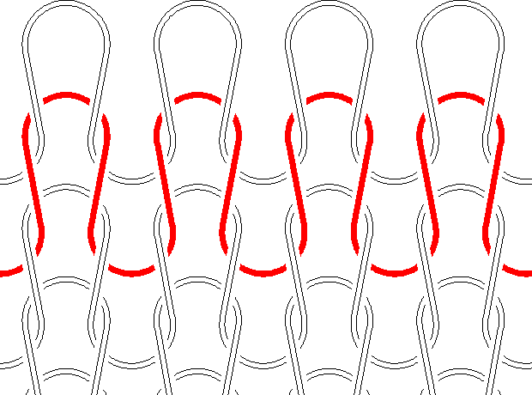

Fig: Weft Knit Fabric

Firstly weft knitted fabric can be divided into two classes. These are
  - Single Jersey or Plain Jersey Fabric
  - Double Jersey

Double jersey fabric can be divided into two classes. These are
- Rib Fabric
- Interlock Fabric

There are lots of derivatives in single jersey fabric. Some important and popular derivative of single jersey fabric is given hereunder.

- Single Jersey 100%
- Single La-coste
- Double La-coste
- Double Pique/ Polo Pique
- Terry Fleece
- French Terry
- Fleece
- Thick Fleece
- Jersey Blister
- Popcorn, Etc

- Warp Knitting: Warp knitting is a method of fabric forming in which the loops are made in a vertical way along the length of the fabric from each warp yarns and intermeshing of loops takes place in a flat form of lengthwise basis. Here, numerous ends of yarns are being fed simultaneously to individuals needles placed in a lateral fashion. Most of the knitted structure is flat or open width form.

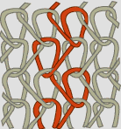

Warp knit fabric

Chapter-3
Terminology and Definition

3.1.Stitch length:
Stitch length is theoretically a single length of yarn which include one needle loop half the length of yarn (half of a sinker loop) between that needle loop and the adjacent needle loops on either side of it. Loop exists in coarse length and it is that which influence fabric dimensional and other properties including weight. In the knit stitch on the left, the next (red) loop passes through the previous (white) loop from below, whereas in the purl stitch (right), the next stitch enters from above. Thus, a knit stitch on one side of the fabric appears as a purl stitch on the other, and vice versa.

3.2.Course and Wales:
There are 2 things making the knit fabric. They are course and Wales. Wales is the vertical yarn. Course is the horizontal yarn.

Wales lines are fixed by the machine gauge. This cannot be changed. Coarse lines can be
altered by adjusting in the machine. This is called Texture.

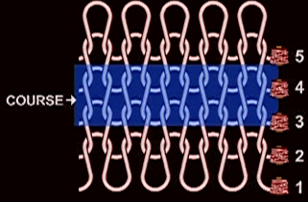
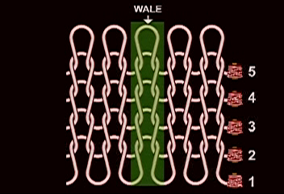

3.3.Coars per inch:

measured by placing an inch glass called counting glass on the fabric and counting the number of courses are contained within the area. This values very if the fabric is distorted.

3.4.Wales per inch:
Wales per inch are measured by placing an inch glass called counting glass on the fabric and counting the number of Wales, which are contained within the area. This values very if the fabric is distorted.

3.5.Needle gauge:
In knitting, the word gauge is used both in hand knitting and machine knitting; the latter, technical abbreviation GG refers to "Knitting Machines" fineness size. In both cases, the term refers to the number of Needles contained in one inch of the needle bed in knitting machine. A needle gauge makes it possible to determine the size of a knitting needle.
Total number of needles can be determined by the help of needle gauge. The formula is following.
Number of Needles = M/C Diameter * Needle Gauge * ∏ (3.1416)

3.6.Machine Gauge:

Knitting machine gauge is used to express the number of needles in a unit length of the needle bed. This needle bed may flat or circular. In circular double knit machine it used for cylinder as well as dial. Knitting machine gauge is denoted by alphabet “E”. The formula is

Machine Gauge=number of needle/inch

CHAPTER-4

4.1.Stuty on knitting machine

4.1.1.circular knitting machine:
We offer circular knitting machines that make the fabric for inner and over wear purposes. These machines are widely used to meet the needs of apparel and textile industry. The circular machine has yarn creel where yarn packages are mounted. The yarn the passes through moving needles which are controlled by cylinder & cams. It is manufactured in compliance with prescribed quality standards using high-grade material. Our clients can avail it in their preferred dimensions at affordable prices.
We are manufacturing 4 types of circular knitting machines.
* Single jersey or sinker body machines.
* Double jersey or interlock machines.
* Rib machines.
* Flate bed knitting machine

4.1.2Single Jersey Knitting Machine:

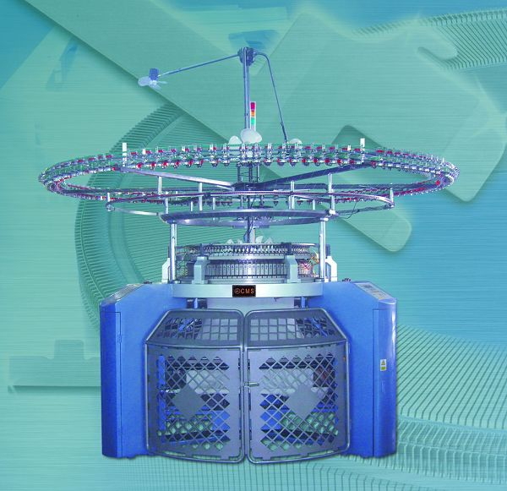

4.1.3.Double Jersey knitting machine(Rib)

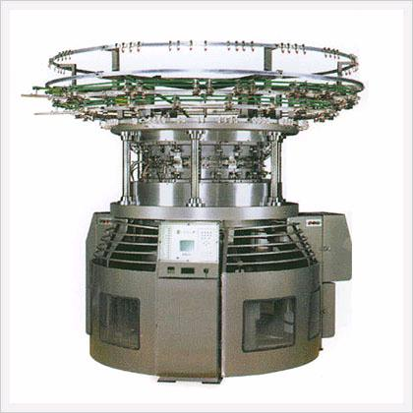

4.1.4 Double jersey circular knitting machine(Interlock)

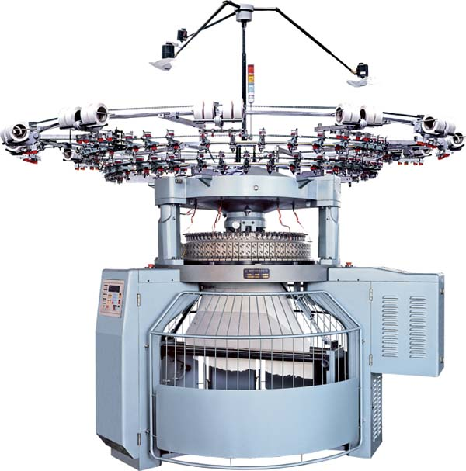

4.1.5. Flate Bed knitting machine

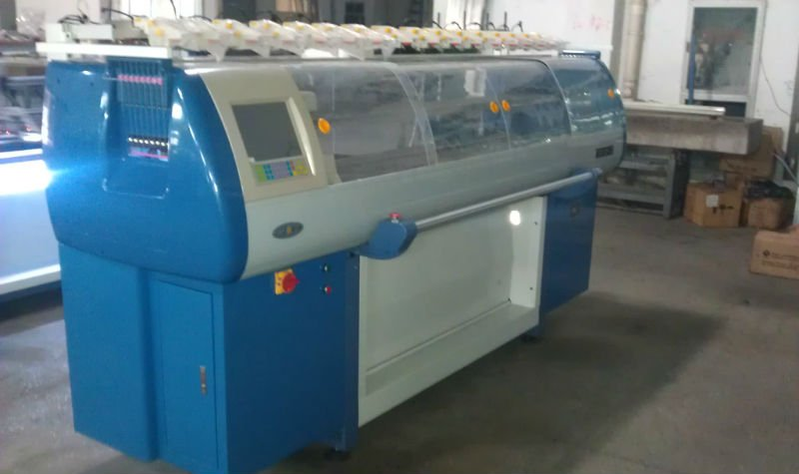

4.1.6.Parts of knitting Machine

- Creel 17. Cylinder Balancer
- Pipe 18. ON/OFF Switch
- VDQ Pulley 19. Power Switch
- Pulley belt 20. Automatic oiler
- Brush 21. Motor
- Knot Cather 22. Machine motherboard
- Tension Disk 23. Manual drive
- Inlet top motion 24.Sinker Ring
9.Yarn guide
10.MPF Wheel 25.Cam box
11.MPF 26. Cam
12.Outlet stop motion 27.Lycra attachment
13.Feeder ring 28. Lycra stop motion
14.Feeder 29.Inverter
15.Needle 30.Cylinder/dial
16Needle track 31. Screen
17.Sinker

4.1.7 Description of elements:

Needle:

metal needle is the principle knitting element of the knitting machine. Prior to yarn feeding, the needle is raised to clear the old loop from the hook and to receive the new loop above it on the needle stem. The new loop is then enclosed in the needle hook as the needle stars to go down. The hook then draws the new loop down through the old loop as the latter slides over the out side of the descending bridge of the closed hook. All needles must therefore have some method of closing the needle hook to retain the new loop and exclude the old loop.

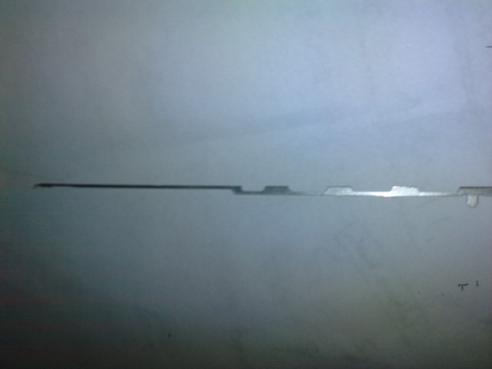

Fig. needle

Sinker: The Sinker is the second primary knitting element. It is a thin metal plate with an individual or a collective action operating approximately at right angles from the hook side of the needle bed, between adjacent needles. It may perform one or more of the following functions, dependent upon the machines knitting action and consequent sinker shape and movement: Loop formation, Holding down and Knocking-over.

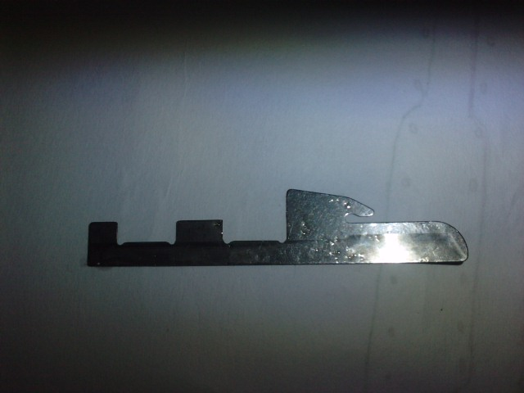

Fig. sinker

Cams: Cams are the devices which convert the rotary machine drive in to a suitable Reciprocating action for the needles and other elements in the circular knitting machine. They are placed in the cam box.

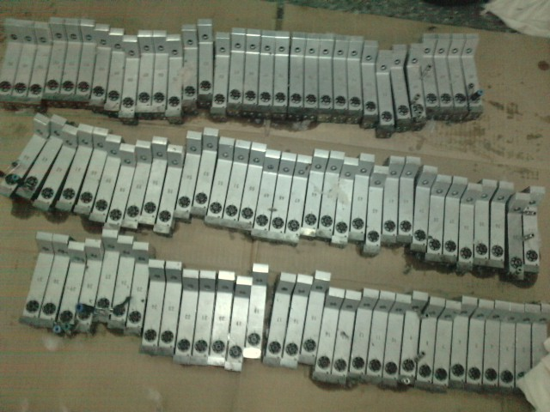

Fig. Cam
Positive feeder: A feeder supplies yarn to needles. A positive feeder contains the following parts.

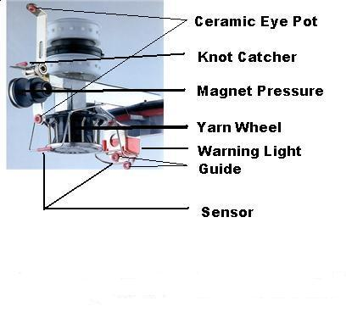

Fig.positive feeder

Fig: positive feeder

a. Knot catcher: This part finds any fault in yarn.
b. signal lamp: when knot catcher finds any fault this part light s on .
c. Yarn tension: this part gives proper tension to yarn for proper knitting.
d. Storing unit: Sufficient yarn is stored here

Creel: This part is used to continue yarn packages.

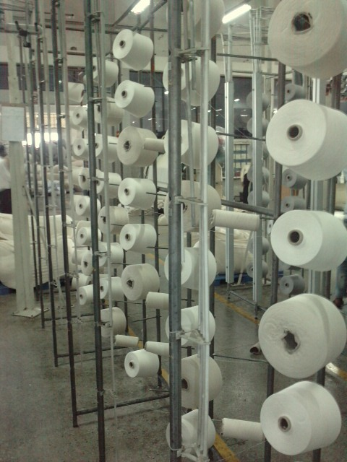

Fig. creel

Cylinder: The needles are set into the trick of cylinder and the cylinder moves with needles This frame contains needles, cams, jacks, and sinkers.

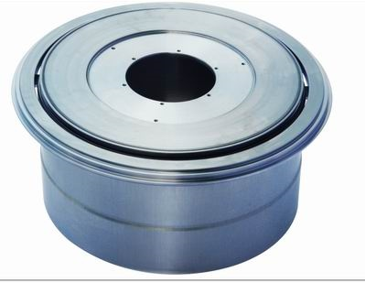
Fig. cylinder

Lycra Feeding Device: Lycra feeding device provides a 100 % positive yarn in feed of Lycra fibers on circular knitting machines. Lycra feeding device units are available to ensure ease of operation on different circular knitting machines. One unit can serve up to four knitting systems.

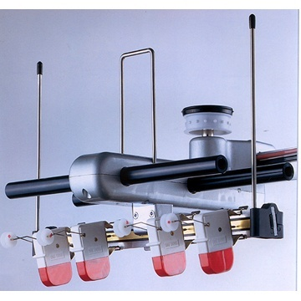

Fig.Lycra feeding device

Fig: Lycra feeding Device

Take-up roller: After producing fabric take up roller take up the fabric.

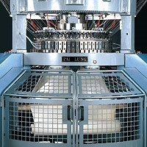

Fig. Take up roller

Indicator: It’s indicated the any type of yarn breakage or faults in m/c.

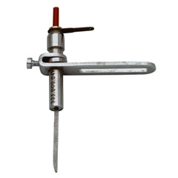
Needle detector: This part detect the any type of faults of needles.

PULSONIC Pressure Oiler: Assured even oil distribution over the entire circumference of the cylinder. Oil volume can be set separately for each lubricating point. Low oil consumption, since no oil is wasted at the lubrication points. Low power costs as no

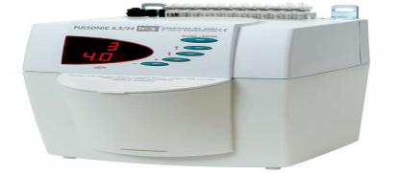
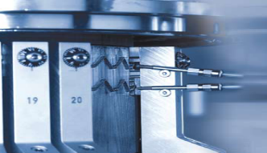

Fig. plutonic Pressure oiler

Adjustable fan: This part removes lint, hairy fiber from yarn and others. To clean the dust by air flow.
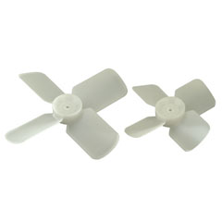
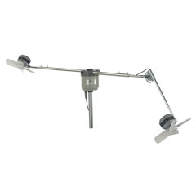

Fig: Adjustable fan

Sinker ring: Sinkers are placed in sinker ring.

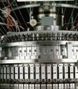

Fig .sinker ring

VDQ pulley: This part is used to control stitch length of the knitted fabric.

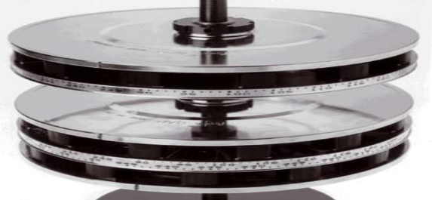

Fig.VDQ pulley

Timing belt/Tooth belt: This part helps machine to stop immediately.

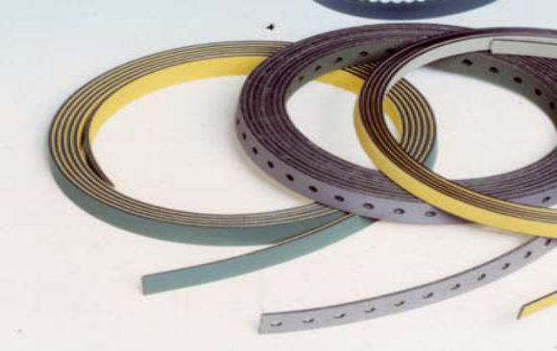

Fig. Timing belt

Air gun nozzle: To feed the yarn; sometimes it is used for cleaning purpose.

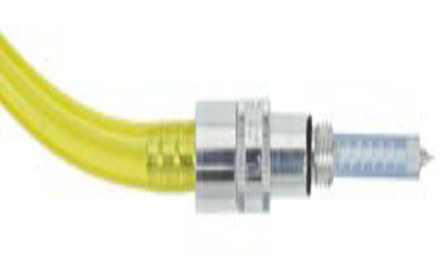

Fig.air gun nozzle

Fig: Air nozzle

Micro processor: It is used for driving m/c & feeding yarn & delivered fabric is controlled by it.

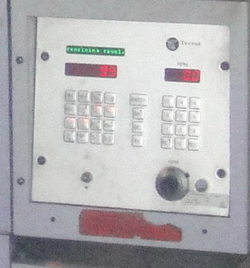

Fig. Micro processor

Expander: To control the width of the knitted fabric. No distortion of the knitting courses. Even take down tension in the knitting machine. As a result, an even fabric structure is achieved over the entire fabric width. The deformation of the knitted fabric goods can be reduced.

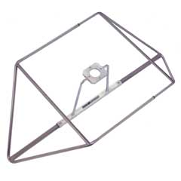

Fig. Expander

Uniwave Lubricators: The Unweave lubricator provides uniform lubrication to needles, cam tracks, lifters and other knitting machine components. The patented nozzle construction separates the air-oil mixture into air and droplets of oil.

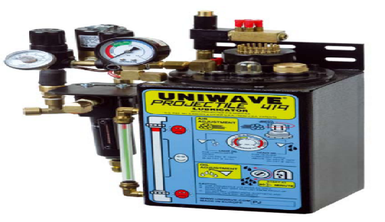

Fig.Uniwave Lubricator

Fig: Unweave Lubricators

4.2.Industrial study

4.2.1.Anlima textile
Table-1:single jersey circular knitting machine
Fabric type: single jersey fabric
Total no. of machine:23

No. of machine | Brand name | Origin | Machin gauge | Machine dia | No of feeder | No. of Needle
05 | Mayre & cie | Germany | 28 | 30 | 90 | 2411
04 | Mayre & cie | Germany | 24 | 26 | 78 | 1959
01 | Mayre & cie | Germany | 20 | 30 | 90 | 2260
03 | Mayre & cie | Germany | 24 | 28 | 84 | 2110
02 | Mayre & cie | Germany | 24 | 32 | 96 | 2411
02 | Mayre & cie | Germany | 26 | 30 | 90 | 2260
04 | Mayre & cie | Germany | 24 | 32 | 96 | 2411
02 | Mayre & cie | Germany | 20 | 30 | 90 | 2260

Table-2:Double jersey circular knitting machine(interlock)
Fabric type: interlock fabric
No of machine:05

No. of machine | Brand name | origin | Machin gauge | Machine dia | No of feeder | No. of Needle
02 | Terrot | Germany | 24 | 30 | 90 | 2260
02 | Terrot | Germany | 28 | 30 | 96 | 2411
01 | Terrot | Germany | 24 | 32 | 90 | 2260

Table-3:Double Jersey circular knitting machine(Rib)
Fabric type: Rib fabric
Total No of machine:07

No. of machine | Brand name | origin | Machin gauge | Machine dia | No of feeder | No. of Needle
02 | Terrot | Germany | 16 | 38 | 108 | 2712
03 | Terrot | Germany | 18 | 38 | 108 | 2712
01 | Terrot | Germany | 18 | 30 | 96 | 2712
01 | Terrot | Germany | 16 | 30 | 96 | 2552

Table-4:single Jersey circular Knitting machine
Fabric Type:3-thread fleece
No of machine:04

No. of machine | Brand name | origin | Machin gauge | Machine dia | No of feeder | No. of Needle
04 | Mayer & cie | Germany | 20 | 30 | 90 | 2260

Table-5:Single Jersey circular knitting machine
Fabric Type:2-thread fleece
No of machine:08

No. of machine | Brand name | origin | Machin gauge | Machine dia | No of feeder | No. of Needle
05 | Mayer & cie | Germany | 20 | 30 | 90 | 2268
02 | Mayer & cie | Germany | 24 | 30 | 90 | 2268
01 | Mayer & cie | Germany | 20 | 32 | 96 | 2411

Table-6:Auto stripe
Fabric Type: Stripe fabric
No of Machine:03

No. of machine | Brand name | origin | Machin gauge | Machine dia | No of feeder | No. of Needle
02 | Mayer & cie | Germany | 20 | 30 | 90 | 2268
01 | Mayer & cie | Germany | 24 | 30 | 90 | 2268

Table-7:jacqured
Fabric type: ornament knitted fabric
No of Machine:02

No. of machine | Brand name | origin | Machin gauge | Machine dia | No of feeder | No. of Needle
01 | Mayer & cie | Germany | 20 | 30 | 90 | 2268
01 | Mayer & cie | Germany | 24 | 30 | 90 | 2268

Table-8:Flate bed knitting Machine
Fabric type: Collar, Cuff
No of Machine:10

No. of machine | Brand name | origin | Machin gauge | Machine dia | No of feeder | No. of Needle
 |  |  |  |  |  | In Collar | IN Cuff
05 | Mayer& cie | Gemany | 54 | 14 | 740X2 | 450 Pc | 1200  Pc
03 | Mayer& cie | Germany | 54 | 14 | 740X2 | 450 Pc | 1200  Pc
02 | Mayer&cie | Germany | 54 | 14 | 740X2 | 450 Pc | 1200  Pc

The fabric produced in Anlima knit composite
Single Jersey:
- Plain
- Drope needle
- Lacoste
- Frence Terry
- Feeder Stripe
- 4 track structure
Interlock:
- Plain
- Drope needle
- Interlocks Pique
- Swiss double pique
- Frence double pique
- Popline variegated Interlock
Rib:
- Full needle Rib
- Drope needle Rib
- Drope face Rib
- Flate Back Rib
- Full & Half cardigan
- 32 lock structure
Fleece:
- 3-thread fleece
- Terry fleece with different sinker hight
- Single jersey plush
- Revers plated
- Micro fleece
- Polar fleece
Auto- striper:
- Single jersey
- Pique
- Engineering stripe
- Float & tuck structure
- Fleece stripers

Auto striper Jacquard:
- Full jacquard single jersey
- Pique
- Lacoste Fabrics
- Jacquard striper fabrics

Flate knitting:
- Plain
- Tipping
- Yarn dyed
- Birds eye
- Butt design
- Tipping & various semi-jacquard design collars & cuff.

4.2.2.Fokruddin knit composite:
Table-9: single jersey circular knitting machine
Fabric Type: single Jersey fabric
Total no. of machine:24

No. of machine | Brand name | origin | Machin gauge | Machine dia | No of feeder | No. of Needle
05 | Pai lung | Taiwan | 24 | 32 | 96 | 2411
01 | Jiun Lung | Taiwan | 24 | 32 | 96 | 2411
07 | Pai lung | Taiwan | 24 | 30 | 90 | 2260
02 | Jiun Lung | Taiwan | 24 | 30 | 90 | 2260
01 | Top knit | Korea | 20 | 36 | 108 | 2260
03 | Pai lung | Taiwan | 24 | 26 | 78 | 1959
01 | Top knit | Korea | 24 | 34 | 102 | 2552
01 | Pai Lung | Taiwan | 24 | 34 | 102 | 2552
01 | Jiun Lung | Taiwan | 24 | 28 | 84 | 2110
02 | Pai Lung | Taiwan | 24 | 28 | 84 | 2110

Table-10:Double Jersey circular knitting machine(Rib)
Fabric type: Rib fabric
Total no. of Machine:06

M/C No | Brand name | Origin | Dia in inch | No of feede | Gauge | No of needle
02 | Pai Lung | Taiwan | 24 | 36 | 108 | 2712
01 | Pai Lung | Taiwan | 24 | 34 | 102 | 2512
03 | Pai Lung | Taiwan | 24 | 32 | 96 | 2411

Table-11:Double Jersey circular knitting machine(Interlock)
Fabric Type: Interlock fabric
Total No of machine:12

M/C No | Brand name | Origin | Dia in inch | No of feede | Gauge | No of needle
03 | Pai Lung | Taiwan | 24 | 96 | 32 | 2411
01 | Pai Lung | Taiwan | 18 | 108 | 36 | 2034
01 | Pai Lung | Taiwan | 18 | 108 | 36 | 2712
01 | Pai Lung | Taiwan | 18 | 120 | 40 | 1695
01 | Pai Lung | Taiwan | 18 | 120 | 40 | 2260
01 | Pai Lung | Taiwan | 24 | 90 | 30 | 2260
01 | Pai Lung | Taiwan | 24 | 102 | 34 | 2411
01 | Pai Lung | Taiwan | 18 | 126 | 42 | 2373

Table-12:Flate Bade knitting Machine
Type of Fabric: Collar & Cuff
No of Machine:04

No of machine | Brand name | Origin | No of needle | Gauge | Carrier | Type of M/C
04 | Shima Seiki | Japan | 840*2 | 14 | 8 | Corp opr.flat

End products of Circular Knitting Machine:
Single Jersey M/C:
- S/J Plain
- Single lacoste
- Double lacoste
- Single pique
- Double pique
- Mini jacquard
- Terry
h) Fleece
Interlock M/C:
- Interlock pique
- Eleyet fabric
c) Mash fabric
d) Honeycomb fabric
e) Face/Back rib

Rib M/C:
a) 1*1 Rib fabric
b) 2*2 Rib fabric
c) Separation fabric
d) Honeycomb

End products of Flat Bed Knitting Machine:
a) Tripping
b) Plain
c) Emboss

4.2.3 HAMS KNIT COMPOSIT:

Table -13: single jersey circular knitting machine
Fabric Type: single Jersey fabric
Total no. of machine:15

M/C No | Brand name | Origin | Dia in inch | No of feede | Gauge | No of needle
01 | Pailung | Taiwan | 30 | 18 | 44 | 1692
01 | Pailung | Taiwan | 34 | 18 | 72 | 1920
01 | Pailung | Taiwan | 36 | 18 | 72 | 2040
01 | Pailung | Taiwan | 40 | 18 | 80 | 2256
01 | Pailung | Taiwan | 42 | 18 | 84 | 2356
01 | Pailung | Taiwan | 24 | 24 | 72 | 1800
02 | Pailung | Taiwan | 26 | 24 | 78 | 1944
02 | Pailung | Taiwan | 28 | 24 | 84 | 2112
02 | Pailung | Taiwan | 30 | 24 | 90 | 2256
02 | Pailung | Taiwan | 38 | 24 | 114 | 2856
42 | Pailung | Taiwan | 42 | 24 | 126 | 3168

Table-14: Double jersey circular knitting machine(Rib/Interlock)
Fabric Type: Rib/Interlock
Total no. of machine:02

M/C No | Brand name | Origin | Dia in inch | Gauge | No. of feeder | No of needle
02 | Pailung | Taiwan | 30 | 24 | 442 | 2256

Table-15: Flate bed knitting machine
Fabric Type: Collar & cuff
Total no. of machine:04

M/C No | Brand name | Origin | Dia in inch | Gauge | No of needle
02 | Pailung | Taiwan | 40 | 14 | 1020
02 | Pailung | Taiwan | 52 | 14 | 1020

4.2.4 Biswas Limited:
Table-16: Single Jersey circular knitting machine
Fabric Type: Single Jersey fabric
Total no. of machine:19

M/C No | Brand name | Origin | Dia in inch | Gauge | No. of feeder | No of needle
01 | Manhua | Taiwan | 32 | 24 | 96 | 2411
01 | Manhua |  | 30 | 18 | 96 | 2712
01 | Manhua | Taiwan | 23 | 24 | 78 | 1959
01 | Manhua | Taiwan | 17 | 24 | 108 | 2712
01 | Manhua | Taiwan | 18 | 24 | 120 | 1695
01 | Manhua | Taiwan | 20 | 24 | 90 | 2260
01 | Manhua | Taiwan | 22 | 24 | 90 | 2260
03 | Manhua | Taiwan | 30 | 18 | 90 | 2260
03 | Manhua | Taiwan | 30 | 19 | 96 | 2552
04 | Manhua | Taiwan | 26 | 18 | 78 | 1995
01 | Manhua | Taiwan | 26 | 18.5 | 78 | 1995
01 | Manhua | Taiwan | 26 | 19 | 96 | 2712

Table-17: Double Jersey Knitting machine(Rib/Interlock)
Fabric Type: Double Jersey fabric
Total no. of machine:09

M/C No | Brand name | Origin | Dia in inch | Gauge | No. of feeder | No of needle
03 | Sun da dask | Taiwan | 42 | 16 | 126 | 3168
01 | Sun da dask | Taiwan | 24 | 24 | 78 | 1995
01 | Sun da dask | Taiwan | 38 | 24 | 90 | 2411
01 | Manhua | Taiwan | 36 | 24 | 108 | 2260
01 | Manhua | Taiwan | 28 | 24 | 90 | 2411
01 | Manhua | Taiwan | 26 | 24 | 90 | 2260
01 | Manhua | Taiwan | 24 | 24 | 78 | 1978

Table-18: Single Jersey circular knitting machine
Fabric Type: Polar Fleece
Total no. of machine:38

M/C No | Brand name | Origin | Dia in inch | Gauge | No. of feeder | No of needle
15 | Sun da dask | Taiwan | 28 | 19 | 96 | 2411
13 | Sun da dask | Taiwan | 30 | 19 | 96 | 2268
10 | Sun da dask | Taiwan | 26 | 19 | 96 | 2268

Table-19: Single Jersey circular knitting machine
Fabric Type: Sherpa Fleece
Total no. of machine:04

M/C No | Brand name | Origin | Dia in inch | Gauge | No. of feeder | No of needle
04 | Grrand course | Taiwan | 26 | 16 | 96 | 2552

Table-20: Single Jersey circular knitting machine
Fabric Type: Micro Fleece
Total no. of machine:63

M/C No | Brand name | Origin | Dia in inch | Gauge | No. of feeder | No of needle
18 | Sun da dask | Taiwan | 30 | 19 | 90 | 2260
06 | Sun da dask | Taiwan | 30 | 19 | 90 | 2260
02 | Sun da dask | Taiwan | 26 | 24 | 78 | 1995
37 | Sun da dask | Taiwan | 26-30 | 19 | 90 | 2260

Table-21: Single Jersey circular knitting machine
Fabric Type: Terry towel
Total no. of machine:23

M/C No | Brand name | Origin | Dia in inch | Gauge | No. of feeder | No of needle
17 | Grand Courser | Taiwan | 30 | 22 | 90 | 2411
06 | Minhua | Taiwan | 30 | 22 | 78 | 1995

End product
- Single jersey.
- Rib.
- Interlock.
- Micro fleece.
- Polar fleece.
- Mesh.
- Stripe.
- Tricot.
- Terry towel.
- Sherpa fleece etc.

CHAPTER-5

Discussion of the Result

5.1. Important Brands of knitting machine used in Bangladesh

Serial No. | Brand Name | Origin country
01 | Terrot | Germany
02 | Mayer &Cie | Germany
03 | Fukuhara | Japan
04 | Keumyong | Korea
05 | Pailung | Taiwan
06 | Karl Mayer | Germany
07 | Grand Courser | Taiwan
08 | Ru Cuing | Taiwan
09 | Minhua | Taiwan
10 | Sun da Dask | Taiwan
11 | JY-Lee | Taiwan
12 | Origio | Italy
13 | Chamber | England
14 | Falmark | Singapur
15 | Jidhao | Chaina
16 | Lisky | Taiwan
17 | Top knit | Korea
18 | Jiunn Lung | Taiwan
19 | Shima Seiki | Japan
20 | Matsuya | Japan
21 | Keum Young | Korea

5.2. Number of needle used in knitting machine surveyed

Single Jersey | Rib | Interlock | Auto stripe
1800 | 2411 | 1695 | 1500
1808 | 2562 | 2034 | 2256
1872 | 2712 | 2260 | 2260
1932 | 3840 | 2373 | 2712
1944 | 4046 | 2411
1959 | 4080 | 2712
2110 | 4248 | 3840
2147 | 4521 | 4080
2260 | 4762 | 4968
2268
2411
2560
2562
2640
2712
2863
3014
4080
4248

In our surveyed industries for single jersey knitting machine minimum number of needle is 1800 maximum number of needle is 4248.for Rib machine number of needle used range is 2411-4762.for Interlock 1695-4968. For Auto Striper 1500-2712

5.3. Machine Gauge & Dia used in knitting machine in our survayed:

Single Jersey |  | Rib |  | Interlock |  | Auto stripe
Dia | Gauge | Dia | Gauge | Dia | Gauge | Dia | Gauge
16 | 20 | 16 | 30 | 16 34 | 30 18 | 30 | 24
16 | 24 | 18 | 34 | 38 | 18 | 36 | 18
17 | 24 | 20 | 24 | 34 | 18 | 36 | 22
18 | 20 | 20 | 30 | 30 | 18 | 30 | 24
20 | 18 | 22 | 30 | 36 | 22
24 | 21 | 24 | 22 | 26 | 22
22 | 24 | 24 | 24 | 40 | 18
25 | 18 | 24 | 30 | 42 | 18
22 | 22 | 24 | 34 | 30 | 26
22 | 20 | 26 | 22 | 42 | 16
22 | 24 | 26 | 24 | 42 | 24
24 | 24 | 28 | 24 | 38 | 24
25 | 24 | 28 | 30 | 36 | 24
25 | 14 | 30 | 26 | 28 | 24
26 | 16 | 30 | 18 | 24 | 24
26 | 18 | 34 | 18 | 20 | 24
26 | 18.5 | 36 | 22 | 24 | 36
26 | 19 | 36 | 24 | 18 | 34
26 | 22 | 36 | 18 | 24 | 34
26 | 24 | 38 | 18 | 24 | 30
28 | 19 | 38 | 24 | 16 | 30
28 | 24 | 40 | 18 | 22 | 30
30 | 22 | 42 | 16 | 38 | 18
30 | 28 | 42 | 18 | 34 | 18
30 | 26 | 42 | 24
34 | 18
34 | 24
34 | 26
36 | 20
36 | 22
38 | 24
38 | 22
38 | 20
40 | 18
40 | 26
42 | 18
42 | 24

In our surveyed industry for single jersey knitting machine minimum machine dia is 16 maximum is 42, In Rib 16 to 42, In interlock 16 to 42, In auto stripe 30,36.
machine Gauge for single jersey is 16 to 28, for Rib 16 to 34 for Interlock 16 to 34 & for Auto striper 18 to 24.

5.4. Number of Feeders/knitting machine in the surveyed Factories:

Single Jersey | Rib | Interlock
51 | 54 | 90
56 | 60 | 96
57 | 64 | 108
64 | 72 | 120
70 | 76 | 126
72 | 96
78 | 102
84 | 108
90
96
102
108
114
120

5.5. GSM used the knitted fabric produced in the surveyed Factiries:

Single jersey |  | Rib |  | Interlock
Grey GSM | Finish GSM | Grey GSM | Finish GSM | Grey GSM | Finish GSM
120 | 140 | 180 | 200 | 180 | 200
140 | 150 | 200 | 220 | 200 | 220
150 | 160 | 220 | 280 | 210 | 250
160 | 180 |  |  | 220 | 280
150 | 190
180 | 200
175 | 210
200 | 220
180 | 240
220 | 260
In our surveyed industry Gsm of single jersey is minimum Grey gsm is 120 and for its finish gsm 140. And maximum grey gsm is 235 finish gsm for its 310.In Rib machine grey gsm is 180 to 220 for its finish gsm is 200 to 280. For interlock grey gsm is 180 to 220 finish gsm for its is 20 t0 280.

5.6. Dia (Finished) of knitted fabric in the surveyed Factories:

Single jersey | Rib | Interlock
30” open | 52” open | 52” open
52 ” open | 54” open | 56” open
60 ” open | 56” open | 70” open
64 ” open | 60” open | 72” open
65 ” open | 72” open
72 ” open
74 ” open
75 ” open
76”open

5.7. Machine Rpm for different number of feeder, dia, Gauge of surveyed Knitting machines:

Rpm | Feeder | Dia | Gauge
11 | 96 | 30 | 20
18 | 96 | 30 | 24
21 | 70 | 34 | 20
22 | 78 | 26 | 24
25 | 60 | 30 | 18
26 | 90 | 30 | 24
28 | 78 | 26 | 24
30 | 108 | 36 | 24
35 | 120 | 38 | 28
40 | 126 | 40 | 24

Here maximum Rpm is 40 minimum rpm is 11 used in surveyed industries. It can be seen that for same dia as the machine speed decreases the no of feeders’ decreases. This because as the no of feeders increases the width of cams decreases as a result the cam angle will be high so that m/c speed must be reduced otherwise the needle will break. Thus higher the numbers of feeder the lower the machine speed and vice versa.

5.8. different Stitch Length, Finish gsm Finish dia for different yarn count, machine dia, machine Gauge, of fabrics used in the surveyed factories:

Yarn count | M/C dia | M/C gage | Finish GSM | Finish dia | Stitch length
28 | 25 | 24 | 167 | 26 | 2.65
28 | 25 | 24 | 168 | 26 | 2.65
28 | 26 | 24 | 162 | 24.8 | 2.57
28 | 26 | 24 | 166 | 26.2 | 2.57
28 | 26 | 24 | 161 | 26.2 | 2.65
28 | 26 | 24 | 165 | 26 | 2.65
28 | 26 | 24 | 157 | 26 | 2.70
28 | 26 | 24 | 166 | 26.5 | 2.75
28 | 21 | 24 | 160 | 22 | 2.80
24 | 24 | 24 | 170 | 27 | 2.92
24 | 21 | 24 | 170 | 23 | 2.90
24 | 24 | 24 | 175 | 26 | 2.85
24 | 24 | 24 | 172 | 26 | 2.90
38 | 22 | 24 | 120 | 19 | 2.70
32 | 17 | 24 | 128 | 17 | 2.70
32 | 23 | 24 | 128 | 21 | 2.60
32 | 22 | 24 | 125 | 21 | 2.70
23 | 24 | 22 | 130 | 22 | 2.65
28 | 21 | 24 | 160 | 22 | 2.80
24 | 24 | 24 | 170 | 27 | 2.92
24 | 21 | 24 | 170 | 23 | 2.50
24 | 24 | 24 | 175 | 26 | 2.85
26 | 18 | 24 | 215 | 26 | 2.60
26 | 18 | 24 | 208 | 27 | 2.75
26 | 18 | 24 | 210 | 26.5 | 2.60
26 | 18 | 24 | 208 | 26 | 2.75
26 | 18 | 24 | 226 | 26 | 2.60
26 | 18 | 24 | 218 | 26 | 2.75
26 | 18 | 24 | 197 | 26 | 2.75
26 | 18 | 24 | 214 | 26 | 2.75
26 | 18 | 24 | 207 | 26 | 2.60
32 | 18 | 24 | 176 | 22.5 | 2.55
26 | 18 | 24 | 210 | 26.5 | 2.62
26 | 18 | 24 | 208 | 26 | 2.70
26 | 18 | 24 | 207 | 26 | 2.65
26 | 18 | 24 | 208 | 25 | 2.70
26 | 17 | 24 | 182 | 23 | 2.65
26 | 17 | 24 | 182 | 23 | 2.80
30 | 17 | 24 | 183 | 23 | 2.75
26 | 19 | 24 | 188 | 25.5 | 2.60
26 | 19 | 24 | 190 | 25.5 | 2.60
26 | 18 | 24 | 193 | 24 | 2.60
26 | 18 | 24 | 190 | 24 | 2.75
26 | 17 | 24 | 193 | 21 | 2.65
26 | 17 | 24 | 172 | 23 | 2.75
28 | 28 | 24 | 163 | 28 | 2.80
26 | 34 | 18 | 238 | 33 | 2.70
28 | 34 | 18 | 228 | 33 | 2.60
25 | 34 | 26 | 190 | 24 | 3
27 | 25 | 24 | 200 | 25 | 3.4
26 | 18 | 24 | 190 | 25 | 3.1
25 | 17 | 24 | 170 | 25.5 | 3.2
22 | 17 | 24 | 172 | 26 | 3.3
24 | 24 | 24 | 170 | 25 | 3.25

From this discussion minimum stitch length is 2.5 and maximum stitch length is 3.25 in our surveyed industries.

5.9. Production per day for different types of brand, machine RPM, gauge, dia.

Brand name | Machine dia | Machine gauge | No. of Feeder | Rpm | Production per day
Terrot | 24 | 21 | 64 | 40 | 1800kg
Origio | 24 | 30 | 96 | 35 | 900kg
Pai lung | 24 | 34 | 108 | 35 | 900kg
Jiaho | 24 | 34 | 96 | 32 | 800kg
Mayer & cie | 20 | 30 | 96 | 30 | 750kg
Chamber | 28 | 30 | 96 | 30 | 750kg
Terrot | 24 | 22 | 70 | 30 | 750kg
Terrot | 20 | 21 | 57 | 25 | 600kg
Sun da dask | 30 | 28 | 90 | 20 | 495kg
Terrot | 18 | 34 | 60 | 22 | 450kg
Lisky | 20 | 24 | 96 | 21 | 400kg
Jiun lung | 30 | 24 | 88 | 20 | 390kg
Falmark | 24 | 26 | 72 | 19 | 300kg
Top knit | 34 | 24 | 100 | 19 | 288kg

We have seen that maximum production is 1800kg per day & minimum production is 288kg.Terrot contain maximum production.

6.1 Recommendation

1) We have experimented in 100% plain single jersey, double jersey fabric sample but other fabrics have not experiment due to time limitation.

2) We haven experiment about the some knitting machine

3) All the experiment have been done only weft knit fabric for circular machine but not any weft knitted fabric of flat bed machine is experimented.

4) We worked and analyze about machine parts, machine quality etc.

5) We worked on S/J fabric with different S/L and WPI and also different yarn count.

6.2.Conclusion
The surveyed information can be divided into two types e.g. machine related and the other is yarn and fabric related. The machine related parameters varied widely depending on the machine manufacturers and their engineering skill to design knitting machine. The yarn and fabric parameters are more or less similar. This is because most of our knitting factories are engaged in producing fabrics for similar types of apparels purposes therefore their parameters are nearly similar.

7.1 BIBLIOGRAPHY:

Books:

1. Knitting Technology; -David J.Spencer. (Third Edition)

2. Circular knitting; - Iyer/ Mammal/ Schacht.

3. KNITTING: FUNDAMENTALS, MACHINES, STRUCTURES and DEVELOPMENTS
- N. Anbumani

7.2 WEBSITE:

http://articles.textileclass.com/bearded-needle-bearded-needle-parts-features/

http://textilearticles4u.blogspot.com/2009/08/fundamentals-of-knitting.html

http://www.teonline.com/knowledge-centre/industrial-knitting-process.html

http://en.wikipedia.org/wiki/Textile

http://www.fibre2fashion.com

http://en.wikipedia.org/wiki/Knitting_needle

7.3 REFERANCES:

• Internet
• Oeko Tex
• Texeurop (BD) Ltd.
• Dr. MD.Mahbubul Haque,Head of TE dept.
• Seminar Paper.
• Books from daffodil international Library.
• Online Books

