TECHNIQUES OF PRODUCING DENIM FABRIC

BY
SHAHINUR ISLAM
ID: 091-23-1237
SAMIM REJA
ID: 091-23-1421
MD. IBRAHIM KHALIL
ID: 091-23-1350
This Report Presented in partial Fulfillment of the requirements for the degree of Bachelor of Science in Textile Engineering
Supervised By
Prof.Dr.Md Mahbubul Haque
Head, Department of Textile Engineering
Faculty of science and information Technology

Department of TE

DAFFODIL INTERNATIONAL UNIVERSITY
DHAKA, BANGLADESH
NOVEMBER , 2012

The project title`` Techniques of Producing Denim Fabrics ̋ submitted by Shahiur Islam, Samim Reja, Md.Ibrahim Khalil to the Department of Textile Engineering, Daffodil International University, has been accepted as satisfactory for the partial Fulfillment of the requirements for the degree of Bachelor of Science in Textile Engineering and approved as to its style and contents. This presentation has been held on 30th November 2012.

BOADR OF EXAMINERS:

Prof. Dr. Md Mahbubul Haque Internal Examiner
Head, Department of Textile Engineering
Faculty of science and information Technology

Dr.S M Mahbubul Haque Majumder Internal Examiner
Professor,
Department of TE
Faculty of science and information Technology

Md. Abrar Ahmed Apu Internal Examiner
Assistant professor
Department of TE
Faculty of science and information Technology

DECLARATION

We hereby declare that, this project has been done by Shahinur Islam,Samim reja & Ibrahim Khalil under the supervision of Dr.Md.Mahbubul Haque, Head, Department of TE, Daffodil International University. We also declare that neither this project nor any part of this project has been submitted elsewhere for award of any B.sc in textile Engineering.

Supervised By:
Prof .Dr. Md Mahbubul Haque
Head, Department of Textile Engineering
Faculty of science and information Technology

Submitted By:

SHAHINUR ISLAM
ID: 091-23-1237
SAMIM REJA
ID: 091-23-1421
MD. IBRAHIM KHALIL
ID: 091-23-1350

ABSTRACT

The project is on “Techniques of Producing Denim Fabrics”. Denim is easily the most versatile fabric on the planet, and the most popular all over the world.
The aim of this project is build up a guideline, by which, one can make decision easily between sheet dyeing and rope dyeing process, which one is better in terms of quality, production, project cost, profit etc.

The main steps of manufacturing denim fabrics include warping, dyeing & sizing and weaving. Though the weaving process is same but the there are completely two routes of manufacturing a weaver’s beam e.g. Slasher/sheet dyeing and rope dyeing. Both the techniques have tremendous impact on the production and quality of denim fabrics. The present study analyses the two routes of producing denim (i.e. Slasher/sheet dyeing and rope dyeing processes) critically. It was found that both the techniques have their own advantages and disadvantages. However it seems that comparatively rope dyeing is better as far as quality is concerned while slasher dyeing is better for mass production at a competitive price.

ACKNOWLEDGEMENT

First we express our heartiest thanks and gratefulness to almighty Allah for His divine blessing makes us possible to complete this project successfully.

We fell grateful to and wish our profound our indebtedness to Prof. Dr.Md.Mahbubul Haque , Head, Department of TE, Faculty of science and information Technology. Daffodil International University, Dhaka. Deep knowledge and keen interest of our supervisor in the field of denim fabric influenced us to carry out this project. His endless patience, scholarly guidance, continual encouragement, constant and energetic supervision, constructive criticism, valuable advice, reading many inferior draft and correcting them at all stage have made it possible to complete this project.

We would like to express our heartiest gratitude to Abdullah –al -Mamun , senior production officer, Sinha denim LTD., Senior Executive, Final Inspection QA, Envoy Textile Ltd and Head, Department of TE, Daffodil International University for his kind help to finish our project and also to other faculty member and the staff of TE Department of Daffodil International University.

We would like to thank our entire course mate in Daffodil International University, who took part in this discuss while completing the course work.

Finally, we must acknowledge with due respect the constant support and patients of our parents.

CONTENTS

INTRODUCTION: CHAPTER-1

1.1 Denim ………………………………………………………………………………………………………………… 9
1.2 Flow chart of denim production……………………………………………………….........................10
1.3 Types of denim………………………………………………………………………………………………………. 10
1.4 Slasher denim…………………………………………………………………………………………………………..10
1.5 Rope denim………………………………………………………………………………………………………………11
LITERATURE SURVEY:CHAPTER-2
2.1 History of denim…………………………….………………………………………………………………………..13
2.2 Raw materials ………………………………………………………. …………………….………………………………14
2.3Process flow of denim manufacturing…………………………………..………………… ….………………17
2.4 BEAM DUING……………………………………………………………………………………..…….….……………17
2.5 Sample of denim fabric………………………………………………………………………………....…….………18
2.6 Denim yarn………………………………………………………………..…………………..…………..……………..…19
2.7 Yarn manyfacturing……………………………………………………………………………………….…..………… 19
2.8 warping……………………………………………………………………………………..………………….……….………20
2.9 Dyeing and slashing warp yarns for denim………………………….…………………………..….…………24
2.10 Slasher Dyeing: ………………………………………………………………………………………………..……...…..26
2.11 Dye used in denim dyeing………………………………………………….………….………………..……..….27
2.12sizing …………………………………………..….…………………………………………………………..…..30
2.13 Weaving process…………………………………………………………………………….………..………………...35
2.14 Dyeing Faults:……………………………………………….……………………………………………..………………41
2.15 Denim Finishing………………………………………….………………………………………..……………………..44
2.16 Several Uses of Denim Fabric………………………………………………………………………………..……50

EXPERIMENTAL DETAILS: CHAPTER-3
3.1 Rope dyeing………………….………………………………………………………………………………………….….…………….53
3.2Flowchart of rope dyeing process……………………………………………….……………………….…………….………..54
3.3 Rope sizing………………………………….……………………………………………………………………….…………..….……..57
3.4 Comperative study dying and sizing…………………………………………………………………………….……...………60
3.5 Comparative study of finishing performance of sheet and rope denim………………………………….…61
3.6 Comparative study: weaving efficiency…………………………………………….……………………….…..………….61
3.7 Table Comparative study: weaving efficiency………………………………………………………………...….…….62
3.8 Fabricquality ……………………………………………………………………………………………………………….……………63
3.9 Comparison of washing effect of sheet dyeing and rope dyeing……………….……....63
3.10 Comparison of washing effect (Width) of sheet dyeing and rope dyeing……….……..64
3.11 Comparison of washing effect (construction) of sheet dyeing and rope dyeing….…...65
3.12 Comparative stude :Flexibility ………………………..……………………………..….65
3.13 Versatility in Denim product Development…………..………………………………....66
3.14 comparative study investment …………………………………………………………..68
3.15 comparison of sheet dying and rope dying……………………………………..........................................70
3.16 Summary of comparative study of slasher dying and rope dying………….…………………………………..…..72

DISCUSSION OF RESULTS: CHAPTER-4………………………………….75

CONCLUSION: CHAPTER-5

Conclusion………………………………………………………………………………………………..…….………………..77
Reference………………………………………………………………………………………………………………………..…78

CHAPTER- 1

INTRODUCTION

1.1 DENIM:
Denim is the oldest, most widely used, most fashionable and most versatile fabric of the world. Though, initially the fabric was developed for using as sail cloth but at present denim is mainly used for producing garments particularly trousers for the young people.
The term “Denim” comes from the city of Nimes in France where “serge de Nimes” was made.
The term “Jeans” came from the cotton workpants worn by sailors in Italy, who were known as “Genes.
Denims are produced from 4 oz. to 16 oz. / sq.yds in weight. Technically Denim is defined as a 3/1 warp faced twill but also produced from weaves like: Left hand twill, right hand twill, broken twill, cross hatches, cords, dobby’s, structures, etc .
Bangladesh is one of the leading producers of garments and a large share of it is denim. In recent years quite good numbers of denim plants were established in the country and most of them are running very successfully. However, we are not yet able to master all the tricks of this highly fashion oriented widely used textile products.
The main stage of manufacturing denim fabrics includes warping, dyeing & sizing and weaving. Though the weaving is same but the there are completely two routes of manufacturing a weaver’s beam e.g. Slasher/sheet dyeing and rope dyeing. Both the techniques have tremendous impact on the production and quality of denim fabrics. The present study analyses the two routes of producing denim (i.e. Slasher/sheet dyeing and rope dyeing processes) critically. It was found that both the techniques have their own advantages and disadvantages. However it seems that comparatively rope dyeing is better as far as quality is concerned while slasher dyeing is better for mass production at a competitive price.

Flow Chart of Denim Production:
Spinning
↓
Bale Warping
↓
Rope Dyeing
↓
Long Chain Beaming
↓
Sizing
↓
Weaving
↓
Finishing
↓
Inspection & Folding
↓
Packing
↓
Dispatch

1.2 TYPES OF DENIM:

Denim can be classified on the basis of continuousness of dyeing processes. On this Basis the dyeing method, the denim is of two types:

1.3 Slasher denim:
In the slasher denim process, dyeing and sizing are done simultaneously. For this reason, it is called continuous process. Dyeing and sizing are done in form of sheet and that is why the process is also called sheet dyeing and the denim is also called sheet denim. The weaver’s beam is produced as the end product of the process. The fed material of the dyeing-sizing machine is warp beam which is produced in the high speed warping machine and the warping machine is attached with dyeing-sizing. . The denim industry is introduced in Bangladesh with the hand of Bengal Denim Ltd. After that, Dip Denim Ltd. came in the production of denim fabric. They started their denim project with the slasher denim dyeing technology and in that time only indigo dyes were used to dye the sheet of warp yarn of the denim fabric.

1.4 Rope Denim:
In rope denim, dyeing and sizing are done separately and for this reason it is called discontinuous process. Warping and dyeing are done in the form of rope and for that reason the process is called rope dyeing. At first ball warping is done in the ball warping machine and is produced the ball warp beam which is fed in the dyeing machine in rope form. Dyeing is then done. After dyeing the dyed ropes are necessary to open and this operation is done in the long chain beamer or rebeaming machine. In this process, warp beam is produced. Twelve to sixteen warp beams are fed in the Creeling section of the sizing machine after rebeaming process and sizing is done as part of discontinuous process. The rope dyeing technology has been introduced in Bangladesh by the Envoy Textile Limited. They are using USA technology for the dyeing rope or ball. It is a one of the modern dyeing technique for denim manufacturing. This technique is also available in Sinha Denim, Ha-Meem Denim in Bangladesh.

CHAPTER-2
LITERATURE SURVEY

2.1THE HISTORY OF DENIM:

Denim is the most versatile fabric on the planet, and the most popular. The word “jeans” is thought to have come from a type of material, called “jean” that was round in the 1600’s. The material was named after sailors from Genoa in Italy, because they wore clothes made from it. The word ‘denim’ probably came from the name of a French material, “serge de nimes” – serge (a kind of material) from Nimes (a town in France).
1800’s: American gold miners wanted clothes that were strong and did not tear easily. To meet this demand, Leob Strauss started a wholesale business, supplying clothes. Strauss later changed his name from the rather plain Leob to the extremely recognizable Levi.
1930′s: Cowboys – who often wore jeans in the movies – became very popular, which lead to an increased interest in the rugged trousers.
1940′s: Fewer jeans were made during World War 2(1943), but American soldiers did introduce them to the world by wearing them when they were off duty. After the war, rival companies, like Wrangler and Lee, began to compete with Levi’s for a share of the international market.
1950′s: Denim became very popular with young people in the 1950′s. It was the symbol of the teenage rebellion in TV programmes and movies – think James Dean in the 1955 film Rebel without a Cause! Some schools in the US went so far as to ban students from wearing denim.
1960-70′s: Manufacturers started to make different styles of jeans to match the 60′s fashions: embroidered jeans, painted jeans, psychedelic jeans… In many non-western countries, jeans became a symbol of ‘western decadence’ and were very hard to get.
1980′s: In the 1980′s jeans became high fashion clothing. Famous fashion designers like Gucci started making jeans, with their own labels on them, and jean sales started to rocket.
1990′s: Although denim is never completely out of style, it certainly goes out of "fashion" from time to time. The 1990′s youth market wasn’t particularly interested in 501s and other traditional jeans styles, mainly because their parents: the "generation born in blue" were still wearing them. No teenager in their right mind would be caught dead in anything their parents are wearing, so the 1990′s youth turned to other fabrics and styles like cargo pants, khakis and branded sportswear.
Denim was still in vogue, but it had to be in different finishes, new cuts, shapes, styles, or in the form of aged, authentic, vintage jeans, discovered in markets, and second-hand stores, not conventional jeans stores. Levi Strauss & Co., the No.1producer of jeans closed 11 factories in the 1990′s.
2000: Jeans made a comeback on the catwalk with big name designers Chanel, Dior, Chloe and Versace adding them to their summer ’99 collections.

2.2 RAW MATERIALS:
True blue jeans are made out of 100 percent cotton, including the threads. Polyester blends are available; however, the majority of jeans sold are 100 percent cotton. The most common dye used is synthetic indigo. The belt loops, waistband, back panel, pockets, and leggings of a pair of blue jeans are all made of indigo-dyed denim. Other features of blue jeans include the zipper, buttons, rivets, and label. Rivets have been traditionally made of copper, but the zippers, snaps and buttons are usually steel. Designers' labels are often tags made out of cloth, leather, or plastic, while others are embroidered on with cotton thread.
Commercial class | Description | Example
Ring denim | Ring yarn warp | 16X16  71X44
Regular/plain denim | Both warp & weft yarn are either ring/OE but no Slub | 7,9,12X7  66X39
Slub denim | Warp yarn Slub, weft yarn ring/OE | 9^{SL}X9  66X48
Cross Slub/ Cross hatch denim | Both warp & weft yarn Slub | 9^{SL}X9^{SL}  66X36
Chambray denim | 1 up 1 down plain weave
Stretch denim | Spandex on weft | 7, 9^{SL}, 12^{S} X 16^{L}40  71X 41

Raw materials:
Brand | Yarn Count | Weight/pack | NO of package/pack
Sinha  (Bangladesh) | 7^{S} OE | 45.5 Kg | 18 Cheese
Sinha  (Bangladesh) | 9^{S} OE | 45.5 Kg | 18 Cheese
Sinha  (Bangladesh) | 12^{S} OE/ 16^{S} OE | 49.5 Kg | 24 Cheese
Quetta  (Pakistan) | 7 ^{S},9 ^{S},12 ^{S} OE | 22.68 Kg | 6 Cheese
Quetta  (Pakistan) | 7^{RSL} , 9^{RSL} | 45.36 Kg | 24 Cheese
Lucky (Thailand) | 7 ^{S} OE | 31.7 Kg | 9 Cone
Lucky (Thailand) | 9 ^{S} OE | 28.1 Kg | 9 Cone
Jamuna (Bangladesh) | 9 ^{S} OE | 50 Kg | 18 Cone

Brand | Yarn Count | Origin
Lucky | 7^{S} OE, 9^{S} OE | Thailand
Quetta | Slub [7 ^{S}, 9 ^{S} m, 9 ^{S} Ring, 12 ^{S} m]  OE [7 ^{S}, 9 ^{S}, 12 ^{S}] | Pakistan
Sinha | 7^{S} OE | Bangladesh
Jamuna | OE [7 ^{S}, 9 ^{S}, 10 ^{S}] | Bangladesh
Square | 16^{S} Slub | Bangladesh
Techno | 7^{S} OE | Pakistan

Weft yarn:
- Generally used counts-
- (6^{S},7^{S}, 8^{S}, 9^{S}, 10^{S}, 12^{S}, 14^{S}, 16^{S}, 20^{S}, 30^{S} ) OE
- 12 OE & polyester
- 16L40 (40 Den Lycra – Coated with 16^{S} Cotton)
- 10L40
- 10L70
- 300L40 (40 Den Lycra – Coated with 300 Den Polyester)
- Ring yarn
2.3 PROCESS FLOW FOR DENIM MANUFACTURING
The warp yarn (length-wise) used in denim fabrics is uniquely prepared for denim manufacturing compared to conventional woven fabrics. The yarn goes through numerous processing steps before it is placed on the weaving machine

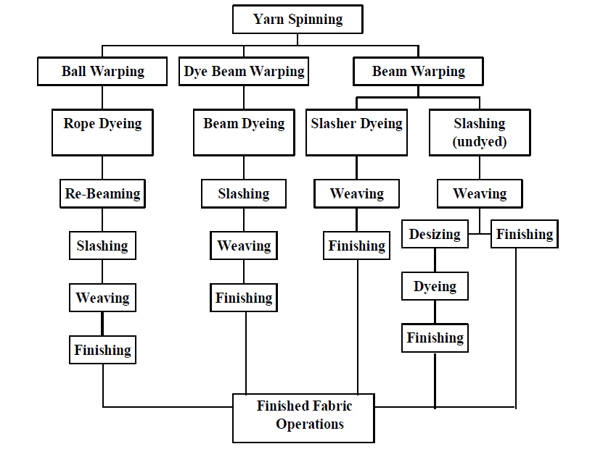
Figure 1. Process Flow for Warp Yarn in Denim manufacturing

2.4 Beam Dyeing:

Another dyeing technique that has been used for dyeing warp yarn for denim is beam dyeing (Figure 9). In this technique, hundreds of individual yarns are wound parallel to each other around a perforated core beam with flanges on each end. The beam is then loaded into a cylindrical dye vessel that is sealed, so dye liquor can be pumped through the perforations in the beam and then through the yarn. After dyeing, the yarn is washed, extracted, dried, and added to other beams for slashing and weaving.
This technique does not lend itself to the unique dyeing properties of indigo, so it is normally used with other dye types including reactives, directs, sulfurs, and vats resulting in a wide range of colors. This is also a well known and accepted technique for many different constructions of cloth, but in denim applications, it has mainly been employed for dyeing yarns in colors rather than indigo.
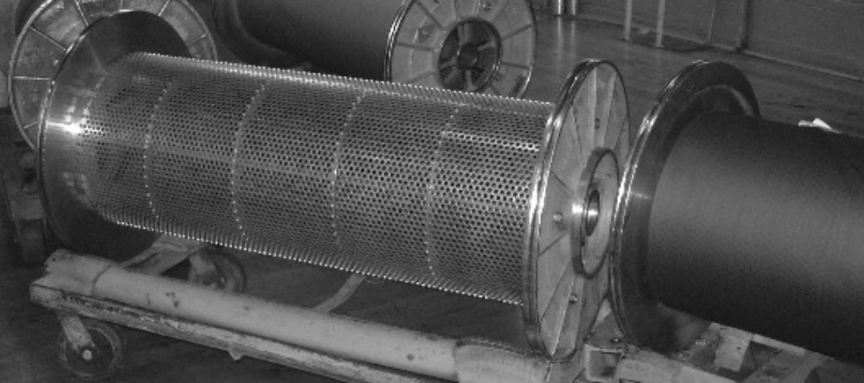

Figure 1. Dye Beams

Undyed Denim:

It is possible for denim fabrics to be finished and sold without going through any dyeing process. These fabrics are known as natural denims sometimes called “bull denims.” These natural denim fabrics exhibit the off-white cream color of natural cotton.
After finishing, cutting, and sewing into garments, they can be used like traditional denim garments, or they can go through garment dyeing and other wet processing to yield various properties. However, these garments will not show the color contrast effects shown by traditional denim garment processing. Also, these natural denims can be bleached to yield “white denim” products.
Additionally, it is also possible to dye natural denim fabrics into solid shades for both warp and filling yarns, employing the standard continuous dyeing techniques. This method is not usually used with indigo dyes, but is used where sulfur, vat, or reactive dyes might be applied. After dyeing, these denim fabrics are finished using the typical denim finishing sequence.

2.5 SAMPLE OF DENIM FABRIC:
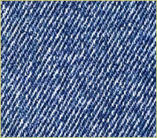
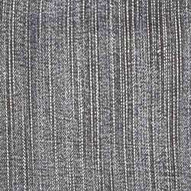

Slasher dyed denim fabric slasher dyed denim fabric
Source: http://www.google.com/search?q=image+of+sheet+denim+fabric&hl=en&biw=1152&bih=616&prmd=imvns&tbm=isch&tbo=u&source=univ&sa=X&ei=L0ySTov6B9KZhQfyrqHvDw&ved=0CC0QsAQ
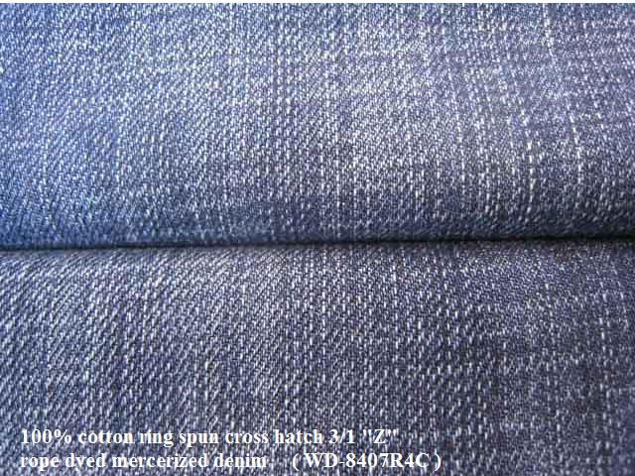
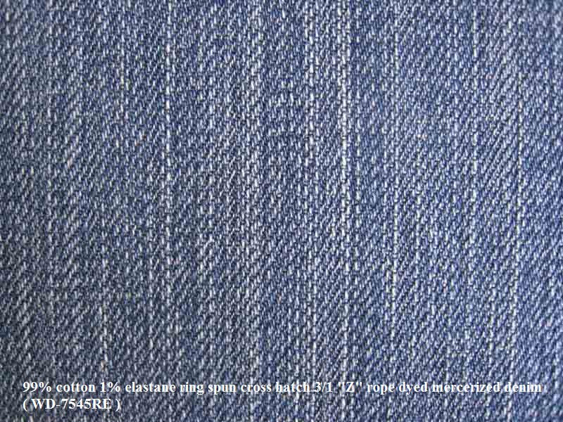

99%cotton 1% elastane ring spun hatch 3/1 ̏ z ̋ 100%cotton ring spun hatch 3/1 ̏ z ̋
rope dyed mercerized denim. rope dyed mercerized denim.
2.6 DENIM YARNS
YARN
- Rotor yarns are the best and most widely used yarns in denim production .Because of their very high speed rotor yarns are much cheaper than ring spun yarns. Off course rotor can only produce of yarn up to 40 Ne. Though cheap rotor yarns are associated with greater imperfections than corresponding ring yarns therefore knit goods are produced from ring yarns.
- Count range from 6 to 16 ne but most widely used range is 7 to 12 Ne. For slub yarn the range is 9 to 20 Ne.
- Quality-count cv <1.2 , single yarn strength>12.8 gm\tex , Elongation > 6.0 , U% <9.5 .
- As huge amount of slub yarns are used today the idea of too much strict U% is non considered. The diameter of slub varies from 1.5D to 2.2D (where D is the normal dia of yarn ). The periodicity of slub also varies widely.
Source- lecture sheet

2.7 Yarn Numbering :
Refer to Cotton Incorporated’s technical bulletin entitled “Yarn Numbering Systems-TRI 1014” for further information on yarn numbering systems and how to convert from one system to another.
Common Yarn Sizes for Denim
Warp yarns for bottom weight jeans typically range in size from Ne 4.0 to Ne 12.5/1. Finer yarns are used for lighter weight chambray shirting fabrics and lighter weight jeans, vests, dresses, and skirts. These yarns may range in count from Ne 12.5 to Ne 30.0.
Yarn Spinning Systems
Before the late 1970s, all denim yarns were ring spun. Today, denim fabrics have different combinations of ring and open-end yarns. When you hear a term such as “ring/ring, open end /open end (OE/OE), and ring/OE,” it is referring to which yarn is in the warp and which yarn is in the filling, respectively. For example, ring/OE indicates a ring-spun warp yarn and an open-end filling yarn. Weaving a combination of ring-spun and open-end yarns can help to reduce fabric costs while still maintaining some favorable ring-spun fabric characteristics.
Refer to Cotton Incorporated’s technical bulletin entitled “Cotton Spun Yarns for Knit and Woven Fabrics-ISP 1006” for more detailed information on yarn spinning systems.

Specialty Yarns :

- Structured Denim Yarns
Modern ring-spinning frames and open-end machines can be installed with devices that can manufacture predetermined yarn effects. These effects can vary from slubs (thick places) with different lengths, different spacing between slubs, or variations in the yarn count. Using these devices, OE yarns can have a more ring-spun like appearance, and ring-spun yarns can have an increased rough or “antiqued” quality. Yarn spinners can design patterns and effects specific to their needs, which can be downloaded into the machine’s electronic control system.

- Elastic Denim Yarns
Core-spun yarns are produced conventionally on ring-spinning machines by introducing a spandex filament at the back of the front drafting roll of the machine. The drafted cotton fibers twist around the spandex core to produce an elastic ring-spun type yarn. There are also open-end and air-jet spinning machines that have been adapted to produce core-spun yarns. The core filament yarn (normally spandex) is inserted through the rotor shaft on OE frame or the spindle of the air-jet frame, and the cotton fiber wraps around the spandex filament
during the process of spinning. The yarn is somewhat similar to the ring core-spun yarns in terms of yarn and fabric characteristics. Open-end and air-jet core-spun yarns have fewer knots and splices as compared to ring core-spun yarns.

2.8 WARPING :
Warping is the process of transferring multiple yarns from individual yarn packages onto a single package assembly. Normally, yarns are collected in a sheet form where the yarns lie parallel to each other and in the same plane onto a beam, which is a cylindrical barrel with side flanges. This is known as beam warping and is shown in Figure 2. For ball warp denim, the yarns are brought together and condensed into a rope before being wound onto a relatively short cylindrical barrel (sometimes called the shell or log) that has no end flanges. This is shown in Figure 3. In both cases, the supply yarn packages are placed on spindles, which are located in a framework called a creel.

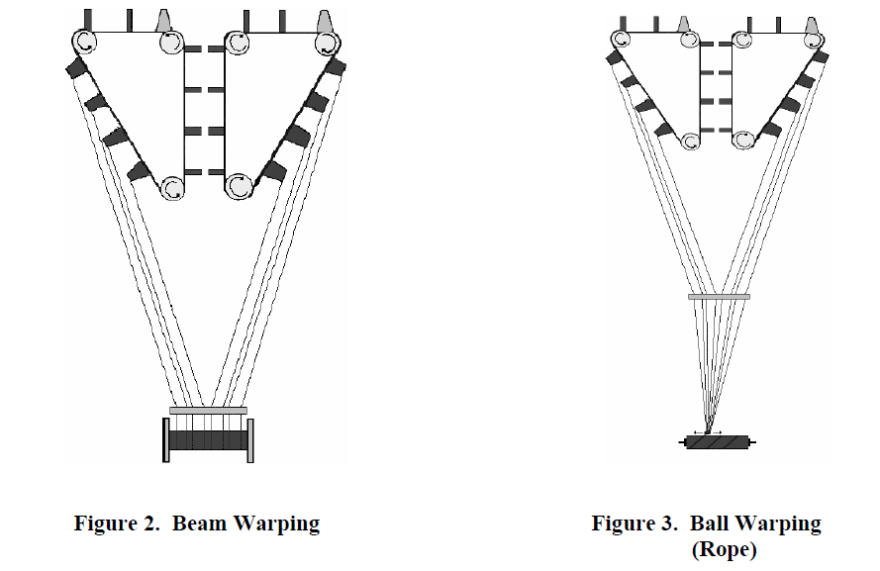

Types of Creels
- Traveling Package Creels
These are V-shaped creels with the actively running yarn packages on the outside of the V and the full yarn packages placed on the inside of the V. When the running packages are depleted, the yarn spindles on the creel are rotated so that the empty packages move to the inside of th creel for replenishment. The full packages move to the outside of the creel. The new yarn ends have to be pulled forward and threaded properly in the machine before
running the next warp. The empty package positions are then replaced with new full packages while the warper is running. This eliminates lost time in creeling up new yarn packages.
- Magazine Creels
These are straight-line creels with enough spindles so that each end-running has a reserve yarn package placed beside of it. The tail end of the running package is tied to the beginning end of the reserve package. Once the running package is depleted, the yarn transfers over to the reserve package and the warper continues to run. This is a random method of creeling yarn packages compared to block creeling normally used on traveling package creels.
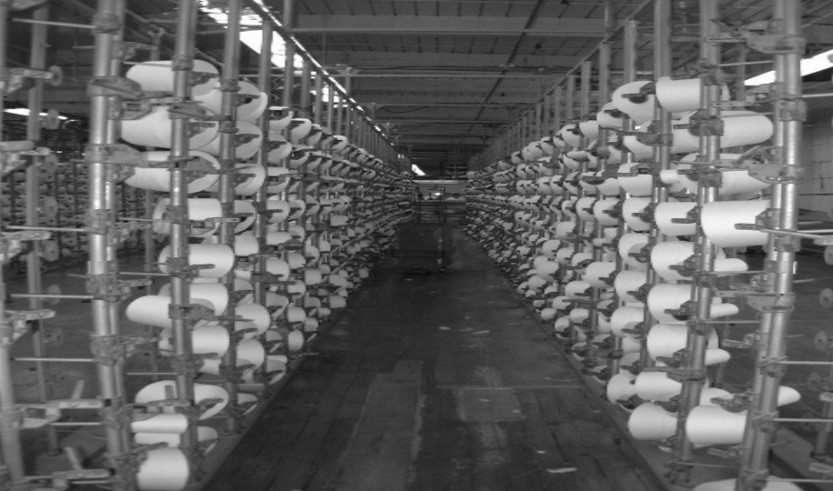

Figure 4. Magazine Creels

Ball Warping
In ball warping (Figure 5), 250 to 400 yarn ends are pulled from the creel. The yarns then pass through a comb-like device (sometimes called a hack or reed), which keeps each warp yarn separate and parallel to its neighboring ends. At intervals of every 1000 or 2000 yards (or meters), a lease string is placed across the sheet of warp yarns to aid yarn separation for the re-beaming operation, which will occur later. The yarns then go through a funnel-shaped device called a trumpet or condenser, which collapses and condenses the sheet of yarn into rope form. This device is located at the base of the warper head and traverses back and forth, guiding the newly formed rope of yarn onto a log. The rope must be wound at a constant tension to keep the yarns from tangling.
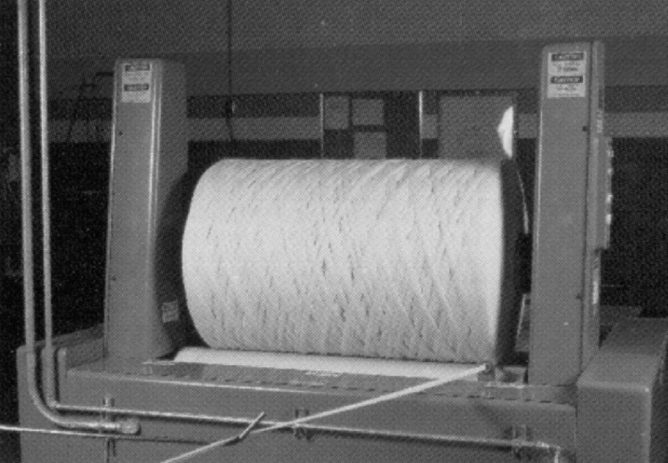
Figure 5. Ball Warping

Beam Warping
Beam warping maintains the yarns in an open sheet form and winds the yarns parallel to each other onto a slightly wider flanged beam. These yarns will not go through the rope indigo dye range, but are left “natural” and will end up either slasher dyed or in an un-dyed fabric, which can later be piece dyed, garment dyed, or left natural. Another option would be to beam dye the yarns using a dye other than indigo.

CHAPTER 1

LITERATURE SURVEY

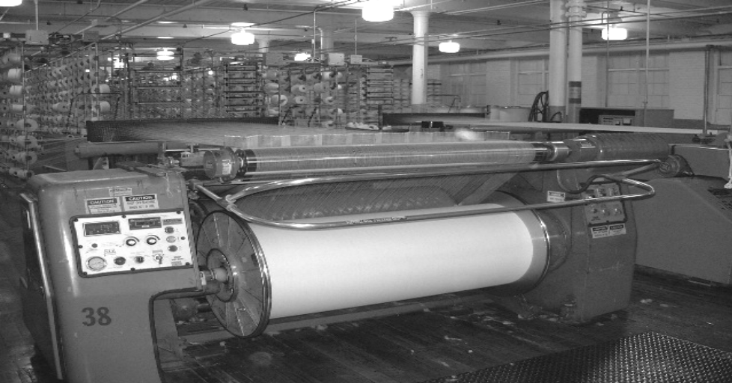

Figure 6. Beam Warping

2.9 DYEING AND SLASHING WARP YARNS FOR DENIM

Rope Dyeing
Most denim is yarn-dyed fabric with the warp yarns dyed with indigo dye and the filling yarns left undyed. There are a number of modifications or alternatives in the dyeing process that are routinely used to change the overall look or performance of the fabric. With the advent of denim garment washing techniques, the consistencies of the indigo dyeing process and its modifications have become crucially important in determining the quality and performance of indigo denim products.
The properties of the indigo dye account for the wide variety of color designs that are available on denim materials. Indigo is unique as a major textile dye, because it has a very low affinity for the cotton fiber. Because of the low substantivity of the indigo, the ball warp dyeing process ring dyes cotton. Unlike almost all other commercially successful dyestuffs, the indigo dye concentrates in the outer layers of the cotton yarn and fiber during the dyeing process. This produces an intense ring of color around a white core in the cotton yarn and the cotton fiber thus the name ring dyeing. When using most other dyes, if the ring-dyeing effect occurs, it would be considered a dyeing defect.
Indigo dye in its normal form is a vibrant blue, it is insoluble in water, and it will not dye cotton fiber. In order to dye cotton, the indigo must be converted to a water-soluble “leuco” form and then applied to the cotton. This process is known as chemical reduction. Reducing agents such as sodium hydrosulfite with sodium hydroxide chemically convert the indigo dye to its soluble form. This also temporarily converts the dye from its blue color to a very pale greenish yellow color. The leuco form of indigo is readily absorbed by the outer layers of the cotton yarn. Once
in the fiber/yarn, the indigo is made insoluble by oxidizing the yarn by passing the yarn through the air (skying). In fact, the dye will start to oxidize immediately when exposed to the air. The oxygen in air converts the dye back to its original blue and insoluble form. Thus the dye becomes trapped inside the outer layers of the cotton yarn. This results in a small amount of dye being deposited on the surface resulting in only light blue dyed yarn. In order to obtain deep blue indigo dyed yarns, the color must be built in layers. The dye is layered by using multiple passes of the rope of yarn into the soluble dye and then exposing it to the air for oxidation. This multiple passing of yarn into dye is called dips. Normally, this process is repeated from three to twelve times to build up a deep indigo blue color. The number of dips is limited to the number of dye boxes on the dye range. If the concentration of indigo dye in the dye boxes is doubled, this will result in slightly darker denim. This acts as a multiplier when labeling the denim. A double concentration of dye in nine dye boxes makes it an 18-dip denim. Tripling the concentration makes it a 27-dip denim. When even darker shades are desired, a sulfur black or blue dye can be applied to the yarn before indigo dyeing. This is known as a sulfur bottom. If the sulfur dye is applied after the yarn has been indigo dyed, it is known as a sulfur top.
.
If a sulfur bottom is required at this point, the ropes of yarn are fed into a bath of a reduced sulfur dye. Similar to indigo, sulfur dyes are water insoluble. They must be reduced to a water-soluble form before applying to cotton. Unlike indigo, the sulfur dye can penetrate into the core of the cotton fiber/yarn. The purpose of this process is to give the indigo dyed yarns a much deeper and darker shade or to slightly change the shade of the blue yarn to make it unique. Once the

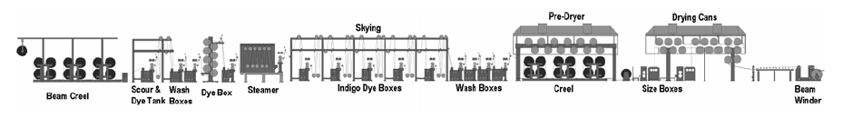
Figure 7. Indigo Dye Range
In rope dyeing, ball warps are continuously fed into the rope or chain-dyeing range for application of the indigo dyeing. Typically, 12-36 individual ropes of yarn are fed side-by-side simultaneously into the range. The ropes are kept separate from each other throughout the various parts of the dye range. For example, if the total number of ends on the loom beam is 3,456, and each ball would have 288 ends, then the dye set would have a total of 12 ball warps. If there can only be a multiple of 10 balls on the dye range, then there would be 345 ends on 9 balls and 351 ends on the tenth ball.
The ropes are first fed into one or more scouring baths, which consist of wetting agents detergents and caustic. The purpose of these baths is to remove naturally occurring impurities found on the cotton fiber such as dirt, minerals, ash, pectin, and naturally occurring waxes. It is very important to remove these materials to guarantee uniform wetting and uniform dyeing. The ropes are subsequently fed into one or more water rinsing baths.
If a sulfur bottom is required at this point, the ropes of yarn are fed into a bath of a reduced sulfur dye. Similar to indigo, sulfur dyes are water insoluble. They must be reduced to a water-soluble form before applying to cotton. Unlike indigo, the sulfur dye can penetrate into the core of the cotton fiber/yarn. The purpose of this process is to give the indigo dyed yarns a much deeper and darker shade or to slightly change the shade of the blue yarn to make it unique. Once the
Reduced sulfur dye is applied to the ropes, they are skyed to allow the dye to oxidize into its normal water insoluble form.
In order to minimize the color variability between denim fabric panels after garment washing, denim manufacturers employ a technique known as sequential dyeing. Basically, this method is based on the concept that the color properties of indigo-dyed yarn processed at a specific time, most closely resemble the color properties of the indigo yarn processed just before and just after that lot. This method has proven much more effective at minimizing color variability in garment washing when compared to the technique of shade sorting alone.

2.10 Slasher Dyeing:

For certain manufacturers, the rope or chain dyeing of indigo is not possible or desirable. Many different types of equipment have been tried as an alternative to the dip and sky method of the rope dye range. For some producers, slasher dyeing has become a reasonable alternative method. A slasher is a range is normally employed to apply size formulations onto warp yarns before weaving. This range (Figure 8), when used for slasher dyeing of indigo, consists of section beams of warp yarn, which are forced into a sheet of yarn. This yarn sheet is then fed into a scouring section where natural impurities are removed. The next section is where indigo is applied. In order to achieve fairly deep shades, the indigo is applied in a series of multiple dip and sky applications to allow for shade build up. If the arrangement of the slasher dyeing does not allow for multiple dip and sky applications, then only light and medium shades can be obtained from indigo. The dye application is followed by afterwashing and drying. With some machinery arrangement, warp size for weaving is immediately applied. In other arrangements, the warp size is applied onto the yarns employing a separate range.

Slasher Indigo Dye Range:

Slasher dyeing ranges have a number of advantages and unique characteristics. Slasher dyeing employs a sheet of yarn, which is wound directly onto a warp beam rather than ropes of yarn, which then requires additional handling. This type of dyeing works well with lightweight denims. In general, these machines require less floor space, enable smaller production runs, have a quicker turn over time, and are more flexible in their response to changes in the market. As an overall process these ranges have lower machinery cost; therefore, lower dye costs are realized for specific fabric types. Additionally, the slasher dyeing technique can be used for other dye types for cotton and thus can produce a wide variety of colors other than indigo blue.

2.11 Dye used in denim dyeing
Indigo dye:
Indigo dye is an organic compound with a distinctive blue color (see indigo). Historically, indigo was a natural dye extracted from plants, and this process was important economically because blue dyes were once rare. Nearly all indigo dye produced today — several thousand tons each year — is synthetic. It is the blue of blue jeans.

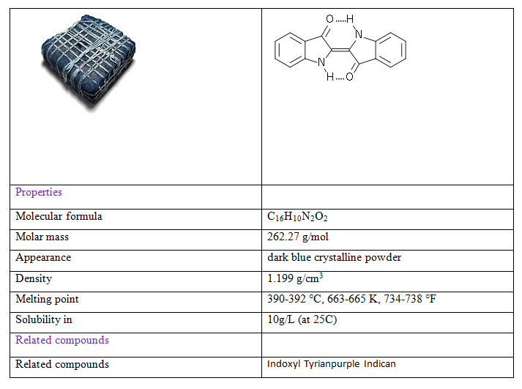

Uses:
The primary use for indigo is as a dye for cotton yarn, which is mainly for the production of denim cloth for blue jeans. On average, a pair of blue jean trousers requires 3 – 12 g of indigo. Small amounts are used for dyeing wool and silk.
Indigo carmine, or indigotine, is an indigo derivative which is also used as a colorant. Approximately 20M kilograms are produced annually, again mainly for blue jeans. It is also used as a food colorant.

Photochemistry of Indigo Dyes:
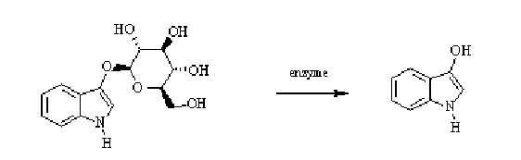
Indican hydroxyl-β-D-glucopyranoside Indoxyl

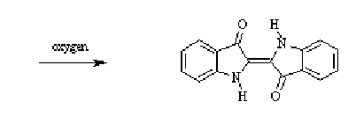

Indigo Dyes

Plant sources of natural indigo:
A variety of plants have provided indigo throughout history, but most natural indigo was obtained from those in the genus Indigo era, which are native to the tropics. The primary commercial indigo species in Asia was true indigo (Indigo era, also known as Indigo era sumatrana). A common alternative used in the relatively colder subtropical locations such as Japan's Ryukyu Islands and Taiwan is Strobilanthes cusia (. Chinese: In Central and South America the two species Indigofera suffruticosa (Añil) and Indigofera arrecta (Natal indigo) were the most important. In temperate climates indigo can also be obtained from woad (Isatis tinctoria) and dyer's knotweed (Polygonum tinctorum), although the Indigofera species yield more dye.

Chemical properties:
Indigo is a dark blue crystalline powder that sublimes at 390–392 °C. It is insoluble in water, alcohol, or ether but soluble in DMSO, chloroform, nitrobenzene, and concentrated sulfuric acid. The chemical formula of indigo is C₁₆H₁₀N₂O₂.

2.12 Sulfur dyes:

Sulfur dyes are the most commonly used dyes manufactured for cotton in terms of volume. They are cheap, generally have good wash-fastness and are easy to apply. The dyes are absorbed by cotton from a bath containing sodium sulfide or sodium hydrosulfite and are made insoluble within the fiber by oxidation. During this process these dyes form complex larger molecules which is the basis of their good wash-fastness.
These dyes have well all round fastness except to chlorine. Due to the highly polluting nature of the dye-bath effluent, slowly sulfur dyes are being phased out. Sulfur dyes are primarily used for dark colors such as blacks, browns, and dark blues. The deep indigo blues of denim blue jeans are a product of sulfur dyes.
Sulfur dyes are water insoluble. They have to be treated with a reducing agent and an alkali at temperature of around 80 degrees Celsius where the dye breaks into small particles which then becomes water soluble and hence can be absorbed by the fabric.
Heating and adding a substance like common salt facilitates the absorption. After this the fabric is removed from the dye solution and then taken for oxidation. During the oxidation step the small particles of dye once more form the parent dye which is insoluble in water.
This oxidation can be done in air or by using oxidizing agents like hydrogen peroxide or sodium bromate in a mildly acidic solution. Now as the dye has become water insoluble in fiber so it will not bleed in water when washed and will not stain other clothes. However the dye may have poor fastness to rubbing that is the dye from the fiber may come out gradually if the fabric is rubbed against. Also the fastness to hypochlorite bleach is poor because hypochlorite breaks the color imparting group in the dye and hence the colored part becomes colorless.
Sulfur dyes are very inexpensive and very important to the dyeing industry. Out of all the sulfur dyes perhaps 50% of production is of the sulfur black color as black is the most popular fabric color.
Sulfur dyes do not have any pure red color in its shade range. A pink or lighter scarlet color is available.

Properties of sulfur dyes:
These are water insoluble dyes and have no affinity for the cellulosic’s as such, but solubilised when treated with a weak alkaline solution of sodium sulphide or any other reducing agent to form a leuco compound. These leuco compounds are water soluble and have affinity for the cellulosic materials such as cotton, viscose, jute and flex etc. These dyes are absorbed by the cellulosic material in the leuco form from aqueous solution and when oxidized by suitable oxidizing agents, got converted into insoluble parent dye, which is fast to normal color fastness parameters.
Main properties of the sulfur dyes are as follows:
1. Economical dyeing with excellent tinctorial value and good build up properties.
2. Good overall colorfastness properties such as wash fastness, light fastness, perspiration fastness etc. Moderate fastness to crocking and poor fastness to chlorines bleaching agents such as bleaching powder and sodium hypochlorite.
3. Limited shade range to produce only dull shades and there is no true red dye in the range.
4. These dyes can be applied by exhaust, semi continuous or continuous dyeing methods on garment, yarn, knits, fabric as well as loose stock etc.
5. Available in powder granule and liquid forms.
6. Sulphur black is the major black dye used world vide for dyeing of cellulosic’s.
7. The conventional dyeing process is not environment friendly due to pollution problems of sodium sulphide.
8. When dyed by using none polluting reducing and oxidizing agents the process is environment friendly.

Types of sulfur dyes:
There are three classes of sulfur dyes, which are available commercially,
1. Convenstional water insoluble dyes which have no substantivity to cellulosic’s.
2. Solubilised sulfur dyes, which are water soluble and non substantive to cellulosics.
3. Pre-reduced sulfur dyes, in the stabilized leuco compound form, which are substantive to cellulosics.

2.13 SLASHING (Sizing):
The main purpose for sizing warp yarns is to encapsulate the yarn with a protective coating. This protective coating reduces yarn abrasion that takes place during the weaving operation and reduces yarn hairiness preventing adjacent yarns from entangling with one another at the weaving machine. Also, this protective coating keeps the indigo dye from rubbing off during the weaving process. For many years, native starches or slightly modified starches with corresponding binders were regarded as the most economical way to size indigo warps. However, the industry shift to garment washed denims has led to new sizing recipes. Many times the type and quantity of size used are determined by the subsequent fabric and garment finishing operations that follow.
At the back end of the slasher range, the section beams from the beaming process are creeled (Figure 11). The yarns from each beam will be pulled over and combined with the yarns from the other beams to form multiple sheets of yarns, the number of sheets corresponding to the number of size boxes .
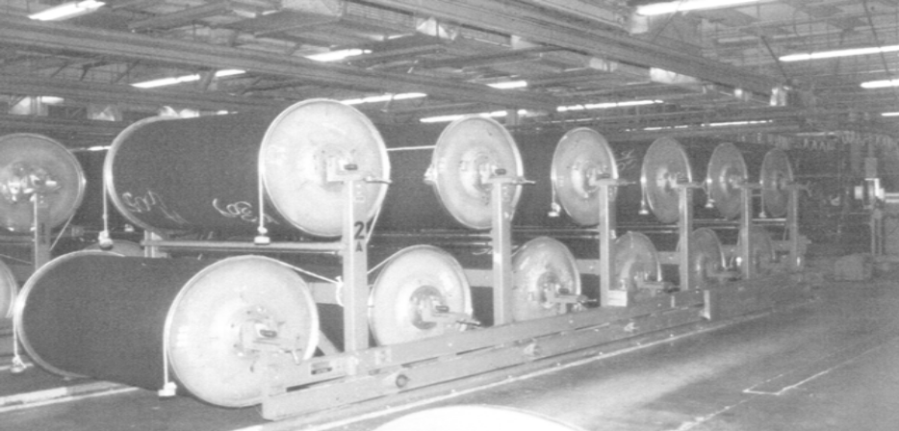
Figure 8. Slasher Creel
As each yarn sheet enters a size box (Figure 12), the yarns are guided downward and submerged in the liquid size. The yarn sheet leaves the size box via a set of squeeze rolls that helps control the wet pick-up, which influences the amount of size added onto the yarn and controls the amount of penetration of the size into the yarn. After this, the yarns are pulled over steam-heated, Teflon® coated cans or cylinders where drying takes place. At this point, the yarns are not totally dry, but are monitored to maintain from 6-8% moisture typically. Most warp yarns for weaving denim have 7-14% size add-on (actual dry solids weight added to the original weight of the yarn). This depends on what type of spinning system is used. Too much size causes yarn chaffing and excessive shedding of size particles at the weaving machine, and too little size causes excessive yarn abrasion resulting in dye streaks, clinging, broken and entangled ends resulting in low weaving efficiencies. In many denim styles, the size is left on the fabric.
and acts as a stiffening agent for cut-and-sew operations. This accounts for the stiffness of certain jeans, which are purchased by the consumer.

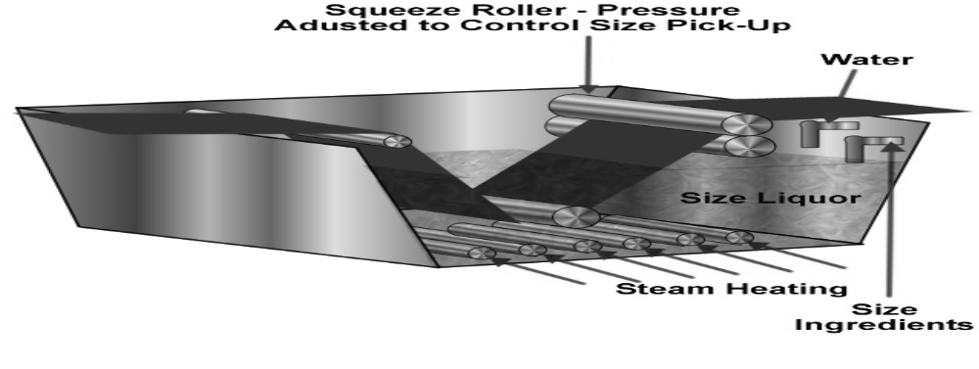

All the yarns go through a set of stainless steel split rods, which help to separate them into individual sheets, equivalent to the number of section beams in the creel. This ensures that yarns from one sheet are adhering to yarns from another sheet. After passing through the split rods, the warp yarns are collected into one single sheet and passed through a comb, which helps to separate individual yarns. This expansion type of comb is adjusted to the desired loom beam width. At this point, all the warp yarns are wound onto the beam (Figure 13). Normally, several loom beams will be produced from a single set of section beams in the slasher creel.
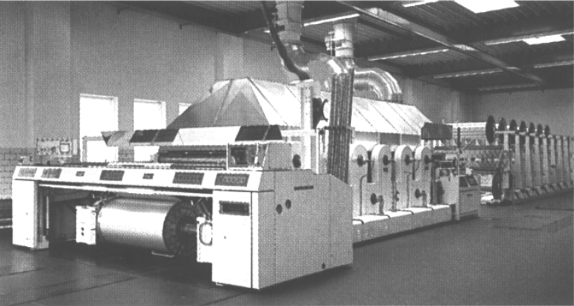
Figure 9. Slasher (loom beam at head-end)

DRAWING-IN AND TYING-IN OF WARP YARNS:
When a new denim style is put on a weaving machine, it is necessary to draw (thread or insert) the warp yarns through various elements as in Figure 14, including stop motion devices (drop wires), weave design control devices (harnesses and heddles), and filling “beat-up” devices (reed). Each end of yarn must have its own individual element. This procedure can be done manually or automatically on drawing-in machines. When producing the same style and when the current loom beam is nearly empty of yarn, an identical full beam of yarn can be tied to the yarns of the old beam. This is done by a tying-in machine, which automatically selects an end of yarn from the old beam and ties it to the appropriate end on the new beam. The knots are then pulled through the weaving machine before fabric is put into production. It is well documented that many loom stops are caused by improper tying-in of the warp yarns.

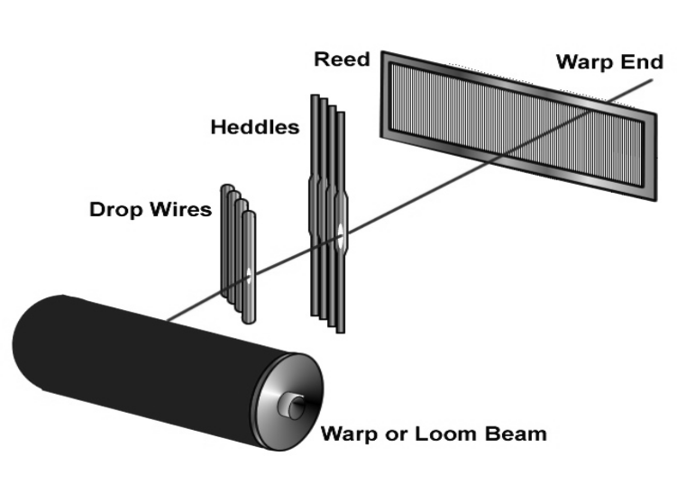

Figure 10. Warp Drawing-in

WEAVING DENIM FABRICS:

Denim fabrics are woven by interlacing two sets of yarns (Figure 15) perpendicular to one another in fabric form. Yarns in the machine direction are called warp yarns or warp ends, and these are interlaced with filling yarns or picks. The sequence or order of interlacing the two sets of yarns can be varied to produce many different weave designs. The finished fabric construction is determined by the number of warp and filling yarns per square inch or centimeter. For example, a typical construction for bottom weight denim may be 62 x 38. This is interpreted as 62 warp yarns per inch of width and 38 filling yarns per inch of length and always in that order. This thread count along with the yarn counts used will influence fabric properties such as weight, fabric tightness, cover, drape, hand, tensile strength, tear strength, and other fabric properties.

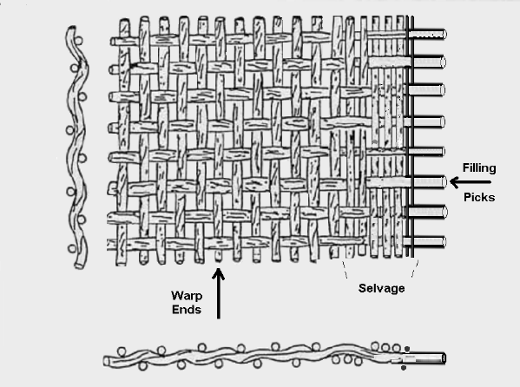
Figure 11. Woven Fabric Structure
2.14 MACHINE PARTS OF DYEING & SIZING MACHINE IN BEXIMCO DENIMS LTD:

- Pre-beam creel zone

- Yarn welding area

- Accumulator BL (80 meter capacity)

- Pre-wetting zone (for regular blue & blue black temperature is 70 degree Celsius), or Mercerizing tank (for regular black temperature is 80 degree Celsius), or Pre- dyeing bath (fordark blue)

- Two washing bath (pure soft water in room is used)

- Four dye bath (dye used in room temperature)

- Three wash bath/ box (30 degree Celsius & pH is controlled)

- Pre-drying cylinder

- Size bath/ Sow box

- Post drying cylinder

- Yarn leasing area

- Weavers beam winder

Some other assisting areas in the dyeing and sizing process are

- Skying zone

- Dye kitchen

- Size kitchen

- Blower

- Reserver tank

- Size cooker

- Beam Crain (two tank capacity)

- Yarn sheet spreader roller

2.15 WEAVING PROCESS:
Weavers beam
↓
Drawing/ Knotting
↓
Denting
↓
Shedding
↓
Picking
↓
Beat up
↓
Fabric Take up
↓
Fabric Let off
↓
Rolling

In the weaving operation the lengthwise yarns, which run from back to the front of the loom, form the basic structure of the fabric and are called warp .The crosswise yarns are the filling, also referred to as the weft or the woof.
Weaving is the main manufacturing process of denim fabric where the dyed warp sheet converted to fabric. To weave denim fabric we need a heavy duty weaving machine like Picanol, tsudacoma, somet etc. there are many types of weaving machines available according to their weft insertion type.
Shuttle Loom
Rapier Loom
Projectile Loom
Air jet Loom
Water jet Loom
After warping, dyeing and sizing a weaver’s beam is produced. The weaver’s beam, after drawing and denting is then mounted in the loom to produce the fabric. Weaving of denim fabric is not much different from weaving all other fabric except the idea about the warp and weft way shrinkage percent. It is well known that fabric shrinks after relaxation and also after any wet process treatment. In order to accommodate the aspect of both way shrinkage it is necessary to use a very decisive EPI and PPI in the loom state so that after relaxation that in general that the fabrics shrinkage percent in the length direction varies from 12%-15% while in the width direction the shrinkage percent lies around 4.5 to 5.5%.The higher shrinkage in the warp direction is mainly due to greater warp tension during weaving and also due to coarser weft yarns than that of the warp yarns. In order to comply with the customer requirement it will be necessary to choose both EPI and PPI very precisely so that the final EPI and PPI of the ultimate fabric conform to the buyer’s requirement.
Source: Textiles fiber to fabric and lecture sheet

2.16 Yarn Flow in Weaving
Warp yarns as seen in Figure 16 are fed from the loom beam and pass over a whip roll or rollers, which control yarn tension variations during weaving motions. The yarns are then directed through drop wires, heddles, and a comb-like device called a reed. The spaces between the reed wires across the width of the reed are called dents. Each reed has a certain number of dents per inch with 12 to 18 being the most common for denim and denim-type fabrics. There are normally four warp yarns drawn per dent in standard 3/1 twill denim fabrics. The heddles, through which the yarn is threaded, are located in harness frames with a designed number of warp yarns drawn through each harness. All warp yarns weaving alike in a design repeat occupy a given harness. The reed establishes the width of the warp yarn sheet and equal spacing of the yarns before weaving. It also is the mechanism used for pushing (beating-up) each inserted filling yarn (pick) into the body of the fabric at the “fell of the cloth.” The fell is the point where yarns become fabric. At this point, the warp yarn is in fabric form and ready to be collected on a cloth roll. Some machines have inspection stands that are backlighted for easy inspection of the fabric as it is woven before cloth roll take-up.
The flow of the filling yarn is somewhat simpler. The filling yarn is fed from large packages located outside of the actual weaving machine. The yarn comes off the package or packages and is wound onto a storage feeder that allows the yarn to be under consistent tension for each pick insertion. The yarn is then introduced to the filling insertion mechanism and inserted across the separated warp yarns, which have formed a tunnel or path called a weave shed.

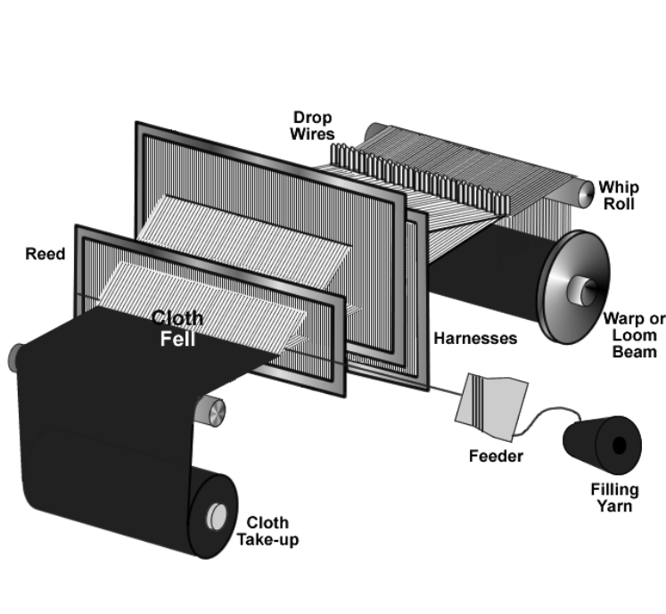

Figure 12. Weaving Machine Elements

Basic Weaving Motions
The five basic motions, which are shown in Figure 17, are required on a weaving machine to weave a fabric such as denim and are detailed as follows:

Shedding
Shedding is the separation of the warp yarn sheet created by some harnesses lifting yarns upward and the remaining harnesses staying in a down position. Therefore, an opening (weave shed) is formed, providing a path for the filling yarns to follow. Cam shedding methods (also know as tappet) are used for simple fabric designs, while dobbies can weave small patterns into the fabric and jacquard systems with their ability to control each warp end are used to weave complex designs. Generally, the more harnesses that are employed on a given machine, the more complex the design. Most denim fabrics are woven on machines using cam shedding. Weaving machines running 3/1 and 2/2 denim fabrics will use four or eight harnesses for the ground weave, and in some cases, two additional harnesses for the selvage, if needed. Machines running 2/1 denim fabrics use three or six harnesses for the ground weave and can use two additional harnesses for the selvage, if required. The shape and profile of the cam determines the lifting motion of the connected harness. There is an individual cam controlling each harness on the weaving machine, while dobby looms use lifting jacks to control each harness and jacquard looms use a jacquard head and cord to control each warp end separately.

Filling Insertion
The filling yarn is inserted through the weave shed by various methods. The oldest method, shuttle weaving, has been replaced to a large degree by methods using projectiles, rapiers, and air. Most denim fabrics are woven using projectile filling insertion or air jet filling insertion. The fastest method, air jet, can insert the yarn at a rate of 1400-2400 meters per minute. Most air jet machines weaving denim run at speeds of 600 to 900 picks per minute. Many machines today have pick-and-pick capability, meaning two filling yarn packages are available. Alternating the picks from different yarn packages helps to break up any repeating

Beat-up
As mentioned previously, the warp yarns pass through a comb-like device called the reed. The reed recedes away from the newly formed fabric during filling insertion and moves forward towards the fabric after pick insertion.

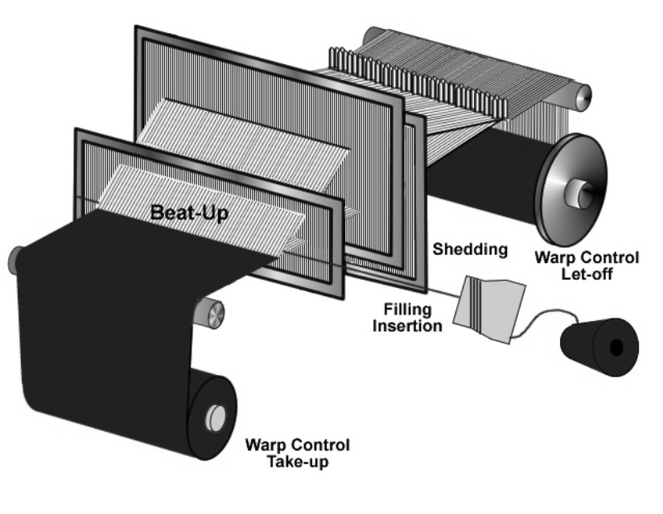
Figure 13. Basic Weaving Motions

Typical Denim Constructions, Weaves, and Weights
The classical construction of a bottom weight 14.5-ounce denim is 60-64 warp yarns per inch and 38-42 filling yarns per inch. The number of warp yarns per inch is sometimes referred to as the fabric sley. The weight is influenced by the size of the yarn used, the fabric weave design, and the fabric tightness. Also influencing the fabric weight is the amount of size left on the finished fabric. Other denim fabrics and denim “look-a-likes” may vary in construction from 52 to 70 warp yarns per inch and from 36 to 52 picks per inch. As a rule, denim is woven as 3/1 twill, 2/1 twill, 3/1 broken twill, or 2/2 broken twill. The weights of these finished fabrics can vary between 3.5 and 16.5 ounces per square yard. The weight of the fabric usually determines what the final garment application will be:
3.5-8.0 ounces per square yard – blouses, tops, shirts, and top of bed fabrics
8.0-16.5 ounces per square yard – trousers, jeans, jackets, and upholstery
Numerical notations for different denim designs, such as 3/1, denote what each warp yarn is doing relative to the filling yarns that it is interlacing with. In this case, each warp yarn is going “over” three picks and then “under” one pick. This would be verbally stated as “3 by 1” twill or “3 by 1” denim. At the next end, moving to the right, the same sequence is repeated but advanced up one pick. This advancing upward sequence continues, giving the characteristic twill line. In this case, the twill line is rising to the right, and the fabric is classified as a right-hand twill weave. If the twill line is made to rise to the left, then the design is left-hand twill. Broken twills are designed by breaking up the twill line at different intervals thus keeping it from being in a straight line.

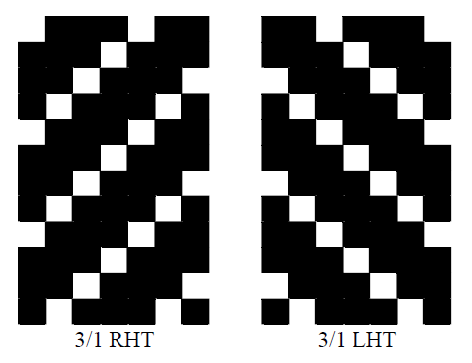
Figure 14. Diagram of 3/1 Right and Left Hand Twills

Yarn Twist Direction and Twill Line Direction
For a more pronounced twill line in a denim fabric, the direction of twist in the warp yarn should be opposite to the twill direction in the fabric. For example, if “Z” twisted yarn in Figure 19 is woven into a right-hand twill (Figure 18), the twill line is less pronounced. If “S” twisted yarn is woven into the same fabric, then the twill line is more pronounced. It must be remembered that only Z-twist yarns are formed in open-end yarns, while ring-spun yarns have either Z or S. For that reason, open-end yarn can be used in left-hand twills when a more pronounced twill line is desirable. Having the twist direction opposite from the twill line direction also tends to make the fabric hand a little softer.

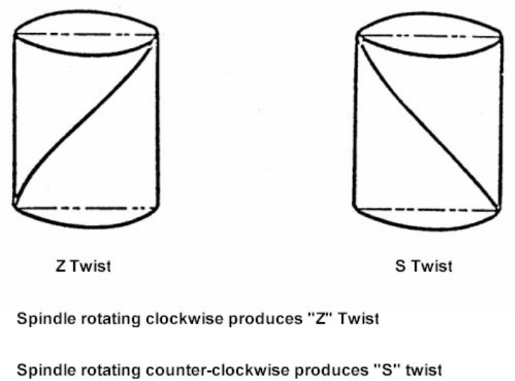

Figure 15. Z and S Twist Directions

Non-conventional Denim Fabric Constructions
Indigo-dyed yarns have been woven in plain weaves known as chambray, oxfords, baskets, herringbones, bedford cords, and combinations of 3/1 and 1/3 twills. Jacquard designs and dobby weaves have also been incorporated into denim designs to produce new looks and textures. As fashion designers create new ideas, the fabric manufacturers have to follow the demands of marketing teams and market leaders.

2.17 Dyeing Faults:
Major dyeing faults which occur during are mentioned below:
- Uneven Dyeing
- Batch to Batch Shade variation
- Patchy dyeing effect
- Roll to roll variation or Meter to Meter variation
- Crease mark
- Dye spot
- Wrinkle mark
- Softener Mark

Uneven Dyeing:
Causes:
- Uneven pretreatment (uneven scouring & bleaching).
- Improper color dosing.
- Using dyes of high fixation property.
- Uneven heat-setting in case of synthetic fibres
- Lack of control on dyeing machine
- Remedies:
- By ensuring even pretreatment.
- By ensuring even heat-setting in case of synthetic fibers.
- Proper dosing of dyes and chemicals.
- Proper controlling of dyeing m/c

Batch to Batch shade variation:
Causes:
- Fluctuation of Temperature.
- Improper dosing time of dyes & chemicals.
- Batch to batch weight variation of dyes and chemicals.
- Dyes lot variation.
- Improper reel speed, pump speed, liquor ratio.
- Improper pretreatment.
Remedies:
- Use standard dyes and chemicals.
- Maintain the same liquor ratio.
- Follow the standard pretreatment procedure.
- Maintain the same dyeing cycle.
- Identical dyeing procedure should be followed for the same depth of the Shade.
- Make sure that the operators add the right bulk chemicals at the same time and temperature in the process.
- The pH, hardness and sodium carbonate content of supply water should check daily.

Patchy Dying Effect:
Causes:
- Entanglement of fabric.
- Faulty injection of alkali.
- Improper addition of color.
- Due to hardness of water.
- Due to improper salt addition.
- Dye migration during intermediate dyeing.
- Uneven heat in the machine, etc.
Remedies:
- By ensuring proper pretreatment.
- Proper dosing of dyes and chemicals.
- Heat should be same throughout the dye liquor.
- Proper salt addition.

Roll to Roll Variation :
Causes:
- Poor migration property of dyes.
- Improper dyes solubility.
- Hardness of water.
- Faulty m/c speed, etc
Remedies:
- Use standard dyes and chemicals.
- Proper m/c speed.
- Use of soft water.

Crease Mark:
Causes:
- Poor opening of the fabric rope
- Shock cooling of synthetic material
- If pump pressure & reel speed is not equal
- Due to high speed m/c running
Remedies:
- Maintaining proper reel sped & pump speed.
- Lower rate rising and cooling the temperature
- Reducing the m/c load
- Higher liquor ratio

Dye Spot:
Causes:
- Improper Dissolving of dye particle in bath.
- Improper Dissolving of caustic soda particle in bath.
Remedies:
- By proper dissolving of dyes & chemicals
- By passing the dissolved dyestuff through a fine stainless steel mesh strainer, so that the large un-dissolved particles are removed.

Wrinkle mark:
Causes:
- Poor opening of the fabric rope
- Shock cooling of synthetic material
- High temperature entanglement of the fabric
Remedies:
- Maintaining proper reel sped & pump speed.
- Lower rate rising and cooling the temperature
- Higher liquor ratio

Softener Mark:
Causes:
- Improper mixing of the Softener.
- Improper running time of the fabric during application of softener.
- Entanglement of the fabric during application of softener
Remedies:
- Maintaining proper reel sped & pump speed.
- Proper Mixing of the softener before addition.
- Prevent the entanglement of the fabric during application of softener

2.18 Denim Finishing
Denim is one of the oldest fabrics, but still, it is one of the most fashionable and widely used fabric. And as the full jeans trend is going wildly this season, we can have a deeper look at the finishing details of your jeans. And somehow, denim has the most sophisticated finishing. Some of the techniques found below can be done by yourself, like bleaching, washing and ripping.

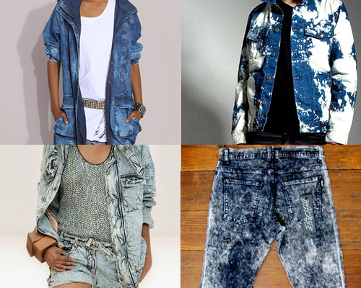

Acid Washing

Patented in 1986, this wash uses pumice stones soaked in bleach to create deep contrast within the coloring of the denim jeans.

Batching
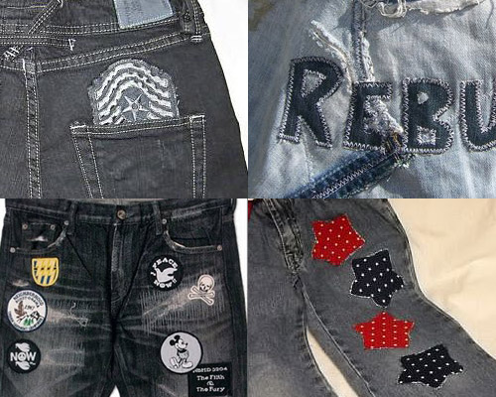
We can find this in many kidswear jeans and old school jacket. As Denim is a durable fabric, the batch is attached on the surface firmly.

Bleaching
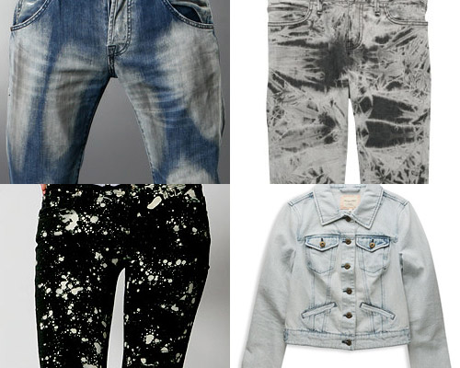
A chemical used to make denim fade. Liquid bleach is usually an aqueous solution of sodium hypochlorite, and dry powdered bleaches contain chloride of lime (calcium hypochlorite).

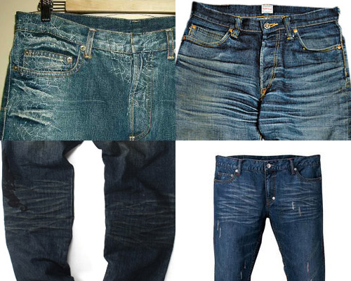

Crushing
A textured effect achieved through a special fabric construction and wet processing. The denim jeans are woven with an overtwisted weft yarn; when the garment is washed, the yarn “shrinks,” acquiring a goffer look that is further enhanced by bleaching and stonewashing.

Dirty Washing
A finish that creates the look of stained jeans.

EmbroideredFound in much high-end denim in Japan. You can see the insanely details done by the Japanese, to replace the printing.

Frayed
A finish in which the waistband and hems of denim jeans have been sanded to create a “worn” effect.

Overdyed
A second dying process executed after denim jeans have been sewn, to make the thread color the same as the jean.

Raw
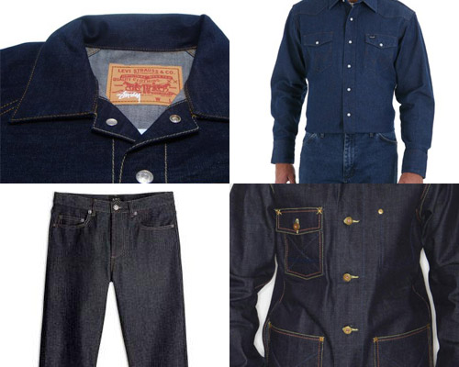
Denim jeans that has been not been treated or finished.

Screen-printing
The majority of denim is 100% cotton and very good for screen printing.

Sandblasting
A laundry process in which denim jeans are shot with guns of sand in order to make the jeans look as if they’ve been worn.

Tearing and ripping
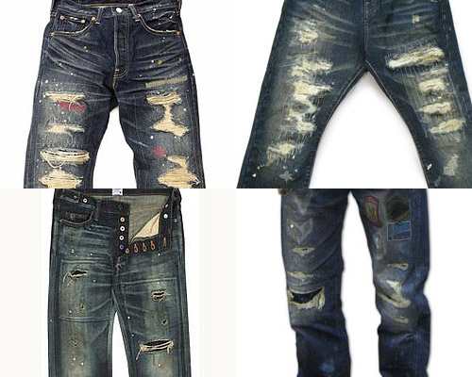
Denim jeans that have purposely been ripped or teared — and not repaired — prior to sale.

Tinted
Denim jeans that have been dyed a second time, usually with a yellow khaki hue, to create the look of vintage denim.

Washing
The are several washing method:
Enzyme wash – Considered a more efficient and environmentally sound way to stone wash jeans. Rather than using pumice stones, organic enzymes (proteins) are used that eat away at the indigo. Jeans finished using enzymes tend to be stronger than those broken down by traditional stone washing, as the fabric is not subjected to the same level of abuse.
Sand wash – A finish achieved through a combination of pumice stones, enzymes and sand; used to create the illusion of aged denim jeans.
Stone wash – A process that physically removes colour and adds contrast. A 20 yard roll of fabric, generally 62 inches in width, is put into a 250-pound washing machine along with pumice stones. The fabric and stones are rotated together for a set period of time.

Whiskered
A denim jeans finish that produces white lines that look like wrinkles near the crotch and sometimes behind the knees.

LATENT DEFECTS IN DENIM FABRIC
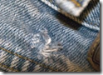
Latent defects are ones that are not apparent in finished denim fabrics, but will appear after garment laundering. They are usually a result of procedures in denim sizing; dyeing and finishing that interfere with garment processing or cause spots, holes or streaks in garments. The most well-known is garment seam twist which results from incorrect skew adjustment.

Holes :
These result from weak places in the fabric, often where knots are in the fabric from repairing broken yarns in spinning or weaving. The problem occurs often in fabric that was re-finished, especially fabric re-Sanforized in order to correct shrinkage or skew. Fabric that has been re-finished has lower strength, inferior hand and a different washed appearance. For that reason, re-finished denim should not be mixed with denim finished only once and re-finished denim should not be sent to demanding customers.

Spots :
These are usually caused by chemicals used in finishing or sizing that are not easily removed by laundry de-sizing or are not soluble and precipitate in garment de-sizing and re-deposit on the garments. Mineral oils, some cationic compounds, polyvinyl alcohol and other compounds often cause these problems. Chemicals that cause spots can be analyzed for their chemical composition and chemical treatments can be devised to correct these problems in the laundry. Also, the fabric supplier can be requested to cease using offensive products.

Alternating Light and Dark Streaks :
When an Indigo dyeing machine stops for more than a few minutes, the yarn that is immersed in the dye boxes will over-reduce and appear as light streaks after garment laundering. The yarns that are in the airing sections after the dye boxes will appear as dark streaks after laundering. The fabric producer can segregate this problem by identifying the yarn that was in the machine during the stop from just after the pre-wet section though the end of the drying section. The standard procedure of submitting a small washed sample of a fabric roll will not allow prediction of the presence of this type of streaking because the sample is taken from one end of a fabric roll and does not represent the appearance of the entire roll. These streaks appear and disappear in the fabric. For that reason, yarn that is involved in an Indigo machine stop should be segregated. The yarn from a machine stop produces such low quality fabric that it is almost not worth weaving. The causes of machine stops need to be rigorously investigated and action taken to eliminate them.

Crack Marks:
These are light streaks that usually appear in garments that do not follow warp yarns. These have often been caused by the use of acrylic hand-builders that result in very inflexible fabric. When the garment is entered into the washing machine, the acrylic film breaks forming a crack and the garment fades more along the area of the crack.

Sudden Shade Difference After Laundering :
After garment laundering a single leg panel, for example, will have 2 completely different shades, 1 light and the other dark, with a distinct, sharp break in color. This results when Indigo-dyed fabric is located on drying cylinders when the finishing machine stops for more than about 5 minutes. Applying high temperature to Indigo for long periods causes the Indigo in the deepest part of the yarn to sublime or evaporate and after surface Indigo is removed in laundering, the fabric part that was on the drying cylinders will be lighter. Therefore, this can not be seen in the original fabric.

Sizing Spots or Streaks:
Basic laundry de-sizing procedures are used to de-size carbohydrate-based sizes like starch or guar gums. Polyvinyl alcohol sizes can be more difficult to remove, especially from yarn that was over-dried in sizing. If not completely removed, polyvinyl alcohol can react with hypochlorite bleaches and result in permanent spots or streaks.
2.19 Several Uses of Denim Fabric:
Denim Coat For Dogs And Pets Even A Denim Toilet Seat !
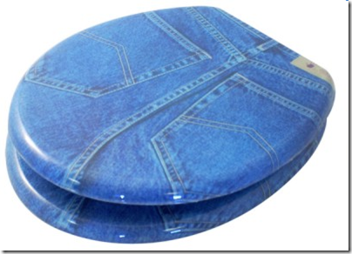

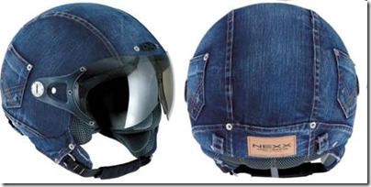
Denim Helmet House were

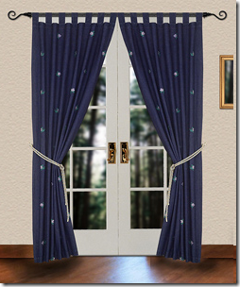
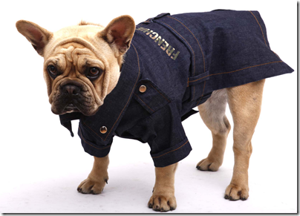

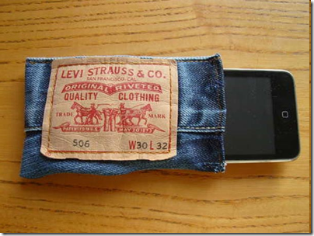
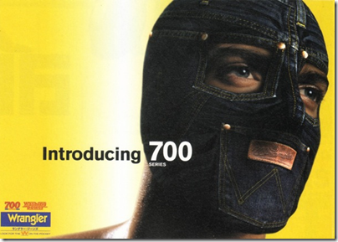
Denim Face Mask Denim Iphone Case (Mobile Case)

6.1 Jacquard Denim products:
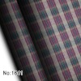
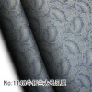
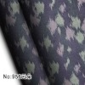

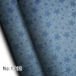
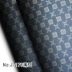
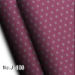

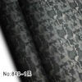
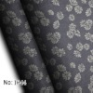
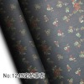

CHAPTER -3
EXPERIMENTAL DETAILS

3.1 ROPE DYEING:
The Rope Dyeing system is the most preferred method by the majority of “World Class” indigo dyers. It offers the highest production and assures multiple warps set range with consistent shade for two or three warp sets as they processed simultaneously. However, this technology is more capital intensive. Hence, sheet dyeing is considered.
In rope denim, dyeing and sizing are done separately and for this reason it is called discontinuous process. Warping and dyeing are done in the form of rope and for that reason the process is called rope dyeing. At first ball warping is done in the ball warping machine and is produced the ball warp beam which is fed in the dyeing machine in rope form. Dyeing is then done. After dyeing the dyed ropes are necessary to open and this operation is done in the long chain beamer or rebeaming machine. In this process, warp beam is produced. Twelve to sixteen warp beams are fed in the Creeling section of the sizing machine after rebeaming process and sizing is done as part of discontinuous process.
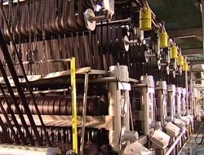

Figure 16: Rope dyeing machine

3.2Flowchart of rope dyeing process:
Sampling (Sample as per requirement)

Yarn Collection (As per requirement)

Ball Warping

Rope Dyeing

Long Chain Beamer

Sizing

Weaving

Finishing

Inspection

Packing

Delivery
Table 1: Comparison of high speed warping and ball warping:
No. | Criteria | High speed warping | Ball warping
1. | Machine speed | Comparatively high(500-1200) m/min(Ben-direct) | Comparatively low (300-500) m/min(Griffin ball warping)we
2 | Creel capacity | 546 | 456
3. | Floor Space for one modern m/c. | 400 m² | 350 m²
4. | Man Power | 5 / m/c | 4/ 1 m/c
5. | count used | Up to 40 Ne | Up to 20 Ne
6. | Production | 24000-30000 meters | 16000-18000 meters
7. | Electricity Consumption | 26 KW | 22KW
8. | Breakage rate | 7to 15 / 10000 meters | 1-2/10000 meters
9. | Price | $ 0.35 million(approximate) | $ 0.1 million(approximate)

Source: Sinha denim Ltd and Envoy textile Ltd.

3.4 Flowchart of slasher or sheet dyeing process:
Sampling (Sample as per requirement)
Delivery
Packing
Weaving
Sizing
Inspection
Finishing
High Speed Warping
Sheet Dyeing
Yarn Collection (As per requirement)

The Dyeing and Sizing are done simultaneously or continuously in the same machine.

3.5 ROPE SIZING:
Sizing is a process by which an adhesive coating is applied around the surface of the yarn. The ingredients of a size recipe are very much depends on lot of factors like quality and type of fiber and yarns their reed and pick.
Separate dyeing and sizing methods are adopted for ball warping and sheet warping process. In the former case, as was mentioned at first balls are prepared from cones and then warp from several balls are dyed as rope form and after that they are collected in a coiler. These coilers are then feed at the back of a sizing machine to prepare a weavers beam.
In the later case i.e. for sheet warping, both dyeing and sizing are carried out in the same machine. Here warp beams are produced as usual and after that the warper’s beam are creeled at the back of a dyeing and sizing machine where the yarns are at
First dyed and then dried. After that the yarns are sized in the same machine and finally a weaver’s beam is produced.
Flowchart for Sizing process:
Creeling
✵
Sizing Box-1
✵
Sizing Box-2
✵
Drying Cylinders
✵
Leasing Unit
✵
Guide Roller
✵
Winding
✵
Weaver’s Beam

Machine Specification:
Brand Name : Griffin
Machine Name : Griffin
Country of origin : United State of Americ
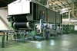
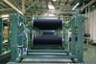
Creel Capacity : 16

Figure 17: sizing machine (Source: Envoy Textile Ltd)

LONG CHAIN BEAMING:
The yarns in the coiler are then creeled at the back of a long chain beam. The purpose of this machine is to convert all the yarns in rope form into a wrapper beam form. The wrapper beam is then creeled at the back of a normal sizing machine to size and make the weaver’s beam.

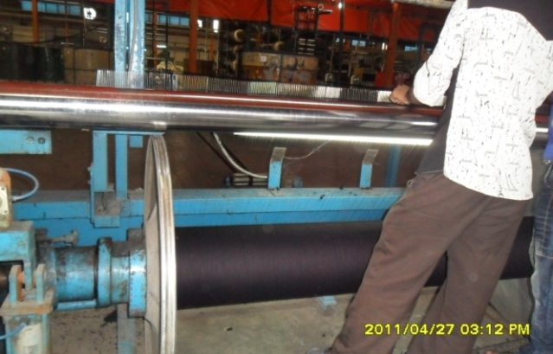
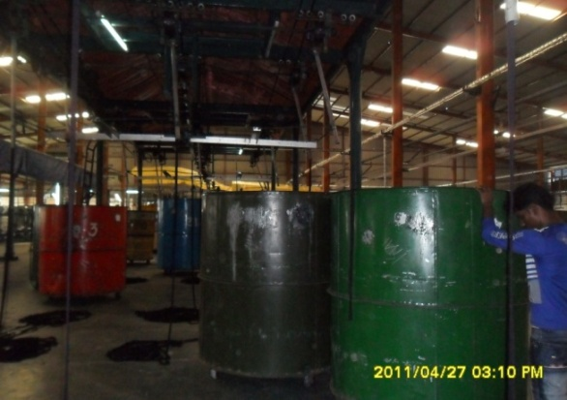

Fig 18: Can use in rope dyeing (Mab Denim) Long chain beam is producing (Mab Denim)

Flowchart of Long Chain Beamer process:
Ball/Rope Dyeing Cans

Echonomitar

Rope Guard

Tension Drum

Densier

Head Stock

Machine Specification:
Brand Name : Griffin
Machine Name : Griffin Long Chain Beamer
Country of origin : United State of America
Speed : 180-220 m/min.

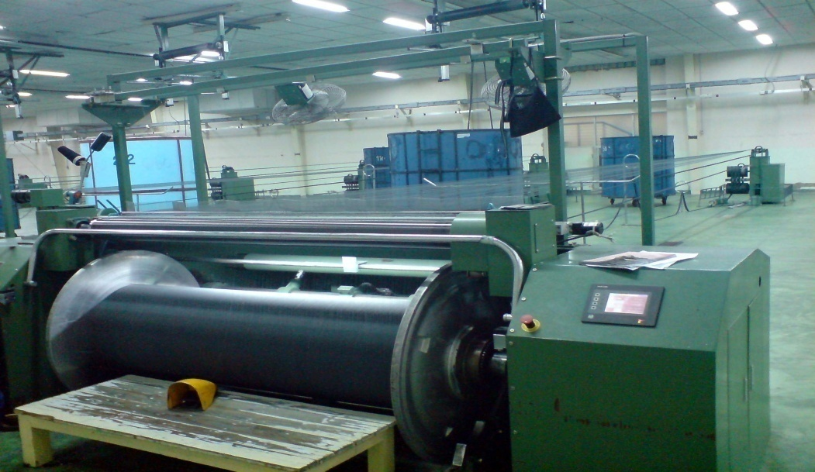

Figure 19: Long Chain Beam (Source: Envoy Textile Ltd)
Note: It is noted that the long chain beam is an extra machine in rope dyeing process

3.6 COMPARATIVE STUDY: DYEING AND SIZING

SLASHER OR SHEET DYEING & SIZING:
Denim is a different type of textile product. The process of sheet or slasher dyeing of denim is somewhat different from traditional dyeing methods. Pretreatment Dyeing and sizing are done continuously in the same machine. Dyeing process is done in highly alkaline condition. Slasher dyeing has become a reasonable method for denim dyeing.
A slasher is a range is normally employed to apply size formulations onto warp yarns before weaving. This range, when used for slasher dyeing of indigo, consists of section beams of warp yarn, which are forced into a sheet of yarn. This yarn sheet is then fed into a scouring section where natural impurities are removed. The next section is where indigo is applied. In order to achieve fairly deep shades, the indigo is applied in a series of multiple dip and sky applications to allow for shade build up. If the arrangement of the slasher dyeing does not allow for multiple dip and sky applications, then only light and medium shades can be obtained from indigo. The dye application is followed by after washing and drying. With some machinery arrangement, warp size for weaving is immediately applied. In other arrangements, the warp size is applied onto the yarns employing a separate range.
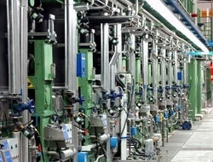

Figure 20: view of sheet dyeing and sizing machine.

Slasher dyeing ranges have a number of advantages and unique characteristics. Slasher dyeing employs a sheet of yarn, which is wound directly onto a warp beam rather than ropes of yarn, which then requires additional handling. This type of dyeing works well with lightweight denims. In general, these machines require less floor space, enable smaller production runs, have a quicker turn over time, and are more flexible in their response to changes in the market. As an overall process these ranges have lower machinery cost; therefore, lower dye costs are realized for specific fabric types. Additionally, the slasher dyeing technique can be used for other dye types for cotton and thus can produce a wide variety of colors other than indigo blue.
There are several types of dyeing available in denim. But in Bangladesh 4(four) types of dyeing processes are used:
- Pure Indigo
- Topping or Indigo Bottoming Sulphur Topping (IBST)
- Bottoming or Sulphur Bottoming Indigo Topping (SBIT)
- Pure Black/Sulphur

Table 2: Comparative study of finishing performance of sheet and rope denim:
 | Serial no. | Sheet Denim | Rope Denim
 | Speed limit | 25-35 m/min. But lower speed used due to higher breakage rate. | 25-40 m/min.But used comparatively higher speed.
 | Production | 30000-35000 meters | 40000-45000 meters

3.8 COMPARATIVE STUDY: WEAVING EFFICIENCY
Common methods of operating Indigo machines have a damaging effect on yarn quality which results in very high warp breaks in weaving, lowering efficiency and increasing off quality. Yarn on the machines is made weaker as yarn tension increases. Sheet Indigo machines, because they are attached to size machines, have very high levels of yarn tension and therefore higher weaving breaks than yarn dyed on rope ranges. A yarn quality that would result in 10 warp breaks per million weft insertions without indigo dyeing often will have around a break level of 200 with sheet dyeing, but as low as 15 if processed on rope machines. This is because tension on rope machines is much lower and can be easily controlled at very low levels.
Another important cause of high weaving breaks in denim is dirty yarn – the cleaner the yarn the higher the weaving efficiency. This is because chemicals not washed from the yarn after Indigo dyeing result in bad sizing and lower protection of warp yarns. Wash boxes on rope ranges are typically more efficient than the smaller wash boxes on sheet ranges that use overflow washing methods. The importance of washing the yarn dictates that it is better not to apply softeners in the final box for rebeaming efficiency which is optimal though improved washing and moisture control after drying.
The need for a separate rebeaming step in rope dyeing is often considered objectionable in rope dyeing, but this is actually an important advantage, since yarn breaks can be repaired at rebeaming resulting in higher weaving efficiencies. Yarn breaks from warping and dyeing cannot be repaired in sheet machines because they are passed directly from dyeing to sizing.
Table 3: Comparative study: weaving efficiency:

 | Criteria | Sheet dyeing | Rope dyeing
 | Weaving efficiency | Lower  Causes:  1.High level of yarn tension  2.Dirty yarn  3. Yarn breaks from warping and dyeing cannot be repaired in sheet machines. | Higher  Causes:  1.low level of yarn tension  2.comparatively clean yarn  3. Yarn breaks can be repaired at rebeaming.

Table 4: COMPARATIVE STUDY: FABRIC QUALITY

Serial no. | Criteria | Sheet denim | Rope denim
1. | Tear strength(warp wise) | Low | High
2. | Tear strength( weft wise) | Low | High
3. | Tensile strength(warp wise) | Low | High
4. | Tensile strength( weft wise) | Low | High
5. | Color fastness to rubbing(dry) | Poor to fair | Fair to good
6. | Color fastness to rubbing(wet) | Poor | Very poor to poor
7. | Color fastness to wash (shade change) | Poor to fair | Fair to good 3.5
8. | Color fastness to wash (staining) | Poor to fair | Fair to good 3.5
9. | Shrinkage(length wise )% | 12% to 15% | 12% to 15%
10. | Shrinkage (width wise)% | 4.5% to 5.5% | 4.5% to 5.5%
Source: Beximco denim limited and envoy textile limited
Table 5: Comparison of washing effect (Weight) of sheet dyeing and rope dyeing:
 | Serial no. | Sheet dyeing | Rope dyeing
 |  | Weight(oz/sq.yd) | Weight(oz/sq.yd)
 |  | Before wash After wash | Before wash After wash
 | 1. | 11.66 12.97 | 9.5 10.6
 | 2. | 10.23 10.29 | 12 13.5
 | 3. | 7.25 9.2 | 8.5 9.0
 | 4. | 9.9 10.9 | 10 11.2
 | 5. | 10.52 11.64 | 7.5 8.7

Table 6: Comparison of washing effect (Width) of sheet dyeing and rope dyeing:
 | Serial no. | Sheet dyeing | Rope dyeing
 |  | Width( inch) | Width(inch)
 |  | Before wash After wash | Before wash After wash
 | 1. | 54 47 | 58 52
 | 2. | 55 45 | 56 48
 | 3. | 51 46 | 52 46
 | 4. | 50 44 | 50 43
Source: Envoy textile limited

Table 7: Comparison of washing effect (construction) of sheet dyeing and rope dyeing:
 | Serial no. | Sheet dyeing | Rope dyeing
 |  | Construction | Construction
 |  | Before wash After wash | Before wash After wash
 | 1. | 86*66 97*64 | 84*60 93*62
 | 2. | 80*52 89*54.5 | 82*58 91*56
 | 3. | 80*48 96*50 | 80*54 89*52
Source: Envoy textile limited

3.14 COMPARATIVE STUDY: FLEXIBILITY IN PRODUCTION:

Sheet ranges are usually limited to producing yarn for only 1 weaving set at a time. In a rope range, normally 12 ropes will produce enough yarn for a weaving set and because rope ranges do not pass the yarn directly to the size machine, from 1 to 50 ropes can be dyed at one time. Any combination of yarns can be processed for completely different fabric constructions at the same time and dyed with the same Indigo color. Also, rope ranges can be operated continuously without stopping, which avoids the waste of yarn which occurs when sheet ranges must stop in order to change yarn lots. Because the yarn is sized separately. Higher priority fabric orders can be processed without delays resulting from the need to complete a dye set as with sheet dyeing.

3.15 COMPARATIVE STUDY: VERSATILITY IN DENIM PRODUCT DEVELOPMENT

Rope ranges have been designed to apply the widest range of dyeing techniques. For example, the Spectrum Dye Machine available from Morrison contains features like additional steamers and drying sections that allow not only the standard dyeing techniques of sulfur bottoming and topping, but also consistent application of all other cotton dyes such as vats, reactive and directs in combination with Indigo or dyeing yarns with these dye classes only
Also available are specially designed dye boxes that allow the simultaneous dyeing of 2 different sulfur applications, such as one set of yarn with a sulfur topping and the other set without topping, or with only a sulfur color, which allows flexibility in production. Rope ranges are also easily adaptable for random effects such as space dyeing of yarn. With the rope design, yarns from different dyeing such as Indigo only and sulfur only, can be blended for producing stripe patterns.

3.16 COMPARATIVE STUDY: INVESTMENT:

The following investment has calculated to produce 50000 meters .In the establishment of a sheet denim industry, 50-55 million USA Dollar required with 1 high speed warping machine, 2 dyeing-sizing machine, 100 air jet looms, 1 finishing machine. There are also required boiler, industrial own electricity production plant and most important ETP (Effluent Treatment Plant).

In the establishment of rope denim industry, 70-75 million USA Dollar required with 3 modern ball warping machine, 1 dyeing machine, 8 long chain beam , 1 sizing machine, 100 air jet looms, 1 finishing machine. There are also required boiler, industrial own electricity production plant and most important ETP (Effluent Treatment Plant).

shows the differences between the investment patterns of the above mentioned two factories:

Machinery | Sheet denim (p_{cs)} | Rope denim (p_{cs)}
Warping machine | High speed warping:2 | Ball warping:3
Dyeing machine | 2 | 1
Sizing machine | Not applicable | 1
Long chine beam | Not applicable | 8
Weaving machine | 100 | 100
Finishing machine | 1 | 1
Total | 103 | 111

Table 8: Comparative study: Investment
Criteria |  | Sheet denim | Rope denim
Machinery | Warping machine | High speed warping:  $ 0.4 million | Ball warping:  $ 0.2 million
Machinery | Dyeing machine | $ 4 million | $ 3 million
Machinery | Sizing machine | $ 4 million | $ 0.50 million
Machinery | Long chain beam |  | $0 .16 million
Machinery | Weaving machine | $ 3.3 million | $ 3.3 million
Machinery | Finishing machine | $ 2.4 million | $ 2.4 million
Infrastructure |  | $ 10 Million | $ 15 Million
Land |  | $ 12 Million | $ 22 Million
Raw Material |  | $ 16 Million | $ 20 Million
Others |  | $ 4 Million | $ 4 Million
Total |  | $ 52 Million | $ 70 Million

Table 9: Comparison of sheet dyeing and Rope dyeing:
No | Criteria | sheet dyeing -sizing machine | Rope dyeing and sizing machine :
1. | Machine speed | 25 m/min(Benninger sheet dyeing-sizing machine) | 30 m/min (Morrison rope dyeing machine)
2. | Floor Space | 1500 m² (include sizing m/c) | 1600 m² (dyeing machine)  700 m² (sizing m/c)
3. | Man Power | 12/day | 45/ day(dyeing machine)  16/ day(sizing m/c)
4. | Count used | Up to 40 Ne | Up to20 Ne
5. | Lapper tendency | Low | High. if finer count is used
6. | production/day | 40000 meters | 60000 meters
7. | Multi Shade Dyeing Capability | Impossible | Possible
8. | Dye bath capacity | 600-750 liters(Benninger sheet dyeing-sizing machine) | 3000 liters (Morrison rope dyeing machine)
9. | Production Capacity | 40000 meters/ day(Benninger sheet dyeing-sizing machine) | 60000 meters/ day. (Morrison rope dyeing machine)
10. | fastness and luster | Not like rope | Comparatively better
11. | Shade Variation | High | Low
12. | Breakage rate | High(as yarn is dyed individually) | Low(as yarn is dyed rope form)
13. | Wastage | 20%-25% | 35%-40%
14. | Electricity Consumption | 180 KW | 170KW(including sizing m/c)
15. | Water Consumption | 8000 liters/hour | 10000 liters/hour
16. | Steam Consumption | 10 tons/hour | 16 tons/hour
17. | Capability of stripe fabric producing | Not Possible | Possible to mix yarn of different color-one can get denim stripe at rebeaming
18. | Flexibility | Less | More
19. | Rebeaming | No such opportunity | Have opportunity of rebeaming to repair broken ends.
20. | Cost | Cost of production is lesser compared to Rope Dyeing | Cost of production is more compared to Rope Dyeing
21. | Weaving efficiency | Lesser compared to rope dyeing | Higher compared to sheet dyeing
22. | Price of the machine | $ 4million | $ 3.5 million

Source: Sinha denim limited.

Table 10: SUMMARY OF COMPARATIVE STUDY OF SLASHER DYEING AND ROPE DYEING:

Serial no. | criteria | Sheet  Denim | Rope denim
Warping  Section | Machine speed | Comparatively high(500-1200) m/min(Ben-direct) | Comparatively low (300-500) m/min(Griffin ball warping)
Warping  Section | Creel capacity | 546 | 456
Warping  Section | Floor Space for one modern m/c. | 400 m² | 350 m²
Warping  Section | Man Power | 5 / m/c | 4/ 1 m/c
Warping  Section | count used | Up to 40 Ne | Up to 20 Ne
Warping  Section | Production | 24000-30000 meters | 16000-18000 meters
Warping  Section | Electricity Consumption | 22 KW | 26 KW
Warping  Section | Breakage rate | 7to 15 / 10000 meters | 1-2/10000 meters
Dyeing,  Sizing,  Long  Chain  Beam  section  Dyeing,  Sizing,  Long  Chain  Beam  Section | Machine speed | 25 m/min(Benninger sheet dyeing-sizing machine) | 30 m/min (Morrison rope dyeing machine)
 | Floor Space | 1500 m² (include sizing m/c) | 1600 m² (dyeing machine)  700 m² (sizing m/c)
 | Man Power | 12/day | 45/ day(dyeing machine)  16/ day(sizing m/c)
 | Count used | Up to 40 Ne | Up to20 Ne
 | Lapper tendency | Low | High. if finer count is used
 | production/day | 40000 meters | 60000 meters
 | Multi Shade Dyeing Capability | Impossible | Possible
 | Dye bath capacity | 600-750 liters(Benninger sheet dyeing-sizing machine) | 3000 liters (Morrison rope dyeing machine)
 | Production Capacity | 40000 meters/ day(Benninger sheet dyeing-sizing machine) | 60000 meters/ day. (Morrison rope dyeing machine)
 | fastness and luster | Not like rope | Comparatively better
 | Shade Variation | High | Low
 | Breakage rate | High(as yarn is dyed individually) | Low(as yarn is dyed rope form)
 | Wastage | 30-35 ends considered as wastage. At least 20-30 m long of sheet wastes during shade change. | Feed line (Rope can use again and again).
 | Electricity Consumption | 180 KW | 170KW(including sizing m/c)
 | Water Consumption | 8000 liters/hour | 10000 liters/hour
 | Steam Consumption | 10 tons/hour | 16 tons/hour
 | Capability of stripe fabric producing | Not Possible | Possible to mix yarn of different color-one can get denim stripe at rebeaming
 | Flexibility | Less | More
 | Rebeaming | No such opportunity | Have opportunity of rebeaming to repair broken ends.
 | Cost | Cost of production is lesser compared to Rope Dyeing | Cost of production is more compared to Rope Dyeing
 | Weaving efficiency | Lesser compared to rope dyeing | Higher compared to sheet dyeing
Weaving  Section | Speed limit | (800-1200) rpm .comparatively lower speed used. | (800-1200) rpm .comparatively higher speed used.
Weaving  Section | Breakage rate | Higher(200/million weft insertion) | Lower(15/ million weft insertion)
Weaving  Section | Production | 500 meters | 600 meters
Weaving  Section | Shade variation | Easily visible | Not easily visible
Finishing  Section | Speed limit | 25-35 m/min. But lower speed used due to higher breakage rate. | 25-40 m/min.But used comparatively higher speed.
Finishing  Section | Production | 30000-35000 meters | 40000-45000 meters
Test  Report | Tear strength(warp ) | Low | High
Test  Report | Tear strength | Low | High
Test  Report | Tensile strength(warp wise) | Low | High
Test  Report | Tensile strength | Low | High
Test  Report | Color fastness to rubbing(dry) | Poor to fair | Fair to good
Test  Report | Color fastness to rubbing(wet) | Poor | Very poor to poor
Test  Report | Color fastness to wash (shade change) | Poor to fair | Fair to good 3.5
Test  Report | Color fastness to wash (staining) | Poor to fair | Fair to good 3.5
Test  Report | Shrinkage | 12% to 15% | 12% to 15%
Test  Report | Shrinkage (width ) | 4.5% to 5.5% | 4.5% to 5.5%

CHAPTER -4

DISCUSSION OF

RESULTS

The oveall study can be summarized that, the both technique of high speed waping and ball warping the high speed warping is most economy than ball warping. The machine speed of high speed warping is higher than ball warping and over all cost of high speed warping is most easier than ball warping and production of high speed warping is high . If we sec the finishing performance of sheet and rope dyeing then we sec that speed limit of sheet denim is lower than rope denim and the production of rope denim is most higher than sheed denim & if we sec the study of weaving efficiency sheet & rope dyeing the weaving efficiency of sheet dyeing is lower than rope dyeing. the over all fabric quality off rope denim is higer than sheet denim because the tear strenghth ,and tensile strenghth is better in sheet denim and color fastness to wash and rubbing is always better in rope denim and finally the commercial cost of rope denim is lower than sheet denim.

CHAPTER -5

CONCLUSION

Conclusion:
The above study can be summarized that, the both technique have their self advantages and disadvantages. The rope dyeing process is better when quality is concerned. There is no side to side variation, good fastness quality, lower breakage rate, higher weaving efficiency, lower fault, good look, deep shade, multi shade dyeing can be possible in rope dyeing process. But skilled manpower, large amount of land, higher project cost, bulk production and coarser count are required in case of rope denim. If finer count is used, there is a possibility of lapper in rope denim which causes higher wastage. While slasher dyeing is suitable in case of lower project cost, less amount of land, less manpower, finer count, local production with competitive price and sample production. If high production is required, but quality is not main concern in that sense sheet denim is profitable.

Referance:

- Source: Reference book of textile Technologies: weaving.
By
Giovanni Castelli
Salvatore Maietta
Giuseppe Sigrisi
Ivo Matteo Slaviero
- Source: understanding textiles for a merchandiser.
By
Engr.Shah Alimuzzaman Belal

- Source: Lecture sheet
- Source: Table 1: Comparison of high speed warping and ball warping
(Sinha denim Ltd and Envoy textile Ltd.)
- Figure 19: Long Chain Beam (Source: Envoy Textile Ltd)
- Table 2: COMPARATIVE STUDY: FABRIC QUALITY
(Beximco denim limited and envoy textile limited)

- Table 3 :Comparison of washing effect (Width) of sheet dyeing and rope dyeing
(Envoy textile limited)
8. Table 4: Comparis0n(: Envoy textile limited)
washing effect (construction) of sheet dyeing and rope dyeing
  - Table 5:Comparison of sheet dyeing and Rope dyeing(: Sinha denim limited.)
  - :Table 6: Comparison of washing effect (Width) of sheet dyeing and rope dyeing
  - : Table 7: Comparison of washing effect (construction) of sheet dyeing and rope dyeing
  - : Table 8: Comparative study: Investment
  - Table 9: Comparison of sheet dyeing and Rope dyeing
14:Table 1o: SUMMARY OF COMPARATIVE STUDY OF SLASHER DYEING A ND ROPE DYEING:

14.Source: www.Google.com
15. Source: http://www.scribd.com/doc/28416760/Denim-A-Fabric-for-All and lecture sheet
16.Source: Previous project

