

Daffodil International University

Project on
“Study of the color fastness of dyed samples using salt after treatment”

SUPERVISED BY
Mrs. Rina Khanum
Assistant Professor
Department of Textile Engineering
Daffodil International University

Group Profile

Name | ID:
Md. Al-Amin | 091-23-1358
Md. Shafi Ullah | 091-23-1385
S.M. Nasim | 091-23-1233
S.M. Zakaria | 091-23-1242

Department of Textile Engineering
Daffodil International University

- “Study of the color fastness of dyed samples using salt after treatment”

- “Study of the color fastness of dyed samples using salt after treatment”

SUPERVISED BY
Mrs. Rina Khanum
Assistant Professor
Department of Textile Engineering
Daffodil International University

Supervisor’s Signature

- “Study of the color fastness of dyed samples using salt after treatment”

Group Profile

Name | ID:
Md. Al-Amin | 091-23-1358
Md. Shafi Ullah | 091-23-1385
S.M. Nasim | 091-23-1233
S.M. Zakaria | 091-23-1242

Department of Textile Engineering
Daffodil International University

Abstract

- Abstract:
In cellulose cotton Knitted fabric reactive dyes are mostly used. In case of reactive, for increasing dye affinity to the cotton fibre used a electrolyte. For this reason electrolytes have some effect on the fabric shade and other fastness properties. There is various types of electrolyte the market, all of them we use Glauber salt and Common salt as a electrolyte of reactive dye on cotton fabric. This is the main object of our project to find out the variation of effect of others by using different electrolyte during after treatment. It is very important that cotton goods are very popular to all of them. Then, for the dyeing of cotton fabric reactive dyes are mostly used. For these reason reactive dye is also important But when cotton dyeing with reactive dye in aqueous method must we need a electrolyte to increase the dye affinity to the fibre, other no color can be produce on cotton fabric. For this reason electrolyte is also important parameter for reactive dye. In the dyeing process all dyes and chemical are remain constant but only salt concentration will change for. Then we have done some test like CCMS and different types of fastness test for making a good comparison due to different amount of Glauber salt and Common salt after treatment

Acknowledgments
First of all we express our gratitude to supreme Allah for blessings, approval, protection, mental power and wisdom in all aspects of our life. The applauses to Allah to complete this project work. This work has been carried out at the dyeing laboratory, Department of Textile Engineering, Daffodil International University. During our project work, many individuals have unselfishly contributed their time, support to make this project possible. We would like to extend our sincere gratitude to those who have provided guidance in every step along the way.

We are deeply indebted to our supervisor Ms. Rina Khanum Assistant professor, Department of Textile Engineering, Daffodil International University, whose help, suggestion and encouragement helped us in all the time of research for and writing of this project. Her scientific curiosity, encouragement and guidance throughout this work have been necessary for this thesis.

Our absolute gratitude and heartiest thanks to Prof. Dr. Eng. Zulhas Uddin, Advisor of Department of Textile Engineering, Daffodil International University, for his dynamic effort and advice in all aspects of this project work. We are also grateful to Prof. Dr. Md. Mahbubul Haque Head, Department of Textile Engineering, Daffodil International University, for their encouragement, love & care with great inspiration in all aspects. We would like to give a special thanks to all our teacher of Department of Textile Engineering, Daffodil International University.

Last but certainly not least, we are forever indebted to the love and caring of our family. Gratefulness for our family's support, encouragement and understanding cannot be expressed in words.

Contents
SL. No. | Topic Name | Page No.
I | Introduction | 2
II | Theoretical Foundation
 | 2.1 Dyes | 4
 | 2.2 Reactive dye | 4
 | 2.3 Mechanism of Slat with Reactive dye | 12
 | 2.4 Color | 16
 | 2.5 Computer color Matching system | 19
 | 2.6 Metamarism | 31
III | Experimental Technique and Methodoloty
 | 3.1 Sample specification | 33
 | 3.2 Dyeing process | 33
 | 3.4 Wash Fastness Test | 37
IV | Result and Discussions
 | 4.1 Dyeing results | 40
 | 4.2CCMS test results | 46
 | 4.3 Rubbing Fastness Test | 47
 | 4.4 Rubbing fastness test results | 50
 | 4.5 Wash fastness test result | 54
V | Conclusion | 64
 | Bibliography | 66

CHAPTER-I
Introduction

Introduction

- 1. Introduction

- For dyeing cotton & other cellulose fiber reactive dyes are mostly used. These dyes gained such popularity because of if s good fastness, lower cost, simple dyeing method, good reproducibility and etc. When we dye a cotton fabric we need choose a dye which has good fastness properties with good shade. For all those reason reactive is widely used in the Textile industries. In our market different types of electrolytes are available, but all electrolytes are not showing same properties for after treatment using salt. As a result effect can be change or fastness properties can be change. For finding the difference between two electrolyte that is between Glauber salt and Common salt we use some technique such as- in same recipe only changing salt concentration we have done after treatment process for both in Glauber salt and Common salt.
- For each salt we dyeing 3 samples with salt concentration 10, 20, 30 g/l and other chemical and dyes are same for both salts.
- Then for evaluating comparison we have done some test like CCMS and difference types of fastness test for finding the difference between two electrolytes.
- Then we can make a decision about electrolyte (Salt) that is which one is best for the cotton fabric after treatment using salt.

CHAPTER-II
Theoretical Foundations

2.1 Dyes
That entire compound contains chromophore group and react with others material physically and chemically and when light reflects from that materials makes it colorfully is called dyes or dyestuff. Dyes are unsaturated complex compound.
2.2.0 Reactive dye
In general reactive dyes with the same functional reactive group or groups have similar dyeing characteristics and can therefore be applied from the same dye bath. Reactive dyes are usually classified according to the chemical reactivity of the characteristics reactive system. In addition substantively and fixation temperatures are parameters that help to characterized reactive dyes. The major reactive systems are listed in descending order of relative reactivity in batch wise dyeing under moderately alkaline condition, together with typical fixation temperatures.
A dye which is capable of reacting chemically with a substance to form a covalent bond or dye substrate linkage is known as reactive dye. These dyes are mainly react with cellulosic fibres e.g. cotton, jute, bast, viscose, flax. It can be applied to protein fibre e.g. wool & silk These dyes are water soluble.
The general formula reactive dye can be written as follows:
D-S0₂-CH2-CH₂-OS03Na+OH-Cell=D-S02-CH2-CH2-0-Cell+NaHS03
Where, D= Dye part
Cell= Cellulose Polymer

2.2.1 Why it is called Reactive Dye
Reactive dyes react with the fibres. Mainly react with cellulose fibres, e.g. cotton, jute, bast fibres, viscose, flax. It can be applied to protein fibre e.g. wool & silk. Reactive dye contains reactive group & this reactive group makes covalent bonds with the fibres & becomes part of the fibre.

2.2.2 History of Reactive dye
On he occasion of 100 years celebration of synthetic dye manufacturing, two chemists of ICL Company (UK) named Sttephen & Rattee tried to manufacture new dye stuff. Thus they succeed to invent a new dye in 1956 which was named Reactive dye. This was manufactured for dyeing cellulosic fibres. The 1st three Reactive dyes were Procion Yellow R, Procion Brilliant Red 2B & Procion Blue 3G. for this effort hey were awarded gold medal of the society of Dyes & Colorists for the year 1960. The dye to our country in mid 60's & became popular during 80's.
2.2.3 Properties of Reactive Dye
- Water soluble dyes
- Makes covalent bonds with the fibres
- A certain amount of dye is hydrolyzed during dyeing (10-60%)
- Dyeing is carried out in alkaline condition (pH=11.5)
- Huge electrolyte is necessary for dyeing with reactive dyes
- Fastness (wash, light, rubbing, perspiration) properties are generally good.
- Easy applicable to cellulosic as well as protein fibres (wool and silk)
- Very popular & wide used in the wet processing industry in Bangladesh.
- Comparatively cheap
- All kind of shade is found
- Dyeing method is easy
2.2.4 Reason of Popularity of Reactive dye
- Good wash fastness (4-5)
- Very good light fastness (6)
- Lower cost
- Simple dyeing method good reproducibility
- Low dyeing temperature
- Ability to produce bright shade
- Dye molecular composition
- Easily applicable to cellulose fibre ae well as protein
- All kinds of shade is found

2.2.5 Importance of Reactive Group Present in Reactive Dye
- Reactive group do not contribute color which is determined dy chromogen
- group
- The reactive group of vinyl sulphone group is less than halogen group
- If number of reactive group increase, binding also increase depending ondye structure
- Reactive dye absorb up to 90%
- If the molecular weight of the reactive group increase, reactivity also
- increase
- Reactive of vinyl sulphone group increase with increase of pH &
- Temperature
- Sulphone group has more solubility but it is not stable
- Chlorine imparts medium reactive, but it is cheap
- Reactive of Fluorine is the least & its rate of hydrolysis is also less

2.2.6 Name of Same Reactive Dyes with company and origin
Trade Name | Company | Country
Cibacron | Cibageigy | Switzerland
Diamarene | Sandoz | Switzerland
Reactone | Cibageigy | Switzerland
Levafix | Bayer | Germany
Remazol | Hoechst | Germany
Livafix | Bayer | Germany
Priazin | BASF | Germany
Sumifix | --------- | Taiwan
Procion | ICI | UK
Cavalite | Dupont | USA
Mikacion | Mitshui Chemical Co. Ltd. | Japan
Uhopid | People's China | China

Table-1: Reactive dyes, Company and Origin.

The trade names and manufacturers are more important ranges of these Reactive Dyes are shown in.

Reactive Group | Fixation temperature (°c) | Relative reactivity
Dichlorotriazin | 30 | 1
Difluorochloropyrimi | 40 | 2
Dichloroquinoxaline | 50 | 3
Monoflurotriazine | 60 | 3
Vinylsulphone | 80 | 4
Monochlorotriazine | 95 | 5
Dichloro- and trichloro- pyrimidine | 95 | 6

1- Most reactive, 6- least reactive.
Table-2: Properties of major types of Reactive dye.
Symmetrical dye structures with two identical reactive group, e.g. two monochlorotriazine groups in procion H-E/H-EXL dyes, have led to products with better compatibility, more reproducible exhaustion and higher fixation efficiency. More recently reactive dyes with two dissimilar reactive groups per molecule have been developed, including the Sumifix Supra (NSK) range, in which each dye molecule has a monochlorotriazine and a sulphatoethylsulphone group attached. A new range of remazol reactive dyes is believed to be of a similar constitution.

In the past reactive dyes were usually classified as cold dyeing ( highly reactive) or hot dyeing ( moderately reactive). In more recent times dyes have been developed foe dyeing at intermediate temperatures or at long liquor ratios, as well as by continuous methods.

2.2.7 Chemicals used in reactive dyeing

Common salt or glauber's salt ( hydrated sodium sulphate) is used in large quantities in all batch wise dyeing. The choice depends on price and availability. In UK common salt is available in very fine and pure from and is widely used. Common salt, being appreciably more soluble than Glauber's salt, is usually added to the dye bath in the dry state.

Where salt consumption is high. The installation of a saturator to produce brine may have advantages. Metering solid salt or brine to the dye bath eliminates repeated weighing's and reduces handling costs. As anhydrous sodium sulphate is difficult to dissolve, it is best slurried in very hot water followed by adding cold water with constant stirring. When using Glauber salt crystals account has to be taken of the water of crystallization when calculating the quantity to be dispensed.
Soda ash is the alkali most widely used in reactive dyeing' sodium bicarbonate and caustic soda also find application. These three alkalis, used either single or in binary mixtures, cover the pH range that is of interest in reactive dyeing. Sodium bicarbonate is widely used in dyeing viscose with reactive dyes. In cotton dyeing it can be mixed with soda ash to give intermediate pH values. Liquid buffer systems and alkali dosing agents in liquid form, such as Alkaflo (Tanatex), are now available for multiproduct injection systems. Provided fabrics are well prepared, it is usually unnecessary to add wetting or leveling agent to the bath . However, the addition of selected antifoam agent can eliminate unwanted foaming in jet dyeing machines.

Selected nonionic dispersing agents have proved useful in overcoming problems of aggregation of some reactive dyes. Certain turquoise and green reactive of the phthalocyanine type tend to show this defect.

As reactive dyes are prone to hydrolysis in the presence of moisture, they will deteriorate unless carefully stored and handled. Cool , dry storage conditions are essential, and lids of drums and packages must be firmly replace after use. Dry scoops, scales and containers must be used when weighing. Care in handling is advisable and the use of dust-excluding respirators is recommended.

A. Depth of shade: ratio of weight of dye to weight of goods dyed, usually expressed as percentage amount of dye owg. Depth of shade ( DOS ), in these terms, is not really a very good way of comparing the darkness or intensity of color of finished fabrics, due to inherent differences in the hues of different dyes within a family, difference between dye families due to the nature of the fabric. Dye manufacturer's shade cards are typically show one or two depth of shade for a particular dye, often between 1% and 4%, except for black, which is typically 3% to 6%.

B. Fixation: formation of the "final" bond between the dye and fibre. The bond type formed between the fibre and the dye varies with the type of dye and the fibre. As examples, reactive dyes fix by covalent bonding while acid dyes fix by a variety of mechanisms such as ionic bonding and hydrophobic forces. Disperse and vat dyes are fixed in the fibre largely by physical entrapment of insoluble dye within the fibre. The bond that causes final fixation is not necessary the same type of bond is first made as the dye exhausts onto the fibre.

C. Fixative: in dyeing , a chemical that helps to improve wash fastness of dyed fabric. Some types of dye do not bond strongly to fibres, and will wash out over time. Direct dye are notorious for this. Fixatives applied after dyeing can help, although some will degrade light fastness or cause shade change. Some fixative contain a small amount of formaldehyde, which is now regarded as carcinogenic. Much care is warranted in use of these fixatives, and garments should be thoroughly washed before being worn. Many of the newer fixatives work vary, but typically form large, relatively insoluble complexes with dye molecules inside the fibre. Soda ash is sometimes called a fixative for reactive dyes, but it actually creates the high-pH condition that allow the reactive dye to bond directly to cellulose fibres, and is not a fixative in the accepted sense.
D. Hydrogen Peroxide: H₂aO₂, normally as a solution in water. Hydrogen peroxide is extensively used in commercial bleaching of textiles, especially cellulose fibres and wool. It is effective and non -polluting. The hydrogen peroxide sold in drug and grocery stores is about a 3% solution. Industrial strength hydrogen peroxide may be 35%, 50% or 70%. At these strengths it is quite dangerous to handle, and spills can cause fires. Hydrogen peroxide can behave as either an oxidation agent or reducing agent. It is some time used as an antichlor. Sodium carbonate and potassium monopersulphate are dry chemicals derived from hydrogen peroxide.

2.3.0 Mechanism of salt with Reactive dye

2.3.1 Why salt used in Textiles?

Is an interesting and basic question in the area of textile processing, particularly in dyeing. The textile substrate and dye molecule, not necessarily should have of homogeneous characteristics to combine with each other. In such case, we require some catalyst to facilitate dyeing action on fabric. Salt plays this crucial role of catalyst. Salt has an extremely high affinity for water. Broadly speaking, Salt is necessary in three ways, firstly, to drive dye into textile during the dyeing process in textile. Secondly, use of salt leads to maximum exhaustion of dye molecules during dyeing process in textiles. Thirdly it is used as an electrolyte for migration, adsorption and fixation of the dyestuff to the cellulose material. Glauber's salt is a common name for sodium sulfate decahydrate, Na2S04-10H20; it occurs as white or colorless monoclinic crystals. Upon exposure to fairly dry air it effloresces, forming powdery anhydrous sodium sulfate. Johann Glauber's was the first to produce the salt (from Hungarian spring waters). The naturally occurring salt is called mirabilite, Glauber's salt is water soluble, has a salty, bitter taste, and is sometimes used in medicine as a mild laxative; it is also used in dyeing.

2.3.2 Dyeing Mechanism
In actual dyeing mechanism vegetable fibres contains cellulose which ionizes in the water

Cell – OH -- Cell - 0- + H+

While reactive dye goes in the water, it is soubise giving dye anions and sodium cations

Reactive dye – SO3Na + Water -- Reactive dye - S03- + Na +
(Dye anion) (Sodium cation)

During dyeing both the negative ions of dye and cellulose repels each other in the absence of salt and thus no exhaustion or very little exhaustion is done but in the presence of salt, it will ionize as follows,

NaCl -- Na + + Cl - (Common Salt) or

Na2S04 - 2 Na + + S04 - (Glauber's Salt)

Thus the salt neutralize the negative ion of the cellulose and facilating the exhaustion,
(Cell - 0- + H+)+ (Na + + Cl - )-- Cell – ONa

Cell - ONa + SOS- - Reactive dye - - Cell - 0 - Reactive dye
(Exhausted dye on the substrate)

Thus the presence of salt in the reactive dyeing increases the affinity of the dye towards the Cellulosic substrate.

Since reactive dyes have low affinity for cellulose, the fixation can be increased by exhausting the dye bath by adding Glauber's salt prior to fixation. The amount of the salts required to produce adequate exhaustion decreases with decreasing liquor ratio. Thus for pale shades on cotton and viscose rayon 10 to 15 gpl may be used.

    - Function of Salt in the Dyeing Process
- The salt in the reactive dyeing increases the affinity of the dye towards the Cellulosic substrate.
- Salt increases the exhaustion rate of reactive dyestuffs.
- As reactive dyestuffs have a lower affinity, more inorganic salt is required when using reactive dyestuffs in order to accelerate absorption.
- While the amount of inorganic salt used varies according to the type of dyestuff used, recently developed high-fixation dyestuffs with improved affinity allow the amount of inorganic salt to be reduced.

Due to considerations of effectiveness and cost, both Glauber's salt and common salt (sodium chloride) are used in dyeing. In terms of their role as an inorganic salt, these two are effectively the same because of the sodium cation active in both.

2.3.4 Sequence of Dyeing:
Grey textile Materials

Pre treatment

Dyeing

Washing (cold)

Neutralization (with acetic acid)

Washing

Soaping

Washing (cold)

2.4.0 Color

Color is the brains reaction to a specific visual stimulus. Although we can precisely describe color by measuring its spectral power distribution ( the intensity of the visible electro-magnetic radiation at many discrete wavelengths) this leads to large degree of redundancy. The reason for this redundancy is that the eye's retina samples color using only three broad bands, roughly corresponding to red, green and blue light. The signals from these color sensitive cells (cones), together with those from the rods (sensitive to intensity only). Are combined in the brain to give several different "sensations" of the color. These sensations have been defined by the CIE and are quote from Hunt's book "Measuring Colour"

- Brightness: The human sensation by which an area exhibits more or less light.
- Hue: the human sensation according to which an area appears to be similar
- to one, or to properties of two, of the perceived colors red, yellow, green and blue.
- Colorfulness: The human sensation according to which an area appears to exhibit more or less of its hue.
- Lightness: The sensation of an area's brightness relative to a reference
white in the scene.
- Chroma: The colorfulness of an area relative to the brightness of a reference white.
- Saturation: The colorfulness of an area relative to its brightness.

The tri-chromatic theory describes the way three separate lights, red, green and blue, can match any visible color- based on the eye's use of three color sensitive sensors. This is the basis on which photography and printing operate, using three different color dyes to reproduce color in scene. It is also the way that most computer color spaces operte, using three parameters to define a color.

2.4.1 Color Space

A color space is a method by which we can specify, create and visualize color. As humans, we may define a color by its attributes of brightness, hue and colorfulness. A computer may describe a color using the amounts of red, green and blue phosphor emission required to match a color. A printing press may produce a specific color in terms of the reflectance and absorbance of cyan, magenta, yellow and black inks on the printing paper. A color is thus usually specified using three co-ordinates, or parameters. These parameters describe the position of the color within the color space being used. They do not tell us what the color is, that depends on what color space is being used. An analogy to this is that I could tell you where I live by giving directions from the local garage, those directions only mean anything if you know the location of the garage beforehand. If you don't know where the garage is the instructions are meaningless.

2.4.2 CIE L*a*b*
This is based directly on CIE XYZ (1931) and is another attempt to linearise the perceptibility of unit vector colour differences. Again, it is non-linear, and the conversions are still reversible. Colouring information is referred to the colour of the white point of the system, subscript n. The non-linear relationships for L* a* and b* are the same as for CIELUV and are intended to mimic the logarithmic response of the eye.

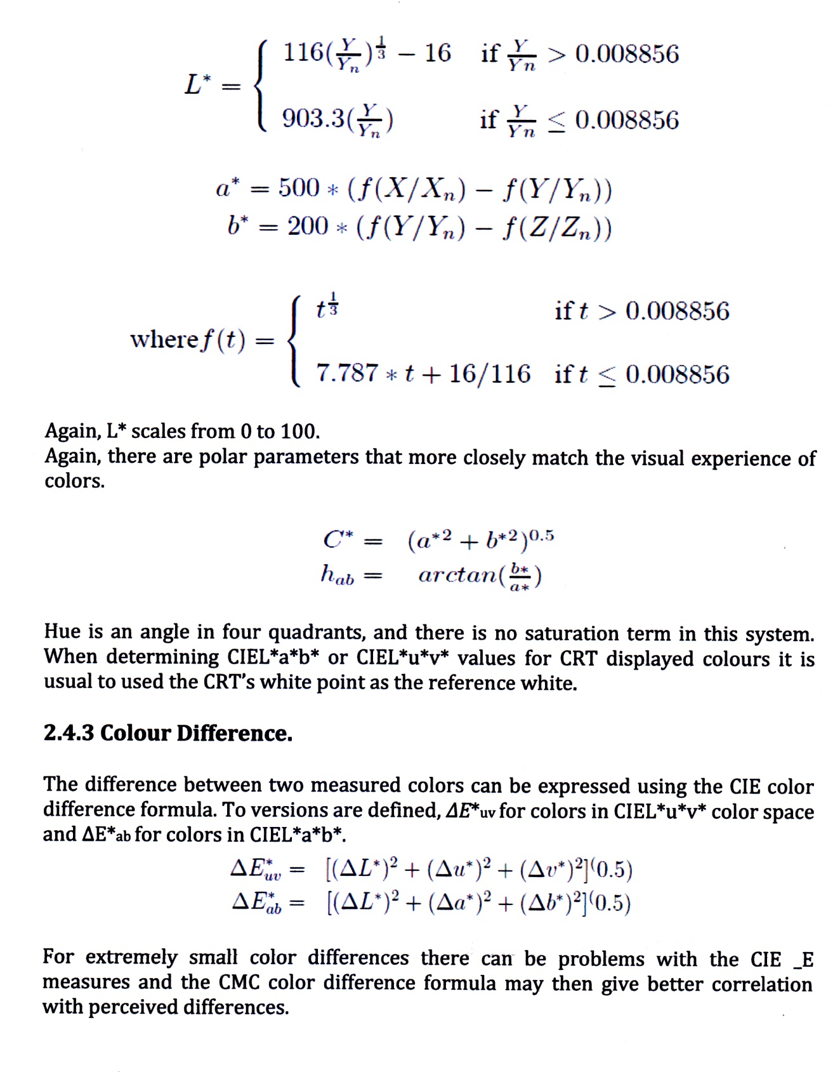
The CMC color difference formula is similar to the CIE versions but includes weighting functions for different areas of the color space. The CMC formula is defined in Hunt's Measuring Color.

2.5.0 Computer Color Matching System (CCMS)
First in1963, ICI dyestuff division (UK), established the CCMS for color match prediction in their lab but it was for their customers only. In 1973, ICS ( international Color System) manufactured CMS commercially.

2.5.1 The basic things required to carry out the matching are:
1. Color measurement instrument (Spectrometer).
2. Reflectance from a mixture of dyes or pigments applied in a specific way.
3. Optical model of color vision to judge.

2.5.2 Function of CCMS:
- Color match prediction
- Measurement of color difference
- Metamerism ( physical test in light)
- Pass or Fail option
- Color fastness rating
- Cost comparison
- Shade library
- Strength evaluation
- Whiteness evaluation
- Reflectance (R) & K/S measurement
- Etc.
2.5.3 Color Matching:
The process of assuring that a color on one medium remains the same when converted to another medium. This is extremely difficult because different media use different color models. Color monitors, for example, use the RGB model, whereas process printing uses the CMYK model. As color desktop publishing matures, color matching is gaining more and more attention. The most recent Windows and Macintosh operating systems include a color management system (CMS) to assist in color matching.
2.5.4 Color Management:
In digital imaging systems, color management is the controlled conversion between the color representation of various devices, such as image scanners, digital cameras, monitors, TV screens, Film Printers, Computer printers, offset presses, and corresponding media.
The primary goal of color management is to obtain a good match across color devices; for example, a video which should appear the same color on a computer LCD monitor, a plasma TV screen, and on a printed frame of video. Color management helps to achieve the same appearance on all of these devices, provided the devices are capable of delivering the needed color intensities.

2.5.5 Main article: Color Calibration

Calibration is like characterization, except that it can include the adjustment of the device, as opposed to just the measurement of the device. Color management is sometimes sidestepped by calibrating device to a common standard color space such as RGB; when such calibration is done well enough, no color translations are needed to get all device to handle colors consistently. This avoidance of the development of RGB.
2.5.6 Color translation:

Color translation, or color space conversion, is the translation of the representation of a color from one color space to another. This calculation is required whenever data is exchanged inside a color managed chain. Transforming profiled color information to different output devices is achieved by referencing the profile data into a standard color space. It is easy to convert colors from one device to a selected standard and from that color space to the colors of another device. By ensuring that the reference color space covers the many possible colors that the humans can see, this concept allows one to exchange colors between many different color output devices.

2.5.7 The Mathematics of Computer Color Matching:

For a computer formulation program to work effectively, there must be a mathematical relationship between the concentrations of each dye used to produce a sample and the samples color. It is not the purpose of this paper to discuss in complete detail the mathematics of color matching, but a brief description will follow. More detailed information may be obtained from a large assortment of textbooks and articles.
The mathematical basic for all color matching software is the Kubelka-Munk series of equations. These equations state that for opaque samples such as textile materials, the ratio of total light absorbed and scattered by the dyes measured separately. Where absorption is defined as "K" and scattering is defined as "S", Kubelka-Munk state that:

(K/S) mixture = (K/S) dyel + (K/S) dye2 + (K/S) dye3+

K/S is not a readily measurable quantity, but it can be calculated from the reflectance of sample - "R"- by the Kubelka-Munk equation that states:

K/S=(1-R)/2R
As an example, if a sample has a reflectance of 20% at a wavelength of 500 nm, then the K/S can be Calculated as:

K/S = ( 1- 0.2 )/ 2(0.2) = 1.6

If the K/S of a target color is measured at several wavelengths, the concentrations of each dye can be calculated by trial and error from primary dyeing's to achieve the closest match. A computer color matching program is capable of performing hundreds of iterations in a short period of time to produce the initial dye concentrations.

2.5.8 Graphical Analysis of Primaries Using K/S:

K/S calculations are invaluable in evaluating the build characteristics of dyestuffs because there is a direct relationship between K/S and dye concentration. In Figure 1, the K/S values of several samples are plotted versus the sample concentrations.
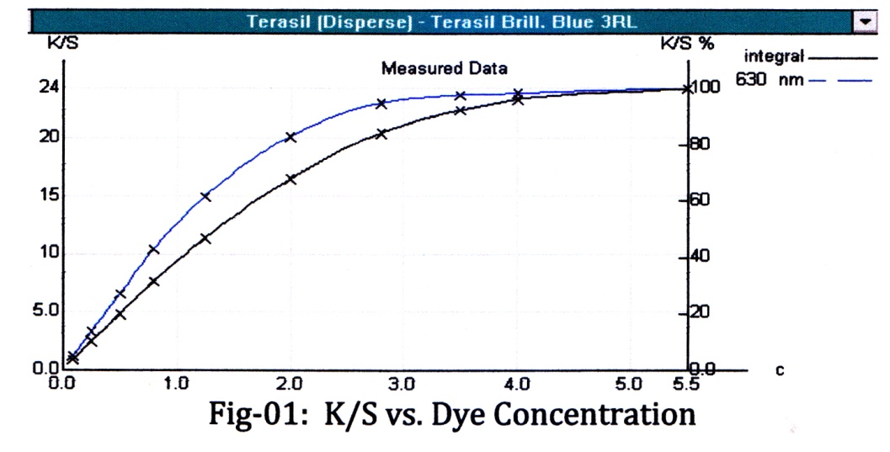

The uniformity of this curve will determine the software's ability to accurately generate new formulas, especially in the unknown areas between the known concentrations. Two curves are displayed, one based on K/S for each dye at the wavelength of maximum light 8 absorbence and one based on K/S integrated over the range of 400-700nm. The shapes of these curves may differ due to hue changes as dye concentration increases. The quality of the dye primaries is indicated by the smoothness of the K/S curves. Most dyes will exhibit linear behavior in the lower concentrations and will begin to flatten as the dye saturation point is approached. The point at which the K/S curve stops increasing corresponds to the maximum achievable depth of shade for a dye, approximately 5% for the dye pictured, and the concentration used should not exceed this amount in shade matching. It is often the case that, due to physical properties such as light fastness and wash fastness, the practical use range of a dye is well below its saturation concentration. A graph of log K/S versus concentration (Figure 2) is useful for evaluating the linearity of lighter concentrations.

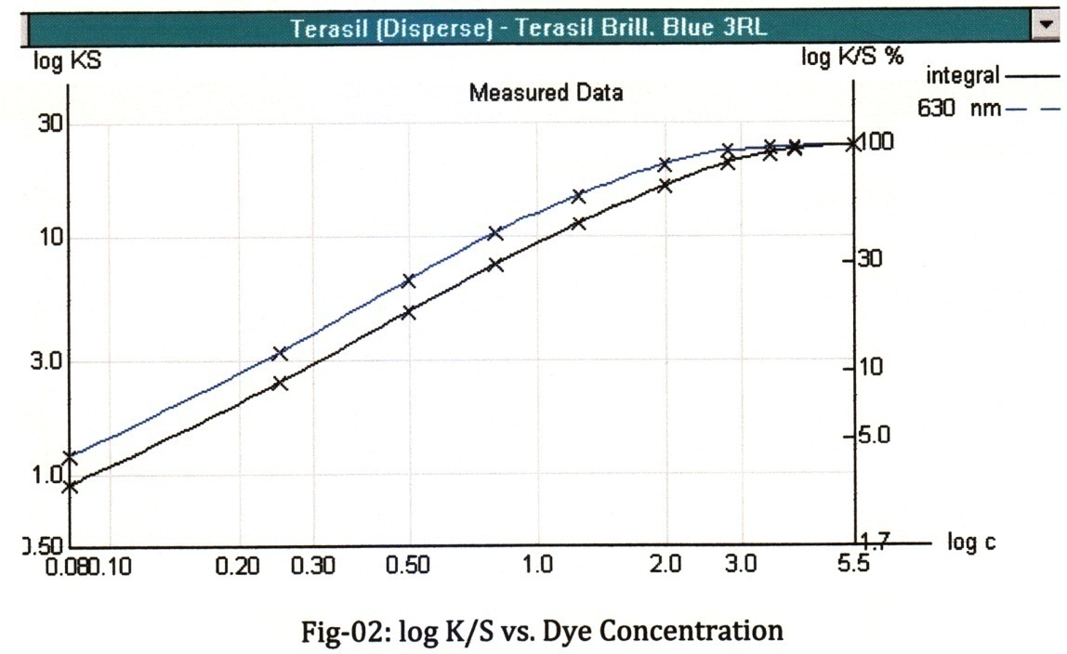

Any samples that appear to deviate from the linearity of the majority of data points should be remeasured for confirmation and redyed if proven to be in error. It is acceptable to delete as many as two points if eight or more concentrations have been dyed as long as 9 they are in the linear portion of the graph and are not one of the two strongest concentrations. If three or more points appear questionable, it is preferable to redye the entire set of primaries for best results from the formulation software. Small variations as indicated in Figure 3 can be corrected using mathematical smoothing techniques to produce the modified curve in Figure 4, but only if the changes are less than 10%

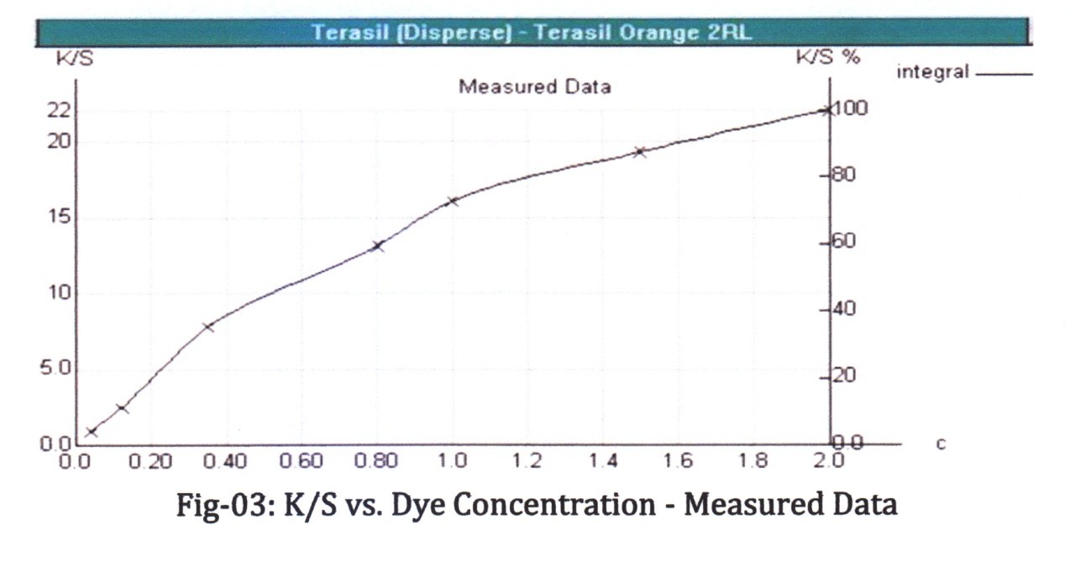

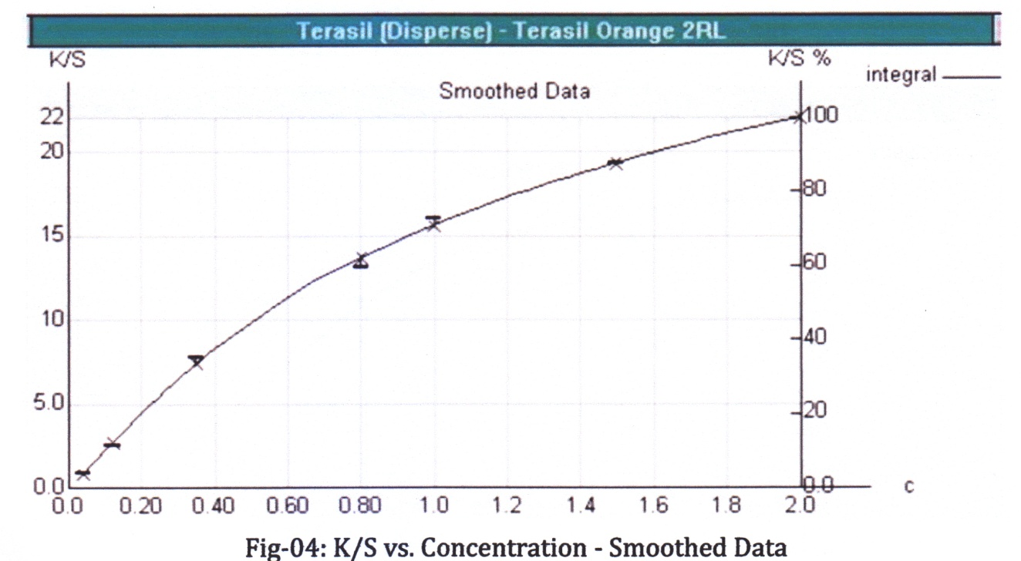
At first glance, the K/S curve for the black dye in Figure 5 appears to be acceptable. If the formulation program were asked to generate a concentration of this dye corresponding to a sample K/S value of 17, it would predict approximately 2.4%. Notice, however, the large gap in the concentration levels between 1% and 4%. I an additional point was dyed at 2.5% and added to the database, the computer’s predicted concentration would change to approximately 1.6%
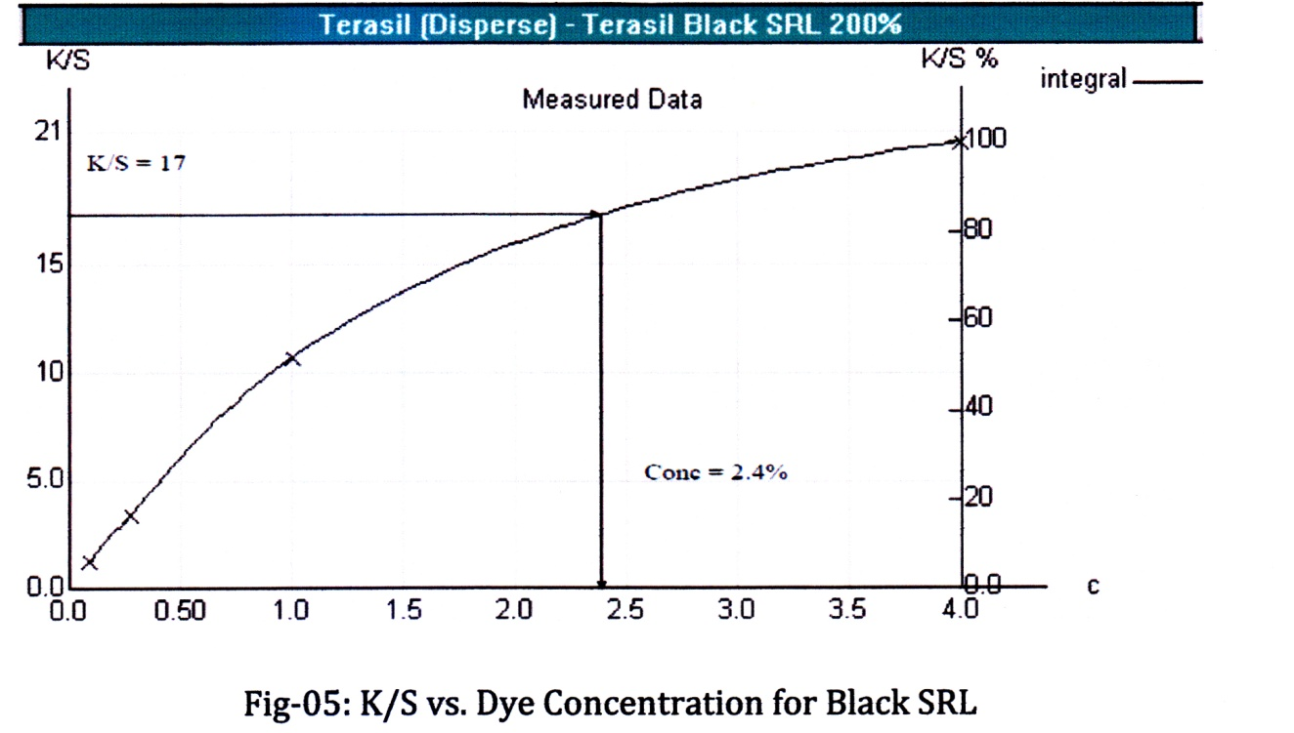
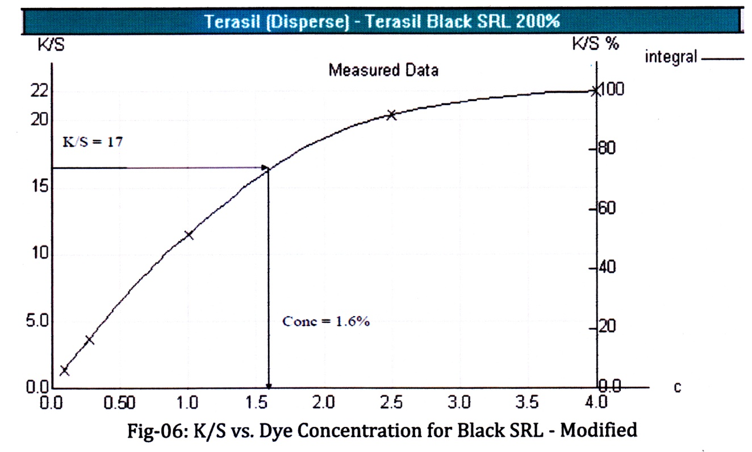

As a rule, it is best not to leave gaps of more than 1.0% between primary dyeings. This will be helpful in preventing the highly variable concentrations predicted in the previous example.

2.5.9 Graphical Analysis of Primaries Using Reflectance:
Graphs of percent light reflectance (%R) versus wavelength for a set of primaries are useful in detecting the presence of contamination, especially in the lighter samples. Figure 7 is a graph of %R versus wavelength for a set of violet primaries:
K/S = 17
Cone = 1.6%
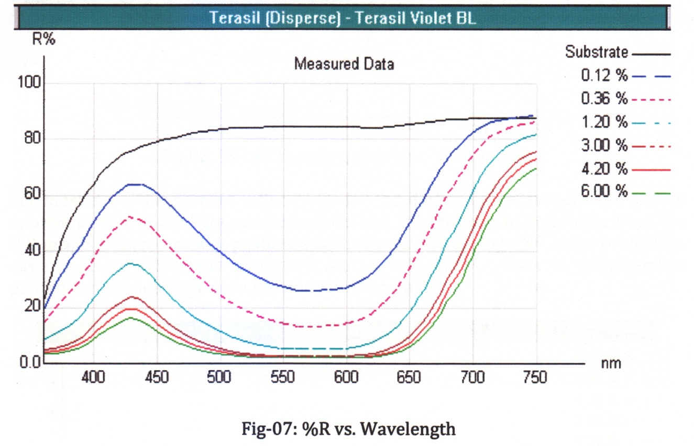
The reflectance curves for the set of primary dyeings should all have the same basic shape with no lines that cross. There will be occasions, however, when some line crossing occurs at higher reflectance values, especially above 600nm for yellow to red dyes. As long as the crossing is not significant, there is no need to remove or redye the sample. If the reflectance curve exhibits significant crossing as in Figure 8 for the 0.15% level of the red dye, then the sample has become contaminated during the dyeing process or by some other means. This point should definitely be redyed or, if the remaining points have a linear K/S versus concentration build, simply deleted.
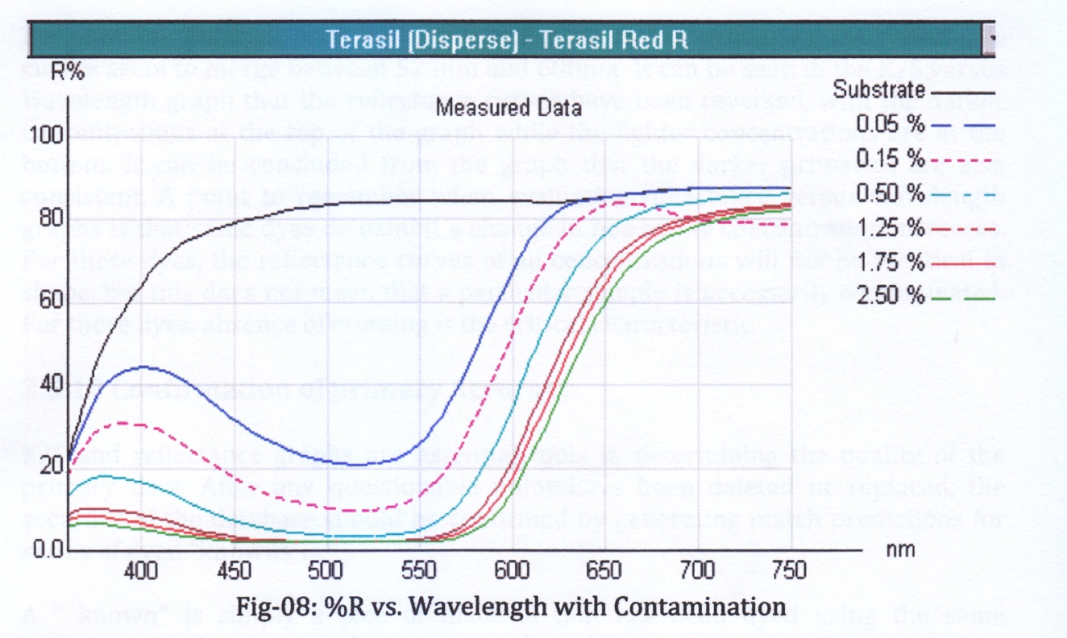
For most dyes, the percent reflectances for the darker concentrations are so low relative to that of the light concentrations that it is difficult to determine from the %R graph if there are any problems with the darker dyeings. To make evaluation easier, a plot of K/S versus wavelength is used. In Figure 9, K/S versus wavelength is plotted for the violet dye seen previously in Figure 7.

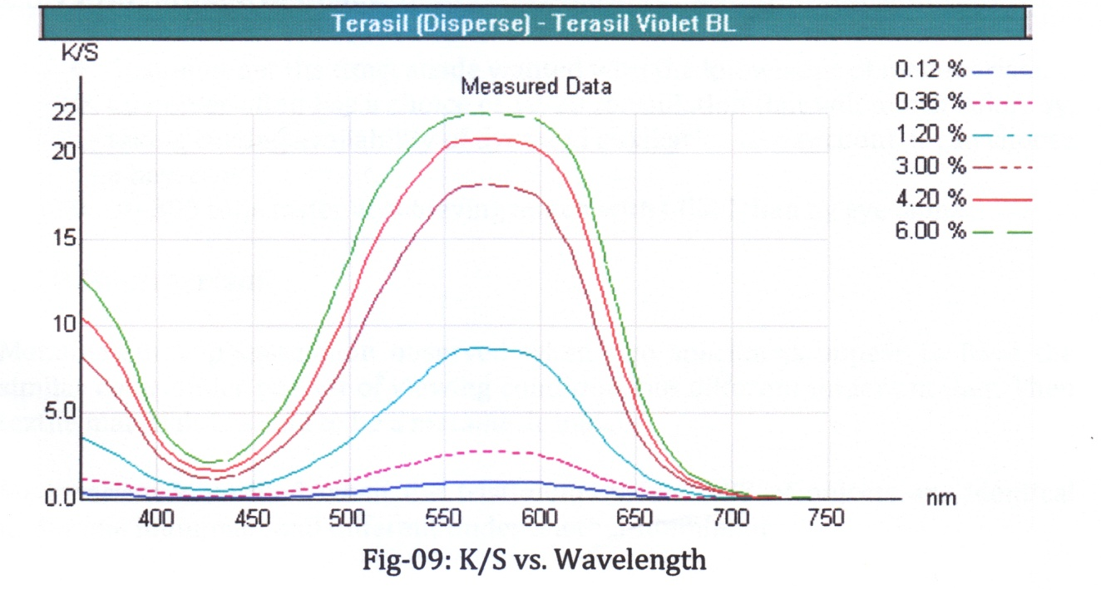
Reexamining Figure 7 does indicate that for the darker primaries, the reflectance curves seem to merge between 525nm and 600nm. It can be seen in the K/S versus wavelength graph that the reflectance curves have been reversed, with the darker concentrations at the top of the graph while the lighter concentrations are at the bottom. It can be concluded from the graph that the darker primaries are also consistent. A point to remember when evaluating reflectance versus wavelength graphs is that some dyes do exhibit a change in hue as the concentration increases. For these dyes, the reflectance curves of all concentrations will not be identical in shape, but this does not mean that a particular sample is necessarily contaminated. For these dyes, absence of crossing is the critical characteristic.

2.5.10 Confirmation of primary Accuracy:
K/S and reflectance graphs are essential tools in determining the quality of the primary data. After any questionable point have been deleted or replaced, the accuracy of the database should be confirmed by generating match predictions for series of dyed "knowns".
A " known" is simply a pice of material that has been dyed using the same techniques and substrate that were used to dye the primaries. When asked to predict a formula for a known sample, the computer formulation software should produce a formula reasonably close to the actual concentrations that were used to produce the sample. Small variations are common and are typical due to dye interaction that cannot be accounted for when the primaries are dyed separately.

2.5.11Advantage of CCMS:
- Customer get the exact shade wanted with the knowledge of metamerism.
- Customer often has a choice of 10-20 formulation that will match color. By, taking costing availability of dyes and auxiliaries into account, it can choose a best one.
- 30-300 time faster at achieving match with CCMS than by eye alone.

2.6.0 Metamerism
Metamerism is phenomenon observed when two specimens appear to have the similar color under one set of viewing condition, but different under another. Then textile materials are said to be a metameric match.
Metamarism is verified when the tristimulus values XYZ of objects are identical under one illuminant and different under another illuminant.
2.6.1 Types of Metamerism
I. Illuminant Metamerism: When the color of two specimens match under
one illuminant but not with another illuminant.
II. Geometric Metamerism: Two object which match in one arrangement of illumination, sample and observer may mismatch by altering the positions. III. Instrumental Metamerism: It arises when two objects match one set of instrumental conditions but fail on another case.
IV. Observer Metamerism: When color of two objects appear to match to one
observer but not to the other.
V. Field size metamerism: It occurs when match fails due to change of the size of visual field or distance of viewing.

CHAPTER-III
Experimental Techniques and Methodology

3.1.0 Sample Specification
- Single jersey knitted fabric
- 160 GSM
- Weight 10 gm per sample
- Color white (pretreated fabric)
- 100% cotton

Dyeing Process
Recipe 01: Dyeing of cotton fabric with reactive dye(For Red SB) :

Reactive dye...........(Red SB)...................1%owf
Sequestering agent(Albatex LD) ............. 0.25ml
Glauber Salt …......................................... 30 g/l
Soda ….......................................................10 g/l
Water……………………....………........... 70ml
Material & liquor ratio…... ........................1:10
Per sample weight ......................................10 g
Temp………………………………………. 60⁰C
Time………………………………………60mim
Neutralization Recipe:
Aceticacid………………………………0.5g/l
Temperature……………………………..40⁰C
Time ……………………………………10min

- Recipe for after treatment using salt(Red sample)

- For Common salt
- Sample1 =10 g/l, NaCl
- Sample2=20 g/l,NaCl
- Sample3=30 g/l,NaCl
- M:L=1:30
- Temperature=50⁰C
- Time=20 min
- For Glauber salt
- Sample1 =10 g/l, Na₂SO₄
- Sample2=20 g/l, Na₂SO₄
- Sample3=30 g/l, Na₂SO₄
- M:L=1:30
- Temperature=50⁰C
- Time=20 min

Recipe 02: Dyeing of cotton fabric with reactive dye(For Novacron 3SR) :

Reactive dye...........(Novacron 3SR)...................1%owf
Sequestering agent(Albatex LD) ............. 0.25ml
Glauber Salt …......................................... 30 g/l
Soda ….......................................................10 g/l
Water……………………....………........... 70ml
Material & liquor ratio…... ........................1:10
Per sample weight ......................................10 g
Temp………………………………………. 60⁰C
Time………………………………………60mim
- Neutralization Recipe:
- Acetic acid………………………………0.5g/l
- Temperature……………………………..40 ⁰C
- Time ……………………………………10min
- Recipe for after treatment using salt(Yellow sample)
- For Common salt
- Sample1 =10 g/l, NaCl
- Sample2=20 g/l,NaCl
- Sample3=30 g/l,NaCl
- M:L=1:30
- Temperature=50⁰C
- Time=20 min
- For Glauber salt
- Sample1 =10 g/l, Na₂SO₄
- Sample2=20 g/l, Na₂SO₄
- Sample3=30 g/l, Na₂SO₄
- M:L=1:30
- Temperature=50⁰C
- Time=20 min

- 3.2.1 Dyeing Curve

- Procedure:
- At first we took required amount of dye & fabric in the dye bath & run the m/c .
- When the temp reached 60⁰C then we added soda 10g/l after 20 min .
- Run the m/c for 40min then cold wash the sample.
- For neutralization added acetic acid 0.5g/l at 40⁰C for 10min &hot wash at 90⁰C.
- For soaping we added soaping agent 2g/l for at 90⁰C for 10 min.
- Then dried the sample & prepared it for after treatment with Glauber & Common salt.

3.3.3 Wash Fastness Test

It color fastness testing system by which we can find out the wash fastness grade of a fabric. Here grey is and multifibe is used for the determination of staining and color change grade.

3.3.4 Adjacent Multifibre

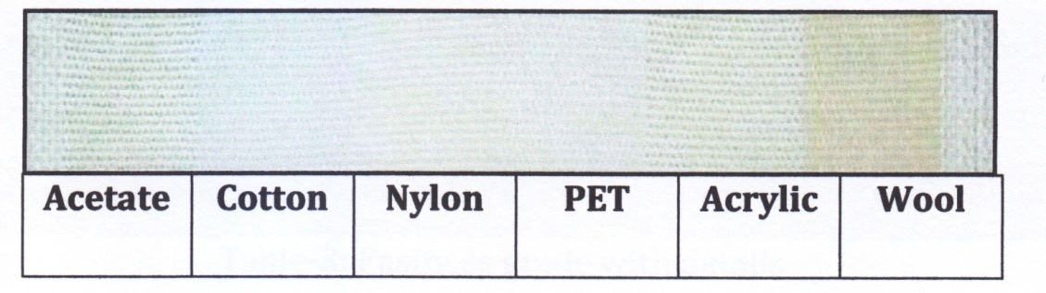

3.3.5 Grey scale:
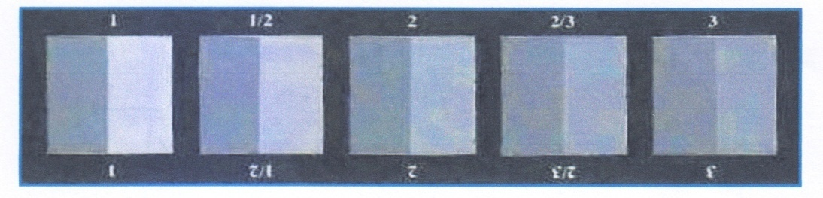

3.3.6 Recipe:
Test soap : 5 g/l (ECE-4g/l+ Sodium perbret 1g/l)
Washing Temperature : 60C
Washing Time : 30 Min
M:L : 1:50
Steel ball : 25
PH : 10.5
3.5.4 Procedure:
The dyed fabric to be tested was cut into a (10cm X 4cm) size and then sewn with Multifibre fabric of same size. Then the specimen was washed with ISO recommended detergent and the given recipe was used.

After washing , the specimen was rinsed well with cold water and then dried Finally the dyed fabric before and after wash was assessed with standard "Grey Scale " and grade for the alternation of the color was obtained. The staining of color in the multifibre fabrics was also evaluated using a different "Grey Scale "

3.5.5 Grade for Wash Fastness:
Fastness grade | Fastness Quality | Staining
Grade-1 | Very poor | Deep staining
Grade-2 | Poor | Significant staining
Grade-3 | Fair | Moderate staining
Grade-4 | Good | Very slight staining
Grade-5 | Excellent | No Staining
Tables-3: Fastness grade with details

CHAPTER-IV
Result and Discussion

4.1.0 Dyeing Results
Sample of Dyed Fabric

4.1 Results for After treatment by salt
Recipe 01& Recipe 02(For red)
There is three After treatment result using Glauber salt 10, 20, 30 g/l . There is three different effect for the different Glauber salt concentration. There is three different effect for the different Common salt concentration 10, 20, 30 g/l .

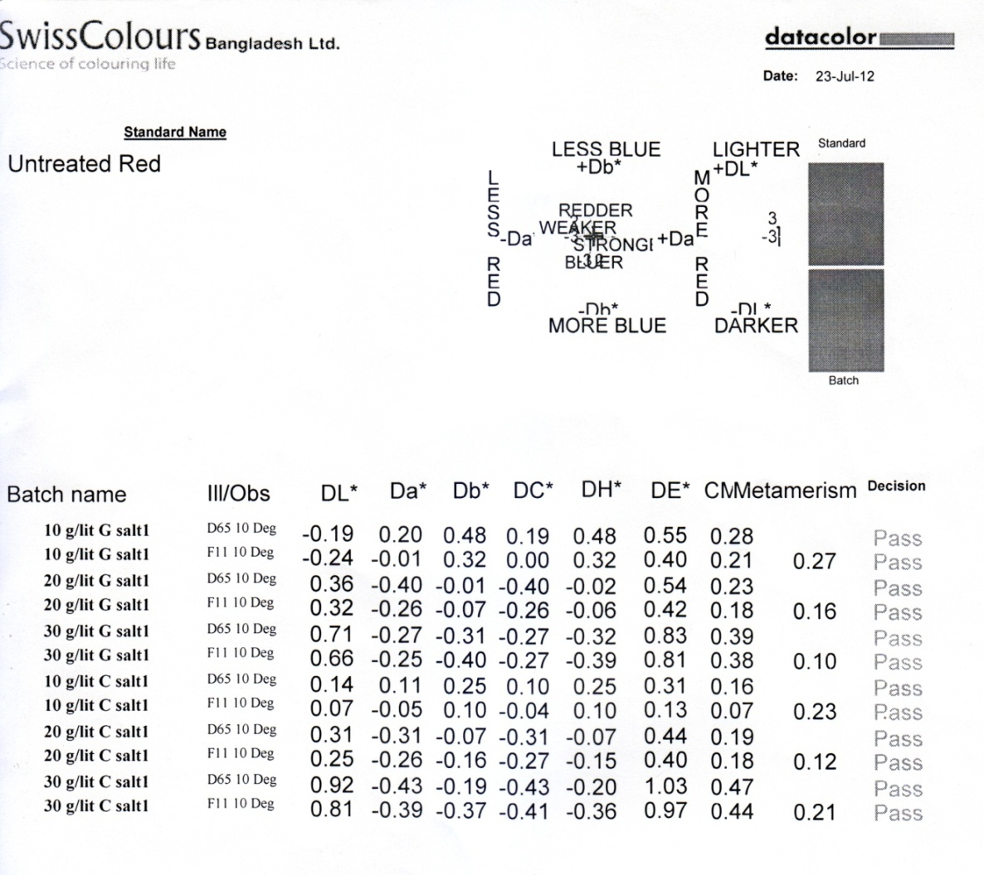

Comparison table For evaluating CCMS Test Result :(Red sample)

Sl. | Glauber salt |  | lll / obs | Amount salt used | Average DE |  | Average Metamerism |  |  | Darker/  Lighter
1 | G.Salt 1 |  | D65 10 Deg  FII 10Deg | 10g/l | 0.48 |  | 0.27 |  |  | Darker
2 | G.Salt 2 |  | D65 10 Deg  FII 10Deg | 20g/l | 0.48 |  | 0.16 |  |  | Lighter
3 | G.Salt 3 |  | D65 10 Deg  FII 10Deg | 30g/l | 0.48 |  | 0.10 |  |  | Lighter
Sl. | Common salt | lll / obs |  | Amount salt used |  | Average DE |  | Average Metamerism | Darker/  Lighter
1 | Common salt1 | D65 10 Deg  FII 10Deg |  | 10g/l |  | 0.22 |  | 0.23 | Lighter
2 | Common salt2 | D65 10 Deg  FII 10Deg |  | 20g/l |  | 0.42 |  | 0.12 | Lighter
3 | Common salt3 | D65 10 Deg  FII 10Deg |  | 30g/l |  | 1.0 |  | 0.21 | Lighter

Discussion: By comparison above two table we see that , average metamerism of
Glauber salt: Common salt 0.18:0.19 ,Two result we approximately same ,but we can say that G.salt is better than common salt .there Average DE for G.salt 0.59 & common salt 0.54

4.1 Results for After treatment by salt for Yellow
There is three After treatment result using Glauber salt 10, 20, 30 g/l . There is three different effect for the different Glauber salt concentration. There is three different effect for the different Common salt concentration 10, 20, 30 g/l.

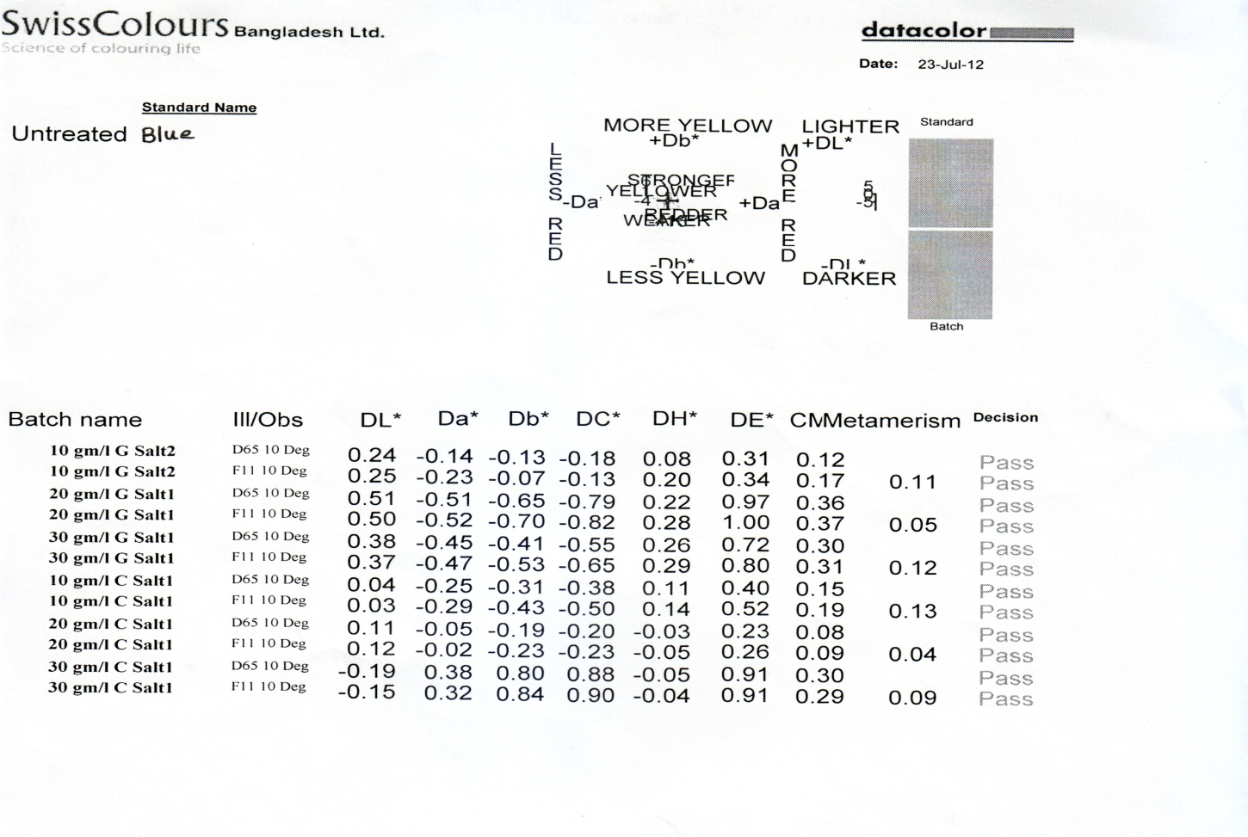

Yellow

Comparison table For evaluating CCMS Test Result (Yellow Sample)
Sl. | Glauber salt | lll / obs | Amount salt used | Average DE | Average Metamerism | Darker/  Lighter
1 | Glauber salt1 | D65 10 Deg  FII 10Deg | 10g/l | 0.33 | 0.11 | Lighter
2 | Glauber salt2 | D65 10 Deg  FII 10Deg | 20g/l | 0.99 | 0.05 | Lighter
3 | Glauber salt3 | D65 10 Deg  FII 10Deg | 30g/l | 0.76 | 0.12 | Lighter

Sl. | Common salt | lll / obs | Amount salt used | Average DE | Average Metamerism |  | Darker/  Lighter
1 | Common salt1 | D65 10 Deg  FII 10Deg | 10g/l | 0.46 |  | 0.13 | Lighter
2 | Common salt2 | D65 10 Deg  FII 10Deg | 20g/l | 0.24 |  | 0.04 | Lighter
3 | Common salt3 | D65 10 Deg  FII 10Deg | 30g/l | 0.91 |  | 0.09 | Lighter
Discussion:
By comparison above two table we see that , average metamerism of
Glauber salt: Common salt0.09:0.08 ,Two result we approximately same ,but we can say that G.salt is better than common salt .there Average DE for G.salt 0.69 & common salt 0.53.There ,common salt is better than G.salt (0.69>0.53).

4.3 Rubbing fastness report
Rubbing fastness report for the shade of Glauber salt (Red Sample)

Rubbing fastness report for the shade of Common salt (Red Sampl

Comparison Table For Evaluating Rubbing Fastness Test Ruselt(red):
Salt name | Amount of salt used | Rating for Dry Rub | Decision | Rating for wet Rub | Decision
G-salt1 | 10g/l | 4-5 | Good Excellent | 4 | Good
G-salt1 | 20g/l | 5 | Excellent | 4 | Good
G-salt1 | 30g/l | 5 | Excellent | 4 | Good
C-salt1 | 10g/l | 4-5 | Good Excellent | 4-5 | Good Excellent
C-salt2 | 20g/l | 4-5 | Good Excellent | 4 | Good
C-salt3 | 30g/l | 4-5 | Good Excellent | 4 | Good
Untreated | No salt used | 4 | Good | 3 | Fair
Discussion: From above table we can saw that Rubbing fastness (Dry rub) property of Glauber salt is better than Common salt & Common salt is better than Untreated sample (4.8>4.5>4),And at the same time wet rub result is better for Common salt from Glauber salt & Glauber salt is better from Untreated sample(4.16>4>3)
Rubbing fastness report for the shade of Glauber salt (yellow Sample)

Rubbing fastness report for the shade of Common salt (yellow Sample)

Comparison Table For Evaluating Rubbing Fastness Test Result(yellow):
Salt name | Amount of salt used | Rating for Dry Rub | Decision | Rating for Dry Rub | Decision
G-salt1 | 10g/l | 4-5 | Good Excellent | 4 | Good
G-salt2 | 20g/l | 4-5 | Good Excellent | 4 | Good
G-salt3 | 30g/l | 4 | Good | 4 | Good
C-salt1 | 10g/l | 4-5 | Good Excellent | 3 | Fair
C-salt2 | 20g/l | 4-5 | Good Excellent | 4 | Good
C-salt3 | 30g/l | 4-5 | Good Excellent | 4 | Good
Untreated | No salt used | 4-5 | Good Excellent | 4 | Good
- Discussion: For yellow shade ,from above table we can saw that Rubbing fastness (Dry rub) property of Untreated &Common salt is better than Glauber salt & Common salt is better than Untreated sample (4.5=4.5>4.33),And at the same time (wet rub )result is Untreated &Common salt is better from Glauber salt (4=4>3.6)

4.2 Wash Fastness Test Result

Shade: Common Salt -3 (30g/l) Multifibre

Comparison Table For wash Fastness Test Result(Red sample)

Comparison Table For wash Fastness Test Result(yellow):

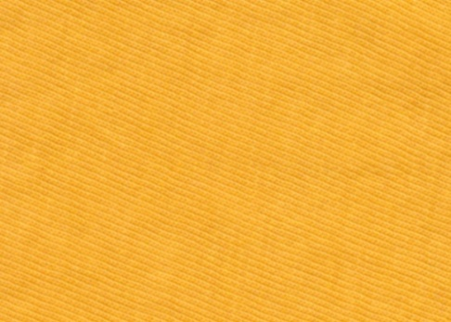

Grade

Crocking cloth (Dry)

Grade

Crocking cloth (Wet)

Grade

Crocking cloth (Wet)

Grade

Grade

Crocking cloth (Dry)

Grade

Grade

Crocking cloth (Wet)

Grade

Crocking cloth (Wet)

Grade

Crocking cloth (Dry)

CHAPTER-V
Conclusion

Conclusion
Our project title was “Study of the color fastness of dyed samples using salt after treatment”. It was a comparative study between different electrolyte in reactive dye.
Reactive dye works in the alkali medium, when the dye dissolve in to water it produce negative charge on the other hand cotton fabric also produce negative charge on surface. As are result repulsion force create between dye and fibre and no dyeing has taken place. For this reason removing this problem a electrolyte is used for the neutralization of negative charge on fibre surface and increase dye affinity to fibre.
Now a dyes different types of electrolyte available in the market. Glauber salt and Common salt is more familiar electrolyte in the market and widely used in the textile sector for dye with reactive dye. Different salt show different effect on the dyed goods. For this reason we try to compare the Gluaber salt and Common salt by using different amount in same Dyeing recipe. Then we try to find out the best one by using various types of testing method like- Computer Color Matching System (CCMS), Rubbing fastness test, Wash fastness test, After getting all information we analysis the all data and make a decision that, which one is best electrolyte for reactive dye. After then make decision, in case of shade (Dakar or Lighter) common salt is best but in case of Fastness properties the glauber salt is better one for the dyeing of cotton goods with reactive dye.At last we say, by this project work we learn more about electrolyte and over all dyeing process and comparing system and etc. practically. All think we learn by project is very important today and also very much important for our future life in Textile sector.

CHAPTER-VI
Bibliography

Bibliography

I) References

a) www.datacolor.com
b) www.fibre2fashion.com
c) www.wikipidia.com
d) Searching by www.google.com
e) DIU library project store
f) Lecture of Diu teacher
g) Our own knowledge

II) List of figure-
1. Fig-01: K/S vs. dye concentration
2. Fig-02: log K/S vs. dye concentration
3. Fig-03: K/S vs. Dye concentration- Measured Data
4. Fig-04: K/S vs. Dye concentration- Smoothed data
5. Fig-05: K/S vs. Dye concentration for black SRL
6. Fig-06: K/S vs. dye concentration for black SRL-modified
7. Fig-07: %R vs. wavelength
8. Fig-08: %R vs. wavelength with contamination
9. Fig-09: K/S vs. wavelength
10. Fig-10: Dyeing process of reactive dye using Glauber salt
11. Fig-11: Dyeing process of reactive dye using Common salt
12. Fig-12: Multifibre adjacent fabric
13. Fig-13: Grey scale for color staining
14. Fig- 14: A Crock meter
15. Fig-15: three different shade using Reactive dye with Glauber salt
16. Fig-16: three different shade using reactive dye with Common salt
17. Fig-17: CCMS report of Glauber salt shade-1 and Common salt shade-1
18. Fig-18: CCMS report of Glauber salt shade-2 and Common salt shade-2
19. Fig-19: CCMS report of Glauber salt shade-3 and Common salt shade-3 1

III) List of tables-
a) Table-01: Reactive dyes company and Origin
b) Table-02: Properties of major types of reactive dye
c) Table-03: Fastness grade with details
d) Table-04: Extracted information from CCMS test
e) Table-OS: Compare of perspiration fastness test of two salt in alkali condition.

