

Industrial Training Report
(Course Code: TE 410)

At

PURBANI FABRICS LIMITED

Nurbag, Mouchak, Kaliakoir, Gazipur, Dhaka

Academic Supervisor: | Industrial Supervisor:
Mr. Sumon Mazumder | Mr. Shamsuddin Ahmed
Assistant Professor | DGM
Department of Textile Engineering | Dyeing Section
Daffodil International University | Purbani Fabrics Limited

Prepared By:
Md. Abnul Hasan
ID: 091-23-1412

Date of Submission: 20’^{Th} December, 2012.


CHAPTER- 1

Introduction

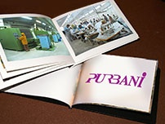

CHAPTER- 4
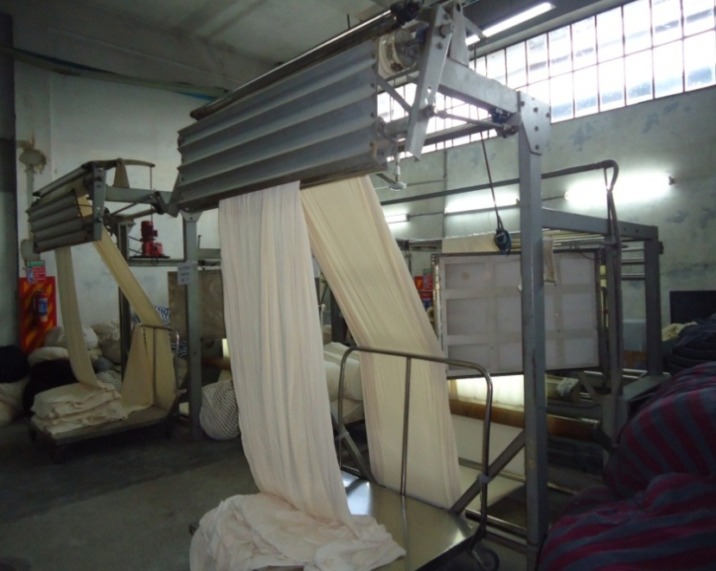

Batching Section

CHAPTER- 2

Profile of the Company



CHAPTER- 3

Knitting Section

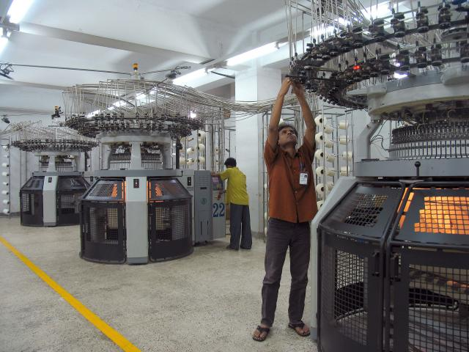

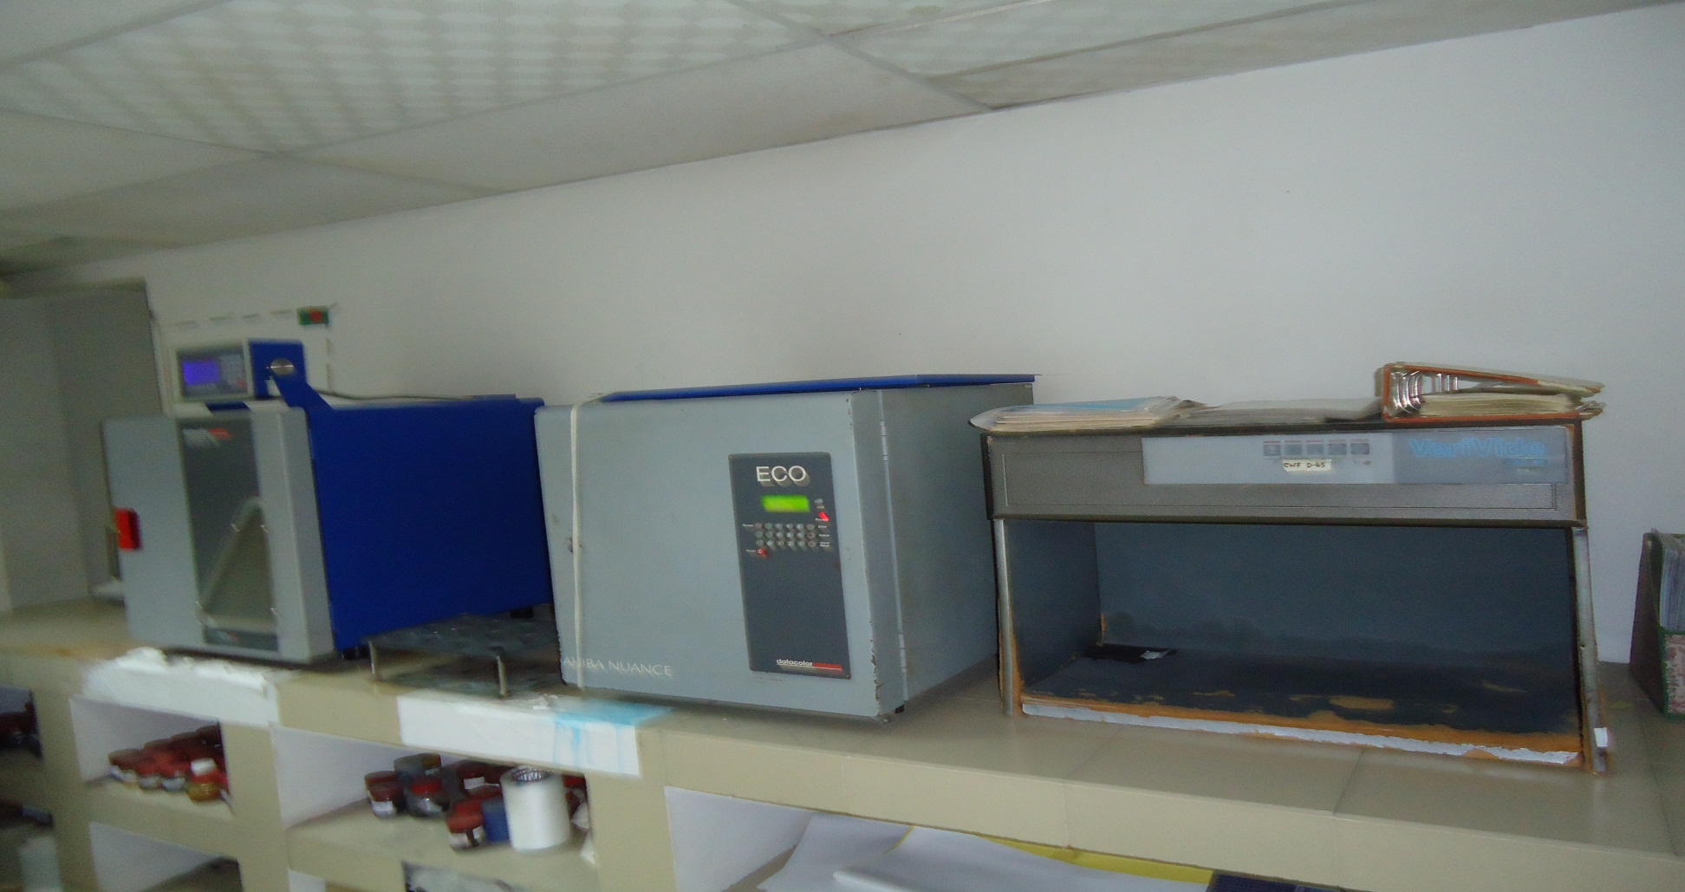

CHAPTER- 5

Dyeing Lab Section

CHAPTER- 6

Dyeing Section

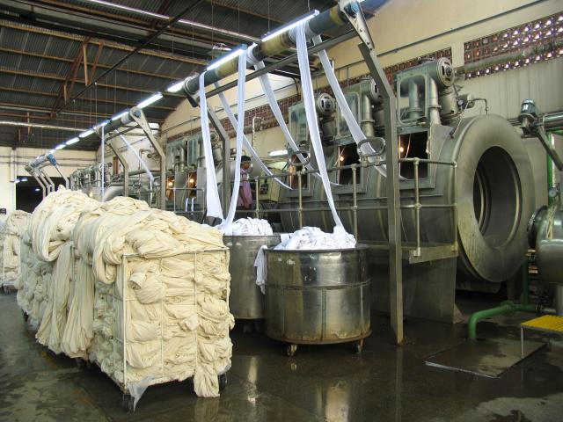

CHAPTER- 7

Finishing Section

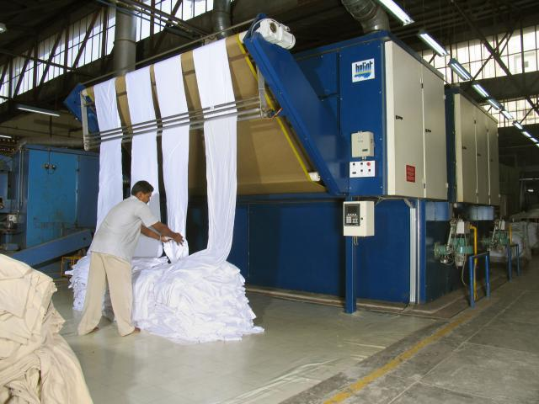

CHAPTER- 8

Garments Manufacturing Section

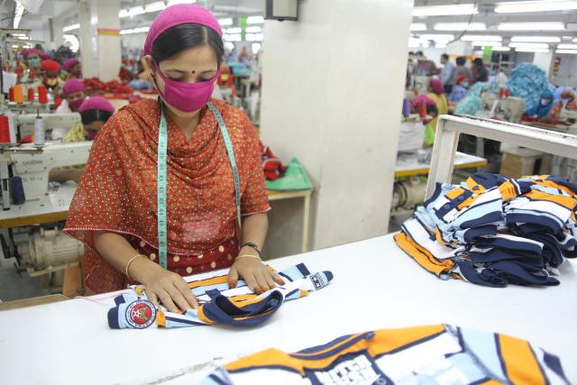

CHAPTER- 9

Quality Control Section



CHAPTER- 14

Utility Department

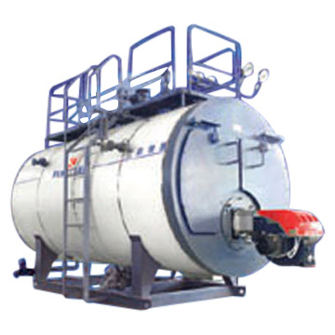

CHAPTER- 15

Maintenance Department



CHAPTER- 16

ETP & WTP Plant

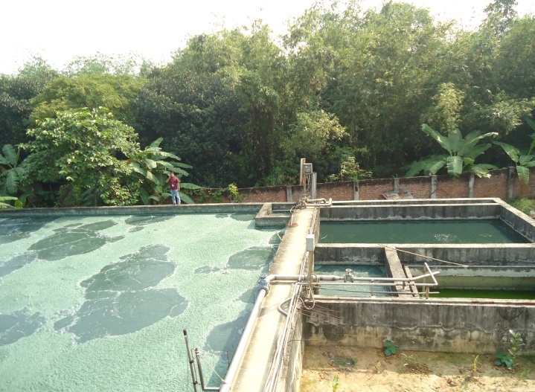

CHAPTER- 10

Inventory Section



CHAPTER- 11

Cost Analysis



CHAPTER- 12

Marketing Department



CHAPTER- 13

HRM & Compliance



CHAPTER- 17

Conclusion



Industrial Training Report
at

PURBANI FABRICS LIMITED

Nurbag, Mouchak, Kaliakoir, Gazipur, Dhaka

Academic Supervisor: | Industrial Supervisor:
Mr. Sumon Mazumder | Mr. ShamsuddinAhmed
Assistant Professor | DGM
Department of Textile Engineering | Dyeing Section
Daffodil International University | Purbani Fabrics Limited

Prepared By
Md. AbnulHasan
ID: 091-23-1412

Date of Submission: 20’^{Th} December, 2012.

Letter of Transmittal

ACKNOWLEDGEMENT
First of all, I like to thanks the almighty ALLAH for enabling us to complete my industrial training and report successfully.
I express my heartiest thanks to my instructor and honorable teacher Mr. Sumon Mazumder, to whom we are extremely indebted for tremendous support and guidance throughout my training period. Being working with his I have not only earned valuable knowledge but also inspired by his innovativeness which helped & enrich my experience to a greater extent. His ideas and way of working was truly remarkable.
Specially, I am very much grateful to Mr. Atiqul Islam, DGM (Admin, HR & Compliance), and Mr. Shamsuddin Ahmed, DGM (Dyeing Section), Md. Rafiqul Islam for giving me the opportunity and cooperating and helping me in collection of necessary data for the preparation of this report.

Once more, I would like to thank’smy industrial supervisor inPurbani Fabrics Ltd. who supervise me cordially, without his help I could not complete my industrial training properly. I would like to thanks to the officers and staffs of Purbani Fabrics Ltd, for their outstanding support and sharing their working experience while working with them. They gave me long patient hearing and sitting, practical orientation and answering all the queries nicely.

I like to thanks ProfessorDr. S.M. MahbubUl HaqueMajumderDean of Faculty of Science and Information Technology and Professor Dr. Md. Mahabubul Haque, Head of the Department of Textile Engineering, Daffodil International University, who has inspired me to take and continue this report.

Last but not least, thanks go to my precious family for their never ending love and inspire at every stages of our life.

EXECUTIVE SUMMARY

Purbani Fabrics Ltd. is going to one of the leading Company in Bangladesh and is going from strength to strength since its inception. By observing the factory existing condition and employees’ behavior to one other, their fastest and quality production and organizational structure, I was led to believe that the company is very centralized. The span of control is very adequate in the management and each manager is given the span of control according to his/her position. One of the industry’s main objectives is to ensure that there is appropriate delegation of authority and accountability of management staff all the way down to the supervisory level.
The factory faces good competition from their competitors which as a result motivates them to work harder to achieve their objectives and goals. The organization uses the multiple departmental bases and according to the management this base is the most appropriate. The upper level managers are accountable to the executive directors, who are regularly reviews and approve the strategic plans for each business unit.
While surveying the organization I found that the factory provides comfortable working conditions, friendly co-workers, efficient management and status , and from the factory management part, they have made ensure the world class accommodation, amenities, services, facilities no doubt.

Serial No | Subject  Table of Content | Page No
1 | Introduction | 1
1.1 | History of the project development | 2
1.2 | Vision & mission of the project | 2
2 | Profile of the Company | 3
2.1 | Achievement | 5
2.2 | Sister Concern of Purbani Fabrics Ltd | 8
2.3 | Upper Level Organizational Structure of Purbani Fabrics Ltd | 8
3 | Knitting Section | 10
3.1 | Organogram of Knitting section in Purbani Fabrics Ltd | 11
3.2 | Yarns | 12
3.2.1 | Counts of Yarns Used: | 12
3.2.2 | Yarn LOT( Specification Card): | 12
3.2.3 | Types of yarns used in PURBANI | 12
3.2.4 | Characteristics of various types of Yarn | 13
3.2.5 | Types of raw material | 14
3.2.6 | Source of yarn for knitting | 14
3.2.7 | Different yarn and count For Knitting | 14
3.3 | Fabrics Produced in Purbani Fabrics Ltd | 15
3.4 | Flow process of knitting section | 16
3.5 | Flat Knitting Section | 16
3.6 | Singlejersey Circular Knitting Machine | 18
3.7 | Double Jersey Circular knitting Machine | 21
3.8 | Process flow chart of knitting | 22
3.9 | Description of Production Process | 23
3.9.1 | Production Parameters | 23
3.9.2 | Relationship between knitting parameters | 23
3.10 | Considerable points to produce knit fabric | 24
3.11 | G.S.M | 24
3.12 | Factors that should be changed in case of fabric design | 24
3.13 | Effect of stitch length of color depth | 24
3.14 | Methods of increasing production | 25
3.15 | Faults and their causes in knitting | 25
3.16 | Collection of faulted knitted fabric | 27
3.17 | Different Fabric GSM and Their Yarn Count | 28
3.18 | Different Parts of Knitting Machine | 29
3.19 | Introduction To Quality Assurance System | 29
3.20 | Some points are needed for maintaining high quality fabric | 29
3.21 | List of Equipment for quality control | 29
3.22 | Quality Assurance Property | 30
3.23 | Quality Standard | 30
3.24 | Production Calculation | 31
3.25 | Photo gallery | 33
3.26 | Sample Collection | 35
4. | Batching Section | 38
4.1 | Layout of Batching Section | 38
4.2 | Grey Fabric Inspection | 38
4.3 | General Instructions for the final inspection | 39
4.4 | Grading procedure | 40
4.5 | Object of Batching | 40
4.6 | Proper batching criteria | 40
4.7 | Batch management | 40
4.8 | M/cs in batch section | 40
5.0 | Dyeing Lab Section | 42
5.1 | Organogram of color lab | 42
5.2 | Definition | 42
5.3 | Objective of Lab Dip | 42
5.4 | Development of Dip | 43
5.5 | Color measurement of standard Sample | 43
5.6 | Preparation and storage of stock dyes | 44
5.7 | Types of Pipette | 44
5.8 | Dyes and chemicals measuring formula for lab | 44
5.9 | Machineries for lab dip | 45
5.10 | Salt and Soda for 30% stock solution | 46
5.11 | For production | 47
5.12 | Procedure of Lab dips | 47
5.13 | Photo gallery | 49
5.14 | Collection of swatch shade with recipe | 50
6.0 | Dyeing Section | 53
6.1 | Organogram of Dyeing & Finishing Section | 53
6.2 | Layout of dyeing Section | 54
6.3 | Raw Materials for Dyeing | 55
6.4 | Grey fabrics | 55
6.5 | Sources | 55
6.6 | Dye & chemicals Used in Purbani Fabrics Ltd. | 55
6.7 | Reactive Dyes | 56
6.8 | Disperse Dyes | 57
6.9 | Responsibility of production officer | 57
6.10 | Job Description | 57
6.11 | Machine Description | 57
6.12 | Recipe at different stages in dyeing cotton fabric | 61
6.13 | Different parameters in dyeing | 62
6.14 | Cotton Dyeing steps with Curve | 63
6.15 | Dyeing Procedure of polyester/cotton blend fabrics with Curve | 66
6.16 | Whitening Recipe & Sequence for Grey mélange | 68
6.17 | Common faults and their remedies in knit dyeing | 73
6.18 | Process Loss In Different stage | 76
6.19 | Collection of faulted dyed fabric | 77
6.20 | Photo Gallery | 78
7.0 | Finishing Section | 79
7.1 | Layout of Finishing Section | 80
7.2 | Organogram of Finishing Section | 81
7.3 | Machine description of finishing section | 81
7.4 | Finishing section classification | 82
7.5 | Different types of machine with their function | 82
7.6 | Finished Fabric Inspection | 87
8.0 | Garments Manufacturing section | 88
8.1 | Layout of Garments section | 89
8.2 | Organogram of Garments section | 92
8.3 | Machine Description | 94
8.4 | Sequence of garment production | 94
8.5 | Photo Gallery of Karim Textile Ltd. | 100
9.0 | Quality Control Section | 103
9.1 | Quality Assurance System | 103
9.2 | Objects of quality Control | 103
9.3 | Quality Assurance at different stage | 103
9.4 | Procedures are described below | 103
9.6 | List of Equipment | 104
9.7 | Different Quality Test Method | 104
9.7.1 | Physical Tests | 104
9.7.2 | Chemical Tests | 104
9.8 | Fabric Inspection | 104
9.8.1 | Grey Fabric Inspection | 104
9.8.2 | Finished Fabric Inspection | 104
9.9 | Machine Stoppage mark | 105
9.10 | Color Fastness to wash Test procedure | 105
9.11 | Measuring dimensional stability (Shrinkage &spirality) | 106
9.12 | Photo Gallery | 108
10.0 | Inventory Section | 112
10.1 | Inventory Control | 112
10.2 | Frequency of Inventory Update | 112
10.3 | Scope of Inventory Control | 112
10.4 | Inventory System for raw material | 112
11.0 | Cost Analysis | 115
11.1 | Factors of costing of a product | 115
11.2 | Price of the Product | 115
12.0 | Marketing Department | 117
12.1 | Consumer of Products | 117
12.2 | Name of Buyers | 117
12.3 | Communication System | 117
12.4 | Importing countries | 118
12.5 | Marketing Strategy | 119
12.6 | Duties & responsibilities of marketing officer | 119
13.0 | HRM & Compliance | 121
13.1 | Definition | 121
13.2 | Health | 122
13.3 | Toilet | 122
13.4 | Fire | 122
13.5 | Safety Guard | 122
13.6 | Others | 123
14.0 | Utility Department | 124
14.1 | Utility Service | 125
14.2 | Water Pumps | 125
14.3 | Natural Water Quality | 125
14.4 | Standard Water Quality for Dye House | 126
14.5 | Methods of water softening | 127
14.6 | Electricity | 127
14.7 | Steam Boiler | 128
14.8 | Air compressor | 128
14.9 | Gas | 128
15.0 | Maintainnance Department | 130
15.1 | Definition | 130
15.2 | Objective of Maintenance | 130
15.3 | Types of Maintenance | 130
15.4 | Maintenances Procedure | 131
15.5 | Check List of Different Parts | 131
15.6 | Maintenance Tools & Equipment’s | 132
16.0 | ETP & WTP Plant | 135
16.1.1 | Layout of Effluent Treatment Plant | 137
16.1.2 | Effluent Treatment Plant | 138
16.1.3 | Pollutants Present in Textile Industry | 138
16.1.4 | Flow Description | 139
16.1.5 | Process Details | 139
16.1.6 | Characteristics of waste water of PFL assumed as follows | 141
16.1.7 | Flow process of ETP | 141
16.1.8 | Department of Environment, Government of Bangladesh required | 143
16.1.9 | Final treated Quality of PFL discharge | 143
16.2 | Water Treatment Plant | 144
16.2.1 | Deep Pump | 144
16.2.2 | Raw Water Tank | 144
16.2.3 | Air Receiver Tank | 144
16.2.4 | Vessel | 144
16.2.5 | Iron Exchanger Tank | 145
16.2.6 | Multi Grade Filter | 145
16.2.7 | Activated Carbon Filter | 145
16.2.8 | Softener Tank | 145
16.2.9 | Soft Water Reserve Tank | 145
16.2.10 | Flow chart of water treatment plant | 146
17.0 | Conclusion | 147
17.1 | Some Suggestions | 148
17.2 | Limitation of the Report | 148
17.3 | Lastly | 148
18.0 | Reference | 150

- Introduction

Textile and garments sector is the biggest and fastest growing sector in Bangladesh. It is also the highest foreign currency earning sector in Bangladesh. Among this sector, knit dyeing is growing very rapidly due to smaller investment requirement, greater backward linkage facility & higher profit than woven garments. That’s why export of knit dyeing garments has increasing steadily for last few years.

Textile education can’t be completed without industrial training. Because this industrial training minimizes the gap between theoretical and practical knowledge and make us accustomed to industrial environment. We got an opportunity to complete two month (8 Weeks) long industrial training in “Purbani Fabrics Ltd." which is a 100% export, oriented composite Knit Dyeing Industry. It has well planned & equipped fabric and Knit dyeing-finishing units in addition to facilitate Knit and knitting wear manufacturing.

The industrial internship is the process, which builds understanding, skills and attitude of the performer, which improves his knowledge in boosting productivity and services. University education provides us vast theoretical knowledge as well as more practical attachment, in despite of all these industrial attachment helps us to be familiar with technical support of modern machinery, skill ness about various processing stages.

It also provides us sufficient practical knowledge about production management, work study, efficiency, industrial management, purchasing, utility and maintenance of machinery and their operation techniques etc. The above mentioned can not be achieved successfully by means of theoretical knowledge only. This is why it should be accomplished with practical knowledge in which it is based on. Industrial attachment makes us reliable to be accustomed with the industrial atmosphere and improve courage and inspiration to take self responsibility.

1.1 History of the project development
Purbani has been involved in the textile business for over thirty five years. In the early seventies, it emerged in the textile business as a yarn trader. In 1984, the group entered textile manufacturing by acquiring a spinning production line. Today, the group has a 100% export oriented vertically integrated knitted apparel production facility. It uses its spinning units to produce yarn and the yarn is used in the subsequent in-house processes to manufacture fabric and apparel export.
The word ‘Purbani’ (Pur-baH-NEE) is derivative of a Sanskrit word that means "eastern incitement" or "the drawing together through eastern influence". The group itself shares that modality since it was never designed as a formal group of companies but only later was drawn together through a common influence and took on such a form. The group’s first venture was M/S Purbani traders in 1973. Since 1973, however, the Purbani group has grown into a leading group of companies in Bangladesh by virtue of its dynamic management approach, competitiveness, efficiency, and clear single-minded vision. All the enterprises represented by the Purbani group are 100% export-oriented and enjoys loyal patronage from a broad client-base all over Europe, Northern America and the Far East.
Purbani has been involved in the textile business for over thirty years. In the early seventies, it emerged in the textile business as a textile yarn trader. In 1984, the group entered into textile manufacturing by acquiring a spinning production line. Today, the group has a 100% export oriented vertically integrated knitted apparel production facility, that is, it uses its own spinning units to produce yarn and the yarn is used in the subsequent in-house processes to manufacture fabric and apparel for export. The manufacturing facilities are located in Narayanganj, Gazipur and Cox's Bazar.
The company has an annual turnover of US$ 100 million annually and a total investment of US$ 60 million. It is currently employing 6000 people.

1.2 Vision& mission of the project

The mission and vision of Purbani Fabrics Ltd." is to manufacture and deliver high quality readymade garments (RMG) to its customers. To attain these objectives, the management has decided to adopt the following:

- To increase awareness regarding customers requirements throughout the organization.
- By providing training to develop efficiency of the employee.

- Profile of the Company

PURBANI Fabrics Limited
At a glance …….

Name of Company :PURBANI FABRICS LIMITED.

Company Logo :

Slogan :1. From Raw Cotton to Readymade Garments.
2. We Spin Knit Dye Stitch for Excellence.
3. Explore new Horizons with Complete Textile.

Address
Factory : Noorbagh, Kaliakoir
Gazipur ,Dhaka, Bangladesh
Telephone: +88-02-9298373
Fax:+88-02-8817567
E-MAIL: admin@purbanigroup.com

Website : www.purbanigroup.com/web
www.purbanigroup.com/index.php

Office : Richmond Concord, 5th Floor
68, Gulshan Avenue, Gulshan-1
Dhaka-1212,Bangladesh
Telephone: 88-02-8825205,
Fax: 88-02-881756
E-mail: info@purbanigroup.com

Established Year : 1984
Contact persons : Shafiqul I. SarkerSohel
Director
M. Yousuf Khan
Director

Nature of business :100% Export-oriented composite knit dyeing factory.

Nature of company : Private Limited Company

Total employees :1000 persons

Turnover :US$ 10 million/year.

Total Area :30Bigha

Building: 8storied dye house and finishing area.

Certificate :Cotton USA licenses,
WRAP&
Oeko-Tex.
Item of product
Knit fabric :Structures, Single Jersey, Pique, Lacoste,
Interlock, Rib, Herring Bone, Knitted Twill, French Terry and other great designs. (100% cotton, polyester, polyamide and blends with elasthane inserts).
In addition, this unit produces interlock fabrics in plain and lycra varieties of the highest quantity.

Garments:T-shirt, Polo shirt, Sweat-shirt,Golf shirt, Cardigan, jogging suit,Short/Trouser, Legging Tank Tops, Children wear, Jogging suits, Fashion dress and Children wear etc.

Byer Name :Olymp, D.H, Casa Moda, Metro, Garcia, Calvinetc.

2.1 Achievement

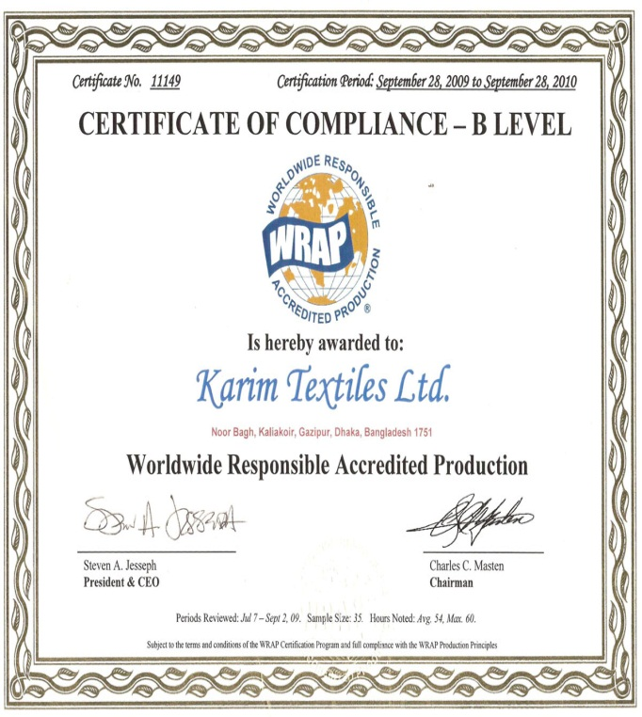
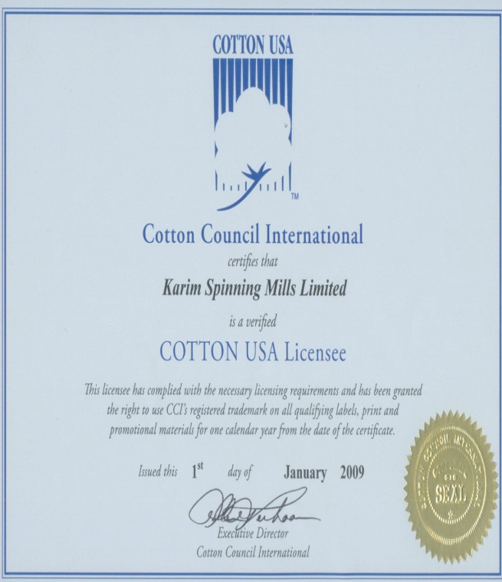
Certified By, WRAP
Cotton USA Licensee

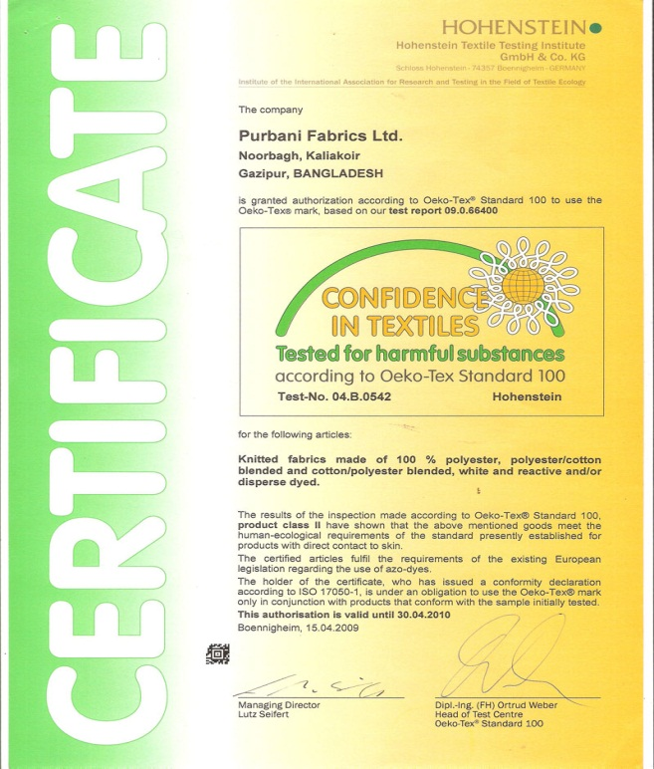
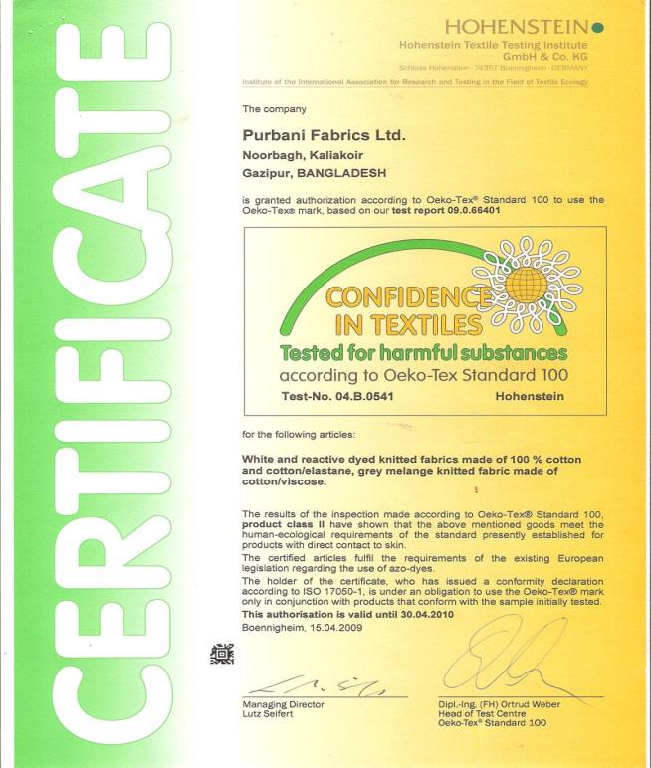

Certified By, Oeko-Tex

Certified By, Oeko-Tex

Location Layout

PURBANI
Nurbag, Mouchak, Kaliakoir
Gazipur, Dhaka

PEPSI
(Industries)

‘MOHONA’
Cinema Hall

Gazipur Bypass

West

North
South

East

Plant Layout of PURBANI

Main Gate
Office Room

Karim Textiles Ltd.
( 8 storied building)

Generator & Boiler Room

Purbani Fabrics Ltd.(Dyeing Section)

Purbani Yarn Dyeing Ltd.

Purbani Fabrics Ltd.
(Knitting Section 8 storied building)

ETP (Capacity-2400mᶟ)
Under construction

ETP (Capacity-1200mᶟ)

2.2 Sister Concern of Purbani Fabrics Ltd.

- Purbani Fabrics Ltd.
- Karim Spinning Mills Ltd.
- Shohagpur Textile Mills Ltd.
- Purbani Synthetic Spinning Ltd.
- Purbani Rotor Spinning Ltd.
- Purbani Yarn Dyeing Ltd.
- Karim Textiles Ltd.
- Purbani Traders.
- Purbani Food & Beverage Ltd.
- Purbani Fisheries.

2.3 Upper Level Organizational Structure of Purbani Fabrics Ltd.
Chairman & Managing director
Marketing & Merchandising
Directors
Production
Utility

Remarks: Elaborate organgram will be added in each section.

Knitting Section

3. Knitting Section

Layout of Knitting Section

WEST
4’Th Floor

Yarn Package

Circular Knitting

Air compressor

Safety Equipment

Office Room
S
O
U
T
H
N
O
R
T
H

EAST

3.1Organogram of Knitting section in Purbani Fabrics Ltd:
Knitting Manager

Knitting Assistance Manager

Knitting Master

Production Master

Production Officer

Knitting Incharge

Knitting Supervisor

Knitting Technician

Knitting Operator

Knitting Helper

Knitting Cleaner

3.2Yarns:
Yarns are the most important part of a Textile industry. Yarn is a generic term for a continuous strand of textile fibers, filaments or material in a form suitable for knitting, weaving or otherwise intertwining to form a textile fabric. Yarn occurs in the following forms:
- Number of fibers twisted together.
- Number of filaments lay together without twist.
- Number of filaments lay together with a degree of twist.
- Single filament with or without twist.
- A narrow strip of material.

3.2.1 Counts of Yarns Used:
Count is an important parameter for the manufacture and processing of fabrics as it indicates the fineness of the yarn. Finer or more count yarns produce finer fabrics and coarser or less count yarns produce coarser fabrics.
Normally the counts of yarns used in the DIVINE Knitting section are given below:
Cotton: 20/1, 24/1, 26/1, 28/1, 30/1, 34/1, 40/1 Ne
PC: 20/1, 26/1, 28/1, 30/1 Ne
CVC: 26/1, 30/1, 34/1 Ne
Mélange: 20/1, 22/1, 26/1, 30/1 Ne
Spandex: 40D, 70D
Polyester: 75D, 150D
Sewing thread: 40/2, 150D etc.

3.2.2 Yarn LOT( Specification Card):
The yarn lot specification card contains the following information:
Yarn Count- 30/CARD
Supply-PSML Lot- 04/10
Quantity- 4650.0 kg
Yarn Count- 34/C.
Slub Supply-PSML Lot-61/10
Quantity-1200.0 Kg

3.2.3 Types of yarns used in PURBANI:
There are various types of yarns used in PURBANI FABRICS LIMITED knitting section which is discussed below:
- Carded Cotton Yarn.
- Combed Cotton Yarn.
- Slub Cotton Yarn.
- 50% Cotton & 50% Modal Yarn.
- Grey Mélange.
- Lycra/Elastane/Spandex Yarn.
- CVC (60% Cotton & 40% Polyester) Yarn.
- Polyester Yarn.
- Cotton Mélange.
- Various Cotton Dyed Yarn.
- PC (60% Polyester & 40% Cotton) Yarn.
- Viscose Yarn.
- Carded Slub Yarn.

3.2.4 Characteristics of various types of Yarn:
There are various types of yarns which are formed of various types of fibers and demonstrate various properties. The varieties of yarns used in PURBANI are discussed below:

Carded Yarn:
A fibrous cotton yarn or cotton blend yarn made of short staple cotton fiber from which most of the impurities have been removed by various processes of carding and drawing.

Combed Yarn:
A fibrous cotton yarn which is combed and the fibers are long with small diameter is called Combed Yarn.

Slub Cotton Yarn:
The cotton yarn which contains irregularity of thick and thin places in the yarn in continuous bases is termed as Slub Cotton Yarn.
50% Cotton & 50% Modal Yarn:
The yarn which is a mixture of 50% cotton fiber and 50% Modal fiber is termed as 50%Cotton& 50%Modal Yarn. Modal is mainly an artificial fiber which has a similar appearance to silk.

Grey Mélange:
The yarn which is a mixture of maximum 15% viscose fiber and 85% cotton fiber is known as Grey Mélange yarn.

Lycra/ Elastane/ Spandex yarn:
A yarn which shows elastic properties and which is formed of polyurethane/ polyamide fibers is known as Elastane/Lycra/Spandex yarn.

CVC yarn:
CVC yarn is a yarn which means Chief Value Cotton and consists of 55% /60% /65% of cotton fiber and 45%/ 40%/ 35% of polyester fiber.

Polyester Yarn:
Such type of yarn which is made from polymers produced from melt spinning of ethylene glycol and teripthelic acid.

Cotton Mélange:
A yarn which consists of 15% black dyed yarn and 85% of grey cotton yarn and spanned to form a yarn is called Cotton mélange.

Viscose Yarn:
Such type of yarn which is formed of spinning of viscose rayon fiber is called Viscose
Yarn.

PC (60% Polyester & 40% Cotton) Yarn:
Such yarns which are formed by blending 60% polyester fiber and 40% cotton fiber through various processes. It is also known as Anthra Mélange.

3.2.5 Types of raw material:
- Yarn: Carded Yarn
- Combed Yarn
- Cotton Modal
- Cotton + Viscose
- Cotton Yarn Cone
- Spun Yarn: 1oo% Polyester
- Lycra

3.2.6 Source of yarn for knitting:
Serial No | Name of the spinning Mills
1 | Karim Spinning Mills ltd.
2 | Square Yarns ltd.
3 | Badsha Textiles ltd.
4 | Shamsuddin Spinning Mills ltd.
5 | CRC Textile Mills ltd.
6 | Syed Spinning and Cotton Mills ltd.
7 | Amber Cotton Mills ltd.
8 | Keya Spinning Mills ltd.
9 | M.S.M.L
10 | Rising Spinning Mills ltd.
11 | Karim Spinning Mills ltd.

3.2.7 Different yarn and count For Knitting:

SL/No | Yarn Type | Composition | Yarn Count
01 | Carded Yarn | 100% Cotton | 10s, 12s, 16s, 20s, 20/2, 22s, 24s, 26s,28s, 30, 32s, 34s,
02 | Combed Yarn | 100% Cotton | 20s, 22s, 24s, 26s, 28s, 30s, 32s, 34s, 36s, 40s, 50s, 60s.
03 | G/M | (Viscose %) | 1%, 2%, 5%, 10%, 15%, 20%, 30%, 40%
04 | Spun Yarn | 100% Polyester | 36D, 70D, 72D, 75D,
05 | PC | Polyster + Cotton | 24s, 26s, 28s,30s, 32s, 34s,
06 | CVC | Cotton + Polyester | 24s, 26s, 28s, 30s, 34s, 36s, 40s
07 | C/M | Cotton 50% + Polyester 50% | 26s, 28s, 30s,
08 | Lycra | Synthetic | 20D, 40D, 70D,

3.3Fabrics Produced in Purbani Fabrics Ltd:
- Single Jersey.
- Single Lacost.
- Double Lacost.
- Double Pk.
- Heavy Jersey.
- Rib Fabrics.(1/1, 2/1)
- Lycra rib (1/1, 2/1)
- Plain Interlock.
- Single Jersey full feeder lycra.
- Single Jersey half feeder lycra.
- Single lacust half feeder lycra.
- Teri fabrics.
- Flat knit collar.
- Fleece fabric.
- Cos Fleece.
- Birds eye.
- Mini eye let.
- Eye let.
- Interlock Pk.
- Wofelet.

3.4Flow process of knitting section:
Yarn bobbin from storage stage

Yarn selection

Attaching bobbin to bobbin stand

Knitting of Yarns to circular knitting machines

Knitted fabrics rolling in the take-up roller

Detaching fabric rolls from the rollers

Inspection of the knitted fabrics

Batching of the knitted fabrics

Storing of the knitted fabrics

3.5Flat Knitting Section:
Generally collar and cuff of knitted garments is produced in this section there are flat knitting machines of the same type. There specifications of the machines are given below:

Place of Origin | Taiwan
Brand Name | JY LEH
Model Number | JL-303
Knitting Style | Flat
Computerized | Yes
Available | 41 pieces

Features:
- Programs are stored in I/C card and can be input to other machines.
- The machine can compile the program input by keyboard without other auxiliary equipment.
- It is adjustable for knitting width without any location limit.
- Feature of single carriage can knit wide or narrow textile of best quality.
Specifications:
Model | JL-303
Gauge | 7, 8, 10, 12, 14 and 16G
Bed Width | 40"(101cm), 52"(132cm), 68"(172cm)
Carriage Speed | 100-120 cm/sec
Knitting Width | Can be set freely
Yarn feeder | Single feeder
Cam Driving | Solenoid driving
Stitch Density | 0-99 stepping motor
Yarn Colors | 6 colors, both side changeable
Racking | 1/2 P x 1 section, 1P x 5 section
Rahben | H-needle tuck, L-needle tuck, all needle tuck
Needles used | High and low butt
Take Down Roller | Automatic auxiliary roller moves with fabric take-down
Data input | Direct input from keyboard, memory by I/C card
Driving | 1/2HP, 3 phase, AC motor by frequency converter control
Language | English and Chinese are available.
Power | 220V, 50/60Hz, single phase
Dimension | 80 x 234 x 185 (cm) / L.W.H for 52"
 | Specifications and appearance may change without notices

Collar:L: 45-50 cm * W:09-10cm * T:3/4/5 ply, 35-45 pcs /Kg(Depends on count, ply of Yarn and tension of knitting.

Cuff: L: 37-39 * W:3.8-4.0cm * T:2/3/4 ply, 60-70 pcs /Kg(Depends on count, ply of yarn and tension of knitting.

Factor should be considered in production:
There should follow several factor when set the program according to buyer requirements.
- Ply of Yarn
- Width of Collar or Cuff
- Stitch Length
- Type of Collar & Cuff (e.g. - Fancy, Tripping, Solid etc.)

3.6Singlejersey Circular Knitting Machine:

Machine NO | Manufacturer | Cylinder Diameter | Feeders | Gauge | Machine Model | Needles | Safety RPM | Manufacturing Year
1 | RUNSHAN (Made in China) | 16’’ | 48 | 24G | RS | 1392 | 24 | 2008
2 | RUNSHAN (Made in China) | 17’’ | 51 | 28G | RS | 1488 | 24 | 2008
3 | RUNSHAN (Made in China) | 19’’ | 55 | 28G | RS | 1680 | 24 | 2008
4 | RUNSHAN (Made in China) | 18’’ | 54 | 28G | RS | 1584 | 24 | 2008
5 | RUNSHAN (Made in China) | 30’’ | 30 | 28G | RS | 2640 | 24 | 2008
6 | RUNSHAN (Made in China) | 34’’ | 102 | 28G | RS | 2990 | 24 | 2009
7 | FALMAC  ( Made in Singapore) | 24’’ | 72 | 24G | FSB 3×SK | 1810 | 24 | 1998
8 | FALMAC  ( Made in Singapore) | 21’’ | 63 | 24G | FSB 3×SK | 1583 | 24 | 1999
9 | FALMAC  ( Made in Singapore) | 23’’ | 69 | 24G | FSB 3×SK | 1734 | 24 | 1998
10 | FALMAC  ( Made in Singapore) | 25’’ | 75 | 24G | FSB 3×SK | 1885 | 24 | 1999
11 | FALMAC  ( Made in Singapore) | 22’’ | 66 | 24G | FSB 3×SK | 1659 | 24 | 1998
12 | FALMAC  ( Made in Singapore) | 20’’ | 60 | 24G | FSB 3×SK | 1508 | 24 | 1999
13 | FALMAC  ( Made in Singapore) | 19’’ | 57 | 24G | PN 3×SK | 1433 | 24 | 2000
14 | FALMAC  ( Made in Singapore) | 17’’ | 51 | 24G | PN3SK-15 | 1282 | 24 | 2000
15 | FALMAC  ( Made in Singapore) | 26’’ | 78 | 24G | PN 3×SK | 1960 | 24 | 2000
16 | FALMAC  ( Made in Singapore) | 20’’ | 84 | 24G | PN3SK-15 | 1507 | 24 | 2006
17 | FALMAC  ( Made in Singapore) | 23’’ | 69 | 28G | PN3SK-15 | 2023 | 24 | 2006
18 | FALMAC  ( Made in Singapore) | 18’’ | 54 | 24G | PN3SK-15 | 1357 | 24 | 2006
19 | Mayer &Cie (Made in Germany) | 16’’ | 51 | 28G | MV4-3.2 | 1408 | 24 | 2002
20 | Mayer &Cie (Made in Germany) | 16’’ | 51 | 28G | MV4-3.2 | 904 | 24 | 2002
21 | Mayer &Cie (Made in Germany) | 30’’ | 96 | 28G | RELANIT411 | 2639 | 24 | 2002
22 | Mayer &Cie (Made in Germany) | 30’’ | 96 | 28G | RELANIT411 | 2639 | 24 | 2002
23 | Mayer &Cie (Made in Germany) | 30’’ | 96 | 28G | RELANIT411 | 2639 | 24 | 2002
24 | Mayer &Cie (Made in Germany) | 30’’ | 96 | 28G | RELANIT411 | 2639 | 24 | 2002
25 | Mayer &Cie (Made in Germany) | 30’’ | 96 | 28G | RELANIT411 | 2639 | 24 | 2002
26 | Mayer &Cie (Made in Germany) | 30’’ | 96 | 28G | RELANIT411 | 2639 | 24 | 2002
27 | JIUNN LONG Machine Co. Ltd(Taiwan) | 34’’ | 102 | 24G | JLS-C | 2544 | 13 | 2012
28 | JIUNN LONG Machine Co. Ltd(Taiwan) | 34’’ | 102 | 24G | JLS-C | 2544 | 13 | 2012
29 | JIUNN LONG Machine Co. Ltd(Taiwan) | 34’’ | 102 | 24G | JLS-C | 2544 | 13 | 2012
30 | JIUNN LONG Machine Co. Ltd(Taiwan) | 36’’ | 108 | 24G | JLS-2 | 2712 | 13 | 2012
31 | JIUNN LONG Machine Co. Ltd(Taiwan) | 36’’ | 108 | 24G | JLS-2 | 2712 | 13 | 2012
32 | JIUNN LONG Machine Co. Ltd(Taiwan) | 36’’ | 108 | 24G | JLS-2 | 2712 | 13 | 2012
33 | Mayer &Cie (Made in Germany) | 30’’ | 96 | 28G | RELANIT411 | 2639 | 24 | 2002
34 | Mayer &Cie (Made in Germany) | 30’’ | 96 | 28G | RELANIT411 | 2639 | 24 | 2002
35 | Mayer &Cie (Made in Germany) | 30’’ | 96 | 28G | RELANIT411 | 2639 | 24 | 2002
36 | Mayer &Cie (Made in Germany) | 30’’ | 96 | 28G | RELANIT411 | 2639 | 24 | 2002
37 | Mayer &Cie (Made in Germany) | 30’’ | 192 | 28G | RELANIT1.6R | 2639 | 24 | 2002
38 | Mayer &Cie (Made in Germany) | 30’’ | 192 | 28G | RELANIT1.6R | 2639 | 24 | 2002
39 | Mayer &Cie (Made in Germany) | 30’’ | 96 | 28G | RELANIT411 | 2639 | 24 | 2002

3.7Double Jersey Circular knitting Machine:

Machine NO | Manufacturer | Cylinder Diameter | Feeders | Gauge | Machine Model | Needles | Safety RPM | Manufacturing Year
01 | Mayer &Cie (Made in Germany) | 12’’ | 23 | 18G | FV 2.0 | 2×684 | 24 | 2002
02 | Mayer &Cie (Made in Germany) | 14’’ | 29 | 18G | FV 2.0 | 2×792 | 24 | 2002
03 | Mayer &Cie (Made in Germany) | 16’’ | 33 | 18G | FV 2.0 | 2×900 | 24 | 2002
04 | Mayer &Cie (Made in Germany) | 16’’ | 33 | 18G | FV 2.0 | 2×900 | 24 | 2002
05 | Mayer &Cie (Made in Germany) | 18’’ | 37 | 18G | FV 2.0 | 2×1008 | 24 | 2002
06 | Mayer &Cie (Made in Germany) | 18’’ | 37 | 18G | FV 2.0 | 2×1008 | 24 | 2002
07 | Mayer &Cie (Made in Germany) | 30’’ | 96 | 24G | OV 3.2 QC | 2×2268 | 24 | 2002
08 | Mayer &Cie (Made in Germany) | 30’’ | 96 | 24G | OV 3.2 QC | 2×2268 | 24 | 2002
09 | Mayer &Cie (Made in Germany) | 30’’ | 96 | 24G | OV 3.2 | 2×2268 | 24 | 2000
10 | Mayer &Cie (Made in Germany) | 30’’ | 96 | 24G | OV 3.2 | 2×2268 | 24 | 2000
11 | Mayer &Cie (Made in Germany) | 30’’ | 96 | 24G | OV 3.2 | 2×2268 | 24 | 2000
12 | Mayer &Cie (Made in Germany) | 30’’ | 60 | 18G | FHG11 | 2×1680 | 24 | 2002
13 | Mayer &Cie (Made in Germany) | 24’’ | 54 | 18G | FV 2.0 | 2×1476 | 24 | 2002
14 | Mayer &Cie (Made in Germany) | 24’’ | 50 | 18G | FV 2.0 | 2×1344 | 18 | 2002
15 | Mayer &Cie (Made in Germany) | 22’’ | 45 | 18G | FV 2.0 | 2×1248 | 18 | 2002
16 | Mayer &Cie (Made in Germany) | 20’’ | 41 | 18G | FV 2.0 | 2×1128 | 24 | 2002
17 | Mayer &Cie (Made in Germany) | 30’’ | 96 | 24G | OV 3.2 | 2×2268 | 24 | 2002

Remarks:
Production runswith the help of mechanical fitters. For any kind of mechanical fault of any machine the fix and work under technical in charge. Production officers take account of daily production by running after the supervisor and workers so on.

3.8Process flow chart of knitting:

Sample fabric

Design analysis

Machine selection

Setting the machine for the specific design

Yarn in cone form

Feeding the yarn cone in the creel

Feeding the yarn in the feeder via trip-tape positive feeding arrangement and tension devices

Knitting

Withdraw the rolled fabric and weighting

Inspection

Numbering
3.9Description of Production Process:
In every mill, there maintains a sequences in production processing. It is also followed in this mill where we were in industrial attachment. The process sequences are in list below:

- Firstly, knitting manager gets a production shit from the merchandiser as accordance as consumer requirements then he informs or orders production officer about it.
- Production officer informs technical in charge and knows about machine in which the production will be running.
- Technical in charge calls for leader of mechanical fitter troops, they two take decision about machine for production considering machine condition, production capacity, maintenance complexity, etc.
- Production officer with experienced mechanical fitter adjusts required stitch length and grey GSM for required final GSM.
- Supervisor checks daily production regularity and make operator conscious about finishing tin due time.
- Operators operate machine in high attention as if there were no faults in the fabrics. If he thinks or sure about any fabric fault, then he calls for the mechanical fitters in duty. Mechanical fitter then fixes it if he can or he informs technical in charge. Then he comes in spot.
- After required production and final inspection in 4-point system, they sent in dyeing section.

3.9.1 Production Parameters:
- Machine Diameter;
- Machine rpm (revolution per minute);
- No. of feeds or feeders in use;
- Machine Gauge;
- Count of yarn;
6. Required time (M/C running time);
7. Machine running efficiency.

3.9.2 Relationship between knitting parameters:

1. Stitch length increase with the increase of GSM.
2. If stitch length increase then fabric width increase and WPI decrease.
3. If machine gauge increase then fabric width decrease.
4. If yarn count increase (courser) then fabric width increase.
5. If shrinkage increases then fabric width decrease but GSM and WPI increase.
6.For finer gauge, finer count yarn should use.
7. Grey GSM should be less than finish GSM.
3.10Considerable points to produce knit fabric:
Before production of knitted fabric, these factors are needed to consider. These includes-

- Type of Fabric or design of Fabric.
- Finished G.S.M.
- Yarn count
- Types of yarn (combed or carded)
- Diameter of the fabric.
- Stitch length
- Color depth.

3.11G.S.M
It is technical term that indicates the weight of the fabric per square meter.
Points considered while setting grey GSM:
- Enzyme level
- Color
- Suided or non- suided

Changing of GSM:
- Major control by VDQ pulley.
- Minor control by stitch length adjustment.
- Altering the position of the tension pulley changes the G.S.M. of the fabric. If pulley moves towards the positive directive then the G.S.M. is decrease. And in the reverse direction G.S.M will increase.

3.12Factors that should be changed in case of fabric design:
- Cam setting
- Set of needle
- Size of loop shape

3.13Effect of stitch length of color depth:
If the depth of color of the fabric is high loop length should be higher because in case of fabric with higher loop length is less compact. In dark shade dye take up% is high so GSM is adjusted then. Similarly in case of light shade loop length should be relatively smaller.

3.14Methods of increasing production:
By the following methods the production of knitted fabric can be increased –

1. By increasing m/c speed:
Higher the m/c speed faster the movement of needle and ultimately production will be increased. But it has to make sure that excess tension is not imposed on yarn because of this high speed.

2. By increasing the number of feeder:
If the number of feeder is increased in the circumference of cylinder, then the number of courses will be increased in one revolution at a time.

3. By using machine of higher gauge:
The more the machine gauge, the more the production is. So by using machine of higher gauge production can be increased.

4. By imposing automation in the m/c:
a) Quick starting & stopping for efficient driving system.
b) Automatic m/c lubrication system for smoother operation.
c) Photo electric fabric fault detector.
5. By imposing other developments:
  - Using creel-feeding system.
  - Applying yarn supply through plastic tube that eliminates the possibilities of yarn damage.
  - Using yarn feed control device.

3.15Faults and their causes in knitting:

Hole mark:
Causes:
- Buckling of the needle latch
- Buckling the sinker
- Higher G.S.M

Star mark:
Causes:
- Buckling of the needle latch.
- Yarn tension variation during production.
- Low G.S.M.

Oil spot/Grease spot:
Causes:
- Excess oil/Grease use.
- Jamming of needle & sinker.

Patta:
Causes:
- Yarn comes from different lot.
- Faulty cam use in the m/c.

Needle mark:
Causes:
- Faulty needle use in the m/c.

Sinker mark:
Causes:
- Faulty sinker use in the m/c

Fabric Shrinkage:
Causes:
- Yarn twist Twist Shrinkage
- Knitting tension
- Fabric G.S.M. ` G.S.M. Shrinkage

3.16 Collection of faulted knitted fabric:

Setup
Hole

Oil or grease spot
Lycra out

Vertical stripe
Needle mark

3.17 Different Fabric GSM and Their Yarn Count:

- S/J without lycra -

Fabric G.S.M | Yarn Count
110 – 120 | 40 ^{S} – 36 ^{S}
120 – 130 | 36 ^{S} - 32 ^{S}
130 – 140 | 32 ^{S} – 28 ^{S}
140 – 150 | 28 ^{S}
150 – 160 | 26 ^{S}
170 – 210 | 24 ^{S}

- Rib without lycra -

Fabric G.S.M | Yarn Count
180 – 190 | 36 ^{S} - 32 ^{S}
190 – 200 | 30 ^{S}
200 – 215 | 28 ^{S}
215 – 230 | 26 ^{S}
230 – 250 | 24 ^{S}
250 – 300 | 24 ^{S}

- Interlock without lycra -

Fabric G.S.M | Yarn Count
200 – 220 | 34 ^{S}
220 – 230 | 32 ^{S}
230 – 250 | 30 ^{S}
250 – 300 | 26 ^{S}

- Lacoste without lycra -

Fabric G.S.M | Yarn Count
180 – 190 | 30 ^{S}
190 – 210 | 28 ^{S}
210 – 230 | 26 ^{S}
230 – 250 | 26 ^{S}

- 40D Lycra Rib -

Fabric G.S.M | Yarn Count
230 – 240 | 32 ^{S}
240 – 250 | 30 ^{S}
250 – 280 | 26 ^{S}
280 – 300 | 24 ^{S}

- 40D Lycra S/J –

Fabric G.S.M | Yarn Count
180 – 190 | 34 ^{S}
190 – 210 | 32 ^{S}
210 – 220 | 30 ^{S}
220 – 240 | 28 ^{S}
240 – 250 | 26 ^{S}

3.18Different Parts of Knitting Machine:

Creel:Creel is used to place the cone.
Feeder:Feeder is used to feed the yarn.
Tensioning device:Tensioning device is used to give proper tension to the yarn.
VDQ pulley:VDQ pulley is used to control the GSM by controlling the stitch length.
Guide:Guide is used to guide the yarn.
Sensor:Sensor is used to seen & the machine stops when any problem occurs.
Spreader:Spreader is used to spread the knitted fabric before take up roller.
Take up roller:Take up roller is used to take up the fabric
Fixation feeder: These types of feeder are used in Electrical Auto Striper Knitting Machineto feed the yarn at specific finger.

3.19Introduction to Quality Assurance System:

After collecting fabric rolls from different machines, these fabrics need to inspect thoroughly by the quality inspectors to assure required quality before dyeing. Quality assurance of knitted grey fabric is described here.

3.20 Some points are needed for maintaining high quality fabric:
- Brought good quality yarn.
- Machines are oiled and greased accordingly.
- G.S.M, Stitch length, Tensions are controlled accurately.
- Machines are cleaned every shift and servicing is done after a month.
- Grey Fabrics are checked by 4 point grading system.

3.21List of Equipment for quality control:
The list of equipment’s to assure quality:-
- Inspection m/c.
- Electronic balance.
- GSM cutter.
- Measuring tape.
- Scissors.
- Indication sticker.

3.22 Quality Assurance Property:
- Body & rib inspection:
All rolls are kept in front of the inspection m/c time to time and are inspected over the inspection m/c visually in a pre-set speed against light. For any major or minor faults like thick-thin, barre mark, fall out, contamination, fly, holes, oil lines, needle line, slubsetc are recorded in inspection report to classify the fabric. Here four points system is used in inspection system.
- Collar & cuff inspection:
Collar& cuff are inspected visually under the light box, any major or minor fault in collar/cuff like having wrong ply, hole, needle line, slubs, wrong design, first round problem etc properly counted and recorded.

3.23 Quality Standard:
Purbani Fabrics Ltd.maintains the ISO: 9001:2000 standards in case of quality. Therefore, the four points system is followed to inspect the body & rib fabric. The defects found and points given against are recorded in the inspection sheet. Following table shows the four point grading system followed by inspection atPurbani Fabrics Ltd.

Four (4) - Point system for knitting fault inspection:

Knitting fault | Point
Slub | 1
Any hole | 4
Needle/Sinker line | 4
Needle breakage(upto 10) | 4
Press off | 4
Thick, Thin, Dirt, Oil spot, Contamination up to 3" in length | 1
Thick, Thin, Dirt, Oil spot, Contamination up to 6" in length | 2
Thick, Thin, Dirt, Oil spot, Contamination up to 9" in length | 3
Thick, Thin, Dirt, Oil spot, Contamination above 9" in length | 4

Quality (points per 100 square meters):
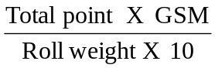

Quality Classification:

1 | 2 | 3
<20 | 20 - 30 | >30
OK | Ask | Reject

3.24Production Calculation:

A. Production/shift in kg at 100% efficiency

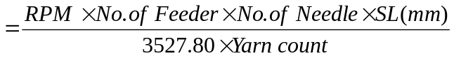

B. Production/shift in meter

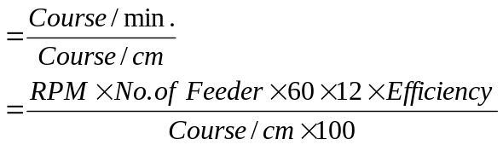

C. Fabric width in meter:

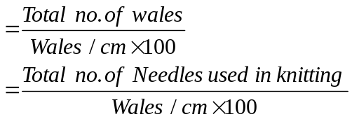

D. Calculation for total number of needle of a machine = G × D × π

Here,

G = Machine gauge

D = Machine diameter

E. From finish G.S.M calculating grey GSM, SL, count:

Suppose a fabric involve 180 finishes G.S.M
So, gray G.S.M=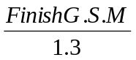=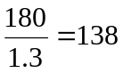
So, count=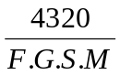=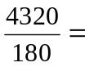24/s

So, S.L = 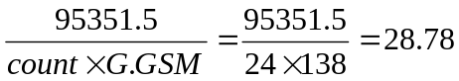 cm=2.9 mm

F. Calculation of S.L where yarns count = 24:

S.L=16.66d
=16.66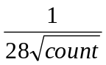
=16.66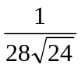=.308 cm =3.08mm

3.25PHOTO GALLERY:
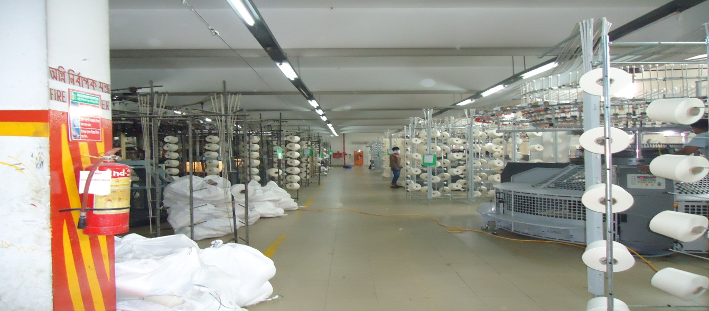
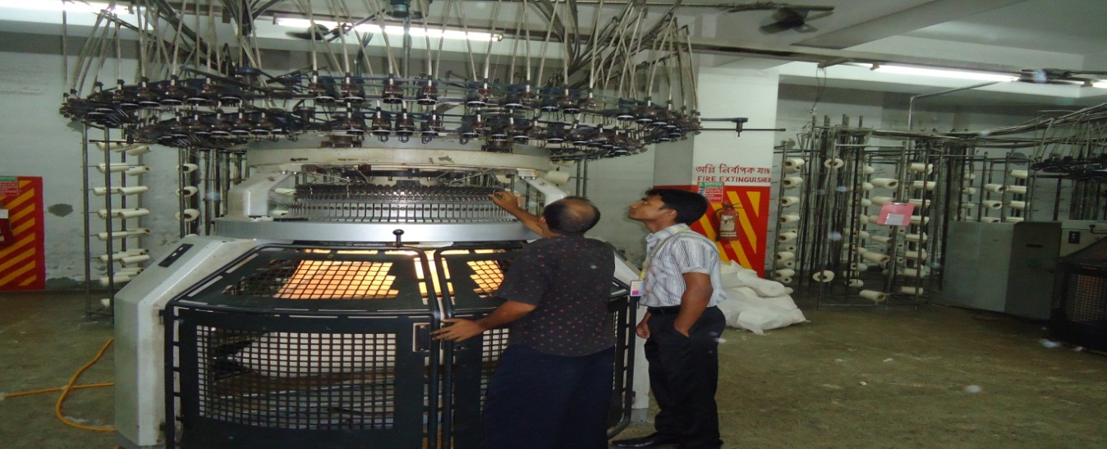
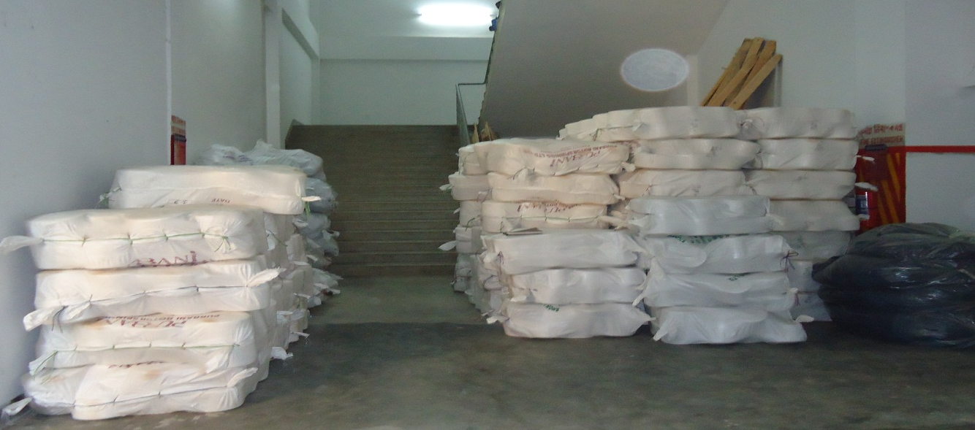

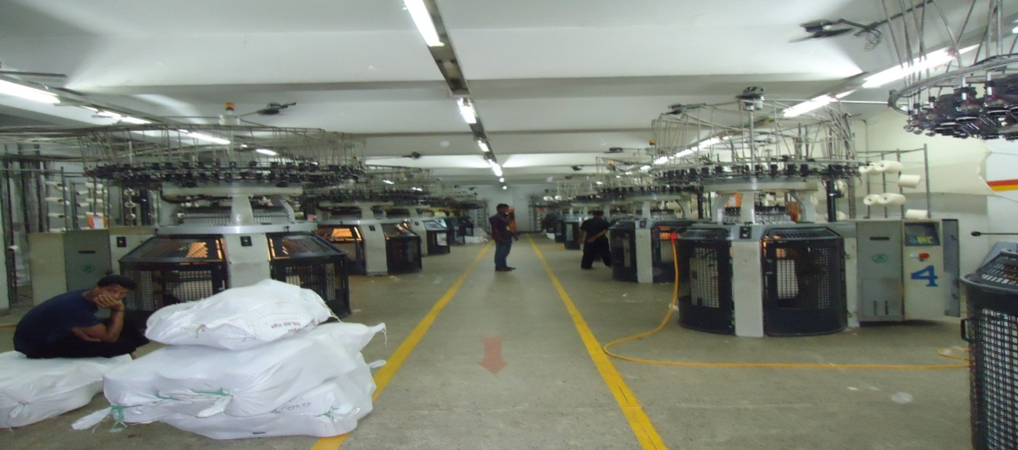
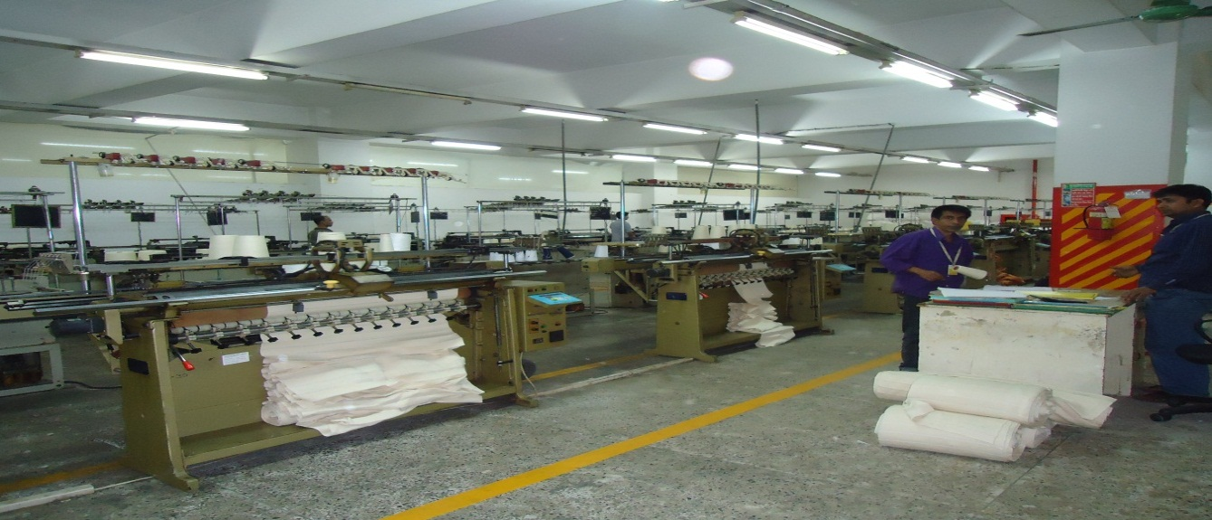

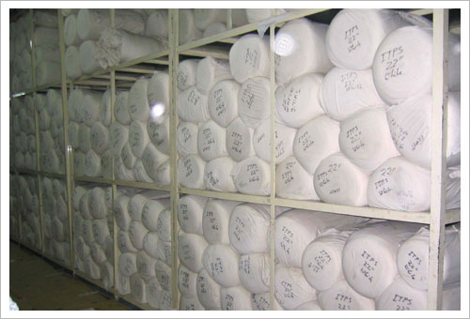

3.26 Sample Collection:
2/1 Rib
1/1 Stripe

Single Jersey(Normal)
Single Jersey Stripe

Single Jersey Full Feeder Lycra
Single Jersey Auto Stripe

Single Jersey Melange

1/1 Rib

Sample Collection:
Single Jersey Polyester
2/2 Rib

Lacost

Interlock Pk

Interlock Plain

Fleece

Mesh Fabric

BATCHING

- Batching Section
4.1Layout of Batching Section:

Air Turning m/c
Grey Fabric Inspection m/c No-2
Grey Fabric Inspection m/c No-1

4.2Grey Fabric Inspection:
The inspection and grading of fabric quality is one of the important functions of Quality Control in the grey or finished state, the grading of fabric is a difficult task, taking two primary considerations: as the frequency of effects and the seriousness of defects.

The grading has two primary functions: First, to classify the fabrics according to standard qualities based on the end-use and costumer demands and second, to supply information as to the qualities actually being produced.
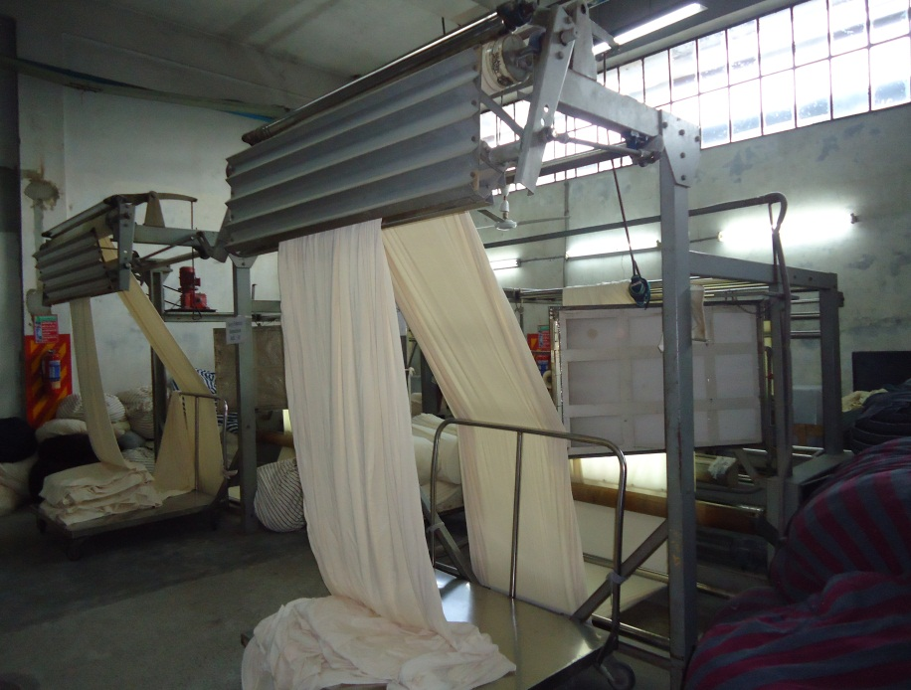

Grey Fabric Inspection

The Knitted fabric can be classified into three levels of quality, each one have a number of points for defects as follows.
The First quality level 40 points per 100 Linear Yards.
The Second quality level (40 – 80) points per 100 Linear Yards.
The Third quality level 80 points or more per 100 Linear Yards.

4.3General Instructions for the final inspection:

- All pieces will be graded on the base of 40 points per 100 Linear yards Mapping will be done on each piece to insure proper grading. Do not count more than 4 points per one yard.
- All defects must be recorded and marked in final inspection and an accurate account of points made to insure proper grading.
- All fabric must meet specifications.
- At the end of each piece of fabric, the inspector will add up total points and decide whether the piece can be shipped as first quality or not, reworked, placed in lower quality, or cut and upgraded for shipment. Fifteen yards or more can be shipped as first quality.
- The quality control supervisor must approve the grading of all quality levels and check the lower quality.
- Major or unsightly defects in the first and last yard of a roll or piece will be cut. All defects of one yard length or more will be cut out of the piece. Defects within the first 2 inches or the last 2 inches of a piece will not be cut out or counted in the grading.

- Open defects on the back of fabric such as drops, runs and hanging picks are to be included in the grading of fabric.
- Pieces can be connected together, once each piece must be the same shade.
- All defects such as runs that extend more than a yard in length will be cut out.
- Fabric up to 70 inches will be allowed a bow of not more than 1 inch and a Bias of not more than 2 inches.
- Defects within one inch of the fabric edge will not be counted except on tubular fabrics. All defects will be counted in tubular goods.

4.4Grading procedure:
- All open defects or major defects counted with 4 points per defect.
- Surface defects over 9 inch length counted with 4 points per defect.
- Surface defects 6 to 9 inches length counted with 3 points per defect.
- Surface defects 3 to 6 inches length counted with 2 points per defect.
- Surface defects up to 3 inches length counted with one point per defect.
- Running defects, such as tucks, needle lines, barre, crack marks, are judgment defects

Batching is the process to get ready the fabrics which should be dyed and processed for a particular lot of a particular order.

4.5Object of Batching:
- To receive the grey fabric roll from knitting section or other source.
- Turn the grey fabric if require.
- To prepare the batch of fabric for dyeing according to the following criteria –
- Order sheet (Received from buyer)
- Dyeing shade (color or white, light or dark)
- M/C capacity
- M/C available
- Type of fabrics(100% cotton, PET, PC, CVC)
- Emergency
- To send the grey fabric to the dyeing floor with batch card.
- To keep records for every previous dyeing.

4.6Proper batching criteria:

- To use maximum capacity of existing dyeing m/c.
- To minimize the washing time or preparation time & m/c stoppage time.
- To keep the no. of batch as less as possible for same shade.
- To use a particular m/c for dyeing same shade.

4.7Batch management:
Primarily batching is done by dyeing manager taking the above criteria under consideration. Batch section in charge receives this primary batch plan from dyeing manager. Some time planning is adjusted according to m/c condition or emergency.

4.8M/cs in batch section:

No. of M/c | : 01
Machine name | : Air turning machine
Origin | : KOREA

No. of M/c | : 02
Machine name | : Fabric Inspection machine
Origin | : KOREA

Dyeing Lab Section

5. Dyeing Lab Section
5.1 Organogram of color lab:
Lab Manager

Lab Incharge

Asst. Incharge

Shift Incharge

Technician

Lab Assistance

LAB DIP Development
5.2 Definition:
LAB dip development means the sample which is dyed according to buyer’s requirements (similar shade and so on). Depending on lab dip development sample dyeing and bulk production the dyeing planning done.

5.3 Objective of Lab Dip:
The main objectives in LAB dip are as follows:
- To calculate the recipe for sample dyeing.
- To compare dyed sample with swatch by light Box or Spectroflash.
- To calculate revise recipe for sample dyeing.
- Finally approved Lab Dip (Grade: A B C).

5.4 Development of Dip:
Receiving standard swatch

Spectrophotometer reading

Recipe start up software

Startup recipe given

Manual dispersion (pipetting)

Pot dyeing

Unload

Normal wash

Acid wash

Hot wash

Cold Rinsing

Drying

5.5 Color measurement of standard Sample:
Color measurement is mainly done for the purpose of shade matching as perfectly as possible. Shade matching of the produced sample with the standard one is compulsory. Color measurement can be done by two methods –

Color measurement

Instrumental method
Manual method

Manual Method:
In manual method, the standard sample’s color is measured by comparing it with previously produced samples of different tri-chromatic color combination. The sample with which the color of the standard matched, that sample’s color recipe is being taken for shade matching .This method’s accuracy completely depends on the vision of the person related to it but person must be needed gather experience about color matching.

Instrumental method:
The instrumental method is more reliable if it is operated accurately to do the work of color measurement. “Spectrophotometer”(Data color) interfaced with a PC is used for shade matching .This instrument works with the principle of reflectance measurement of light at different wave length. When the standard sample is being subjected under spectrophotometer, then the instrument suggest a recipe with required tri-chromatic colors within the tolerance limit of color difference. In this way, color measurement of the standard sample is carried out for the purpose of shade matching.

5.6 Preparation and storage of stock dyes:

Preparation of Concentration of stock dye sol^{n} -
[
Normally 0.1%, 0.5%, 1%, 1.5%, 2% and 4% stock solution of dyes are prepared in beakers for daily used.

Preparation of Concentration of stock chemical sol^{n}-

Similarly 25% salt and 25% soda stock solutions are prepared in beakers for daily use.

5.7 Types of Pipette:
    - 0.1ml
    - 0.2ml
    - 0.5ml
    - 1.0ml
    - 2.0ml
    - 5.0ml
    - 10ml
    - 20ml

5.8Dyes and chemicals measuring formula for lab:
The amount of dye solution (ml) is calculated as follow -

Fabric weight * Shade %
Amount of dye sol^{n} (ml) = ----------------------------------------
Concentration of stock dye sol^{n} %

Example –

In recipe, Fabric wt. = 5gm
Shade % = 2%

[ If used 0. 5 % stock sol^{n}of dyes ] then ,

5 * 2
Amount of dye sol^{n} (ml) = --------- = 20ml .
0. 5

The amount of chemical sol^{n} (ml) is measured as follow -

Fabric wt. * M : L * g/l
Amount of chemical sol^{n} (ml) = --------------------------------------
1000 * Conc. of stock sol^{n}%

Example –

In recipe, Fabric wt. = 5 gm
Salt = 20 g/l
M: L = 10

[ If taken 25 % stock sol^{n} of salt] then ,

5 * 10 * 20
Amount of chemical sol^{n} (ml) = --------------------- = 4 ml
1000 * 0.25

5.9 Machineries for lab dip:
Machine No-1 | Types | Water Heater
Machine No-1 | Brand | Fongs
Machine No-1 | M/C No | SDM2-12-140
Machine No-1 | SER NO | 93-10-017
Machine No-1 | Volt | 415
Machine No-1 | Amp. | 13
Machine No-1 | Origin | Hongkong

Machine No-2 | Types | Dry Iron
Machine No-2 | Brand | Sebec
Machine No-2 | Model | SDI-8
Machine No-2 | SER NO | 93-10-017
Machine No-2 | Volt | 220-240 volts(50-60Hz)
Machine No-2 | Origin | China

Machine No-3 | Types | Sample Dyeing Machine
Machine No-3 | Brand | Datacolor AHIBA IR™
Machine No-3 | Model | SDI-8
Machine No-3 | SER NO | 93-10-017
Machine No-3 | Volt | 220-240 volts(50-60Hz)
Machine No-3 | Origin | USA

Machine No-4 | Types | Sample Dyeing Machine
Machine No-4 | Brand | ECO Datacolor AHIBA NUANCE
Machine No-4 | Model | SDI-8
Machine No-4 | SER NO | 93-10-017
Machine No-4 | Volt | 220-240 volts(50-60Hz)
Machine No-4 | Origin | USA

Machine No-5 | Types | Spectrophotometer
Machine No-5 | Brand | Datacolor
Machine No-5 | Model | SDI-8
Machine No-5 | SER NO | 93-10-017
Machine No-5 | Volt | 220-240 volts(50-60Hz)
Machine No-5 | Origin | USA

Machine No-5 | Types | CMC(Light Box)
Machine No-5 | Brand | Verivide
Machine No-5 | Light-1 | TL84
Machine No-5 | Light-2 | -D65
Machine No-5 | Light-3 | -Florescent
Machine No-5 | Light-4 | -Ultraviolet (UV)

5.10 Salt and Soda for 30% stock solution:
Salt and Soda (g/l) | Salt & Soda Solution (C.C)
4 | 0.53
5 | 0.67
6 | 0.80
7 | 0.93
8 | 1.07
10 | 1.33
12 | 1.60
14 | 1.87
15 | 2.00
17 | 2.27
18 | 2.40
20 | 2.65
25 | 3.30
30 | 4.00
40 | 5.33
50 | 6.70
60 | 8.00
70 | 9.30
80 | 10.66
100 | 13.30

5.11 For production:
S/L | Shade % | salt | soda
01 | 0.001-0.1 | 12 | 5
02 | 0.1-0.5 | 15 | 6
03 | 0.5-1.0 | 20 | 7
04 | 1.0-1.5 | 30 | 8
05 | 1.5-3.0 | 40 | 9
06 | 3.0-4.0 | 50 | 10
07 | 4.0-7.0 | 60 | 13

5.12 Procedure of Lab dips:
For 100% cotton fabric (all in one method):
- Fabric weight measured by electric balance.
- Calculate the recipe.
- Keep the fabric in the pot.
- Then required amount of dyes, water, salt, soda and other chemicals are taken to the pot by pipeting.
- Start the program for dyeing. The dyeing time and temperature depend on types of dyes being used.

Program – 1: For light shade
Fixed temperature = 60⁰c
Time = 60 min.

Program – 2: For dark shade
Fixed temperature = 80⁰c
Time = 60 min.
- After finished the dyeing time then cold wash two times.
- Acid wash for neutralization.
- Then soaping by required soap solution for 10 min. at 95⁰c.
- Cold wash then drying the lab dip and compare with the standard.

For Polyester/cotton blend fabric (all in one method):
- Fabric weight measured by electric balance.
- Calculate the recipe for polyester part.
- Keep the fabric in the pot.
- Then required amount of dyes, water, dispersing agent, acetic acid and sodium acetate are taken to the pot by pipeting.
- Start the program for dyeing. The dyeing time and temperature are carried out for 30 min. at 130⁰c.
- After finished the dyeing time then cold wash two times.
- Then reduction clearing by hydrous, caustic & detergent for 20 min at 70⁰c.
- Cold wash then drying and match with the standardsample.
Again,
- Calculate the recipe for cotton part.
- Keep the fabric in the pot.
- Then required amount of dyes, water, salt, soda and other chemicals are taken to the pot by pipetting .
- Start the program for dyeing. The dyeing time and temperature depends on what types of dyes are being used.
- Then soaping by required soap solution for 10 min. at 95⁰c.
- Cold wash then drying the lab dip and compare with the standard sample.
Program –01:
Fixed temp. = 60⁰c
Time = 60 min.

Program – 02 :
Fixed temp. = 80⁰c
Time = 60 min.

5.13 PHOTO GALLERY
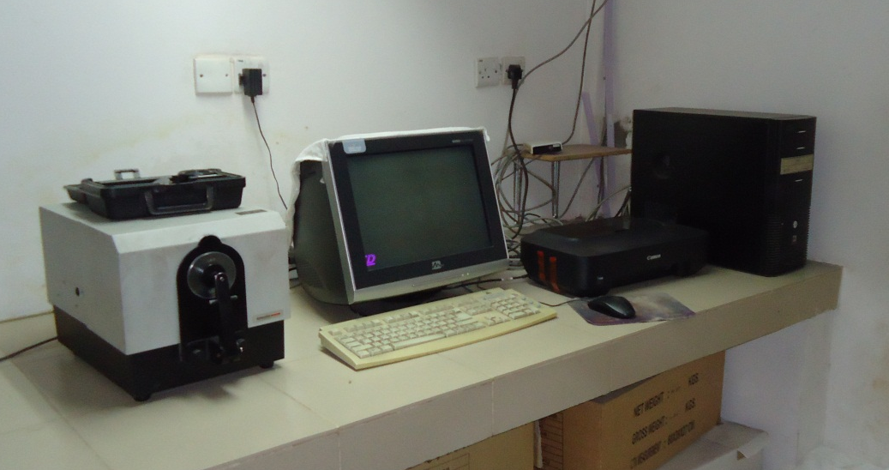

Spector photo-meter

Sample dyeing machine

5.14 Collection of swatch shade with recipe:
Swatch shade-1
Recipe | Amount
S.Yellow S4GL | 1.2 ml
R.Yellow RR | 0.32 ml
Ev.T.B.G | 0.042 ml
Salt | 30 g/l
Soda | 10 g/l

Swatch shade-2
Recipe | Amount
R.Yellow RR | 0.50 ml
R.Red RR | 0.009 ml
R Blue RR | 0.002 ml
Salt | 20 g/l
Soda | 7 g/l

Swatch shade-3
Recipe | Amount
R.Yellow RR | 0.044 ml
R.Red RR | 0.0088 ml
S. Blue RS | 2.86 ml
Salt | 40 g/l
Soda | 14 g/l

Swatch shade-4
Recipe | Amount
R.Yellow RR | 1.92 ml
S.Yellow S4GL | 1.08 ml
R Blue RR | 1.26 ml
Salt | 60 g/l
Soda | 1g/l

Swatch shade-5
Recipe | Amount
Elb.Yellow SB | 1.28 ml
Elb. Red SB2B | 4.5 ml
Elb. D. Blue SB | 0.054 ml
Salt | 80 g/l
Soda | 20 g/l

Swatch shade-6
Recipe | Amount
R.Yellow RR | 0.005 ml
R.Red RR | 0.003 ml
S.Blue RS | 0.10 ml
Salt | 15 g/l
Soda | 6 g/l

{
Swatch shade-7
Recipe | Amount
S.Yellow SSR | 1.1 ml
S.Red SS | 1.04 ml
Salt | 40 g/l
Soda | 14 g/l

Swatch shade-8
Recipe | Amount
S. Red. 3BFN | 0.15 ml
B.Orange | 0.98 ml
Salt | 30 g/l
Soda | 10 g/l

Dyeing Section

6. Dyeing Section
6.1 Organogram of Dyeing & Finishing Section:

Deputy General Manager (DGM)
Asst. Manager (Dyeing)
Dyeing Master
Dyeing Asst. Master
Shift In Charge
Production Officer
Supervisor
Senior Operator
Operator
Helper
Manager (Finishing)
Finishing In charge
Shift In charge
Supervisor
Operator
Helper

6.2 Layout of dyeing Section:
F. Inspection m/c No-2

F. Inspection m/c No-1
AIR TURNING m/C

EXIT

Finishing Area
DILMENLER (9)
DILMENLER (8)

THIES (7)

THIES (6)

DILMENLER (5)

DILMENLER (1)

PRANAV (01)

DYEING LAB & OFFICE
THIES (04)

THIES (03)

North
East
West
THIES (02)

South
THIES (01)

BANGLA (05)
BANGLA (02)
EXIT
BANGLA (04)
BANGLA (03)

6.3 Raw Materials for Dyeing:
The raw materials used for production are-
- Grey Fabric
- Dyes and Chemical

6.4 Grey fabrics:
Following types of grey fabrics are dyed –
- Single jersey
- Interlock
- Lacoste
- Rib
- Lycra rib
- 1 x 1 rib & others
- Collar & cuff
- Polyester fabrics etc.

6.5 Sources:
The required grey fabric is produce in this industry.

6.6 Dye & chemicals Used in Purbani Fabrics Ltd.

Aids | Chemicals Name | Price (kg/tk)
General Chemicals | Soda Ash | 20
General Chemicals | Caustic | 37
General Chemicals | H₂0₂ | 41
General Chemicals | Hydrose | 52
General Chemicals | Antifoam-39 | 400
General Chemicals | Gluber Salt (anhydrous) | 17
Acid | H₂S0₄
Acid | Acetic Acid | 70-97
Acid | Formic Acid
Acid | Oxalic Acid
Cationic Softener |  | 210-230
Anti-crease |  | 140-165
 |  | 180-200
Fixing |  | 360-400
Buffer |  | 30-160
 |  | 117-145
Sequestering |  | 110-163
Enzyme |  | 480-550
Stabilizer |  | 145-210
Brightener |  | 289-550

6.7 Reactive Dyes:
Serial No | Name of Reactive Dyes
1 | Sunzol Red S3B
2 | Sunfix Red SPD
3 | Star fix Red SPD
4 | Starfix Yellow 3RFN
5 | Boditive Orange
6 | Everzol Blue Lx
7 | Everzol Blue Lx
8 | Starfix Red SS
9 | Novacron Yellow S3R
10 | NovacronRubby S3B
11 | Everzol Yellow Lx
12 | Starfix Yellow SSR
13 | Sunflix Blue RS
14 | Sarfix Black EDHG
15 | Remazol Red RGB
16 | Remazol Navy RGB
17 | Remzol Yellow RGB
18 | Elbezol Deep Blue SB
19 | Elbezol Deep Blue SB2B
20 | Elbezol Yellow SB
21 | Remazol Red RR
22 | Remazol Yellow RR
23 | Remazol Blue RR
24 | Starfix Yellow S4GL
25 | Everzol Turkish Blue G

6.8Disperse Dyes:
Serial No | Name of Disperse Dyes
01 | CoralineRedBF
02 | Coraline Navy MD
03 | Coraline Blue 2RX
04 | Coraline Yellow 4GNL
05 | Coraline Navy MD
06 | Coraline Yellow GDR
07 | Coraline Red GDB

6.9 Responsibility of production officer:

- Overall supervision of dyeing & finishing.
- Dyes & chemicals requisition issue & check.
- Program making, sample checking color measurement.
- Control the supervisor’s operators & helpers of machines.
- To give dye-line or the program slip according to daily production plan, batch preparation & P^{H} check.
- To rectify the finished fabric which rejected from quality control department?
- To check daily production report.
- To study dye & chemicals nature delivery by the manufacture & applied them correctly to the production to get best product.

6.10 Job Description:

Title: Production officer.
Dept: Dyeing
Report to: Senior production officer.
Job summary: To plan execute & follow up the production activities & control the quality production with related activities.

6.11 Machine Description:
Machine Type | Quantity
Winch dyeing m/c HT&HP | 03
Winch dyeing m/c(Sample) | 01
Winch dyeing m/c(Atmospheric) | 06
Bangla dyeing m/c(Sample) | 04

Machine no:01
Machine name | Winch dyeing m/c(Atmospheric)
Brand | Thies
Origin | Germany
Capacity | 200 kg
Nozzle pressure | 0.5 bar
Temperature range | Up to 98⁰C

Machine no:02
Machine name | Winch dyeing m/c
Brand | Thies
Origin | Turkey
Capacity | 400 kg
Nozzle pressure | 0.5 bar
Temperature range | Up to 98⁰C

Machine no:03
Machine name | Winch dyeing m/c
Brand | Thies
Origin | Germany
Capacity | 400 kg
Nozzle pressure | 0.5
Temperature range | Up to 98⁰C

Machine no:04
Machine name | Winch dyeing m/c
Brand | Thies
Origin | Germany
Capacity | 600 kg
Nozzle pressure | 0.5 bar
Temperature range | Up to 98⁰C

Machine no:05
Machine name | HT Winch dyeing m/c
Brand | Dilmenler
Origin | Turkey
Capacity | 900 kg
Pressure | 2.5 bar
Temperature range | Up to 135⁰C

Machine no:06
Machine name | Winch dyeing m/c
Brand | Thies
Origin | Germaany
Capacity | 250 kg
Temperature range | Up to 98⁰C

Machine no:07
Machine name | Winch dyeing m/c(Atmospheric)
Brand | Thies
Origin | Germany
Capacity | 750 kg
Nozzle pressure | 0.5 bar
Temperature range | Up to 98⁰C

Machine no:08
Machine name | HT Winch dyeing m/c
Brand | Dilmenler
Origin | Turkey
Capacity | 600 kg
Nozzle pressure | 0.5 bar
Temperature range | Up to 98⁰C

Machine no:09
Machine name | HT winch Dyeing m/c
Brand | Dilmenler
Origin | Turkey
Capacity | 600 kg
Temperature range | Up to 135⁰C

Machine no:10
Machine name | Pranav Aqua Soft HT & HP soft flow fabric dyeing machine
Brand | Pranav
Origin | India
Capacity | 25 kg
Temperature range | Up to 135⁰C

Machine no:11
Machine name | Sample Dyeing Machine
Brand | Bangla
Origin | Bangladesh
Capacity | 50 kg
Temperature range | Up to 98⁰C

Machine no:12
Machine name | Sample dyeing m/c
Brand | Bangla
Origin | Bangladesh
Capacity | 50 kg
Temperature range | Up to 98⁰C

Machine no:13
Machine name | Sample dyeing m/c
Brand | Bangla
Origin | Bangladesh
Capacity | 50kg
Temperature range | Up to 98⁰C

Machine no: 14
Machine name | Sample dyeing m/c
Brand | Bangla
Origin | Bangladesh
Capacity | 50 kg
Temperature range | Up to 98⁰C
6.12 Recipe at different stages in dyeing cotton fabric:
PRETREATMENT
Ingredient | Quantity
Detergent (NOF) | 0.5 g/l
Sequestering agent(2UD) | 0.5 g/l
Anti-creasing agent (C2G) | 1.0 g/l
Soda Ash (Na2CO3) | 3.0 g/l
Caustic Soda (NaOH) | 1.0 g/l
Hydrogen per oxide (H₂O₂) | 3.0 g/l
Detergent (NOF) | 0.2 g/l
Acetic Acid(CH3-COOH) | 1.2 g/l
Peroxide killer(Oxilist-P) | 0.15 g/l
Enzyme (BT-2) | 1.5 g/l
Dyeing
Leveling Agent (CL-225) | 0.5 g/l
Ladiquist | 1.0 g/l
Dyes
Salt | 40% owf
Soda | 14% owf
After Treament
Acetic acid(CH3-COOH) | 1.0 g/l
Color Removing Agent (SP) | 1.0 g/l
Fixing Agent (CR) | 1.0 g/l
Softener (Q9) | 1.0 g/l
Acetic acid | 0.2 g/l

Recipe for machine wash
Ingredient | Amount
Detergent (NOF) | 0.5 gm/L
Caustic Soda ( NaOH) | 1 gm/L
Hydrous | 2 gm/L

6.13 Different parameters in dyeing:
A. pH
During peroxide bleaching & scouring | 9-11
During enzyme treatment | 4.5-5
Before addition of leveling agent | 6-6.5
Before addition of color softener | 6-6.5
Before addition of white softener | 4.5-5
Softener at stenter& de-watering | 5.5-6
Silicon softener | 5.5-6
Reactive dyeing | 10.5-12
Disperse dyeing | 4.5-5.5

B. Temperature
For cotton scouring | 95-100˚C
For cotton bleaching | 50-60˚C
For cotton hot wash | 70-80˚C
For cotton acid wash | 60-70˚C
For cotton dyeing | 80˚C ( For hot brand)/60˚C(For cold brand)

C. Time
For scouring and bleaching | 60-90 mins
For reactive dyeing | 60-90 mins
For disperse dyeing | 60-90 mins

6.14 Cotton Dyeing steps with Curve:
Required amount of water was taken into the machine

The fabric was loaded and run for 5-10 minutes in normal temperature

Nof+ 2UD+ C2G were added at a time for 5 minutes

Caustic was added at normal temperature for 5 minutes

Temperature increased at 60⁰ C

HydrogenperOxide(H₂O₂)was added for 5 minutes

Temperature increased at 95⁰C and continue for 1 hrs

Sample check

Cold wash at 75⁰C for 5-10 minutes

Hot wash at 90⁰C for 5-10 minutes

Required amount of water was loaded

Enzyme (BT2) was added

Acetic acid was added

Temperature increased at 55⁰C for 60 minutes

Temperature increased at 80⁰C for 5-10 minutes

Cold wash at 40⁰C and drain

Leveling agent is added

Temperature increased at 60⁰C

Run time 10 minutes

Salt dosing
Temperature increased at 60⁰C

Run for 10 min

Color addition

Dosing time 30 min

Temperature increase at 60⁰C for 5 min

Run for 10 min

Soda Ash

60⁰C for 40 min dosing

Shade check (Shade match/BD)

Rinsing

Wash

Acetic acid was added for neutralization for 10 min

40⁰C temperature

Washing agent

Hot wash at 90⁰C for 90 min

Fixing agent

90⁰C temperature for 10 min dosing

Run time 10min

Cold wash

Drain

Softener

40⁰C for 20 min

Fabric Unload

Temp.(^{O}C )
0 20 40 60 80 100 120 140 160 180 200 220 Min.

Time of addition for Scouring & Bleaching Chemicals:
0 = Fabric load
10 = NOF, 2UD, C2G(Scouring auxiliaries)
20 = Caustic Soda (NaOH)
30 = Hydrogen Peroxide (H₂O₂)
170= Oxilist-P, Acetic Acid

90
80
60
70
50
40
100
Scouring & Bleaching
Hot wash
H₂O₂ Killer

Fig: Scouring & Bleaching treatment curve.
Time of addition for Enzyme & Chemicals:
0 = Water filled
10 = Acetic acid added
25 = Enzyme (BT-2) added

0 20 40 60 80 100 120 140 160 180 200 220 Min.
Temp.(^{O}C )
90
80
60
70
50
40
100

Figure: Enzyme Treatment Curve.

6.15 Dyeing Procedure of polyester/cotton blend fabrics with Curve:
Required amount of water filled

Fabric was loaded and run for 10 min.

C2G and Nofwas added for 5 min.

Run for 10 min. at 78⁰ C

Rinse for 10 min.

Drain

Required amount of water filled

Leveling agent added

Check P^{H} at 4.5

Color/Dyes added for 15 min.

Temperature increased at 80⁰ CRun for 15 min.

Temperature increase at 130⁰ C

Run for 45 min.

Cooling at 80⁰ C

Shade check(ok)

Rinsing for 15 min.

Drain

Required amount of water filled

Add NOf, 2UD, C2G in Dyeing machine

Temperature increased at 60⁰ C

Run for 20 min.

Add caustic soda

Temperature increased at 70⁰ C

Add H2O2and temperature increased at 98⁰ C

For light color run 60 min, for deep color run 40 min

Sample check (absorbency)

OK

Check P^{H}

Add enzyme at60⁰ C temperature

Run 40 min

Add leveling agent

Add salt

Add color at same temperature

Run 10 min

Add Soda and run 35 min

Shade check(ok)

Hot wash

Cold wash

Softener add and run 30 min

Drain

Fabric upload

Temp.(^{O}C )
Time of addition Dyeing Chemicals:
0 = Fabric load
10 = NOF,Oxalic acid added
60 = Formic acid added
65 = leveling agent added
80 = Dyes Dosing

90
80
60
70
50
40
100
110
120
130
Hot wash
Dyeing

0 20 40 60 80 100 120 140 160 180 200 220 Min.
Figure: Dyeing Curve of Polyester/cottn blend.

6.16 Whitening Recipe & Sequence for Grey mélange:
Ingredient | Amount
NOF(detergent) | 0.5 g/l
Sequestering Agent(2UD) | 1.0 g/l
Ant creasing agent(C2G) | 0.8 g/l
Stabilizer | 0.8 g/l
Caustic soda | 3 g/l
Per oxide kiler(Crocks-N) | 3 g/l
OBA(Brightening agent) | 0.1 g/l

Sequence:
Water load

Fabric load

Run 5’ at normal temperature

Drain

Water load

NOF,2UD,C2G,Stabilizer are added at normal temperature

Run 5 minute

Caustic dosing 10' at 40 ⁰C

Steam rise to 70⁰C

Peroxide (60⁰C X 10' dosing)

Temperature 95⁰C

Run time 40’ at 95⁰C

OBA dosing 20'

Run 10'

Sample check

Unload

Process sequence of topping:
Required amount of water filled

Fabric was loaded and run for 10 min.

Drain

Required amount of water filled

Acetic acid was added for 5 min.

Temperature increased at 60⁰ C

Run for 20 min.

Rinsing for 10 min.

Drain

Require amount of water filled

Detergent was added

Temperature increased at 95⁰ C

Run for 30 min.

Rinsing for 20 min.

Leveling agent added for 10 min.

Salt dosing

Color dosing for 30 min

Run for 10 min

Soda dosing

Run for 1 hrs

Temperature increase at 60⁰C for 5 min

Run for 10 min

Shade check (OK)

Rinsing for 20 min.

Drain

Acetic acid was added for neutralization for 10 min

Shade check (ok)

Hot wash at 70⁰C

Rinsing for 10 min.

Fixing agent was added for 10 min

Rinsing for 10 min.

Water was filled at required amount

P^{H} check at 5.5

Softener was added

Final shade check and run for 20 min

Unloading the dyed fabric

Process sequence of stripping:
Required amount of water was taken into the machine

The fabric was loaded and run for 5-10 minutes in normal temperature

Nof were added at a time for 5 minutes

Caustic was dosing at normal temperature for 5 minutes

Run for 10 min.

Temperature increased at 110⁰C and continue for 40 min.

Cooling at 80⁰C

Hydrose inject for 5 min.

Temperature increased at 110⁰C for 10 min.

Run for 30 min.

Cooling at 80⁰C

Sample check

Rinsing for 15 min.

Hot wash

Cold Wash

Unload the Fabric

Process sequence of Removal Softener spot:
Required amount of water filled

Fabric was loaded and run for 10 min.

Drain

Required amount of water filled

Acetic acid was added for 5 min.

2UD added for 5 min.

Run for 10 min. at 70⁰ C

Rinse for 15 min.

Drain

Required amount of water filled

Acetic acid added for P^{H}- controlled

Check P^{H} at 4.5

BT-2(enzyme) added

Run for 1 hrs

Shade check

Rinsing for 10 min.

Anti-crease (C2G) was added for 5 min.

Leveling agent (CL225) added for 5 min.

Run for 20 min at 80⁰ C

Rinsing for 10 min.

Acetic acid added for P^{H}- controlled

Check P^{H} at 6.5

Q-9 (Softening agent) injected

Run for 10 min. at 50⁰ C

Unload the Fabric

6.17 Common faults and their remedies in knit dyeing:

1. Crack, rope & crease marks:
Causes:
- Poor opening of the fabric rope
- Shock cooling of synthetic material
- Incorrect process procedure
- Higher fabric speed

Remedies:
- Pre-Heat setting
- Lower rate rising and cooling the temperature
- Reducing the m/c load
- Higher liquor ratio
- Running at a slightly higher nozzle pressure

2. Fabric distortion and increase in width:
Causes:
- Too high material speed
- Low liquor ratio
Remedies:
- By decreasing both nozzle pressure & winch speed

3. Pilling:
Causes:
- Too high mechanical stress on the surface of the fabric
- Excess speed during processing
- Excess foam formation in the dye bath

Remedies:
- By using of a suitable chemical lubricant
- By using antifoaming agent
- By turn reversing the Fabric before dyeing

4. Running problem:
A. Ballooning:
Causes:
- Seam joining with too densely sewn

Remedies:
    - By cutting a vertical slit of 10-15 cm in length for escaping the air.
B. Intensive foaming:
Causes:
    - Pumping a mixture of air and water
Remedies:
    - By using antifoaming agent

5. Uneven dyeing:
Causes:
    - Uneven pretreatment (uneven scouring, bleaching & mercerizing)
    - Uneven heat-setting in case of synthetic fibres
    - Quick addition of dyes and chemicals
    - Lack of control of dyeing m/c

Remedies:
    - By ensuring even pretreatment
    - By ensuring even heat-setting in case of synthetic fibers
    - By slow addition of dyes and chemicals
    - Proper controlling of dyeing m/c

6. Shade variation (Batch to batch):

Batch to batch shade variation is common in exhaust dyeing which is not completely avoidable. Even though, to ensure a consistent batch to batch production of shade the following matters should be controlled carefully-
    - Use standard dyes and chemicals
    - Maintain the same liquor ratio
    - Follow the standard pretreatment procedure
    - Maintain the same dyeing cycle
    - Identical dyeing procedure should be followed for the same depth of the shade
    - Make sure that the operators add the right bulk chemicals at the same time and temperature in the process.
    - The Ph, hardness and sodium carbonate content of supply water should check daily.

7. Dye spot:
Causes:
    - Improper mixing of dyestuff in the solution, in right amount of water, at the temperature.
Remedies:
    - We should pass the dissolved dyestuff through a fine stainless steel mesh strainer when adding it to the chemical tank, so that the large un-dissolved particles are removed.

8. Patchy dyeing:
Causes:
- Uneven heat in the machine.
- Improper impregnation of dye liquor due to the low wetting property of the fabric.
- Dye migration during intermediate dyeing.
Remedies:
- By proper pretreatment.
- By adding extra wetting agent.
- Heat should be same throughout the dye liquor.

9. Specky dyeing:
Causes:
- Excessive foam in the dye bath.
- Fall of water droplets on fabric surface before or after dyeing.
- In sufficient after treatment.
Remedies:
- By using antifoaming agent.
- Sufficient after treatment.
- By using a good wetting agent in the dye bath.

10. Roll to roll variation or Meter to Meter variation:
Causes:
- Poor migration property of dyes.
- Improper dyes solubility.
- Hardness of water.
- Faulty m/c speed, etc
Remedies:
- Use standard dyes and chemicals.
- Proper m/c speed.
- Use of soft water

11. Crease mark:
Causes:
- Poor opening of the fabric rope
- Shock cooling of synthetic material
- If pump pressure & reel speed is not equal
- Due to high speed m/c running
Remedies:
- Maintaining proper reel sped & pump speed.
- Lower rate rising and cooling the temperature
- Reducing the m/c load
- Higher liquor ratio

12. Dye spot:
Causes:
- Improper Dissolving of dye particle in bath.
- Improper Dissolving of caustic soda particle in bath.
Remedies:
- By proper dissolving of dyes & chemicals
- By passing the dissolved dyestuff through a fine stainless steel mesh strainer, so that thelarge un-dissolved particles are removed

13. Softener Mark:
Causes:
- Improper mixing of the Softener.
- Improper running time of the fabric during application of softener.
- Entanglement of the fabric during application of softener
Remedies:
- Maintaining proper reel speed & pump speed.
- Proper Mixing of the softener before addition.
- Prevent the entanglement of the fabric during application of softener.

6.18 Process Loss In Different stage:
1. White / light shade fabric process loss = 06%

If,
Grey fabric weight = 500 kg
Finished fabric weight = 470 kg

Grey fabric weight – Finished fabric weight
Process loss = ----------------------------------------------------------------------- X 100
Grey fabric weight

500 - 470
= --------------------- X 100 = 6%
500

Add Enzyme for white/ light shade fabric process loss = 10%

Grey fabric weight – Finished fabric weight
Process loss = ----------------------------------------------------- X 100
Grey fabric weight

500 - 450
= ------------------ X 100
500

= 10%

2. Black or Deep color fabric process loss = 4% or 5%

Add enzyme Black or deep color fabric process loss = 8% or 9%

6.19 Collection of faulted dyed fabric:

Oil Spot
Hole

Crease Mark
Shade Variation

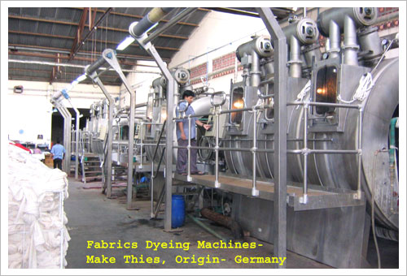
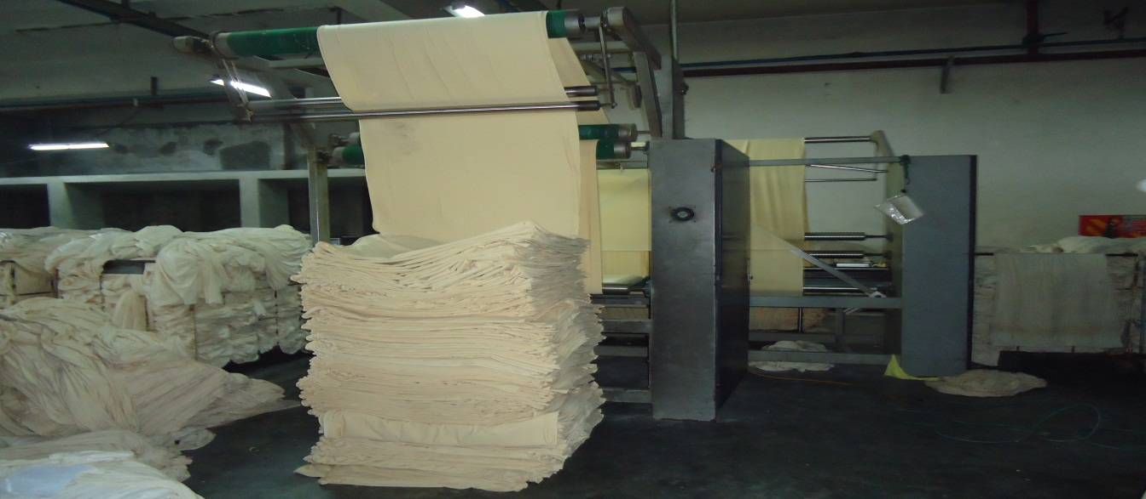
6.20 Photo Gallery

7. Finishing Section

7.1 Layout of Finishing Section:

Back Sewing M/C

Scutcher M/C

Scutcher M/C

Stenter M/C

Stenter

Slitting M/C
Fabric Reversing M/C

Dryer

Hydro

Dryer M/C

Calenderinhg M/C

Dryer M/C

Dyeing Lab

Calenderinhg M/C

Dryer M/C

Inspection Table

Fabric Inspection Table

N
EXIT
W E
S

7.2 Organogram of Finishing Section:

Finishing Manager

Finishing In-charge

Shift In-charge

Supervisor

Operator

Helper

7.3 Machine description of finishing section:

S/L | Machinery | No. of machine | Brand | Origin
1 | Fabric Reversing M/C | 01 | MERSAN | Turkey
2 | Scutcher M/C | 02 | SANTEX | Switzerland
3 | Dryer M/C | 01 | SANTEX | Switzerland
4 | Dryer M/C | 01 | HELINT | Switzerland
5 | Calendering M/C | 01 | FERRARO | Italy
6 | Slitting M/C | 01 | SANTEX | Switzerland
8 | Stenter M/C | 01 | BRUCKNER | Italy
9 | Back sewing M/C | 01 | HSING CHENG | Taiwan
10 | Dryer M/C | 01 | SANTEX | Switzerland
11 | Hydroextractor | 01
12 | Tumble dryer | 01
13 | Tumble Dryer | 01

7.4 Finishing section is consisting of two lines. These are –
- Open line
- Tube line

A.The machine that are used for open line are given bellow –

- Back sewing machine
- Slitting machine
- Stenter machine
- Calendering machine

B.The machines that are used for tube line are given bellow –

- Fabric Reversing machine
- Scutcher machine
- Dryer machine
- Tube calendaring machinemachine

7.5 Different types of machine with their function:

Machine No:01
Name: Wet Fabric Reversing Machine
Function:
- Turn tube fabric face side to back side or back side to face side to remove loosen fibers.

Details
Brand | Mersan
Serial No | 13200909
Electric Power | 2KW
Weight | 650 Kg
Origin | Turkey

Machine No: 02
Name: Scutcher Machine
Function:
- Clean the fabric.
- Increases the softness of fabric.
- Remove water through squeezing.
- Dewatering, softener application and overstretching.

Details
Brand | Santex
Type | SANTASTRETCH PLUS 120
ELECTR. DIAGR.NR: | 94-3540
Working Speed | 0-80m/min
Working Widths | 100-240cm
Electric Power Supply | 4-8KW
Year of construction | 1994
Origin | Switzerland

Machine No: 03
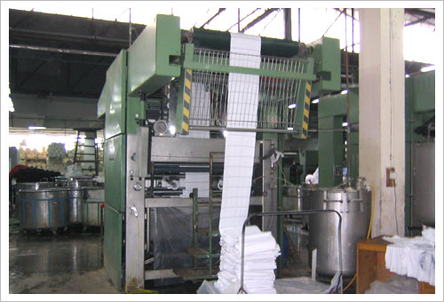
Name: Scutcher machine.
Function:
- Clean the fabric
- Increases the softness of fabric.
- Remove water through squeezing.
- Dewatering, softener application and overstretching.

Details
Brand | Santex
Type | Santastretch Plus
ELECTR. DIAGR.NR: | 01-5552
Electric Voltage | 3*380 volt+PEN 220 V/50Hz
Connected Load | 20 Kw
Year of construction | 2002
Origin | Switzerland

Machine No: 04
Name: Dryer Machine
Function:

- To dry the fabric.
- To control the overfeed system.
- To control the vibration which increase the G.S.M.
- Tensionless drying, shrinking and relaxing for knitted and woven fabrics.

Details
Brand | Santex
Model | CH-9555 Tobel
Working Width | 60-420cm
Evaporation Capacity | 320 Kg/h
Machine Speed | 5-80m/min
Electr. Diagr.Nr | 93-3541
Electric Voltage | 3*388 volt+N+E220V,50 Hz
Connected Load | 60 Kw
Year of Manufacturing | 1994

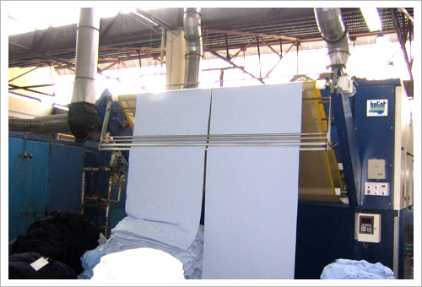
Machine: 05
Name: Dryer
Function:
- To dry the fabric.
- To control the overfeed system.
- To control the vibration which increase the G.S.M.

Details
Brand | Helint
Model | CH-9555 Tobel
Type | ONDLLOMAX 3.3.2GAZ
Connected Load | 60 Kw
Year of Manufacturing | 1994

Machine No: 06
Name: Dryer machine(Tube)
Function:
- To dry the fabric.
- To control the overfeed system.
- To control the vibration which increase the G.S.M.
- Steaming and Compacting of tubular fabrics.

Details
Brand | Santex
Model | CH-9555 Tobel
Type | Santaspread 120
Working Width | 100-180cm
Working Speed | 5-50m/min
Electr. Diagr.Nr | 93-3542
Electric Voltage | 3*388 volt+N+E230V,50 Hz
Connected Load | 8 Kw
Year of Manufacturing | 1994

Machine No: 07
Name: Calendaring Machine
Function:
- Removing shrinkage of fabric.
- Control dia of fabric.
Details
Brand | Ferraro
Connected Load | 10 Kw
Year of Manufacturing | 2006
Origin | Italy

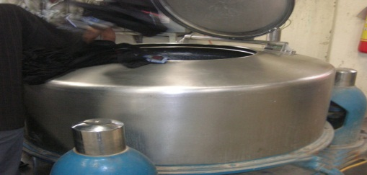
Machine No: 08
Name: Hydro Extractor
Function:
- To extract excess water.

Details
Brand | Dilmenler
Capacity | 125 Kg
Extraction % | 80
Origin | Turkey
Time | 5-10 mins

Machine No: 08
Name: Slitting machine.
Function:
- To open tube fabric according to specific needle mark.
- Slitting of tubular fabrics.

Details
Brand | Santex
Model | CH-9555 Tobel
Electr.diagr.Nr | 01-5553
Working Width | 2400mm
Electric Voltage | 3* 380 V+PE 220 V/50 Hz
Connected Load | 21 Kw
Year of Manufacturing | 2002

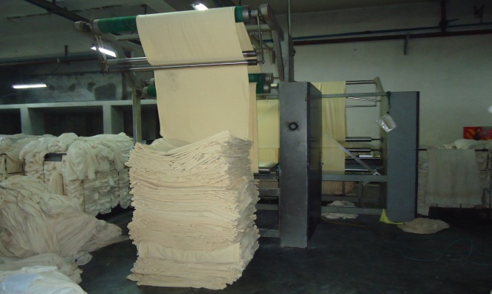
Machine No: 09
Name: Back Sewing Machine

Function:
- To removing side dull.

Details
Brand | Hsing Cheng
Model | HC-AEN-2600mm-A12797
Year of Manufacturing | 2005
Origin | Taiwan

Machine No: 10
Name: Stenter Machine
Function:
- GSM of the fabric is controlled by stenter.
- Spirality controlled by the stenter.
- Moisture of the fabric is controlled by the stenter.
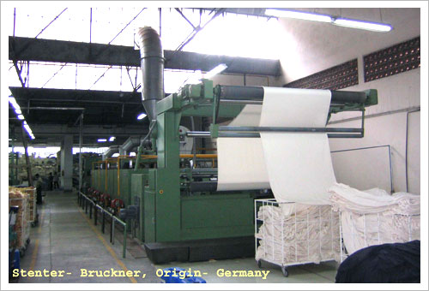
- Loop of the knit fabric is controlled by the stenter.
- Finishing chemicals apply on the fabric by the stenter.
- Width of the fabric is controlled by the stenter.
- Heat setting is done by the stenter for lycra fabric, synthetic and blended fabric.
- Fabric is dried by the stenter.
- Shrinkage property of the fabric is controlled by the stenter.

Details
Brand | Bruckner
Serial No | 72276-0463
Temperature Range | 50-250 ͦC
Max Speed | 120 (m/min)
Production Capacity | 8 ton/day
No of Chamber | 3
Max. Fabric Width | 102”
Minimum Fabric Width | 30’’
Steam Pressure | 2 bar
Air pressure | 10 bar
No of rotamatic burner | 6
Extra Attachment | Mahlo weft straightener
Year of Manufacturing | 2002
Origin | Germany

Machine No: 11
Name:Calendaring Machine
Function:
- Removing shrinkage.
- Increase smoothness.
Details
Brand | Santex
Model | CKN/280
Year of Manufacturing | 2002
Origin | Italy

7.6 Finished Fabric Inspection:

The following defects are found in the final inspection.
- Uneven shade
- Oil spot
- Naps
- Crease mark
- Machine Stoppage mark
- Listing
- Line mark
- Pick missing
- Double yarn
- Dead cotton
- Bowing
12. Fly yarn contamination

Garments manufacturing Section

8. Garments manufacturing Section

8.1 Layout of Garments section:

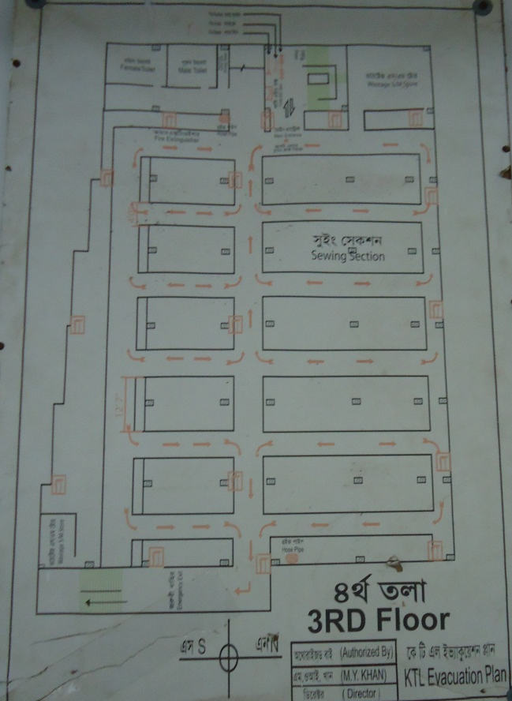

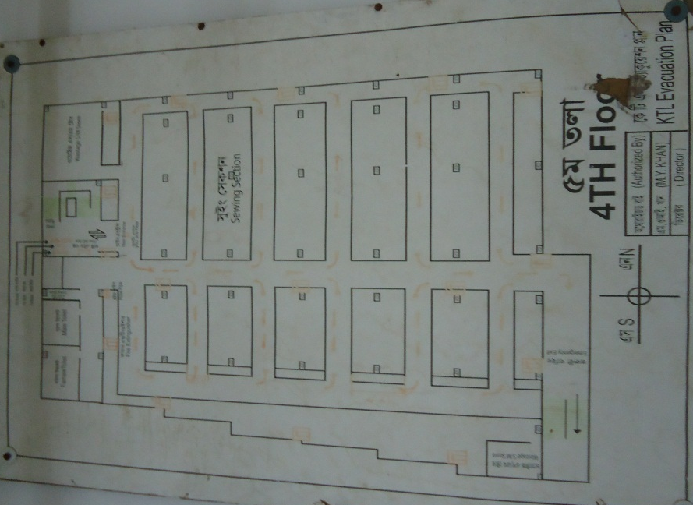

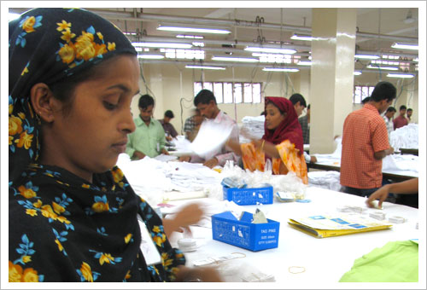
Packaging Section in Garments

This is the garment sewing and printing unit of this group. In finishing of garments we use vacuum steam ironing. On buyer’s request, we use a metal detector to check all garments. Finished boxes are being kept in a separate warehouse, where we have two inspection rooms available for our buyers.
We have a sampling section with 15 people. Each style is being sampled first with available fabrics. After style approval, we make size-set with available fabrics. After approval, we make pre-production sample with right material.

Machinery: The sewing section has m/c combination of Juki and Pegasus, which can make 40,000 pcs per day. Additional m/cs are being installed to improve the production efficiency and quality. We have Plain, Over Lock, Flat Lock, Button Hole, Button Stitch, Snap Button Attaching, Feeder over the Arm, Zigzag, Kansai Special sewing machines.

Annual turnover: US$ 15 million,75% of which is generated out of Purbani Fabrics Ltd.

Products: Apparel
The daily cutting capacity is currently 32,000 pieces (extendable up to 40,000 pieces), breaking into following product - mix:

Polo: 8000 pcs/day

T-shirt+tank top:20,000 pcs/day
Fancy items: 4000 pcs/day
Total:32,000 pcs/day

Printing Section in Purbani Fabrics Ltd
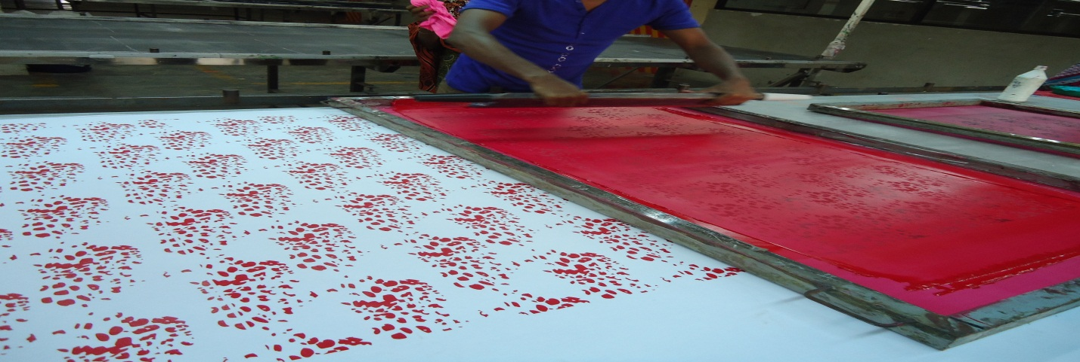

Our printing unit is using screen printing method to print on garments and has a daily capacity of 20,000 pes.

Products: Printing
Pigment photo, discharge, plastisol, rubber, cracle, high density etc.

8.2 Organogram of Garments section:
General Manager

Production Manager

Printing In-charge

Printing Quality In-charge
Cutting Manager

Asst. Production Manager

Finishing Manager

Quality
Line Chief

Designer

Cutting In-charge

Finishing In-charge

Expose man
Supervisor

Color master

Supervisor

Supervisor

Exposer
Importman

Supervisor

Marker Man

Helper

Operator

Machine Cutter Man

Sample man

Helper

Scissor Cutter Man

Operator

Import Man

Layer man

Nack Man

Helper

Lay Man

Helper

8.3 Machine Description:

Sl. No | Name of Machine |  | Quantity
1 | Plain machine single needle |  | 269
2 | Plain machine double needle |  | 8
3 | Over lock 4 thread |  | 140
4 | Over lock 5 thread |  | 1
5 | Gathering over lock |  | 2
6 | Flat lock cylinder bed normal |  | 50
7 | Cylinder bed Computerized |  | 20
8 | Cylinder bed auto trimmer |  | 8
9 | Picot |  | 3
10 | Smoke 32 needle |  | 1
11 | Smoke 33 needle |  | 1
12 | Zig-zag |  | 1
13 | Feed of the arm02 needle |  | 1
14 | Feed of the arm04 needle |  | 10
15 | Rib cutter machine |  | 10
16 | Chain stitch double needle |  | 3
17 | Fusing |  | 1
18 | Elastic Join Flat Lock |  | 1
19 | Flat bed |  | 40
20 | General category button hole |  | 8
21 | Button Stitch |  | 8
22 | Kansal Special |  | 3
23 | Snap button |  | 8
24 | Bar-tack |  | 3

8.4 Sequence of garment production:

Sewing Sequence of T-shirt:

Number matching front 2 back pant (back on pant on upper side)

Solder stitching (By over lock m/c)

Neck rib truck (By plain m/c)

Neck rib sewing by plain m/c

Neck rib joins with body pant

Neck top sin

Solder to solder back tip

Size label sewing

Solder to solder back top sin

Sleeve marking ad number matching with body parts.

Sleeve tuck with body part (Sleeve mark point & solder mark point)

Sleeve joint with the body part

Side sewing and care label joint

Bottom hem tuck (at the end side)

Bottom hem sewing

Arm bottom hem joint

Inspection

Trouser sewing sequence:

Number matching back & front pant

Back rise & Front rise joint

Pocket facing joint with pocket part by over lock m/c

Pocket part sewing by over lock m/c

Pocket tracing joint by plain m/c

Top stitch pocket with pocket facing

To sin Zigzag (pocket Rolling)

Pocket marking by catalog & scissor

Number matching pocket & body part

Pocket tuck (2 end side of the pocket)

Pocket joint with the body part

Pocket top sin (ZigZag)

Back & front matching (number)

Side sewing of the trouser

Side top sin (ZigZag )

In side sewing by over lock

Elastic tuck for waist belt

Eye lot at middle point of the belt

Rib tuck sewing for belt

Elastic cutting at size wise

Elastic + Rib (belt) tuck

Belt surfacing

Belt & body tuck

Belt & body joint

Label joint

Top sin belt joining point

Bottom hem sewing

Dosting cutting &fildeng

Dosting tuck

Supporting tuck on bottom hem & belt top sin

Pocket Eye lot snap button M/C

Inspection

Polo- Shirt sewing sequence:

Lining joint with collar part by heat pressing

Collar marking for open stitch

Collar inside open stitch

Collar marking

Collar ¼ top sin

Collar cutting

Band Rolling

Band joint with Collar

Band top sin 1/6

Placket lining

Placket marking

Placket Rolling

Placket joint

Placket top sin 1/6

Placket Pattern top sin

Placket pattern top sin 1/6

Box Sewing

Pocket Rolling

Pocket iron

Pocket marking

Pocket joint with body

Yoke joint with back part

Yoke ¼ top sin

Back & front part matching number

Solder joint

Solder top sin

Collar marking

Collar & body number matching

Collar joint with body part

Collar top sin in jointing point

Sleeve marking

Sleeve over locked

Sleeve Rolling

Sleeve pair matching

Sleeve & body matching

Sleeve body tuck

Sleeve joint with body part

Sleeve marking for batch

Sleeve batch joint (left & right side)

Body marking for batch

Batch joint with body part

Label make

Label Iron

Main label joint in back side

Sleeve opening tuck

Body hem sewing

Care label sewing

Side joint

Band tuck

Band tape joint

Band top sin

Sleeve chap tuck

Inspection

8.5 Photo Gallery of Karim Textile Ltd.:

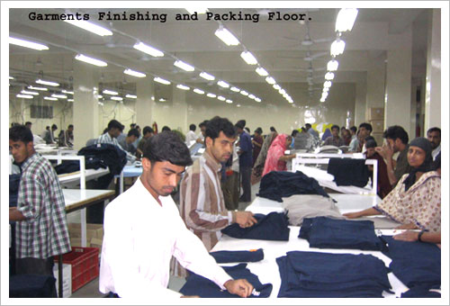
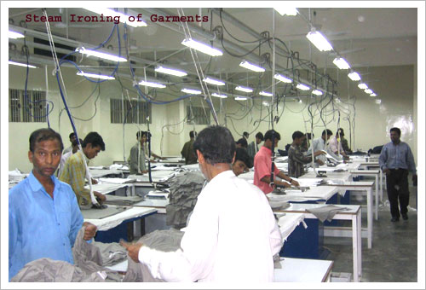
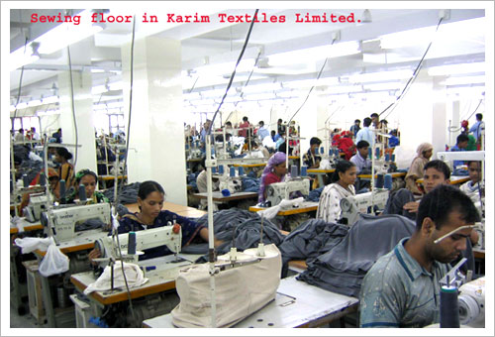
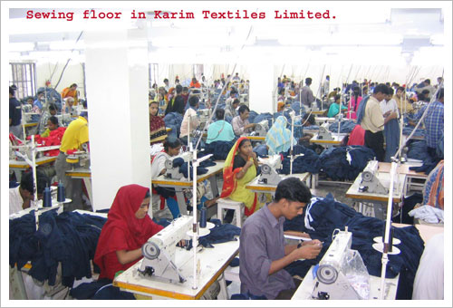

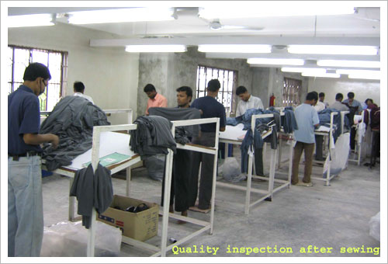
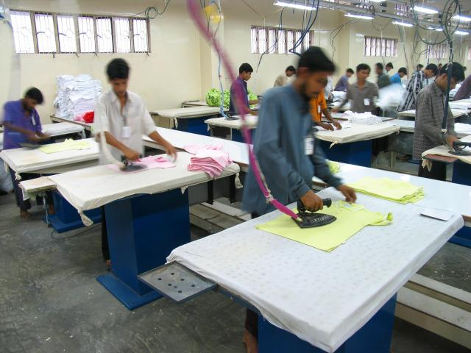
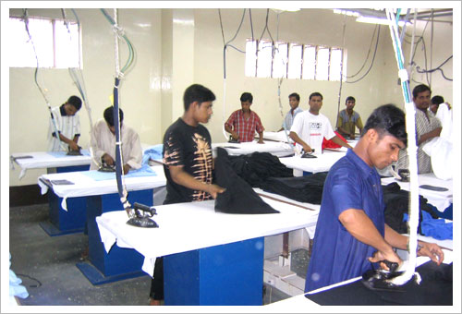
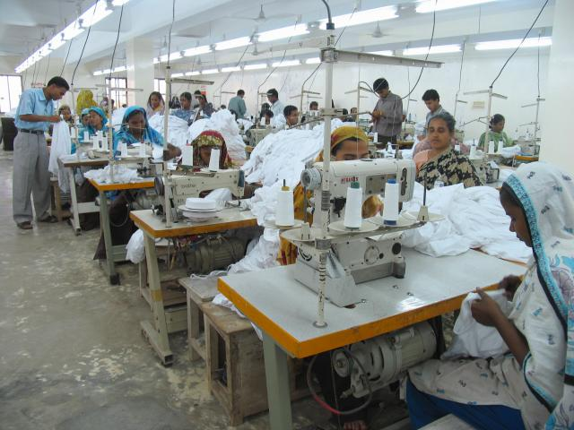

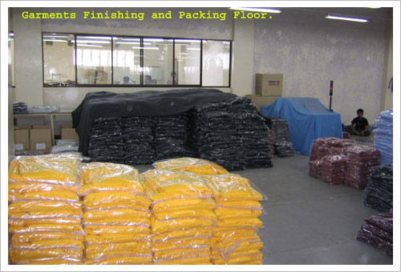
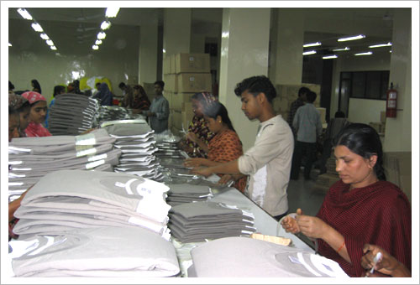
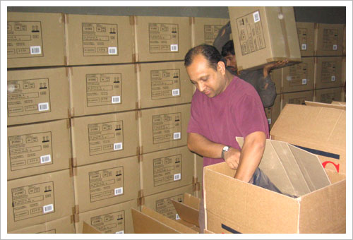

Quality Control Section

9. Quality Control Section

9.1 Quality Assurance System:
The Quality Assurance Department is assigned to maintain consistently uniform quality of the material in process and various stages of its manufacturing.

9.2 Objects of quality Control:
- Research.
- Selection of raw materials.
- Process control.
- Process development.
- Product testing.
- Specification test.

9.3 Quality Assurance at different stage:
Purbani Fabrics Limited assures the quality of the products of dyeing section in the following three steps:
- In laboratory
- In dyeing section &
- In finishing section

9.4 Procedures are described below:
In laboratory:
- Swatch card from buyer according to their requirement
- recipe prediction for sample dyeing
- sample dyeing until matching with swatch card
- Fastness & other tests of the fabric or yarn are done here.

In dyeing section:
- According to the buyer’s sample, sample dyeing is done in sample dyeing machine in dyeing shed & again matched with the approved sample.
- If result is OK, then bulk production.
- During dyeing, samples are taken until accurate shade matching. The interval may be 30-40 minutes.
- After dyeing sample is collected after softening matching is done.
- Last of all, sample is collected after fixation & matched.
- Then allowed the fabrics to be finished.

In finishing section:
By using a series of finishing machines correct width, softness & appearance are maintained according to requirements.
Then sampling is done for several times to test GSM, Shrinkage & fastness properties.
Finally fabric is inspected & prepared for delivery.

9.5 Quality Standard:
Purbani Fabrics Ltd. Follows the quality standard: ISO-9001:2000.

9.6 List of Equipment:
In the quality assurance Department the followings equipment’s are used-
  - Electronics Balance
  - Iron
  - Ahiba Nuance lab. Dip Dyeing Machine
  - Rota Wash
  - Crock Meter
  - Spectro Photometer with software (Data Color)
  - P^{H} meter

9.7 Different Quality Test Method:
Different types of fastness tests of the dyed fabric are done in quality control department of the Purbani Fabrics Ltd. Different types of method (Standard or buyer’s recommended) are followed for different types of tests.
There are two types of tests are done in Quality Assurance department. They are-
- physical Tests
- Chemical Test.

9.7.1 Physical Tests:
- GSM Test
- Shrinkage test
- Spirality test
- Pilling resistance

9.7.2 Chemical Tests:
- Fastness to washing.
- Fastness to rubbing

9.8 Fabric Inspection:
The inspection of fabric is a procedure by which the defects of fabric are identified and fabric is classified according to degree or intensity of defects. The fabric inspection is done for both grey and finished fabric.

9.8.1 Grey Fabric Inspection:
Grey fabric inspection is performed according to 4-point system.

9.8.2 Finished Fabric Inspection:
4 point numbering system is followed for finished fabric inspection. Defects found in the final inspection.
- Uneven shade
- Oil spot
- Neps
- Crease mark

9.9 Machine Stoppage mark
- Listing
- Line mark
- Pick missing
- Double yarn
- Dead cotton
- Bowing
- Fly yarn contamination

9.10 Color Fastness to wash Test procedure:
Colorfastness:
The “color fastness” of a colored textile is defined as its resistance to these changes when subjectedto particulars of conditions. It follows that color fastness must be specified in terms of these changes and expressed in terms to the magnitude.

Required materials:
- Sample size 40 x 100 mm
- multifiber at 40 x 100 mm
- ECE detergent (WOB)-4g/L
- Sodium Perborate (Na₂BO₃.H₂O₂-1g/L)-1g/L
- Distilled water
- Normal cold water
- Steel balls

Required instrument:
- Rota wash
- Scissor
- Stitch machine
Procedure:
- Cut sample &multifibre at 40 x 100 mm
- 50 ml ECE detergent (WOB) & 50 ml Sodium per borate is taken with the sample. For marks & Spencer, the solution is taken by the following formula: (Sample fabric + Multifibre weight) x 50 ml
- the sample is kept in 60⁰C for 30 minutes in Rota Wash Machine
- Rinse the sample twice with cold water.
- Dry at 60⁰C by hanging or by Flat iron pression but temperature should bot be more than 150⁰C.
Report:
Dry the specimen and the change of shade & degree of staining is measured by Grey Scale & Staining Scale.

Color fastness to rubbing (Dry & Wet) Test:
Sample :
- Dyed fabric -15 cm x 5 cm
- White Test Cloth -5 cm x 5 cm
Procedure:
- White test cloth is put on to the grating and stag by steel wire.
- The sample is run twenty times manually for ten seconds. And the rubbing fastness of the sample cloth and degree of staining is accessed.
- For rubbing fastness (Wet), the rubbing cloth is placed in the water and socked and squeeze. The wet rubbing cloth is placed on to the grating and stag with stainless steel wire and run ten times manually then assesses the attaining on to the rubbing cloth and the rubbing fastness of the sample cloth is accessed.
Report :
- Change of shade of the sample is measured with grey scale and degree of staining of the white test cloth is measured by Staining Scale.
- There are also some tests are done in the lab. And the process is described below-

9.11 Measuring dimensional stability (Shrinkage &spirality):
Sample:
- Two piece of 50 cm x 50 cm fabric is taken for test.
Procedure :
- onditioning: Put the sample in the table for 4 hours for conditioning before
starting test.
- Cut the sample 50 x 50 cm & benchmark should be 35 x 35 cm. Stitch the
sample (3 sides) by over lock sewing machine.
- Put sample in washing machine and run according to buyer’s choice.
- Drying: All Buyers’ requirement is tumble Dry except ECHO SCOURING is
flat dry.

Shrinkage test calculation:
Shrinkage % (Percentage) =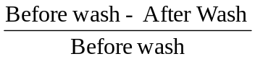

Spirality test calculation
S= (S₁+ S₂)/2
Spirality = (S+S X L)/100.
Suppose,
S₁= The right side distance of the specimen from the stitch line wash.
S₂= The left side distance of the specimen from the stitch line after wash.
L = Length before wash.

Remarks:
Purbani Fabrics Ltd. Always about the quality of the product. The quality of the product is always approved by the buyer. They follow the quality standard: ISO – 9001:2000. Purbani Fabrics Ltd is well equipped for checking the quality of the product. They sent the quality report to batch. We think as Purbani Fabrics Ltd strictly meet up the quality level that’s why they are the only one direct manufacture of Marks & Spencer garments.

9.12 Lab Test Report Sheet:

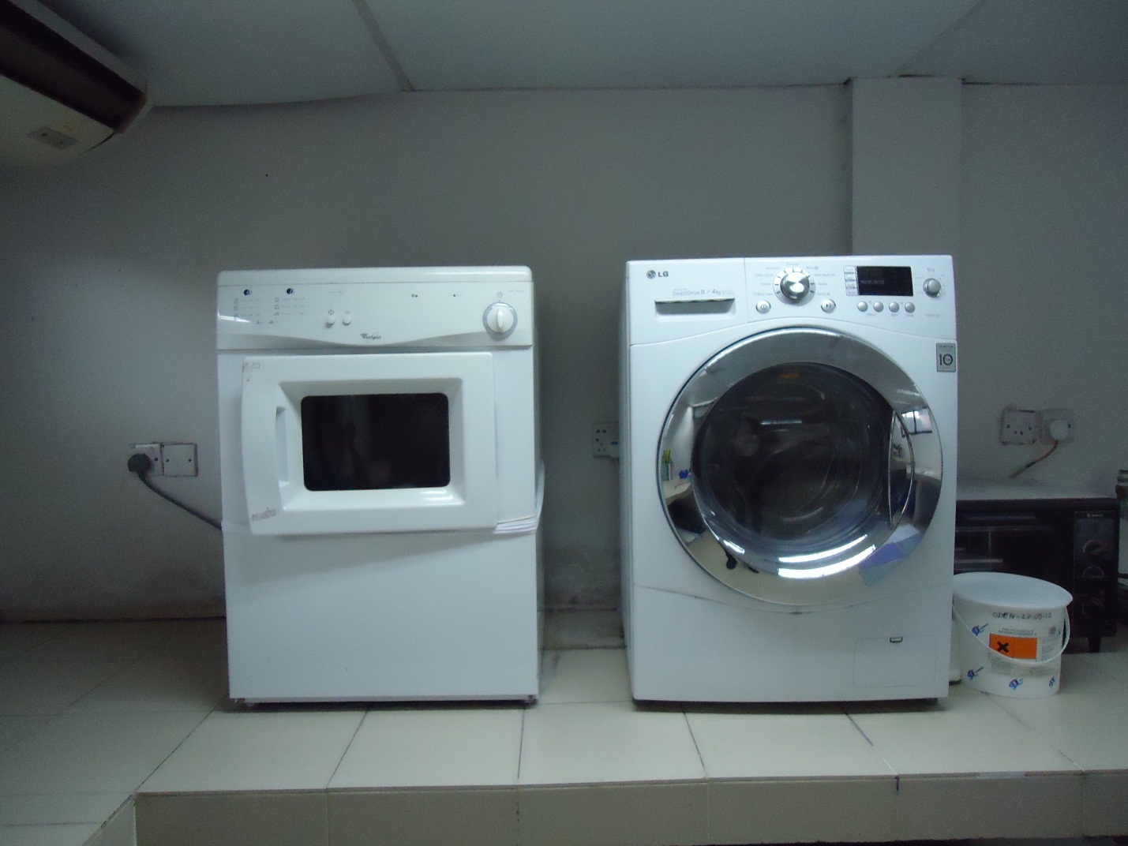
9.13Photo Gallery
Dryer & Washing Machine
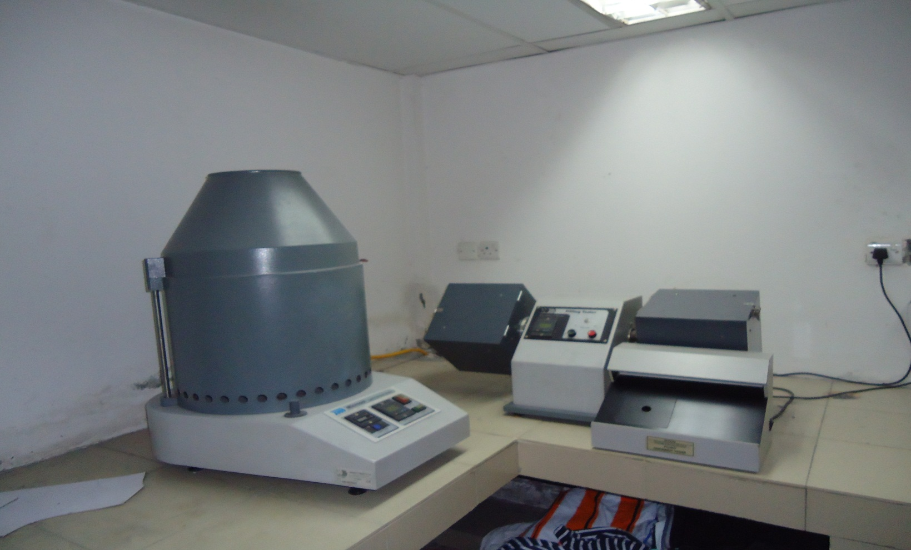

Light fastness tester and pilling tester.

Light fastness tester &Pilling tester
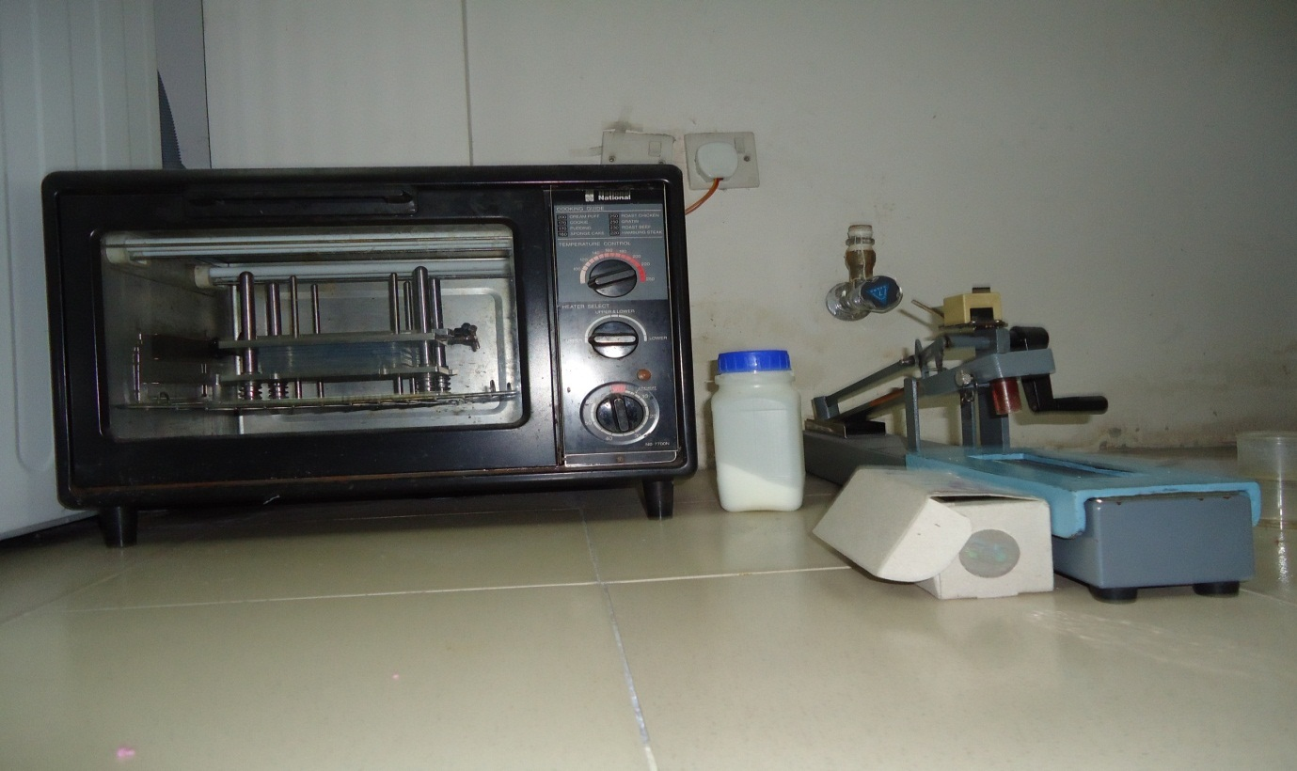
Micro-oven & Crock meter.

Spector photometer.
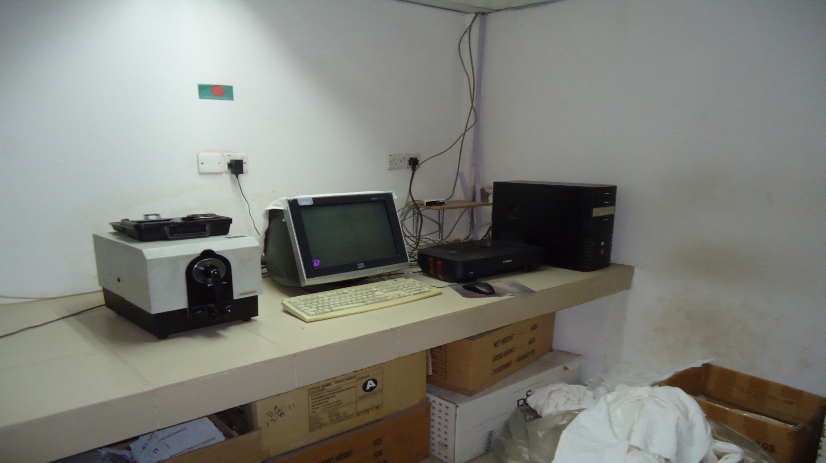
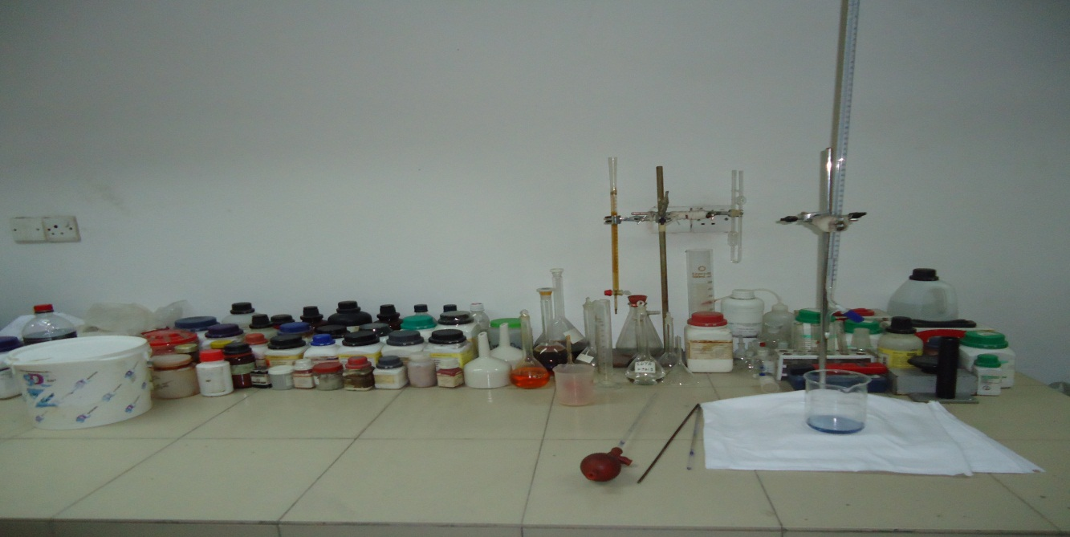

Different Chemicals for different test.

INVENTORY

10. Inventory Section
1o.1 Inventory Control:
Store is the place where every type of raw materials, spares finished goods are kept in proper system. Inventory control means the accurate calculation and data of every type of raw materials spares and finished goods in time to time. Store inventory control are necessary, because –
  - To know about the required amount of raw material.
  - To know about the job no – which would be processed?
  - To be continued the production process.
  - To fine out the profit or loss of a company.
  - Stock and stock value for consumption measuring.

10.2 Frequency of Inventory Update:

  - Daily
  - Monthly
  - Annual

10.3 Scope of Inventory Control:
  - Dyes store.
  - Raw material.
  - Other chemicals.
  - Grey fabrics.
  - Spare parts.
  - General store.
  - Capital equipment’s.
  - Accessories.
  - Stationary.
  - Maintenance parts.

10.4 Inventory System for raw material:
In Purbani Fabrics Ltd. There are different inventory systems for different raw materials.

Grey Fabric Store:
All the grey fabrics are stored in the fabric store near the batch section. Different types of fabric are listed in the sheet according to fabric types, quantity and consumer’s requirement.

Dyes and Chemicals:
There is different store for dyes and chemicals. Varies types of dyes and chemicals are stored here according to dyes and chemicals companies. Different types of dyes and chemicals are listed in a sheet. In the sheet the stored quantity of dyes and chemicals are also included. Every day the sheet is updated and a copy of this sheet is supplied to the dyeing manager, dye house and lab section.

Spares:
In Purbani Fabrics Ltd. required amount of spears of different machines are stored in the mechanical store room. All the spears are listed in a sheet which is controlled by the mechanical & maintenance personnel. Spares are arranged in the store room according to their size, quantity & requirements. There are shelves in the store room to keep the small spare parts.

Finished Goods:
Purbani Fabrics Ltd. Supplies its finished dyed fabrics to its garments section. So, dyed finished fabrics are stored for short time in the finishing section. All the delivered fabrics are noted on the tally khata according to the lot no, quantity, fabrics diameter, buyer’s name, color & considering other technical parameters.

Remarks:
Purbani Fabrics Ltd. Have individual stores for raw materials, finished goods etc. There is not enough space to store the finished goods. It requires increasing the store area. In Purbani Fabrics Ltd. the store for inventory control is satisfactory. Sometime, they fluctuate form ideal process otherwise they are ok.

COST ANALYSIS

11. Cost Analysis

11.1 Factors of costing of a product:
The following factors are considered for costing any dyed product:
- Total dyes and chemical cost.
- Total utility cost
- Salary
- Lunch
- Entertainment cost
- Government cash incentive
- Yarn cost
- Knitting cost
- Cost of dyeing
- Cost of finishing
- Cost of cutting, sewing, accessories etc.
- Cost of printing (If any)
- Labor cost (direct & indirect)
- Factory cost
- Sales and caring cost
- Others cost.

11.2 Price of the Product:
Are not available.

Remarks:
The costing of the product is a secret matter of the Ind. They are not interested to flash up the cost related data. So we could not collect the price of product & costing of the product.

Marketing Department

12. Marketing Department

12.1 Consumer of Products:
PFL is a 100% export oriented industry. All the goods produced in this industry are exported into various foreign countries. Name of the main buyers are given below:

12.2 Name of Buyers:

1. Colombus
2. Max
3. Garcia
4. Nayomi
5. Betty
6. Barcaly
7. ZXY
8. Calvin- Calin
9. Lerros
11. Trimarx
12. Radiance
13. P.Q.S
14. D-tex
15. Aftab
16. Spicy
17. Avrora
18. H.S Fash
19. Knit Zone
20. Anando
21. T.C.G
22. Scott
23. Dress-up
24. Astro-knit
25. Blith
26. S.R.G
27. Oxford
28. Shocby
29. Kooke- Design
30. Non.wash
31. Eshan
32. Faruquee.knit

12.3 Communication System:
- Intercom telephone
- Fax
- E-mail
- Written letters
- Oral

12.4 Importing countries:
There are some countries which are importing gods from The PPC. The name of the countries are given below –

- Spain
- Germany
- Denmark
- Europe
- Denmark
- Europe Union
- United State of America

12.5 Marketing Strategy:
Marketing strategy is a very important factors to sale the products to the buyer. If the marketing strategy is not so developed, it will be very hard to reach the goal. In case of garments marketing the dealings with the buyer is a very important factor.

Purbani Fabrics Ltd. mainly senior marketing officers, merchandiser & higher officials deal with the buyer. There are some fixed buyers of the industry. The buyers give their orders continuously all over the year. The marketing officers & the merchandisers communicate with the buying houses to collect the orders.
By both side understanding the rate & the order quantity are fixed.

12.6 Duties & responsibilities of marketing officer:
Dealing with the buyer & convince the buyer is the main duty of marketing officer. A marketing officer also has some other duties. The main duties & responsibilities of a marketing office are given bellow –

  - To prepare cost sheet by dealing with the buyer.
  - To take different steps by discussing with the high officials & merchandisers.
  - To maintain a regular & good relationship between commercial officer & merchandisers.
  - To maintain a communication with the buyers and buying houses.
  - Communicate with better criteria of the products.

Remarks:
Purbani Fabrics Ltd. hasmarketing & merchandising team. They always communicate with the buyers.Purbani Fabrics Ltd. has some fixed buyers. The marketing section also looks the quality & quantity of buyers.

HRM & COMPLIENCE
13. HRM & Compliance
13.1 Definition:
Compliance means conformity of certain standard. PPC maintain a moderate working condition for their employees. Though it is well established project, there is some lacking of proper compliance issues. Here is list of compliance in which some points are maintained fully and some are partially.

- Compensation for holiday
- Leave with wages
- Health register
- Time care
- Accident register
- Workman register
- Equal remuneration
- National festival holiday
- Overtime register
- Labor welfare
- Weekly holiday fund
- Sexual harassment policy
- Child labor abolition policy
- Anti-discrimination policy
- Zero abasement policy
- Working hour policy
- Hiring /recruitment policy
- Environment policy
- Security policy
- Buyers code of conduct
- Health and safety committee
- Canteen

13.2 Health:
- Drinking water at least 4.5 L/day/employee
- Cup availability
- Drinking water supply
- Water cooler ,heater available in canteen
- Drinking water signs in Bangla and English locate min. 20 feet away from work place
- Drinking water vassal clean at once in a week
- Water reserve at least once a week
- Water center in charge person with cleanliness
- Suggestion box register

13.3 Toilet:
- Separate toilet for women and men
- A seat with proper privacy and lock facility
- Urinal accommodation
- Effective water sewage system
- Soap toilet
- Water tap
- Dust bins
- Toilet white washed one in every four month
- Daily cleaning log sheet
- No-smoking signs
- Ladies /gents toilet signs both in bangle and English
- Deposal of wastes and effluent

13.4 Fire:
- Sufficient fire extinguisher and active
- Access area without hindrance
- Fire signs in both languages
- Fire certified personal photo
- Emergency exit

13.5 Safety Guard:
- Metal glows on good conditions
- Rubber mats & ironers
- First aid box one
- Ironers wearing sleepers
- First trained employees
- Motor/needle guard
- Eye guard
- Nurse
- Doctor
- Medicine
- Medicine issuing register
- Welfare officer

13.6 Others:
- Room temperature
- Lighting facilities

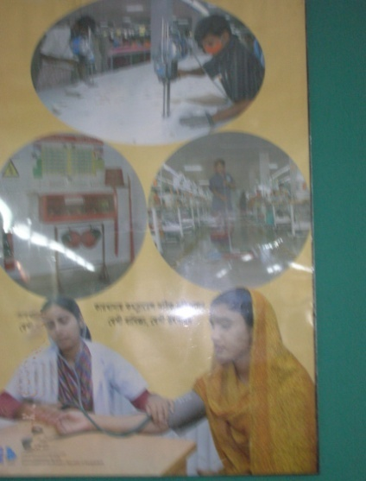
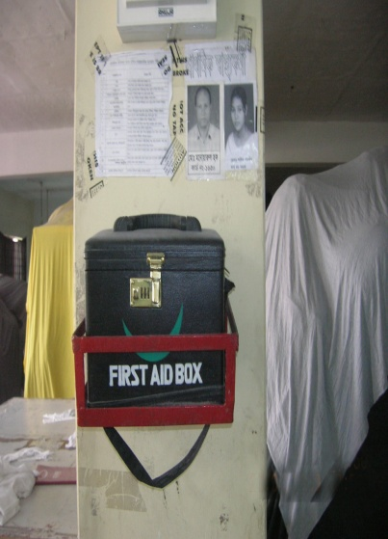
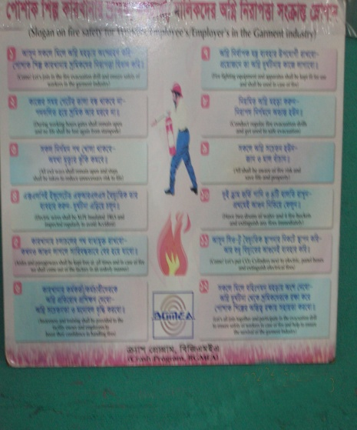
Fig: Doctor Fig: First aid box Fig: Fire training

14. Utility Department

14.1 Utility Service:
Here the following utility services are available-
- Water
- Electricity
- Steam
- Gas
- Compress air

14.2 Water Pumps:
 | Centrifugal Pump for water supply to Dyeing & Others Section
1 | 20 H. P Pedrollo Pump each pump, 1000L/min | 4 Units | 4,000.00L/min
2 | 10 H.P Pedrollo Pump flow rate, 600 L/Min | 1 Unit | 600.00L/min
3 | 5.5 H.P Pedrollo – Pump flow rate, 50 L/Min | 1 Unit | 350.00L/min
4 | Spare Pump Motor Pedrollo 20 H.P1 Unit and 5.5 H.P | 1 Unit | 1, 00L/min
5 | Jhonson Pump (30 H.P) | 2 Unit | 100 m³/hr
6 | KSB Pump (30 H.P) | 1 Unit | 100 m³/hr
7 | Submerssible Pump KSB | 46 Kw | 150 m³/hr

14.3 Natural Water Quality:
Water for a textile plant may come from various sources. These include surface water from rivers and lakes, and subterranean water from wells. In PPC they collect water from Under ground. Natural and pretreated water may contain a variety of chemical species that can influence textile wet processing in general, and dyeing in particular.

The various salts present in water depend on the geological formations through which the water has flowed. These salts are mainly the carbonates (CO₃²⁻ ), hydrogen carbonates or bi-carbonates ( HCO₃⁻ ), Sulphates ( SO₄²⁻ ) and chlorides ( Cl⁻ ) of calcium ( Ca²⁺), magnesium (Mg²⁺) . Although calcium and magnesium carbonates in limestone are relatively insoluble in water. So in this reasons, water hardness can be divided into two ways-

1) Temporary hardness : Temporary hardness of water which contain such this materials as Ca(HCO₃)₂ , Mg(HCO₃)₂ , Fe(HCO₃)_{2 .}

2) Permanent hardness :Parmanent hardness of water which contain such this materials as CaCl₂ , CaSO₄ , Ca (NO₃)₂ , MgCl₂ , MgSO₄ , Mg(NO₃)₂ .

This water hardness causes some serious consequences in a textile dyeing and finishing industries and these are -

- Precipitation of soaps.
- Redeposit ion of dirt and insoluble soaps on the fabric being washed ,
this can cause yellowing and lead to uneven dyeing and poor handle.
- Precipitation of some dyes as calcium and magnesium salts.
- Scale formation on equipment and in boilers and pipelines.
- Reduction of the activity of the enzymes used in washing.
- Incompatibility with chemicals in finishing recipes and so on.

Hardness expressed by parts per million (ppm) of CaCO₃ which is standard hardness scale and it is also called American hardness. The hardness of raw water is 100 ppm or more. To use it in dyeing and in boiler this water must need to soft & foreign materials needs to remove.

14.4 Standard Water Quality for Dye House:

Parameter | Permissible concentration
Color | Color less
Smell | No bad smell
Water Hardness | <5 ppm
PH value | 7-8 (Neutral)
Dissolve solid | < 1 ppm
Inorganic salt | < 500 ppm
Iron (Fe) | < 0.1 ppm
Manganese (Mn) | < 0.01 ppm
Copper (Cu) | <0.005 ppm
Nitrate (NO3) | < 50 ppm
Nitrate (NO2) | < 5 ppm

14.5 Methods of water softening:
There is an ion exchange method by which hardness of water is removed in industrial scale–

The flow chart of water treatment plant is given below -

Delivery
Pump

Resin
Filter

Carbon
Filter

Stone
Filter

Hard Water Store Tank

Soft Water Store Tank

Fig: Water treatment plan

14.6 Electricity:
Brand | Waukesha
Gas Intake | 0.20 mm
Gas Exhaust | 0.66 mm
RPM | 1500
Fuel | Natural Gas
Capacity | 164 KW
Orogin | USA
Available | 3 pieces

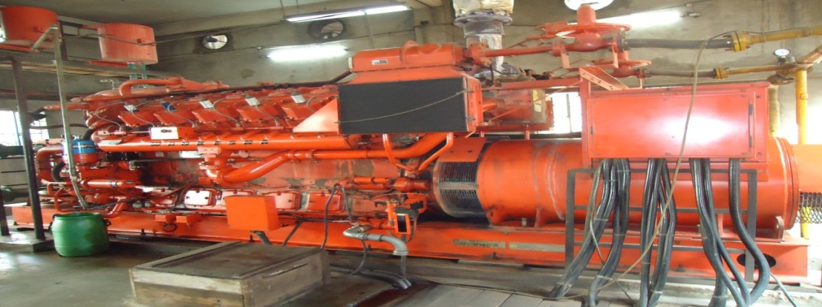

Waukesha gas Generator

14.7 Steam Boiler:
Brand | Revotherm
Evaporation Rate | 6000 kg/hr
Output | 3.76 MW
Fuel | Natural Gas
Frequency | 50 Hz
Connected Load | 19.5 KW
Available | 4 pieces

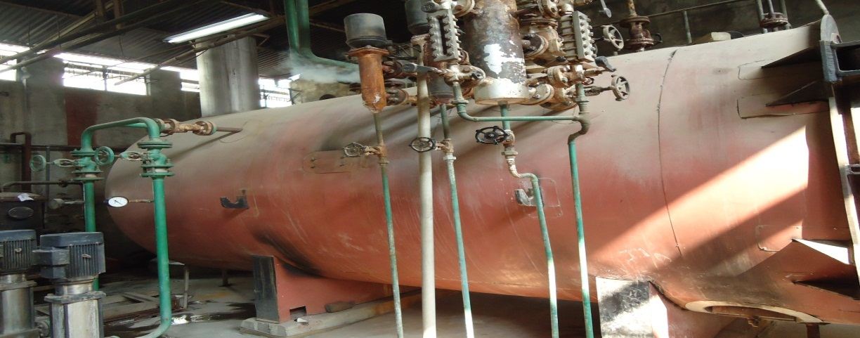

Revotherm Boiler

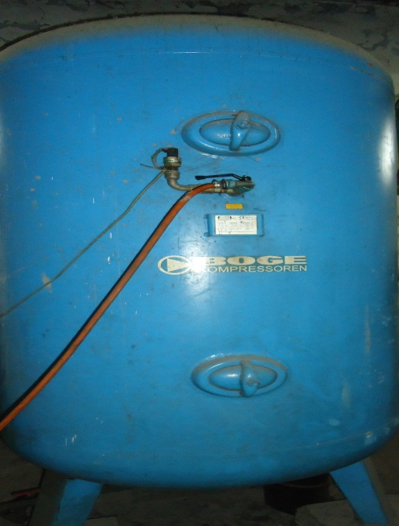
14.8 Air compressor:
Brand | BOGE
Rate of Flow | 4.30 m3/min
Max. service Pressure | 10 bar
Motor Speed | 3000min
Motor Power | 10 KW
Available | 2 pieces

Fig:Boge Compressor

14.9 Gas:
PURBANI es natural gas comes from Titas Gas Transmission Company. Gas is used as the fuel of Boiler, Generator and also used for heating dryer, Stenter and compactor m/cs etc.

MAINTAINANCE

15. Maintenance Department
15.1 Definition:
Machine, Buildings and other facilities are subjected to deterioration due to their use and exposure to environmental condition process of deterioration, if unchecked, culminates in rendering these service facilities unserviceable and brings them to a standstill. In Industry, therefore has no choice to attend them from time to time to repair and recondition them so as to elongate their life to the extent it is economically and physically possible to do so.

15.2 Objective of Maintenance:
- To keep the factory plants, equipments, machine tools in an optimum working condition.
- To ensure specified accuracy to product and time schedule of delivery to customer.
- To keep me downtime of machines to me minimum must to have control over me production program.
- To keep the production cycle within the stipulated range.
- To modify the machine tools to meet the need for production.

15.3 Types of Maintenance:

Break down maintenance

Electrical Maintenance

Electrical Maintenance
(Production)
e
Mechanical Maintenance
Maintenance
Mechanical Maintenance
Preventive Maintenance

Preventive maintenance:
Preventive maintenance is a predetermined routine actively to ensure on time inspection/ checking of facilities to uncover conditions that may lead to production break downs or harmful description.

Break down maintenance:
In this case, repairs are made after the equipment is out of order and it can not perform its normal functions.

Routine Maintenance:
Maintenance of different machines are prepared by expert engineer of maintenance department. Normally in case of dyeing machine maintenance after 30 days complete checking of different important parts are done.

Manpower setup for maintenance:

- A Shift | 7 AM | 2 PM
- B Shift | 7 PM | 10 AM
- General Shift | 10 AM | 7 PM

15.4 Maintenances Procedure:
Normally preventive maintenance should be done. During maintenance procedure following points should be checked.

15.5 Check List of Different Parts:
Maintenance: Mechanical
Machine: Dyeing machine

Sl No | Items need to be checked & Serviced
01 | Crease the M/C bearing.
02 | Complete cleaning of machine.
03 | Cleaning of drain valves, replace seals if required.
04 | Check air supply filters, regulators auto drain seals
05 | Clean filters element and blow out.
06 | Greasing of unloading roller bearing.
07 | Checking of oil level and bolts of unloading roller gearbox.
08 | Checking of unloading roller coupling and packing.
09 | Checking & cleaning (if required) of main vessel level indicator.
10 | Check the oil level of pump bearing and refill if required.
11 | Check the function of heat and cool modulation valves
12 | Check all door seals

Maintenance: Electrical
Machine: Dyeing machine

Sl No | Items need to be checked & Serviced
01 | Check & clean fluff and dirt at dirt at all motor fan covers.
02 | Check all motor’s terminals
03 | Check main panels (by using compressed air)
04 | Check panel cooling fan & clean its filter
05 | Clean main pump inverter and its cooling fan.
06 | Check all circuit breaker, magnetic conductors and relays.
07 | Check current setting of all circuit breaker & motor over load.
08 | Visual checking of all power & control cables.
09 | Check all pressure switches.
10 | Check calibration of main vessel & all addition tank.
11 | Check all pneumatic solenoids
12 | Check calibration of heating / cooling modulation value
13 | Check setting of tangle sensor.
14 | Check setting & operation of lid safely switches
15 | Check all emergency switches
16 | Check all indication lamps
17 | Check all on/off switches
18 | Check all signal isolators

15.6 Maintenance Tools & Equipment’s:
1. Combination tools / spanner
Function : Tightening & loosening of nuts & bolts.

2. Socket ratchet set
Function : Tightening of nuts & bolts

3. Slide Range
Function : Tightening & loosening of nuts & bolts

4. Monkey pliers
Function : Tightening & loosening of nuts & bolts
5. Pipe threat cutting tools
Function : To cut the threat in pipe.

6. Bearing puller
Function : To assist the opening of bearing from shaft.
7. Pipe range
Function: Tightening & loosening of pipe joint

8. Pipe cutting tools
Function : for pipe cutting.

9.Hole punch
Function : Punching the hole.

10. Divider
Function : For circle making on metal & wood.

11. Easy opener
Function : To open the broken head bolt.

12. External threat die
Function : For external threat cutting.

13. Heavy scissor
Function : Cutting of gasket & steel sheet

14. Pipe threat cutting tools
Function: To cut the threat in pipe.

15. Drill machine and drill bit.
Function : for drilling.

16. Grease gun
Function : For greasing of moving parts of M/C.

17. Grinding M/C
Function : For grinding & cutting of mild steel.

18. Welding M/C
Function : For welding & cutting.

19. Spirit leveler
Function : For perfect leveling.

20. File
Function : For smoothing the surface.

21.Harmmer
Function : For scaling & Right angling.
22.Circlip tools
Function :Circlip opening & closing.

23. Hacksaw blade
Function: For metal cutting.
24. Handsaw (wood)
Function: For wood cutting.

25. Grinding stone
Function: For smooth finishing.

26. Grinding paste
Function: For easy cutting of metal.

Remarks:
Maintenance of M/C’s are very essential to prolong the M/C life and good maintenance is important consideration. It is necessary to check that all routine maintenance is being done regularly and properly otherwise efficiency of each department will be reduced.

ETP & WTP

Effluent Treatment Plant

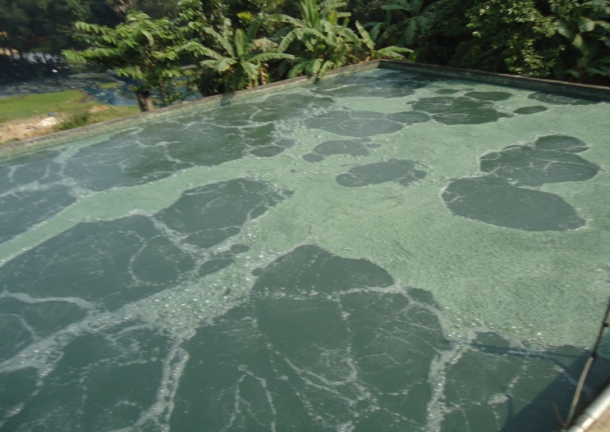
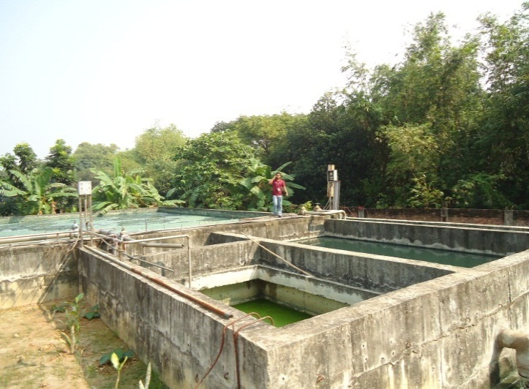
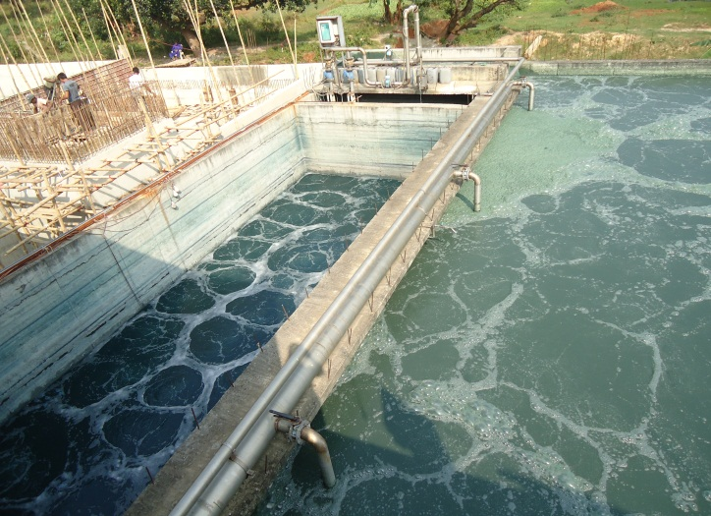

16.1 Layout of effluent treatment plant:

Layout of ETP

Oxidation Tank
Distributor

Neutralization Tank

Homogeneous Tank

Sedimentation Feeding Tank
Lifting Station

Screen
Re-circulation Tank

Sludge Thickener Tank

Clarifier Tank

Treated Water Discharge

Figure: Layout of Effluent Treatment Plant.

16.2 Effluent Treatment Plant:
Effluent treatment is a must in the textile industry because the water that comes out after dyeing is harmful for the environment. Effluent treatment is a process by which the water passed from the textile Industry which contains various pollutants is cured. The Effluent treatment process is briefly discussed below:

16.3 Pollutants Present in Textile Industry:
Various types of pollutants are present in textile industries which are responsible for the faults caused in the processes. These pollutants are discussed below:

Color:
The presence of color in the waste water is one of the main problems in the textile industry. Most of the colors are stable and has no effect of light or oxidizing agent. These colors cannot be easily degraded by conventional methods of treatment.

Dissolved Solids:
Dissolved solids are also one of the important causes of water pollution. It is a critical parameter of the effluent present in the textile industry. Use of common salt and glauber salt etc. in textile processing increases the amount of total dissolved solids (TDS). Disposal of high amount of TDS can lead to increase of TDS in ground and surface water. It is also harmful for agricultural purpose.

Toxic Metals:
Waste water of textiles is not free from metal contents. There are mainly two sources of metals. Firstly, the metals may come as impurity with the chemicals used during processing such as caustic soda, sodium carbonate and salts. For instance, caustic soda may contain mercury if produced using mercury cell processes. Secondly, the source of metal could be dye stuffs like metalized mordent dyes. The metal complex dyes are mostly based on chromium.

Residual Chlorine:
The use of chlorine compounds in textile processing, residual chlorine is found in the waste stream. The waste water (if disposed without treatment) depletes dissolved oxygen in the receiving water body and as such aquatic life gets affected. Residual chlorine may also react with other compounds in the waste water stream to form toxic substances.

Other Effluents:
Textile effluents are often contaminated with non-biodegradable organics termed as refractory materials. Detergents are typical example of such materials. The presence of these chemicals results in high chemical oxygen demand (COD) value of the effluent. Organic pollutants, which originate from organic compounds of dye stuffs, acids, sizing materials, enzymes, tallow etc. are also found in textile effluent, such impurities are reflected in the analysis of bio-chemical oxygen demand (BOD) and COD. These pollutants are controlled by use of biological treatment processes. In many textile units, particularly engaged in synthetic processing, low BOD/COD ratio of effluent is observed which makes even biological treatment not a ready proposition. The waste water of cotton based textile units is usually alkaline, whereas synthetic and woolen fabric processing generates acidic effluent.

16.4 Flow Description:
The Effluent Treatment Plant of PURBANI has capacity of 1200 m3/day. Treatment processes are maintained by three steps which are given below:
a) Physical/ Mechanical step:
Screen Chamber.
Equalization/ Homogenous process.
Clarifying process (2 times).
Intermediate period.
Filter press.

b) Chemical treatment step:
Ozonation by Ozonator (2 times).
Flocculation/ Coagulant process (Z times).
Neutralization process.

c) Biological treatment step:
Sequencing Batch Reactor (SBR).

16.5 Process Details:
Screen Chamber:
There are two types of screen chambers for screening system and removing the floating dust particles from the wastewater.
1. Manual bar screen.
2. Mechanical screen.

Equalization or Homogenous System:
All the effluents reach the equalization tank to make it equal or homogenous by providing air from air blower through coarse type diffuser. Effluents can retain here for about 20-22 hours.

Ozonation System:
Ozone is re-circulated along with the effluents for all 24 hours to get the excellent output by removing micro color and add more dissolved oxygen as well as kill anaerobic bacteria which will come along with raw effluent. Ozone gas is continuously produced in the Ozonator machine.

Ozone Generator:
Oxygen concentrator collects pure dry oxygen by purging nitrogen from air and sent pure oxygen to the Ozonator. In the Ozonator ozone generation is done by creating high voltage of 8000 volts.

Flocculation System:
Coagulant-Flocculants are used for dosing into the Flocculation tank in order to remove the color bond. For example:
Lime,
Ferrous Sulphate,
Polymer, etc.
During dosing the reactions which take place in the Flocculation tank is discussed in the following:
As only ferrous sulphate cannot be used as a precipitant so lime is also added at the same time to a proper precipitate. When ferrous sulphate is added to the waste water the following reaction occurs:

FeSO4.7H20 + Ca (HCO3)2 — Fe (HCO3)2 + CaSO4 + 71-120. After adding Lime,
Fe (HCO3)2 +2 Ca (OH) 2 = Fe (OH) 2 +2 CaCO3 +2 H20.

The ferrous hydroxide can be oxidized and convert to ferric hydroxide, the desired final form caused by dissolving oxygen into the wastewater. The reaction follows the following procedure:

Fe (OH) 2 ± 1/4 02 ± 1/2 F120 = Fe (OH) 3.

The insoluble ferric hydroxide is formed as a bulky, gelatinous floc.

Inclined Plate Clarifier (IPC)/ Clarifying System:
Contains both solid and liquid parts and is achieved by breaking color and separating color bonds.

Neutralization System:
Raw effluent pH is 9.5-11, so it is neutralized by dosing Hydrochloric Acid (HC1). Ideal pH for maintaining the Biological process should range within 6.5-8.5.

Sequencing Batch Reactor (SBR)/ Biological System:
This is the biological treatment process where live micro-organisms are nourished. Bacteria are populated in microbial process. These micro-organisms eat those effluents and the remaining color and also remove Biological Oxygen Demand (BOD) and Chemical Oxygen Demand (COD). ETP plant is continuously operated for 24 hours to ensure that the bacteria are provided with sufficient food (i.e. waste water) and oxygen to keep them alive. Like other living creatures micro-organisms need a balance diet with source of carbon, nitrogen, phosphorous and sulfur. As from textile wastes have carbon and sulfur (sulphate), so lacking compound nitrogen and phosphorous are adding from outside of urea and di-ammonium phosphate.
This SBR digester is maintained through batch wise system. The Sequencing Batch Reactor consists of three chambers and at least 4 batches are maintained per chamber.
In the factory, the Mix Liquor Suspended Solids (MLSS) of micro-organism level is checked in regular basis by In-hof-man cone.

Intermediate Tank:
This is the buffer zone where treated clear water is preserved before final discharge.

Filter Press & Sludge Disposal:
The sludge generated by effluent treatment needs to be further processed of safely. It is the byproduct of the effluent treatment process, produced in the form of solid waste. In fact the production of sludge is a good indicator as to out whether the ETP is running continuously or not. Sludge can be generated at different stages of treatment, including screening, primary settling, chemical precipitation but most will come from the physiochemical stage of treatment. The sludge collected from different stages has different characteristics and compositions. Despite the differences in the nature of the sludge from each process stage, all the sludge is usually combined and handled together.

16.6 Characteristics of waste water of PFL assumed as follows:
pH = 9-11.5
BOD = 300 mg/L
COD=200 mg/L
Suspended solid (SS) = 200 mg/L
Color = dark

16.7 Flow process of ETP:
Inlet Water

Screening
Lifting Station
Acid
Poly

Poly
Sludge Discharge
Filterpress
Thickener
Sludge Recycling
O2
O2
Blower
Blower
Antifoam
Blower
Lifting Station
Post Oxygenation
Sedimentator
Distributor
Oxidation Tank
Neutralization Tank
Homogenizing Tank

16.8 Department of Environment, Government of Bangladesh required:
PH = 6-9
BOD = 50 mg/L
COD= 200 mg/L
Suspended solid = 150 mg/L
Color = Light brownish.
Ferrous sulphate tank
16.9 Final treated Quality of PFL discharge is:
PH = 7-8
BOD = 30 mg/ L
COD = 160 mg / L
Suspended solid = 30 mg/L
Color = color less.

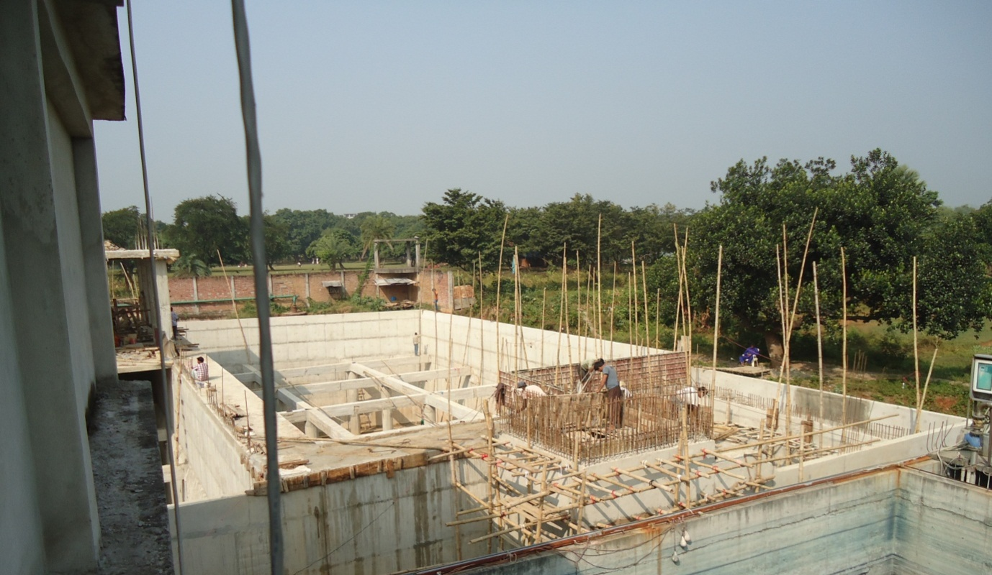

Photo: New ETP plant under construction.(Capacity2400m³).

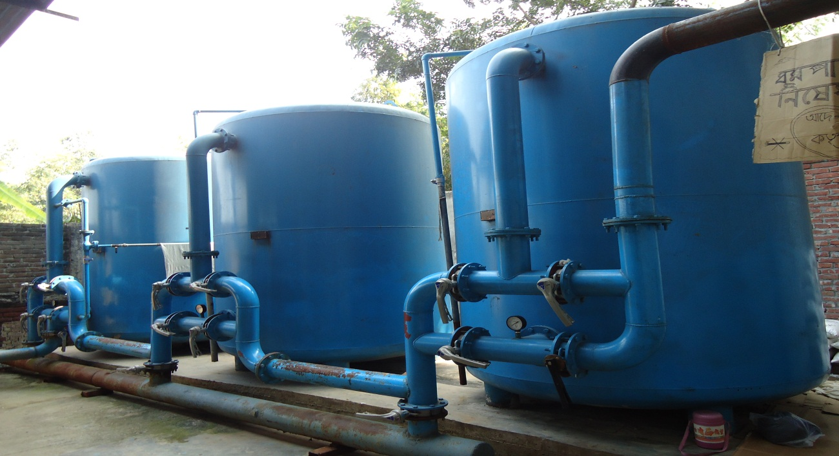

Water Treatment Plant

16.2 Water Treatment Plant:
The water treatment plant is a vital part of the dyeing section where the supply water of the dyeing floor is treated and cured for proper dyeing. The supply water contains various soluble effluents like dissolved solids, metal compounds and other impurities which can lead to any sort of fabric fault during dyeing the knitted fabrics. The process sequence of the water treatment plant in Divine Textile Limited textile mill is briefly discussed below:

16.2.1Deep Pump:
The Deep pump is used for extracting water from raw water tank to pass in the dyeing section for the process of fabric dyeing.

16.2.2 Raw Water Tank:
Raw water tank is placed 20 feet deep tank where the water needed in the dyeing and finishing process is deposited and by the water pump the water in the tank is extracted.

16.2.3 Air Receiver Tank:
Air receiver tank is used for the passage of air from the boiler to the Iron exchanger tank.

16.2.4 Vessel:
The vessel is where the water from the WTP pump is collected.

16.2.5Iron Exchanger Tank:
The metals contained in the water are removed or broken down by applying air from the received from the air receiver tank.

16.2.6 Multi Grade Filter:
The multi grade filter is used for removing the residual iron contained in the treated water.

16.2.7 Activated Carbon Filter:
The activated carbon filter is used for removing the remaining metals and other impurities by passing the water flow through rocks of different sizes arranged in different layers of the tank. At first there is a layer of small rocks and next is a layer of medium rocks and finally comes a layer of big rocks. The tank contains a carbon layer in middle.

16.2.8 Softener Tank:
The softener tanks contains resin and in the softening tank water softening chemicals are applied for reducing the hardness of the water and making the water flow suitable for fabric dyeing.

16.2.9 Soft Water Reserve Tank:
The processed soft water is reserved in the soft water reserve tank.

16.2.10 Flow chart of water treatment plant:

Deep pump water supply

Raw water Tank

WTP Pump

Air Receiver Tank

Vessel

Iron Remover Tank

Multi-grade Filter

Activated Carbon Filter

Softener Tank or Filter

Soft water reserve Tank

Booster Pump

Dye House

CONCLUSION

PURBANIFABRICS LTD. is a well-planned versatile project. The administrations, management, chain of command – all are well organized. They are devoted to satisfy the customer by their activities. However, some of the point we want to mention for the good of PURBANI FABRICS LTD.

17.1 Some Suggestions:
- During the transport of the fabric in the dyeing floor and also during the loading of the M/C, fabrics are soiled for the contact with floor. This makes the fabric / part of the fabric dirty. It may require more scouring/bleaching agent or may create stain making it faulty.
- The dyeing floor is water most of the time: it should be cleaned all the time.
- The illumination of the dyeing shade should be enhanced. It may exert the worker fatigue ness
- More skilled labor should be used in a project as PURBANI FABRICS LTD. Many times the dosing pipelines are clogged due to the careless dosing of chemicals.
- The M/C stoppage time should be analyzed and minimized. The maintenance should be carried out when the M/C is out of action.

17.2 Limitation of the Report:
- Because of secrecy act the data on costing and marketing activities has not been supplied & hence this report excludes these chapters.
- Some of the points in different chapter are not described as these were not available.
- The whole process is not possible to bind in such a small frame as this report, hence our effort spent on summarizing them.
- We had a very limited time in spite of our willing to study more details it was not possible to do so.

17.3 Lastly:
At last I again give thanks to almighty ALLAH for successfully completed my industrial attachment. Actually, PURBANI is a 100% export oriented knit composite industry. During the training period, I have completed our industrial attachment to a systematic routine which was provided by PURBANI FABRICS LTD.

PURBANI FABRICS LTD. is a well-planned versatile project. The administrations, management, chain of command- all are well organized. They are devoted to satisfy the customer by their activities. However, some of the point we want to mention for the good of PURBANI FABRICS LTD.

The specially of this report is that the information, data & description very much subjective & practical. So, one can easily have an idea about the whole dyeing unit of PURBANI FABRICS LTD. at a single look on it.
The factory runs by a number of efficient textile engineers, skilled technical and non-technical persons. All the textile engineers and technical and non-technical persons are very sincere, co-operative and helpful.

I wish good luck of them and also for this factory.

18. Reference:

Websites:
- Purbanigroup.com/index.php
- Purbanigroup.com/web

Books:
- Garments and Textile Merchandising.
  - By- M. A Razzaque
- Garments & Technology.
  - By- M.A Kashem

Industry:
- Purbani Fabrics Ltd.

