

FACULTY OF SCIENCE & INFORMATION TECHNOLOGY
DEPARTMENT OF TEXTILE ENGINEERING

“STUDY ON EFFECT OF DIFFERENT PARAMETERS ON SPIRALITY OF WEFT KNITTED FABRIC”

Submitted By:
Md. Rezaur Rahman Manik; 091-23-1186
S.M. Jubaer Ahmed; 091-23-1199
Shuvo Kumar Kundu; 091-23-1238
Supervisor:
Dewan Murshed Ahmed
Lecturer & supervisor
Department of Textile Engineering
Daffodil International University

This thesis report is submitted to the Department of Textile Engineering of Daffodil International University in partial fulfillment of the requirement for the Degree of Bachelor of Science in Textile Engineering

Abstract
Spirality is particularly serious problem for single jersey knitted fabrics due to their asymmetrical loop formation. We focused on spirality of the single jersey knitted fabrics as key aspects. We investigated the different studies such as effect of Wales per inch, Course per inch, Stitch length and Count on the spirality of single jersey knitted fabrics. The paper also explicitly determined the effects of those parameters on spirality. The result also concludes that the Stitch length, WPI, CPI and Count are also influence fabric spirality. We worked on total 9 samples of single jersey plain fabric. Finally we found that, there are direct relationship or above parameters with Spirality.

Acknowledgements
First of all, we would like to thanks God for makes us enable to complete our project work.
Then we would like to thank our supervisor Dewan Murshed Ahmed, Lecturer, Department of Textile Engineering, for his important guidelines and presence during our project work, for his numerous advises for our future development and also for lead us throughout the project with his incredible knowledge and support.
We are cordially grateful to Prof. Dr. Md. Mahbubul Haque, Head of Department, Department of Textile Engineering, whose watchful guidance and inspiration enabled us to work hard and study more to complete this project.
Finally, we like to thank all our respected teachers of our Department for their insights, advice and suggestions. And also we like to thank all our departmental lab assistants to help us at the laboratory.

Declaration
We hereby declaring that, we have completed a thesis on “Effect of Different Parameters of Weft Knitted Fabric on Spirality” as a part of BSc in Textile Engineering, under the department of Textile Engineering. We have completed our thesis on the basis of Literature review and Experimental work.
Declared by:
- Dewan Murshed Ahmed
Lecturer & supervisor
Department of Textile Engineering
Daffodil International University

_________________________
(Dewan Murshed Ahmed)

- Rezaur Rahman Manik
ID: 091-23-1186

________________________
(Rezaur Rahman Manik)

- S.M.Jubaer Ahmed
ID:091-23-1199

_______________________
(S.M.Jubaer Ahmed)

- Shuvo Kumar Kundu
ID: 091-23-1238

______________________
(Shuvo Kumar Kundu)

Contents
1.Introduction 2
1.1.Objective of the study: 2
2.Literature review 3
2.1.Yarn Count 3
2.2.Course 4
2.3. Wale 4
2.4.Stitch length 5
2.5.Spirality 5
2.6.Causes of Spirality 6
2.6.1.Fiber causes 7
2.6.2.Yarn causes 8
2.6.3.Fabric causes 10
2.6.4.Machine causes 11
3.Methodology 13
4.Experimental 14
4.1.Analyzed data in table: 14
4.2.Overview of all table: 29
4.3.Statistical Analysis: 29
4.4.Final overview in graphical representation 33
5.Discussion of Result 34
6.Limitations 35
7.Conclusion 36

1.Introduction
The ever increasing demand of knitted apparels has attracted attention in global niche market. In comparison to woven garment, around 50% of the clothing needs are met by the knitted goods. It is well known that weft knitted fabrics tend to undergo certain dimensional changes that causes distortion in which there is a tendency of the knitted loops to bend over, causing the wales to be at diagonal instead of perpendicular to the courses.
Spirality of knitted fabric is obtained when the wale is not perpendicular to the course, forming an angle of spirality with vertical direction of the fabric. It affects particularly single jersey fabrics and presents a serious problem during garment confection and use. The t-shirt production, for example, suffers from many quality problems linked to fabric spirality such as mismatched patterns, sewing difficulties, displacement of side seam to the back and front of the body and garment distortion. Spirality has an evident influence on garment aesthetics. The spirality phenomenon concerns essentially unbalanced structures such as single jersey fabrics. The symmetry of rib structures reduces considerably the spirality. Unset yarns under low tensile loads have a tendency to return to their untwisted state.
This project proposed to measure spirality angle of cotton plain knitted fabric by manually technique with protector at finished stage. This project work have also investigate the effect of fabric and machine parameters such as wales per inch, loop length, course per inch and count on fabric spirality.

1.1.Objective of the study:
- To understand the effects of different parameters on spirality.
- Determination the effects of different parameters on spirality.
- To relate the relations among studied parameters.
- To know the effect the spirality on weft knitted fabric.
- To know the causes of spirality and their effect.

2. Literature review

2.1.Yarn Count
The count of a yarn is a numerical expression which indicates its fineness or coarseness. i.e. whether the yarn is thin or thick.
According to Textile Institute, yarn count is a number indicating mass/unit length or length/unit mass of yarn.
Systems of yarn Count:
We have two systems of yarn count
- Direct System(Mass/Unit length or Weight/Unit length)
- Indirect system(Length/unit mass or length/unit weight)
Direct system of yarn count | Weight Unit | Unit length
Tex | gm. | 1000m.
Denier | gm. | 9000m.
lbs/Spyndle | lbs. | 14400m.
In Direct system if the No. of yarn count is increase, yarn fineness is decrease.
Indirect system of yarn count | Length Unit | Unit Weight
Ne(English Count) | 840 yds. | 1 lb.
Nm(Metric Count) | 1000m. | 1 kg.
Nw(Worsted Count) | 560 yds. | 1 lb.
In Indirect system if the No. of yarn count is increase, yarn fineness is also increase.

2.2.Course
The row of loops or stitches running across the width of a fabric corresponding to filling of a knitted fabric.
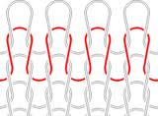
Fig: course of knitted fabric
Numbers of course per inch in knitted fabric is called CPI (course per inch)

2.3. Wale
In knit fabrics, a column of loops running lengthwise the fabric.
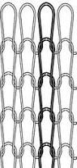
Fig: wales in knitted fabric
Numbers of wales per inch in knitted fabric is WPI (wales per inch)

2.4.Stitch length
Distance from a point of a knit loop to the same point of subsequent loop is called stitch length.
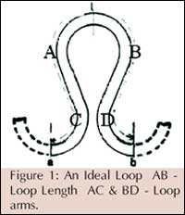

2.5.Spirality
"Spirality" arises from twist stress in the constituents yams of plain fabric, causing all loops to distort and throwing the fabric wales and courses into an angular relationship other than 90 degree.

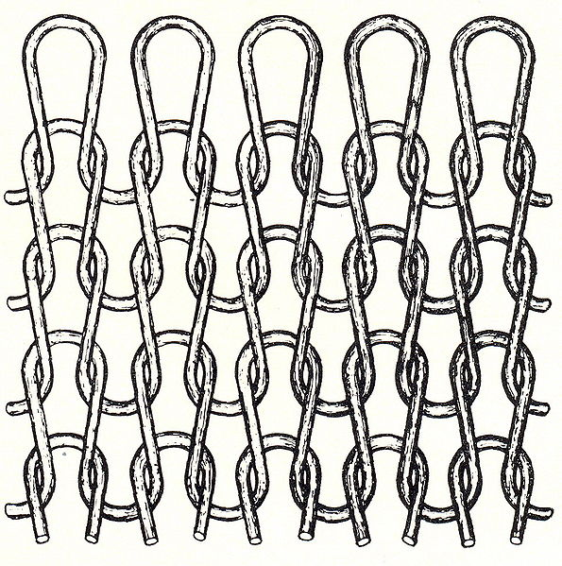

Fig: Ideal knit structure

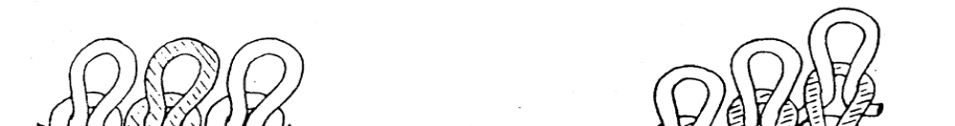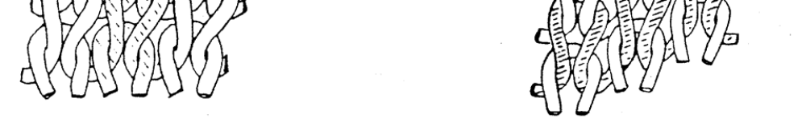
Fig: Spirality of wale Fig: Spirality of course

2.6.Causes of Spirality
The ultimate benefit of studying the spirality phenomenon is to understand the various factors influencing the dimensional stability of knit fabrics, particularly fabric spirality so that ways to select appropriate levels of these factors that result in optimum dimensional stability can be established. This can be achieved through a cause and effect analysis of the various potential factors influencing fabric spirality. The importance of cause and effect analysis stems from the fact that several theoretical approaches were taken to analyze the spirality phenomenon, yet because of the complexity of the phenomenon, each study focused on a limited number of factors, either for the sake of simplifying the analysis, or due to limited ability to verify the theory using experimental approaches. Other studies dealt with the analysis of spirality from strictly experimental view by examining the effects of a number of factors some of which were machine-related and others were fabric-related on the extent of spirality of knit structures. Obviously, these approaches resulted in many common causes and effects of this critical phenomenon. However, these were scattered in the bulk of literatures presented to such an extent that makes it difficult for researchers to have a complete view of all factors that can potentially result in an increase or a reduction in knit fabric spirality. It was important, therefore to perform this analysis in this study by examining causes and effects of fabric spirality on the basis of observations obtained in this study as well as the findings of the massive literatures available. Figure shows the various causes of fabric spirality and they are divided into four main categories: yarn causes, knit causes, fiber causes, and finishing causes

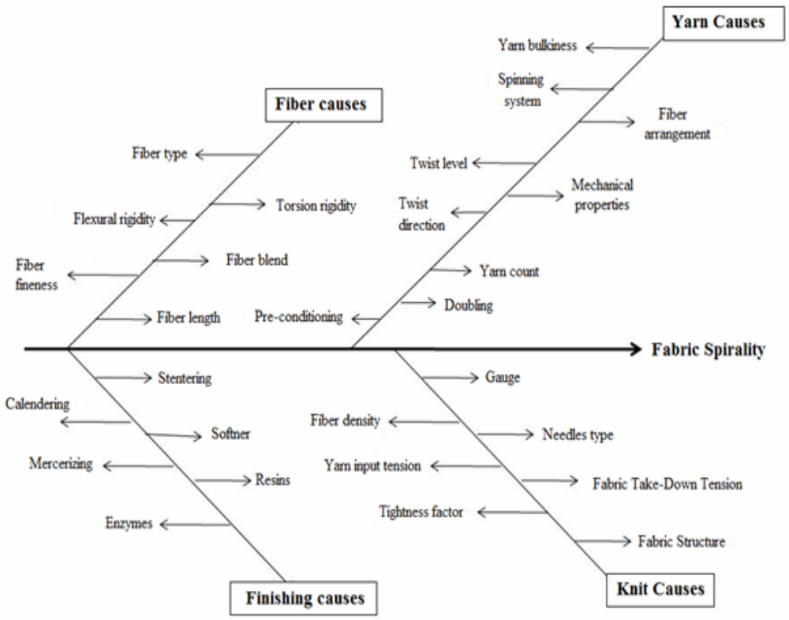

2.6.1.Fiber causes

- Fiber types
Different fibers have different properties like absorbency and elastic recovery vary fiber to fiber, which have a great impact on fiber relaxation after knit.

- Flexural rigidity
It is the property of fiber against flex or bend. It influences the straighten affinity of fiber from bend form.

- Torsion rigidity
It is the property of fiber against torsion force. It influences detwist force of fiber or yarn.

- Fiber fineness
With increase of fiber fineness twistability of increase. So it is an important factor for detwist force.

- Fiber length
Fiber length has an effect on bending property of fiber.
- Blend
In general, 50/50 cotton/polyester blends have a lower tendency to produce spirality in fabrics than the 100% cotton yarns. Spirality can be virtually eliminated by using 50/50 cotton/polyesters blend of air jet and rotor yarns.

2.6.2.Yarn causes
- Count
Degree of freedom of yarn movement in the fabric structure contributes significantly to the increase in spirality. Dimensional parameters of fully relaxed single jersey fabrics depend on the yarn linear density and tightness of construction. If diameter is reduced, its resistance to deformation is lowered. It indicates that, deformation of loop structure is influenced by yarn count. In other words, the finer the yarn, the more will be the spirality due to more twisting.\

- Twist
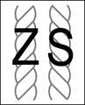
Fig: types of twist
Usually in knitting, low twisted yarns are used. High twisted yarn has a great impact on spirality due to its unrelieved torque. With the increase in twist, the twist liveliness increases, this in turn, causes the angle of spirality to increase. The direction of spirality in the fabrics knitted from short staple ring spun single yarns is determined by the yarn twist direction. Thus, the technical face of single jersey fabric exhibits spirality in the Z direction if a Z twisted yarn is knitted.

- Yarn Twist Multiplier (TM)
This index is represented by the following formula:
TM = T.P.I. / √N, where T.P.I. indicates twist per inch and N represents yarn number in an indirect system, the cotton system unless otherwise specified. With the increase in twist multiplier, the angle of spirality increases.

- Yarn Twist Factor (TF)
TF is related with the following formula:
TF = TPCm x √ T, where T signifies yarn number in Tex.
Raising the twist factor of two ply yarn increases the left hand or S-direction spirality, whereas increasing the twist factor of single yarn increases the right hand or Z-direction spirality.

- Conditioning
The minimum Spirality level that can be achieved by several ways such as storing yarn at
appropriate temperature and relative humidity or by thermal conditioning with low temperature saturated
steam in vacuum that results in a speedy relaxation. This process balances the twist so that it does not
regain its original state. However, there is no systematic study carried out to understand the effect of yarn
conditioning on spirality of single jersey fabrics.

- Spinning method
Yarn produced by different spinning technique has a direct bearing on spirality of knitted fabric. Friction spun yarn made of 100% cotton produce fabrics with highest degree of spirality, followed by ring spun yarns. Both rotor spun and air jet yarns produce fabrics with a low degree of spirality.

- Yarn bulkiness
Yarn bulkiness increase compactness of fabric, which make loops immobilize in fabric.

- Twist level
Higher the TPI higher detwist force act per inch of yarn.

- Mechanical properties
Mechanical properties like young’s modulus, elastic recovery, tenacity etc. of yarn influence the spirality of fabric.

2.6.3.Fabric causes
- Fabric stitch length
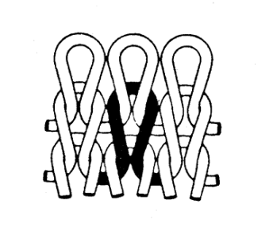
This is the length of one loop in knitted fabric. Spirality increases with the length of loop.
- Fabric structure
More spirality in single jersey due to non-arrest of loops. By adding moisture to such a structure, the twist will try to revert as it swells, that distorts the shape of the loop. In double jersey, the effect of spirality is nullified. Pique and honey comb also show spirality even if sometimes two beds are used. Spirality can be noticed in certain jacquard structures. In stripe pattern, it increases with the size. No appreciable problem of spirality is there in ribs and interlocks.
- Tightness
Slack fabric presents higher spirality angle compared to tightly knitted fabrics. At each level of yarn twist factor, the degree of spirality decreases linearly with fabric tightness factor.

- Fabric relaxation
Fabric relaxation (dry and wet) treatment removes the residual knitting tension in the yarn introduced during the knitting process. The relaxation treatment relieves the residual yarn torque as a result of changes in the molecular structure and increasing yarn mobility.

2.6.4.Machine causes

- Number of feeders
The number of feeders in a circular knitting machine also influences the angle of spirality. Due to more course inclination, spirality will be more.
- Direction of machine rotation
The direction of machine rotation has influence on spirality. For Z twist yarns, the wales go to the right and thus, giving Z skew and S twist yarns makes the wales go to the left, giving S skew to the fabric. With multi feed machines, the fabric is created in helix, which gives rise to course inclination and consequently wale spirality. Direction of spirality depends on the rotational direction of the knitting machine. Earlier research work revealed that, for a clockwise rotating machine, the wale would be inclined towards the left, thus producing the S spirality
- Gauge
In knitting terminology, number of needles per inch is called the gauge. Smaller the gauge, lesser will be the spirality keeping other parameters constant. A proper combination of linear density and gauge is required to reduce spirality e.g. torque can be controlled in 20 gauge and 40s count.
- Knitting tension
The effects of various knitting tensions including the whole process of loop formation on fabric spirality had been could not establish consistent trends with respect to variations in fabric quality with knitting tensions. The twist factors of ply and single yarn, loop length, and fiber diameter have significant effects on the angle of spirality, while yarn linear density and fabric tightness factor have comparatively lesser effect. So that it is clearly show that the spirality angle is reduced to a certain level with the other parameters are keep constant.

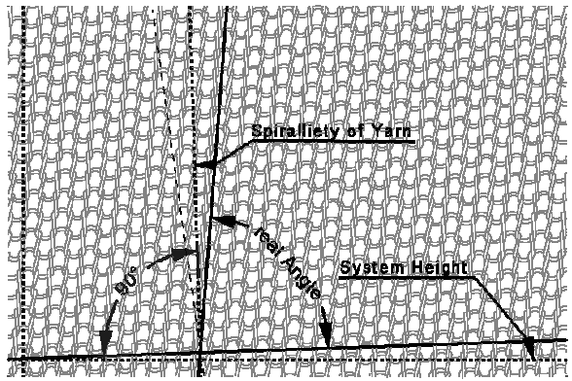
Fig: spirality of weft knitted fabric

3. Methodology

We collected 9 sample of single jersey weft knitted plain fabric.
We count number of wales widthwise in 10 inch of fabric by means of counting glass and needle then divided the result by 10 to find out the WPI. We took 5 readings and average the value to find average value of WPI of a sample. In same way we calculate the WPI of all samples.
We count number of course lengthwise in 10 inch of fabric by means of counting glass and needle then divided the result by 10 to find out the CPI. We took 5 readings and average the value to find average value of CPI of a sample. In same way we calculate the CPI of all samples.
In term of angle measurement, marked a wales then measured angle between a course and marked wale by means of a protector. We carefully took 5 readings for “angle of spirality” of all 9 samples. Then average the value of 5 angles to get average “angle of spirality”.
We opened yarn form 10 inch fabric and measured its length in mm by means of scale when the yarn was straight but relaxed. We took 5 readings for each sample then divided them by respective WPI to find out staple length. We average the 5 values to get average stitch length of each sample.
To measure count we took 20 yarns of length 12 inch from each sample and weight them by means of electrical scale. We took 20 samples of 12 inch yarn which in total 240 inch or 6.67 yds of yarn. We did this operation for five times for each sample. We recorded the weight of each sample carefully. We put the values of length and weight in following equation to find out the yarn count,

N = (L × w) / (l × W)

Where,
N = yarn count
L = length of sample
W = the weight of the sample at the official regain in the units of the system
l =the unit length of the system
w= the unit weight of the system
We average 5 counts to get average count of a sample.

4. Experimental

4.1. Analyzed data in table:
We have got following tables from our research on 9 samples.
No of sample: 01
Table for Wales per inch (WPI)
No of experiment | Wales per 10 inch | Wales per inch (WPI)  Wales per 10 inch/ 10 | Average WPI  ∑WPI/ 5
01 | 354 | 35.4
02 | 356 | 35.6
03 | 355 | 35.5 | 35.54
04 | 352 | 35.2
05 | 360 | 36
Table: 1
Table for Course per inch (CPI)
No of experiment | Course per 10 inch | Course per inch (CPI)  Course per 10 inch/ 10 | Average WPI  ∑CPI/ 5
01 | 536 | 53.6
02 | 544 | 54.4
03 | 560 | 56 | 54.28
04 | 533 | 53.3
05 | 541 | 54.1
Table: 2

Table for stitch length (SL)
No of experiment | Linear length of yarn / 10 inch  (x in mm) | Wales per 10 inch  (y) | Stitch length (SL) in mm  (x/y) | Average stitch length
01 | 925 | 354 | 2.61
02 | 925 | 356 | 2.59
03 | 926 | 355 | 2.6 | 2.59
04 | 922 | 352 | 2.61
05 | 924 | 360 | 2.56
Table: 3

Table for angle of spirality
No of experiment | Angel of spirality | Average
01 | 83°
02 | 82°
03 | 83° | 82.5°
04 | 83°
05 | 81.5°
Table: 4

Table for count
No of experiment | Length of sample L  (yds) | Weight of the sample W (lbs) | Unit length of the system l  (yds) | Unit weight of the system w (lbs) | Count N =  L × w  Ι × W  (Ne) | Average count  (Ne)
01 | 6.67 | 0.0003174 | 840 | 1 | 25.01
02 | 6.67 | 0.0003182 | 840 | 1 | 24.95
03 | 6.67 | 0.0003176 | 840 | 1 | 25 | 25.01
04 | 6.67 | 0.0003172 | 840 | 1 | 25.03
05 | 6.67 | 0.0003168 | 840 | 1 | 25.06
Table: 5

No of sample: 02
Table for Wales per inch (WPI)
No of experiment | Wales per 10 inch | Wales per inch (WPI)  Wales per 10 inch/ 10 | Average WPI  ∑WPI/ 5
01 | 364 | 36.4
02 | 368 | 36.8
03 | 362 | 36.2 | 36.48
04 | 366 | 36.6
05 | 364 | 36.4
Table: 6

Table for Course per inch (CPI)
No of experiment | Course per 10 inch | Course per inch (CPI)  Course per 10 inch/ 10 | Average WPI  ∑CPI/ 5
01 | 555 | 55.5
02 | 536 | 53.6
03 | 539 | 53.9 | 54.72
04 | 548 | 54.8
05 | 558 | 55.8
Table:7

Table for stitch length (SL)
No of experiment | Linear length of yarn / 10 inch  (x in mm) | Wales per 10 inch  (y) | Stitch length (SL) in mm  (x/y) | Average stitch length
01 | 915 | 364 | 2.51
02 | 920 | 368 | 2.5
03 | 930 | 362 | 2.56 | 2.53
04 | 925 | 366 | 2.52
05 | 935 | 364 | 2.56
Table: 8

Table for angle of spirality
No of experiment | Angel of spirality | Average
01 | 80°
02 | 84.5°
03 | 83.5° | 83°
04 | 82.5°
05 | 84.5°
Table: 9

Table for count
No of experiment | Length of sample L  (yds) | Weight of the sample W (lbs) | Unit length of the system l  (yds) | Unit weight of the system w (lbs) | Count N =  L × w  Ι × W  (Ne) | Average count  (Ne)
01 | 6.67 | 0.0003042 | 840 | 1 | 26.1
02 | 6.67 | 0.0003041 | 840 | 1 | 26.11
03 | 6.67 | 0.0003056 | 840 | 1 | 25.98 | 26.08
04 | 6.67 | 0.0003034 | 840 | 1 | 26.17
05 | 6.67 | 0.0003045 | 840 | 1 | 26.07
Table: 10

No of sample: 03
Table for Wales per inch (WPI)
No of experiment | Wales per 10 inch | Wales per inch (WPI)  Wales per 10 inch/ 10 | Average WPI  ∑WPI/ 5
01 | 388 | 38.8
02 | 386 | 38.6
03 | 382 | 38.2 | 38.58
04 | 388 | 38.8
05 | 385 | 38.5
Table: 11

Table for Course per inch (CPI)
No of experiment | Course per 10 inch | Course per inch (CPI)  Course per 10 inch/ 10 | Average WPI  ∑CPI/ 5
01 | 568 | 56.8
02 | 565 | 56.5
03 | 558 | 55.8 | 56
04 | 547 | 54.7
05 | 562 | 56.2
Table: 12

Table for stitch length (SL)
No of experiment | Linear length of yarn / 10 inch  (x in mm) | Wales per 10 inch  (y) | Stitch length (SL) in mm  (x/y) | Average stitch length
01 | 923 | 388 | 2.37
02 | 922 | 386 | 2.38
03 | 923 | 382 | 2.41 | 2.38
04 | 931 | 388 | 2.39
05 | 924 | 385 | 2.4
Table: 13

Table for angle of spirality
No of experiment | Angel of spirality | Average
01 | 77°
02 | 78.5°
03 | 74° | 76.5°
04 | 75.5°
05 | 77.5°
Table: 14

Table for count
No of experiment | Length of sample L  (yds) | Weight of the sample W (lbs) | Unit length of the system l  (yds) | Unit weight of the system w (lbs) | Count N =  L × w  Ι × W  (Ne) | Average count  (Ne)
01 | 6.67 | 0.0002512 | 840 | 1 | 31.61
02 | 6.67 | 0.0002520 | 840 | 1 | 31.50
03 | 6.67 | 0.0002518 | 840 | 1 | 31.53 | 31.59
04 | 6.67 | 0.0002506 | 840 | 1 | 31.68
05 | 6.67 | 0.0002510 | 840 | 1 | 31.63
Table: 15

No of sample: 04
Table for Wales per inch (WPI)
No of experiment | Wales per 10 inch | Wales per inch (WPI)  Wales per 10 inch/ 10 | Average WPI  ∑WPI/ 5
01 | 381 | 38.1
02 | 385 | 38.5
03 | 384 | 38.4 | 38.1
04 | 378 | 37.8
05 | 380 | 38.0
Table: 16

Table for Course per inch (CPI)
No of experiment | Course per 10 inch | Course per inch (CPI)  Course per 10 inch/ 10 | Average WPI  ∑CPI/ 5
01 | 515 | 51.5
02 | 509 | 50.9
03 | 532 | 53.2 | 51.9
04 | 518 | 51.8
05 | 525 | 52.5
Table: 17

Table for stitch length (SL)
No of experiment | Linear length of yarn / 10 inch  (x in mm) | Wales per 10 inch  (y) | Stitch length (SL) in mm  (x/y) | Average stitch length
01 | 930 | 381 | 2.44
02 | 928 | 385 | 2.41
03 | 937 | 384 | 2.44 | 2.43
04 | 932 | 378 | 2.46
05 | 929 | 380 | 2.44
Table: 18

Table for angle of spirality
No of experiment | Angel of spirality | Average
01 | 84°
02 | 85°
03 | 85° | 85°
04 | 84.5°
05 | 86.5°
Table: 19

Table for count
No of experiment | Length of sample L  (yds) | Weight of the sample W (lbs) | Unit length of the system l  (yds) | Unit weight of the system w (lbs) | Count N =  L × w  Ι × W  (Ne) | Average count  (Ne)
01 | 6.67 | 0.0003526 | 840 | 1 | 22.51
02 | 6.67 | 0.0003520 | 840 | 1 | 22.55
03 | 6.67 | 0.0003532 | 840 | 1 | 22.48 | 22.5
04 | 6.67 | 0.0003528 | 840 | 1 | 22.50
05 | 6.67 | 0.0003530 | 840 | 1 | 22.49
Table: 20

No of sample: 05
Table for Wales per inch (WPI)
No of experiment | Wales per 10 inch | Wales per inch (WPI)  Wales per 10 inch/ 10 | Average WPI  ∑WPI/ 5
01 | 357 | 35.7
02 | 352 | 35.2
03 | 361 | 36.1 | 35.66
04 | 358 | 35.8
05 | 355 | 35.5
Table: 21

Table for Course per inch (CPI)
No of experiment | Course per 10 inch | Course per inch (CPI)  Course per 10 inch/ 10 | Average WPI  ∑CPI/ 5
01 | 535 | 53.5
02 | 519 | 51.9
03 | 542 | 54.2 | 53.34
04 | 543 | 54.3
05 | 528 | 52.8
Table: 22

Table for stitch length (SL)
No of experiment | Linear length of yarn / 10 inch  (x in mm) | Wales per 10 inch  (y) | Stitch length (SL) in mm  (x/y) | Average stitch length
01 | 967 | 357 | 2.70
02 | 984 | 352 | 2.79
03 | 984 | 361 | 2.72 | 2.73
04 | 975 | 358 | 2.72
05 | 978 | 355 | 2.75
Table: 23

Table for angle of spirality
No of experiment | Angel of spirality | Average
01 | 83.5°
02 | 84.5°
03 | 85.5° | 84°
04 | 84°
05 | 82.5°
Table: 24

Table for count
No of experiment | Length of sample L  (yds) | Weight of the sample W (lbs) | Unit length of the system l  (yds) | Unit weight of the system w (lbs) | Count N =  L × w  Ι × W  (Ne) | Average count  (Ne)
01 | 6.67 | 0.0003394 | 840 | 1 | 23.39
02 | 6.67 | 0.0003380 | 840 | 1 | 23.49
03 | 6.67 | 0.0003385 | 840 | 1 | 23.45 | 23.41
04 | 6.67 | 0.0003400 | 840 | 1 | 23.35
05 | 6.67 | 0.0003392 | 840 | 1 | 23.4
Table: 25

No of sample: 06
Table for Wales per inch (WPI)
No of experiment | Wales per 10 inch | Wales per inch (WPI)  Wales per 10 inch/ 10 | Average WPI  ∑WPI/ 5
01 | 375 | 37.5
02 | 370 | 37.0
03 | 379 | 37.9 | 37.3
04 | 371 | 37.1
05 | 374 | 37.4
Table: 26

Table for Course per inch (CPI)
No of experiment | Course per 10 inch | Course per inch (CPI)  Course per 10 inch/ 10 | Average WPI  ∑CPI/ 5
01 | 562 | 56.2
02 | 550 | 55.0
03 | 560 | 56.0 | 55.5
04 | 555 | 55.5
05 | 551 | 55.1
Table: 27

Table for stitch length (SL)
No of experiment | Linear length of yarn / 10 inch  (x in mm) | Wales per 10 inch  (y) | Stitch length (SL) in mm  (x/y) | Average stitch length
01 | 980 | 354 | 2.76
02 | 984 | 356 | 2.76
03 | 978 | 355 | 2.75 | 2.75
04 | 982 | 352 | 2.78
05 | 979 | 360 | 2.71
Table: 28

Table for angle of spirality
No of experiment | Angel of spirality | Average
01 | 76°
02 | 80.5°
03 | 82° | 79.5°
04 | 80.5°
05 | 78.5°
Table: 29

Table for count
No of experiment | Length of sample L  (yds) | Weight of the sample W (lbs) | Unit length of the system l  (yds) | Unit weight of the system w (lbs) | Count N =  L × w  Ι × W  (Ne) | Average count  (Ne)
01 | 6.67 | 0.0002821 | 840 | 1 | 28.14
02 | 6.67 | 0.0002815 | 840 | 1 | 28.20
03 | 6.67 | 0.0002820 | 840 | 1 | 28.15 | 28.12
04 | 6.67 | 0.0002825 | 840 | 1 | 28.10
05 | 6.67 | 0.0002830 | 840 | 1 | 28.05
Table: 30

No of sample: 07
Table for Wales per inch (WPI)
No of experiment | Wales per 10 inch | Wales per inch (WPI)  Wales per 10 inch/ 10 | Average WPI  ∑WPI/ 5
01 | 377 | 37.7
02 | 380 | 38.0
03 | 378 | 37.8 | 37.7
04 | 378 | 37.8
05 | 376 | 37.6
Table: 31

Table for Course per inch (CPI)
No of experiment | Course per 10 inch | Course per inch (CPI)  Course per 10 inch/ 10 | Average WPI  ∑CPI/ 5
01 | 470 | 47.0
02 | 476 | 47.6
03 | 480 | 48.0 | 48
04 | 488 | 48.8
05 | 490 | 49.0
Table: 32

Table for stitch length (SL)
No of experiment | Linear length of yarn / 10 inch  (x in mm) | Wales per 10 inch  (y) | Stitch length (SL) in mm  (x/y) | Average stitch length
01 | 938 | 377 | 2.48
02 | 955 | 380 | 2.51
03 | 956 | 378 | 2.52 | 2.5
04 | 949 | 378 | 2.51
05 | 935 | 376 | 2.48
Table: 33

Table for angle of spirality
No of experiment | Angel of spirality | Average
01 | 82°
02 | 83°
03 | 82.5° | 82.5°
04 | 82°
05 | 83°
Table: 34

Table for count
No of experiment | Length of sample L  (yds) | Weight of the sample W (lbs) | Unit length of the system l  (yds) | Unit weight of the system w (lbs) | Count N =  L × w  Ι × W  (Ne) | Average count  (Ne)
01 | 6.67 | 0.0003173 | 840 | 1 | 25.02
02 | 6.67 | 0.0003165 | 840 | 1 | 25.08
03 | 6.67 | 0.0003175 | 840 | 1 | 25 | 24.99
04 | 6.67 | 0.0003183 | 840 | 1 | 24.94
05 | 6.67 | 0.0003185 | 840 | 1 | 24.93
Table: 35

No of sample: 08
Table for Wales per inch (WPI)
No of experiment | Wales per 10 inch | Wales per inch (WPI)  Wales per 10 inch/ 10 | Average WPI  ∑WPI/ 5
01 | 364 | 36.4
02 | 362 | 36.2
03 | 360 | 36.0 | 36.1
04 | 358 | 35.8
05 | 363 | 36.3
Table: 36

Table for Course per inch (CPI)
No of experiment | Course per 10 inch | Course per inch (CPI)  Course per 10 inch/ 10 | Average WPI  ∑CPI/ 5
01 | 570 | 57
02 | 546 | 54.6
03 | 528 | 52.8 | 54.94
04 | 555 | 55.5
05 | 548 | 54.8
Table: 37

Table for stitch length (SL)
No of experiment | Linear length of yarn / 10 inch  (x in mm) | Wales per 10 inch  (y) | Stitch length (SL) in mm  (x/y) | Average stitch length
01 | 951 | 364 | 2.61
02 | 956 | 362 | 2.64
03 | 942 | 360 | 2.61 | 2.62
04 | 940 | 358 | 2.62
05 | 952 | 363 | 2.62
Table: 38

Table for angle of spirality
No of experiment | Angel of spirality | Average
01 | 84°
02 | 84°
03 | 80° | 82.5°
04 | 82°
05 | 82.5°
Table: 39

Table for count
No of experiment | Length of sample L  (yds) | Weight of the sample W (lbs) | Unit length of the system l  (yds) | Unit weight of the system w (lbs) | Count N =  L × w  Ι × W  (Ne) | Average count  (Ne)
01 | 6.67 | 0.0003085 | 840 | 1 | 25.73
02 | 6.67 | 0.0003080 | 840 | 1 | 25.78
03 | 6.67 | 0.0003078 | 840 | 1 | 25.79 | 25.73
04 | 6.67 | 0.0003091 | 840 | 1 | 25.68
05 | 6.67 | 0.0003088 | 840 | 1 | 25.71
Table: 40

No of sample: 09
Table for Wales per inch (WPI)
No of experiment | Wales per 10 inch | Wales per inch (WPI)  Wales per 10 inch/ 10 | Average WPI  ∑WPI/ 5
01 | 358 | 35.8
02 | 360 | 36.0
03 | 356 | 35.6 | 35.8
04 | 357 | 35.7
05 | 361 | 36.1
Table: 41

Table for Course per inch (CPI)
No of experiment | Course per 10 inch | Course per inch (CPI)  Course per 10 inch/ 10 | Average WPI  ∑CPI/ 5
01 | 573 | 57.3
02 | 567 | 56.7
03 | 565 | 56.5 | 57
04 | 570 | 57.0
05 | 575 | 57.5
Table: 42

Table for stitch length (SL)
No of experiment | Linear length of yarn / 10 inch  (x in mm) | Wales per 10 inch  (y) | Stitch length (SL) in mm  (x/y) | Average stitch length
01 | 935 | 358 | 2.61
02 | 939 | 360 | 2.6
03 | 935 | 356 | 2.62 | 2.6
04 | 935 | 357 | 2.61
05 | 942 | 361 | 2.6
Table: 43

Table for angle of spirality
No of experiment | Angel of spirality | Average
01 | 80.5°
02 | 81.5°
03 | 81° | 80.5°
04 | 79°
05 | 80.5°
Table: 44

Table for count
No of experiment | Length of sample L  (yds) | Weight of the sample W (lbs) | Unit length of the system l  (yds) | Unit weight of the system w (lbs) | Count N =  L × w  Ι × W  (Ne) | Average count  (Ne)
01 | 6.67 | 0.0002799 | 840 | 1 | 28.36
02 | 6.67 | 0.0002785 | 840 | 1 | 28.51
03 | 6.67 | 0.0002795 | 840 | 1 | 28.4 | 28.39
04 | 6.67 | 0.0002804 | 840 | 1 | 28.31
05 | 6.67 | 0.0002797 | 840 | 1 | 28.38
Table: 45

4.2.Overview of all table:
Sample no. | Wales per inch (WPI) | Course per inch (CPI) | Stitch length (SL) | Angel of Spirality | Count
1 | 35.54 | 54.28 | 2.59 | 82.5 | 25.01
2 | 36.48 | 54.72 | 2.53 | 83 | 26.08
3 | 38.58 | 56 | 2.38 | 76.5 | 31.59
4 | 38.1 | 51.9 | 2.43 | 85 | 22.5
5 | 35.66 | 53.34 | 2.73 | 84 | 23.41
6 | 37.3 | 55.5 | 2.75 | 79.5 | 28.12
7 | 37.7 | 48 | 2.5 | 82.5 | 24.99
8 | 36.1 | 54.94 | 2.62 | 82.5 | 25.73
9 | 35.8 | 57 | 2.6 | 80.5 | 28.39
Table: 46

4.3.Statistical Analysis:
Effect of WPI on Spirality:
Sample no. | Wales per inch (WPI) | Angel of Spirality
1 | 35.54 | 82.5
2 | 36.48 | 83
3 | 38.58 | 76.5
4 | 38.1 | 85
5 | 35.66 | 84
6 | 37.3 | 79.5
7 | 37.7 | 82.5
8 | 36.1 | 82.5
9 | 35.8 | 80.5
Table: 47

Fig : chart 1
Effect of CPI on Spirality:
Sample no. | Course per inch (CPI) | Angel of Spirality
1 | 54.28 | 82.5
2 | 54.72 | 83
3 | 56 | 76.5
4 | 51.9 | 85
5 | 53.34 | 84
6 | 55.5 | 79.5
7 | 48 | 82.5
8 | 54.94 | 82.5
9 | 57 | 80.5
Table: 48

Fig: chart 2

Effect of Stitch length (SL) on Spirality:
Sample no. | Stitch length (SL) | Angel of Spirality
1 | 2.59 | 82.5
2 | 2.53 | 83
3 | 2.38 | 76.5
4 | 2.43 | 85
5 | 2.73 | 84
6 | 2.75 | 79.5
7 | 2.5 | 82.5
8 | 2.62 | 82.5
9 | 2.6 | 80.5
Table: 49

Fig: chart 3

Effect of Count on Spirality:
Sample no. | Count | Angel of Spirality
1 | 25.01 | 82.5
2 | 26.08 | 83
3 | 31.59 | 76.5
4 | 22.5 | 85
5 | 23.41 | 84
6 | 28.12 | 79.5
7 | 24.99 | 82.5
8 | 25.73 | 82.5
9 | 28.39 | 80.5

Table: 50

Fig: chart 4

4.4.Final overview in graphical representation

Fig: chart 5

- Discussion of Result
We have found the effects of four parameters (WPI, CPI, SL and Count) on Angle of Spirality. We have found four different count groups from 9 samples.
- Theoretically, Spirality increases with the increase of WPI. From table 47 and chart 1we have found the same relation. The deviation of Wales from 90 ̊ is higher with decrease of Angle of Spirality . From chart 1 we can see that with increase of WPI, Angle of Spirality decrease. That’s mean with the higher WPI, Spirality is also higher.

- As deviation of Wales from 90 ̊ or Spirality is higher with decrease of Angle of Spirality . From table 48 and chart 2 we can see that with increase of CPI, Angle of Spirality decrease. That’s mean with the higher CPI, Spirality is also higher.

- According to previous researches, Spirality increases with increase of Stitch Length (SL). This is because when stitch is higher than loop bent more freely due to torsional force during relaxation. As a result Spirality increases with higher Stitch Length (SL). In our research, we have found the effect of Stitch Length (SL) on weft knitted fabric unpredictable. This is because, we have worked with samples having nearer Stitch Length (SL) and since we have worked with samples of different Count, the effect of counts interrupt our result.

- According to English System, the higher the count the finer the yarn. Theoretically, Spirality increases with count. This is because higher count indicates lower diameter. In structure, yarns of lower diameter can move more freely than that of higher diameter during relaxation. As a result, Spirality increases. From our research, we have found clear effect of Count on Spirality. From table 50 and chart 4 we can observe that Angle of Spirality decreases with count increase. Since Angle of Spirality inversely proportional to Spirality, hence Spirality increases.

- Limitations

- If we could work with more sample our result would be more accurate.
- We did some experiment manually, if we could do those experiments by the help of automatic machine, it would be fine.
- If we could work in a lab it would be more helpful.

- Conclusion

Textile industry, as a leading force in the economy of our country lacks minimal research and studies on the field. As a part of continuous development this field needs more focus from the scholars.
As this field is production oriented and highly competitive, any improvement over quality and performance will give us an edge over others. This project may help the knitters to improve their production performance and product quality. Through we feel the work somewhat unfinished due to lack of necessary arrangements for more work, but still the progress we’ve made on this matter should be taken into consideration.
We would like to see more work on this matter in the future.

References
- Principles of Textile Testing J.E. Booth, B.Sc. F.T.L.

- Knitting Technology(third edition,) David J. Spencer.

- Causes and Remedial Measures of Spirality in Knitted Fabrics, Dr. Subrata Das.

- Vishal Desale, P.P.Raichurkar, Akhilesh Shukla & Ramkesh Yadav:A study on spirality of single jersey knitted fabric.

- Jiang T, Dhingra R C, Chan C K and Abbas M S: Effect of yarn and fabric construction on spirality of cotton single jersey fabrics, Textile res j, 67, 57-68 (1997).

- M.A. Shahid, F. Ahmed, A.K.M. Mahabubuzzaman, M.A. Hannan and A.N. Khan: Spirality in cotton knit fabrics before and after compacting using selected yarn count and stitch length.

- S. C. Anand, K. S. M. Brown, L. G. Higgins, D. A. Holmes, m. E. Hall and d. Conrad: Effect of laundering on the dimensional stability and Distortion of knitted fabrics.

- De Araujo M D and Smith G W: Spirality of knitted fabrics, part i: the nature of spirality, textile res j 59, 247-256 (1989).

