Study on Quality Issues in Circular Weft Knitting
Prepared By
G. M. Salah Uddin Kader  ID:092-23-1472 | Md. Nahid Rana  092-23-1491

This Report Presented in partial Fulfillment of the Requirements for the Degree of Bachelor of Science in Textile Engineering.

Supervised by:
Prof. Dr. Md. Mahbubul Haque
Professor & Head of the Department
Department of Textile Engineering
Daffodil International University


Department of Textile Engineering
Daffodil International University
Dhaka, Bangladesh
April, 2013

I

Declaration

We hereby declare that, this project has been done by us under the supervision of Prof. Dr. Md. Mahbubul Haque, Daffodil International University. We also declare that neither this project nor any part of this project has been submitted elsewhere for award of any degree or diploma.
Supervised by:
Prof. Dr. Md. Mahbubul Haque
Professor & Head of the Department
Department of Textile Engineering
Faculty of Science & Information Technology
Daffodil International University
Submitted by:
G. M. Salah Uddin Kader
092-23-1472
Md. Nahid Rana
092-23-1491
Department of Textile Engineering
Faculty of Science & Information Technology
Daffodil International University

II
ACKNOWLEDGEMENT
First we express our heartiest thanks and gratefulness to almighty Allah for His blessings makes us possible to complete this project successfully.

We fell grateful to and wish our profound our indebtedness to Prof. Dr. Md. Mahbubul Haque. Head of the Department of Textile Engineering, Daffodil International University, Dhaka. Deep Knowledge & keen interest of our supervisor who helps us to carry out this project. His endless patience, scholarly guidance, continual encouragement, constant and energetic supervision, constructive criticism, valuable advice, reading many inferior draft and correcting them at all stage have made it possible to complete this project.

We would like to thank our entire course mate in Daffodil International University, who took
part in this discuss while completing the course work.

We would like to express our thanks to all staff of Chaity Composite Ltd who have given us time and moral support during ours internship program for providing necessary information about our project.

Finally, we must acknowledge with due respect the constant support and patients of our parents.

III
ABSTRACT

The project is on the “Quality Issues in Circular Weft Knitting”. In these days quality has become a great issue in every aspect. People are now more concerned about the quality. They are willing to pay more for the good quality product. So the manufactures have to be more concerned about the quality. As our country is a renowned supplier of readymade knit garments so the manufacturers have maintain the quality through the processes. Our knit industry is an integrated industry so it is mandatory to check the processes from the beginning. It becomes from the yarn to the finished product. We are here tried to illustrate the quality parameter in the knitting sector.
This paper contains the data about the problems arise during knitting, their rectifications and the remedies. Here we tried to show all the parameters taken to resolve the quality problems in an industry. Normally in knitting the quality is checked in three different stages. First preventive measurement this include; yarn quality checking, machine quality, the tension checking finding the faults and rectifying them. Then comes the process control. Here the process is checked and verified on-line and off-line. This includes the checking of GSM, the stitch length of the fabric, the speed of the machine. Finally comes the product control. Here the fabric is checked through 4-point system, 10-point system, the Graniteville’78 system and Dallas system. So we can say that a fabric has to pass too many levels to be on the next stage.
In the market of supplying the competition is increasing day by day. A single and silly mistake in quality controlling can be good reason for the rejection of the product. So it becomes necessary to maintain all the quality requirements of the consumer.

IV
Table of content
Declaration …………………………………………………………………… I
Acknowledgement………………………………………………………………II
Abstract ………………………………………………………………………... III

Topic no. | Topic |  | Page no.
Chapter 01: Introduction
1.0 |  | Introduction |  | 01
Chapter 02: Literature Review
2.0. |  | Literature Review |  | 04
2.1. |  | Quality and Quality Control |  | 05
2.1.0. |  | Quality? |  | 05
2.1.1. |  | Quality control |  | 07
2.1.2. |  | History of Quality Control |  | 07
2.2. |  | Quality Control in Circular Weft Knitting |  | 10
2.2.1. |  | Preventive Measures |  | 10
2.2.1. (a) |  | Yarn Quality Requirement |  | 10
2.2.1. (b) |  | Machine Quality Requirement |  | 14
2.2.2. |  | Process Control |  | 19
2.2.2. (A) |  | Online Quality Control |  | 20
2.2.2. (B) |  | Off-line Quality Control |  | 23
2.2.3 |  | Product Control in Weft Knitting |  | 32
2.3 |  | Defect in Knitted Fabric |  | 36
2.3.1. |  | Yarn Related defects |  | 36
2.3.2. |  | Knitting Element Related Defects |  | 42
2.3.3. |  | Machine Setting Related Defects |  | 45
Chapter 03: Experimental Work
3.0 |  | Experimental Work |  | 49
3.1 |  | Probable GSM for Different Count |  | 49
3.2 |  | Testing Stitch Length |  | 51
3.3 |  | GSM Checking |  | 53
3.4 |  | Factors Considered For GSM |  | 54
3.5 |  | Machine Quality Checking During Production |  | 55
3.6 |  | Fabric Inspection |  | 57
Chapter 04: Result and Discussion
4.0 |  | Result and Discussion |  | 61
Chapter 06: Conclusion
5.0 |  | Conclusion |  | 64
6.0 |  | References |  | 65

1. Introduction:
In the modern age of trade and business, competition is becoming stiffer by the day. About 20-25 years ago, minor fabric defects like the starting mark and small length of missing ends etc. were overlooked by the customers. But at a time, when the WTO agreement is knocking at our door and globalization of the market has been introduced in national and international policies, a fabric manufacturer is bound to compare his product with not only his Indian counterparts but also with that produced in other countries. If one fails to match the quality with the international standards, one shall have to either sell his fabric for the purpose of floor cleaning etc. or just stop production or make exodus from the market.
"Quality itself has been defined as fundamentally relational: 'Quality is the ongoing process of building and sustaining relationships by assessing, anticipating, and fulfilling stated and implied needs.'
According to Deming,‘‘A consistent and predictable uniformity at a low cost’’.
According to Joseph Juran, ‘‘Quality refers to ‘fitness for use’ and ‘conformance to specification’.
Quality is neither mind nor matter, but a third entity independent of the two, even though Quality cannot be defined, you know what it is. (Persig, 1974)
Quality means conformance to requirements. (Crosby, 1979)
[Quality is] a system of means to economically produce goods or services which satisfy customers' requirements. (Japanese Industrial Standards Committee, 1981)
Quality means best for certain conditions...(a) the actual use and (b) the selling price. (Feigenbaum, 1983)
[Quality] means that the organization's culture is defined by and supports the constant attainment of customer satisfaction through an integrated system of tools, techniques, and training. (Sashkin & Kiser, 1993)
You cannot separate the process and the human factor, therefore I believe that Quality, when built into a product, generates emotions and feelings within those who have taken part in it's creation. When you have made something that you are proud of, when you have produced a product that brings smiles to your customers, then you have achieved Quality. You'll know it, they'll know it, and each of you will prosper from it.
Error-free, value-added care and service that meets and/or exceeds both the needs and legitimate expectations of those served as well as those within the Medical Center.
Quality is the most variable things which are totally depend on the consumers demand. The same properties in a textile could be the most desirable quality for a consumer but it not for the other consumer. It has a great relation with the fashion of time. For example the fading effect in the jeans pants is the most desirable quality for young generation people & also it is granted as a most fashionable fabric but on the other hand it is not the quality for the old generation people. In the sense of fabric characteristics it is a fault due to loss of the strength.
We can spell out the clarity of quality as follows point of view:-
1. General: Measure of excellence or state of being free from defects, deficiencies, and significant variations. ISO 8402-1986 standard defines quality as "the totality of features and characteristics of a product or service that bears its ability to satisfy stated or implied needs."
2. Manufacturing: Strict and consistent adherence to measurable and verifiable standards to achieve uniformity of output that satisfies specific customer or user requirements.
3. Objective: Measurable and verifiable aspect of a thing or phenomenon, expressed in numbers or quantities, such as lightness or heaviness, thickness or thinness, softness or hardness.
4. Subjective: Attribute, characteristic, or property of a thing or phenomenon that can be observed and interpreted, and may be approximated (quantified) but cannot be measured, such as beauty, feel, flavor, taste.
Quality is meeting the customer's needs in a way that exceeds the customer's expectations.
Different people have different views about quality;
- The best money can buy
- Meeting a specification or conformance to specifications.
- Craftsmanship
- The degree of excellence that an item possesses.
- Product with no defect found
- Absence of variation in its broad sense.
- Meeting or exceeding customer expectation.
These responses depend on people’s perception of the value of a product or service under consideration and their explanation of performance, durability, reliability etc. of that product or service.
"Quality is nothing more or less than the perception the customer has of you, your products, and your services"!

Chapter 02: Literature

2.0. Literature Review:
Many companies promote quality as the central customer value and consider it to be a critical
Success factor for achieving competitiveness. Any serious attempt to improve quality must take
Into account the costs associated with achieving quality since the objective of continuous
Improvement programs is not only to meet customer requirements, but also to do it at the lowest
cost. This can only happen by reducing the costs needed to achieve quality, and the reduction of
These costs are only possible if they are identified and measured.
It has been estimated that the price of fabrics is reduced by 45%-65% due to the presence of defects. The fabric quality is affected by yarn quality and/or loom defects. The poor quality of raw materials and improper
Conditioning of yarn result in yarn quality defects and effects such as color or width inconsistencies, hairiness, slubs, broken ends, etc. There are numerous quality tests for yarns, such as ASTM D2255-96 , for predicting the quality of fabric to be produced from the entire lots of sampled yarns. The tests on the quality of yarns are usually performed at the output of spinning-mills. Quality test runs for looms and knitting machines require interruption of the weaving process.
This interruption is not practically feasible for the machines that are intended for large production runs of fabric rolls. The quality test runs on the older, worn, or obsolete model weaving machines generally produce unacceptable results. These test runs tend to be smaller and may not register recurring fabric defects that are generated due to sinusoidal occurring inconstancies in the weaving machines. Therefore, such fabric defects can be incorrectly read as resulting from poor yarn quality. The fabric defects resulting from variations in the
Tension of one or more yarn strands are generally misread as the defects resulting from poor yarn quality. The weaving irregularities generated in the weaving machines due to the change in operating conditions (temperature, humidity, etc.) also result in various fabric defects independently of yarn quality. The population of fabric defects may vary dynamically as small changes in the weaving process can result in entirely new class of fabric defects.

From the beginning of the textile, from the 27000 B.C. With the use of spindle to make yarn from fiber. We get the evidence of flax cultivation in the Near East in the year 8000 B.C. Approximate date of Naalebinding examples found in Nehal Hemar cave, Israel in 6500 BC. This technique, which uses short separate lengths of thread, predated the invention of knitting (with its continuous lengths of thread) and requires that all of the as-yet unused thread be pulled through the loop in the sewn material. This requires much greater skill than knitting in order to create a fine product. We get evidence of woven textiles used to wrap the dead at Çatalhöyük in Anatolia in 6000 B.C. The Production of linen cloth in Ancient Egypt, along with other bast fibers including rush, reed, palm, and papyrus was found in 5000 BC.The concept of "Needle Knitting" in Peru was invented in 200 BC to 200 AD, a form of Naalebinding that preceded local contact with the Spanish .Spinning wheel in use in India500 to 1000 AD .In 1600 the modern spinning wheel comes together with the addition of the treadle to the flyer wheel. Later finely decorated examples of cotton socks made by true knitting using continuous thread appear in Egypt 1000's AD. In 1806 Pierre Jeandeau patents brought the first latch needle (for using on knitting machine).Near about 1813 William Horrocks improves the power loom. Then in1849
Matthew Townsend patents the variant of latch needle which has been the most widely used needle in weft knitting machines. The American Mac Nary patents the circular knitting machine (with vertical needles) for fabrication of socks and stockings with heel and toe pouches found in1866.In 1878 Henry Griswold adds a second set of needles (horizontal needles) to the circular knitting machine enabling knitting of rib fabrics as cuff for socks.In1920 Hattersley loom developed by George Hattersley and Sons.1949 Heinrich Mauersberger invents the sewing-knitting technique and his "Malimo" machine .
These are the chronological development time-line of textile in our civilization. In that time all the manufacturer and consumers were thought about just textile goods / products but they were not wide awake about the quality. Yet but after 1970 the concept of quality was coming gradually. There after the term “quality” is the most vital issues behind production.
Therefore now-a-days, for ensuring the quality of fabric there are several quality measurement standards are established as like as follows :
- AATCC
- ASTM
- CAN
- ISO
- DIN
- AS
- BS
- ETC

2.1. Quality and Quality Control:
2.1.0. Quality?
“It is defined as that combination of design and properties of materials of a product which are needed for the intended end use and level of the market in which it is sold”

DIMENSIONS OF QUALITY
Dimension 1: Performance
Does the product or service do what it is supposed to do, within its defined tolerances?
Performance is often a source of contention between customers and suppliers, particularly when
deliverables are not adequately defined within specifications. The performance of a product often influences profitability or reputation of the end-user. As such, many contracts or specifications include damages related to inadequate performance.

Dimension 2: Features
Does the product or services possess all of the features specified, or required for its intended purpose?
While this dimension may seem obvious, performance specifications rarely define the features required in a product. Thus, it’s important that suppliers designing product or services from performance specifications are familiar with its intended uses, and maintain close relationships with the end-users.
Dimension 3: Reliability
Will the product consistently perform within specifications?
Reliability may be closely related to performance. For instance, a product specification may define parameters for up-time, or acceptable failure rates.
Reliability is a major contributor to brand or company image, and is considered a fundamental
dimension of quality by most end-users.
Dimension 4: Conformance
Does the product or service conform to the specification?
If it’s developed based on a performance specification, does it perform as specified? If it’s developed based on a design specification, does it possess all of the features defined?
Dimension 5: Durability
How long will the product perform or last, and under what conditions?
Durability is closely related to warranty. Requirements for product durability are often included within procurement contracts and specifications.
For instance, fighter aircraft procured to operate from aircraft carriers include design criteria intended to improve their durability in the demanding naval environment.
Dimension 6: Serviceability
Is the product relatively easy to maintain and repair?
As end users become more focused on Total Cost of Ownership than simple procurement costs, serviceability (as well as reliability) is becoming an increasingly important dimension of quality and criteria for product selection.

Dimension 7: Aesthetics
The way a product looks is important to end-users. The aesthetic properties of a product contribute to a company’s or brand’s identity. Faults or defects in a product that diminish its aesthetic properties, even those that do not reduce or alter other dimensions of quality, are often cause for rejection.
Dimension 8: Perception
Perception is reality. The product or service may possess adequate or even superior dimensions of quality, but still fall victim to negative customer or public perceptions. As an example, a high quality product may get the reputation for being low quality based on poor service by installation or field technicians. If the product is not installed or maintained properly, and fails as a result, the failure is often associated with the product’s quality.

2.1.1. Quality Control:
"The systems required for programming and co-coordinating the efforts of the various groups in an organization to maintain the requisite quality" As such Quality Control is seen as the agent of Quality Assurance or Total Quality Control.
In any manufacturing process quality of a product is controlled in three stages. They are,
- Preventive Measure
- Process Control
- On-line quality control
- Off –line quality control
- Product Control.

2.1.2. History of Quality Control:
If we consider the situation that prevailed in the UK weft knitting industry just prior to and post 1945, then we would find an industry that was expanding rapidly. Knitted goods had become fashionable items of clothing in the 1930s, not just within women's wear but also within tennis, cricket and cycling sportswear. They had also made inroads into the growing leisurewear market. In addition, knitted jumpers and sweaters were to become favoured items of combat uniform for the British military during the Second World War.
At that time, the weft knitting industry was divided into a number of sectors including:
- Stocking and hose manufacture
- Jersey fabric manufacture (single and double jersey)
- Fully fashioned (Cotton's Patent machines) garment manufacture (jumpers, sweaters and underwear).
- Circular garment length manufacture
- V-bed garment length manufacture (jumpers and sweaters)
It was only in one sector - that of fully fashioned garment manufacture - that the problem of quality control was adequately resolved: this was largely because of the way in which the knitted loop was formed on the Cotton's Patent machine.
In the Cotton's Patent machine, the yarn is pulled into the knitting zone by the action of the sinkers totally independently from the action of the needles in their function of loop formation, and without the influence of takedown tension. The length of yarn associated with each needle was determined by the geometry of the sinker penetration without any yarn transfer from needle to needle (robbing back). The sinker penetration could be accurately adjusted and, consequently, the loop length and course length could be accurately controlled.
Furthermore, the absence of significant takedown traction meant that the fabric was much closer to the relaxed condition (see the reference to Munden) than with most other forms of weft knitting. As a direct consequence of these favourable circumstances the fully fashioned industry had an enviable reputation for high quality and reproducibility. The garments were accurately sized and did not shrink excessively in wear (see causes of shrinkage).
In all the other sectors, quality control was a hit and miss affair, the problem being particularly serious for the cut and sews knitwear sector and the jersey fabric industry.
Discussions with knitting technicians instigated in the 1950s by researchers from HATRA (Hosiery and Allied Trades Research Association) about the causes of variability produced a list of many parameters that were considered to be responsible for changes in quality. This list included:
- Air temperature in the plant
- Temperature of the machine bed
- Air humidity in the plant
- Moisture content in the yarn
- Wax content of the yarn
- Color of the yarn
- Cone angle
- Diameter of the cone
- Stitch cam position
- Dial height
- Needle timing
- Sinker penetration
- Sinker timing
- Machine speed
- Take-down tension
- Stretcher board width
The extent and diversity of the parameters in this list convinced the researchers at HATRA that a systematic empirical study was needed to narrow down the most important variables.
The results of this research, published by Doyle in 1953 in the Journal of the Textile Institute (JTI), suggested that the stitch density of a wide range of plain knitted woolen fabrics was inversely proportional to the square of the loop length. This relationship offered the prospect of developing simple systems to control fabric quality. Encouraged by these results, Munden continued with the work and in 1959, published (JTI) a wide ranging empirical and theoretical analysis of the factors controlling the course density, the wale density, the stitch density and the thickness of plain knit and 1x1 rib woolen fabrics.
This ground breaking research led to an outpouring of research into the geometry and properties of weft knitted fabrics by researchers such as Knapton, Leaf and Postle - much of it carried out at Leeds University under the supervision, or with the collaboration of, Munden. The outcome of all this work was a conviction, both in the academic world and in industry, that the key to controlling fabric quality was the control of loop length and this conviction led directly to the development of positive feed systems.

2.2. Quality Control in Circular Weft Knitting:
As said before quality of any process can be controlled in three stages. In knitting industry the system is same. Before going to any production the quality parameters start from the preventive measures. It indicates towards the quality checking of yarn and the different quality checking of the machine. After that there comes the quality checking during the production of the fabric. It is called the on-line quality checking. After that there comes the off-line quality checking. Here the GSM, tensile strength, shrinkage, spirality is been checked. Faults are indicated and rectified. After all these then comes the product control. Here the fabric is finally checked for the last time to be on the next process. Here the faults are inspected through different system. They are; 4-point system, the 10-point system, the dallas system etc... Here the fabric is graded according to their amount of faults. Which is helpful for the further processes.

2.2.1. Preventive Measures:
It is the pre-quality controlling. In this stage the raw materials and the stuffs which are related to knitting is checked and the errors are repaired. This stage includes the yarn quality requirement and maintenance of the machine. It helps to minimize the problems arise during knitting. If the problems are rectified before production the amount of the faults will reduce in the production.
Preventive measure includes,
- Yarn quality Requirements
- Well maintained knitting machine.

2.2.1. (a) Yarn Quality Requirements:
For the best knitting we have to choose the best yarn or ideal yarn for knitting to fault free fabric or quality full fabric. So we have to careful about the yarn properties or for ideal yarn. The following yarn properties should have to be said textile yarn as a ideal yarn-
1. The yarn in circular in cross-section and is uniform along its length.
2. Yarn is composed of concentric layers of different radial.
3. Each fiber follows a uniform helical path around one of the concentric cylinder so that its distance from yarn axis remains constant.
4. A fiber at the centre will follow a straight line of the axis.
5. The axis of circular cylinders coir sides with yarn axis.
6. The number of filaments or fibers crossing the unit area is constant; that is the density of packing. Fibers in the yarn are constant throughout the model.
7. Every filament in the yarn will have the same amount of twist per unit length.
8. The yarn consists of very large number of filaments.
If the above mentioned yarn properties is absent on any yarn than the yarn should not be allowed on knitting to make fabric. Because it will not be able to give you perfect knitting where the yarn’s parameter is mandatory to be maintained.
Yarn quality parameters such as
- Evenness,
- Count
- Breaking strength,
- Elongation,
- Twist,
- Moisture contents,
- Yarn winding,
- Yarn lubrication,
- Yarn hairiness.

- Yarn counts (tex) and twist (turns/cm):
The responsibility for the accuracy of the yarn count and the tolerance levels for variation in yarn count and twist (turns/cm), as well as the type and level of lubricant/finish, lie with the spinner and are normally declared in the terms and conditions of sale. For highly critical end-uses such as military items and technical textiles, special yarn quality specifications and variability limits will be required and must be negotiated with the spinner.
Selection of suitable yarn count should be based on:
a) Machine gauge
Yarn Tex = {100/G}²
b) Machine types which are having varied needle strength hook sizes and dial and cylinder distances.
c) Knitted structures which are produced with from one feeder (Plain, rib etc.,) to 3 or 4 feeders (blister and multicolor jacquards). More number of needles/inch necessitates the use of finer counts.

- Yarn evenness:
Yarn evenness is a measure of the level of variation in yarn linear density or mass per unit length of yarn. In other words, it refers to the variation in yarn count along its length. It is the evenness of staple spun yarn that is of concern here. Continuously filament yarns have virtually no variation in linear density so evenness is not an issue for those yarns. A yarn with poor evenness will have thick and thin places along yarn length, while an even yarn will have little variation in mass or thickness along length. While a yarn may vary in many properties, evenness is the most important quality aspect of a yarn, because variations in other yarn properties are often a direct result of yarn count irregularity. We already know that twist tends to accumulate in the thin places in yarn, so irregularity in yarn linear density will cause variations in twist along yarn length. This preferential concentration of twist in thin places along a yarn also exacerbates the variations in yarn diameter or thickness, which often adversely affects the appearance of the resultant fabrics. An irregular yarn will also vary in strength along the yarn.
- Breaking Strength & Elongation of Yarn:
Tensile property of textile yarns is a prime important parameter in determining the suitability for any particular application. It is therefore of utmost importance to determine this characteristic accurately. There are three basic principles for measuring yarn tensile strength. But for measuring single yarn tensile strength mainly constant rate of extension (CRE) and constant rate of loading (CRL) principles are used. A single yarn shows two different results of breaking load and elongation value in these two methods due to the difference in measuring system.
Table showing the quality parameter of yarn[table-1]:
Parameters | 30/1 cotton combed |  | 30/1 cotton carded |  | 30/1 poly cotton
Parameters | Best | Acceptable limit | Best | Acceptable limit | Best | Acceptable limit
Uniformity % | 9-9.5 | 9.7-10.2 | 11.5-12.1 | 12.8-13.5 | 9.5-9.8 | 10.4-10.7
Thin (-50%) | 0 | 3-5 | 16-22 | 50-60 | 2-3 | 7-10
Thick (+50%) | 7-12 | 32-43 | 75-90 | 250-300 | 15-20 | 34-42
Neps (+200%) | 38-47 | 73-88 | 140-175 | 300-380 | 30-45 | 48-58
Hairiness | 4.0-4.4 | 4.6-4.9 | 4.75-5.1 | 5.5-5.81 | 4-4.44 | 4.45-4.8
Tenacity(CN/tex) | 21.8-22.6 | 18.4-18.9 | 16.7-17.6 | 16.2-15.4 | 25.5-24 | 23.4-22.1
elongation | 6.7-6.9 | 6.2-6.4 | 7.3-7.08 | 6.6-6.4 | 14.7-13.7 | 11.8-11.2

- Winding:
Winding, which is the transfer of the yarn from the primary or 'spinners' package to a secondary conical package (cone) more suitable for weft knitting, provides an opportunity to monitor the yarn electronically for a number of faults, including:
- Knots
- Thin places
- Slubs or thick places
- Weak places
The tension employed in winding causes weak places to break and results in knots. Slubs and thin places are cut out by the electronic clearer and also replaced by knots. All knots, including those generated by the clearing process, are placed on the nose of the cone where they may be counted prior to packing. An agreed maximum limit of knots per cone will be set and any cone that exceeds this limit will be rejected.

- Yarn lubrication:
The type and level of yarn lubrication determine the coefficient of friction of the yarn. In weft knitting in particular, the coefficient of friction is a key factor in determining the quality of the knitted product as it has a direct influence on the peak yarn tension in the knitting zone and thus on the number of yarn breakages, as well as the extent to which dropped stitches will ladder.
Objectives of yarn lubrication
The main aim of yarn lubrication is to reduce yarn friction. Added advantages include:
- Reduced abrasion effects on guide surfaces and needles - this is important with hard synthetics (PA, PE)
- Dissipation of static charges - this is important with 100% synthetic yarns
- Better cohesion of the filaments
- Improved yarn pliability. Due to lubrication, yarn becomes softer and more pliable offering less resistance to the loop formation

    - (b) Machine Quality Requirement:

- Initial machine settings:
The initial machine settings are important especially if a number of similar machines in the plant are to produce the same fabric quality and for consistency when repeat orders are likely. An agreed setting protocol must be established including the machine bed temperature (either ambient or running temperature) and the specific settings to be measured and set.
For single jersey sinker machines the sinker timing and the sinker penetration must be the same at all feeders on all machines producing the same fabric quality and the fabric take-down systems must be set to produce the same take-down traction. A knock-over gauge should also be used to check the calibration of the stitch cam gauges on all the feeders (on modern machines with vernier stitch cam settings this will not be necessary). The setting of the positive feed systems will be dealt with in the section on stitch/loop length.
For cylinder and dial machine machines the dial height must be set as well as the needle timing and knock-over gauges should be used to check the calibration of all the cylinder and dial stitch cams (note: on modern machines with vernier stitch cam settings this will not be necessary). Similarly the take-down systems should be set to produce the same take-down traction.
On modern machines with DC motor take-down systems, this is simply a matter of setting the control current for the motor to a specified level. For older mechanical take-down systems it will be necessary to use a take-down tension gauge once the positive feed systems and stitch cams have been set and fabric with the correct loop length has been knitted down through the take-down rollers.
- Loop length control:
The complexity of the interaction of the factors that control loop length has been discussed in depth in the module 'Yarn tension, cam forces and robbing back'. From this discussion it is apparent that it is necessary to control the following variables in order to be certain of controlling loop length:
- Knock-over depth
- Cam angle
- Gauge
- Sinker timing and penetration on a single jersey machine
- Needle timing (delay) on a cylinder and dial machine
- Yarn input tension
- Fabric take-down tension
- Coefficient of yarn on metal friction
At first sight, this list of variables seems too extensive to deal with. The coefficient of yarn on metal friction is determined by the yarn structure and fibre type, as well as the level and type of lubricant. Efficient yarn quality control measures should be sufficient to ensure consistency.
In addition, the yarn rubs against the inside of the creel transfer tubes as well as several ceramic yarn guides as it travels to the needles. This process causes a transfer of lubricant onto the tube or ceramic when there are high levels of lubricant on the yarn and a reverse transfer of lubricant from the tube or guide to the yarn when the yarn lubricant levels are low. This tends to average or even-out any variations that may be present.

Loop length control on jacquard machines:
When circular machines are knitting jacquard structures, the amount of yarn needed per course is continually changing with the design and a constant speed positive feed system will not work. In this case the solution to minimizing the changes in loop length is to use an assisted feed system. Figure shows the IRO assisted feed system.
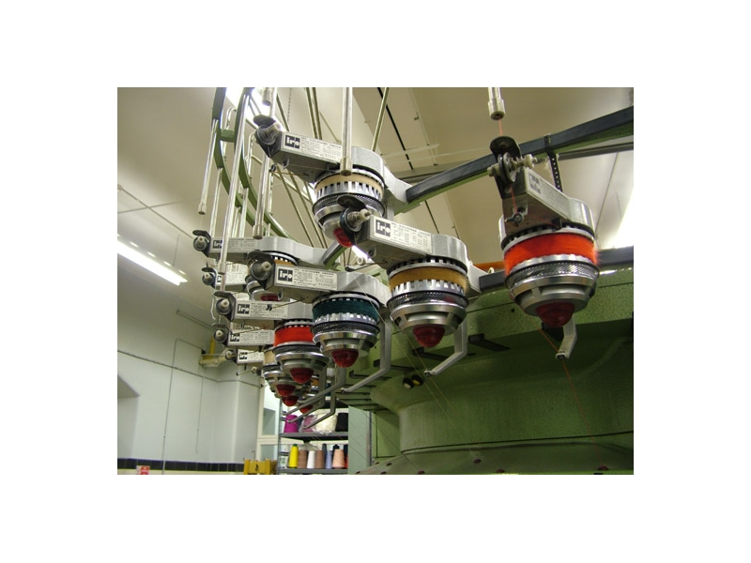
Fig: IRO assisted feed system

In this system each capstan wheel is driven by an individual synchronous motor in such a way that a constant supply of yarn is maintained on an idealized smooth conical surface situated immediately above the knitting point. In this way the tension variations due to changes in cone diameter are largely eliminated, although the resultant loop length is not as consistent as with positive feed.

- Yarn Input Tension:
The problem that remains is how to control the input tension at the feed point for all the feeders (typically 76-96) for a multi-feeder machine. If the needles are left to pull the yarn directly from the supply package a number of factors intervene to cause the input tension to vary.
Perhaps the most important factor relates to the diameter of the cone. On a machine where the yarn speed is constant (plain fabric), as the diameter of the cone steadily reduces during unwinding, the rotational velocity of the balloon increases in inverse proportion and as a result, the air resistance and the carioles forces steadily increase, causing the running yarn tension to increase.
Assuming the creel is filled with full cones at the start of knitting then the yarn tension on all feeders will steadily increase as the cones wind down. If all the other control variables remain constant then an increase in input tension will shift the tension balance in the knitting zone towards the input side so that the number of needles involved in robbing-back increases, with the result that the loop length decreases.
Conversely when an empty cone is changed for a full cone the reduced balloon tension will result in a reduction in input tension with a corresponding increase in loop length. If this process is allowed to continue without check then the quality of the fabric will be continuously altering and, if high tension feeders are situated adjacent to low tension feeders, then the difference in loop length may well produce horizontal bars in the fabric.

- Positive feed:
Once the principal of ‘robbing-back' is understood then it becomes clear that the solution to controlling the input tension is to supply yarn to each feeder at the required constant rate such that the yarn speed in meters/sec divided by the number of needles knitting/unit time is equal to the required loop length.
The photograph shows a positive feed system comprising non-slip drive belts that drive a series of driven capstan wheels (at least two driven by different belts at each feeder). The yarn is taken round the capstan roller with multiple wraps so that no yarn slip can take place.
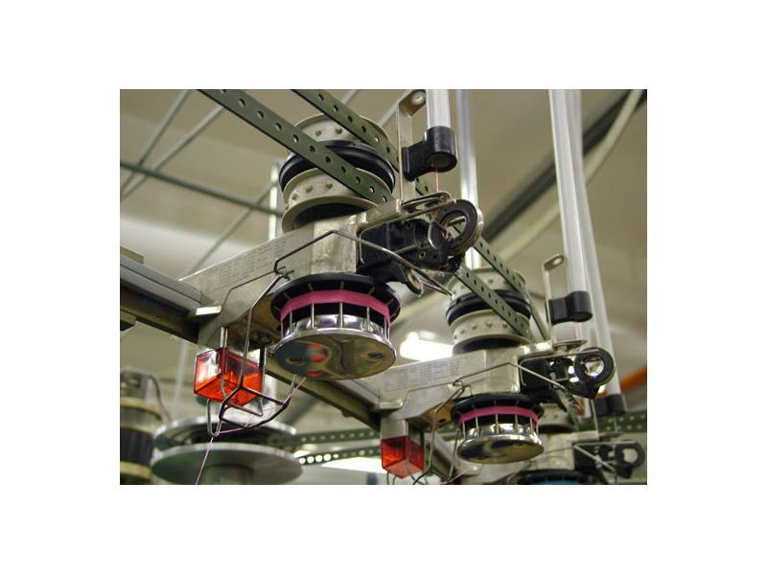
Fig: Positive Feed System

With effective positive feed the knitting zone becomes a closed loop control system so that if the loop length being knitted is greater than the amount being fed by the feed system then the input tension will increase, causing an increase in robbing back and a reduction in loop length. Conversely if the loop length being knitted is less than the amount being fed then the input tension will decrease, as will the robbing back, and the loop length will increase. In this way the system self compensates and the loop length remains the same as the positive feed setting.
In practice this type of positive feed system makes the task of setting up the machine relatively straightforward.
The first task is to calculate the belt speeds, which are the same as the yarn speeds. The belt speed is equal to the loop length multiplied by the number of needles knitting per second. Normally the machine is equipped with four separate belt driven feed systems so that four different loop lengths can be controlled at any one time.
Once the belt speeds are adjusted (by means of the variable diameter pulley shown in the bottom left of the photograph) then the stitch cams can be set. Initially the positive feed is disengaged at each feeder and a yarn speed meter may be used to set each of the stitch cams to roughly the correct setting. Once this is done each positive feed drive is engaged in turn and, with the machine knitting at creep speed, the stitch cam is adjusted so that the yarn input tension stabilizes at 1-2 grams.
Once all the feeders have been adjusted in this way it is necessary to run the machine at speed and fine tune the tension at each feed position. When the machine has been stabilized in this way it will only be necessary to check the tension once during each shift.
On the most modern machines, the variable diameter drive wheel is replaced with a servo motor so that changes in belt speed can be made quickly and easily. The servo motor driven positive feed system was first developed and published by Dr Tilak Dias at UMIST and has now been adopted by most of the main machine builders.
Digital drive positive feed:
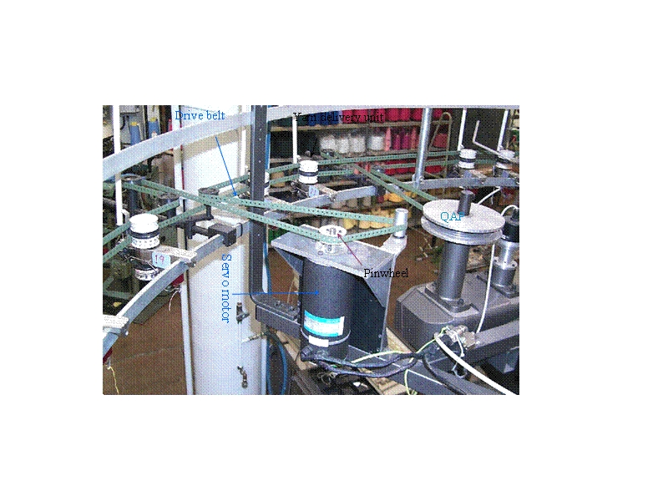
Fig: Digital drive positive feed

In order to eliminate the often time consuming adjustment of the variable diameter pulley, the pulley was replaced by a digitally controlled servo motor that could be accurately adjusted to a pre-set speed by a digital drive system. This digital drive positive feed proved to be extremely accurate and reproducible. The concept was demonstrated to an industry partner in 1988 and published in 2000.The figure shows the UMIST research prototype.
Beside those the following care should be taken to maintain the machine;
- Long lasting and trouble free quality functioning of the knitting machine could be possible by proper maintenance care and lubrication.

- Proper horizontal installation of the machine, tension free yarn feeding,

- Flawless yarn guides and needles, exact centering of needle bed towards one another, proper fabric take-off and proper lubrication are the basic quality needs of a knitting machine
.
- Checking the lubrication unit for sufficient oil and compressed air for specified pressure are the daily checks before switching on the machine.

- Knitting section gets dirty very rapidly; cleaning all the yarn passages and yarn path guides elements are the weekly checks to be carried out.

- As a monthly maintenance routine, flush needles and cams. If needle beds and cams are heavily fouled, remove the cams and air-blast both the cam and needle beds.

- Half a litre of needle oil heated to 70º C is poured into the oiling points of the cams and onto the needle heads.

- Remove cams once more and wipe oil and dirt.

- Once in every three months, remove all cam segments, needles and sinkers, thoroughly clean them with compressed air or paraffin.

- Liberally oil all components and replace. Once in very three years replace the counter memory battery.

- Machine bed should be cleaned with petroleum, Hand wheel, take up and cylinder gear should receive few drops of light machine oil every day.

2.2.2 Process Control:
The preventive measures and the product control are old fashioned. Now the production system has been become modern. Now the problems arises during knitting is rectified on-line that means during the production. Many modern technologies like yarn monitoring sensor, automatic tensioner of yarn is introduced with the knitting technology. Besides there is off-line quality checking. Where the GSM, loop-length, some faults are inspected.
So process control is categorized into two segments they are;
- On-line quality control
- Off-line quality control

2.2.2. (A) On-line Quality Control:
On-line quality control means the controlling process during production. Which indicates the fault level is reducing. These are done through controlling the tension of the yarn, by controlling the loop-length, injecting the lubricant within certain period of interval, needle checking and more.
The modern and effective approach in on-line quality control through computer aided tools. In such cases many sensors and/or transducers act as a monitoring unit for faults and deviation from set values. This gives message to the central computer which will interpret the results and send the control signals to the controllers which are mostly electronically controlled mechanical devices. And these controllers either control the process directly or stop the process temporarily.

Sensors and controllers found in a modern knitting machine
- Yarn monitoring sensor.
- Automatic lubrication monitoring and controlling unit.
- Fabric monitoring CCD cameras.
- Speed control servo motors-prevents speed variation due variation of voltage.
- Production monitoring and displaying unit.
- Needles monitoring and electronic needle control system.

The following Memminger-Iro products will be showcased

Yarn Sensor MIS
According to Memminger-Iro, the MIS self learning sensor system permanently controls all yarns on knitting machines and can be applied to all kind of yarns. MIS is said to persuade with the following features:
- Detects 3 yarn statuses: moving, stand still and present yarns

- Checks before the knitting cycle if all necessary yarns are present, otherwise the knitting cycle cannot be started. This, Memminger-Iro says results in a dramatic increase of the machine efficiency and in addition costs arising in connection with material wastage are reduced dramatically

- The sensor has very fast reaction times and can also therefore be used to monitor small patterns. Control rows at and the end of the knitting cycle are no longer necessary.

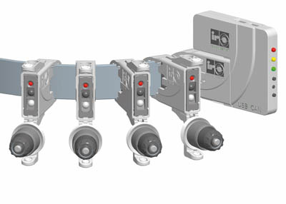

Spray Lubricator PJ ELF

PJ ELF is the latest development of the well know UNIWAVE spray lubricator. Memminger-Iro says that due to a brand new technology the air consumption of this new PJ ELF is 30-50% lower than existing spray oilers on the market, which leads to a tremendous reduction in maintenance costs. Special nozzles are said to reduce oil fog in the knitting room to a minimum and the focus is on easy handling combined with integrating many functional control devices such as pressure switch and relief valve.
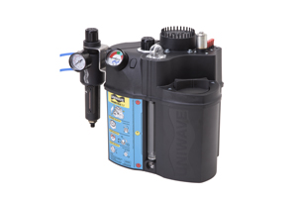

Knitting machine controller NAVIGATOR
The NAVIGATOR is a modular system designed to run a large diameter knitting machine. Memminger-Iro can supply the controller and distribution board only as the minimum configuration or the complete set which incorporates additionally all cables, push buttons, inverter, power unit and other parts

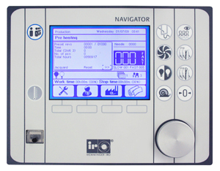

The main idea is to implement all machine parts from the feeders to the take down system into one machine controller designed by Memminger-Iro. The main features are:
- Can be fitted to new machines and second hand machines
- Quick installation through ‘plug and play'
- User friendly menu
- Integrated connection of several Memminger-Iro products e.g. lubricator, fabric scanner, yarn consumption control unit, motor drive belt system and others
- The machine controller can be installed on any large diameter circular knitting machine. Memminger-Iro says that if all machines in a knitting room are equipped with this kind of machine controller, it is very convenient for the knitting machine operator due to only having one system instead of several different systems

Needle controller MNC2

MNC 2 detects broken or bent needles on large diameter circular knitting machines. The system can be adapted on machines up to 44 gauge with a speed factor of 1500. It aims to reduce second grade fabric because the optical sensor stops the machine immediately in case of broken or bent needle.

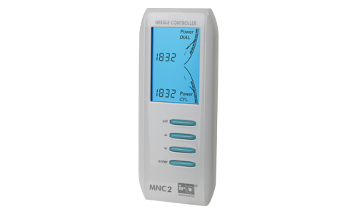

2.2.2. (B) Off-line Quality Control:

- DIMENSIONAL STABILITY:
The yarns after knitting, which were originally straight and desire to return to the straight state, were prevented from doing so by the frictional forces acting over the regions of loop interlacing. Thus an apparent equilibrium of loop shape may be purely due to instantaneous equilibrium between restorative and frictional forces and not because the loop has attained the interlocking points are of high friction in addition, the yarns are often temporarily distorted by the throw of the needle during knitting. The knitting strains therefore are dissipated only gradually on standing, as the fabric tends towards its state of minimum energy. Thus this gradual relaxation mechanism causes instability in the dimensional behavior of knitted fabrics. In most cases the dimension of the fabric decreases. The dimensional stability of knitted fabrics is an important area of the knitting industry. Fabric shrinkage is the ultimate problem if the dimensional stability of the knitted fabrics is not properly taken care.
Factors responsible for dimensional stability
- fiber characteristics,
- stitch length,
- machine gauge,
- yarn twist,
- knitting tension and
- washing and drying methods causes dimensional variations,

The first factor mostly responsible is the relaxation of internal stress, since these have been imposed on the yarn during the knitting processes.
The second factor is the swelling of the yarn when the fabrics are subjected to wet treatments.
When cotton is swollen in water its cross-sectional area increases by 20% to 40% but its length changes very little. Thus sewlling of fibers has no role to play in the shrinkage of fabric; it is the change in cross-sectional changes in fabrics.
The configuration of the loops change, due to yarn swelling.
It is important to examine the exact geometrical loop change upon swelling and further to associate the fabric shrinkage with loop geometry.
So, it can be concluded that the geometry of knitted fabrics are based on two fundamental factors such as:

- The different dimensionally stable states (i.e. relaxation states) to which the knitted fabrics are imposed, and
- The loop length i.e. the length of yarn in the knitted loop (Stitch length)

- FABRIC RELAXATION:
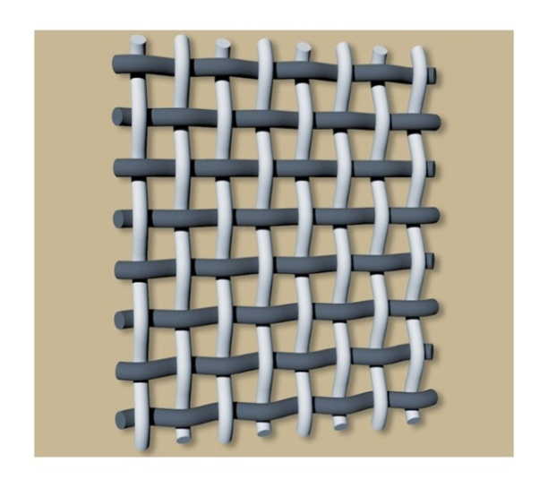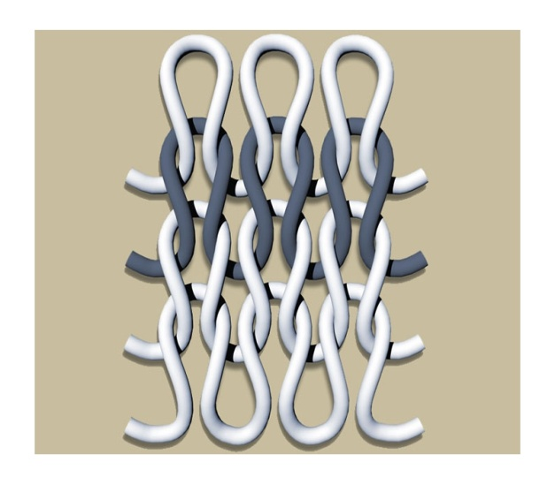
Above Figure shows Plain woven fabric and plain knitted fabric, with the introduction of effective positive feed systems to the jersey industry it seemed as if many of the quality control problems would be resolved. Unfortunately due to the phenomenon of fabric relaxation this was not the case, especially for fabrics containing a significant proportion of natural fiber (cotton or wool).
Munden and Knapton had both demonstrated that knitted fabrics are distorted when they are taken from the machine and that they change in width and length with time, simply by leaving them on a smooth surface for example. This process was called relaxation.
In order to understand the relaxation process better, the following diagrams will help the reader to visualize the process.
In contrast, if we apply an axial force to a plain knitted fabric (see the diagram) then much of the strain derives from changes in the bending radii at the feet and head of the loops.
The diagram shows forces being applied along the Wales or length axis of the fabric. The result of this stress is shown in the diagram below.
This diagram shows that that the radii of curvature at the head and feet of the loops after length axis deformation are now much tighter and there has also been a transfer of yarn from the head and feet of the loop into the legs of the loop, resulting in further lengthwise strain.
In the case of plain knit fabrics, this mode of stretch may yield strains of 30 to 40 per cent in the width axis and 15 to 20 per cent in the length axis. It is only when the fabric is ‘jammed' in the condition shown above, that significant strain starts to occur in the yarns leading to an elastic deformation of the fibers. When the stress is removed, the elastic strain in the yarns and some of the bending and tensional strain in the head and feet of the loops are recovered but some of the bending and tensional strain and some of the yarn interchange remains trapped by the frictional forces at the contact points between the loops. This trapped strain results in a hysteresis in the recovery process or trapped deformation that will ultimately be recovered when the fabric is subjected to the conditions described below or, more commonly, the processes of domestic laundry.
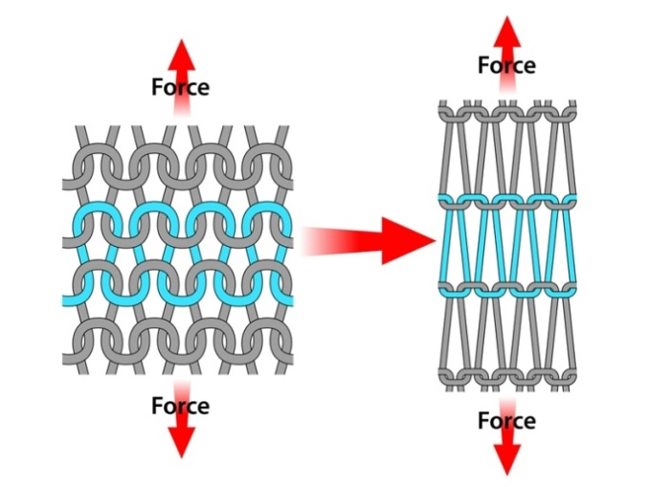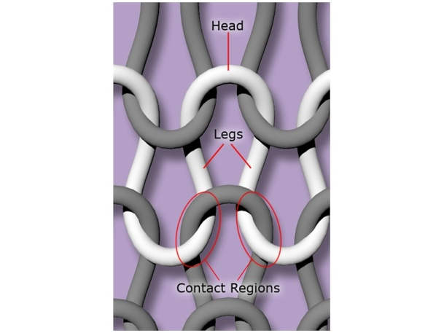
Fig: Force applied along Wales Fig: Head and legs of the loop

At this stage in the development of the jersey industry, the majority of double jersey fabrics destined for tailoring into outerwear were manufactured from synthetic yarns, false twist textured polyester or cotton spun acrylic. In order to resolve the problem of relaxation, the process of heat setting on a pin stenter was introduced. When synthetic yarns are heated above the second order transition temperature, the polymer softens and any stored strains dissipate. In this way, the stored tensional and bending energy that causes relaxation to occur are eliminated. Heat setting does, therefore, provide a solution to the problem of fabric relaxation for 100 per cent synthetic fabrics, provided the fabric can be heat-set at a specified course and wale density and overall width. The combination of:
- Positive feeding
- A knitting machine where the initial machine settings have been carefully controlled (see module on circular knitting quality control)
- The use of tensionless examination tables
- The use of low tension jet dying machines
- Very careful control of stenter variables (pin width, overfeed, oven temperature and speed)
Enables fabric to be manufactured to tight specifications free from relaxation potential. Such high quality, high performance synthetic fabrics have now become well established in the sportswear and extreme wear sectors, where their properties of controlled stretch, breath-ability, wicking, and durability offer comfort, high performance and long life to the users.
The three important dimensionally stable states are:
- Dry relaxed state.
- Wet relaxed state
- Finished relaxed state

- Spirality Testing:

The ultimate benefit of studying the spirality phenomenon is to understand the various factors influencing the dimensional stability of knit fabrics, particularly fabric spirality so that ways to select appropriate levels of these factors that result in optimum dimensional stability can be established. This can be achieved through a cause and effect analysis of the various potential factors influencing fabric spirality. The importance of cause and effect analysis stems from the fact that several theoretical approaches were taken to analyze the spirality phenomenon, yet because of the complexity of the phenomenon, each study focused on a limited number of factors, either for the sake of simplifying the analysis, or due to limited ability to verify the theory using experimental approaches. Other studies dealt with the analysis of spirality from strictly experimental view by examining the effects of a number of factors some of which were machine-related and others were fabric-related on the extent of spirality of knit structures. Obviously, these approaches resulted in many common causes and effects of this critical phenomenon. However, these were scattered in the bulk of literatures presented to such an extent that makes it difficult for researchers to have a complete view of all factors that can potentially result in an increase or a reduction in knit fabric spirality. It was important, therefore to perform this analysis in this study by examining causes and effects of fabric spirality on the basis of observations obtained in this study as well as the findings of the massive literatures available. Figure shows the various causes of fabric spirality and they are divided into four main categories: yarn causes, knit causes, fiber causes, and finishing causes.
Causes of spirality

The following are some predominant causes of spirality in knitted fabrics.
- Yarn twist multiplier is the principle cause of spirality and it is directly proportional.
- Residual torque in the yarn or the twist liveliness.
- Number of feeders-though higher feeder numbers increases production, spirality also increased.
- Different spinning technologies such as ring, rotor, airjet etc., also influence spirality. The physical properties of these yarns, their geometrical characteristics, their basic fibre properties (i.e. modules, fineness, cross section etc.) and blends are the causes.
- Variation in knitting tension, yarn frictional properties, yarn/metal coefficient of friction, yarn lubrication, number of contact points in the knitting zone i.e. needles and sinkers) also influence spirality.
- Washing wet treatments increases fabric relaxation and also increases spirality.
- Direction of machine rotation has little influence on spirality. Slight inclination of loops occurs in the direction of machine rotation. Multifeed machines rotating clockwise produce spirality to the left and machines rotating anti clock wise produce spirality to the right.

- Shrinkage Testing:

Shrinkage is the process in which a fabric becomes smaller than its original size, usually through the process of laundry. Cotton fabric suffers from two main disadvantages of shrinking and creasing during subsequent washing.
There are two types of shrinkage occurs during washing
1) Length wise
2) Width wise
Cause :
Due to high tension during preparation of fabric which result in excess stretch in yarn. This type of shrinkage is known as London shrinkage. Due to swelling of fibers for fiber structure.

Determination of Fabric Shrinkage:
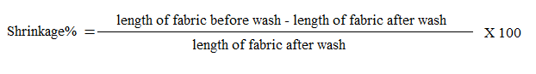
- OTHER QUALITY TESTS FOR WEFT KNITTED FABRICS

To assure quality production, it is necessary to have on the spot inspection of the cloth as it comes off the machine as well as post inspection of the fabric. The usual method of examination is to feed the fabric over a lighted frame of a table at a normal speed of 10-12 meters per minute for single colour.

Following are the tests that the finished knitted fabrics normally undergo.

(1) Fabric yield: Piece weight gives a correct ideal about the quality of the fabric.
Sample courses are marked for required number of revolution and the fabric is cut and weighed to determine the yield and width.
However machines with revolution counters enable to get accurate number of courses to be knitted per piece.

- Fabric appearance: The fabric is inspected for appearances to determine its acceptability from quality view point AAMA (American Apparel Manufacturers Association). Four point grading system is widely used. The maximum points per 100 yd² should be less than 40. The size of defects and their respective points are considered for evaluation.

- Fabric pilling: 12 x 12 cms fabric sewn on 15 cms long tube of rubber is placed inside the cork-lined pill box, rotated for a given number of revolutions. The pills on the fabric surface are compared to standard photographs and graded.

- Fabric extension: In an extension tester, the sample piece is applied between two jaws and a uniform weight is applied to the fabric and the percentage extension is measured.
- Air permeability: The apparatus measures the rate of airflow through the fabric. The sample is clamped between two circular discs and air is drawn through the fabric by a suction pump, the area of the fabric being specified.

- Mass per unit area: Fabric weight in terms of grams per square meter (GSM) can be obtained either by using template or by calculating through yarn linear density, stitch density and loop length.

- Fabric width: Width shall be measured with an accurate tape after laying circular knitted fabric flat on the table without tension or elongation (Ref. ASTM 3887-80). Width determination is based on one of the following methods :
- Width between gummed edges of gummed fabrics.

- Width between tenter frame pin marks when pin marks remain in shipped fabrics.

- Overall width of circular knit fabric when (a) and (b) not exist. For a width started as 60/62 inches for example, the lower figure governs cuttable width.

- Length: Length shall be measured with any surface contact device (Trumeter or equivalent) that is calibrated regularly. The device contacts the back or a smooth surface of the fabric. (Ref. ASTM D1910 – 64 hand method) Actual yardage of each piece shall be accurate to within plus or minus 2% when measured by the above method.

- Visible courses and wales (WPI & CPI) : Measured using counting glass, after laying fabric in flat horizontal.

- Loop length and course length

- Yarn tex

- Tightness

- Reference relaxation: A fabric is relaxed by being subjected to one cycle of washing and tumble drying followed by four cycles of rinsing and tumble drying.

- Dimensional changes: A fabric subjected to a specified washing procedure, dried under the appropriate conditions and any changes in dimensions are determined.
% DC = 100 x (B-A)/A

Where DC = Dimension changes
A = original dimension.
B = Dimension after laundering.

- Angle of spirality: The angle of spirality is measured before and after a specified relaxation process and the change obtained

- Abrasion resistance: Evaluation is made on the basis of weight loss of the specimen Laboratory type abrasion testing instruments are used.

- Bursting strength: It is the strength of a fabric against multi directional flow of pressure Knitted fabrics cannot be tested easily in strip form and hence this is the preferred method. A bursting type of force is applied perpendicular to the surface of the fabric. The test can be conducted on hydraulic pressure principle.

- Fabric bow : It is a fabric condition resulting when knitted courses are displaced from a line perpendicular to the selvages and form one or more arcs across the width of the fabric as i.The measurement is as follows :

A straight edge is placed across the fabric between the points at which a marked knitted course meets the two edges. The greatest distance between the straight edge and the marked course is measured parallel to the edges.
- Fabric skewness: Skewness or bias is a fabric condition resulting when knitting courses are angularly displaced from a line perpendicular to be edge of side of the fabric Fig. 12.2.

Skew ness is measured in three places spaced as widely as possible along the length of the fabric (1 yard). If possible make no measurements closer to the ends of the roll or piece of fabric than 1 m.
Draw a line perpendicular to the selvage across the fabric from a point C where the marked course meets one selvage, meeting the other selvage at point B. Measure the distance between points A and B or D and B as shown in Fig. 12.2 Record the three or more skewness or bias as a percentage of the fabric width.

Skewness (bias) % = Distance AB or DB x 100/Width BC

2.2.3 Product control of Weft Knitting:
In this stage of quality control the fabric is inspected for the last time to identify the faults which are not detected previously. Different industry uses different techniques. Like the 4-Point system, 10- Point system the Dallas system. Amongst them the most popular is the 4-Point system. Most of the industry uses the data to rectify the fault. After detecting and rectifying the fault the fabrics are graded according to their amount of faults. The systems are described below.
- FOUR POINT SYSTEM:
It was published in 1959 by the National Association of Shirt Pajama Sportswear Manufacturers. Widely adopted and used in knitted fabric.
Amount to select
Inspect at least 20% of the total rolls of the shipment.
Selection of rolls
Select at least one roll of each color. If more than one role must be selected, then choose the additional roles in proportion to the total number of roles per color received.
Defect Classification for 4-Point System [Table-2]:
Defect | penalty |  |  |  | Grading
Less than 3 inch |  | 1 |  |  |  | Up to 28 points = A
3 inch to less than 6 inch |  | 2 |  |  |  | 28 to 40 points = B
6 inch to less than 9 inch |  | 3 |  |  |  | 40 to 52 points = C
9 inch and over |  | 4 |  |  |  | More than 52 points = F

The length of the defect is used to determine the penalty point. Only major defects are considered. No penalty points are assigned to minor defects. (A major defect is any defect that would cause a final garment to be considered a second.)
Major Defects
Major woven fabric defects include but are not limited to slubs, holes, missing yarns, yarn variation, end out, soiled yarns, and wrong yarn.
Major dye or printing defects are out of register, dye spots, machine stop, color out, color smear, or shading.

Acceptance Criteria and Calculation
40 points per 100 yards is the acceptable defect rate
# of Points per 100 yds = # of penalty points x 100
Yds inspected
Inspection Procedure
- Determine the amount to inspect 20%).
- Select the rolls to inspect.
- Put the rolls on the inspection machine or other viewing device.
- Cut off a 6 inch piece across the width off the end of the roll. Mark the right and left side of the strip. Stop the inspection process every 50 yards and use the strip to check for any shading problems. Also make sure to check the end of the role.
- Inspect for visual defects with the light on at a speed slow enough to find the defects. (The fabric must be checked at a slow rate in order to effectively find flaws). Sometimes you may have to turn the light off to see how a flaw will affect the appearance of a garment.
- Check that the roll contains the correct yardage as stated by the piece goods source.
- Check for skewed, biased, and bowed fabric.
- Mark any defects to the side with colored tape so that they can be easily found and noted.
- Record any defects. The weaving division functions under the principles of the internationally acclaimed American 4 point system to reduce wastage and ensure quality. Under this system, fabric inspection and grading is carried out as per ASTM standard.
Advantages
- 4 point system has not width limitation.
- Worker can easily understand it.

- TEN POINT SYSTEM
The ten point system for piece goods evaluation was approved by the Textile distributors institute and the National Federation of Textile, in 1955. The earliest inspection system and is designed to identify defects and to assign each defect a value based on severity of defect. The system assigns penalty points to each defect depending on its length and whether it is in the warp (ends) or weft (fill) direction. While sounding simple, it can get quite complicated in practical use. The following table shows the assignment of penalty points.
Defect classification; 10- point system[Table-3]:
Warp defects | Points |  |  | Weft defects |  | Points
Under 1” |  | 1 |  |  | Under 1” |  |  | 1
1”- 5” |  | 3 |  |  | 1” – 5” |  |  | 3
5” - 10” |  | 5 |  |  | 5” – ½ width of the goods |  |  | 5
10” – 36” |  | 10 |  |  | ½ width of the goods |  |  | 10

The grading is done as a piece or roll of fabric is considered good if the total penalty points, assessed to that piece or roll, do not exceed the length of fabric on it. If the points exceed the length, then the roll considered seconds, and may be rejected.
For example if we had a roll of 50 yards of fabric and if we found defects totaling to less than 50 points, then the roll was considered good. If there were more than 50 penalty points, then the piece was considered seconds. There have been some questions raised about the fairness of the system based on the argument that this system does not allow for the inspection of various widths. If one will study the system closely, it can be seen that apparent inequity of the system is just that, apparent although stringent. This method is still used by some manufacturers.
Advantages
- Oldest and most used in woven finished fabric.
- In it length of fabric is used and along the length of warp and weft defects are identified.
Disadvantage
- It has width limitation.
- It is difficult in practical use.

- GRANITEVILLE’78 SYSTEM
It was introduced in 1975 for the field of fabric grading. The system divided defects into major and minor types .The major defect was one which was very obvious and lead the goods to second quality. The minor defect was one may or may not have cause garment to second, depending on its location in the end use item.
Penalty Point Assignment Of Grantville’78[Table-4]
Defect Length | Penalty Points
9” | 1
9”-18” | 2
18”-27” | 3
27”-36” | 4

The principle was established in garment cutting piece, which the short length defects (less than 9”) will normally be removed. The system tries to balance the importance of longer defects (over 9”) and put less weight on 1-10” defects such as slubs .The system also suggests the viewing distance of 9 foot instead of normal 3-foot viewing distance. The system tends to eliminate very small defects from the total penalty score.
Disadvantages:
- As this system is used on cutting pieces according to my point of view it also increase the cost of production. We should control problems before cutting.

- DALLAS SYSTEM
There is also a Dallas System published in the 1970's. That system was developed specifically for knits. According to this system, if any defect was found on a finished garment the garment would then be termed a second. In regard to fabric, this system defines a second as "more then one defect per ten linear yards, calculated to the nearest ten yards." For example, one piece 60 yards long would be allowed to have six defects.
Disadvantage
- It increases the cost of production as defect is located after the garment is finished.

2.3 . DEFECTS IN THE KNITTED FABRICS
A defect in the knitted fabric is an abnormality, which spoils the aesthetics i.e. the clean & uniform appearance of the fabric & effects the performance parameters, like; dimensional stability etc.
There are various types of defects, which occur in the Knitted fabrics of all types, caused by a variety of reasons. The same type of defects may occur in the fabric, due to a variety of different causes e.g. Drop Stitches, Spirality. Prime causes of the fabric defects are, as follows;
- Yarns
- Knitting Elements
- Knitting Machine Settings
- Dyeing
- Finishing

2.3.1. Yarn related defects:
Almost all the defects appearing in the horizontal direction, in the knitted fabric are, yarn related. These defects are mainly;
- Barriness
- Dark or Light horizontal lines
- Imperfections
- Contaminations
- Snarling
- Spirality

- Barriness: Barriness defect appears in the Knitted fabric, in the form of horizontal stripes of uniform or variable width.

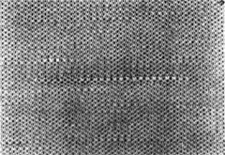
Fig: Barriness
Causes:
- High Yarn Tension
- Count Variation
- Mixing of the yarn lots
- Package hardness variation

Remedies:
- Ensure uniform Yarn Tension on all the feeders.
- The average Count variation in the lot, should not be more than + 0.3
- Ensure that the yarn being used for Knitting is of the same Lot / Merge no.
- Ensure that the hardness of, all the yarn packages, is uniform, using a hardness tester.

- Dark or Light horizontal lines:

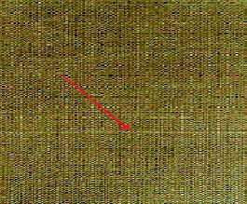
Fig: Dark or Light horizontal lines

Causes:
- Fault in bobbin
- Irregular tension on cams.
- Yarn feeder badly set.
- Differences in the yarn running – in tension.
Remedies:
- Replace that bobbin.
- Check cams positioning
- Take-down re-adjustment.
- Dial cam position re-adjustment.
- Use of fabric fault detector.

- Imperfections: Imperfections appear on the fabric surface in the form of unevenly placed or randomly appearing Knots, Slubs & Neps, Thick & Thin places in the yarn.

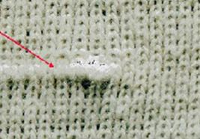
Fig: Slub Fig: Thick and thin place

Causes:
- Big Knots, Slubs & Neps in the yarn, Thick & Thin yarn.
Remedies:
- Specify the quality parameters of the yarns to be used for production to the yarn supplier.

- Contaminations: Contaminations appear, in the form of foreign matter, such as; dyed fibers, husk, dead fibers etc., in the staple spun yarn or embedded in the knitted fabric structure.

Causes:
- Presence of dead fibers & other foreign materials, such as; dyed fibers, husk & synthetic fibers etc.
- Dead Fibers appear in the fabric, as a result of the, presence of excessive immature Cotton fibers, in the Cotton fiber crop.
- Dead fibers do not pick up color during Dyeing.
- Presence of the foreign materials, in the, staple fiber mixing (Kitty, Husk, Broken Seeds, dyed fibers & fibers like Poly Propylene, Polyester, Viscose etc)
- Dyed & other types of fibers flying from the adjacent Knitting machines cling, to the yarn being used for knitting & get, embedded in the Grey Fabric.

Remedies:
- Use rich fiber mixing for the yarns, to be used for Knitting, in order to have less dead fibers, appearing in the fabric.
- Rigid control measures in the Blow Room, to prevent the mixing of foreign matters in the Cotton mixing.
- Segregate the Spinning & Knitting Machines, with Plastic Curtains or Mosquito Nets, to prevent the fibers flying from the neighboring machines, from getting embedded in the yarn / fabric.

- Snarling: Snarls appear on the fabric surface, in the form of big loops of yarn getting twisted, due to the high twist in the yarn (Unbalanced twist yarn).

Causes:
- High, twist in the, yarn.
- Hosiery yarns are soft twisted. High, twist in the yarn, is the cause of snarling.
- Snarls cause, fabric defects & needle breakages.

Remedies:
- Ensure using Hosiery Yarns, of the recommended T.P.M. only.
- Hold a few inches of the yarn in both the hands, in the form of a ‘U’.
- The yarn has a balanced twist, if it doesn’t tend to rotate or turn, in the form of a snarl. (Such yarn can be used for Hosiery applications.)

- Spirality: Spirality appears in the form of a twisted garment after washing. The seams on both the sides of the garment displace from their position & appear on the front & back of the garment.

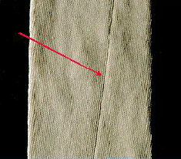
Fig: Spirality

Causes:
- High T.P.I. of the Hosiery Yarn
- Uneven Fabric tension on the Knitting machine.
- Unequal rate of Fabric feed on the Stenter, Calender & Compactor machines.
Remedies:
- Use the Hosiery yarns of the recommended TPM level for Knitting (Hosiery yarns are soft twisted, in comparison to the Warp yarns)
- Fabric pull or the Take Down tension, on both sides of the grey fabric tube, on the knitting machine, should be equal.
- Ensure uniform rate of feed of the dyed fabric, on both the edges, while feeding the fabric to the Calander, Compactor or Stenter machines.

2.3.2 Knitting Elements related defects
Almost all the defects appearing in the vertical direction, in the knitted fabrics, are as a cause of bad Knitting Elements. These defects are mainly;
- Needle Lines
- Sinker Lines
- Drop Stitches etc.

- Needle Lines: Needle lines are prominent, vertical lines, along the length of the fabric, which are easily visible in the grey as well as finished fabric.
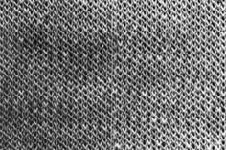
Fig: Needle Lines
Causes:
- Bent Latches, Needle Hooks & Needle stems.
- Tight Needles in the grooves
- Wrong Needle selection (Wrong sequence of needles, put in the Cylinder or Dial)

Remedies:
- Inspect the grey fabric on the knitting machine for any Needle lines.
- Replace all the defective needles having, bent latches, hooks or stems.
- Remove the fibers accumulated in, the Needle tricks (grooves).
- Replace any bent Needles, running tight in the tricks.
- Check the Needle filling sequence in the Cylinder / Dial grooves (tricks)

- Sinker Lines: Sinker lines are prominent or feeble vertical lines, appearing parallel to the Wales, along the length of the knitted fabric tube.
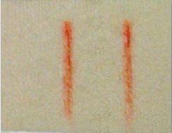
Fig: Sinker Lines
Causes:
- Bent or Worn out Sinkers
- Sinkers being tight in, the Sinker Ring grooves

Remedies:
- Replace, all the worn out or bent sinkers, causing Sinker lines in the fabric.
- Sinker lines are very fine & feeble vertical lines, appearing in the fabric.
- Remove the fibers, clogging the Sinker tricks (Grooves)

- Drop Stitches: Drop Stitches are randomly appearing small or big holes of the, same or different size, which appear as defects, in the Knitted fabrics.
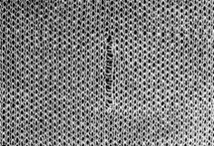
Fig: Drop Stitches

Causes:
- High Yarn Tension
- Yarn Overfeed or Underfeed
- High Fabric Take Down Tension
- Obstructions in the yarn passage, due to the clogging of eyelets, yarn guides & tension discs, with wax & fluff etc.
- Incorrect gap between the Dial & Cylinder rings.

Remedies:
- Ensure uniform yarn tension on all the feeders, with a Tension Meter.
- Rate of yarn feed should be strictly regulated, as per the required Stitch Length.
- The fabric tube should be just like a fully inflated balloon, not too tight or too slack.
- Eyelets & the Yarn Guides, should not have, any fibers, fluff & wax etc. stuck in them.
- The yarn being used, should have no imperfections, like; Slubs, Neps & big knots etc
- The gap between the Cylinder & the Dial should, be correctly adjusted, as per the knitted loop size.

2.3.2. Machine Settings related Defects
These defects appear randomly in the knitted fabrics, due to the wrong knitting machine settings & that of the machine parts. The defects are mainly;
- Drop Stitches
- Yarn Streaks
- Barriness
- Fabric press off
- Broken Ends
- Spirality

- Yarn Streaks: Streaks in the Knitted fabrics appear as; feeble, irregularly spaced & sized, thin horizontal lines.

Causes:
- Yarn slippage on the IRO Pulley, due to the yarn slipping in & out from underneath the IRO Belt, due to a tilted IRO Pulley.
- Worn out IRO belts, yarn guides & eyelets etc
- Faulty winding of the yarn packages
- Yarn running out of the belt, on the IRO Pulley

Remedies:
- Ensure very smooth, clean & obstruction free passage of the yarn, through the eyelets, yarn & tension discs etc.
- No cuts or rough surfaces, in the Porcelain Eyelets, Yarn Guides & the Yarn Feeder holes etc.
- Flawless winding of the, Yarn Package (The yarn coils should unwind smoothly, without any obstruction)
- The yarn should be running under the IRO belt, between the belt & around the IRO pulley

- Fabric press off: Fabric press off appears, as a big or small hole in the fabric, caused due to the interruption of the, loop forming process, as a result of the yarn breakage, or closed needle hooks.
Press off takes place, when the yarn feeding to both the short butt & long butt needles, suddenly stops, due to the yarn breakage.
At times, complete fabric tube can fall off the needles, if the needle detectors are not functioning, or are not properly set.

Causes:
- End breakage on feeders, with all needles knitting.
- Yarn feeder remaining in lifted up position, due to which, the yarn doesn’t get fed in the hooks of the needles.

Remedies:
- Needle detectors, should be set precisely, to detect the closed needles & prevent the fabric tube from completely pressing off.
- Proper yarn tension should be maintained, on all the feeder

- Broken Ends: Broken ends appear as equidistant prominent horizontal lines along the width of the fabric tube when a yarn breaks or is exhausted.

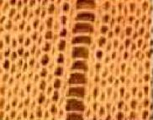

Causes:
- High Yarn Tension
- Yarn exhausted on the Cones.
Remedies:
- Ensure correct yarn tension on all the feeders.
- Ensure that the Yarn detectors on all the feeders are working properly.
- Depute a skilled & alert machine operator on the knitting machine.

Chapter 03: Experimental Details

3.0 Experimental Details:
3.1 Probable GSM for following count [table-5]:
Fabric Type: Single Jersey: (Carded Yarn)

Yarn Count | GSM | Machine Gauge
40/1 | 110 | 24G
34/1 | 120-125 | 24G
32/1 | 130-135 | 24G
30/1 | 140-145 | 24G
28/1 | 150 | 24G
26/1 | 160-165 | 24G
24/1 | 170-175 | 24G
24/1 | 180-185 | 24G
22/1 | 190 | 24G
20/1 | 200 | 24G
18/1 | 220 | 20G

Fabric Type: Single Jersey : (Combed Yarn)

Yarn Count | GSM | Machine Gauge
40/1 | 110 | 24G
34/1 | 120-125 | 24G
32/1 | 130-135 | 24G
30/1 | 140-145 | 24G
28/1 | 150 | 24G
26/1 | 160-165 | 24G
24/1 | 170-175 | 24G
24/1 | 180-185 | 24G
22/1 | 190 | 24G
20/1 | 200 | 24G
18/1 | 220 | 20G

Fabric Type: 1x1 Rib : (Carded Yarn)

Yarn Count | GSM | Machine Gauge
40/1 | 150 | 18G
34/1 | 170 | 18G
32/1 | 180 | 18G
30/1 | 190 | 18G
28/1 | 200-210 | 18G
26/1 | 220-230 | 18G
24/1 | 240 | 18G

Fabric Type: 2x1 Rib : (Carded Yarn)
Yarn Count | GSM | Machine Gauge
40 | 150-160 | 18G
34 | 170-180 | 18G
30 | 190-200 | 18G
26 | 220-2230 | 18G
24 | 240-250 | 18G

Fabric Type: Interlock : (Carded Yarn)

Yarn Count | GSM | Machine Gauge
40/1 | 190 | 22G
34/1 | 220 | 22G
30/1 | 250 | 22G
26/1 | 300-310 | 22G

This is how the count of yarn is set to the machine for the desired GSM. This is controlled by the GM of the knitting section. This data helps the feeder man to set the count in the machine. It is very important to keep the suitable count in order to get the accurate GSM to minimize the costs.

3.2 Testing Stitch Length:
Maintaining the optimum Stitch Length is a very important parameter of knitting because it is related with the GSM. The testing of Stitch Length is very important. In the industry the stitch length of the fabric is measured by HATRA coarse length tester. But it could be tested manually. In many industries it is done manually. The formula is stated below:

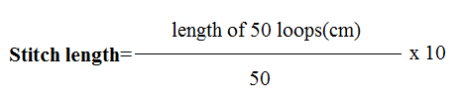

By executing the formula in the Stitch length is checked during production.
The following chart gives the determination of stitch length of the single jersey knit fabric [table-6(a)]:
No. of Reading | Single Jersey (Normal)
No. of Reading | Length of 50 loops(cm) | Stitch Length | Average
Reading#1 | 16.03 | 3.20 | 3.2025
Reading#2 | 16.10 | 3.22 | 3.2025
Reading#3 | 16.01 | 3.20 | 3.2025
Reading#4 | 15.96 | 3.19 | 3.2025

The following chart gives the determination of stitch length of the double jersey knit (2 x 1 rib)fabric [table-6(b)]:

No. of Reading | double jersey (2 x 1 rib)
No. of Reading | Length of 50 loops(cm) | Stitch Length | Average
Reading#1 | 18.20 | 3.64 | 3.6375
Reading#2 | 18.10 | 3.62 | 3.6375
Reading#3 | 18.20 | 3.64 | 3.6375
Reading#4 | 18.30 | 3.66 | 3.6375

The following chart gives the determination of stitch length of the single lacoste knit fabric [table-6]:
No. of Reading | Single Lacoste
No. of Reading | Length of 50 loops(cm) | Stitch Length | Average
Reading#1 | 13.55 | 2.71 | 2.715
Reading#2 | 13.50 | 2.70 | 2.715
Reading#3 | 13.65 | 2.73 | 2.715
Reading#4 | 13.60 | 2.72 | 2.715

Comment:
Form above data we can say that the loop length of the fabric remains almost close to each other. The average value of the stitch length is almost same as the buyer’s requirement. These data is taken after one batch is taken down from the machine.

3.3 Checking GSM during Production:
In the industry during the production the GSM of the fabric is determined by the GSM cutter. At first the cut sample is weighed in a digital balance in gm. Then the taken weight is multiplied with the Dia Constant of the cutter.
The formula is stated below;
GSM= Weight of the sample X Dia Constant

Table for determining GSM for different fabric [table-7]:
Fabric | Finished GSM | Reading#01 |  | Reading#02 |  | Reading#03 |  | Average
Fabric | Finished GSM | Fabric wt. (gm) | GSM | Fabric wt. | GSM | Fabric wt. | GSM | GSM
Single Jersey | 175 | 1.4 | 140 | 1.38 | 138 | 1.43 | 143 | 140.33
2x1 Rib | 200 | 1.72 | 172 | 1.71 | 171 | 1.69 | 169 | 170.67
Single Jersey (Auto Stripe) | 162 | 1.61 | 161 | 1.62 | 162 | 1.62 | 162 | 161.67
1x1 Rib | 190 | 1.40 | 140 | 1.38 | 138 | 1.41 | 142 | 140

Comment:
- The gray GSM of the fabric is always lower than the finished GSM. There is some difference in gray GSM and the finished GSM. The difference between two GSM is recovered in the finishing process. This operation is to be done again and again to be parallel with the quality.
- But in the following experiment we saw, in the Auto-Stripe the GSM difference is low.

3.4 FACTORS CONSIDERED FOR REQUIRED G.S.M:
Yarn Count (English count):
Through our project work we manage to find out the following relation between
yarn count and G.S.M:
$GSM α \frac{1}{Stitch length}$ …………………... (1)[When yarn count is same]
Again,
$GSM α \frac{1}{Yarn Count}$…………………. (2)[When stitch length is same]
From equation (1) and(2) we get,
$GSM α \frac{1}{Stitch length X yarn Count}$[When stitch length and count of yarn both are variables]
Therefore,
GSM x Stitch Length x Yarn Count = K Where, K is the Constant
K varies for the single jersey with different GSM, count, and loop length.
Chart of the Constant for single jersey collected from different Fabric [Table-8]:
S/N | GSM | Stitch Length | Count | Constant  k | Average
1 | 145 | 3.2 | 26 | 12064 | 12040
2 | 135 | 3.2 | 28 | 12096 | 12040
3 | 144 | 2.75 | 30 | 11880 | 12040
4 | 140 | 2.4 | 36 | 12096 | 12040
5 | 116 | 2.6 | 40 | 12064 | 12040

Comment:
The data were taken from the several fabrics to determine the value of the constant K. From these values we can set a knitting parameter. If we set the average value as the standard, then it is possible to find the GSM for several counts and stitch length.
3.5 Machine Quality Checking During Production:
During production there is several problems arises like needle breakage, yarn breakage lycra breakage and more. The most common problem is the yarn breakage and the lycra breakage. This is found often. It is the main reason for machine stoppage.

The following chart gives us the approximate idea about the machine stoppage time during the production[Table-9]:
Total time for machine stoppage in an hour (sec) |  | 330 | 370 | 330 | 460
Machine Failure | Total time to fix in an hour (sec) | 150 | 210 | 150 | 240
Machine Failure | Time to fix a single break (sec) | 30
Machine Failure | No. of lycra break in an hour | 5 | 7 | 5 | 8
Machine Failure | Total time to fix in an hour (sec) | 180 | 160 | 180 | 220
Machine Failure | Time to fix a single break (sec) | 20
Machine Failure | No. of yarn break per hour | 9 | 8 | 9 | 11
Machine Failure | Total time in an hour | 0 | 0 | 0 | 0
Machine Failure | Time to fix single break | 0 | 0 | 0 | 0
Machine Failure | No. of needle break per hour | 0 | 0 | 0 | 0
No. of readings |  | 1 | 2 | 3 | 4
Comment:
- By the above study we came to learn about if the machine stoppage time per hour caused by different faults. We can see that machine stops on an average of 6-7 minutes per hour.
- The breakage rate is almost same but in the last reading we saw the breakage rate increased. The reason behind that, at that time there was a slight problem in the tension system.
- This study indicates that if the machine maintained properly the rate of faults will be minimized and the production will be high.

3.6. Fabric Inspection:
4-Point System:
In most of the industries the most practiced system of fabric inspection is the 4-Point system. It is the easiest system for the gray fabric inspection. The grading of thee fabric is easier than the others. There some rules were followed to execute the system.
$$\frac{points}{100sqtd}=\frac{total points x 100 x 36}{length in yds x width in inch}$$

Fabric Specification:
Fabric type: French Terry
Finished Width:64” | Stitch Length: 2.70+1.3
Finished GSM: 240 | Yarn lot: 947+ 954
Yarn Count: 30% PC | M/C Dia X Gauge

The following table shows the determination system of the fabric faults [table-10]:
Class | A | B | A | B | B | A | A | A | B
Point sq yd | 24.54 | 31.30 | 21.52 | 30.00 | 33.75 | 24.54 | 22.50 | 27.39 | 30.00
Total point | 24 | 32 | 22 | 32 | 36 | 24 | 22 | 28 | 32
others | |||| | |||| | |||| | |||| | |||| | |||| | |||| | |||| | ||||
Fly conta | || | |||| | |||| | |||| | |||| | |||| | |||| | || | ||||
Loop | 1 x 4 | 1 x 4 | --- | 1 x 4 | 1 x 4 | --- | --- | 1 x 4 | 1 x 4
knot | |||| | |||| | |||| | |||| | |||| | |||| | |||| | |||| | ||||
Oil- spot | || | |||| | || | |||| | |||| | |||| | || | |||| | ||||
Ink- Spot | |||| | |||| | |||| | |||| | |||| | |||| | |||| | || | ||||
Yarn Conta | |||| | |||| | |||| | |||| | |||| | |||| | |||| | |||| | ||||
Set off | --- | 1 x 4 | --- | 1 x 4 | 2 x 4 | --- | --- | 1 x 4 | 1 x 4
Roll mtr. | 44 | 46 | 46 | 48 | 48 | 44 | 44 | 46 | 48
Roll weight (kg) | 17.5 | 18.6 | 18.5 | 19.2 | 19.2 | 17.5 | 17.6 | 18.5 | 19.2
Grey width  (inch) | 80 | 80 | 80 | 80 | 80 | 80 | 80 | 80 | 80
Roll no. | 1 | 2 | 3 | 4 | 5 | 6 | 7 | 8 | 9

Comment:
- From the above table we came to learn to grade the fabric on the basis of the amount of faults present on the fabric. The more no. of faults lowers the grade. This has to be carried out by an expert.
- We have seen there is two faults loop and set-off. In this kind of fault, for a single presence of these 4 points are given because these faults are big in size.
- It is very convenient for anyone to understand and apply the system.

Chapter 04: Result and Discussion

4.0 Result and Discussion:
From those work we have found some of the results which were described in our project paper. We have found the quality parameter from the industry and some of the experiments were done by ourselves. The findings are discussed below.
4.1 Analysis of yarn:
Yarns are the main element for knitting. So the quality of the yarn has to be perfect to knit a good quality fabric. From the table-2 we can find the factors that represent the quality of the yarn. It is mandatory to use best quality yarn to have the best quality fabric.
4.2 Machine setting analysis:
After yarns then comes the machine setting parameters. This is very true that if our quality of yarn is first class but the condition of machine is poor then it will be impossible to get good quality fabric. We had a study on a machine during production that is in table-9. We studied on that machine for four hours. We found that at first the machine ran very smoothly but after a while there was a problem in the tension device. The rate of yarn breakage was increased within that hour. Therefore more time required knotting. This reduced the rate of production a bit. This definitely indicates that proper maintenance of the machine is how much required.

4.3 GSM analysis:
Through our experiment work we put most of our concentration on controlling of the GSM. To make this work we collected many fabrics from different structure and design. Then we used different ways to find out the GSM of the fabric. It is very important to maintain the GSM because there is a big difference between the finished GSM and gray GSM. A gray fabric has to go through many finishing processes. If the finished GSM does not meet the buyer demand then there will be a big trouble for the manufacturer. There are two factors mainly influence the GSM. They are; count of the yarn and the stitch length. During doing this work we found out a relation between the GSM, count and stitch length of the fabric. That is shown in the table-8.
4.4 Stitch length analysis:
Stitch length is another factor that influences the quality of the fabric. It is an essential parameter of GSM. A little difference in the stitch length may change the value of the GSM. We made the experiment on several fabrics. We measured the loop length manually. And we also implemented the formula to find out the loop length. Table-6 shows the value of stitch length at different stages of production.

4.5 Fault analysis:
Grading a fabric is another important part of quality control of knitting. It is very important to find and rectifying the faults. The faults are meant to be removed from the fabric for further processes. For inspecting the faults we used the 4- point system. This is the most commonly used system in the industries. The faults are identified on the fabric inspection machine and they were given points according to their amount of faults. Table-2 and Table-10 shows the system to grade the fabric

CHAPTER 06:
CONCULSION

  - Conclusion:

Now a days quality becomes a great issue for producing goods. People are interested to pay more to get the quality products. Today buyers are more concerned about the quality of the goods. In the market of competition, all the suppliers of the textile are trying to maintain quality in their product. So to be in the market it is necessary to maintain quality for producing goods.
As we all know our country is a knit garments producer. If we fail to meet the quality of the fabric it will make us face different difficulties. It could be the cause of rejection. From a good quality fabric it is possible to make good quality fabric.
In our country most of the industries maintain quality parameters but till now we are still behind using the advanced technology. Some of the industries implemented the tech but most of them do not. The tech mostly covers the area of the on-line quality control. Which helps to reduce the time loss during the production.

6.0 References:
- David J. Spencer – Knitting Technology, Wood head Publishing ISBN 1 85573 333 1
- J. E. Booth - Principle of Textile Testing, Heywood Books ISBN 0 408 01487 3
- Dr. J Herzfeld – Technical Testing of Yarns and Textile Fabrics
- Raul Jewel – Textile Testing, A P H Publishing ISBN 81-7648-748-1
- Horrocks & Anand - Handbook of Technical Textile

Web Resources:
- http://www.fibre2fashion.com/industry-article/pdffiles/16/1567.pdf
- http://textilelearner.blogspot.com/2011/04/introduction-of-textile-testing-and_4641.html
- http://www.indiantextilejournal.com/articles/FAdetails.asp?id=2423
- http://www.knitepedia.co.uk/browse/knit_tech/knit_tech/QualControl/default.htm
- http://www.textiletoday.com.bd/magazine/2008-09_issues/2009-apr/Kneting_technolohy.htm
- http://www.memminger-iro.de/en/ueberwachung/mis.php?thisID=131
- http://www.fibre2fashion.com/industry-article/technology-industry-article/latest-technology-adds-excellence-in-weft-knitting/latest-technology-adds-excellence-in-weft-knitting1.asp

